**Installing Kafka and Zookeeper**

<https://kafka.apache.org/quickstart>

Point the data Dir to a valid Dir in windows

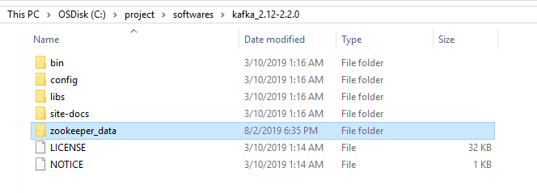

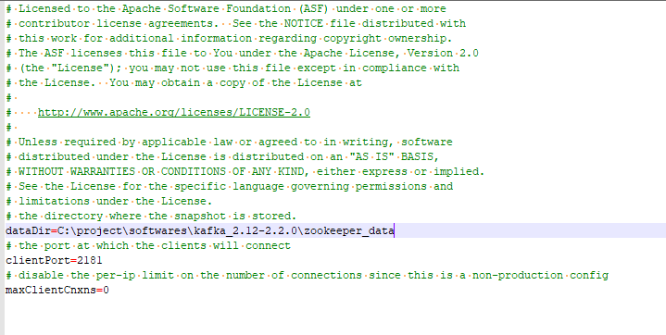

Create directory for Kafka logs

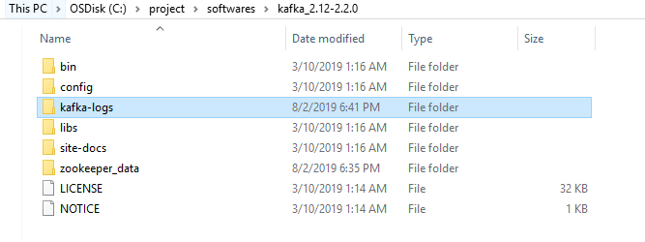

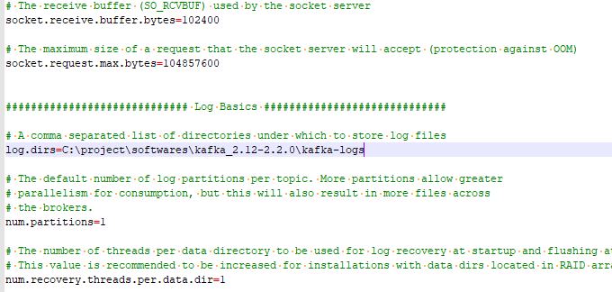

Change the log.dirs to valid directory in server.properties file

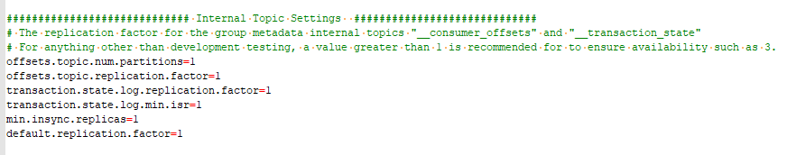

**Start Zookeeper**

C:\project\softwares\kafka_2.12-2.2.0\bin\windows>zookeeper-server-start.bat C:\project\softwares\kafka_2.12-2.2.0\config\zookeeper.properties

**Start Kafka**

C:\project\softwares\kafka_2.12-2.2.0\bin\windows>kafka-server-start.bat C:\project\softwares\kafka_2.12-2.2.0\config\server.properties

**To Test**

C:\project\softwares\kafka_2.12-2.2.0\bin\windows>zookeeper-shell.bat localhost:2181 ls /brokers/ids

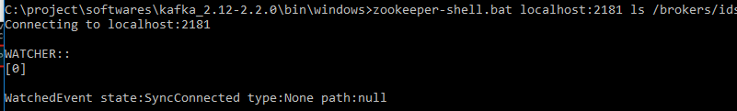

C:\project\softwares\kafka_2.12-2.2.0\bin\windows>kafka-topics.bat --create --zookeeper localhost:2181 --replication-factor 1 --partitions 1 --topic test

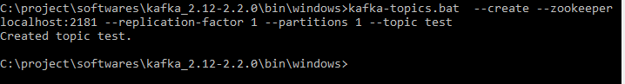

**Sending message to the topic test**

C:\project\softwares\kafka_2.12-2.2.0\bin\windows>kafka-console-producer.bat --broker-list localhost:9092 --topic test

>hello kafka

>how are you?



**Receiving message from topic test**

C:\project\softwares\kafka_2.12-2.2.0\bin\windows>kafka-console-consumer.bat --bootstrap-server localhost:9092 --topic test --from-beginning



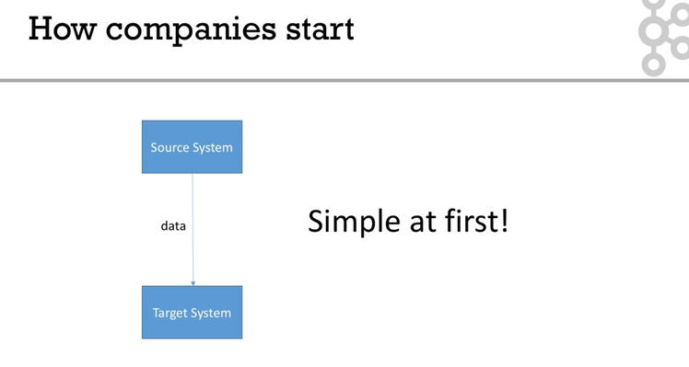

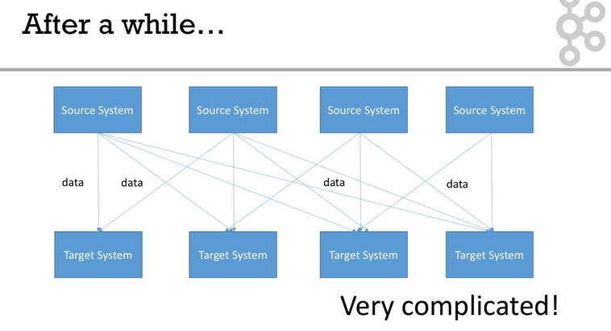

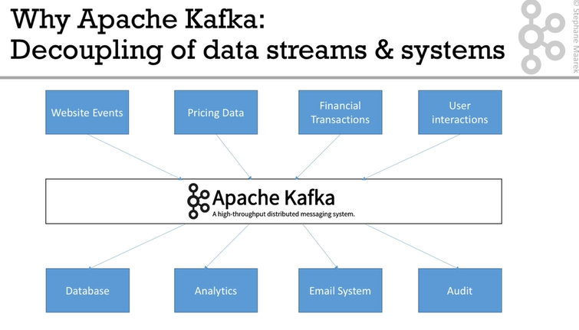

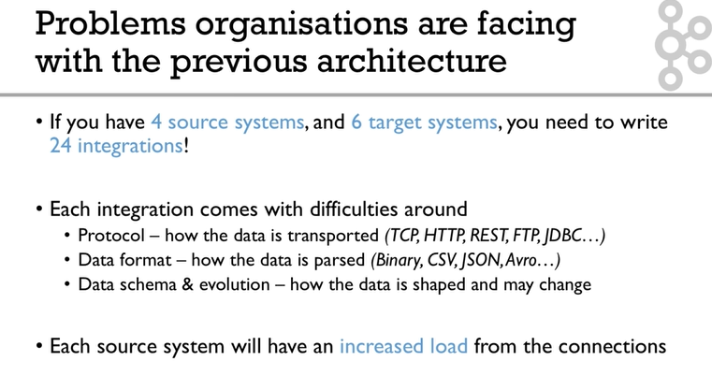

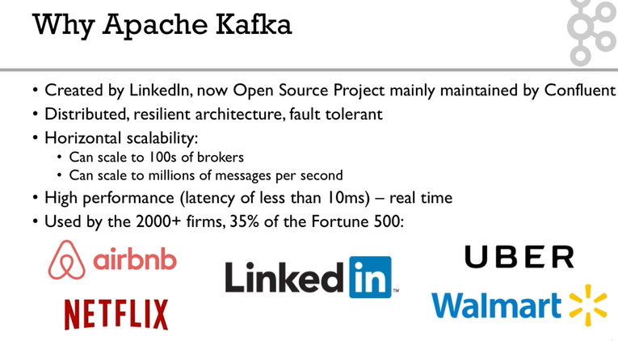

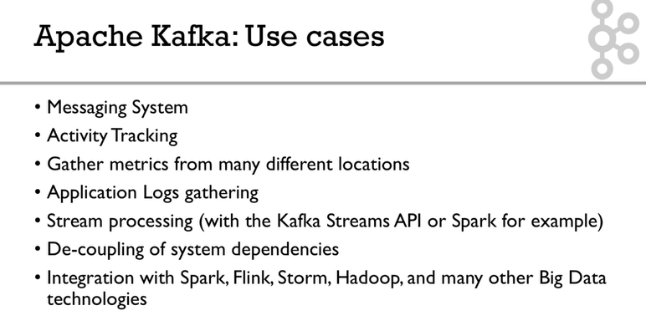

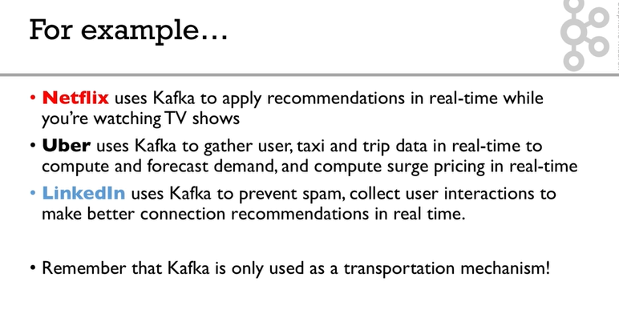

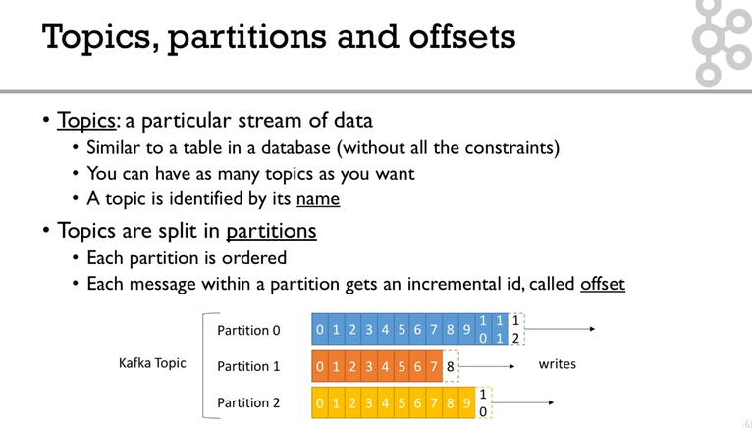

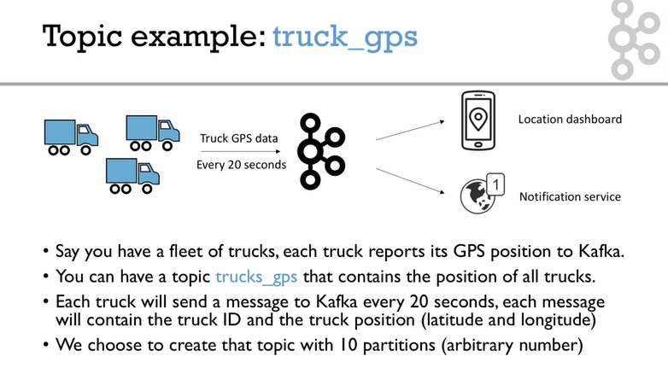

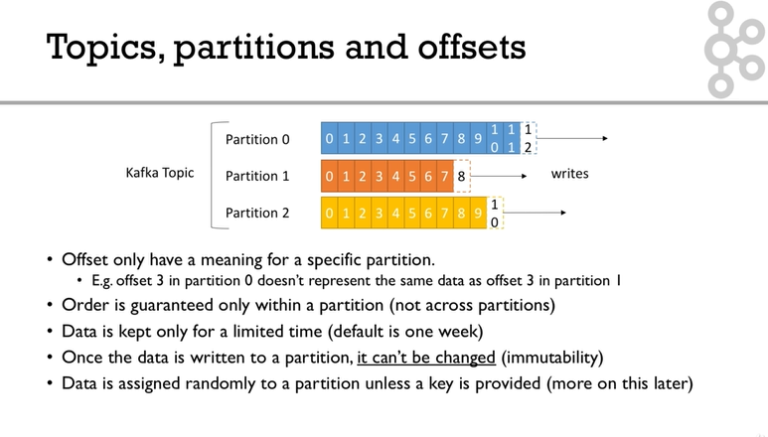

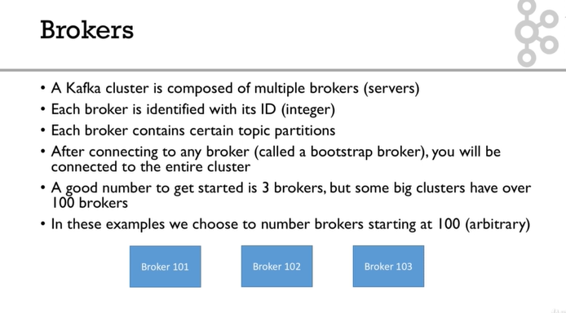

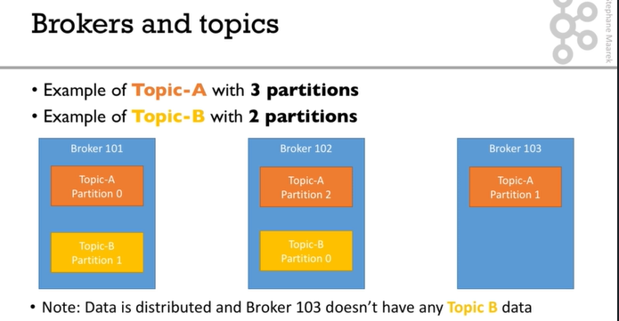

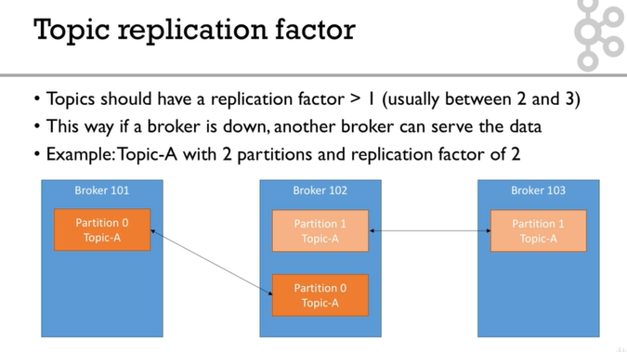

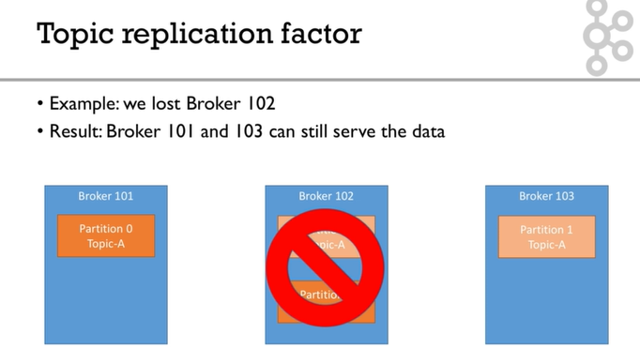

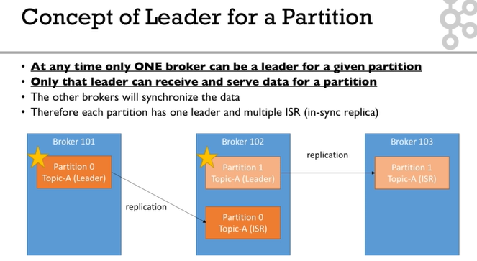

The leader and ISR are decided by zookeeper.

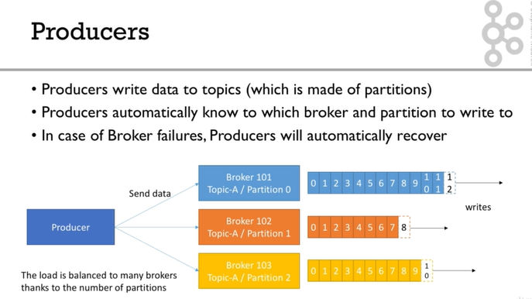

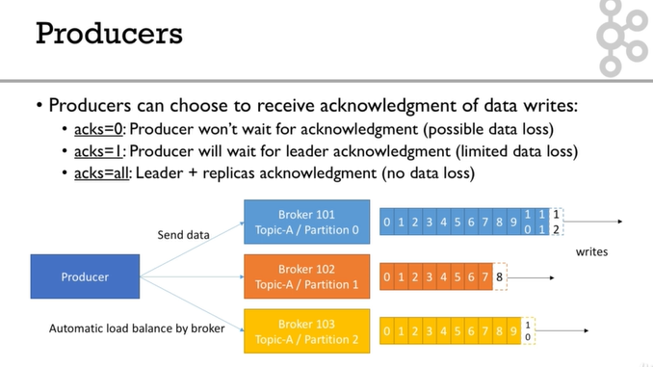

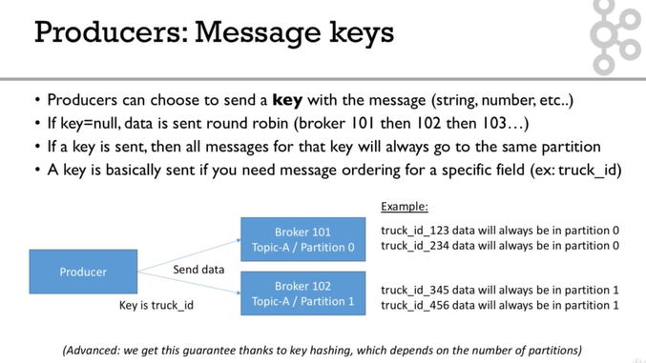

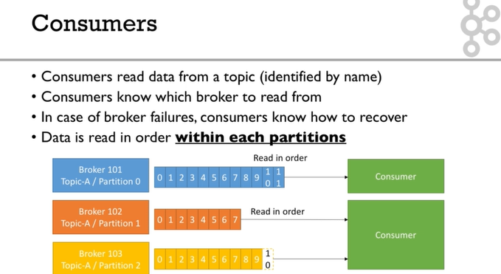

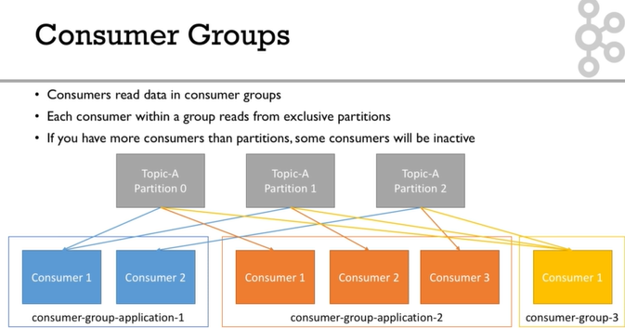

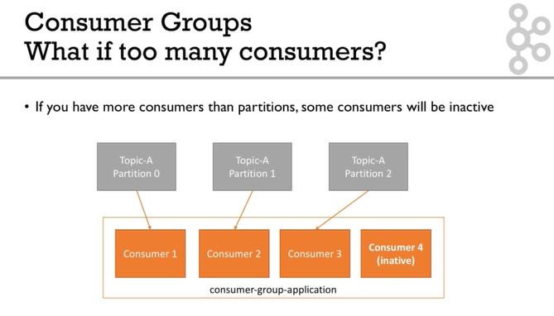

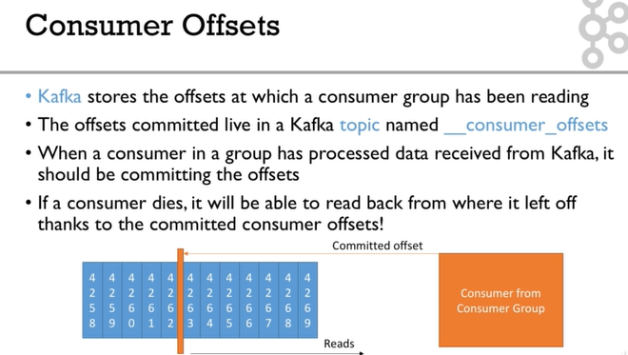

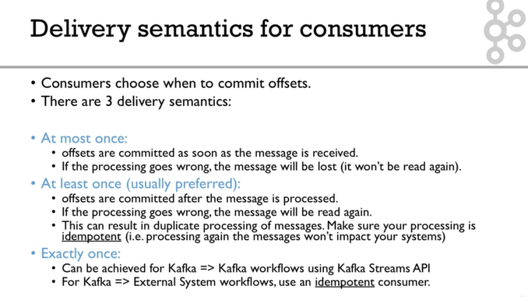

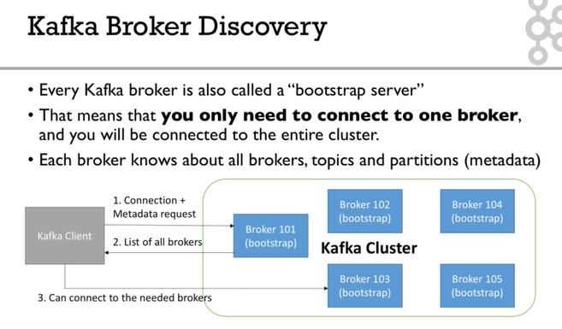

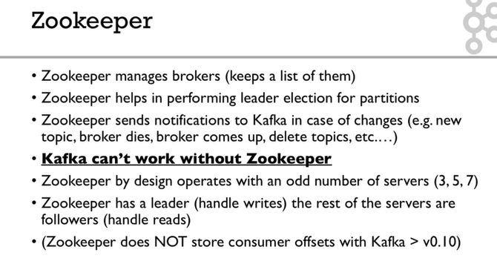

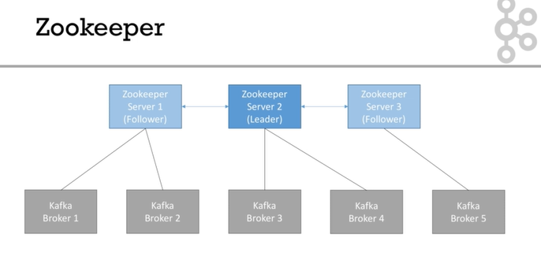

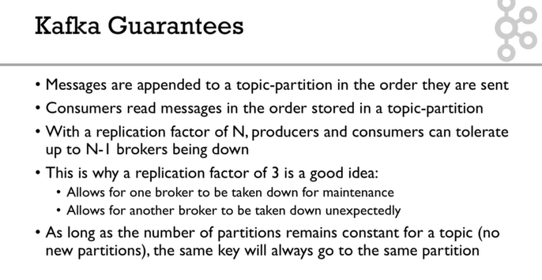

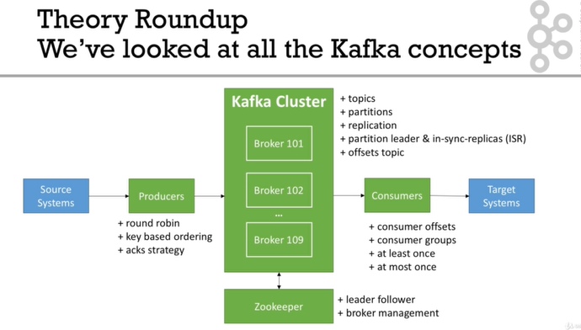

**In summary, for Linux (ex: Ubuntu)**

1. Download and Setup **Java 8 JDK:**
   1. sudo apt install openjdk-8-jdk
2. Download & Extract the Kafka binaries from <https://kafka.apache.org/downloads>
3. Try Kafka commands using bin/kafka-topics.sh (for example)
4. Edit PATH to include Kafka (in ~/.bashrc for example) PATH="$PATH:/your/path/to/your/kafka/bin"
5. Edit Zookeeper & Kafka configs using a text editor
   1. zookeeper.properties: dataDir=/your/path/to/data/zookeeper
   2. server.properties: log.dirs=/your/path/to/data/kafka
6. Start Zookeeper in one terminal window: zookeeper-server-start.sh config/zookeeper.properties
7. Start Kafka in **another** terminal window: kafka-server-start.sh config/server.properties

**Important: For the rest of the course, don't forget to add the extension .sh to commands being run**

Windows - Summary

**In summary, for Windows**

1. Download and Setup **Java 8 JDK**
2. Download the Kafka binaries from <https://kafka.apache.org/downloads>
3. Extract Kafka at the root of C:\
4. Setup Kafka bins in the **Environment variables** section by editing **Path**
5. Try Kafka commands using kafka-topics.bat (for example)
6. Edit Zookeeper & Kafka configs using NotePad++ <https://notepad-plus-plus.org/download/>
   1. zookeeper.properties: dataDir=C:/kafka_2.12-2.0.0/data/zookeeper (yes the slashes are inversed)
   2. server.properties: log.dirs=C:/kafka_2.12-2.0.0/data/kafka (yes the slashes are inversed)
7. Start Zookeeper in one command line: zookeeper-server-start.bat config\zookeeper.properties
8. Start Kafka in **another** command line: kafka-server-start.bat config\server.properties

**Important: For the rest of the course, don't forget to add the extension .bat to commands being run**