Linux

Os

It’s a kernel

Linux is a layer between hardware and application.

It can be used as server or desktop.

Linux has multiple distribution Ubuntu, Debian, fedora ,Radhat

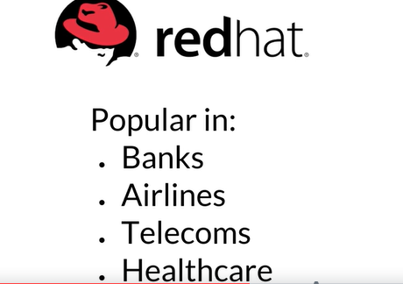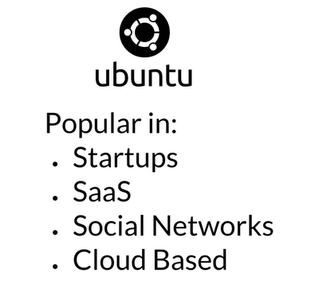

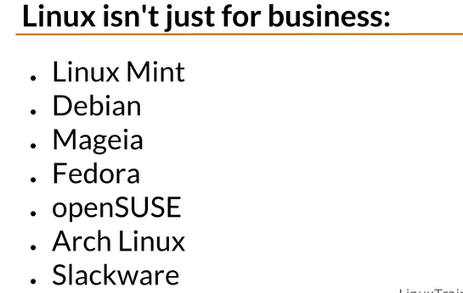

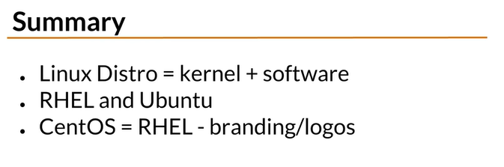

<https://www.virtualbox.org/>

<https://www.linuxtrainingacademy.com/vdi/>

