**WEB PAGE**

1. Login Page:

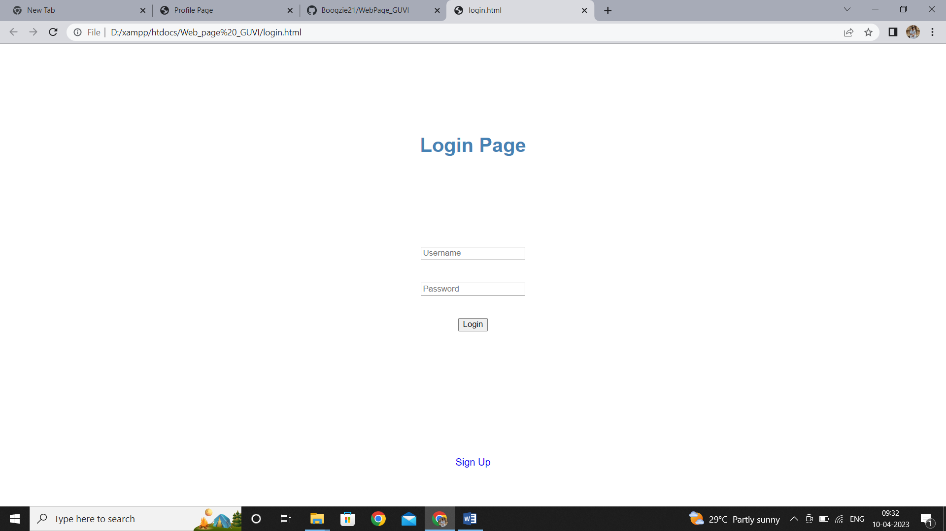

If the username and password are correct, then the page is loaded into profile page. Else if the password is wrong, then it shows an alert that the password is wrong. If username does not exist, then it takes you to the register page.

2. Register Page

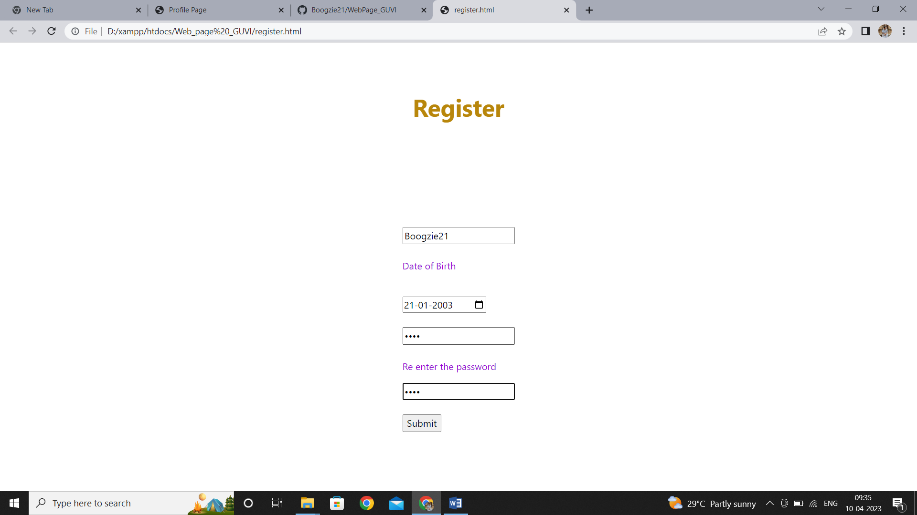

The user register their username here. They give their date of birth from which age is automatically computed. The registration is successful only if the password field and he re enter the password field are the same. Then the page takes you to the login page on successful registration.

3. Profile Page

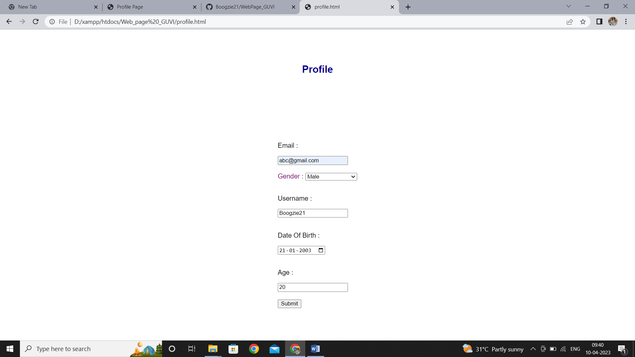

The details of the user is registered here. The field username and age are read only. Username is the unique ID which is different for every user. On clicking the submit button, the changes roll over to the database (which is SQL) and age is computed before updating in case there is a change in the date of birth.