Six Degree of Freedom Launch Vehicle Guidance Navigation and Control Simulation with Delayed Sensor Fusion and Monte Carlo Diagnostics
Arvind Kanagasabapathi Chandirakala
University of Florida
Corresponding author: arvindarush22@gmail.com

Abstract
Background: Design-stage launch vehicle analysis requires coupled assessment of vehicle dynamics, navigation uncertainty, control limits, and dispersed operating conditions. Methods: A C++17 software tool was developed for six degree of freedom rigid-body simulation with variable mass, central gravity, altitude-dependent wind, aerodynamic force models, thrust-vector control, inertial measurement unit, Global Positioning System, and barometric sensors. The navigation module uses inertial propagation, delayed Global Positioning System measurement handling, modified Rodrigues parameter attitude errors, and normalized estimation error squared and normalized innovation squared diagnostics. Results: Fourteen automated tests passed. In a 1,000-run, 600 s Monte Carlo use case with 10 ms integration, all runs produced valid impacts. The mean Global Positioning System normalized innovation squared was 0.73, mean barometer normalized innovation squared was 0.97, and the median six-state normalized estimation error squared was 4.87. Conclusions: The tool provides a reproducible environment for early-stage guidance, navigation, and control studies, uncertainty propagation, and estimator-diagnostic analysis. Numerical outputs are configuration-specific and do not constitute flight qualification.

Keywords
launch vehicle; six degree of freedom simulation; guidance navigation and control; unscented Kalman filter; delayed measurements; Monte Carlo analysis; normalized estimation error squared; normalized innovation squared

Introduction
Launch vehicle performance depends on coupled translational and rotational dynamics, atmospheric disturbances, vehicle mass properties, propulsion, aerodynamics, sensors, and control authority. A nominal trajectory cannot quantify the effect of uncertainty in these elements. Six degree of freedom simulation and Monte Carlo analysis are therefore established components of launch-vehicle guidance, navigation, and control evaluation [1-3].
Several tools provide trajectory and performance analysis for rockets. The present software addresses a complementary need: a compact, inspectable C++ implementation that combines a rigid-body plant, timing-explicit sensors, nonlinear navigation estimation, actuator-constrained control, and estimator consistency diagnostics within one reproducible Monte Carlo workflow. The design supports transparent modification of model assumptions and direct inspection of saved run-level and time-history data.

Methods

Implementation
The software is written in C++17 and built with CMake. Linear algebra is provided by Eigen. Automated tests use GoogleTest. OpenMP is used when available for parallel Monte Carlo execution. The implementation is organized into dynamics, sensors, delayed-measurement queue, estimator, control, Monte Carlo, configuration, and analysis modules.
The truth model is a six degree of freedom rigid body. Translational motion is integrated in Cartesian coordinates according to
m dv_i/dt = F_i,thrust + F_i,aero + F_i,gravity + F_i,other, (1)
and central gravity is represented by
F_i,gravity = -mu m r_i / ||r_i||^3. (2)
Here, m is vehicle mass, r_i is inertial position, v_i is inertial velocity, and mu is the gravitational parameter. Aerodynamic loads depend on atmosphere and air-relative velocity. The vehicle model includes a thrust schedule, propellant depletion, full and dry inertias, an aft thrust application point, altitude-dependent wind, drag versus Mach number, and lift versus angle of attack.
Rotational dynamics are represented by Euler rigid-body dynamics, I dω_b/dt + ω_b × (Iω_b) = M_b. Quaternion normalization is applied after numerical integration. Thrust-vector control and transverse center-of-gravity displacement generate moments through the thrust application geometry.
The sensor suite includes inertial measurement unit samples, delayed Global Positioning System position measurements, and barometric altitude measurements. Measurement acquisition time and arrival time are stored separately. The barometer includes lag and pressure-to-altitude conversion. Sensor turn-on bias and random-walk behavior are represented explicitly.
The navigation estimator propagates from the latest inertial specific-force and angular-rate samples. Position, velocity, attitude error, accelerometer bias, and gyro bias are represented in the error state. Modified Rodrigues parameters are used for attitude error representation; a shadow-set transformation is applied near the singularity. A delayed Global Positioning System update is evaluated at its measurement epoch using a state history and propagated to the current epoch. The covariance update uses Joseph form. Global Positioning System/inertial integration through Kalman filtering is consistent with standard integrated-navigation practice [4]. Delayed location measurements are a known source of error in dynamic systems, motivating explicit latency treatment [5].
The controller calculates a thrust-axis pointing error and combines it with body angular rate. The resulting command is passed through a thrust-vector actuator model with first-order lag, slew-rate limitation, and saturation. This prevents idealized commands from being interpreted as physically achievable actuation.

Operation
The executable reads vehicle parameters from config/vehicle.yaml and Monte Carlo settings from config/dispersions.yaml. The configuration specifies vehicle mass, inertia, aerodynamic tables, motor schedule, wind profile, run count, seed, timestep, duration, thread count, closed-loop state, consistency sampling interval, and uncertainty distributions. Command-line arguments can override selected campaign settings for short diagnostic runs.
The software requires a C++17 compiler, CMake version 3.20 or later, Eigen3, GoogleTest, and optionally OpenMP. The primary executable is run_monte_carlo. The analysis scripts read comma-separated output files and generate apogee distributions, landing ellipses, normalized estimation error squared and normalized innovation squared plots, and sensitivity rankings.
The normalized estimation error squared is e^T P^-1 e, where e is the truth-known estimation error and P is the reported covariance. The normalized innovation squared is ν^T S^-1 ν, where ν is the measurement innovation and S is its innovation covariance. These measures are used to assess whether errors and innovations are commensurate with reported uncertainty [6,7].

Use case
A final closed-loop use case was executed with 1,000 Monte Carlo runs, a 600 s simulation duration, a 10 ms integration step, and the configured plant and sensor dispersions. Wind magnitude, thrust, dry mass, aerodynamic scale, sensor bias scale, thrust misalignment, and center-of-gravity offset were independently sampled. A deterministic seed was used to make the campaign reproducible. The simulation wrote one run-level output table and one time-history trace table.
The use case demonstrates four complementary output types. Figure 1 shows the apogee distribution and summarizes vertical performance across dispersed conditions. Figure 2 shows the landing scatter and three-sigma ellipse, which summarize terminal-location dispersion. Figure 3 reports normalized estimation error squared and normalized innovation squared diagnostics that cannot be obtained from a trajectory plot alone. Figure 4 ranks standardized sensitivity contributions and identifies the variables with the largest influence on the selected output.

Discussion
The use case exercised the full closed loop and produced valid impact states in all 1,000 runs. Mean barometer normalized innovation squared was close to the one-degree-of-freedom reference value, while mean Global Positioning System normalized innovation squared was lower than one. The median six-state normalized estimation error squared was near the nominal six-state reference value; however, the mean was increased by high-error cases. These results support use of the tool for diagnosis and design trades, while also identifying covariance tuning and powered-phase modeling as priority areas for further work.
The software is not a flight-qualified vehicle model. Current aerodynamic and propulsion inputs are representative configuration values and have not been correlated with a specific flight article. No hardware-in-the-loop evaluation or external trajectory comparison against a reference tool is included in the present release. The numerical outputs should therefore be interpreted as configuration-specific simulation results rather than as certified performance or safety predictions.

Conclusions
A reproducible launch-vehicle software tool has been implemented for six degree of freedom simulation, delayed sensor fusion, actuator-limited control, and Monte Carlo uncertainty analysis. The tool produces interpretable mission-level and estimator-level outputs from declarative input files and includes automated verification of key dynamics, timing, estimator, and control interfaces. The combination is suitable for early-stage design studies, estimator tuning, sensitivity analysis, and future comparison with externally validated aerodynamic or trajectory models.

Data and software availability

Underlying data
The numerical datasets supporting the reported use case are archived in Zenodo as part of Launch Vehicle GNC Simulator, version 1.0.0, DOI: https://doi.org/10.5281/zenodo.22801065. The principal run-level file is formal_1000_final.csv. The associated time-history trace is formal_1000_final_trace.csv. Additional smoke, consistency, full-campaign, and 10,000-run datasets are included in the archive. Each run-level dataset records apogee, terminal location, sampled dispersions, estimator summary statistics, and impact-validity status. Trace datasets record run index, time, metric, value, and degrees of freedom.

Extended data
Extended data include the YAML vehicle and dispersion configurations, CMake build configuration, automated tests, analysis scripts, figure sets generated from the formal campaigns, a data dictionary, and reproducibility instructions. These materials are included in the Zenodo archive associated with DOI: https://doi.org/10.5281/zenodo.22801065.

Software availability
The software package contains C++17 source code, CMake build files, YAML input configurations, automated tests, and Python analysis scripts. Version 1.0.0 is archived in Zenodo with the supporting data and documentation at DOI: https://doi.org/10.5281/zenodo.22801065. The archive provides the versioned software release used to generate the reported results.

Competing interests
No competing interests were disclosed.

Grant information
Grant information was not reported.

Acknowledgements
No acknowledgements were reported.

References
1. NASA. Time and Frequency-Domain Cross-Verification of SLS 6DOF Trajectory Simulations. NASA Technical Reports Server; 2017. Available from: https://ntrs.nasa.gov/citations/20170001827.
2. NASA. Applying Monte Carlo Simulation to Launch Vehicle Design and Requirements Verification. NASA Technical Reports Server; 2010. Available from: https://ntrs.nasa.gov/archive/nasa/casi.ntrs.nasa.gov/20100035661.pdf.
3. McMillin SN, et al. The X-43A Six Degree of Freedom Monte Carlo Analysis. NASA Technical Reports Server; 2008. Available from: https://ntrs.nasa.gov/citations/20080006638.
4. Smalling KM, Eure KW. A Short Tutorial on Inertial Navigation System and Global Positioning System Integration. NASA/TM-2015-218803; 2015. Available from: https://ntrs.nasa.gov/archive/nasa/casi.ntrs.nasa.gov/20150018921.pdf.
5. Bouvet D, Garcia G. GPS latency identification by Kalman filtering. Robotica. 2000;18(5):475-485. doi:10.1017/S0263574700002654.
6. Piche R. Online tests of Kalman filter consistency. Tampere University of Technology; 2014. Available from: https://trepo.tuni.fi/bitstream/handle/10024/212922/KFconsistency2015.pdf?sequence=-1.
7. Chen Z, Biggie H, Ahmed N, Julier S, Heckman C. Kalman filter auto-tuning through enforcing chi-squared normalized error distributions with Bayesian optimization. arXiv. 2023;2306.07225. doi:10.48550/arXiv.2306.07225.
8. Chandirakala AK. Launch Vehicle GNC Simulator, version 1.0.0. Zenodo; 2026. doi:10.5281/zenodo.22801065.

Tables
Table 1. Vehicle and Monte Carlo configuration.
Item | Configured value | Purpose
Dry mass | 100 kg | Vehicle dry-mass parameter
Initial propellant mass | 50 kg | Powered-flight mass depletion
Reference area | 0.01 m² | Aerodynamic force scaling
Motor schedule | 9,000 N, 0-25 s;  taper to zero by 30 s | Nominal propulsion
Wind scale dispersion | Normal distribution, sigma 0.20 | Atmospheric uncertainty
Thrust scale dispersion | Normal distribution, sigma 0.02 | Propulsive uncertainty
Aerodynamic scale dispersion | Normal distribution, sigma 0.03 | Aerodynamic uncertainty
CG offset dispersion | Normal distribution, sigma 0.001 m | Thrust moment uncertainty

Table 2. Final closed-loop Monte Carlo use case.
Metric | Result | Interpretation
Monte Carlo runs | 1,000 | Final campaign sample size
Simulation duration | 600 s | Terminal-impact window
Integration step | 10 ms | Numerical propagation step
Valid impacts | 1,000 / 1,000 | All final states reached a valid impact
Mean apogee | 76,282 m | Configuration-specific outcome
Median apogee | 84,983 m | Distribution center less sensitive to low cases
Mean GPS NIS | 0.73 | Conservative GPS update on average
Mean barometer NIS | 0.97 | Close to one-degree-of-freedom reference
Median NEES | 4.87 for 6 states | Near six-state reference scale
Mean NEES | 12.2 | Elevated by high-error cases

Figure legends
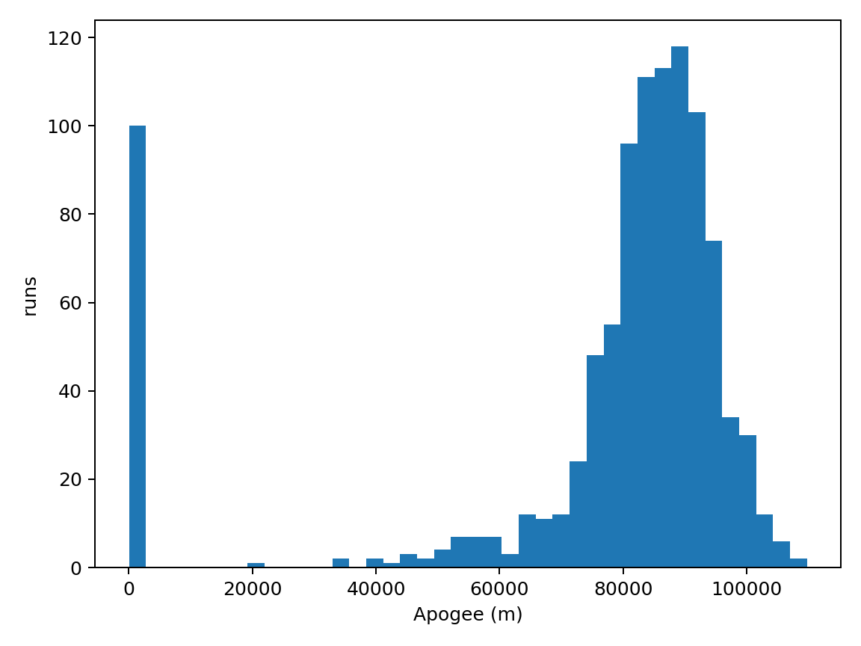
Figure 1. Apogee distribution. Histogram of apogee across the final 1,000-run Monte Carlo campaign.
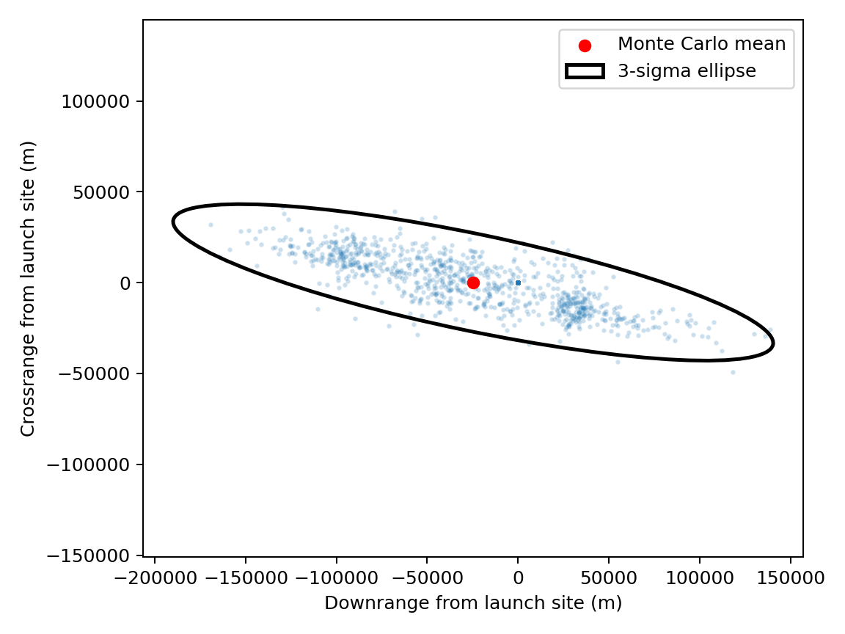
Figure 2. Landing dispersion. Points show terminal locations; red marker is the sample mean and black contour is the three-sigma covariance ellipse.
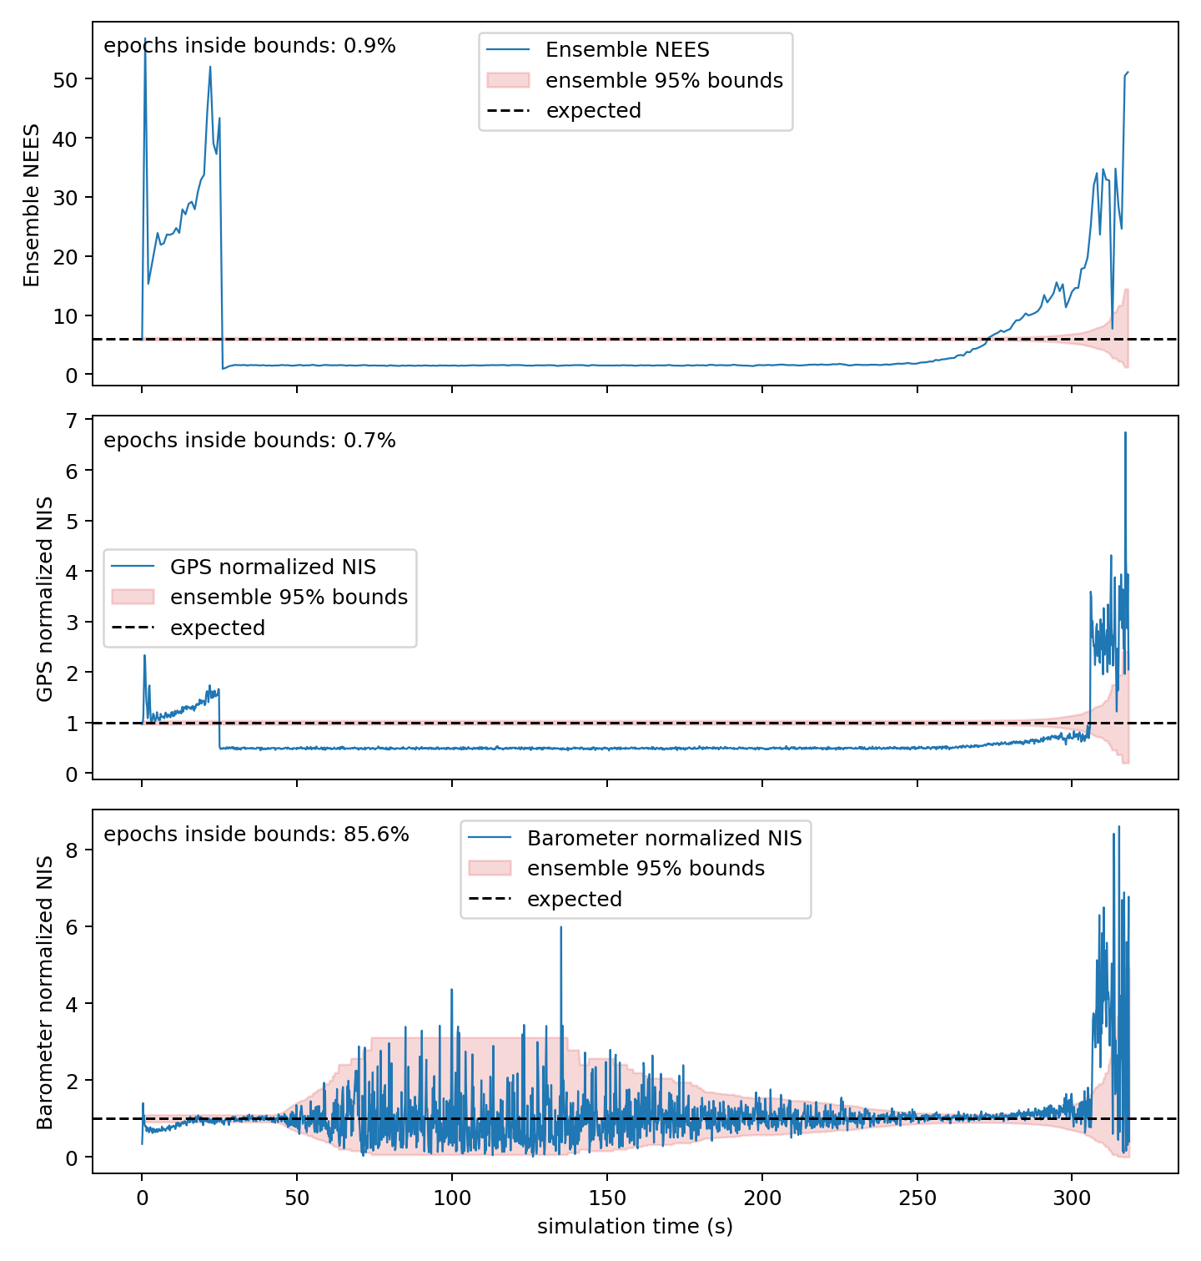
Figure 3. Estimator consistency. Panels show normalized estimation error squared, Global Positioning System normalized innovation squared, and barometer normalized innovation squared.
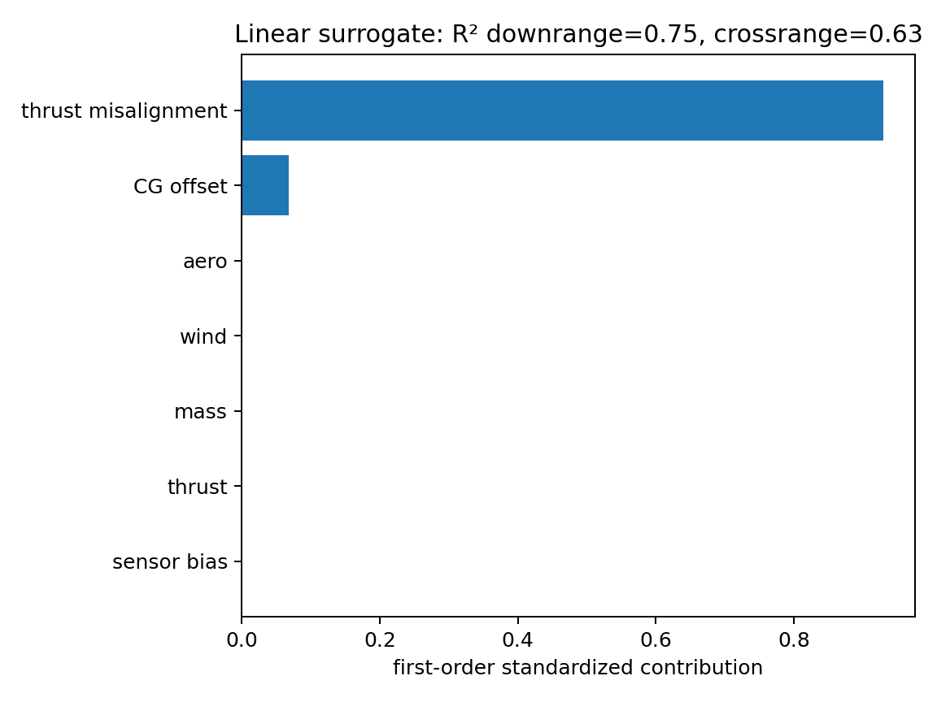
Figure 4. Sensitivity ranking. Bars show normalized first-order contributions of dispersed variables to the selected output.

