NAME: Rahul Rajkapoor Nag
ROLL NO: TYBsc.IT 14
SUBJECT: IS Practical
COURSE: TYBsc.IT
SEMESTER: 6

Index
Practical No. | Practical Names | Date | Sign
1 | Configure Routers:  a. OSPF MD5 authentication.  b. NTP.  c. to log messages to the syslog server. | 17/11/25
2 | Configure AAA Authentication:  a. Configure a local user account on Router and configure authenticate on the console and vty lines using local AAA.  b. Verify local AAA authentication from the Router console and the PC-A client. | 24/11/25
3 | Configuring Extended ACLs:  a. Configure, Apply and Verify an Extended Numbered ACL | 10/12/25
4 | Configure IP ACLs to Mitigate Attacks and IPV6 ACLs:  a.Verify connectivity among devices before firewall configuration.  b. Use ACLs to ensure remote access to the routers is available only from management station PC-C.  c. Configure ACLs on to mitigate attacks. d. Configuring IPv6 ACLs | 13/12/25
5 | Configuring a Zone-Based Policy Firewall | 15/12/25
6 | Configure IOS Intrusion Prevention System (IPS) Using the CLI:  a. Enable IOS IPS.  b. Modify an IPS signature. | 05/01/26
7 | Layer 2 Security:  a. Assign the Central switch as the root bridge.  b. Secure spanning-tree parameters to prevent STP manipulation attacks. c. Enable port security to prevent CAM table overflow attacks. | 12/01/26
8 | Layer 2 VLAN Security | 19/01/26
9 | Configure and Verify a Site-to-Site IPsec VPN Using CLI | 02/02/26
10 | Configuring ASA Basic Settings and Firewall Using CLI a. Configure basic ASA settings and interface security levels using CLI b. Configure routing, address translation, and inspection policy using CLI c. Configure DHCP, AAA, and SSH d. Configure a DMZ, Static NAT, and ACLs | 05/02/26
Practical-1
Configure Routers:
a. OSPF MD5 authentication.
b. NTP.
c. to log messages to the syslog server.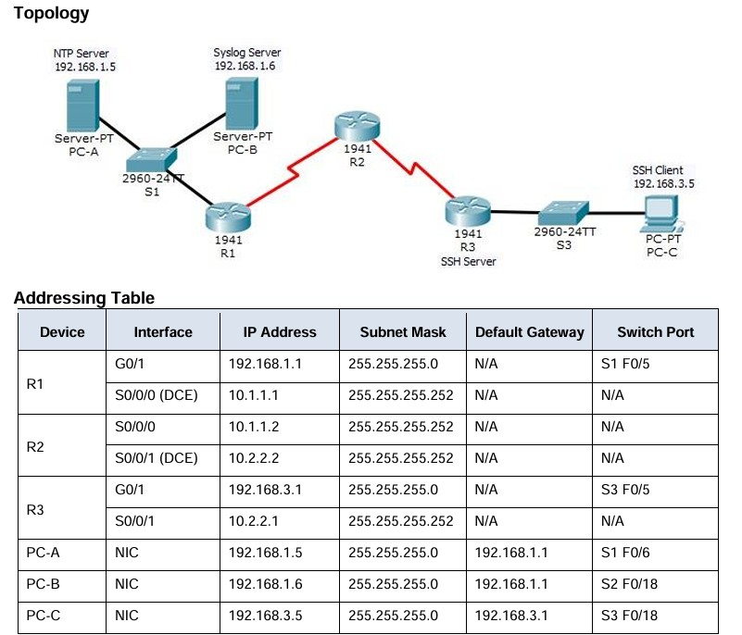

A. OSPF MD5 authentication.
Step 1: Test connectivity. All devices should be able to ping all other IP addresses.
Step 2: Configure OSPF MD5 authentication for all the routers in area 0. Configure
OSPF MD5 authentication for all the routers in area 0.
R1(config)# router ospf 1
R1(config-router)# area 0 authentication message-digest
R2(config)# router ospf 1
R2(config-router)# area 0 authentication message-digest
R3(config)# router ospf 1
R3(config-router)# area 0 authentication message-digest
Step 3: Configure the MD5 key for all the routers in area 0. Configure an MD5 key on the serial
interfaces on R1, R2 and R3. Use the password MD5pa55 for key 1.
R1(config)# interface s0/0/0
R1(config-if)# ip ospf message-digest-key 1 md5 MD5pa55
R2(config)# interface s0/0/0
R2(config-if)# ip ospf message-digest-key 1 md5 MD5pa55
R2(config-if)# interface s0/0/1
R2(config-if)# ip ospf message-digest-key 1 md5 MD5pa55
R3(config)# interface s0/0/1
R3(config-if)# ip ospf message-digest-key 1 md5 MD5pa55
Step 4: Verify configurations.
a. Verify the MD5 authentication configurations using the commands show ip ospf interface. b.
Verify end-to-end connectivity.

B. NTP.
Step 1: Enable NTP authentication on PC-A.
a. On PC-A, click NTP under the Services tab to verify NTP service is enabled.
b. To configure NTP authentication, click Enable under Authentication. Use key 1 and password NTPpa55 for authentication.
Step 2: Configure R1, R2, and R3 as NTP clients.
R1(config)# ntp server 192.168.1.5
R2(config)# ntp server 192.168.1.5
R3(config)# ntp server 192.168.1.5
Verify client configuration using the command show ntp status.
Step 3: Configure routers to update hardware clock. Configure R1, R2, and
R3 to periodically update the hardware clock with the time learned from NTP.
R1(config)# ntp update-calendar
R2(config)# ntp update-calendar
R3(config)# ntp update-calendar
Exit global configuration and verify that the hardware clock was updated using the command show clock.
Step 4: Configure NTP authentication on the routers. Configure NTP
authentication on R1, R2, and R3 using key 1 and password NTPpa55.
R1(config)# ntp authenticate
R1(config)# ntp trusted-key 1
R1(config)# ntp authentication-key 1 md5 NTPpa55
R2(config)# ntp authenticate
R2(config)# ntp trusted-key 1
R2(config)# ntp authentication-key 1 md5 NTPpa55
R3(config)# ntp authenticate
R3(config)# ntp trusted-key 1
R3(config)# ntp authentication-key 1 md5 NTPpa55
Step 5: Configure routers to timestamp log messages.
Configure timestamp service for logging on the routers.
R1(config)# service timestamps log datetime msec
R2(config)# service timestamps log datetime msec
R3(config)# service timestamps log datetime msec

C. to log messages to the syslog server.
Step 1: Configure the routers to identify the remote host (Syslog Server) that will receive logging messages.
R1(config)# logging host 192.168.1.6
R2(config)# logging host 192.168.1.6
R3(config)# logging host 192.168.1.6
The router console will display a message that logging has started.
Step 2: Verify logging configuration.
Use the command show logging to verify logging has been enabled.
Step 3: Examine logs of the Syslog Server.
From the Services tab of the Syslog Server’s dialogue box, select the Syslog services button. Observe the logging messages received from the routers.
Note: Log messages can be generated on the server by executing commands on the router. For example,
entering and exiting global configuration mode will generate an informational configuration message. You may
need to click a different service and then click Syslog again to refresh the message display.
Practical -2
Configure AAA Authentication
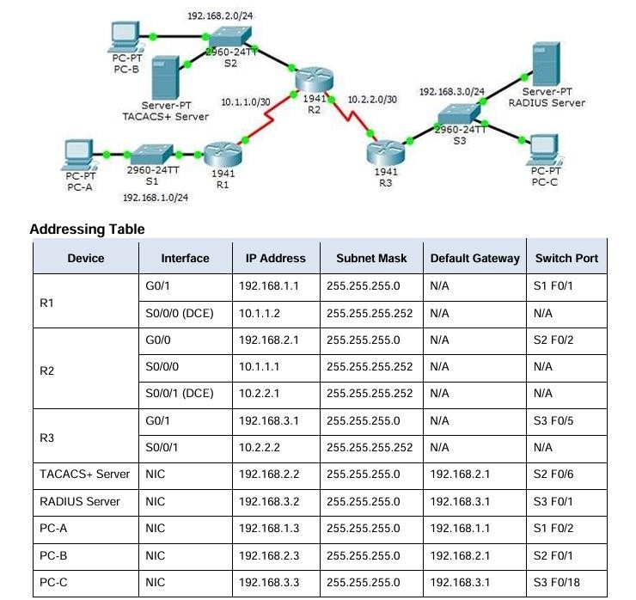

A. Configure a local user account on Router and configure authenticate on the console and vty lines using local AAA
Configure Local User Account on the Router:
1.Access the Router CLI
Connect to the router using the console or SSH.
2.Enable AAA on the Router Router# configure terminal
Router(config)# aaa new-model
3.Create a Local User for Authentication
Router(config)# username admin privilege 15 secret Admin123
4.Configure Local Authentication for Console and VTY
Router(config)# aaa authentication login default local
Router(config)# line console 0
Router(config-line)# login authentication default
Router(config-line)# exit
Router(config)# line vty 0 4
Router(config-line)# login authentication default
Router(config-line)# exit
Router(config)# exit

Step 1: Configure domain name and crypto key for use with SSH.
a.Use ccnasecurity.com as the domain name on R1.
R1(config)# ip domain-name ccnasecurity.com
b.Create an RSA crypto key using 1024 bits.
R1(config)# crypto key generate rsa
Choose the size of the key modulus in the range of 360 to 2048 for your
General Purpose Keys. Choosing a key modulus greater than 512 may take a few minutes.
How many bits in the modulus [512]: 1024
% Generating 1024 bit RSA keys, keys will be nonexportable...[OK]
Step 2: Configure a named list AAA authentication method for the vty lines on R1.
Configure a named list called SSH-LOGIN to authenticate logins using local AAA.
R1(config)# aaa authentication login SSH-LOGIN local
Step 3: Configure the vty lines to use the defined AAA authentication method.
Configure the vty lines to use the named AAA method and only allow SSH for remote access.
R1(config)# line vty 0 4
R1(config-line)# login authentication SSH-LOGIN R1(config-line)# transport input ssh R1(config-line)# end
Step 4: Verify the AAA authentication method.
Verify the SSH configuration SSH to R1 from the command prompt of PC-A..
PC> ssh –l Admin1 192.168.1.1
Open
Password: admin1pa55

B. Verify local AAA authentication from the Router console and the PC-A client
Step 1: Configure Local AAA Authentication on the Router
Access the Router CLI
Connect to the router using the console or SSH.
Enable AAA on the Router
Router# configure terminal
Router(config)# aaa new-model
Create a Local User for Authentication
Router(config)# username admin privilege 15 secret Admin123
Configure Local Authentication for Console and VTY
Router(config)# aaa authentication login default local
Router(config)# line console 0
Router(config-line)# login authentication default
Router(config-line)# exit
Router(config)# line vty 0 4
Router(config-line)# login authentication default
Router(config-line)# exit
Router(config)# exit
Step 2: Verify Local AAA Authentication from the Router
Console
Log out of the router
Router# exit
Log back in via console
- You should be prompted for a username and password.
- Enter Username: admin
- Enter Password: Admin123
- If successful, you will get access to the router CLI.
Step 3: Verify Local AAA Authentication from PC-A Client
Option 1: Telnet Test
On PC-A, open the Command Prompt or Terminal. Attempt to access the router via Telnet telnet <router-ip>
When prompted, enter the username and password:
- Username: admin
- Password: Admin123
If successful, you should gain access to the router CLI.

Option 2: SSH Test
On PC-A, open the Command Prompt or Terminal. Use SSH to connect to the router ssh admin@<router-ip>
Enter the password when prompted
- Password: Admin123
If authentication succeeds, you will access the router CLI.
Step 4: Verify Authentication Logs (Optional)
To check authentication logs on the router, use:
Router# show aaa sessions
Router# show users

Practical 3
Configuring Extended ACLs
a. Configure, Apply and Verify an Extended Numbered ACL
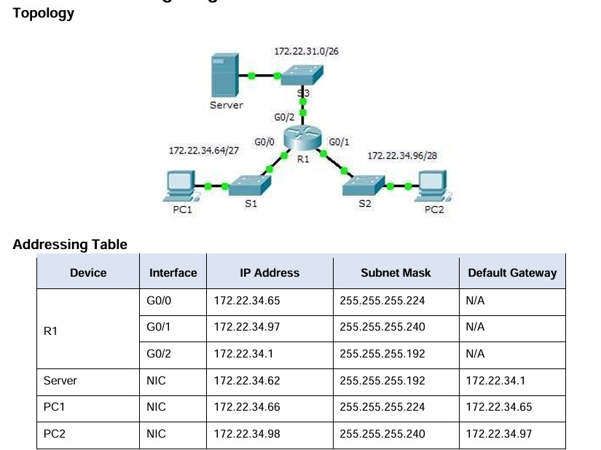

Step 1: Configure an ACL to permit FTP and ICMP.
a.From global configuration mode on R1, enter the following command to determine the first valid number
for an extended access list.
R1(config)# access-list ?
<1-99> IP standard access list
<100-199> IP extended access list
b. Add 100 to the command, followed by a question mark.
R1(config)# access-list 100 ?
deny
permit
Specify packets to reject
Specify packets to forward
remark Access list entry comment
c. To permit FTP traffic, enter permit, followed by a question mark.
R1(config)# access-list 100 permit ?
ahp Authentication Header Protocol
eigrp Cisco's EIGRP routing protocol
esp Encapsulation Security Payload
gre
Cisco's GRE tunneling icmp
Internet Control Message Protocol ip
Any Internet Protocol ospf OSPF
routing protocol tcp Transmission
Control Protocol udp
User Datagram Protocol
d.This ACL permits FTP and ICMP. ICMP is listed above, but FTP is not, because FTP uses TCP.
Therefore,enter tcp to further refine the ACL help.
R1(config)# access-list 100 permit tcp ?
A.B.C.D Source address
Any source host
single source host
host any A
e. Notice that we could filter just for PC1 by using the host keyword or we could allow any host. In this case,
any device is allowed that has an address belonging to the 172.22.34.64/27 network. Enter the network address, followed by a question mark.
R1(config)# access-list 100 permit tcp 172.22.34.64 ?
A.B.C.D Source wildcard bits
f. Calculate the wildcard mask determining the binary opposite of a subnet mask.
11111111.11111111.11111111.11100000 = 255.255.255.224
00000000.00000000.00000000.00011111 = 0.0.0.31
g. Enter the wildcard mask, followed by a question mark.
R1(config)# access-list 100 permit tcp 172.22.34.64 0.0.0.31 ? A.B.C.D Destination address
host eq any Any destination Match only packets on a given port number
gt host Match only packets with a greater port number Match only
A single destination host
packets with a lower port number Match only
packets not on a given port number Match only
packets in the range of port numbers lt neq range Match only
h. Configure the destination address. In this scenario, we are filtering traffic for a single destination, which is the server. Enter the host keyword followed by the server’s IP address.
R1(config)# access-list 100 permit tcp 172.22.34.64 0.0.0.31 host 172.22.34.62
?
dscp Match packets with given dscp value eq Match only packets on a given port number established gt Match only packets with a greater established port number lt number neq
Match only packets with a lower port Match only packets not on a given port
number precedence Match packets with given precedence value
range Match only packets in the range of port numbers
<cr>
i. Notice that one of the options is <cr> (carriage return). In other words, you can press Enter and the statement would permit all TCP traffic. However, we are only permitting FTP traffic; therefore, enter the eq keyword, followed by a question mark to display the available options. Then, enter ftp and press Enter.
R1(config)# access-list 100 permit tcp 172.22.34.64 0.0.0.31 host 172.22.34.62
eq ?
<0-65535> Port number ftp File
Transfer Protocol (21) pop3 Post Office
Protocol v3 (110) smtp Simple Mail Transport Protocol (25) telnet Telnet (23) www World Wide Web (HTTP, 80)
R1(config)# access-list 100 permit tcp 172.22.34.64 0.0.0.31 host
      - q ftp
j. Create a second access list statement to permit ICMP (ping, etc.) traffic from PC1 to Server. Note that the access list number remains the same and no particular type of ICMP traffic needs to be specified.
R1(config)# access-list 100 permit icmp 172.22.34.64
0.0.0.31 host

k. All other traffic is denied, by default.
Step 2: Apply the ACL on the correct interface to filter traffic.
From R1’s perspective, the traffic that ACL 100 applies to is inbound from the network connected to Gigabit
Ethernet 0/0 interface. Enter interface configuration mode and apply the ACL.
R1(config)# interface gigabitEthernet 0/0
R1(config-if)# ip access-group 100 in Step 3: Verify the ACL implementation.
a.Ping from PC1 to Server. If the pings are unsuccessful, verify the IP addresses before continuing.
b.FTP from PC1 to Server. The username and password are both cisco.
PC> ftp 172.22.34.62
c.Exit the FTP service of the Server.
ftp> quit
d.Ping from PC1 to PC2. The destination host should be unreachable, because the traffic was not explicitly permitted.

Practical 4
Configure IP ACLs to Mitigate Attacks and IPV6 ACLs
A. Verify connectivity among devices before firewall configuration.
Step 1: Check Physical and Logical Connections Ensure all cables are properly connected.
Verify interfaces are enabled on routers, switches, and PCs. Run the following on each router/switch to check interface status:
show ip interface brief
Ensure interfaces are UP/UP and assigned correct IP addresses.
Step 2: Verify IP Address Configuration On each PC, check the assigned IP:
Windows (Command Prompt):
ipconfig
Linux/macOS (Terminal):
ifconfig or ip a
On the router, verify interface IPs: show running-config | section interface
Step 3: Test Connectivity Using Ping
From each PC to the Default Gateway (Router) ping <router-ip> Example:
ping 192.168.1.1
If successful, the PC can communicate with the router.
From Router to PC ping <pc-ip> Example:
ping 192.168.1.10
If successful, the router can reach the PC. From PC to Another PC ping <other-pc-ip>
If successful, devices can communicate within the same network.
From PC to Another Network
If multiple networks exist, try pinging a PC in another network: ping <remote-pc-ip>
If unsuccessful, check routing settings.
Step 4: Verify Routing Configuration (For Multi-Network Setups) On the router, check the routing table:
show ip route
Ensure routes to all networks exist.
If using Static Routes, verify they are correctly set:
show running-config | section ip route Example of adding a static route:
ip route 192.168.2.0 255.255.255.0 192.168.1.2 If using Dynamic Routing (OSPF, EIGRP, etc.), check: show ip protocols
show ip ospf neighbor # For OSPF show ip eigrp neighbors # For EIGRP
Step 5: Test Connectivity Using Traceroute
From a PC, trace the path to another device: tracert <destination-ip> # Windows traceroute <destination-ip> # Linux/macOS If the path stops unexpectedly, check for:
Misconfigured routes
Disabled interfaces
Incorrect subnet masks
Step 6: Verify DNS Resolution (If Applicable)
If testing internet connectivity, check if DNS resolution works:
nslookup google.com # Windows dig google.com # Linux/macOS
If unsuccessful, check DNS settings on the router or PC.
Step 7: Ensure No Existing Firewall Rules Are Blocking Traffic Before configuring a firewall, ensure no ACLs are blocking traffic: show access-lists
show running-config | section access-list Remove any ACLs temporarily if needed:
no access-list <ACL-ID>
Final Check
If all pings, traceroutes, and routing tests are successful, connectivity is verified, and you can proceed with firewall configuration.

B. Use ACLs to ensure remote access to the routers is available only from management station PC-C.
Step 1: Identify IP Addresses
Router's management IP: (e.g., 192.168.1.1)
PC-C's IP: (e.g., 192.168.3.10)
Subnet Mask: 255.255.255.0
VTY lines used for SSH/Telnet: 0 - 4
Step 2: Enable SSH on the Router
Set a domain name
Router(config)# ip domain-name mynetwork.com
Generate SSH key (for SSH only) Router(config)# crypto key generate rsa Choose a key size of 1024 or higher.
Enable SSH & Local Authentication
Router(config)# ip ssh version 2
Router(config)# aaa new-model
Router(config)# username admin privilege 15 secret Admin123
Router(config)# line vty 0 4
Router(config-line)# login local
Router(config-line)# transport input ssh
Router(config-line)# exit
Step 3: Configure an ACL to Permit Only PC-C
Create an Access Control List (ACL)
Router(config)# access-list 100 permit tcp host 192.168.3.10 any eq 22
Router(config)# access-list 100 permit tcp host 192.168.3.10 any eq 23
Router(config)# access-list 100 deny tcp any any eq 22
Router(config)# access-list 100 deny tcp any any eq 23
Router(config)# access-list 100 permit ip any any Permit SSH (port 22) & Telnet (port 23) only from PC-C.
Deny SSH/Telnet from any other device.
Allow all other traffic after applying restrictions.
Apply ACL to the VTY Lines
Router(config)# line vty 0 4
Router(config-line)# access-class 100 in
Router(config-line)# exit
Step 4: Verify the Configuration Check the ACL show access-lists 100
Ensure only PC-C is allowed for SSH/Telnet.
Test from PC-C
Try SSH/Telnet from PC-C: ssh admin@192.168.1.1 or
telnet 192.168.1.1
Authentication should succeed.
Test from Any Other PC
Try SSH/Telnet from another device (e.g., PC-A or PC-B).
It should be denied.
Step 5: Monitor ACL Hits To check if ACL is working:
show access-lists 100 show logging

C. Configure ACLs on to mitigate attacks.
Step 1: Identify Common Threats & Protection Methods
Attack Type Mitigation Using ACLs
Unauthorized Access Allow only trusted management IPs
Denial of Service (DoS) Limit ICMP and SYN flood attacks
Spoofing Block private IPs on external interfaces
Malware Spread Block unused or dangerous ports
Brute Force Attacks Restrict SSH/Telnet access
Step 2: Create a Secure ACL
This ACL blocks malicious traffic while allowing legitimate communication.
Modify the IPs according to your network.
1. Block Private IP Spoofing (on Internet-Facing Interface) Router(config)# ip access-list extended SECURE_ACL
Router(config-ext-nacl)# deny ip 10.0.0.0 0.255.255.255 any
Router(config-ext-nacl)# deny ip 172.16.0.0 0.15.255.255 any Router(config-ext-nacl)# deny ip 192.168.0.0 0.0.255.255 any
✔ Blocks packets with private IPs from entering the internet-facing interface (anti-spoofing).
2. Block Unnecessary or Dangerous Services
Router(config-ext-nacl)# deny tcp any any eq 23 ! Block Telnet (use SSH instead)
Router(config-ext-nacl)# deny tcp any any eq 3389 ! Block Remote Desktop (RDP)
Router(config-ext-nacl)# deny udp any any eq 69 ! Block TFTP (used in attacks)
Router(config-ext-nacl)# deny udp any any eq 161 ! Block SNMP if not needed
Router(config-ext-nacl)# deny udp any any eq 514 ! Block syslog from unauthorized sources
✔ Prevents unauthorized remote access and exploitation of vulnerable services.
3. Prevent ICMP-Based Attacks
Router(config-ext-nacl)# deny icmp any any echo ! Block ICMP Ping (DDoS Prevention)
Router(config-ext-nacl)# deny icmp any any redirect ! Block malicious redirects
Router(config-ext-nacl)# permit icmp any any time-exceeded ! Allow traceroute functionality
Router(config-ext-nacl)# permit icmp any any unreachable ! Allow ICMP unreachable messages
✔ Limits ping-based DoS attacks while allowing necessary ICMP functions.
4. Restrict Remote Management (SSH Only from Admin PC)
Router(config-ext-nacl)# permit tcp host 192.168.3.10 any eq 22
Router(config-ext-nacl)# deny tcp any any eq 22
✔ Only allows SSH access from the Admin PC (192.168.3.10). Blocks others.
5. Allow Essential Traffic (Keep Network Functional)
Router(config-ext-nacl)# permit ip any any
- Ensures that legitimate traffic is not completely blocked.
Step 3: Apply the ACL to Interfaces
Apply ACL to the Internet-Facing Interface
Router(config)# interface GigabitEthernet0/0
Router(config-if)# ip access-group SECURE_ACL in
Router(config-if)# exit
- Applies ACL to filter incoming traffic from the internet.
Step 4: Verify and Monitor the ACL Check ACL Configuration show access-lists SECURE_ACL
Monitor ACL Hits (Verify if Attacks are Blocked) show ip access-list show logging

D. Configuring IPv6 ACLs
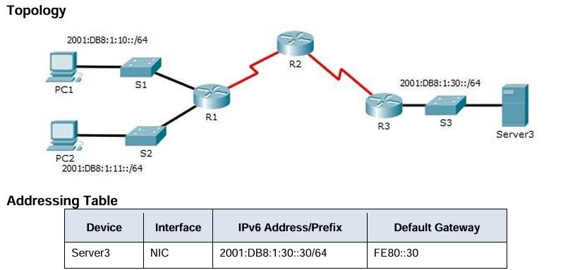

Step 1: Configure an ACL that will block HTTP and HTTPS access.
Configure an ACL named BLOCK_HTTP on R1 with the following statements. a.
Block HTTP and HTTPS traffic from reaching Server3.
R1(config)# deny tcp any host 2001:DB8:1:30::30 eq www R1(config)# deny tcp any host 2001:DB8:1:30::30 eq 443
b. Allow all other IPv6 traffic to pass.
R1(config)# permit ipv6 any any
Step 2: Apply the ACL to the correct interface. Apply the ACL on the interface closest to the source of the traffic to be blocked.
R1(config)# interface GigabitEthernet0/1
R1(config-if)# ipv6 traffic-filter BLOCK_HTTP in
Step 3: Verify the ACL implementation.
Verify that the ACL is operating as intended by conducting the following tests:
- Open the web browser of PC1 to http://2001:DB8:1:30::30 or https://2001:DB8:1:30::30. The website should appear.
- Open the web browser of PC2 to http://2001:DB8:1:30::30 or https://2001:DB8:1:30::30. The website should be blocked.
- Ping from PC2 to 2001:DB8:1:30::30. The ping should be successful.

Practical 5
Configuring a Zone-Based Policy Firewall
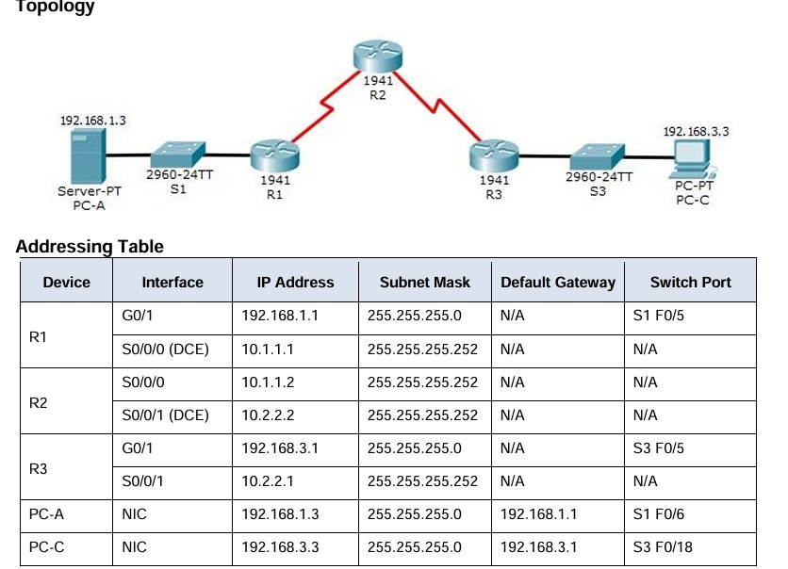

5. Configuring a Zone-Based Policy Firewall

Part 1: Verify Basic Network Connectivity
Verify network connectivity prior to configuring the zone-based policy firewall.
Step 1: From the PC-A command prompt, ping PC-C at 192.168.3.3.
Step 2: Access R2 using SSH.
- From the PC-C command prompt, SSH to the S0/0/1 interface on R2 at 10.2.2.2. Use the username
Admin and password Adminpa55 to log in. PC> ssh -l
Admin 10.2.2.2
- Exit the SSH session.
Step 3: From PC-C, open a web browser to the PC-A server.
a. Click the Desktop tab and then click the Web Browser application. Enter the PC-A IP address
192.168.1.3 as the URL. The Packet Tracer welcome page from the web server should be displayed. b.
Close the browser on PC-C.
Part 2: Create the Firewall Zones on R3
Note: For all configuration tasks, be sure to use the exact names as specified.
Step 1: Enable the Security Technology package.
- On R3, issue the show version command to view the Technology Package license information.
- If the Security Technology package has not been enabled, use the following command to enable the package.
R3(config)# license boot module c1900 technology-package securityk9
- Accept the end-user license agreement.
- Save the running-config and reload the router to enable the security license.
- Verify that the Security Technology package has been enabled by using the show version command.
Step 2: Create an internal zone. Use the zone security command to create a zone named IN-ZONE. R3(config)# zone security
IN-ZONE
R3(config-sec-zone) exit
Step 3: Create an external zone. Use the zone security command to create a zone named OUT-ZONE.
R3(config-sec-zone)# zone security OUT-ZONE R3(config-sec zone)# exit
Part 3: Identify Traffic Using a Class-Map
Step 1: Create an ACL that defines internal traffic.
Use the access-list command to create extended ACL 101 to permit all IP protocols from the 192.168.3.0/24
R3(config)# access-list 101 permit ip 192.168.3.0 0.0.0.255 any Configuring a Zone-Based Policy Firewall (ZPF)
Step 2: Create a class map referencing the internal traffic ACL.
Use the class-map type inspect command with the match-all option to create a class map named IN
NETCLASS-MAP. Use the match access-group command to match ACL 101.
R3(config)# class-map type inspect match-all IN-NET-CLASS-
MAP
R3(config-cmap)# match access-group 101
R3(config-cmap)# exit
Part 4: Specify Firewall Policies
Step 1: Create a policy map to determine what to do with matched traffic. Use the policy-map type inspect command and create a policy map named IN-2-OUT-PMAP.
R3(config)# policy-map type inspect IN-2-OUT-PMAP
Step 2: Specify a class type of inspect and reference class map IN-
NET-CLASS-MAP.
R3(config-pmap)# class type inspect IN-NET-CLASS-MAP
Step 3: Specify the action of inspect for this policy map.
The use of the inspect command invokes context-based access control (other options include pass and drop).
R3(config-pmap-c)# inspect
%No specific protocol configured in class IN-NET-CLASS-MAP for inspection. All
protocols will be inspected. Issue the exit command twice to leave config-pmap-c mode and return to config mode.
R3(config-pmap-c)# exit
R3(config-pmap)# exit Part 5: Apply Firewall Policies Step 1: Create a pair of zones.
Using the zone-pair security command, create a zone pair named IN-2-OUT-ZPAIR. Specify the source and destination zones that were created in Task 1.
R3(config)# zone-pair security IN-2-OUT-ZPAIR source IN-
ZONE destination
OUTZONE
Step 2: Specify the policy map for handling the traffic between the two zones.
Attach a policy-map and its associated actions to the zone pair using the service-policy type inspect
command and reference the policy map previously created, IN-2OUT-PMAP.
R3(config-sec-zone-pair)# service-policy type inspect IN-2-OUTPMAP
R3(config-sec-zone-pair)# exit
R3(config)#
Step 3: Assign interfaces to the appropriate security zones.
Configuring a Zone-Based Policy Firewall (ZPF)
Use the zone-member security command in interface configuration mode to assign G0/1 to IN-ZONE and S0/0/1 to OUT-ZONE.
R3(config)# interface g0/1
R3(config-if)# zone-member security IN-ZONE
R3(config-if)# exit
R3(config)# interface s0/0/1
R3(config-if)# zone-member security OUT-ZONE R3(config-if)# exit
Step 4: Copy the running configuration to the startup configuration.
Part 6: Test Firewall Functionality from IN-ZONE to OUTZONE
Verify that internal hosts can still access external resources after configuring the ZPF.
Step 1: From internal PC-C, ping the external PC-A server.
From the PC-C command prompt, ping PC-A at 192.168.1.3. The ping should succeed.
Step 2: From internal PC-C, SSH to the R2 S0/0/1 interface.
- From the PC-C command prompt, SSH to R2 at 10.2.2.2. Use the username Admin and the password
Adminpa55 to access R2. The SSH session should succeed.
- While the SSH session is active, issue the command show policy-map type inspect zone-pair sessions on R3 to view established sessions.
R3# show policy-map type inspect zone-pair sessions policy exists on zp IN-2-OUT-ZPAIR Zone-pair: IN-2-OUT-ZPAIR
Service-policy inspect : IN-2-OUT-PMAP
Class-map: IN-NET-CLASS-MAP (match-all)
Match: access-group 101
Inspect
Number of Established Sessions = 1
Established Sessions
Session 175216232 (192.168.3.3:1028)=>(10.2.2.2:22) tcp
SIS_OPEN/TCP_ESTAB
Created 00:00:25, Last heard 00:00:20
Bytes sent (initiator:responder) [1195:1256]
Class-map: class-default (match-any)
Match: any
Drop (default action)
0 packets, 0 bytes
What is the source IP address and port number?
________________________________________________________
192.168.3.3:1028 (port 1028 is random)
What is the destination IP address and port number?
________________________________________________________
10.2.2.2:22 (SSH = port 22)
Step 3: From PC-C, exit the SSH session on R2 and close the command prompt window.
Step 4: From internal PC-C, open a web browser to the PC-A server web page.
Enter the server IP address 192.168.1.3 in the browser URL field, and click Go. The HTTP session should
succeed. While the HTTP session is active, issue the command show policy-map type inspect zone-pair sessions on R3 to view established sessions.
Note: If the HTTP session times out before you execute the command on R3, you will have to click the Go button on PC-C to generate a session between PC-C and PC-A. R3# show policy-map type inspect zone-pair sessions policy exists on zp IN-2-OUT-ZPAIR Zone-pair: IN-2-OUT-ZPAIR
Service-policy inspect : IN-2-OUT-PMAP
Class-map: IN-NET-CLASS-MAP (match-all)
Match: access-group 101
Inspect
Number of Established Sessions = 1
Established Sessions
Session 565266624 (192.168.3.3:1031)=>(192.168.1.3:80) tcp SIS_OPEN/TCP_ESTAB
Created 00:00:01, Last heard 00:00:01
Bytes sent (initiator:responder) [284:552]
Class-map: class-default (match-any)
Match: any
Drop (default action)
0 packets, 0 bytes
What is the source IP address and port number?
________________________________________________________
192.168.3.3:1031 (port 1031 is random)
What is the destination IP address and port number?
________________________________________________________
192.168.1.3:80 (HTTP web = port 80) Step 5: Close the browser on PC-C.
Part 7: Test Firewall Functionality from OUT-ZONE to INZONE
Verify that external hosts CANNOT access internal resources after configuring the ZPF.
Configuring a Zone-Based Policy Firewall (ZPF)
Step 1: From the PC-A server command prompt, ping PC-C.
From the PC-A command prompt, ping PC-C at 192.168.3.3. The ping should fail.
Step 2: From R2, ping PC-C.
From R2, ping PC-C at 192.168.3.3. The ping should fail.
Step 3: Check results.
Your completion percentage should be 100%. Click Check Results to see feedback and verification of which required components have been completed.

Practical 6
Configure IOS Intrusion Prevention System (IPS)
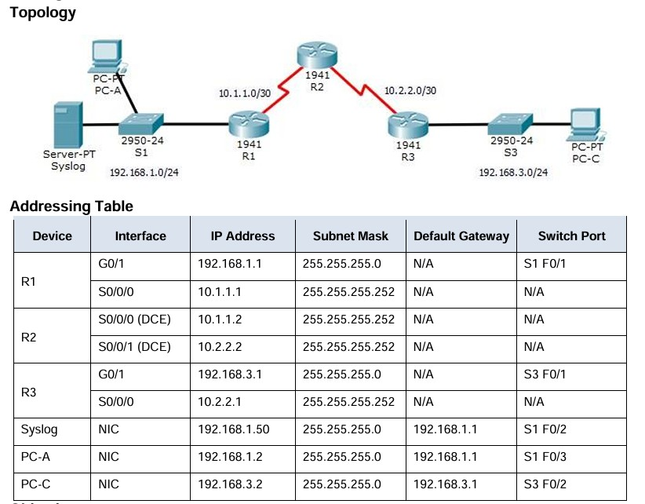

A. Enable IOS IPS.
Step 1: Enable the Security Technology package.
- On R1, issue the show version command to view the Technology Package license information.
- If the Security Technology package has not been enabled, use the following command to enable the
package.
R1(config)# license boot module c1900 technology-package securityk9
- Accept the end user license agreement.
- Save the running-config and reload the router to enable the security license.
- Verify that the Security Technology package has been enabled by using the show version command.
Step 2: Verify network connectivity.
- Ping from PC-C to PC-A. The ping should be successful.
- Ping from PC-A to PC-C. The ping should be successful.
Step 3: Create an IOS IPS configuration directory in flash. On R1, create a directory in flash using the mkdir command. Name the directory ipsdir.
R1# mkdir ipsdir
Create directory filename [ipsdir]? <Enter> Created dir flash:ipsdir
Step 4: Configure the IPS signature storage location. On R1, configure the IPS signature storage location to be the directory you just created.
R1(config)# ip ips config location flash:ipsdir Step 5: Create an IPS rule.
On R1, create an IPS rule name using the ip ips name name command in global configuration mode. Name the IPS rule iosips.
R1(config)# ip ips name iosips Step 6: Enable logging.
IOS IPS supports the use of syslog to send event notification. Syslog notification is enabled by default. If logging console is enabled, IPS syslog messages display.
- Enable syslog if it is not enabled.
R1(config)# ip ips notify log
Configure IOS Intrusion Prevention System (IPS) using CLI
- If necessary, use the clock set command from privileged EXEC mode to reset the clock. R1# clock set 10:20:00 10 january 2014
- Verify that the timestamp service for logging is enabled on the router using the show run command.
Enable the timestamp service if it is not enabled. R1(config)# service timestamps log datetime msec
- Send log messages to the syslog server at IP address
192.168.1.50. R1(config)# logging host 192.168.1.50 Step 7: Configure IOS IPS to use the signature categories.
Retire the all signature category with the retired true command (all signatures within the signature release).
Unretire the IOS_IPS Basic category with the retired false command. R1(config)# ip ips signature category
R1(config-ips-category)# category all
R1(config-ips-category-action)# retired true
R1(config-ips-category-action)# exit
R1(config-ips-category)# category ios_ips basic
R1(config-ips-category-action)# retired false
R1(config-ips-category-action)# exit
R1(config-ips-cateogry)# exit
Do you want to accept these changes? [confirm] <Enter> Step 8: Apply the IPS rule to an interface.
Apply the IPS rule to an interface with the ip ips name direction command in interface configuration mode.
Apply the rule outbound on the G0/1 interface of R1. After you enable IPS, some log messages will be sent to the console line indicating that the IPS engines are being initialized.
Note: The direction in means that IPS inspects only traffic going into the interface. Similarly, out means that IPS inspects only traffic going out of the interface. R1(config)# interface g0/1
R1(config-if)# ip ips iosips out Part
B. Modify an IPS signature.
Step 1: Change the event-action of a signature.
Un-retire the echo request signature (signature 2004, subsig ID 0), enable it, and change the signature action to alert and drop.
R1(config)# ip ips signature-definition
R1(config-sigdef)# signature 2004 0
R1(config-sigdef-sig)# status
R1(config-sigdef-sig-status)# retired false
R1(config-sigdef-sig-status)# enabled true
R1(config-sigdef-sig-status)# exit
R1(config-sigdef-sig)# engine
R1(config-sigdef-sig-engine)# event-action produce-alert
R1(config-sigdefsig-engine)# event-action deny-packet-inline
R1(config-sigdef-sig-engine)# exit
R1(config-sigdef-sig)# exit
R1(config-sigdef)# exit
Do you want to accept these changes? [confirm] <Enter>
Step 2: Use show commands to verify IPS.
Use the show ip ips all command to view the IPS configuration status summary.
To which interfaces and in which direction is the iosips rule applied?
G0/1 outbound.

Step 3: Verify that IPS is working properly.
- From PC-C, attempt to ping PC-A. Were the pings successful? Explain.
The pings should fail. This is because the IPS rule for event-action of an echo request was set to “deny- packetinline”.
- From PC-A, attempt to ping PC-C. Were the pings successful? Explain.
The ping should be successful. This is because the IPS rule does not cover echo reply. When PC-A pings PC-C, PC-C responds with an echo reply.
Step 4: View the syslog messages.
  - Click the Syslog server.
  - Select the Services tab.
  - In the left navigation menu, select SYSLOG to view the log file.
Step 5: Check results.
Your completion percentage should be 100%. Click Check Results to see feedback and verification of which required components have been completed.
!!!Script for R1
clock set 10:20:00 10 january 2014 mkdir ipsdir config
Configure IOS Intrusion Prevention System (IPS) using CLI license boot module c1900 technology-package securityk9 yes end reload config t ip ips config location flash:ipsdir ip ips name iosips ip ips notify log service timestamps log datetime msec logging host 192.168.1.50 ip ips signature-category category all retired true exit category ios_ips basic retired false exit exit interface g0/1 ip ips iosips out exit ip ips signature-definition signature 2004 0 status retired false enabled true exit engine event-action produce-alert event-action deny-packet-inline exit exit exit

Practical 7 - Layer 2 Security
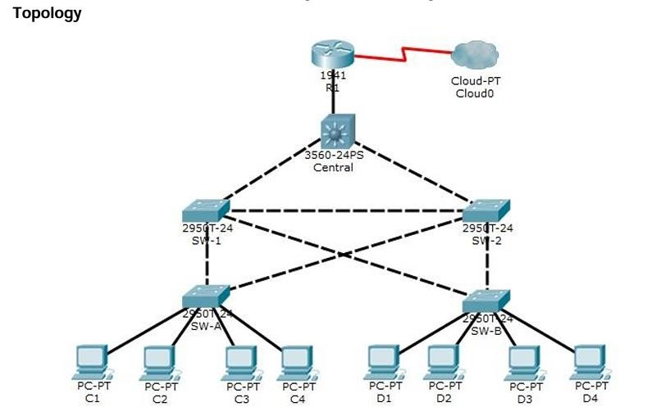

A. Assign the Central switch as the root bridge.

Step 1: Determine the current root bridge.
From Central, issue the show spanning-tree command to determine the current root bridge, to see the ports in use, and to see their status.
Which switch is the current root bridge?
Current root is SW-1.
Based on the current root bridge, what is the resulting spanning tree? (Draw the spanning-tree topology.)
Step 2: Assign Central as the primary root bridge. Using the spanning-tree vlan 1 root primary command, and assign Central as the root bridge.
Central(config)# spanning-tree vlan 1 root primary
Step 3: Assign SW-1 as a secondary root bridge. Assign SW-1 as the secondary root bridge using
the spanning-tree vlan 1 root secondary command. SW-1(config)# spanning-tree vlan 1 root secondary
Step 4: Verify the spanning-tree configuration. Issue the show spanning tree command to verify that Central is the root bridge.
Central# show spanning-tree
VLAN0001
Spanning tree enabled protocol ieee
Root ID Priority 24577
Address 00D0.D31C.634C
This bridge is the root
Hello Time 2 sec Max Age 20 sec Forward Delay 15 sec Which switch is the current root bridge?
Current root is Central
Based on the new root-bridge, what is the resulting spanning tree? (Draw the spanning-tree topology.)
B. Secure spanning-tree parameters to prevent STP manipulation attacks.
Secure the STP parameters to prevent STP manipulation attacks.
Step 1: Enable PortFast on all access ports.
PortFast is configured on access ports that connect to a single workstation or server to enable them to become active more quickly. On the connected access ports of the SW-A and SW-B, use the spanning-tree portfast command.
SW-A(config)# interface range f0/1 - 4
SW-A(config-if-range)# spanning-tree portfast
SW-B(config)# interface range f0/1 - 4 SW-B(config-if-range)# spanning-tree portfast
Step 2: Enable BPDU guard on all access ports.
BPDU guard is a feature that can help prevent rogue switches and spoofing on access ports. Enable BPDU guard on SW-A and SW-B access ports.
SW-A(config)# interface range f0/1 - 4
SW-A(config-if-range)# spanning-tree bpduguard enable
SW-B(config)# interface range f0/1 - 4
SW-B(config-if-range)# spanning-tree bpduguard enable
Note: Spanning-tree BPDU guard can be enabled on each individual port using the spanning-tree bpduguard enable command in interface configuration mode or the spanning-tree portfast bpduguard default command in global configuration mode. For grading purposes in this activity, please use the spanning-tree bpduguard enable command.

Step 3: Enable root guard.
Root guard can be enabled on all ports on a switch that are not root ports. It is best deployed on ports that connect to other nonroot switches. Use the show spanning-tree command to determine the location of the root port on each switch.
On SW-1, enable root guard on ports F0/23 and F0/24. On SW-2, enable root guard on ports F0/23 and F0/24. SW-1(config)# interface range f0/23 - 24
SW-1(config-if-range)# spanning-tree guard root
SW-2(config)# interface range f0/23 - 24
SW-2(config-if-range)# spanning-tree guard root

C. Enable port security to prevent CAM table overflow attacks.
Step 1: Configure basic port security on all ports connected to host devices.
This procedure should be performed on all access ports on SW-A and SW-B. Set the maximum number of learned MAC addresses to 2, allow the MAC address to be learned dynamically, and set the violation to shutdown. Note: A switch port must be configured as an access port to enable port security.
SW-A(config)# interface range f0/1 - 22
SW-A(config-if-range)# switchport mode access
SW-A(config-if-range)# switchport port-security
SW-A(config-if-range)# switchport port-security maximum 2 SW-A(config-if-range)# switchport port-security violation shutdown SW
A(config-if-range)# switchport port-security mac-address sticky
SW-B(config)# interface range f0/1 - 22
SW-B(config-if-range)# switchport mode access
SW-B(config-if-range)# switchport port-security
SW-B(config-if-range)# switchport port-security maximum 2
SW-B(config-if-range)# switchport port-security violation shutdown
SW-B(config-if-range)# switchport port-security mac-address sticky
Why is port security not enabled on ports that are connected to other switch devices?
Ports connected to other switch devices have a multitude of MAC addresses learned for that single port.
Limiting the number of MAC addresses that can be learned on these ports can significantly impact network functionality.
Step 2: Verify port security.
a. On SW-A, issue the command show port-security interface f0/1 to verify that port security has been configured.
SW-A# show port-security interface f0/1
Port Security : Enabled
Port Status : Secure-up
Violation Mode : Shutdown
Aging Time : 0 mins
Aging Type : Absolute
SecureStatic Address Aging : Disabled
Maximum MAC Addresses : 2
Total MAC Addresses : 0
Configured MAC Addresses : 0
Sticky MAC Addresses : 0
Last Source Address:Vlan : 0000.0000.0000:0
Security Violation Count : 0
b. Ping from C1 to C2 and issue the command show portsecurity interface f0/1 again to verify that the switch has learned the MAC address for C1.
Step 3: Disable unused ports.
Disable all ports that are currently unused.
SW-A(config)# interface range f0/5 - 22
SW-A(config-if-range)# shutdown
SW-B(config)# interface range f0/5 - 22
SW-B(config-if-range)# shutdown Step 4: Check results.
Your completion percentage should be 100%. Click Check Results to view feedback and verification of which of the required components have been completed.
!!!Script for Central conf t
spanning-tree vlan 1 root primary end
!!!Script for SW-1 conf t spanning-tree vlan 1 root secondary interface range f0/23 - 24 spanning-tree guard root end !!!Script for SW-2 conf t interface range f0/23 - 24 spanning-tree guard root end
!!!Script for SW-A conf t interface range f0/1 - 4 spanning-tree portfast spanning-tree bpduguard enable interface range f0/1 - 22 switchport mode access switchport port
security switchport port-security maximum 2 switchport port-security violation shutdown switchport port-security mac-address sticky interface range f0/5 - 22 shutdown end !!!Script for SW-B conf t interface range f0/1 - 4 spanning-tree portfast spanning-tree
bpduguard enable interface range f0/1 - 22 switchport mode access switchport port
security switchport port-security maximum 2 switchport port-security violation shutdown switchport port-security mac-address sticky interface range f0/5 - 22 shutdown end

Practical 8
Layer 2 Security
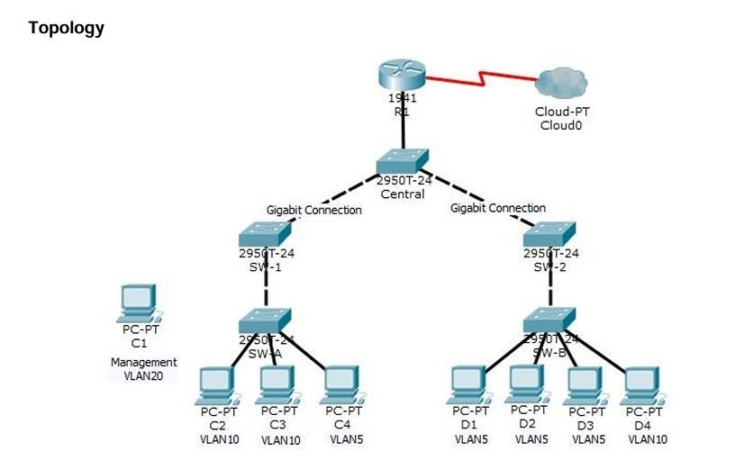

Layer 2 VLAN Security

Part 1: Verify Connectivity
Step 1: Verify connectivity between C2 (VLAN 10) and C3 (VLAN 10).
Step 2: Verify connectivity between C2 (VLAN 10) and D1 (VLAN 5).
Note: If using the simple PDU GUI packet, be sure to ping twice to allow for ARP.
Part 2: Create a Redundant Link Between SW-1 and SW-2 Step 1: Connect SW-1 and SW-2.
Using a crossover cable, connect port F0/23 on SW-1 to port F0/23 on SW-2.
Step 2: Enable trunking, including all trunk security mechanisms on the link between SW-1 and SW-2.
Trunking has already been configured on all pre-existing trunk interfaces. The new link must be configured for trunking, including all trunk security mechanisms. On both SW-1 and SW2, set the port to trunk, assign native VLAN 15 to the trunk port, and disable auto-negotiation.
SW-1(config)# interface f0/23
SW-1(config-if)# switchport mode trunk
SW-1(config-if)# switchport trunk native vlan 15
SW-1(config-if)# switchport nonegotiate
SW-1(config-if)# no shutdown
SW-2(config)# interface f0/23
SW-2(config-if)# switchport mode trunk
SW-2(config-if)# switchport trunk native vlan 15
SW-2(config-if)# switchport nonegotiate
SW-2(config-if)# no shutdown
Part 3: Enable VLAN 20 as a Management VLAN
The network administrator wants to access all switch and routing devices using a management PC. For
security purposes, the administrator wants to ensure that all managed devices are on a separate VLAN.
Step 1: Enable a management VLAN (VLAN 20) on SW-A.
- Enable VLAN 20 on SW-A.
SW-A(config)# vlan 20 SW-A(config-vlan)# exit
- Create an interface VLAN 20 and assign an IP address within the 192.168.20.0/24 network.
SW-A(config)# interface vlan 20
SW-A(config-if)# ip address 192.168.20.1 255.255.255.0
Step 2: Enable the same management VLAN on all other switches.
- Create the management VLAN on all switches: SW-B, SW-1, SW-2, and Central.
SW-B(config)# vlan 20
SW-B(config-vlan)# exit
SW-1(config)# vlan 20
SW-1(config-vlan)# exit
SW-2(config)# vlan 20
SW-2(config-vlan)# exit
Central(config)# vlan 20 Central(config-vlan)# exit
- Create an interface VLAN 20 on all switches and assign an IP address within the 192.168.20.0/24 network.
SW-B(config)# interface vlan 20
SW-B(config-if)# ip address 192.168.20.2 255.255.255.0
SW-1(config)# interface vlan 20
SW-1(config-if)# ip address 192.168.20.3 255.255.255.0
SW-2(config)# interface vlan 20
SW-2(config-if)# ip address 192.168.20.4 255.255.255.0
Central(config)# interface vlan 20
Central(config-if)# ip address 192.168.20.5 255.255.255.0 Step 3: Connect and configure the management PC.
Connect the management PC to SW-A port F0/1 and ensure that it is assigned an available IP address within the 192.168.20.0/24 network.
Step 4: On SW-A, ensure the management PC is part of VLAN
20. Interface
F0/1 must be part of VLAN 20.
SW-A(config)# interface f0/1
SW-A(config-if)# switchport access vlan 20 SW-A(config-if)# no shutdown
Step 5: Verify connectivity of the management PC to all switches.
The management PC should be able to ping SW-A, SW-B, SW-1, SW-2, and Central.
Part 4: Enable the Management PC to Access Router R1 Step 1: Enable a new subinterface on router R1.
- Create subinterface g0/0.3 and set encapsulation to dot1q 20 to account for VLAN 20.
R1(config)# interface g0/0.3
R1(config-subif)# encapsulation dot1q 20
- Assign an IP address within the 192.168.20.0/24 network.
R1(config)# interface g0/0.3
R1(config-subif)# ip address 192.168.20.100 255.255.255.0
Step 2: Verify connectivity between the management PC and R1.
Be sure to configure the default gateway on the management PC to allow for connectivity.
Step 3: Enable security.
While the management PC must be able to access the router, no other PC should be able to access the management VLAN.
- Create an ACL that allows only the Management PC to access the router. Example: (may vary from student configuration)
R1(config)# access-list 101 deny ip any 192.168.20.0
0.0.0.255
R1(config)# access-list 101 permit ip any any
R1(config)# access-list 102 permit ip host 192.168.20.50 any
- Apply the ACL to the proper interface(s).
Example: (may vary from student configuration)
R1(config)# interface g0/0.1
R1(config-subif)# ip access-group 101 in
R1(config-subif)# interface g0/0.2
R1(config-subif)# ip access-group 101 in
R1(config-subif)# line vty 0 4
R1(config-line)# access-class 102 in
Note: Access list 102 is used to only allow the Management PC (192.168.20.50 in this example) to access the router. This prevents an IP address change to bypass the ACL.
Note: There are multiple ways in which an ACL can be created to accomplish the necessary security. For this reason, grading on this portion of the activity is based on the correct connectivity requirements. The management PC must be able to connect to all switches and the router. All other PCs should not be able to connect to any devices within the management VLAN.
Step 4: Verify security.
a. only the Management PC can access the router. Use SSH to access R1 with username SSHadmin and password ciscosshpa55. PC> ssh -l SSHadmin 192.168.20.100
b. From the management PC, ping SW-A, SW-B, and R1. Were the pings successful? Explain.
The pings should have been successful because all devices within the 192.168.20.0 network should be able to ping one another. Devices within VLAN20 are not required to route through the router.

c. From D1, ping the management PC. Were the pings successful? Explain.
The ping should have failed because for a device within a different VLAN to successfully ping a device within VLAN20, it must be routed. The router has an ACL that prevents all packets from accessing the 192.168.20.0 network.
Step 5: Check results.
Your completion percentage should be 100%. Click Check Results to view feedback and verification of which required components have been completed.
If all components appear to be correct and the activity still shows incomplete, it could be due to the connectivity tests that verify the ACL operation.
!!!
Script for SW-1 conf t interface f0/23 switchport mode trunk
switchport trunk native vlan 15 switchport nonegotiate no
shutdown vlan 20
exit
interface vlan 20
ip address 192.168.20.3 255.255.255.0
!!!
Script for SW-2 conf t interface f0/23 switchport mode trunk
switchport trunk native vlan 15 switchport nonegotiate no
shutdown vlan 20
exit
interface vlan 20 ip address 192.168.20.4 255.255.255.0
!!! Script for SW-A conf t vlan 20 exit interface vlan 20
ip address 192.168.20.1 255.255.255.0 interface f0/1 switchport access vlan
20 no shutdown

!!! Script for SW-B conf t vlan 20 exit interface vlan
20
192.168.20.2 255.255.255.0 ip address

!!! Script for Central
conf t vlan 20 exit interface vlan
20
192.168.20.5 255.255.255.0

!!! Script for R1 conf
ip address
interface GigabitEthernet0/0.1 ip access-group 101 in interface GigabitEthernet0/0.2 ip access group 101 in interface g0/0.3 encapsulation dot1q 20 ip address 192.168.20.100 255.255.255.0 access-list 101 deny ip any 192.168.20.0 0.0.0.255 access-list 101 permit ip any any access-list
102 permit ip host 192.168.20.50 any line vty 04 access-class 102 in

Practical 9
Layer 2 VLAN Security

Topology
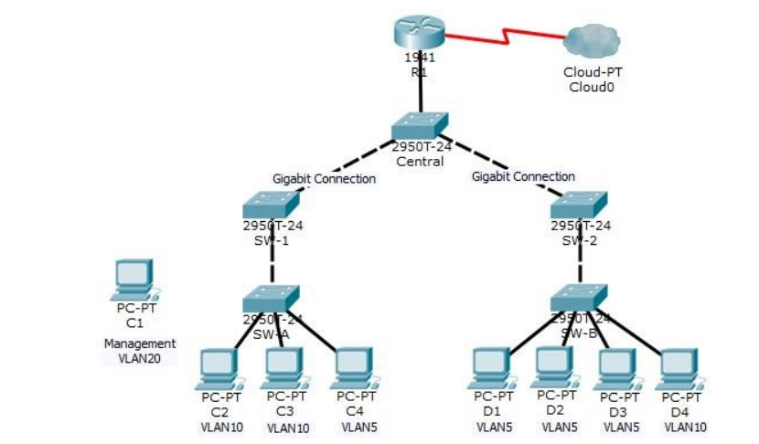
Objectives
• Connect a new redundant link between SW-1 and SW-2.
• Enable trunking and configure security on the new trunk link between SW-1 and SW-2.
• Create a new management VLAN (VLAN 20) and attach a management PC to that VLAN.
• Implement an ACL to prevent outside users from accessing the management VLAN.
Background / Scenario
A company’s network is currently set up using two separate VLANs: VLAN 5 and VLAN 10. In addition, all trunk ports are configured with native VLAN 15. A network administrator wants to add a redundant link between switch SW-1 and SW-2. The link must have trunking enabled and all security requirements should be in place.
In addition, the network administrator wants to connect a management PC to switch SW-A. The administrator would like to enable the management PC to connect to all switches and the router, but does not want any other devices to connect to the management PC or the switches. The administrator would like to create a new VLAN 20 for management purposes.
All devices have been preconfigured with:
- Enable secret password: ciscoenpa55
- Console password: ciscoconpa55
- SSH username and password: SSHadmin / ciscosshpa55

Part 1: Verify Connectivity
Step 1: Verify connectivity between C2 (VLAN 10) and C3 (VLAN 10).
Step 2: Verify connectivity between C2 (VLAN 10) and D1 (VLAN 5).
Note: If using the simple PDU GUI packet, be sure to ping twice to allow for ARP.

Part 2: Create a Redundant Link Between SW-1 and SW-2
Step 1: Connect SW-1 and SW-2.
Using a crossover cable, connect port F0/23 on SW-1 to port F0/23 on SW-2.
Step 2: Enable trunking, including all trunk security mechanisms on the link between SW-1 and SW-2.
Trunking has already been configured on all pre-existing trunk interfaces. The new link must be configured for trunking, including all trunk security mechanisms. On both SW-1 and SW-2, set the port to trunk, assign native VLAN 15 to the trunk port, and disable auto-negotiation.

SW-1(config)# interface f0/23
SW-1(config-if)# switchport mode trunk
SW-1(config-if)# switchport trunk native vlan 15
SW-1(config-if)# switchport nonegotiate
SW-1(config-if)# no shutdown
SW-2(config)# interface f0/23 SW-2(config-if)# switchport mode trunk
SW-2(config-if)# switchport trunk native vlan 15
SW-2(config-if)# switchport nonegotiate
SW-2(config-if)# no shutdown

Part 3: Enable VLAN 20 as a Management VLAN
The network administrator wants to access all switch and routing devices using a management PC. For security purposes, the administrator wants to ensure that all managed devices are on a separate VLAN.
Step 1: Enable a management VLAN (VLAN 20) on SW-A.
a. Enable VLAN 20 on SW-A.
SW-A(config)# vlan 20
SW-A(config-vlan)# exit
b. Create an interface VLAN 20 and assign an IP address within the 192.168.20.0/24 network.
SW-A(config)# interface vlan 20
SW-A(config-if)# ip address 192.168.20.1 255.255.255.0

Step 2: Enable the same management VLAN on all other switches.
- Create the management VLAN on all switches: SW-B, SW-1, SW-2, and Central.
SW-B(config)# vlan 20
SW-B(config-vlan)# exit

SW-1(config)# vlan 20
SW-1(config-vlan)# exit

SW-2(config)# vlan 20
SW-2(config-vlan)# exit

Central(config)# vlan 20
Central(config-vlan)# exit

- Create an interface VLAN 20 on all switches and assign an IP address within the 192.168.20.0/24 network.
SW-B(config)# interface vlan 20
SW-B(config-if)# ip address 192.168.20.2 255.255.255.0

SW-1(config)# interface vlan 20
SW-1(config-if)# ip address 192.168.20.3 255.255.255.0

SW-2(config)# interface vlan 20
SW-2(config-if)# ip address 192.168.20.4 255.255.255.0

Central(config)# interface vlan 20
Central(config-if)# ip address 192.168.20.5 255.255.255.0

Step 3: Connect and configure the management PC.
Connect the management PC to SW-A port F0/1 and ensure that it is assigned an available IP address within the 192.168.20.0/24 network.

Step 4: On SW-A, ensure the management PC is part of VLAN 20. Interface

F0/1 must be part of VLAN 20.
SW-A(config)# interface f0/1
SW-A(config-if)# switchport access vlan 20
SW-A(config-if)# no shutdown

Step 5: Verify connectivity of the management PC to all switches.
The management PC should be able to ping SW-A, SW-B, SW-1, SW-2, and Central.

Part 4: Enable the Management PC to Access Router R1
Step 1: Enable a new subinterface on router R1.
- Create subinterface g0/0.3 and set encapsulation to dot1q 20 to account for VLAN 20.
R1(config)# interface g0/0.3
R1(config-subif)# encapsulation dot1q 20
- Assign an IP address within the 192.168.20.0/24 network.
R1(config)# interface g0/0.3
R1(config-subif)# ip address 192.168.20.100 255.255.255.0

Step 2: Verify connectivity between the management PC and R1.
Be sure to configure the default gateway on the management PC to allow for connectivity.
Step 3: Enable security.
While the management PC must be able to access the router, no other PC should be able to access the management VLAN.
- Create an ACL that allows only the Management PC to access the router. Example: (may vary from student configuration)
R1(config)# access-list 101 deny ip any 192.168.20.0 0.0.0.255
R1(config)# access-list 101 permit ip any any

R1(config)# access-list 102 permit ip host 192.168.20.50 any

- Apply the ACL to the proper interface(s).
Example: (may vary from student configuration)
R1(config)# interface g0/0.1
R1(config-subif)# ip access-group 101 in
R1(config-subif)# interface g0/0.2
R1(config-subif)# ip access-group 101 in
R1(config-subif)# line vty 0 4
R1(config-line)# access-class 102 in
Note: Access list 102 is used to only allow the Management PC (192.168.20.50 in this example) to access the router. This prevents an IP address change to bypass the ACL.
Note: There are multiple ways in which an ACL can be created to accomplish the necessary security. For this reason, grading on this portion of the activity is based on the correct connectivity requirements. The management PC must be able to connect to all switches and the router. All other PCs should not be able to connect to any devices within the management VLAN.

Step 4: Verify security.
- Verify only the Management PC can access the router. Use SSH to access R1 with username SSHadmin and password ciscosshpa55.
PC> ssh -l SSHadmin 192.168.20.100
- From the management PC, ping SW-A, SW-B, and R1. Were the pings successful? Explain.
The pings should have been successful because all devices within the 192.168.20.0 network should be able to ping one another. Devices within VLAN20 are not required to route through the router.
- From D1, ping the management PC. Were the pings successful? Explain.
The ping should have failed because for a device within a different VLAN to successfully ping a device within VLAN20, it must be routed. The router has an ACL that prevents all packets from accessing the 192.168.20.0 network.

Step 5: Check results.
Your completion percentage should be 100%. Click Check Results to view feedback and verification of which required components have been completed.
If all components appear to be correct and the activity still shows incomplete, it could be due to the connectivity tests that verify the ACL operation.

!!! Script for SW-1 conf t
interface f0/23 switchport mode
trunk switchport trunk native
vlan 15 switchport nonegotiate
no shutdown vlan 20 exit
interface vlan 20
ip address 192.168.20.3 255.255.255.0

!!! Script for SW-2 conf t
interface f0/23 switchport mode
trunk switchport trunk native
vlan 15 switchport nonegotiate
no shutdown vlan 20 exit
interface vlan 20
ip address 192.168.20.4 255.255.255.0

!!! Script for SW-A
conf t vlan 20
exit interface
vlan 20
ip address 192.168.20.1 255.255.255.0
interface f0/1 switchport access vlan 20
no shutdown

!!! Script for SW-B conf t vlan 20 exit
interface vlan 20 ip address 192.168.20.2 255.255.255.0

!!! Script for Central conf t vlan 20 exit
interface vlan 20 ip address
192.168.20.5 255.255.255.0

!!! Script for R1 conf t
interface GigabitEthernet0/0.1 ip access-group
101 in interface GigabitEthernet0/0.2 ip accessgroup
101 in interface g0/0.3 encapsulation dot1q
20 ip address 192.168.20.100 255.255.255.0
access-list 101 deny ip any 192.168.20.0 0.0.0.255
access-list 101 permit ip any any access-list
102 permit ip host 192.168.20.50 any line vty 0
4
access-class 102 in

Practical 10
Configure and Verify a Site-to-Site IPsec VPN Using CLI
Topology

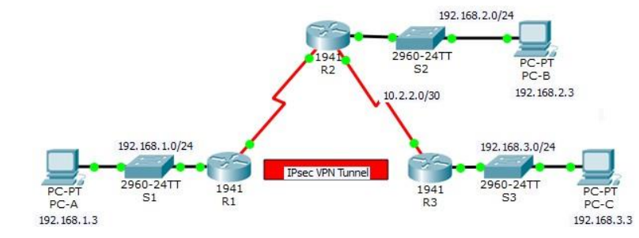

Aim: Configuring Intrusion Detection System (IDS)

Background/Scenario
Your task is to enable IPS on R1 to scan traffic entering the 192.168.1.0 network. The server labeled syslog is used to log IPS messages. You must configure the router to identify the syslog server to receive logging messages. Displaying the correct time and date in syslog messages is vital when using syslog to monitor the network set the clock and configure the timestamp service for logging on the routers. Finally, enables Ips to produce an alert and drop ICMP echo reply packets inline. The server and PC’s have been pre configured. The routers have also been preconfigured with the following:

- Enable password: ciscoenpa55
- SSH username and password: SSHadmin / ciscosshpa55
- OSPF 101

Part 1: Configure IPsec Parameters on R1
Step 1: Test connectivity.
Ping from PC-A to PC-C.
Step 2: Enable the Security Technology package.
a. On R1, issue the show version command to view the Security Technology package license information.
b. If the Security Technology package has not been enabled, use the following command to enable the package.
R1(config)# license boot module c1900 technology-package securityk9
c. Accept the end-user license agreement.
d. Save the running-config and reload the router to enable the security license.
e. Verify that the Security Technology package has been enabled by using the show version command.

Step 3: Identify interesting traffic on R1.
Configure ACL 110 to identify the traffic from the LAN on R1 to the LAN on R3 as interesting. This interesting traffic will trigger the IPsec VPN to be implemented when there is traffic between the R1 to R3 LANs. All other traffic sourced from the LANs will not be encrypted. Because of the implicit deny all, there is no need to configure a deny ip any any statement.
R1(config)# access-list 110 permit ip 192.168.1.0 0.0.0.255 192.168.3.0 0.0.0.255

Step 4: Configure the IKE Phase 1 ISAKMP policy on R1.
Configure the crypto ISAKMP policy 10 properties on R1 along with the shared crypto key vpnpa55. Refer to the ISAKMP Phase 1 table for the specific parameters to configure. Default values do not have to be configured. Therefore, only the encryption method, key exchange method, and DH method must be configured.
Note: The highest DH group currently supported by Packet Tracer is group 5. In a production network, you would configure at least DH 14.
R1(config)# crypto isakmp policy 10
R1(config-isakmp)# encryption aes 256
R1(config-isakmp)# authentication pre-share
R1(config-isakmp)# group 5
R1(config-isakmp)# exit
R1(config)# crypto isakmp key vpnpa55 address 10.2.2.2

Step 5: Configure the IKE Phase 2 IPsec policy on R1.
a. Create the transform-set VPN-SET to use esp-aes and esp-sha-hmac. R1(config)# crypto ipsec transform-set VPN-SET esp-aes esp-sha-hmac

- Create the crypto map VPN-MAP that binds all of the Phase 2 parameters together. Use sequence number 10 and identify it as an ipsec-isakmp map. R1(config)# crypto map VPN-MAP 10 ipsec-isakmp
R1(config-crypto-map)# description VPN connection to R3
R1(config-crypto-map)# set peer 10.2.2.2
R1(config-crypto-map)# set transform-set VPN-SET
R1(config-crypto-map)# match address 110
R1(config-cryptomap)# exit
Step 6: Configure the crypto map on the outgoing interface.
Bind the VPN-MAP crypto map to the outgoing Serial 0/0/0 interface
R1(config)# interface s0/0/0
R1(config-if)# crypto map VPN-MAP

Part 2: Configure IPsec Parameters on R3
Step 1: Enable the Security Technology package.
a. On R3, issue the show version command to verify that the Security Technology package license information has been enabled.
b. If the Security Technology package has not been enabled, enable the package and reload R3.
Step 2: Configure router R3 to support a site-to-site VPN with R1.
Configure reciprocating parameters on R3. Configure ACL 110 identifying the traffic from the LAN on R3 to the LAN on R1 as interesting.
R3(config)# access-list 110 permit ip 192.168.3.0 0.0.0.255 192.168.1.0 0.0.0.255 Step 3: Configure the IKE Phase 1 ISAKMP properties on R3.
Configure the crypto ISAKMP policy 10 properties on R3 along with the shared crypto key vpnpa55.
R3(config)# crypto isakmp policy 10
R3(config-isakmp)# encryption aes 256 R3(config-isakmp)# authentication pre-share
R3(config-isakmp)# group 5
R3(config-isakmp)# exit
R3(config)# crypto isakmp key vpnpa55 address 10.1.1.2

Step 4: Configure the IKE Phase 2 IPsec policy on R3.
a. Create the transform-set VPN-SET to use esp-aes and esp-sha-hmac. R3(config)# crypto ipsec transform-set VPN-SET esp-aes esp-sha-hmac
b. Create the crypto map VPN-MAP that binds all of the Phase 2 parameters together. Use sequence number 10 and identify it as an ipsec-isakmp map. R3(config)# crypto map VPN-MAP 10 ipsec-isakmp
R3(config-crypto-map)# description VPN connection to R1
R3(config-crypto-map)# set peer 10.1.1.2
R3(config-crypto-map)# set transform-set VPN-SET
R3(config-crypto-map)# match address 110
R3(config-crypto-map)# exit

Step 5: Configure the crypto map on the outgoing interface.
Bind the VPN-MAP crypto map to the outgoing Serial 0/0/1 interface.
Note: This is not graded.
R3(config)# interface s0/0/1
R3(config-if)# crypto map VPN-MAP

Part 3: Verify the IPsec VPN
Step 1: Verify the tunnel prior to interesting traffic.
Issue the show crypto ipsec sa command on R1. Notice that the number of packets encapsulated, encrypted, decapsulated, and decrypted are all set to 0.

Step 2: Create interesting traffic.
Ping PC-C from PC-A.

Step 3: Verify the tunnel after interesting traffic.
On R1, re-issue the show crypto ipsec sa command. Notice that the number of packets is more than 0, which indicates that the IPsec VPN tunnel is working.

Step 4: Create uninteresting traffic.
Ping PC-B from PC-A.
Note: Issuing a ping from router R1 to PC-C or R3 to PC-A is not interesting traffic.

Step 5: Verify the tunnel.
On R1, re-issue the show crypto ipsec sa command. Notice that the number of packets has not changed, which verifies that uninteresting traffic is not encrypted.

Step 6: Check results.
Your completion percentage should be 100%. Click Check Results to see feedback and verification of which required components have been completed.

!!! Script for R1
config t
license boot module c1900 technology-package securityk9
yes end
copy running-config
startup-config reload
config t
access-list 110 permit ip 192.168.1.0 0.0.0.255 192.168.3.0 0.0.0.255
crypto isakmp policy 10 encryption aes 256 authentication preshare
group 5 exit
crypto isakmp key vpnpa55 address 10.2.2.2 crypto ipsec
transform-set VPN-SET esp-aes esp-sha-hmac crypto map
VPN-MAP 10 ipsec-isakmp description VPN connection to
R3 set peer 10.2.2.2 set transform-set VPN-SET match
address 110 exit
interface S0/0/0
crypto map VPN-MAP

!!! Script for R3
config t
access-list 110 permit ip 192.168.3.0 0.0.0.255 192.168.1.0 0.0.0.255
crypto isakmp policy 10
encryption aes 256 authentication pre-share group 5 exit
crypto isakmp key vpnpa55 address 10.1.1.2 crypto ipsec
transform-set VPN-SET esp-aes esp-sha-hmac crypto map
VPN-MAP 10 ipsec-isakmp description VPN connection to
R1 set peer 10.1.1.2 set transform-set VPN-SET match address 110 exit
interface S0/0/1 crypto map VPN-MAP

