M.D. Education Society’s
Maharshi Dayanand College of Arts, Science & Commerce
Parel, Mumbai – 400 012
B.Sc. (Computer Science)

CERTIFICATE

Class _____________ Roll No. ___________
Seat No. __________

This is to Certify that Mr./Miss____________________________________ of Class ____________B.Sc. (Computer Science) has duly completed the practical course: _____________________________________________ in Computer Science during the academic year 2025-26 as per the syllabus prescribed by the University of Mumbai.

____________________________ _____________________
Prof. Incharge of Practical Internal/External Examiner
Date:- ____________________ Date:- _____________

_________________________
Head of the Department
Date :__________________

INDEX
Practical No. | Practicals | Date | Page No. | Sign
1A | HTML Document Structure and Text Formatting Tags
1B | HTML Lists: Ordered, Unordered, Description and Nested Lists
1C | Images and Image Maps
2A | HTML Table Tags
2B | HTML Form Tags with Various Form Elements
3A | Navigation Across Multiple Web Pages (Home, About, Contact)
3B | Embedded Multimedia Elements (Image, Audio, Video, YouTube)
4A | CSS Background Properties
4B | CSS Fonts and Text Styling
4C | CSS Positioning of Elements
5A | JavaScript Mathematical Operations (Factorial, Fibonacci, Prime, Reverse, Expressions)
5B | JavaScript Form Validation
6A | JavaScript Objects: String, RegExp, Math, Date
6B | JavaScript Browser Objects: Window, Navigator, History, Location, Document
6C | Cookies: Storing and Retrieving Data
7A | XML with Internal/External DTD and CSS
7B | XML with XSL Transformation
8A | AJAX Using Mouseover Event
8B | AJAX Using Button Click
9A | PHP: Retrieving Data from HTML Forms
9B | PHP Mathematical Operations (Factorial, Fibonacci, Prime, Reverse, Expressions)
10A | PHP Arrays
10B | PHP File Handling (Reading and Writing Files)

Practical No.1
A.&amp; B. Design a webpage that makes use of Document Structure and Various Text Formatting Tags.
INPUT:-
<HTML>
<BODY>
<p>This is <b>bold text</b>.</p>
<p>This is <strong>strongly important text</strong>.</p>
<p>This is <i>italic text</i>.</p>
<p>This is <em>emphasized text</em>.</p>
<p>This is <mark>highlighted text</mark>.</p>
<p>This is <code>computer code</code>.</p>
<p>This is <small>smaller text</small>.</p>
<p>This is <sub>subscript</sub> and <sup>superscipt</sup> text.</p>
<p>This is <del>deleted text</del>.</p>
<p>This is <ins>inserted text</ins>.</p>
<p><strong>WARNING!</strong> Please proceed with caution.</p>
<p>The concert will be held at <b>Hyde Park</b> in London.</p>

<address> Mozilla Foundation<br> 331 E. Evelyn Avenue<br> Mountain View, CA 94041, USA </address>

<h1> This is heading 1</h1>
<h2> This is heading 2</h2>
<h3> This is heading 3</h3>
<h4> This is heading 4</h4>
<h5> This is heading 5</h5>
<h6> This is heading 6</h6>
</BODY>
</HTML>
OUTPUT:-
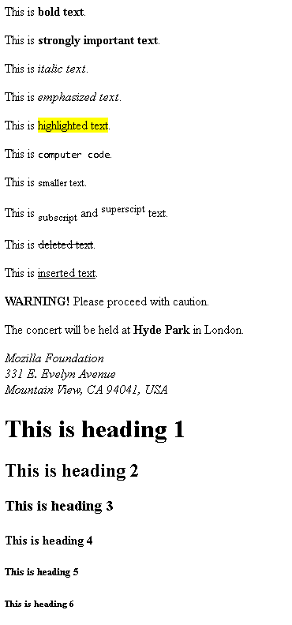
C. Design a webpage that makes use of List Tags
INPUT:-
<html>
<body>

<h2>Grocery list</h2>
<ul>
<li>Breads</li>
<li>Eggs</li>
<li>Milk</li>
<li>Coffee</li>
</ul>
</body>
</html>
OUTPUT:-
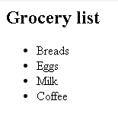
INPUT:-
<html>
<body>

<h2>Unordered List with Disc Bullets</h2>
<h2>Grocery list</h2>
<ul style="list-style-type:disc">
<li>Breads</li>
<li>Eggs</li>
<li>Milk</li>
<li>Coffee</li>
</ul>

</body>
</html>
OUTPUT:-
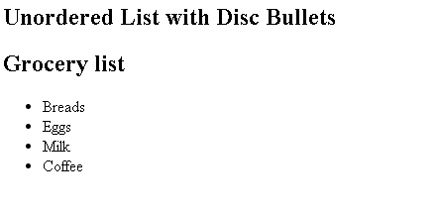
INPUT:-
<html>
<body>

<h2>Unordered List with Circle Bullets</h2>
<h2>Grocery list</h2>
<ul style="list-style-type:Circle">
<li>Breads</li>
<li>Eggs</li>
<li>Milk</li>
<li>Coffee</li>
</ul>

</body>
</html>
OUTPUT:-
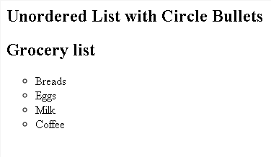
A description list is a list of terms, with a description of each term.
The &lt;dl&gt; tag defines the description list, the &lt;dt&gt; tag defines the term name,
and the &lt;dd&gt; tag describes each term.
INPUT:-
<html>
<body>
<h2>A Description list</h2>

<dl>
<dt>Coffee</dt>
<dd>- 500 gms</dd>
<dt>Milk</dt>
<dd>- 1 ltr Tetra Pack</dd>

</dl>
</body>
</html>
OUTPUT:-
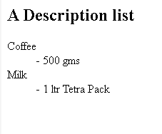
INPUT:-
<html>
<body>
<h2>A Nested list</h2>
<ul>
<li>Coffee</li>
<li>Tea
<ul>
<li>Black Tea</li>
<li>Green Tea</li>
</ul>
</li>
<li>Milk</li>
</ul>
</body>
</html>
OUTPUT:-
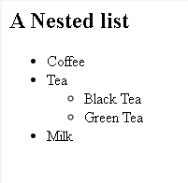
d. Image and Image Maps
INPUT:-
<!DOCTYPE html>
<html>
<head>
<title>World Map Image Map</title>
</head>
<body>

<h2>World Map Image Map(Image and Image Maps) Example</h2>

<!-- WORLD MAP IMAGE -->
<img src="https://upload.wikimedia.org/wikipedia/commons/thumb/8/80/World_map_-_low_resolution.svg/800px-World_map_-_low_resolution.svg.png"
usemap="#worldmap" alt="World Map">

<!-- IMAGE MAP -->
<map name="worldmap">

<!-- North America (rectangle) -->
<area shape="rect"
coords="40,120,160,220"
href="https://en.wikipedia.org/wiki/North_America"
alt="North America">

<!-- South America (circle) -->
<area shape="circle"
coords="200,300,60"
href="https://en.wikipedia.org/wiki/South_America"
alt="South America">

<!-- Africa (rectangle) -->
<area shape="rect"
coords="350,180,470,350"
href="https://en.wikipedia.org/wiki/Africa"
alt="Africa">

</map>

</body>
</html>
OUTPUT:-
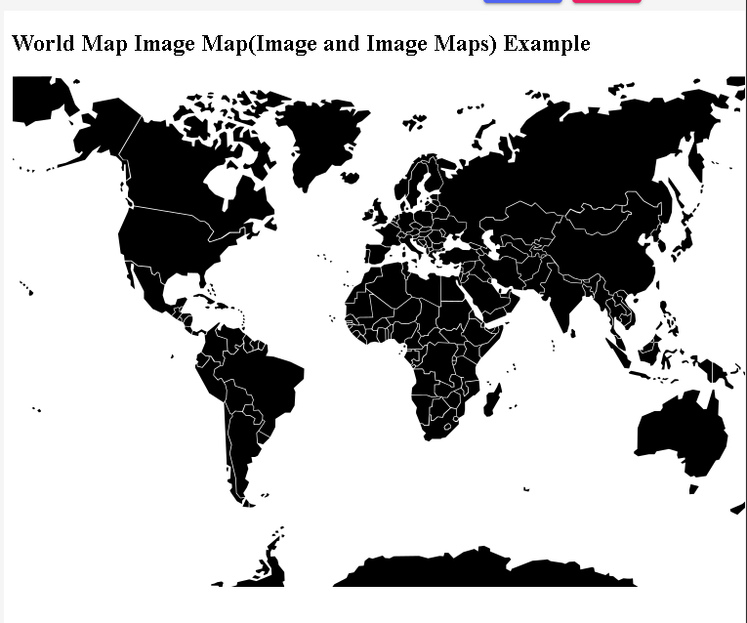

Practical No. 2
Design a webpage that makes use of A. Table tags
INPUT:-
<HTML>
<BODY>
<TABLE BORDER="5" WIDTH="50%" CELLPADDING="4" CELLSPACING="3">
<TR>
<TH COLSPAN="2">
<H3><BR>TABLE TITLE</H3>
</TH>
</TR>
<TH>Column A</TH>
<TH>Column B</TH>

<TR>
<TD>Data 1</TD>
<TD>Data 2</TD>
</TR>
<TR>
<TD>Data 3</TD>
<TD>Data 4</TD>
</TR>
<TR>
<TD>Data 5</TD>
<TD>Data 6</TD>
</TR>
</TABLE>
</BODY>
</HTML>
OUTPUT:-
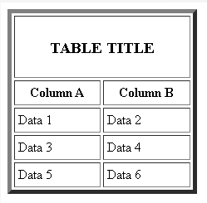
Design a webpage that makes use of B. Form Tags (forms with various form elements)
INPUT:-
<html>
<!-- the title will appear on the page-->
<head>
<title>Employee Interests Survey</title>
</head>
<body>
<!-- as it is a survey form,we will need to submit the details, hence we use form -->
<!--we can give absolute url, or relative url like /nextpage.jsp, and specify POST or GET method -->
<form action="http://google.co.in">
<!-- IF we remove this, everythong will move to the left of the page-->
<div align="center">
<!--Adds a headimg to the form-->
<h1>Employee Interests Survey form</h1>
Enter your name:
<!--Input type text for small texts, specify size -->
<input type="text" name="UserName" size=35 maxlength=35 value="">
<!--Adds spaces - remove and see what happens -->
</br></br>
Enter your department:
<input type="text" name="Deptt" size=35 maxlength=35 value=""> </br> </br>
Tell us a little about yourself:
<!-- For writing lot of text like descriptions with text wrapping,
if you dont want text wrapping, you can add wrap = "off" (horizontal scrollbar -->
<textarea name="Comments" cols=30 rows=4></textarea> </br> </br>
Do you exercise at home?
<!-- Radio buttons help you choose one out of the many values -->
<input type="radio" name="exe" value=1>Yes
<input type="radio" name="exe" value=2>No
</p>
How do you like to read about your favorite topics?
<p>
<!--Checkbox lets you select multiple options -->
<input type="checkbox" name="Books">Books
<input type="checkbox" name="Web">Online resources
<input type="checkbox" name="Phone">Phone apps
<input type="checkbox" name="Magazines">Magazines
</p>
What genre of movies do you like?
<!--Select box lets you choose one of the multiple dropdown options-->
<select name="moviepref" ><option>
<option value=1 selected = "true">comedy
<option value=2 >romance
<option value=3 >thriller
<option value=4 >horror
<option value=5 >biopic
</select>
</br></br>
<!--submits the information entered in the form by the user -->
<input type=submit value="Submit form">
</div>
</form>
</body>
</html>
OUTPUT:-
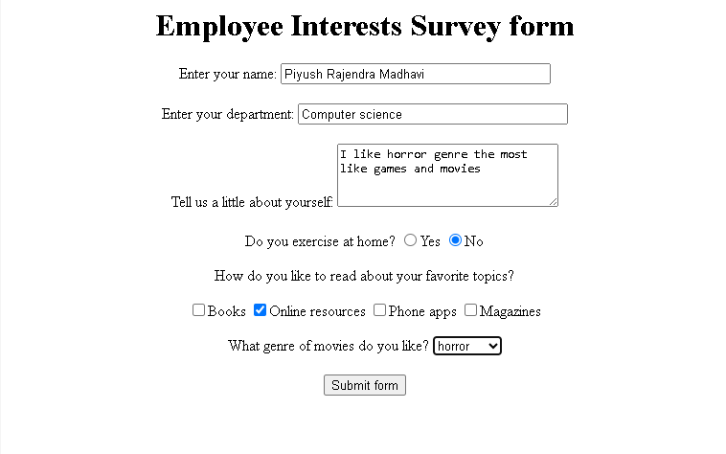

Practical No. 3
Design a webpage that makes use of
a. Navigation across multiple pages:
Index.html
INPUT:-
<!DOCTYPE html>
<html lang="en">
<head>
<meta charset="UTF-8">
<meta name="viewpoint" content="width=device-width, initial-scale=1.0">
<title>Home - My Website</title>
<link rel="stylesheet"href="style.css">
</head>
<body>
<header>
<h1>Welcome to My Website</h1>
<nav>
<ul class="navbar">
<li><a href="index.html" class="active">Home</a></li>
<li><a href="about.html">About</a></li>
<li><a href="contact.html">Contact</a></li>
</ul>
</nav>
</header>
<main>
<h2>Home Page</h2>
<p>This is the homepage.Navigate using the menu above to learn more about us!</p>
</main>
<footer>
<p>&copy;2025 My Website</p>
</footer>
</body>
</html>
OUTPUT:-
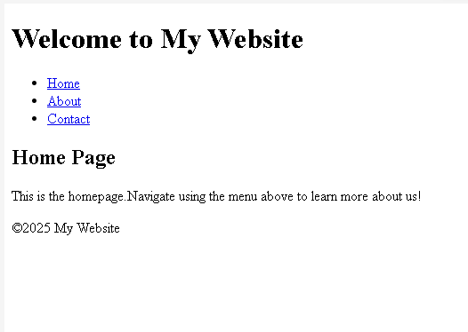

About.html
INPUT:-
<!DOCTYPE html>
<html lang="en">
<head>
<meta charset="UTF-8">
<meta name="viewport" content="width=device-width, initial-scale=1.0">
<title>Home - My Website</title>
<link rel="stylesheet"href="style.css">
</head>
<body>
<header>
<h1>About Us</h1>
<nav>
<ul class="navbar">
<li><a href="index.html">Home</a></li>
<li><a href="about.html" class="active">About</a></li>
<li><a href="contact.html">Contact</a></li>
</ul>
</nav>
</header>
<main>
<h2>Our Story</h2>
<p>We are a team passionate about web design and development. Our mission is to create beautiful and fuctional websites.</p>
</main>
<footer>
<p>&copy;2025 My Website</p>
</footer>
</body>
</html>
OUTPUT:-
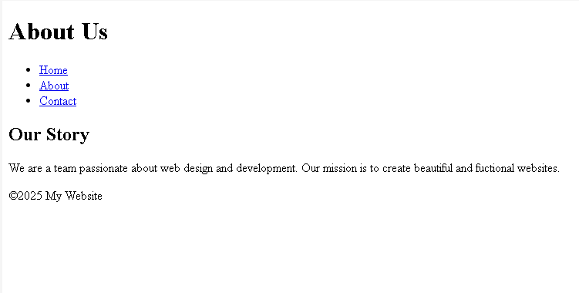
Contact.html
INPUT:-
<!DOCTYPE html>
<html lang="en">
<head>
<meta charset="UTF-8">
<meta name="viewport" content="width=device-width, initial-scale=1.0">
<title>Home - My Website</title>
<link rel="stylesheet"href="style.css">
</head>
<body>
<header>
<h1>Contact Us</h1>
<nav>
<ul class="navbar">
<li><a href="index.html">Home</a></li>
<li><a href="about.html">About</a></li>
<li><a href="contact.html"class="active">Contact</a></li>
</ul>
</nav>
</header>
<main>
<h2>Get in Touch</h2>
<form>
<label>Name:</label>
<input type="text" placeholder="Enter your Name" required><br><br>

<label>Email:</label>
<input type="email" placeholders="Enter your email" required><br><br>
<label>Message:</label><br>
<textarea rows="4" cols="40" placeholder=""></textarea>br><br>

<button type="submit">Send</button>
</form>
</main>
<footer>
<p>&copy;2025 My Website</p>
</footer>
</body>
</html>
OUTPUT:-
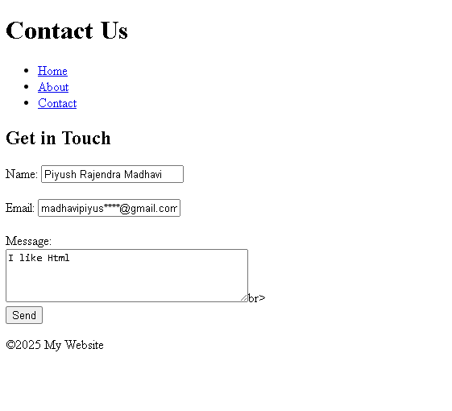
Style.css
INPUT:-
<!DOCTYPE html>
<html>
<head>
<style>
body {
font-family: Arial, sans-serif;
margin: 0;
padding: 0;
background-color:white;
}

header {
background-color: blue;
color: white;
padding: 20px 0;
text-align: center;
}

.navbar {
list-style: none;
padding: 0;
margin: 10px 0;
}

.navbar li {
display: inline;
margin: 0 15px;
}

.navbar a {
color: white;
text-decoration: none;
font-weight: bold;
}

.navbar a:hover,
.navbar a.active {
text-decoration: underline;
}

main {
padding: 20px;
text-align: center;
}

footer {
background-color: purple;
color: white;
text-align: center;
padding: 10px;
position: fixed;
bottom: 0;
width: 100%;
}
</style>
</head>

<body>

<header>
<h1>Save Water</h1>
<ul class="navbar">
<li><a href="#" class="active">Home</a></li>
<li><a href="#" class="active" >Places</a></li>
<li><a href="#" class="active" >Contact</a></li>
</ul>
</header>

<main>
<h2>Welcome to our Website</h2>
<p>This site is help create awareness about <b>Saving Water</b></p>
</main>

<footer>
My Website @2025
</footer>

</body>
</html>
OUTPUT:-
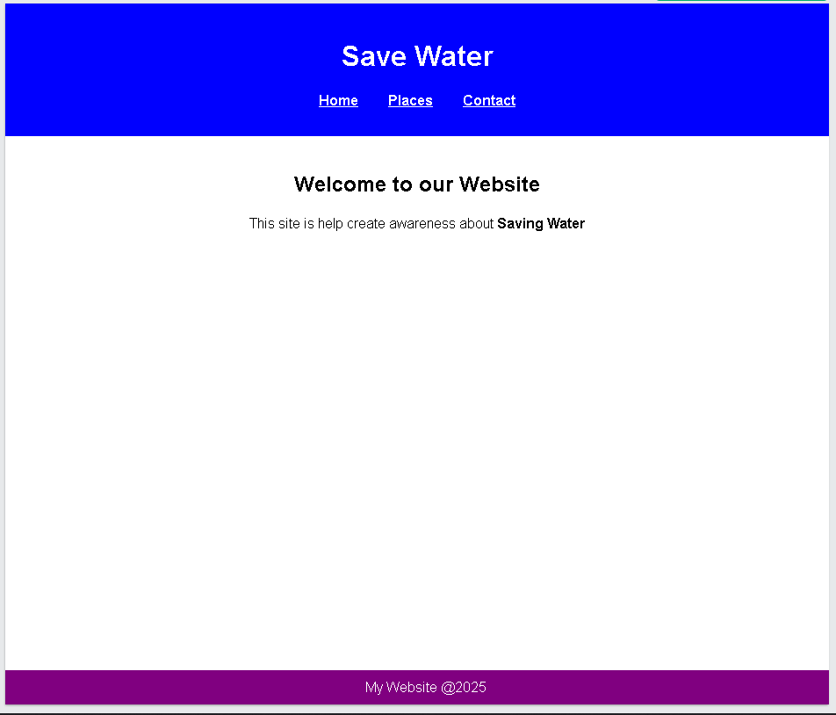

- Design a webpage that makes use of Embedded Multimedia elements.
INPUT:-
<!DOCTYPE html>
<html lang="en">
<head>
<meta charset="UTF-8">
<meta name="viewport" content="width=device-width, initial-scale=1.0">
<title>Embedded Multimedia Example</title>
</head>
<body>

<h1>Welcome to My Multimedia Webpage</h1>
<hr>

<!-- Image Section -->
<h2>1. Embedded Image</h2>
<p>This is an image embedded using the <code>&lt;img&gt;</code> tag.</p>
<img src="https://upload.wikimedia.org/wikipedia/commons/3/3f/JPEG_example_flower.jpg"
alt="Beautiful Flower"
width="400"
height="300">
<hr>

<!-- Audio Section -->
<h2>2. Embedded Audio</h2>
<p>Listen to the sample audio clip below (controls added for play/pause):</p>
<audio controls>
<source src="https://www.w3schools.com/html/horse.mp3" type="audio/mpeg">
Your browser does not support the audio element.
</audio>
<hr>

<!-- Video Section -->
<h2>3. Embedded Video</h2>
<p>Here is a sample video embedded using the <code>&lt;video&gt;</code> tag:</p>
<video width="480" height="270" controls>
<source src="https://www.w3schools.com/html/mov_bbb.mp4" type="video/mp4">
Your browser does not support the video tag.
</video>
<hr>

<!-- YouTube Embed -->
<h2>4. Embedded YouTube Video</h2>
<p>You can also embed online videos using the <code>&lt;iframe&gt;</code> tag:</p>
<iframe width="480" height="270"
src="https://www.youtube.com/embed/tgbNymZ7vqY"
title="YouTube video player"
frameborder="0"
allow="accelerometer; autoplay; clipboard-write; encrypted-media; gyroscope; picture-in-picture"
allowfullscreen>
</iframe>
<hr>

<!-- Closing Section -->
<h2>End of Page</h2>
<p>We have used image, audio, and video elements without any CSS.</p>

</body>
</html>
OUTPUT:-
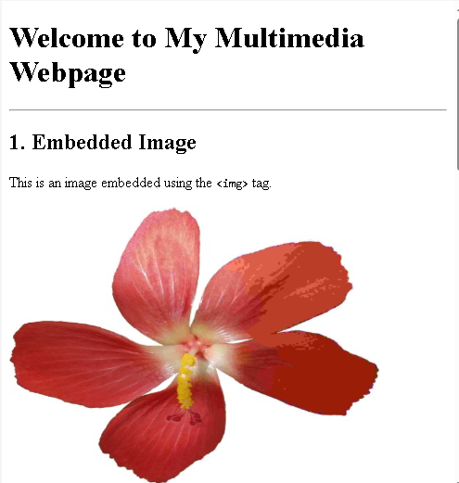
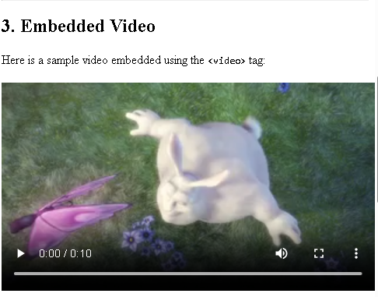
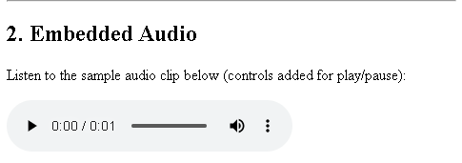

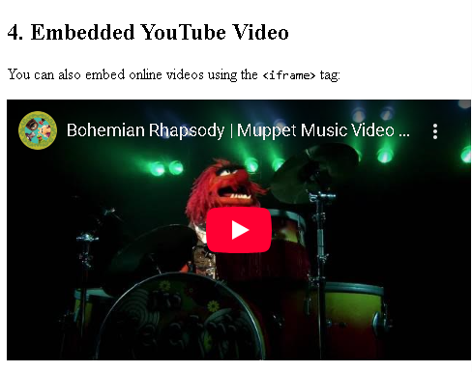
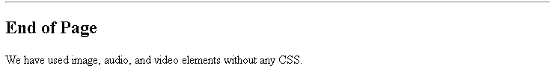

Practical No. 4
Design a webpage that make use of Cascading Style Sheets with:
a. CSS properties to change the background of a Page
Input:-
<!DOCTYPE html>
<html>
<head>
<style>
body {
background-color: lightblue;
}
</style>
</head>
<body>

</body>
</html>
Output:-

b. CSS properties to change Fonts and Text Styles
Input:-
<!DOCTYPE html>
<html>
<head>
<style>
body {
font-family: Arial, sans-serif;
}

p {
font-style: italic;
}
</style>
</head>
<body>

<h1>My First CSS Example</h1>
<p>This is a paragraph.</p>

</body>
</html>
Output:-
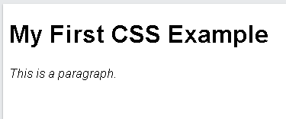
c. CSS properties for positioning an element.
Input:-
<!DOCTYPE html>
<html>
<head>
<style>
body {
background-color: lightblue;
}
p {
position: absolute;
top: 20px;
right: 100px;
}

</style>
</head>
<body>

<p>This is a paragraph.</p>

</body>
</html>
Output:-


Practical No. 5
Write JavaScript code for:
- Performing various mathematical operations such as:

Calculating factorial
Input:-
function factorial(n) {
if (n < 0) return "Factorial not defined for negative numbers";
let fact = 1;
for (let i = 1; i <= n; i++) fact *= i;
return fact;
}

console.log(factorial(5));
Output:-
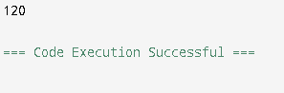
Finding Fibonacci Series
Input:-
function fibonacci(n) {
let a = 0, b = 1;
let series = [];
for (let i = 0; i < n; i++) {
series.push(a);
[a, b] = [b, a + b];
}
return series;
}

console.log(fibonacci(10));
Output:-
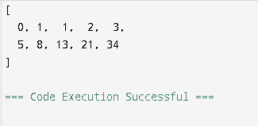
Displaying Prime Numbers in a given range
Input:-
function isPrime(num) {
if (num < 2) return false;
for (let i = 2; i <= Math.sqrt(num); i++) {
if (num % i === 0) return false;
}
return true;
}

function primesInRange(start, end) {
let primes = [];
for (let i = start; i <= end; i++) {
if (isPrime(i)) primes.push(i);
}
return primes;
}

console.log(primesInRange(10, 50));
Output:-
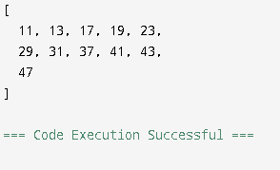
Evaluating Expressions
Input:-
function evaluateExpression(expr) {
try {
return eval(expr); // Use carefully!
} catch {
return "Invalid expression";
}
}

console.log(evaluateExpression("3 + 5 * 2"));
Output:-
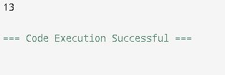
Calculating reverse of a number
Input:-
function reverseNumber(n) {
let isNegative = n < 0;
let reversed = Number(String(Math.abs(n)).split("").reverse().join(""));
return isNegative ? -reversed : reversed;
}

console.log(reverseNumber(12345));
console.log(reverseNumber(-987));
Output:-
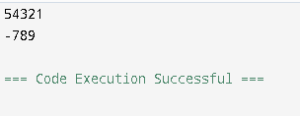

- Validating the various Form Elements:
Input:-
<!DOCTYPE html>
<html>
<head>
<script>
function validateForm() {
if (document.getElementById("name").value === "") {
alert("Enter your name");
return false;
}

if (document.getElementById("email").value === "") {
alert("Enter your email");
return false;
}

if (!document.getElementById("terms").checked) {
alert("You must accept the terms");
return false;
}

alert("Form submitted successfully!");
return false; // stops reload so you can SEE the success message
}
</script>
</head>

<body>
<form onsubmit="return validateForm()">
Name: <input id="name"><br><br>
Email: <input id="email"><br><br> Accept Terms: <input type="checkbox" id="terms"><br><br>

<button type="submit">Submit</button>
</form>
</body>
</html>
Output:-
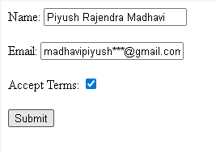
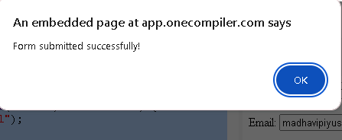

Practical No. 6
Write JavaScript code for:
- Demonstrating different JavaScript Objects such as:
String Object:
Input:-
<!DOCTYPE html>
<html>
<body>

<h2>JavaScript String Properties</h2>

<p>The length property returns the length of a string:</p>

<p id="demo"></p>

<script>
var txt ="ABCDEFGHIJKLMNOPQRSTUVWXYZ";
var sIn = txt.length;
document.getElementById("demo").innerHTML = sIn;
</script>

</body>
</html>
Output:-
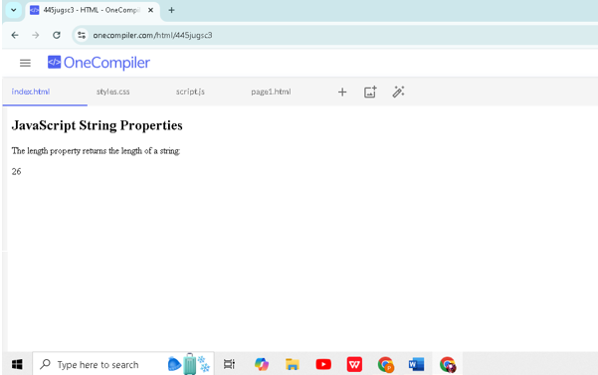
RegExp
Input:-
<!DOCTYPE html>
<html>
<body>

<h2>JavaScript String Methods</h2>

<p>Search a string for "college", and display the position of the match:</p>

<p id="demo"></p>

<script>
var str = "Visit college!";
var n = str.search("college");
document.getElementById("demo").innerHTML = n;

</script>

</body>
</html>
Output:-

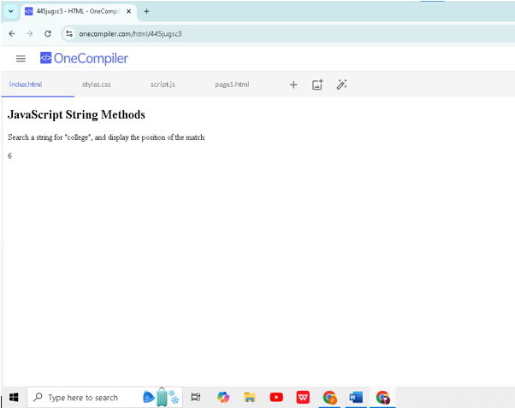
Math object
Input:-
<!DOCTYPE html>
<html>
<body>

<h2>JavaScript Math.round()</h2>

<p>Math.round(x)returns the value of x rounded to its nearest integer:</p>

<p id="demo"></p>
<script>
document.getElementById("demo").innerHTML = Math.round(4.4);
</script>

</body>
</html>
Output:-
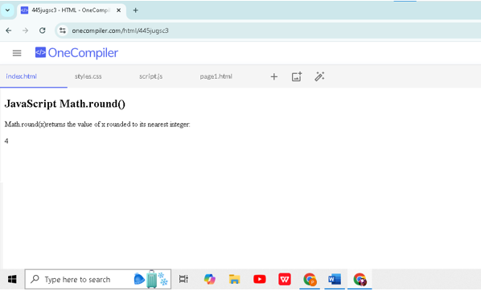
Date object
Input:-
<!DOCTYPE html>
<html>
<body>

<h2>JavaScript new Date()</h2>

<p>Using new Date(7 numbers),creates a new date object with the specified date and time:</p>

<p id="demo"></p>

<script>
var d = new Date(2018, 11, 24, 10, 33, 30, 0);
document.getElementById("demo").innerHTML = d;
</script>

</body>
</html>
Output:-
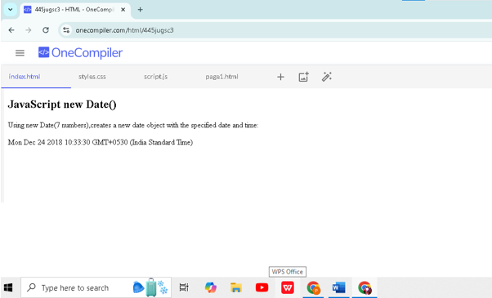

- Demonstrating different JavaScript Objects such as:

- Window:
Input:-
<!DOCTYPE html>
<html>
<head>
<title>Window Object Demo</title>
<style>
body { font - family: Arial; padding: 20px; }
button { padding: 10px 15px; }
#output { margin-top: 20px; padding: 15px; border: 1px solid #333; background: #f4f4f4;
</style>
</head>
<body>

<h2>A Window Object Demonstration</h2>

<button onclick="showWindow()">Show Window Object</button>

<div id="output">Output will appear here...</div>

<script>
function showWindow() {
alert("This is the Window Object alert!");

document.getElementById("output").innerHTML =
"<b>WINDOW OBJECT OUTPUT:</b><br>" +
"Window Inner Width: " + window.innerWidth + "<br>" +
"Window Inner Height: " + window.innerHeight + "<br>" +
"Window Location (URL): " + window.location.href;
}
</script>

</body>
</html>
Output:-
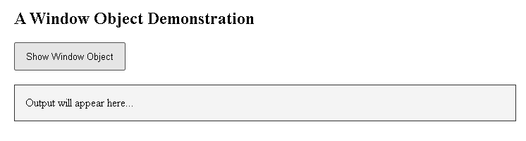
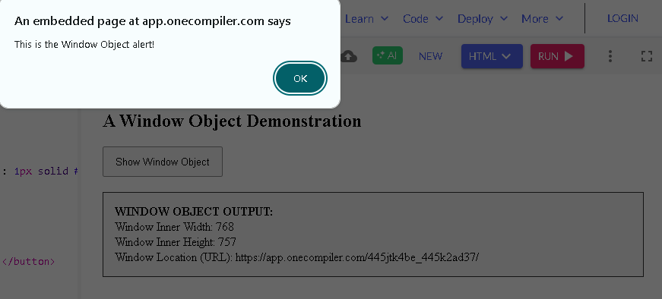
- Navigator:
Input:-
<!DOCTYPE html>
<html>
<head>
<title>Navigator Object Demo</title>
<style>
body { font-family: Arial; padding: 20px; }
button { padding: 10px 15px; }
#output { margin-top: 20px; padding: 15px; border: 1px solid #333; background: #f4f4f4;
</style>
</head>
<body>

<h2>A Navigator object Demonstration</h2>

<button onclick="showNavigator()">Show Navigator object</button>

<div id="output">Output will appear here...</div>
<script>
function showNavigator() {
document.getElementById("output").innerHTML =
"<b>Navigator OBJECT OUTPUT:</b><br>" +
"Browser Name: " + navigator.appName + "<br>" +
"Browser Version: " + navigator.appVersion + "<br>" +
"User Agent: " + navigator.userAgent + "<br>" +
"Online Status: " + navigator.online + "<br>" +
"Platform: " + navigator.platform;
}
</script>

</body>
</html>
Output:-
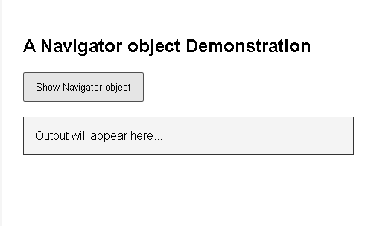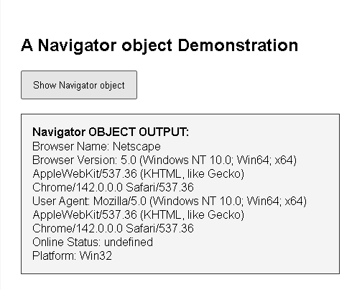
- History:
Input:-
<!DOCTYPE html>
<html>
<head>
<title>History Object Demo</title>
<style>
body { font-family: Arial; padding: 20px; }
button { padding: 10px 15px; margin-right: 10px; }
#output { margin-top: 20px; padding: 15px; border: 1px solid #333; background:#f4f4f4;
</style>
</head>
<body>

<h2> A History Object Demonstration</h2>

<button onclick="showHistory()">Show History Info</button>
<button onclick="goBack()">Go Back</button>
<button onclick="goForward()">Go Forward</button>

<div id="output">Output will appear here...</div>

<script>
function showHistory() {
document.getElementById("output").innerHTML =
"<b>HISTORY OBJECT OUTPUT:</b><br>" +
"Length of browsing history: " + history.length + "<br>" +
"(Note: Actual pages cannot be shown for security reasons.)";
}
function goBack() {
history.back();
}

function goForward() {
history.forward();
}
</script>

</body>
</html>
Output:-
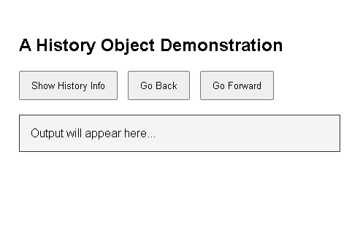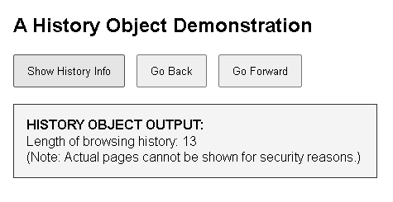
- Location:
Input:-
<!DOCTYPE html>
<html>
<head>
<title>Location Object Demo</title>
<style>
body { font-family: Arial; padding: 20px; }
button { padding: 10px 15px; margin-right: 10px; }
#output { margin-top: 20px; padding: 15px; border: 1px solid #333; background: #f4f4f4;
</style>
</head>
<body>

<h2> A Location Object Demonstration</h2>

<button onclick="showLocation()">Show Location Info</button>
<button onclick="redirectPage()">Redirect to Example.com</button>

<div id="output">Output will appear here...</div>

<script>
function showLocation() {
document.getElementById("output").innerHTML =
"<b>LOCATION OBJECT OUTPUT:</b><br>" +
"Full URL: " + location.href + "<br>" +
"Hostname: " + location.hostname + "<br>" +
"Pathname: " + location.pathname + "<br>" +
"Protocol: " + location.protocol + "<br>" +
"Port: " + location.port;
}

function redirectPage() {
location.href = "https://example.com";
}
</script>
</body>
</html>
Output:-
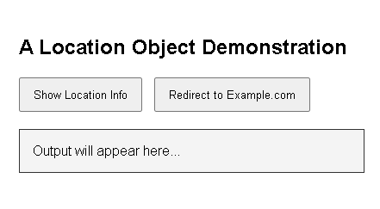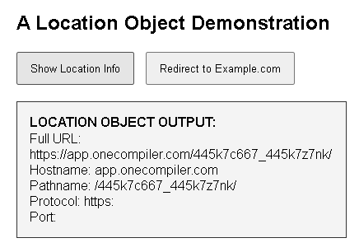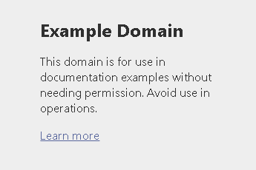
- Document:
Input:-
<!DOCTYPE html>
<html>
<head>
<title>Document Object Demo</title>
<style>
body { font-family: Arial; padding: 20px; }
button { padding:10px 15px; margin-right: 10px; }
#output {margin-top: 20px; padding: 15px; border: 1px solid #333; background: #f4f4f4; }
h3 { margin-top: 20px; }
</style>
</head>
<body>

<h2> A Document Object Demonstration</h2>

<button onclick="showDocumentInfo()">Show Document Info</button>
<button onclick="changeTitle()">Change Page Title</button>
<button onclick="addParagraph()">Add Paragraph</button>

<h3 id="demoHeading"> Heading Example (for Document Demo)</h3>

<div id="output">Output will appear here...</div>

<script>
function showDocumentInfo() {
document.getElementById("output").innerHTML =
"<b>DOCUMENT OBJECT OUTPUT:</b><br>" +
"Page Title: " + document.title + "<br>" +
"URL: " + document.URL + "<br>" +
"Domain: " + document.domain + "<br>" +
"Number of Forms: " + document.forms.length + "<br>" +
"Number of Links: " + document.links.length;
}

function changeTitle() {
document.title = "New Page Title (Document Object)";
document.getElementById("output").innerHTML = "Page title changed to: " + document.title;
}

function addParagraph() {
const p = document.createElement("p")
p.textContent = "This paragraph was added using the Document object.";
document.body.appendChild(p);
}
</script>

</body>
</html>
Output:-
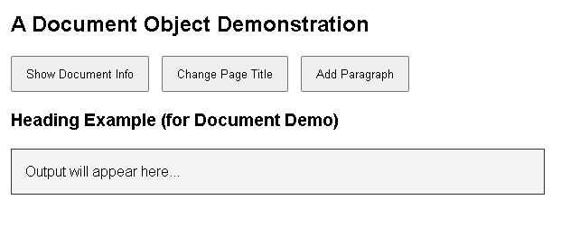
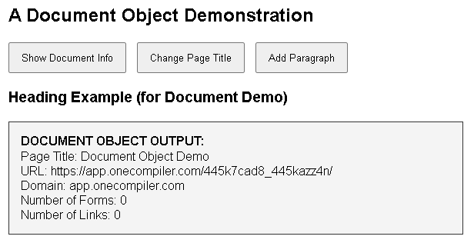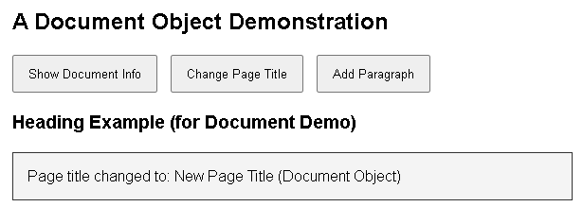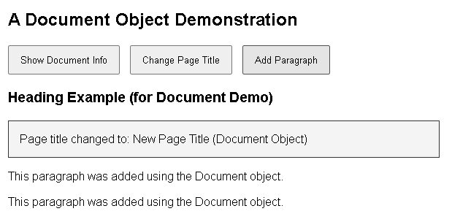

C . Storing and Retrieving Cookies
Input:-
<!DOCTYPE>
<html>
<head>
<script>

function setCookie(cname, cvalue, exdays) {
var d = new Date();
d.setTime(d.getTime() + (exdays * 24 * 60 * 60 * 1000));
var expires = "expires=" + d.toUTCString();
document.cookie = cname + "=" + cvalue + ";" + expires + ";path=/";
}

function getCookie(cname) {
var name = cname + "=";
var decodedCookie = decodeURIComponent(document.cookie);
var ca = decodedCookie.split(';');
for (var i = 0; i < ca.length; i++) {
var c = ca[i];
while (c.charAt(0) == ' ') {
c = c.substring(1);
}
if (c.indexOf(name) == 0) {
return c.substring(name.length, c.length);
}
}
return "";
}

function checkCookie() {
var user = getCookie("username");
if (user != "") {
alert("Welcome again " + user);
} else {
user = prompt("Please enter your name:");
if (user != "" && user != null) {
setCookie("username", user, 30);
}
}
}
</script>
</head>
<body onload="checkCookie()">
</body>
</html>
Output:-
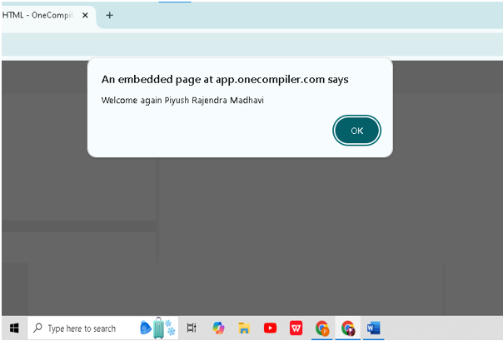

Practical No. 7
Create a XML file with Internal / External DTD and display it using:
a. CSS:
Input:-
<?xml version="1.0"?>

<!DOCTYPE book [
<!ELEMENT book (title, author)>
<!ELEMENT title (#PCDATA)>
<!ELEMENT author (#PCDATA)>
]>

<?xml-stylesheet type="text/css"?>

<book>
<title>XML</title>
<author>Piyush</author>
</book>

<!-- CSS -->
<style>
book {
display: block;
font-family: Arial;
background: #eee;
padding: 10px;
}
title {
display: block;
color: blue;
font-weight: bold;
}
author {
display: block;
color: green;
}
</style>
Output:-
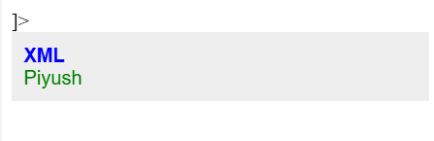

b. XSL:
File .1
Input:-
<?xml version="1.0"?>

<!DOCTYPE book [
<!ELEMENT book (title, author)>
<!ELEMENT title (#PCDATA)>
<!ELEMENT author (#PCDATA)>
]>

<?xml-stylesheet type="text/xsl" href="book.xsl"?>

<book>
<title>XML Basics</title>
<author>John Doe</author>
</book>

File .2
Input:-
<?xml version="1.0"?>
<xsl:stylesheet version="1.0"
xmlns:xsl="http://www.w3.org/1999/XSL/Transform">

<xsl:template match="/">
<html>
<body>
<h3>Book Details</h3>
<p>Title: <xsl:value-of select="book/title"/></p>
<p>Author: <xsl:value-of select="book/author"/></p>
</body>
</html>
</xsl:template>

</xsl:stylesheet>
Output:-
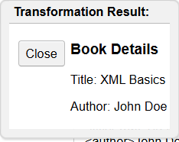

Practical No. 8
Design a webpage to handle asynchronous requests using AJAX on:
a. Mouseover:
Input:-
<div id="box">Hover here</div>
<p id="out"></p>

<script>
document.getElementById("box").onmouseover = function () {
setTimeout(() => {
document.getElementById("out").innerHTML =
"Data loaded asynchronously on mouseover";
}, 500);
};
</script>
Output:-
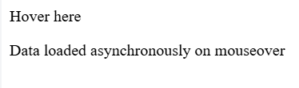

b. button click:
Input:-
<!DOCTYPE html>
<html>
<body>

<button onclick="loadData()">Click Me</button>
<p id="result"></p>

<script>
function loadData() {
setTimeout(function () {
document.getElementById("result").innerHTML =
"Data loaded asynchronously on button click";
}, 500);
}
</script>

</body>
</html>
Output:-
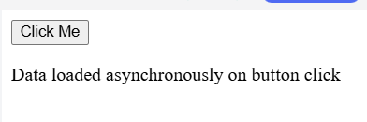

Practical No. 9
Write PHP scripts for:
a. Retrieving data from HTML forms:
Input:-
<?php
if ($_SERVER["REQUEST_METHOD"] == "POST") {
echo "Name: " . $_POST["name"];
// Email is retrieved but not displayed
$email = $_POST["email"];
}
?>

<form method="post">
Name: <input type="text" name="name"><br>
Email: <input type="email" name="email"><br>
<input type="submit" value="Submit">
</form>
Output:-
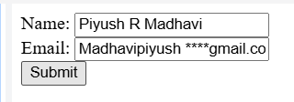

b.(1) Performing certain mathematical operations such as calculating factorial:
Input:-
<?php
$n = 5; // Number to find factorial
$fact = 1;
for ($i = 1; $i <= $n; $i++) {
$fact *= $i;
}
echo "Factorial of $n is: $fact";
?>
Output:-
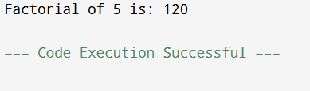

b.(2) Performing certain mathematical operations such as Finding Fibonacci Series:
Input:-
<?php
$n = 10; // Number of terms
$a = 0;
$b = 1;
echo "Fibonacci Series: ";
for ($i = 1; $i <= $n; $i++) {
echo $a . " ";
$c = $a + $b;
$a = $b;
$b = $c;
}
?>
Output:-
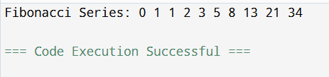

b.(3) Performing certain mathematical operations such as Displaying Prime Numbers in a given range:
Input:-
<?php
$start = 1;
$end = 20;
echo "Prime numbers between $start and $end: ";
for ($i = $start; $i <= $end; $i++) {
if ($i < 2) continue; // Skip numbers < 2
$isPrime = true;
for ($j = 2; $j <= sqrt($i); $j++) {
if ($i % $j == 0) {
$isPrime = false;
break;
}
}
if ($isPrime) echo $i . " ";
}
?>
Output:-
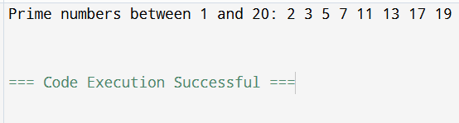

b.(4) Performing certain mathematical operations such as Evaluating Expressions:
Input:-
<?php
$a = 10;
$b = 5;
$result = ($a + $b) * 2;
echo "Result of ($a + $b) * 2 = $result";
?>
Output:-
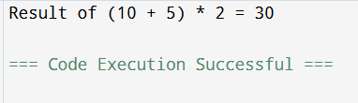

b.(5) Performing certain mathematical operations such as Calculating reverse of a number:
Input:-
<?php
$num = 1234;
$rev = 0;
$temp = $num;
while ($temp > 0) {
$rev = ($rev * 10) + ($temp % 10);
$temp = intdiv($temp, 10);
}
echo "Reverse of $num is: $rev";
?>
Output:-
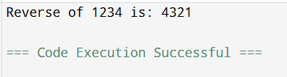

Practical No. 10
Write PHP scripts for:
a. Working with Arrays:
Input:-
<?php
$numbers = array(10, 20, 30, 40, 50);
echo "Length of the array: " . count($numbers);
?>
Output:-
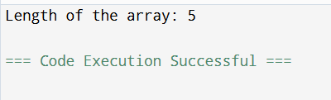

b. Working with Files (Reading / Writing):
Input:-
<?php
// Simulated file content storage
$fileContent = "";

// Simulate writing to "file"
function writeToFile($data) {
global $fileContent;
$fileContent = $data;
return "Data written successfully.";
}

// Simulate reading from "file"
function readFromFile() {
global $fileContent;
if ($fileContent === "") {
return "File is empty.";
}
return $fileContent;
}

// Writing data
echo writeToFile("Hello! This simulates writing data to a file awesome work by piyush.") . "\n\n";

// Reading data
echo "Reading from 'file':\n";
echo readFromFile();
?>
Output:-
