Write the Shell Script to Monitor Logs : Create a script that monitors server logs for errors and alert you

Name:Arvindan S Department:ADS

# tep-by-Step Overview

## Step 1:

Create a Folder called logs for Your Logs and Script

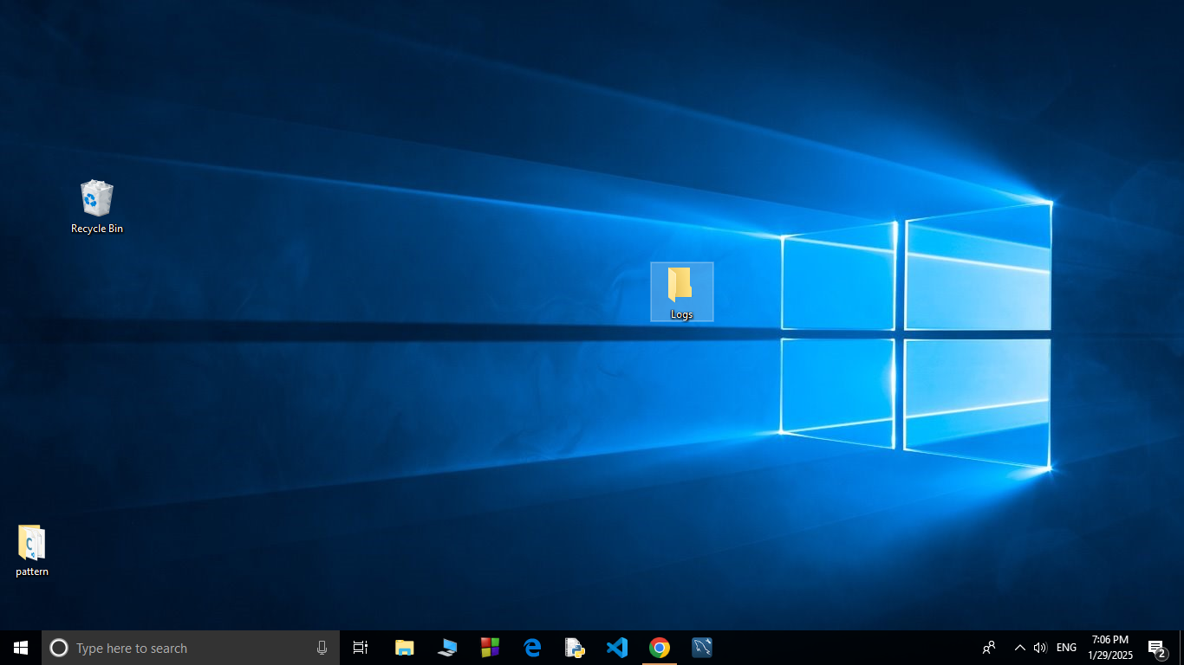

## Step 2:

Open Notepad and Add the following sample text to it and Save the file as **mylogfile.log** inside the logs folder

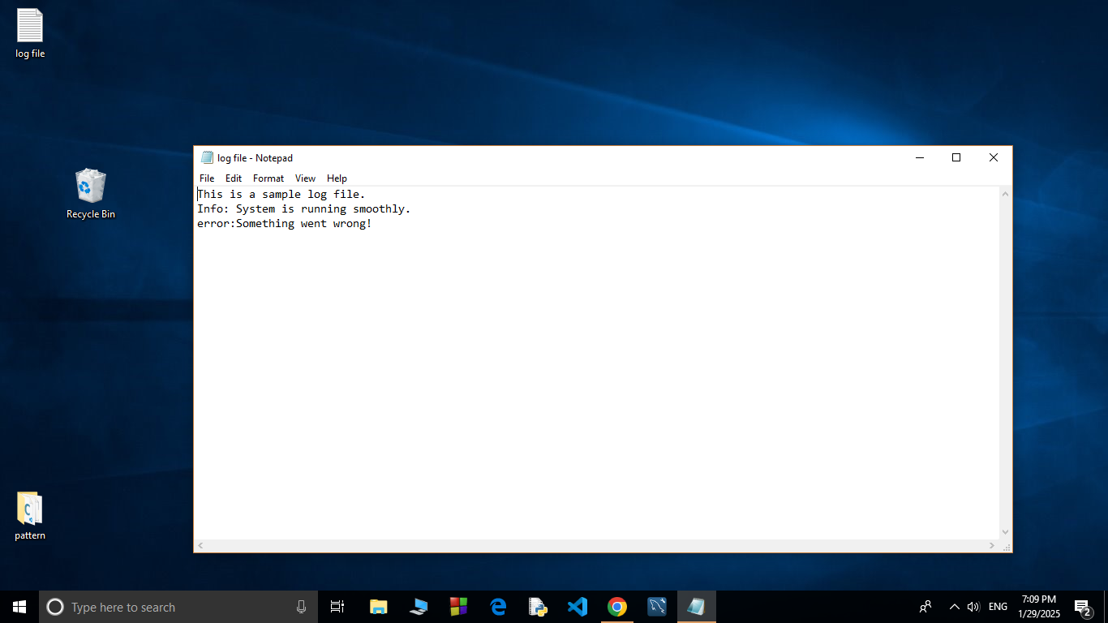

## Step 3:

Open Notepad and Type the following PowerShell script into it and Set the $LogFilePath address to the mylogfile.log which you saved in logs folder. Save the file as monitor_logs.ps1 inside the same logs folder

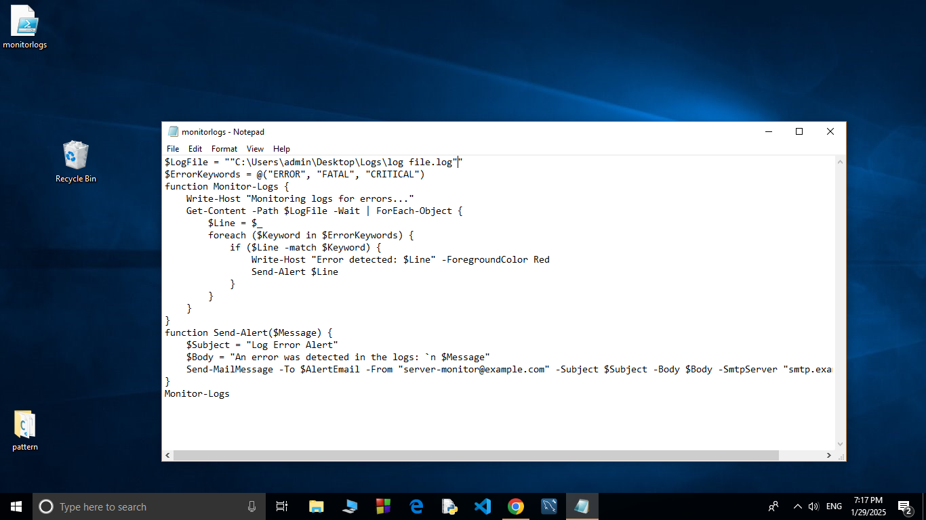

## Step 4:

Click the Windows Key and Search for Windows PowerShell and click Run as Administrator.

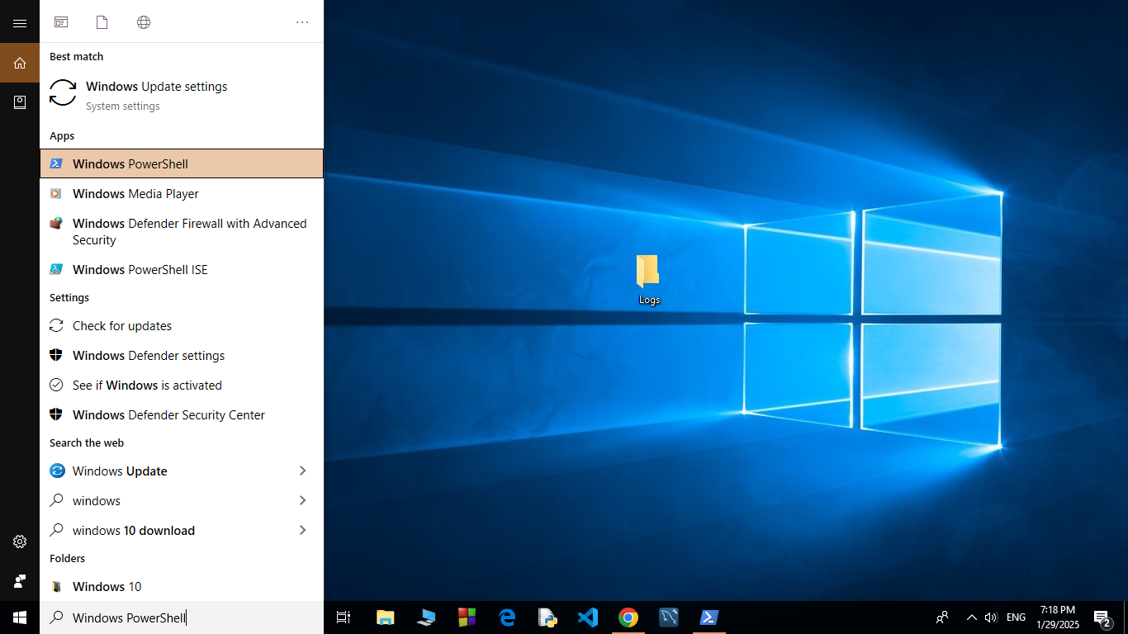

## Step 5:

Run the following command to allow script execution:

### Set-ExecutionPolicy -Scope CurrentUser -ExecutionPolicy RemoteSigned

When prompted, type Y and press Enter.

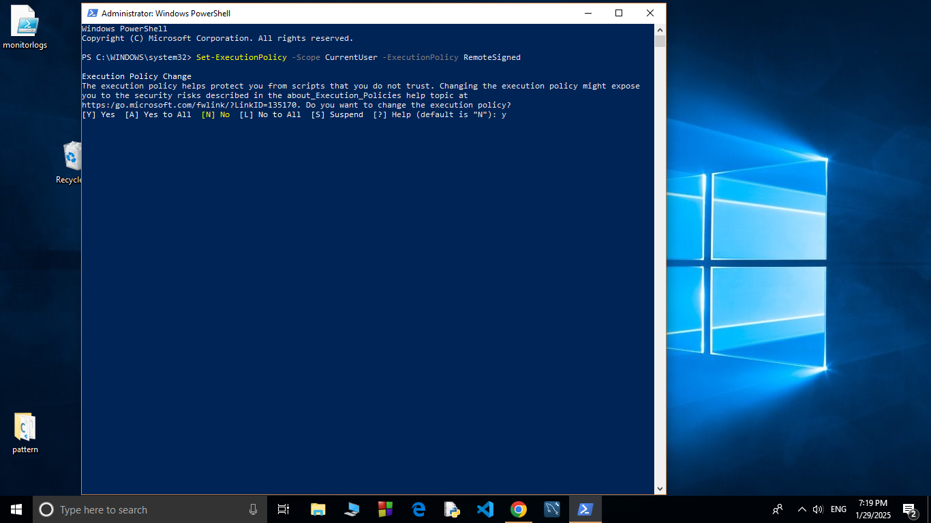

## Step 6:

Navigate to the logs folder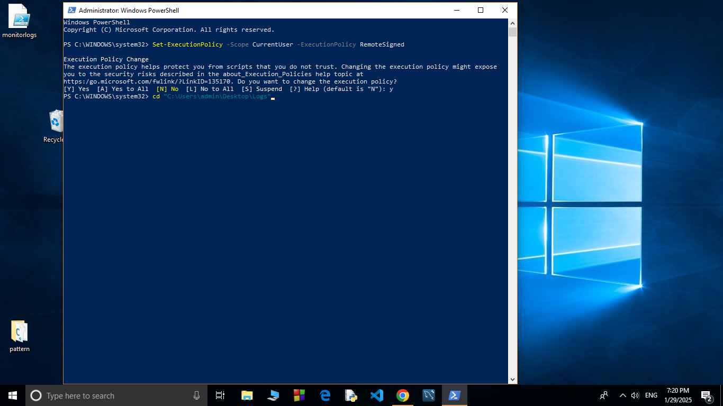

## Step 7:

Run the script:

**.\monitor_logs.ps1**

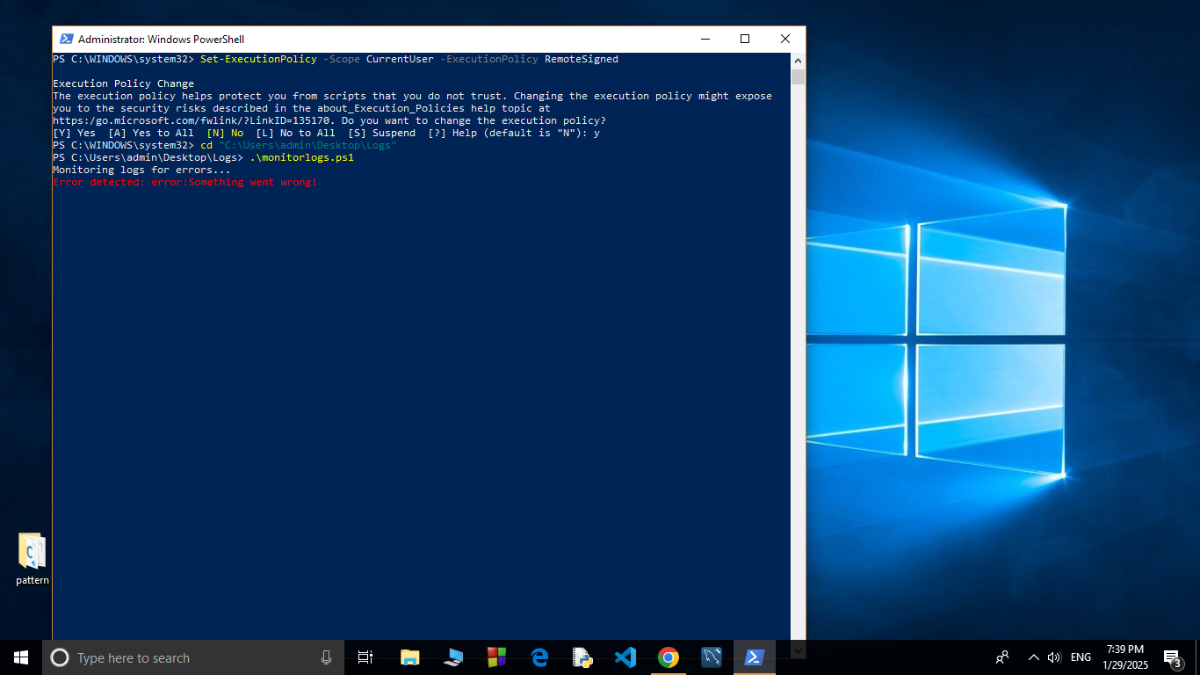

## Step 8:

Open mylogfile.log in Notepad and Add a new line with the word "error" and Save the file.

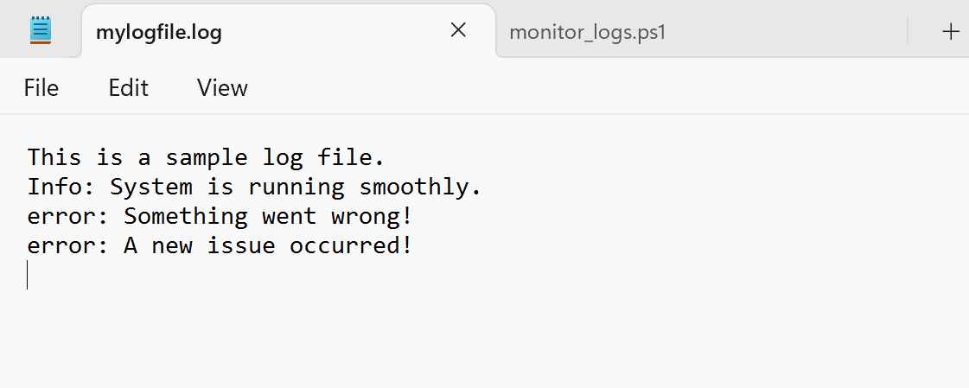

## Step 9:

Check PowerShell — you should see an alert like:

**ALERT: Keyword 'error' found in log: error: A new issue occurred!**

