Smart Fit Gym - Daily Member Equipment Tracker

Step 1: The Four Pillars of Computational Thinking
Before writing any code, we must analyze and break down the problem logically.

- Decomposition (Breaking it Down)
We break down the tracker into manageable tasks:
- Enter the members name’s
- Track the piece of equipment used
- Get the total minutes spent on it
- Calculate the usage score
- Display which machines need cleaning or service

- Pattern Recognition (Identifying Trends)
We notice that every tracker follows the same mathematical pattern regardless of the member or machine:
Total usage score = Minutes × 1.5 We can reuse this logic for any calculation.

- Abstraction (Focusing on Essentials)
We focus only on what’s essential and what’s not essentials:
- Essential: Members name, used equipment , total minutes
- Irrelevant: The brand of the member's sneakers, the type of gym wear they were wearing, or whether they were exhausted or not
- Algorithm Design (Step-by-steps logic)
A clear step by step instruction for the computer to follow:
1.Start the system
2.Prompt members to input their name
3.Allow members to input the equipment used
4.Prompt members to input the total minutes spent on it
5.Calculate the total usage score using mathematical form
6.Print a message showing the members name, equipment used and the total minutes
7.Display the total usage score and summary
8.End the program

Step 2: Behavioral Design (IPO and Flowchart)
We now translate our plan into professional design models used by developers.
- The IPO Model (Input-Process-Output)

IPO MODEL
Fitness tracker – daily usage tracker

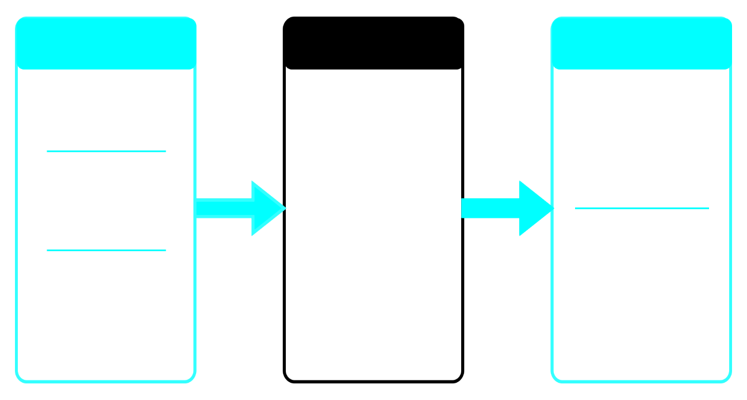
message
- Total usage-
- Summary
score
minutes * 1.5
Usagescore =
Calculate
spent
- Total minutes
equipments
used
- Input the
name
- Put members
PROCESS
OUTPUT
INPUT

- The Logic Flowchart
A flowchart uses standard shapes to show the flow of control.
1. [Start] (Oval)
2. Input: user_name ,equipment_used and total_minutes (Parallelogram)
3. Process: Set total_usagescore = mintues* 1.5 (Rectangle)
4. Output: Display the fitness summary (Parallelogram)
5. [Stop] (Oval)

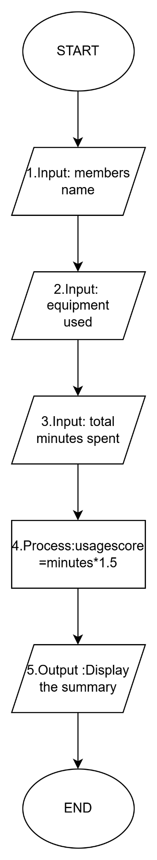
Step 3: Implementation (Python Code)
This program uses Snake Case for variable naming, handles different Data Types, and uses Comments to explain the logic to others.
###################################################
#Smart Fitness gym : Member Equipment Tracker
#This program calculates the total usage score
###################################################

#---------------------------------------------
#1.Input :Get data from the user/members
#---------------------------------------------

#*Get members name (string)*#
member_name=input("Enter your name:")

#*Get members equipment used(string)*#
equipment_used=input("Enter which equipment you used ,eg.treadmill,rowing machine etc:")

#*Get the total minutes spent on it(intgers)*#
total_minutes=int(input("How many minutes did you spent on the machine"))

#-----------------------------------------------
#2.Process :Perform calculation
#-----------------------------------------------

#Calculate usagescore
# 1.5 a decimal (float)
Usage_score=total_minutes * 1.5

#------------------------------------------------
#3.Output :Display results
#------------------------------------------------

print("--------------------------------------------")
print("Member Equipment Tracker")
print("--------------------------------------------")

print("Name : " , member_name )
print("Equipment : " ,equipment_used)
print("Total mintues : ", total_minutes)

print("--------------------------------------------")
print("Usage_score : " , Usage_score)

print("<Have Fun Exercising>")
print("------------------------------------------------")

##################################################################
#END PROGRAM
#Develop by - Eaint Nadi Maung
##################################################################

