Task 1: Test Plan for Budget Buddy Expense Validation System
The test plan is to to ensure that every recorded expense is checked against common-sense financial rules before the budget is updated.
Test Case 1: A student makes a standard, affordable purchase.
Test Case 2: A student accidentally enters a negative value or zero.
Test Case 3: A student tries to spend more than their remaining monthly allowance.
Test Case ID | Scenario | Description | Test Data (amount, budget) | Expected Result | Pass/Fail
TC-01 | Normal Expense | Test whether the system accepts a valid purchase that is affordable and within the student’s remaining budget. This represents the normal use of the application. | amount = 5000, budget = 20000 | Function returns True because the amount is positive and within budget. | Pass
TC-02 | Negative Entry / Zero | Test whether the system rejects invalid expenses such as negative values or zero. These values could incorrectly increase the remaining balance or create invalid financial records. | amount = -1000, budget = 20000 | Function returns False because expense values must be greater than zero. | Pass
TC-03 | Over Budget | Test whether the system prevents a student from spending more than their available monthly allowance. This ensures budget protection and prevents negative balances. | amount = 25000, budget = 20000 | Function returns False because the expense exceeds the remaining budget. | Pass

Code for Test Case 1,2 and 3
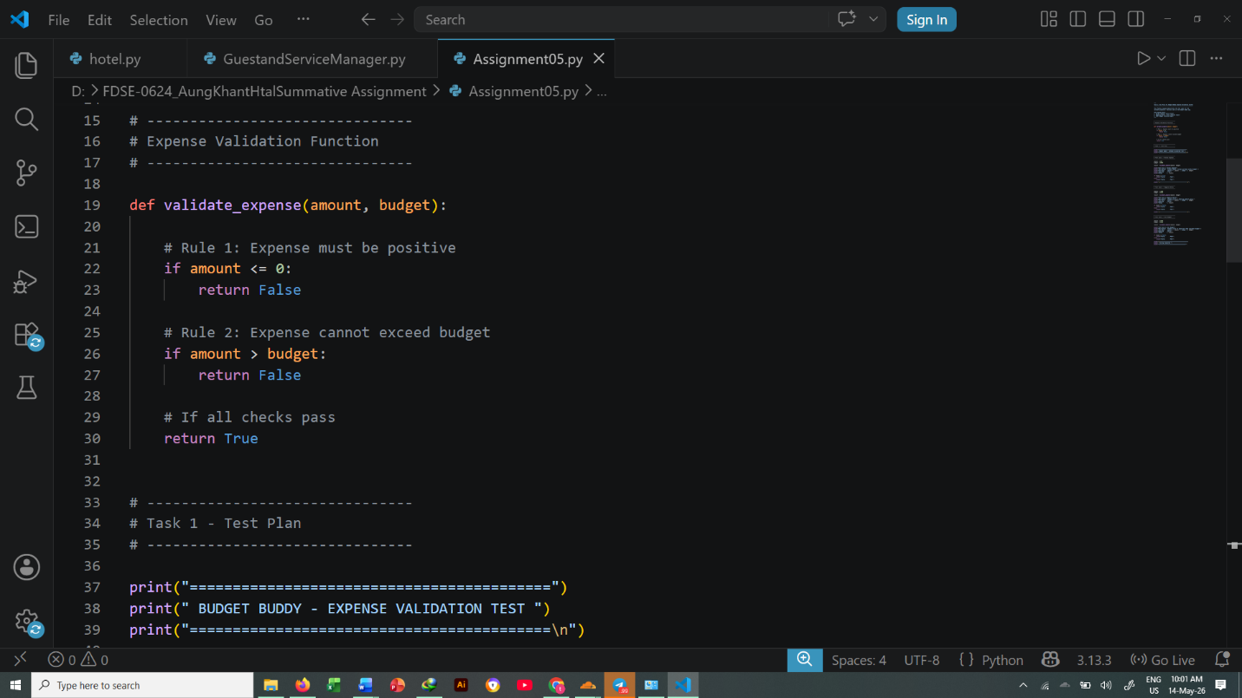
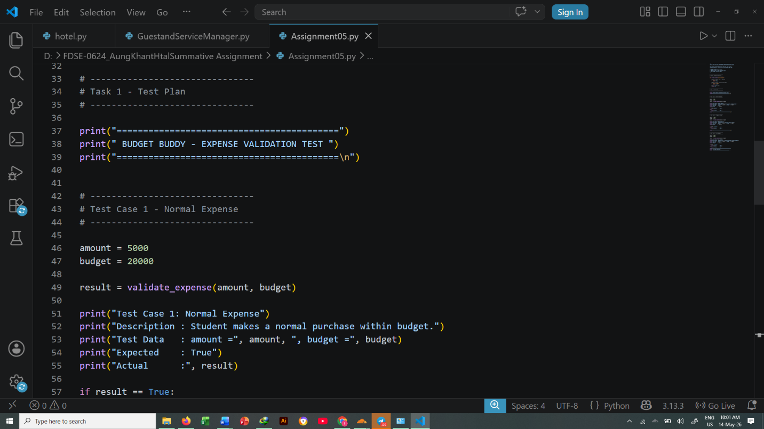

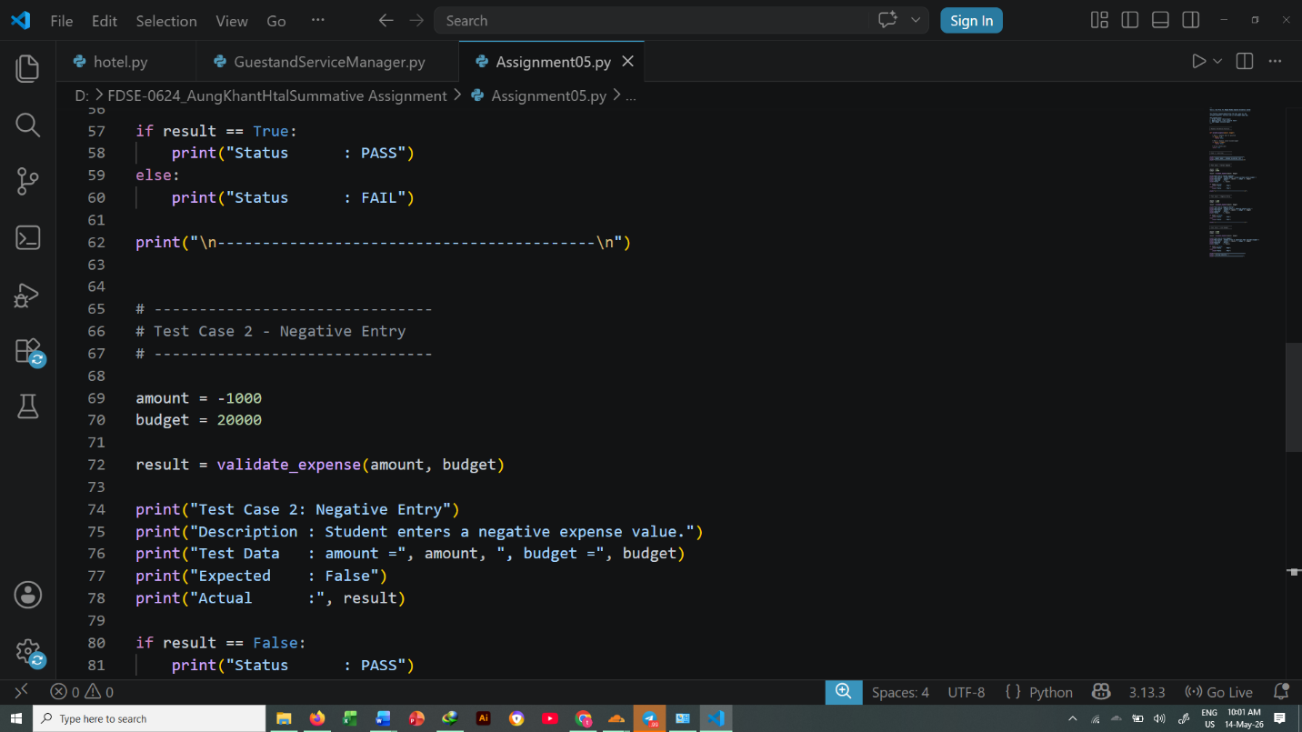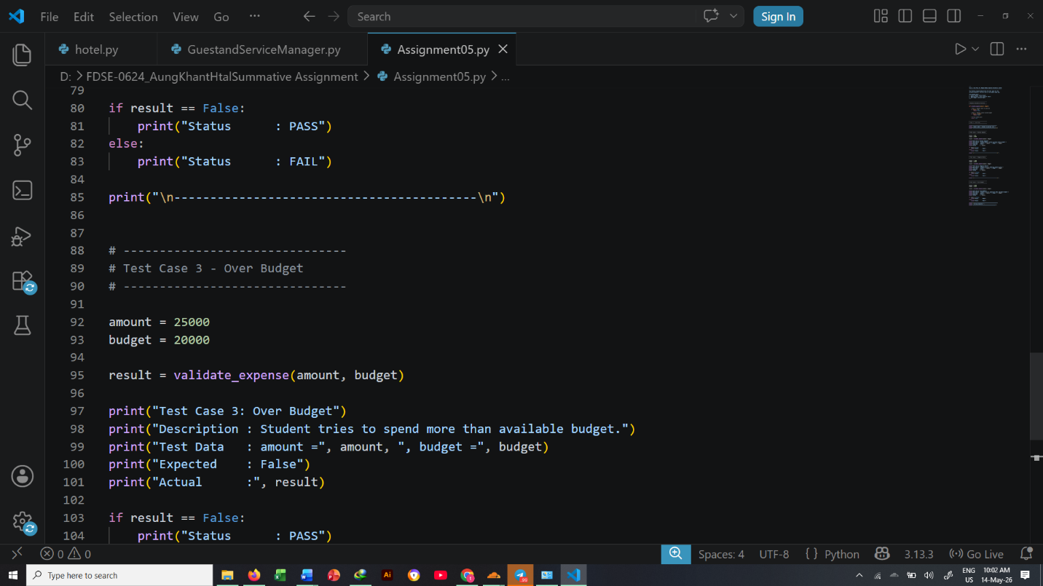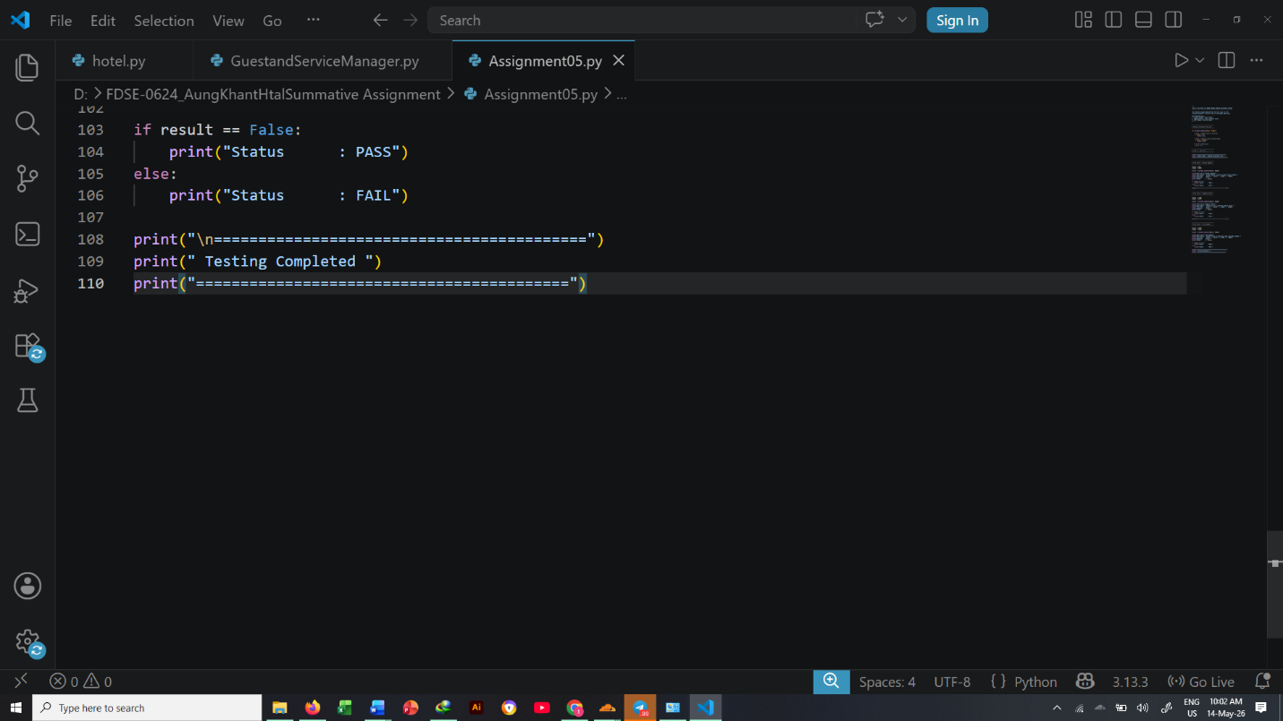

Results for Test case 1,2 and 3
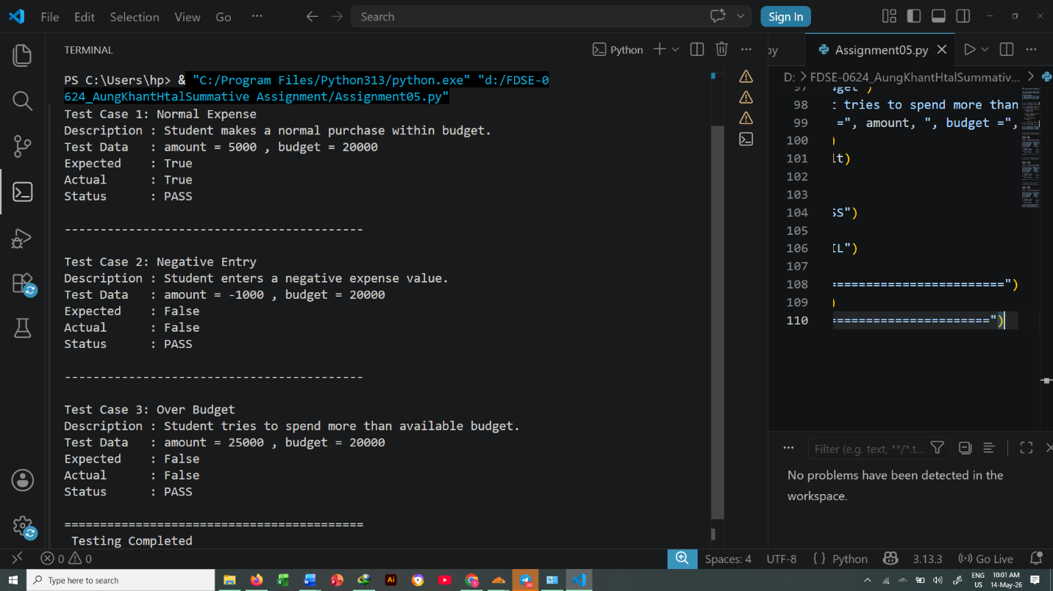

Task 2: Writing Unit Tests for Budget Buddy
The following Python code uses the built-in unittest library to automatically test the validate_expense() function.
The unit tests verify:
- Valid expenses are accepted
- Negative or zero expenses are rejected
- Expenses larger than the budget are rejected

budget_logic.py Code
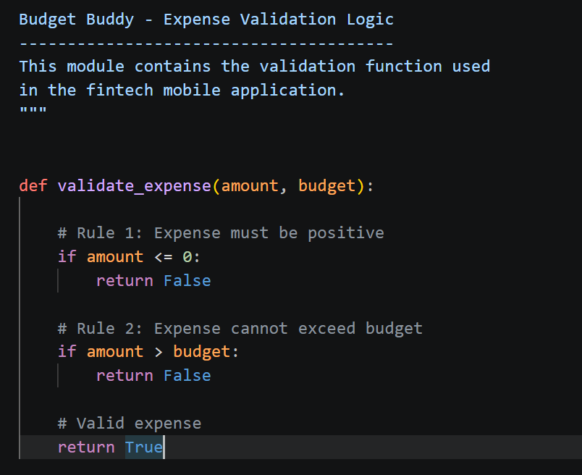

test_budget_logic.py Code
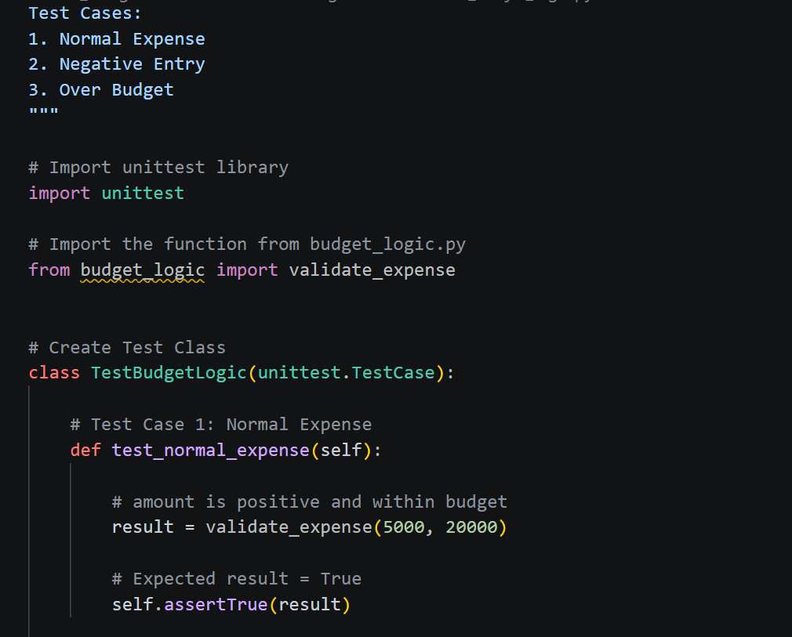
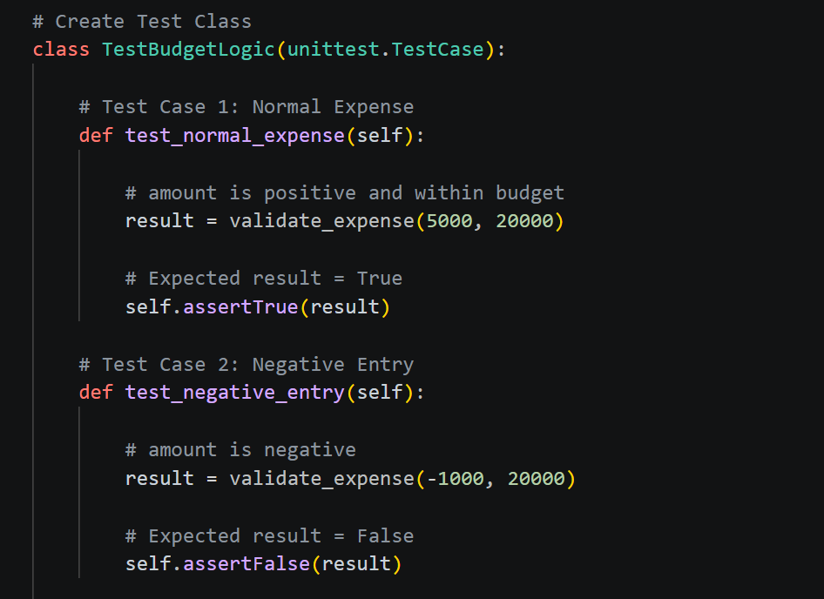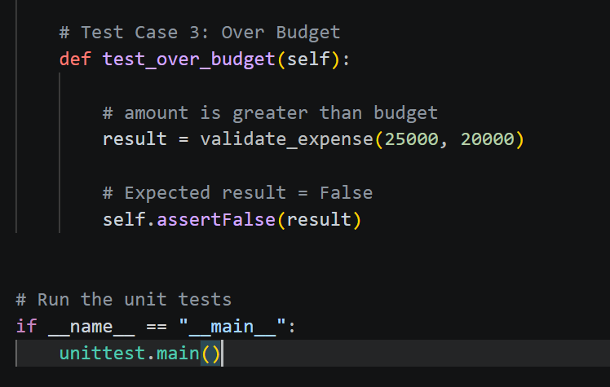
Task 3: Test Report and Output Explanation
Test Execution Output
After running the unit tests in VS Code terminal using:
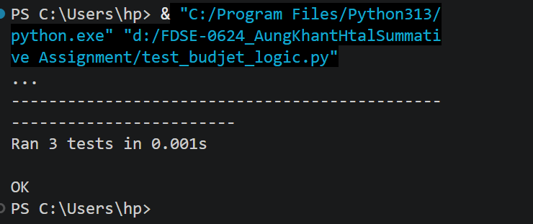

Explanation of output symbol means;
Symbol | Meaning
. | A test passed successfully
F | A test failed because the logic produced an incorrect result

There are 3 dots, meaning:
- Test Case 1 passed
- Test Case 2 passed
- Test Case 3 passed
No F symbols appeared, which means no logic errors were found.


This confirms that:
- All 3 unit tests were executed successfully
- The testing process completed very quickly


The OK status means
- Every test passed
- The validation logic works correctly
- The module is ready to be integrated into the Budget Buddy application.

