Task 1: Test Plan 1
Expense Validation System – Test Plan 1
Happy Path and Edge Cases 1
Happy Path 1
Edge Cases 1
Task 2: Writing Unit Tests 2
Task 3: Explanation of Outputs 2
1. Meaning of Symbols 3
2. Test Summary 3
3. Business Logic Mapping 3
Test Report 3
Brief Report 3
Submission Checklist 3

Task 1: Test Plan

Expense Validation System – Test Plan
Test  Case  ID | Scenario | Test Data  (amount, budget) | Description | Expected Result | Pass/Fail
TC001 | Normal Expense | amount = 5000, budget  = 20000 | Test if the system accepts a normal expense that is within the student’s remaining budget. | Function should return True because the expense is valid. | Pass
TC002 | Negative Entry | amount = 3000, budget  = 20000 | Test if the system blocks a negative expense value | Function should  return False because negative | Fail
 |  |  | entered by mistake. | expenses are not allowed.
TC003 | Over Budget | amount = 25000, budget  = 20000 | Test if the system prevents a student from spending more than the remaining budget. | Function should return False because the expense is greater than the budget. | Fail

Happy Path and Edge Cases

Happy Path
- The user enters a positive expense amount.
- The expense is smaller than or equal to the remaining budget.
- Example: amount = 5000, budget = 20000.

Edge Cases
- The user enters a negative number.
- The user enters zero as an expense.
- The expense amount is larger than the available budget.

Task 2: Writing Unit Tests

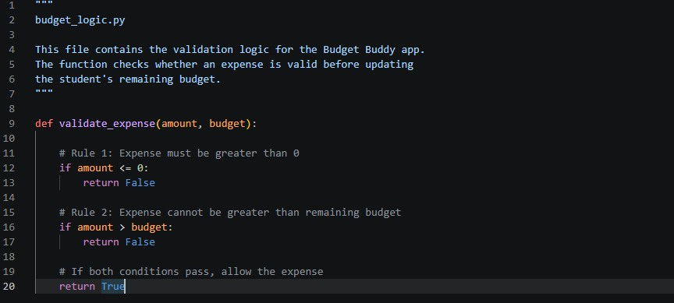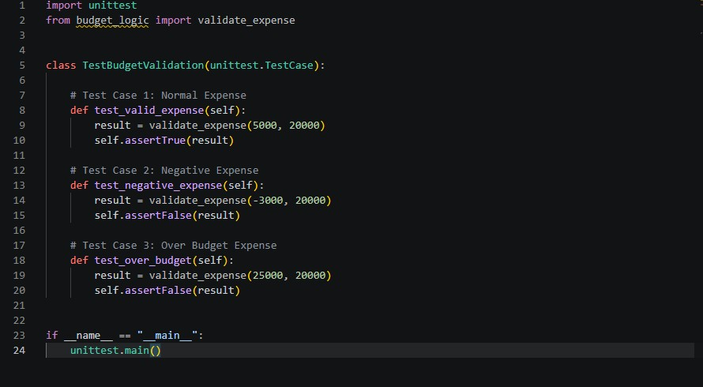

Task 3: Explanation of Outputs
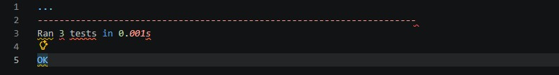

1. Meaning of Symbols
- Each dot (.) means one test passed successfully.
- If there is an F, it means one test failed because the actual result did not match the expected result.

2. Test Summary
- “Ran 3 tests” means the system checked all three test cases.
- “OK” confirms that every test passed successfully and the validation logic is working correctly.

3. Business Logic Mapping
- The normal expense test confirmed that students can record valid purchases within their budget.
- The negative expense test confirmed that the system blocks invalid negative values that could incorrectly increase the balance.
- The over-budget test confirmed that students cannot spend more than their remaining allowance, preventing negative balances in the app.

Test Report

Brief Report
The Expense Validation System was tested using three different test cases. The first test checked whether a normal expense within budget was accepted. The second test checked if the system rejected negative expense values. The third test checked whether overspending beyond the available budget was blocked.
All three tests passed successfully. The terminal output displayed OK, showing that the validation logic works correctly and follows the financial rules required for the Budget Buddy application.

Submission Checklist
budget_logic.py test_budget.py
Test Report with explanation and terminal screenshot
No syntax errors
No __pycache__ or .env folders included

