Budget Buddy Student Expense Tracker

- Task 1: Create the Test Plan

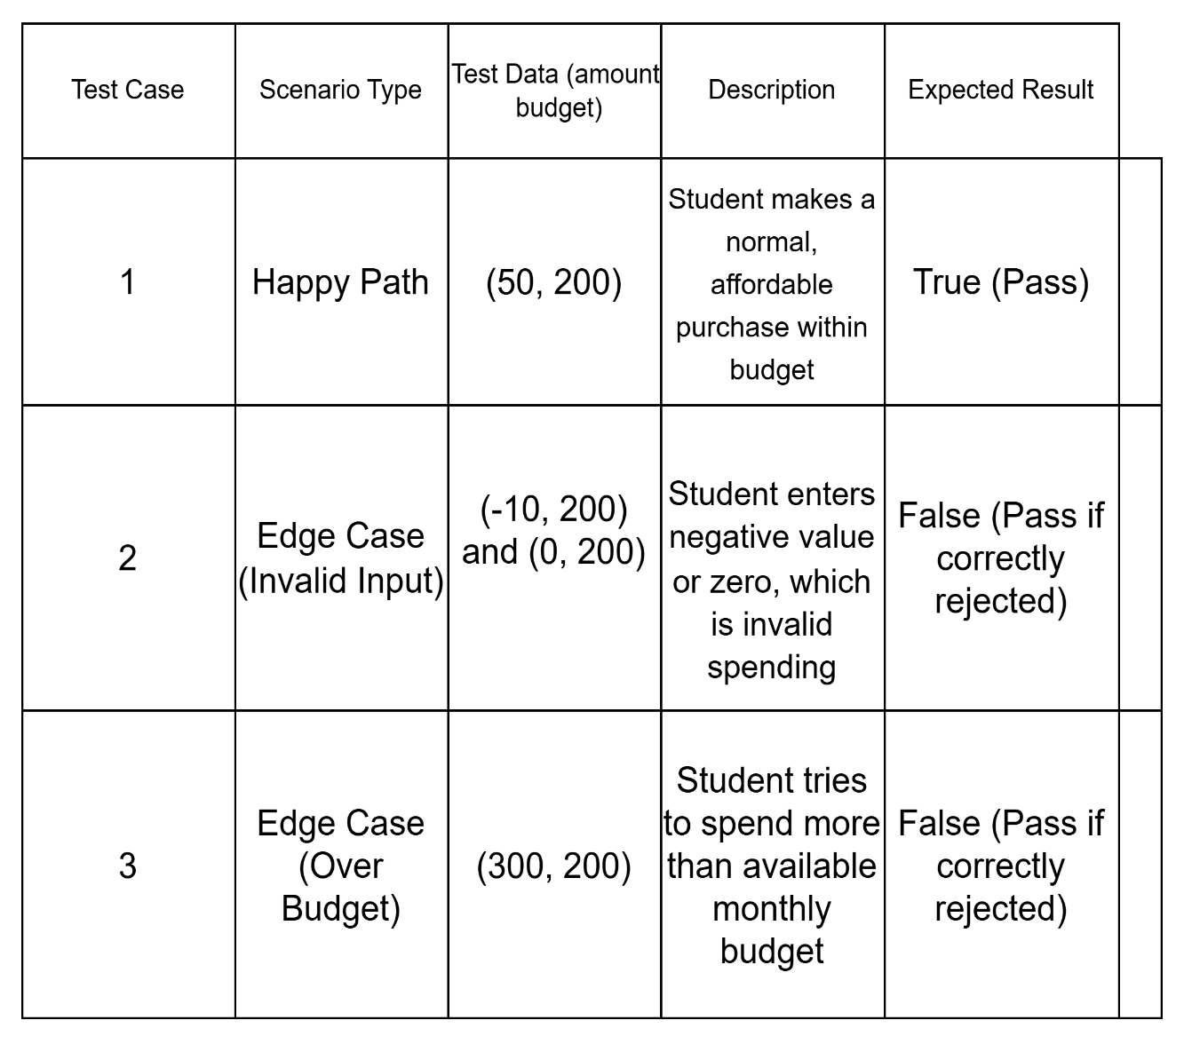

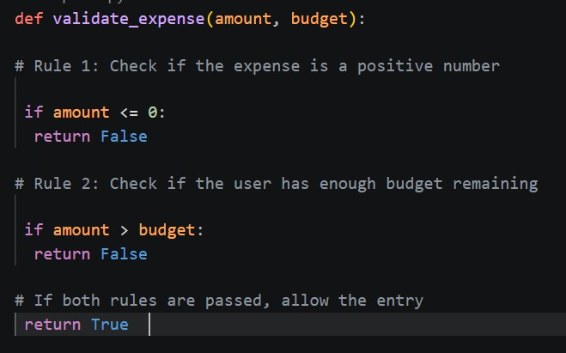

- Task 2: Writing Unit Tests
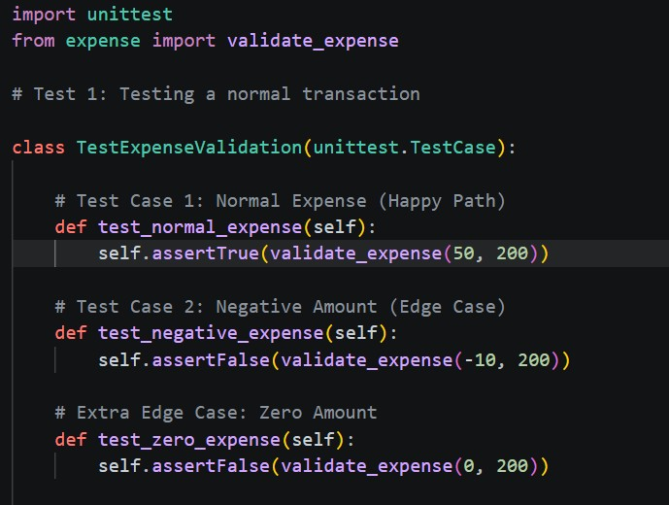
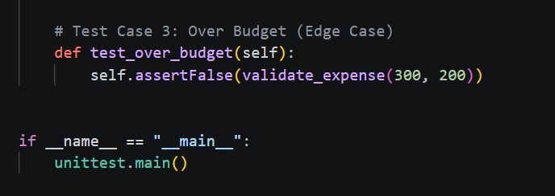

✓ Test Report: A screenshot of your terminal showing the "OK" status after running the tests.
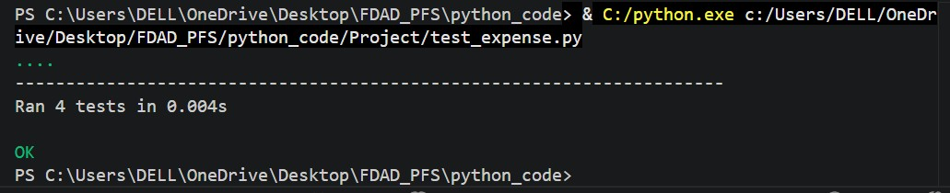

• Task 3: Write explanations for the outputs of each test case
When running the unit tests, a dot (.) means the test has passed successfully, while an F indicates a failure where the actual result did not match the expected result.
The final summary shows the total number of tests executed and whether they all passed. If the output shows “OK”, it means all tests passed and the function is working correctly. If it shows “FAILED”, then at least one rule in the code is incorrect and needs to be fixed.
Each test case checks a financial rule in the system. The normal expense test ensures that valid spending within the budget is allowed. The negative or zero expense test ensures that invalid inputs are rejected. The over-budget test ensures that a user cannot spend more than their available allowance.
Overall, the tests confirm that the expense validation system correctly enforces financial rules and prevents invalid or excessive spending.

