1. Project Background

Traffic congestion is common, especially during peak hours. Traditional traffic lights use fixed timers and do not adapt to real-time conditions. This causes delays, longer waiting times, and safety issues. A smart traffic system can solve this by using sensors and real-time data.

2. Project Objective

The objective is to design a smart traffic light system that:
- Improves traffic flow
- Reduces waiting time
- Detects emergency vehicles
- Manages pedestrian crossings safely
- Adapts to peak and low traffic conditions
- Reduces congestion and accidents

3. Task 1 - Decomposition (Break the problem down)

- Detect vehicles using sensors
- Count how many vehicles are waiting in each lane
- Detect when a pedestrian presses the crossing button
- Identify emergency vehicles using sirens or signals
- Control traffic light colors (red, yellow, green)
- Set and manage timers for each light
- Adjust signal timing based on traffic conditions
- Handle night-time low traffic mode
- Give priority to pedestrians when needed
- Override normal signals for emergency vehicles

4. Task 2 - Pattern Recognition (Identify trends and behaviours)

- Traffic is heavier during morning and evening rush hours
- More pedestrians cross during school and work times
- Emergency vehicles appear rarely but need quick access
- Traffic is very low late at night
- Some lanes get more crowded than others
- Cars often arrive in groups rather than evenly spaced

5. Task 3 - Abstraction (Filter what matters vs. what doesn’t)

Essential
- Number of vehicles in each lane
- Waiting time of vehicles
- Pedestrian button status
- Emergency vehicle detection
- Time of day

Irrelevant
- Color of the cars
- Brand of the vehicles
- Who is driving the car
- Music playing in the car
- Driver’s personal preferences

6. Task 4 - Algorithm Design (Create step-by-step logic)

- Start the system and set all lights to red
- Read data from sensors and pedestrian buttons
- Check if an emergency vehicle is detected
- If yes, turn that lane green immediately and others red
- If no emergency, check traffic levels in all lanes
- Find the lane with the most vehicles or longest wait time
- Check if a pedestrian has requested to cross
- If yes, allow pedestrian crossing when safe
- Turn the selected lane green
- Set how long the green light stays on based on traffic
- Change green to yellow, then to red
- If it is night and traffic is low, switch to shorter cycles
- Repeat the process continuously

7. Task 5 - IPO Model (Mapping the System)

Input:
- Vehicle sensor data (traffic count, presence)
- Pedestrian button signals
- Emergency vehicle detection signals
- Time of day

Process:
- Analyse traffic density and waiting times
- Check priority conditions (emergency > pedestrian > normal traffic)
- Calculate optimal signal timing • Decide next lane to receive green light
Output:
- Traffic light colour changes (red/yellow/green)
- Pedestrian “Walk/Don’t Walk” signals • Emergency override activation

8. Task 5 – Logic Flowchart (Visual Representation)
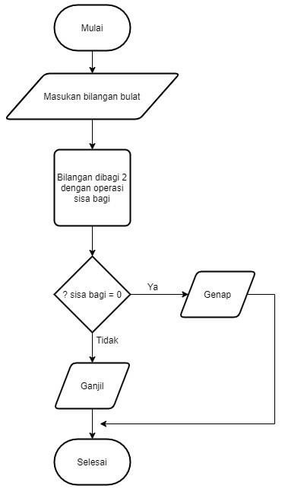
Use any appropriate tools such as Lucid Chart, Visio, Draw.io, Canva.

