Assignment: Community BookHub Rental Tracker

Task 1: Algorithm Design (Logic Planning)
- Start: Begin the program execution.
- Input Member Details: Prompt the user to enter the member's name and a unique Rental ID.
- Initialize Object: Create a new Rental object instance using the provided name and ID, initializing an empty list for books.
- Input Book Data: Prompt the user to enter the title and rental price of a book.
- Add Book: Append the book's details (title and price) to the object's book list.
- Check for More Books: Determine if there are additional books to be added. If yes, repeat steps 4 and 5.
- Calculate Total: Iterate through the book list and sum the prices to calculate the total rental cost.
- Display Report: Generate and print a full summary report including the member name, ID, all rented books, and the total cost.
- End: Terminate the program.

Task 2: Logic Flowchart (Visual Representation)
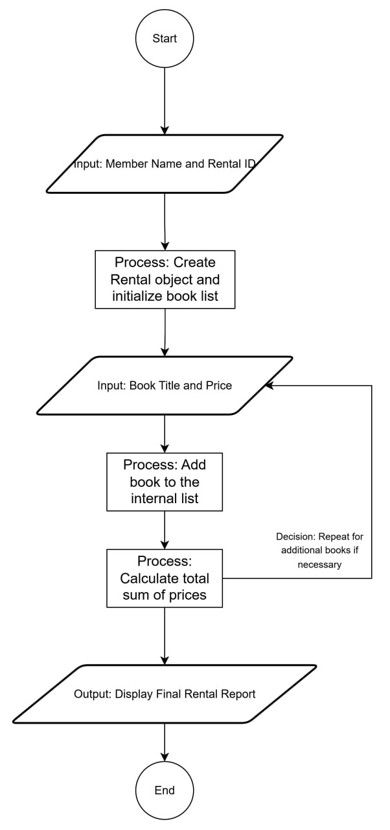

Task 3: Implementation (Python OOP Code )
# Assignment: Community BookHub Rental Tracker
class Rental:
def __init__(self, member_name, rental_id):
# Set up member details and an empty list for books
self.member_name = member_name
self.rental_id = rental_id
self.books = []
def add_book(self, title, price):
# Add book title and price to the list
self.books.append({"title": title, "price": price})
def calculate_total(self):
# Add up all the prices in the book list
total = sum(book['price'] for book in self.books)
return total
def display_report(self):
# Print the final report with all details
print("\n--- COMMUNITY BOOKHUB RENTAL REPORT ---")
print(f"Member Name : {self.member_name}")
print(f"Rental ID : {self.rental_id}")
print("-" * 30)
for book in self.books:
print(f"- {book['title']}: ${book['price']}")
print("-" * 30)
# Call the total method and show the result
print(f"TOTAL COST: ${self.calculate_total()}")
# --- Program Start ---
def main():
# Get user input for member info
name = input("Enter Member Name: ")
rid = input("Enter Rental ID: ")
# Create the object
my_rental = Rental(name, rid)
# Loop to let the user add multiple books
while True:
book_title = input("\nEnter Book Title (or 'done' to stop): ")
if book_title.lower() == 'done':
break
book_price = float(input(f"Enter price for {book_title}: "))
# Add the book data to the object
my_rental.add_book(book_title, book_price)
# Show the final report
my_rental.display_report()
if __name__ == "__main__":
main()

