
Project Report

Module Name | Front End Development
Course Name | Foundation Diploma in Software Engineering
Assignment Title | TravelVista Tourism Website

Learner Name |  | Assessor Name
Eaint Nadi Maung |  | Arvinder Kaur
Date Issued | Completion Date |  | Submitted On
6/8/26 | 6/8/26 |  | 6/9/26

Plagiarism
Plagiarism covers both copying or paraphrasing with the source without proper understanding and citation. The source includes but is not limited to:
- Books, Journal Articles, Online resources
- Others Assignment or project
- Software program
- Images

The learners must submit their work without plagiarism while producing the evidence against the assessment criteria. They must apply proper citation and Harvard referencing. Their work must go through the Turnitin software to check for the similarity index. Please consult the relevant module instructor or mentor if you need any further advice.

Learner declaration
I certify that the work submitted for this assignment is my own and research sources are fully acknowledged.

Student signature: star Date: 6/8/26
Table of Contents
1. Project Background 3
2. Project Objective 3
3. Task 1 3
4. Task 2 4
5. Task 3 5
6. Task 4 7
7. Task 5 7
8. Task 6 7
9. Task 7 7
10. Task 8 7

Project Background

A new tourism company, TravelVista, is preparing to launch a modern website for both local and international travelers. The website has already gone through several development stages in previous units, including website planning, basic HTML and CSS structure, responsive Bootstrap layout, and JavaScript booking inquiry validation. The TravelVista website now includes multiple pages and interactive features. These include the homepage, destinations page, tour packages page, responsive navigation bar, destination cards, package cards, and a booking inquiry form with JavaScript validation. However, before the website can be shared with real users, it must be tested carefully. A website may appear complete, but it can still have problems such as broken navigation links, incorrect form validation, poor layout on small screens, browser compatibility issues, or low performance scores. To improve website quality, learners must now test the completed TravelVista Tourism Website and prepare a simple testing documentation report

Project Objective

Overall, the goal is to help learners understand how a completed website is checked before release. This assessment focuses on practical beginner-friendly testing and documentation skills using the same TravelVista Tourism Website project from the previous units.

Task 1: Testing Scope
The TravelVista Tourism Website was tested to ensure that all website pages, features, and interactive elements function correctly before the website is shared with users. Testing is important because websites may contain issues such as broken navigation links, incorrect form validation, browser compatibility problems, layout issues on smaller devices, or poor website performance.
The testing process helps improve the quality, usability, responsiveness, and reliability of the website.
The following parts of the TravelVista Tourism Website were tested:

Website Pages
- Homepage
- Destinations page
- Tour Packages page

Navigation and Links
- Navigation bar
- Cross-page navigation links
- Buttons and clickable links

Booking Inquiry Form
- Blank field validation
- Email validation
- Form submission validation
- Error message display
- Successful submission message

Responsive Layout Testing
- Mobile devices
- Tablet devices
- Desktop screens

Browser Compatibility Testing
- Google Chrome
- Microsoft Edge
- Firefox

Lighthouse Testing
- Performance
- Accessibility
- Best Practices
- SEO

Task 2: Simple Test Plan

Feature / Component | Testing Type | Expected Result
Homepage | Functional testing | Homepage opens correctly
Destinations/Tour  Packages Page | Functional testing | Destinations/Tour  pages displays properly
Navigation Bar | Functional Testing | Navigation links  open correct pages
Booking Inquiry Form | Validation Testing | Form validates  user input correctly
Email Validation | Validation Testing | Invalid emails are rejected
Responsive Layout | Responsive Testing | Website adjusts to different screen sizes
Browser Compatibility | Cross-browser Testing | Website works in different browsers
Lighthouse Report | Lighthouse Testing | Website receives acceptable scores

Task 3: Functional Testing Results

Test Case | Expected Result | Actual Result | Status
Homepage opens correctly | Homepage loads successfully | Homepage loaded correctly | PASS
Destinations page opens | Destinations page displays correctly | Page displayed correctly | PASS
Tour packages page opens | Packages page loads properly | Page loaded correctly | PASS
Navigation links work | Links open correct pages | Links functioned correctly | PASS

Navigation bar consistency | Navbar appears on all pages | Navbar displayed consistently | PASS
Buttons and links respond | Buttons work correctly | Buttons functioned properly | PASS

Screenshots Evidence
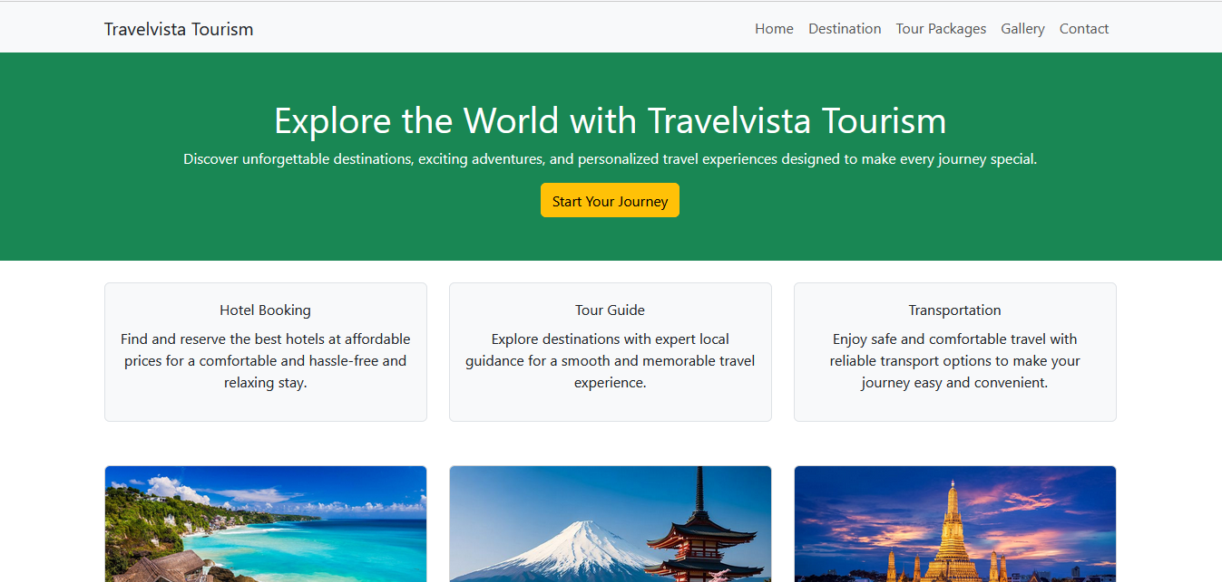
- Homepage screenshot

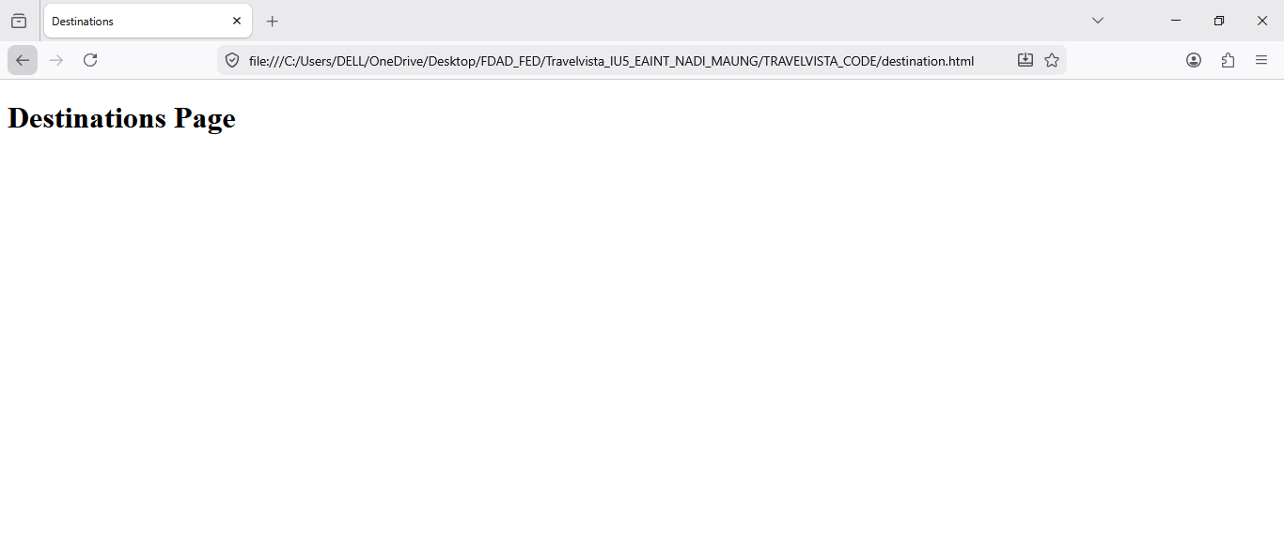
- Destinations page screenshot
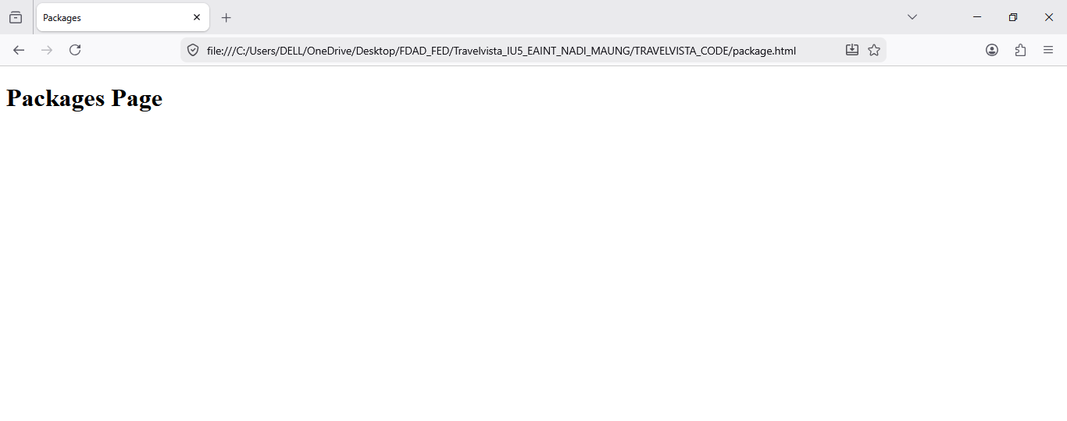
- Packages page screenshot
- Navigation bar screenshot

Task 4: Booking Inquiry Form Validation Testing

Test Scenario | Expected Result | Actual Result | Status
Blank input field | Error message displayed | Validation message displayed correctly | PASS
Invalid email format | Invalid email rejected | Input fail & Validation message displayed | PASS
Successful form submission | Form submits successfully | Form submitted successfully | PASS
Success message display | Success message appears | Success message displayed correctly | PASS
Form reset after submission | Form clears after submission | Form reset correctly | PASS
Screenshots Evidence
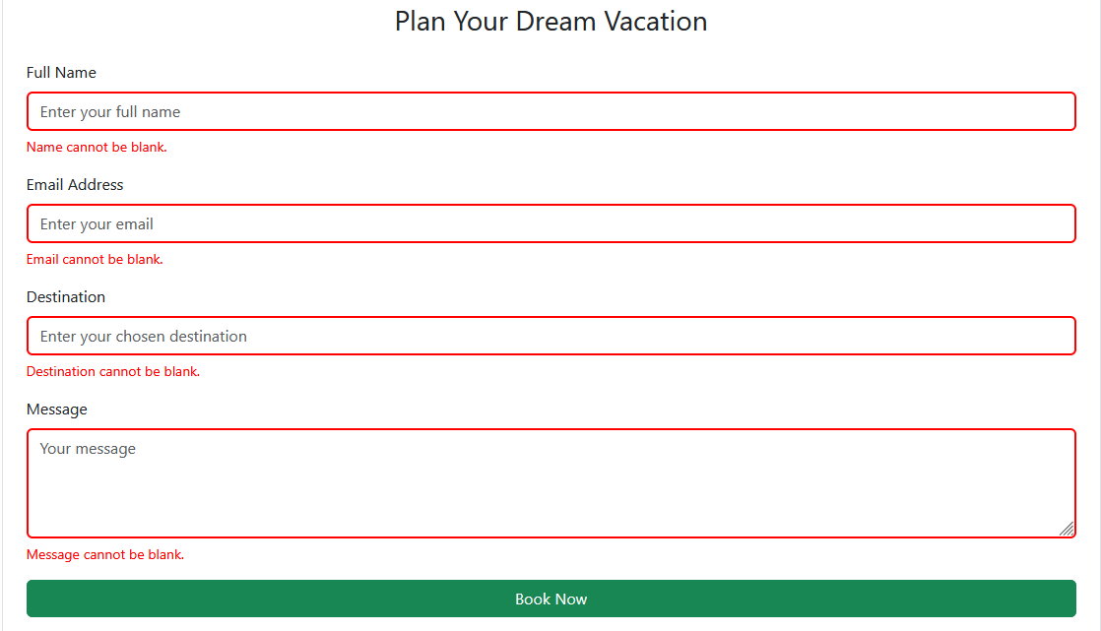
- Invalid validation screenshot

- Successful form submission screenshot
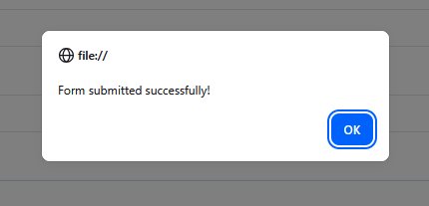

Task 5: Cross-Browser Compatibility Testing

Browser | Expected Result | Actual Result | Status
Google Chrome | Website functions correctly | Website worked correctly | PASS
Microsoft Edge | Website functions correctly | Website functions correctly | PASS
Mozilla Firefox | Website functions correctly | Website functions correctly | PASS

Task 6: Responsive Layout Testing

Device Type | Expected Result | Actual Result | Status
Mobile View | Layout adjusts properly | Layout displayed correctly | PASS
Tablet View | Content remains aligned | Layout displayed correctly | PASS
Desktop View | Full layout displays correctly | Layout displayed correctly | PASS

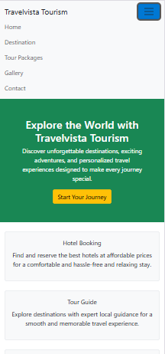
Screenshots Evidence
- Mobile view screenshot

- Tablet view screenshot
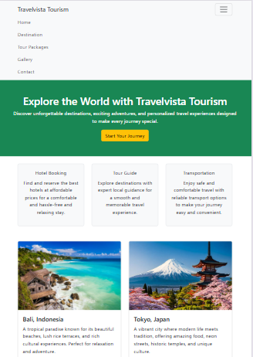

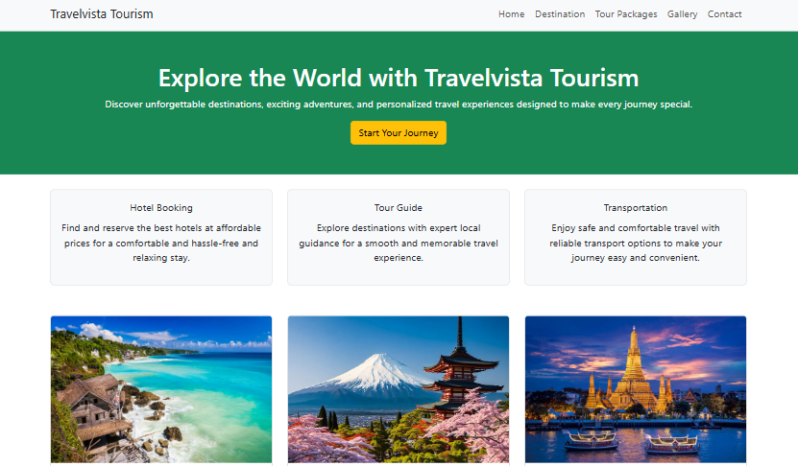
- Desktop view screenshot

Task 7: Lighthouse Testing

Lighthouse Category | Score
Performance | 100
Accessibility | 95
Best Practices | 81
SEO | 91

Recommendation
One recommendation from the Lighthouse report is to optimize image sizes to improve website loading performance. Compressing large images can help reduce loading time and improve the user experience.
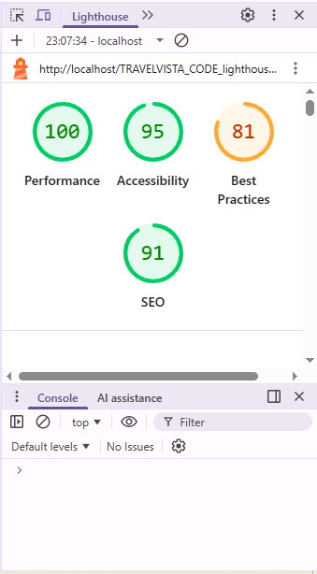
Screenshots Evidence
- Lighthouse report screenshot

10. Task 8: Final Testing Summary
The TravelVista Tourism Website was successfully tested using multiple testing methods including functional testing, booking form validation testing, responsive testing, cross-browser compatibility testing, and Lighthouse testing.
The testing results confirmed that the website pages, navigation links, destination cards, package cards, and booking inquiry form function correctly. Responsive testing showed that the website adapts properly to mobile, tablet, and desktop screen sizes. Cross-browser testing confirmed compatibility with Google Chrome, Microsoft Edge, and Mozilla Firefox.
The booking inquiry form correctly handled invalid input and accepted valid submissions successfully. Lighthouse testing also showed acceptable website quality in terms of performance, accessibility, best practices, and SEO.
Overall, the TravelVista Tourism Website is functional, responsive, user-friendly, and ready for deployment.

