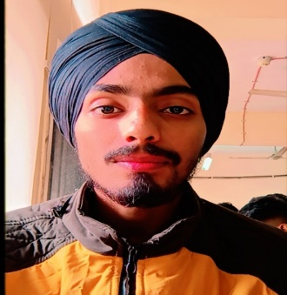**Arvinder Singh**

**Address**: - A-5/6 Sector 14 Rohini Delhi-89

**Contact no**: 9310501550

**Objective:** To work with an organization can learn new skills and increase my abilities for the organization goals as well as myself

**____________________________________________________________**

**Academics Qualification**:

|  |  |  |  |
| --- | --- | --- | --- |
| **S. No.** | **Course Name** | **University/Board** | **Status** |
| **1** | Matriculation | CBSE | 2016 |
| **2** | Intermediate | CBSE | 2018 |
| **3** | BCA | IGNOU | 2022 |

**Technical Qualification**:

|  |  |  |  |
| --- | --- | --- | --- |
| **S. No.** | **Course Name** | **University/Board** | **Status** |
| **1** | Advance Diploma in IT, Networking & Clouding | DGT | Pursuing |
| **2** | ITI (CHNM) | NCVT | 2019 |

**Additional Skills**

* MS Office
* Linux
* Tally
* Networking

**Key Responsibilities**

* Team Work
* Time Management
* Leadership
* Creativity

**Personal Details**

Father's Name: Parduman Singh

D.O.B : 01 February 2000

Marital Status: Unmarried

Languages : Hindi, English and Punjabi

**Declaration**

I hereby declare that all the information given above is true and correct to the bes of my knowledge.

**Date:** 11 January 2022

**Place:** Noida (Arvinder Singh)