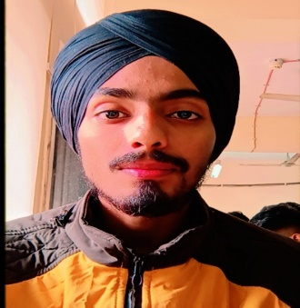
Arvinder Singh
Address: - A-5/6 Sector 14 Rohini Delhi-89
Contact no: 9310501550

Objective: To work with an organization can learn new skills and increase my abilities for the organization goals as well as myself
____________________________________________________________

Academics Qualification:
S. No. | Course Name | University/Board | Status
1 | Matriculation | CBSE | 2016
2 | Intermediate | CBSE | 2018
3 | BCA | IGNOU | 2022

Technical Qualification:
S. No. | Course Name | University/Board | Status
1 | Advance Diploma in IT, Networking & Clouding | DGT | Pursuing
2 | ITI (CHNM) | NCVT | 2019

Additional Skills
- MS Office
- Linux
- Tally
- Networking

Key Responsibilities
- Team Work
- Time Management
- Leadership
- Creativity

Personal Details

Father's Name: Parduman Singh
D.O.B : 01 February 2000
Marital Status: Unmarried
Languages : Hindi, English and Punjabi

Declaration
I hereby declare that all the information given above is true and correct to the bes of my knowledge.

Date: 11 January 2022
Place: Noida (Arvinder Singh)

