AFSCPFinancialReport — User Manual
  - Acumatica 2025 R2 Customization, v2.1.3
AFS
2026-04-28
Table of Contents
Introduction 5
Module workflow at a glance 5
How to read this manual 6
Project-truth notes (v2.1.x) 6
Chapter 1: Connected Application Setup (SM303010) 6
Prerequisites 7
Steps 7
Step 1 — Navigate to Connected Applications 7
Step 2 — Create a New Record 7
Step 3 — Enter Client Name 7
Step 4 — Set the Flow 8
Step 5 — Configure Refresh Tokens 9
Step 6 — Save the Record 9
Step 7 — Add a Shared Secret 10
Step 8 — Fill in Secret Details 11
Step 9 — Click OK 11
Step 10 — Final Save 12
Summary of Values to Record 12
Chapter 2: Tenant Credentials (FR101001) 13
Prerequisites 13
Steps 13
Step 1 — Navigate to AFS Credentials Config 13
Step 2 — Add a New Row 15
Step 3 — Fill the 8 Columns 15
Step 4 — Save 17
Step 5 — (Optional) Discard Without Saving 17
How the Engine Uses This Row 18
Field Reference (DAC) 18
Security Notes 19
Validation Errors You May See 19
Chapter 3: Report Definition Setup (FR101002) 20
Prerequisites 20
Steps 20
Step 1 — Navigate to AFS Report Definition 20
Step 2 — Create a New Record 21
Step 3 — Fill the Header 21
Step 4 — Choose the Report Type 22
Step 5 — Pick the Generic Inquiry 23
Step 6 — Map the GI Columns (Data Source) 24
Step 7 — Configure Formatting (Rounding) 26
Line Items Grid 27
Columns — overview 28
Line Type values 29
Balance Type values 30
Sign Rule values 31
Account Type Filter values 32
Worked Examples 33
ACCOUNT line — sum a range 33
SUBTOTAL line — sum child lines 33
CALCULATED line — formula over other codes 33
HEADING line — section divider 34
Placeholder Key Format 34
End-to-End Example — Mini Balance Sheet 34
1 — Raw GI data (input) 34
2 — Definition header 35
3 — Line Items grid 35
4 — How each row computes 36
5 — Placeholders emitted 37
Cross-Definition Formulas 37
Reference syntax 37
Automatic CY / PY evaluation 38
Requirements & caveats 38
Save and Validate 38
Chapter 4: MBR Definition Setup (FR101004) 39
Prerequisites 39
Concepts 40
Steps 40
Step 1 — Navigate to AFS MBR Config 40
Step 2 — Fill the Identity & Description 42
Step 3 — Pick the Generic Inquiry 43
Step 4 — Detect Columns 44
Step 5 — Configure the Period Filter 45
Step 5b — Configure the Dimension Filters (Branch / Organization / Ledger) 46
Step 6 — Add Column Rows 48
Step 7 — Save and Test Fetch 56
Step 8 — (Optional) Discard / Delete 58
Validation Errors 58
Chapter 5: Financial Report Generation (FR101000) 59
Prerequisites 59
Steps 59
Step 1 — Navigate to the Financial Report screen 59
Step 2 — Create a new record 60
Step 3 — Fill the header 60
Step 4 — Pick the Current Year 62
Step 5 — Pick the Financial Month 62
Step 6 — Scope the GL data (Organization / Branch / Ledger) 63
Step 7 — Attach the Word template 65
Step 8 — Link one or more Report Definitions 66
Step 9 — Save 68
Header actions 68
Generate Report 68
Download Report 68
Reset Status 68
Status lifecycle 69
Worked Example — BS Annual Report 2024 70
1 — Load or create the record 70
2 — Link the definition 70
3 — Attach the template 71
4 — Generate and download 71
Worked Example — Recovering from a Failed run 72
The Records List — FR401000 72
Chapter 6: MBR Report Generation (FR101003) 73
Prerequisites 73
Steps 74
Step 1 — Navigate to AFS Monthly Board Report (MBR) 74
Step 2 — Fill the Header 76
Step 3 — Link MBR Definitions (GI Data Sources) 77
Step 4 — Preview the Markdown (optional but recommended) 79
Step 5 — Generate the Presentation 81
Step 6 — Download the Presentation 82
Step 7 — (Optional) Reset Status 82
Step 8 — (Optional) Delete the Record 83
Status lifecycle 83
How the Engine Builds the Markdown 84
Appendix A: Placeholder Reference 84
A.1 Report Definition Placeholders 84
Period suffixes 85
Examples 85
Lines that do not emit placeholders 85
A.2 Year-Label Placeholders 85
A.3 MBR Definition Placeholders 86
A.3a Single Value (LineType = VALUE) 86
A.3b Multi-Row Expand (LineType = MULTIROW) 86
A.3c Calculated (LineType = CALCULATED) 87
A.4 Cross-Definition Formula Placeholders 87
A.5 Placeholder Resolution Rules 87
A.6 Quick Lookup — Where Each Placeholder Comes From 88
A.7 Diagnosing a Stale or Wrong Placeholder 88
Appendix B: Troubleshooting 89
B.1 Authentication & Tenant Errors 89
B.2 Report Generation Errors (FR101000) 104
B.3 Report Definition Errors (FR101002) 117
B.4 MBR Report Generation Errors (FR101003) 117
B.5 MBR Definition Errors (FR101004) 118
FormatException: Input string was not in a correct format (most common runtime error) 118
B.6 “All values come back as 0” 118
B.7 Reset Status 119
B.8 Where to Find Logs 119
Trace prefix catalogue 119
Useful trace entries 120
About This Manual 120
Producing this Word document 120
Source code references 121

Introduction
The AFSCPFinancialReport customization for Acumatica 2025 R2 turns GL data and Generic Inquiry results into mail-merged Word reports and AI-generated PowerPoint presentations. This manual walks an administrator through every screen end-to-end, in the order you would set them up on a fresh tenant.

Module workflow at a glance
1. Connected Application (SM303010) Acumatica OAuth2 client
│ Client ID + Shared Secret
▼
2. Tenant Credentials (FR101001) API credentials + Gamma key
│ encrypted credentials per tenant
▼
┌──────────────────────────────┐
│ 3. Report Definitions │ ── GL Trial Balance statements (BS / PL / CF / EQ / Custom)
│ (FR101002) │ Five FY-to-date balance types, two placeholder periods.
└──────────────────────────────┘
│ placeholders: {{PFX_LINE_CY}}, {{PFX_LINE_PY}}
│
┌──────────────────────────────┐
│ 4. MBR Definitions │ ── Any GI mapped to placeholder columns
│ (FR101004) │ Single-period, multi-row, calculated, formatted.
└──────────────────────────────┘
│ placeholders: {{PFX_ALIAS}}, {{PFX_ALIAS_N_GICol}}
▼
┌────────────────────────┐ ┌─────────────────────────────────┐
│ 5. Financial Report │ │ 6. MBR Report Generation │
│ (FR101000) → .docx │ │ (FR101003) → .pptx via Gamma │
└────────────────────────┘ └─────────────────────────────────┘

How to read this manual
- Chapters 1–6 cover one screen each, in the recommended setup order. Skim a chapter end-to-end before clicking through the screen for the first time, then come back as you fill the fields.
- Appendix A — Placeholder Reference is the catalogue of every placeholder shape the engine emits. Use it when authoring a Word template or a Gamma prompt.
- Appendix B — Troubleshooting lists every error message in Helper/Messages.cs with its cause and fix, plus the trace-prefix reference.

Project-truth notes (v2.1.x)
Two facts changed in the v2.1.x refactor — keep these in mind when reading any older .docx template you inherit:
- Balance types. Five FY-to-date types only — ENDING, BEGINNING, DEBIT, CREDIT, MOVEMENT. The legacy single-period types (PDEBIT, PCREDIT, PMOVEMENT) were removed.
- Placeholder periods. Two suffixes only — _CY (current FY-to-date) and _PY (previous FY same window). The legacy _PM (previous-month) suffix was removed. Compute month-only deltas inside the Word template ({{X_X_CY}} − {{X_X_PY}}), not inside a Definition formula.

Chapter 1: Connected Application Setup (SM303010)
This chapter describes how to create a Connected Application in Acumatica to obtain the Client ID and Client Secret required by the AFS Financial Report module.

Prerequisites
- Acumatica 2025 R2 or later
- Administrator access to the Acumatica instance
- AFS Financial Report customization published

Steps

Step 1 — Navigate to Connected Applications
- Log in to Acumatica as an administrator.
- In the top search bar, type Connected and select Connected Applications under Integration > Preferences.
Screen ID: SM303010
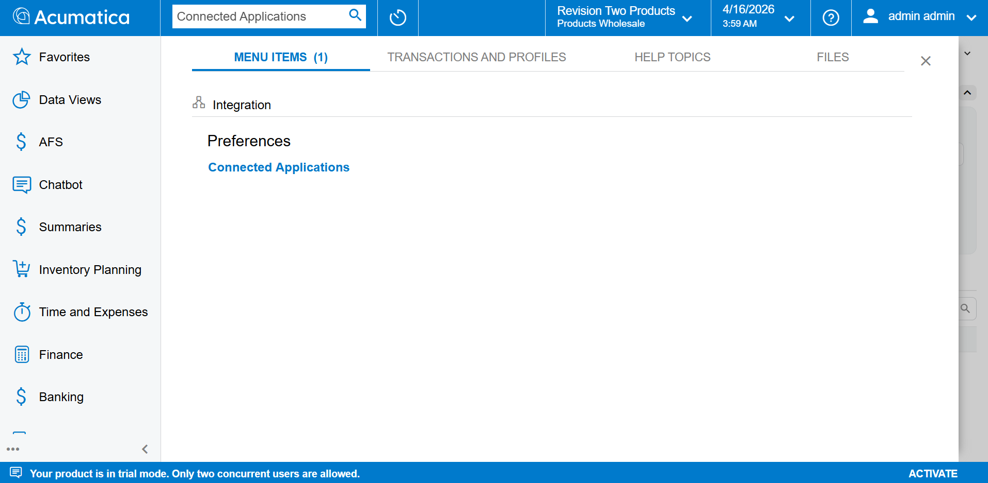
Connected Applications screen

Step 2 — Create a New Record
Click the + (Add) button in the toolbar to create a new record. The Client ID field will show <NEW> until saved.

Step 3 — Enter Client Name
In the Client Name field, enter a meaningful name that identifies this application.
Example: AFS Financial Report API
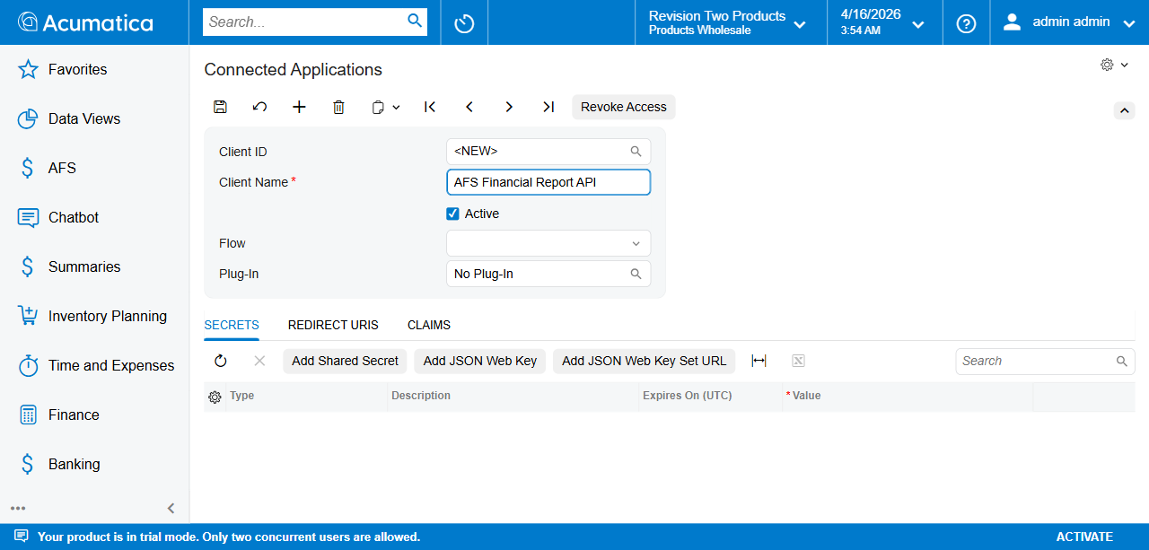
Enter Client Name

Step 4 — Set the Flow
Click the Flow dropdown and select Resource Owner Password Credentials.
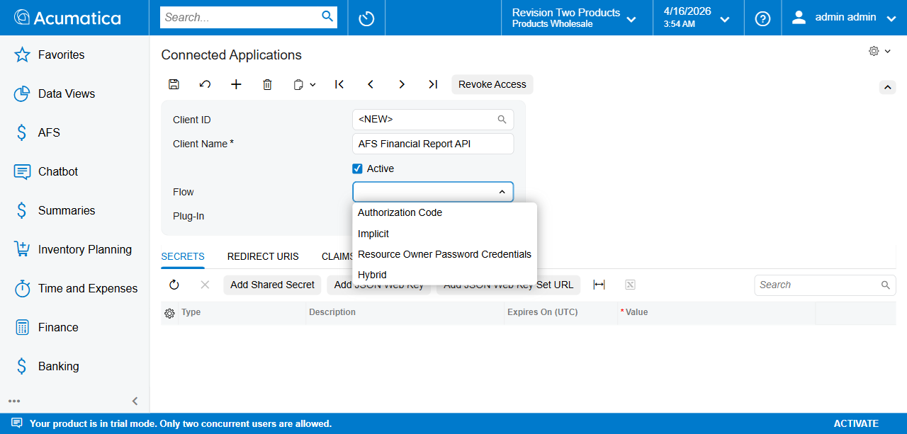
Flow dropdown open
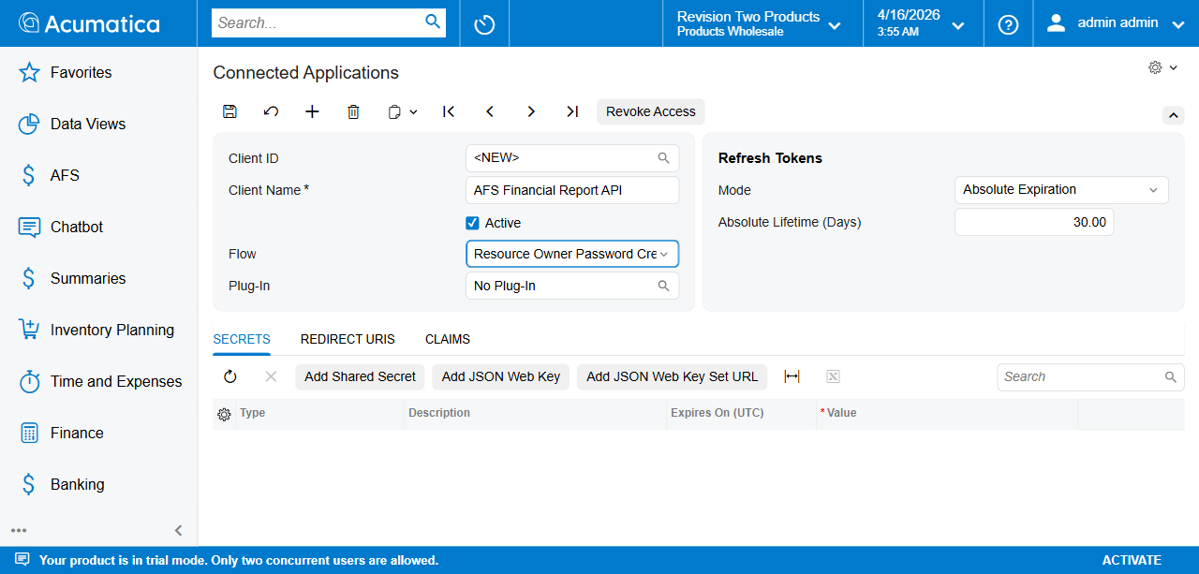
Flow selected
Selecting this flow automatically reveals the Refresh Tokens section on the right.

Step 5 — Configure Refresh Tokens
The Refresh Tokens section appears automatically with these defaults:
Field | Default Value
Mode | Absolute Expiration
Absolute Lifetime (Days) | 30.00
Adjust the Absolute Lifetime (Days) if a longer token validity is required (e.g. 365 for 1 year).

Step 6 — Save the Record
Click Save (or press Ctrl+S). Acumatica generates a unique Client ID.
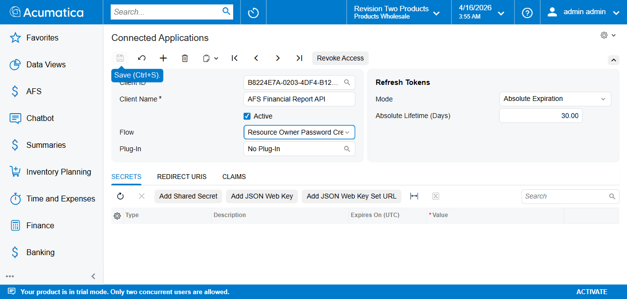
Saved with Client ID
Important: Copy and store the full Client ID value. It will be needed in the Tenant Credentials screen (FR101001).
The Client ID format is: {GUID}@{TenantName} Example: B8224E7A-0203-4DF4-B12B-7990E65C4524@SalesDemo

Step 7 — Add a Shared Secret
In the Secrets tab, click Add Shared Secret. A popup appears with an auto-generated secret value.
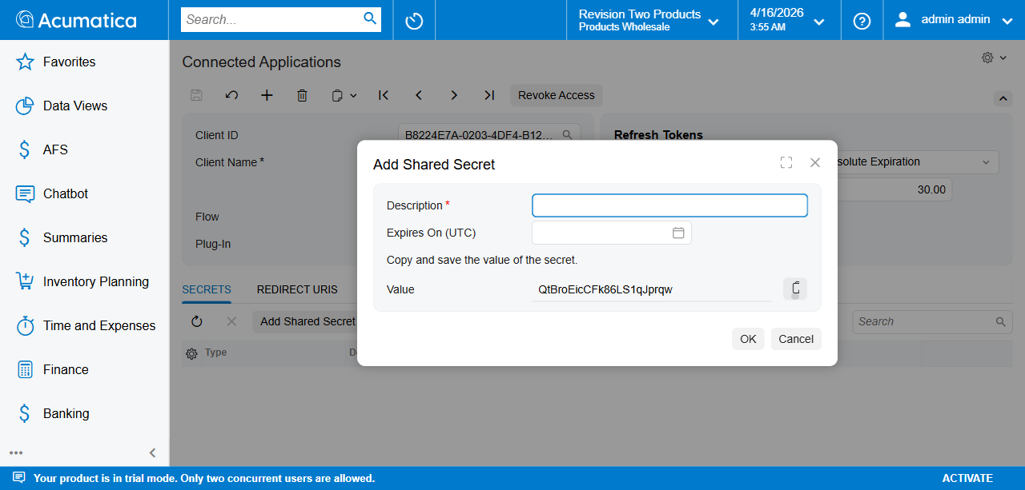
Add Shared Secret popup
Important: The secret value is shown only once. Copy it now before clicking OK.

Step 8 — Fill in Secret Details
- Description — Enter a meaningful label. Example: AFS Financial Report Secret
- Expires On (UTC) — Set an expiry date.
- Value — The secret is auto-generated. Copy this value and store it securely.
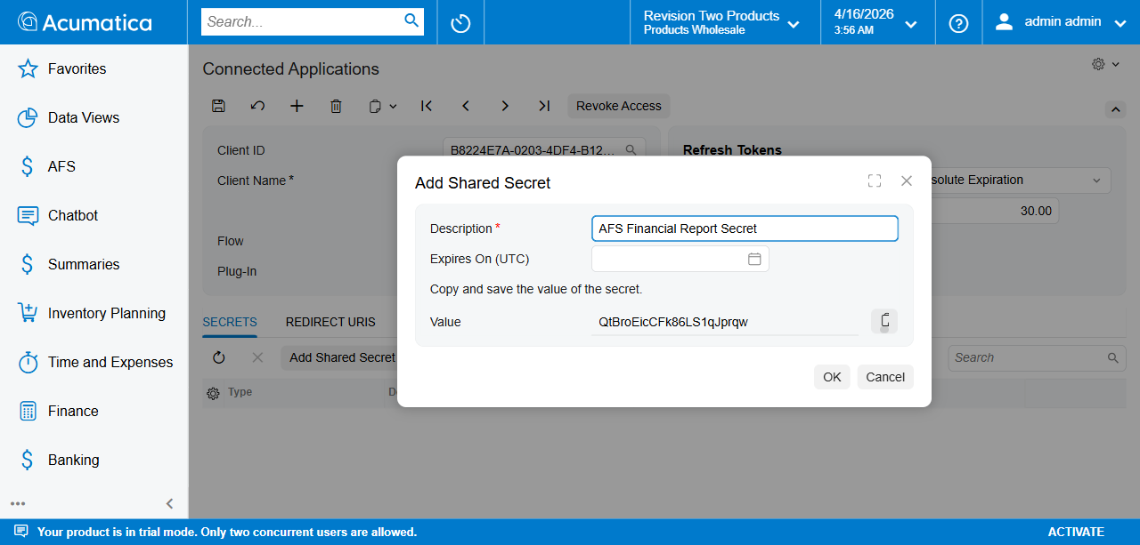
Secret details filled
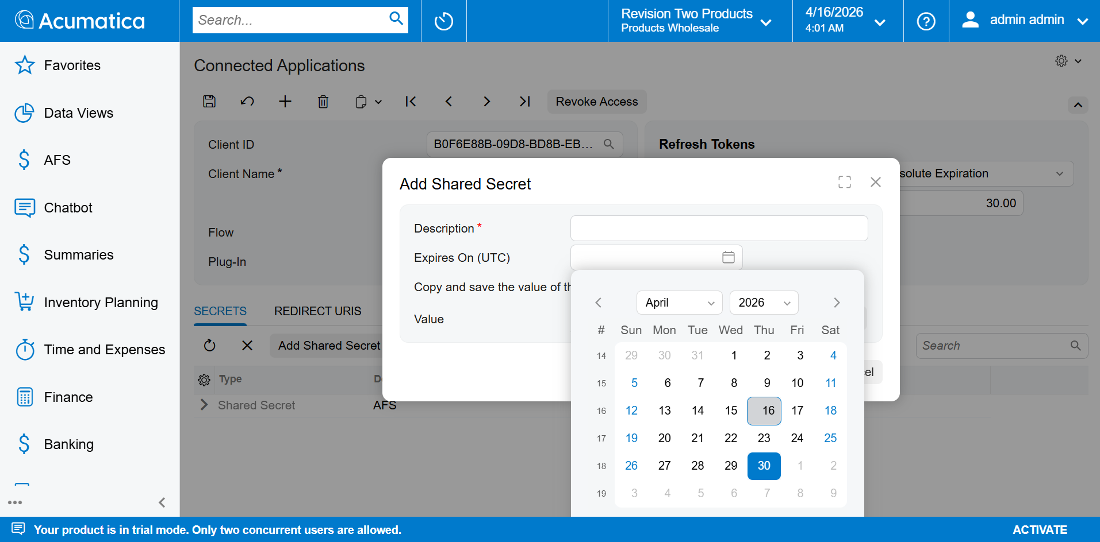
Secret expiry and value

Step 9 — Click OK
Click OK to confirm. The secret appears in the Secrets grid with the value masked as ********.
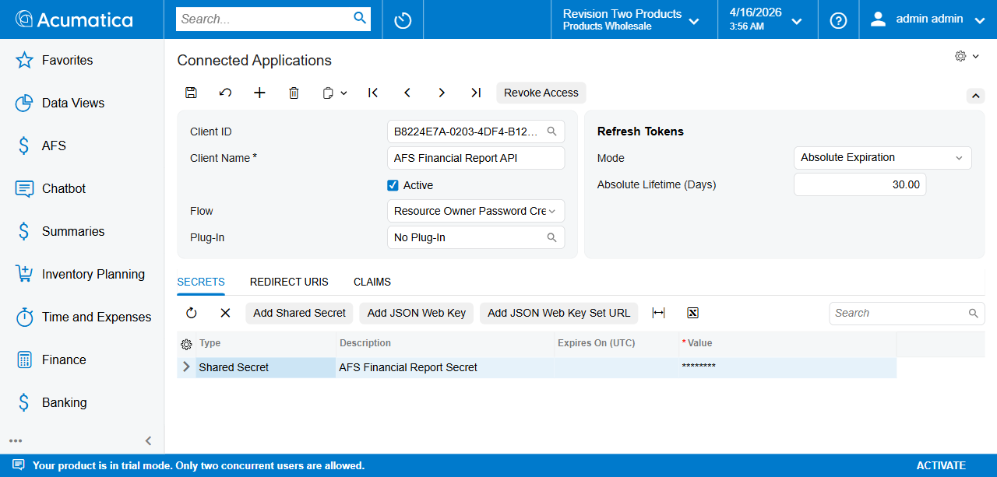
Secret added to grid

Step 10 — Final Save
Click Save again to persist the secret.
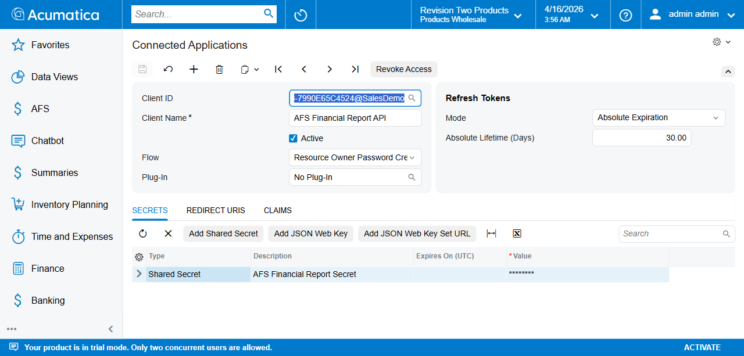
Final saved state

Summary of Values to Record
After completing setup, note down:
Field | Where to Find
Client ID | Client ID field (full value with @TenantName)
Client Secret | Copied from Add Shared Secret popup (Step 8)
Acumatica URL | Base URL of your instance, e.g.http://localhost/2025R2
Username | Acumatica user with API access
Password | Password of above user
These values are entered in Tenant Credentials (FR101001) during AFS Financial Report setup — see Chapter 2.

Chapter 2: Tenant Credentials (FR101001)
This chapter describes how to store the API credentials that the AFS Financial Report module uses to read GL data from Acumatica’s OData layer and (optionally) generate presentations through the Gamma API. One row per tenant — the engine looks up credentials by Company Number at run time.
Screen ID: FR101001 Screen Title: AFS Credentials Config Menu path: AFS → Configuration → AFS Credentials Config

Prerequisites
- Acumatica 2025 R2 with the AFSCPFinancialReport customization published.
- A Connected Application already created in Acumatica — see Chapter 1. You will need its Client ID and Client Secret.
- An Acumatica user account with access to the Generic Inquiries the report definitions read from (typically AFS-Trial-Balance).
- The Company Number for the tenant. Find it in System → Manage → Companies; it is the integer key, not the tenant name.
- (Optional) A Gamma API key from gamma.app, only needed if you plan to use the MBR Report Generation screen (FR101003).

Steps

Step 1 — Navigate to AFS Credentials Config
- Log in to Acumatica.
- In the top search bar, type AFS Credentials and select AFS Credentials Config under AFS → Configuration.
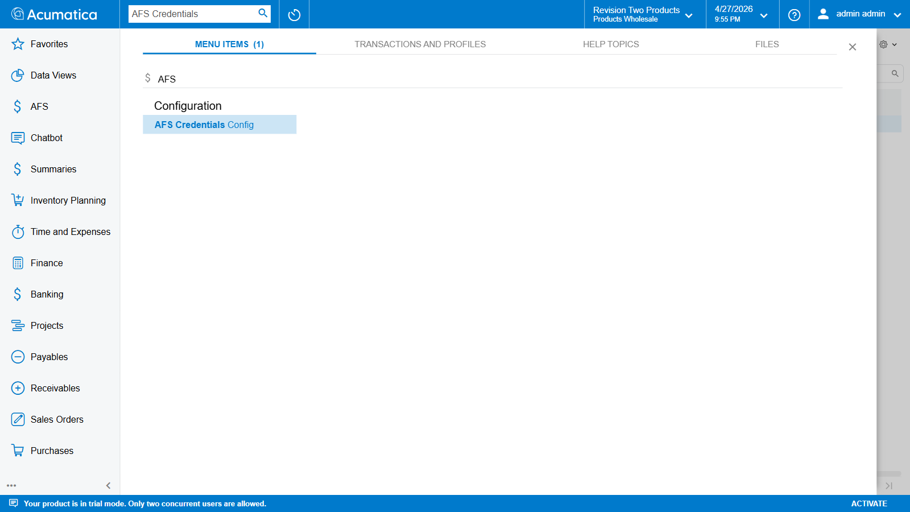
Top search showing AFS Credentials Config result
The screen opens in grid mode. Each existing tenant occupies one row. Sensitive columns (Client ID, Client Secret, Username, Password, Presentation API Key) display as ******** — they are encrypted at rest with PXRSACryptString and never re-shown in plaintext after save.
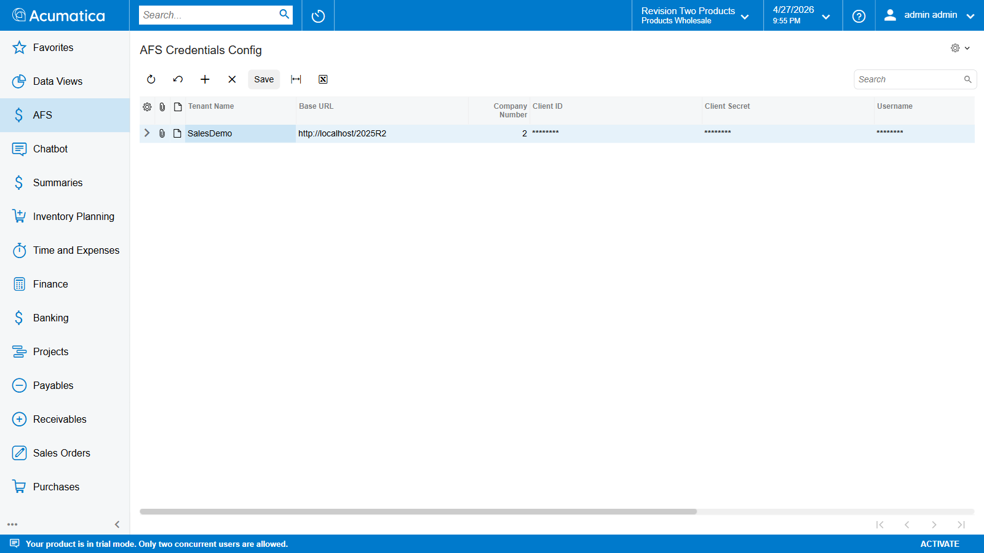
FR101001 landing — existing SalesDemo row with masked fields
The toolbar carries the standard Acumatica grid actions:
Icon | Tooltip | Purpose
↻ | Refresh | Reload data from the database.
↶ | Cancel (Esc) | Discard all unsaved changes in the grid.
+ | Add Row | Insert a new empty row at the bottom.
× | Delete | Delete the currently selected row.
Save | Save | Persist all pending inserts / edits / deletes.
⊢ | Adjust Columns | Auto-fit column widths.
⊠ | Export to Excel | Export the grid contents.

Step 2 — Add a New Row
Click the + (Add Row) button on the toolbar. An empty row appears at the bottom of the grid with focus in the Tenant Name cell.
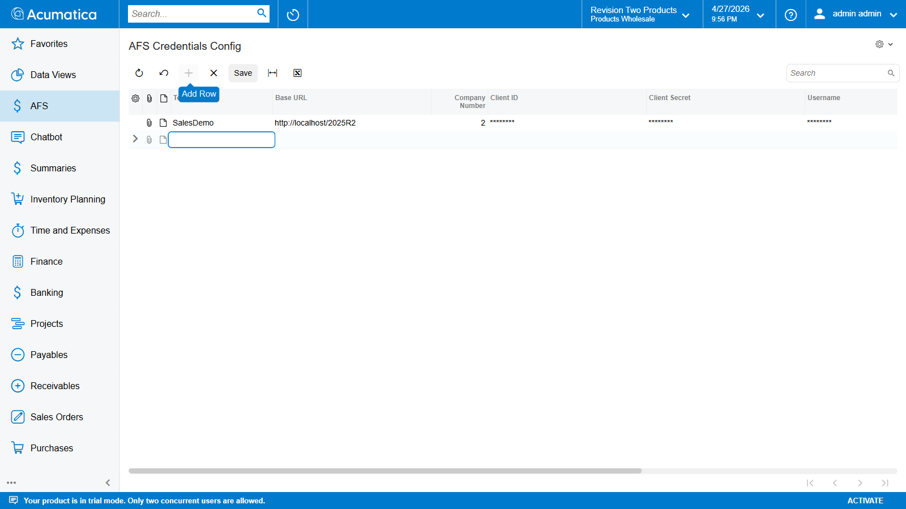
Add Row tooltip + empty editable row inserted
The grid edits in place — there is no separate detail pane. Use Tab to move between cells.

Step 3 — Fill the 8 Columns
Enter values for every column. Five of the eight are RSA-encrypted on save; once you tab out of an encrypted cell the value is masked as ********, but it is committed to the row buffer correctly — Save persists it.
# | Column | Required | Encrypted | Example
1 | Tenant Name | yes | no | SalesDemo
2 | Base URL | yes | no | http://localhost/2025R2
3 | Company Number | yes (key) | no | 2
4 | Client ID | yes | yes | B8224E7A-0203-4DF4-B12B-7990E65C4524@SalesDemo
5 | Client Secret | yes | yes | (value copied once from Connected App popup)
6 | Username | yes | yes | admin
7 | Password | yes | yes | (API user’s password)
8 | Presentation API Key | optional | yes | gamma_xyz… (only needed for FR101003)
Field rules
- Tenant Name must match the tenant segment in the Acumatica URL exactly. It also appears as the suffix of the Connected Application’s Client ID ({GUID}@{TenantName}).
- Base URL is the root of your Acumatica instance with no trailing slash. Use HTTPS in production.
- Company Number is the primary key of this row. Each tenant maps to exactly one row; saving two rows with the same Company Number fails on the unique key.
- Client ID / Client Secret come from the Connected Application created in Chapter 1 — paste the full values without trimming.
- Username / Password are an Acumatica user account with access to the Generic Inquiries the report definitions read.
- Presentation API Key is the Gamma API key. Leave blank unless using FR101003 — the Financial Report screen (FR101000) does not need it.
After filling, the row looks like the screenshot below — non-encrypted fields show plain values; encrypted fields already mask once focus leaves the cell:
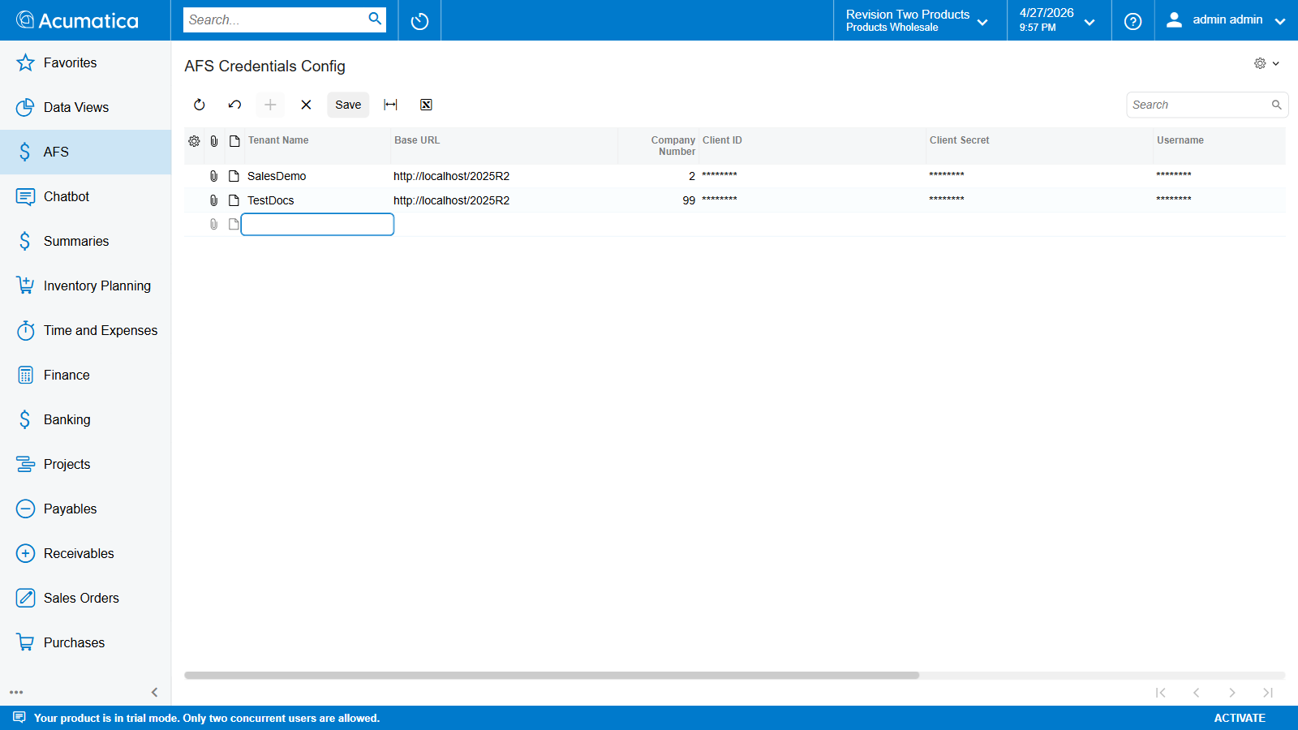
Filled row — Tenant Name, Base URL, Company Number visible; encrypted fields masked

Step 4 — Save
Click Save in the toolbar (or press Ctrl+S). The graph runs validation and persists the row:
- Tenant Name must be unique across all rows (Messages.TenantNameMustBeUnique).
- Company Number must be set (Messages.CompanyNumRequired).
If both pass, the encrypted fields are written to the database via PXRSACryptString and the row reloads showing all five sensitive columns as ********. The saved row matches the existing SalesDemo example shown in Step 1.
Important. The plaintext you typed is not retrievable after save. If you need to rotate a credential, paste a new value into the masked cell and Save again — Acumatica replaces the encrypted blob.

Step 5 — (Optional) Discard Without Saving
If you started a new row by mistake, click the Cancel (Esc) button on the toolbar (curved-arrow icon). All pending inserts / edits / deletes are reverted; the grid returns to its last-saved state.
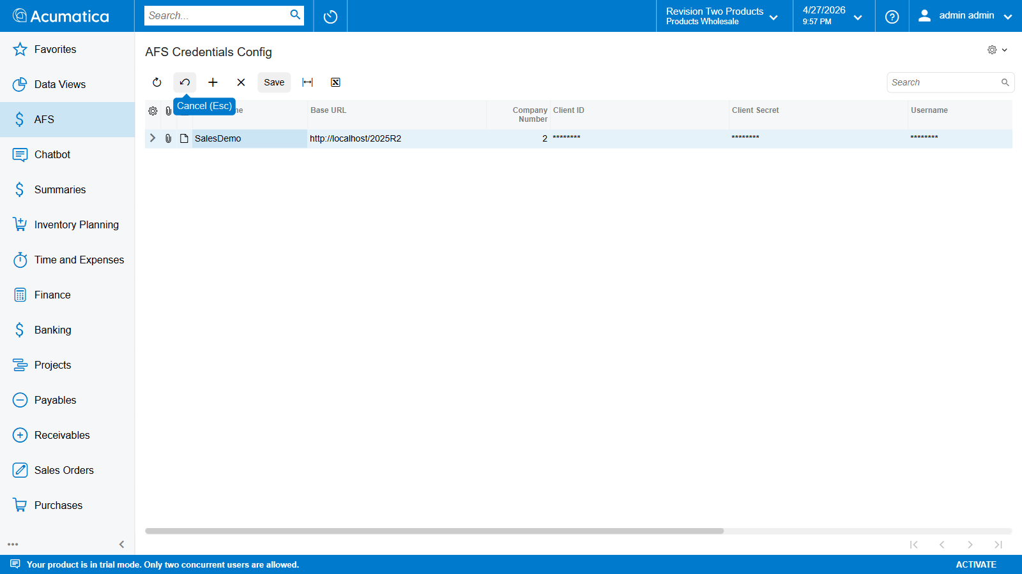
Cancel (Esc) toolbar button — discard pending changes

How the Engine Uses This Row
When Generate Report runs on FR101000:
- The graph reads the report record’s CompanyID (the Acumatica company the record was created under).
- MapCompanyIDToTenantName looks up the matching FLRTTenantCredentials row by CompanyNum and returns its TenantName.
- CredentialProvider.GetCredentials(tenantName) decrypts the row and returns a strongly-typed AcumaticaCredentials object holding the Base URL, Client ID, Client Secret, Username, and Password.
- AuthService performs the OAuth2 Resource Owner Password Credentials flow against {BaseURL}/identity/connect/token and caches the bearer token for the duration of the run.
- FinancialDataService uses the bearer token to fetch the Generic Inquiry rows over OData.
If the row is missing or the Company Number doesn’t match, the run fails immediately with Messages.NoTenantMapping — “Tenant mapping not found.”

Field Reference (DAC)
DAC field | Display name | Type | Notes
CompanyNum | Company Number | PXDBInt (key) | Primary key. Maps to Acumatica CompanyID.
TenantName | Tenant Name | PXDBString(50) | Plain text. Used to scope OAuth login.
BaseURL | Base URL | PXDBString(255) | Plain text.
ClientIDNew | Client ID | PXRSACryptString | Encrypted at rest.
ClientSecretNew | Client Secret | PXRSACryptString | Encrypted at rest.
UsernameNew | Username | PXRSACryptString | Encrypted at rest.
PasswordNew | Password | PXRSACryptString | Encrypted at rest.
GammaApiKey | Presentation API Key | PXRSACryptString | Encrypted at rest. Optional — FR101003 only.
The *New suffix on the encrypted fields is a legacy artefact from a schema migration; the UI just labels them Client ID / Client Secret / Username / Password.

Security Notes
- All five sensitive fields use PXRSACryptString — the plaintext only exists in memory during the request that wrote it; the column on disk holds an RSA-encrypted blob keyed off the Acumatica web.config machine key.
- CredentialProvider caches decrypted values per tenant for the duration of a single report run, then drops the reference at job exit so the values are not retained between runs.
- Always use HTTPS for the Base URL in any non-local environment — the OAuth flow sends Username and Password in the request body.
- This row is the only place the Acumatica password and the Gamma API key live in the customization database. Treat the row as sensitive and restrict screen rights on FR101001 accordingly.

Validation Errors You May See
Error | Cause | Fix
Tenant Name must be unique. | Two rows share the same Tenant Name. | Pick a unique name or edit the existing row instead of inserting.
Company Number is required. | Saved a row with the Company Number cell blank. | Fill the Company Number from System → Manage → Companies.
Tenant mapping not found. | Generated a report under a CompanyID with no matching CompanyNum row in this screen. | Add a row for that CompanyID, or move the report record to a tenant that already has credentials.
Failed to authenticate. | Wrong Client ID / Client Secret / Username / Password, or Connected Application’s Flow is not Resource Owner Password Credentials. | Re-paste the credentials from the Connected Applications screen.

Chapter 3: Report Definition Setup (FR101002)
This chapter describes how to create an AFS Report Definition. A Report Definition is the blueprint that tells the Financial Report engine:
- Which Generic Inquiry (GI) to pull GL data from,
- Which columns on that GI carry the balance figures, filter keys, and period tags, and
- Which line items (account ranges, subtotals, calculated lines, headings) to emit as placeholders in the final report.
One definition is typically created per statement type (Balance Sheet, P&L, Cash Flow, etc.) and then linked to the Financial Report (FR101000) or MBR Report Generation (FR101003) screen.
Period model. All balances surfaced by a definition are fiscal-year-to-date figures (FY start → selected period end). Each visible line emits two placeholders: _CY (current year) and _PY (previous year). There is no single-period / month-only balance type.

Prerequisites
- Tenant credentials already saved in Tenant Credentials (FR101001).
- A Generic Inquiry is published that exposes the GL balances you want to consume. The stock GI is AFS-Trial-Balance; any GI with account / balance / period columns works.
- You know the GL account ranges that make up each line of the statement you are modelling.

Steps

Step 1 — Navigate to AFS Report Definition
In the top search bar type AFS Report and select AFS Report Definition under the AFS workspace.
Screen ID: FR101002
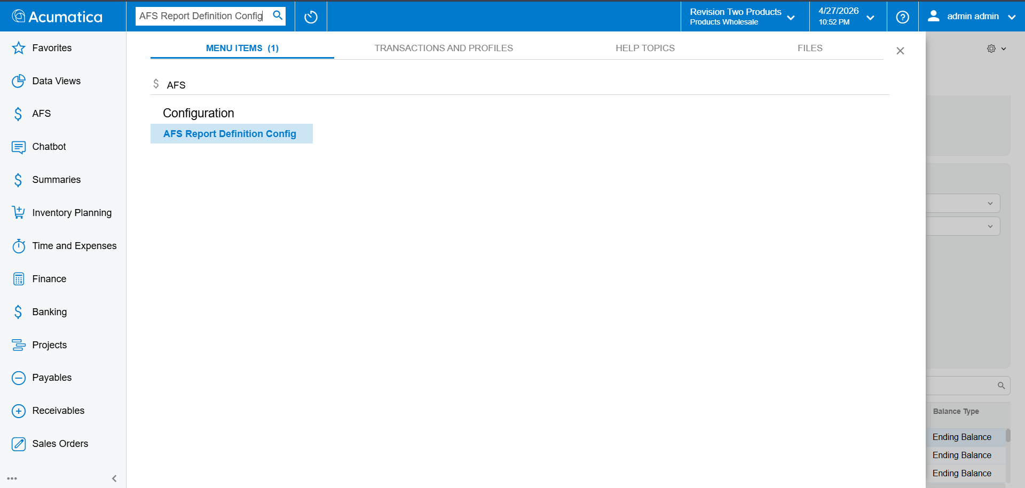
AFS Report Definition landing screen

Step 2 — Create a New Record
Click the + (Add) button. The Definition Code field shows <NEW> until saved.

Step 3 — Fill the Header
Enter the four required header fields:
Field | Example | Notes
Definition Code | DEMO-BS | Unique key, max 50 chars. This is the code the Financial Report / Presentation screen will select.
Prefix | DB | Short alphanumeric tag, max 10 chars (^[A-Za-z0-9]+$ — letters and digits only, no separators). Namespaces all placeholders emitted by this definition, e.g. {{DB_TOTAL_ASSETS_CY}}. Must be unique across all definitions in the tenant.
Description | Demo Balance Sheet | Free-text label, max 255 chars. Appears in the selector dropdown on downstream screens.
Report Type | Balance Sheet | Metadata tag — see Step 4.
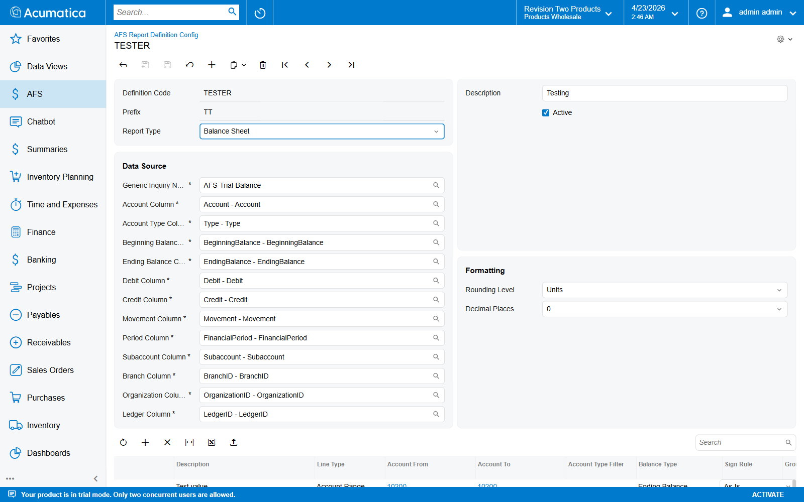
Header filled — TESTER record showing Definition Code, Prefix, Report Type, and Data Source

Step 4 — Choose the Report Type
Report Type tags the definition so downstream screens can group it. It does not alter calculation — it is metadata only.
Value | Label
BS | Balance Sheet (default)
PL | Profit & Loss
CF | Cash Flow
CU | Custom
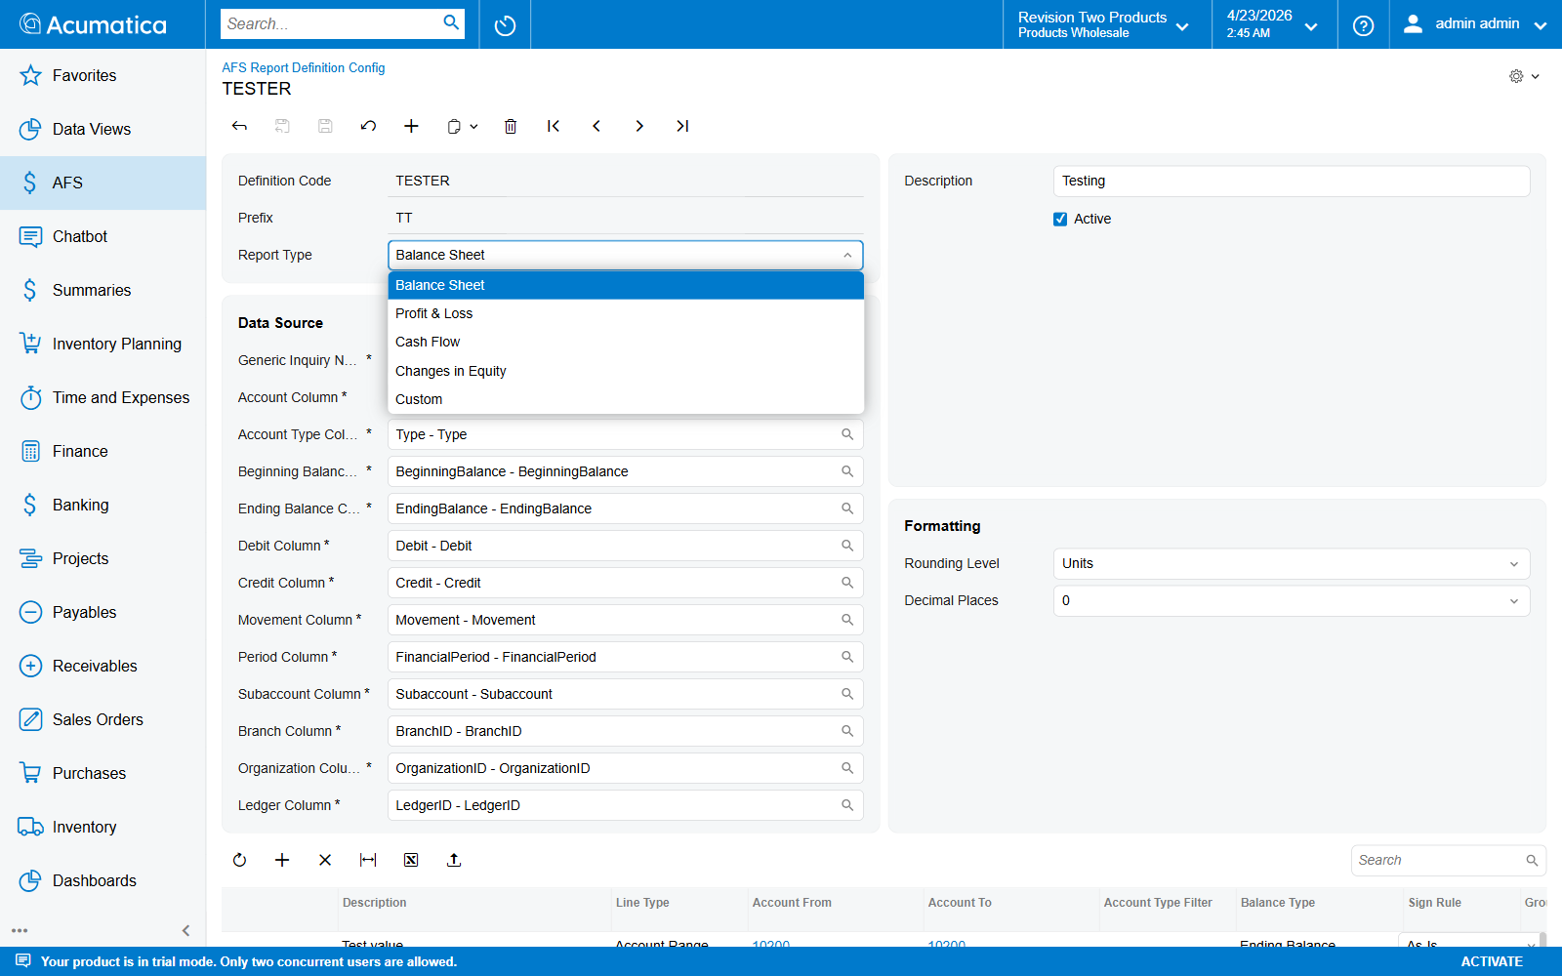
Report Type dropdown open — 5 values
Also visible on the same header row:
- Active — uncheck to hide this definition from the selector on FR101000 / FR101003 without deleting it.

Step 5 — Pick the Generic Inquiry
Generic Inquiry Name drives where the engine pulls GL balances from. Defaults to AFS-Trial-Balance. Use the selector (magnifier icon) to pick any published GI.
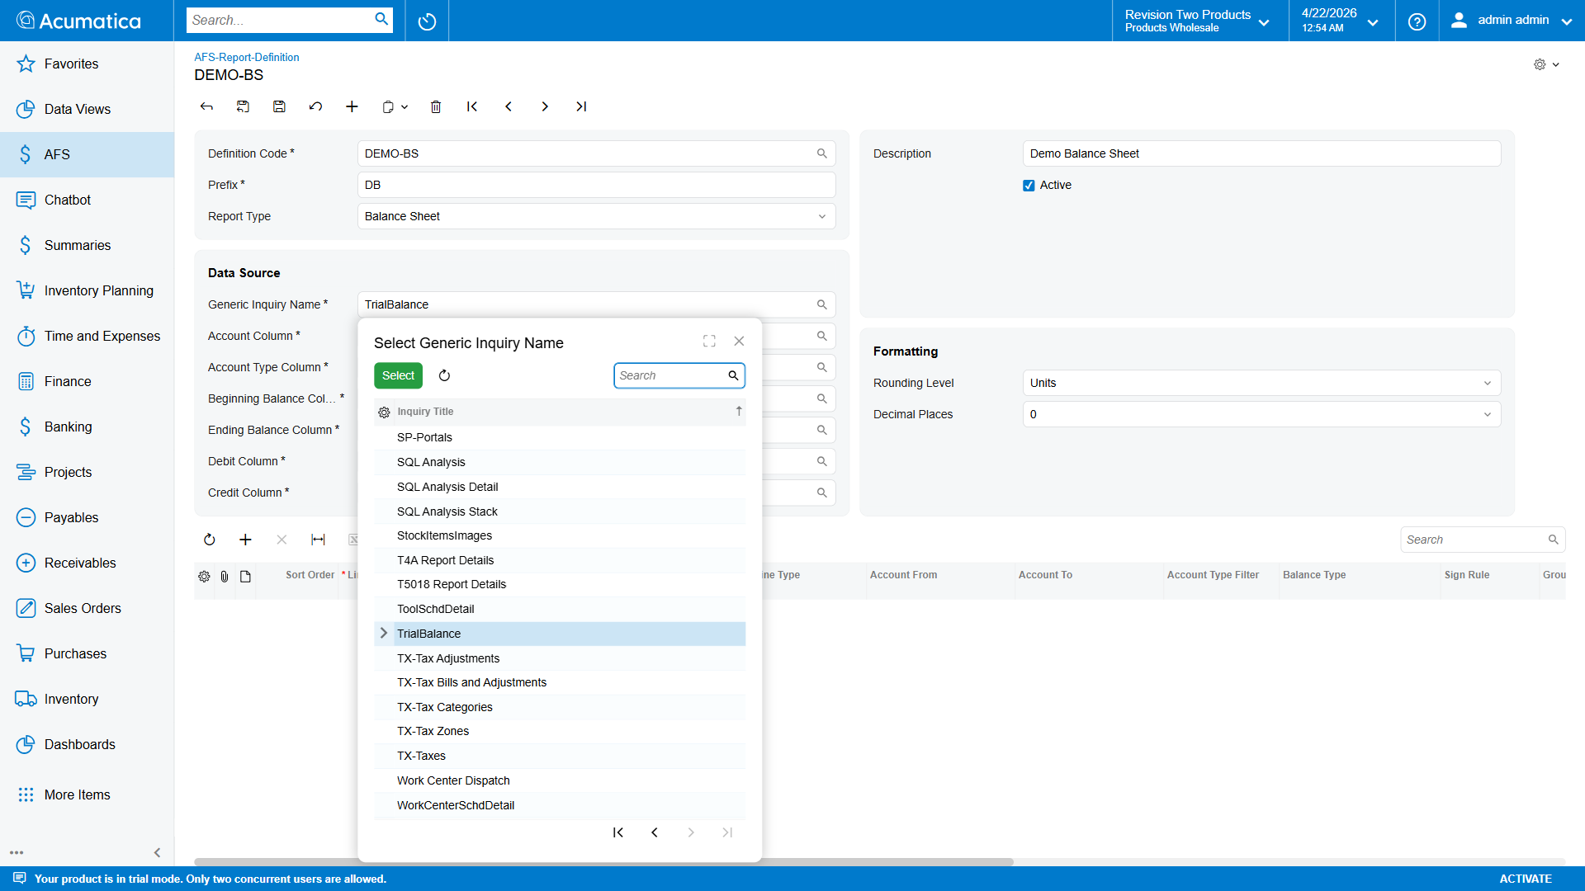
Generic Inquiry selector
The selector lists all GIDesign records in the tenant. Any GI that returns rows keyed by account with balance figures can be used — the column mapping in Step 6 tells the engine which GI column carries each concept.

Step 6 — Map the GI Columns (Data Source)
This section tells the engine which column in the chosen GI holds each balance concept, filter key, or period tag. Each field is a GI-column selector — it only shows columns that exist on the GI picked in Step 5. The defaults match Acumatica’s stock AFS-Trial-Balance GI.

Balance columns
Field | Default Column | Purpose
Account Column | Account | GL account code. Used for account-range filtering on ACCOUNT lines.
Account Type Column | Type | Returns A/L/E/I. Drives automatic account-type sign normalization and the optional Account Type Filter on line items.
Beginning Balance Column | BeginningBalance | Opening balance at the start of the fiscal year. Read when Balance Type = BEGINNING.
Ending Balance Column | EndingBalance | Closing balance as at the selected period end. Read when Balance Type = ENDING (default).
Debit Column | Debit | Fiscal-year-to-date debit sum. Read when Balance Type = DEBIT.
Credit Column | Credit | Fiscal-year-to-date credit sum. Read when Balance Type = CREDIT.
Movement Column | Movement | Listed in the OData $select clause for completeness. Not consumed by the engine — when Balance Type = MOVEMENT the engine derives the value as Debit − Credit from the columns mapped above. Safe to leave at the default.

Period & filter columns
Field | Default Column | Purpose
Period Column | FinancialPeriod | Period tag on each GI row (e.g. 04-2026). The engine uses this to slice CY vs PY rows.
Subaccount Column | Subaccount | Column holding the Subaccount code. Referenced by the optional Subaccount Filter on each line item.
Branch Column | BranchID | Branch code column. Referenced by Branch Filter.
Organization Column | OrganizationID | Organization code column. Referenced by Organization Filter.
Ledger Column | LedgerID | Ledger code column. Referenced by Ledger Filter.
If you clone or customize the stock GI, rename these columns here to match the new field names. The 13 mapping fields default to the stock AFS-Trial-Balance column names — save is not blocked if you blank one out, but the engine will fall back to the default name (Account, EndingBalance, …) at fetch time. Set them explicitly when working against a renamed GI.
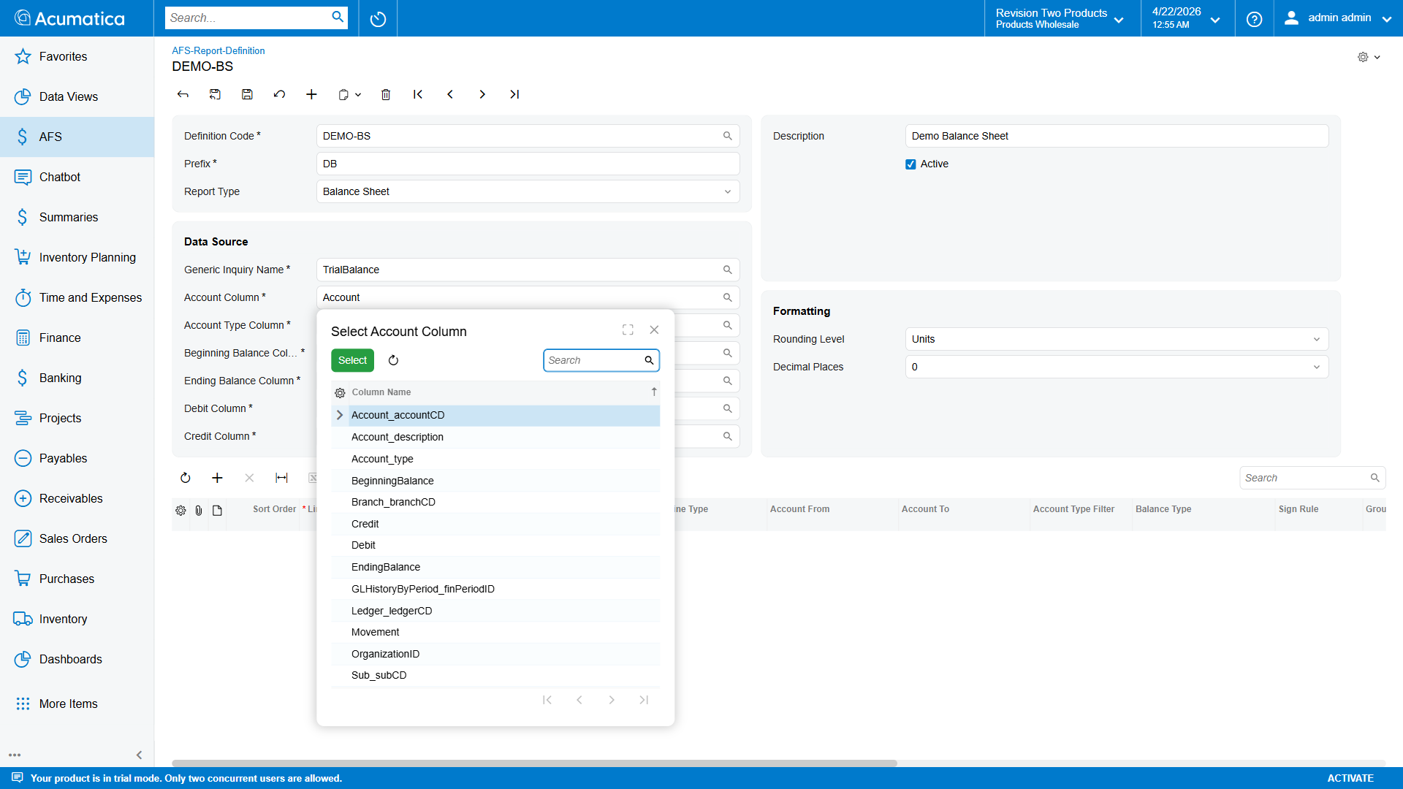
Account Column selector open

Step 7 — Configure Formatting (Rounding)
Controls how numeric placeholders are formatted when they appear in the final Word / markdown output.
Field | Values | Notes
Rounding Level | UNITS (default), THOUS, MILL | Divides all numbers by 1 / 1,000 / 1,000,000 before rendering.
Decimal Places | 0 (default), 1, 2 | Digits shown after the decimal point.
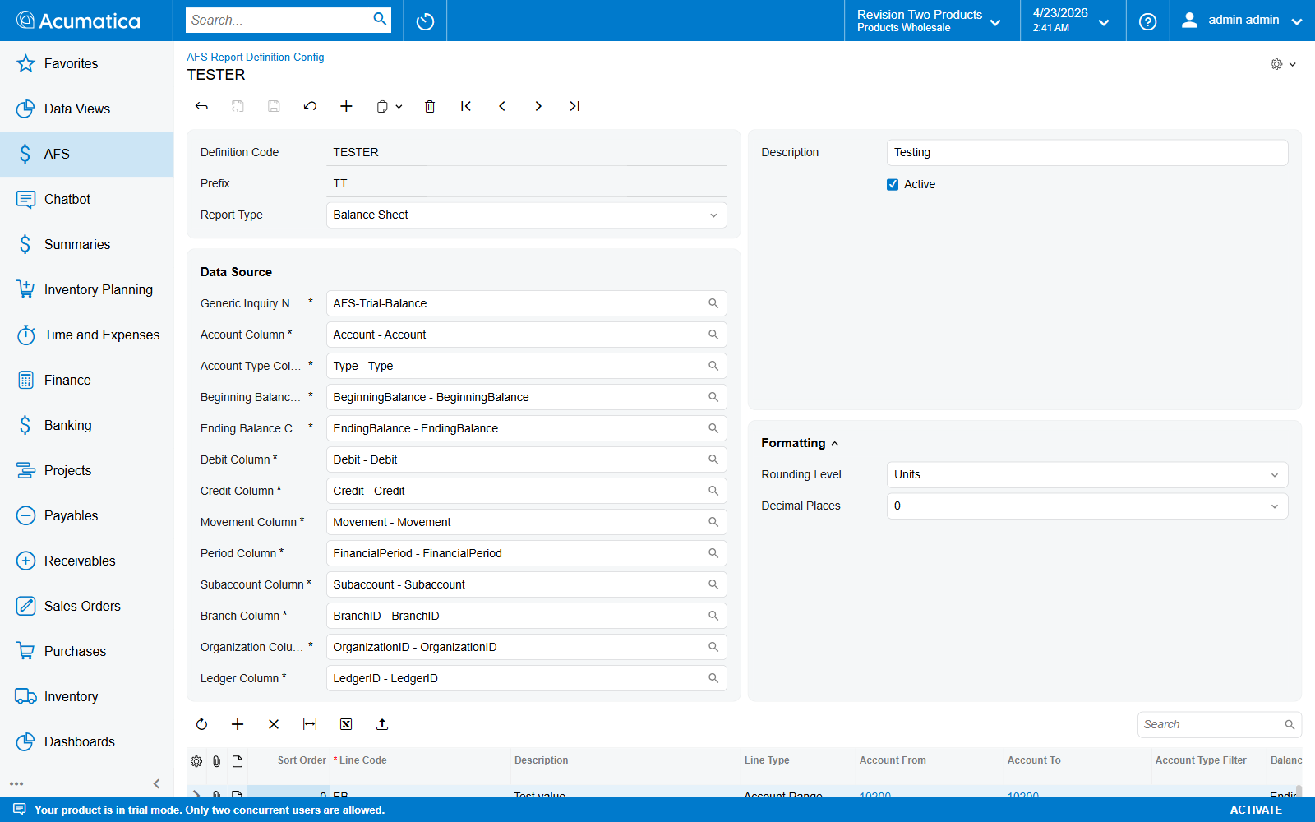
Formatting section expanded — Rounding Level = Units, Decimal Places = 0
Example: With Rounding Level = THOUS and Decimal Places = 1, a raw value of 1,234,567.89 renders as 1,234.6.
Save the header (Ctrl+S) before adding line items.

Line Items Grid
Each row in Line Items is a single placeholder that will appear in the generated report. The engine calculates one CY and one PY value per visible row. The grid columns are as follows.
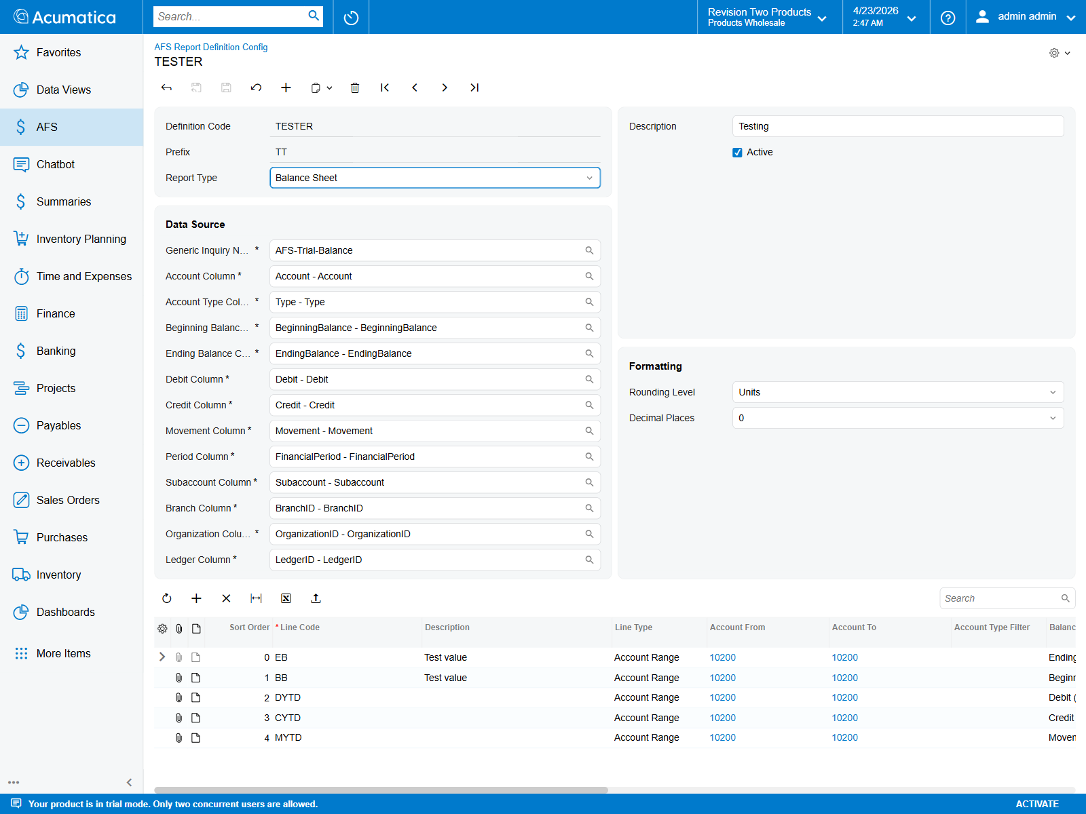
Line Items grid — TESTER record with 5 rows demonstrating all 5 balance types

Columns — overview
Column | Required | Description
Sort Order | yes | Integer controlling row order in the report. Lines are emitted in ascending SortOrder.
Line Code | yes | Unique token within this definition (≤100 chars). Forms the placeholder key, e.g. CASH → {{DB_CASH_CY}}, {{DB_CASH_PY}}.
Description | yes if visible | Human-readable label, shown in the generated markdown table.
Line Type | yes | Determines how the engine computes this line. See table below.
Account From / To | Account lines | Inclusive GL account range to sum. Example: 10000…10999.
Account Type Filter | optional | Restrict the range to a single GL account type.
Sign Rule | Account lines | ASIS keeps the raw GL sign; FLIP multiplies by −1 for presentation (typical for Liability / Income).
Balance Type | Account lines | Which GI balance column to read. Five options — all fiscal-year-to-date except the two point-in-time balances. See Balance Type values.
Group / Parent Line | optional | The subtotal LineCode this row rolls up into. Editable on ACCOUNT, SUBTOTAL, and CALCULATED lines (so subtotals can nest, and a calculated KPI can roll into a parent subtotal). Disabled on HEADING. Example: child rows CASH, AR, INV all set Parent = CURRENT_ASSETS.
Formula | Calculated lines | Arithmetic expression over other LineCodes using + − × ÷ and parentheses. Example: REVENUE - COGS. References may also cross definitions using the fully qualified <Prefix>_<LineCode> form — see Cross-Definition Formulas.
Visible in Report | yes | Default true. Uncheck to keep the value internal (usable in formulas / subtotals) without emitting a placeholder.
Subaccount Filter | optional | Exact-match subaccount, e.g. 000-000. Blank = all subaccounts.
Branch Filter | optional | BranchCD selector. Blank = all branches.
Organization Filter | optional | OrganizationCD selector. Blank = all organizations.
Ledger Filter | optional | LedgerCD selector. Blank = all ledgers.
All filter columns only apply when Line Type = ACCOUNT. They are ignored by Subtotal / Calculated / Heading lines.

Line Type values
Code | Label | Behaviour
ACCOUNT | Account Range | Sum all GI rows where the account code falls inside AccountFrom…AccountTo (inclusive), apply Sign Rule, use Balance Type.
SUBTOTAL | Subtotal | Sum all lines whose ParentLineCode equals this row’s LineCode.
CALCULATED | Calculated | Evaluate Formula at runtime, referencing other LineCodes. Supports + − × ÷ and parentheses.
HEADING | Heading | Display-only. No value is computed; used to emit a section header into the report.
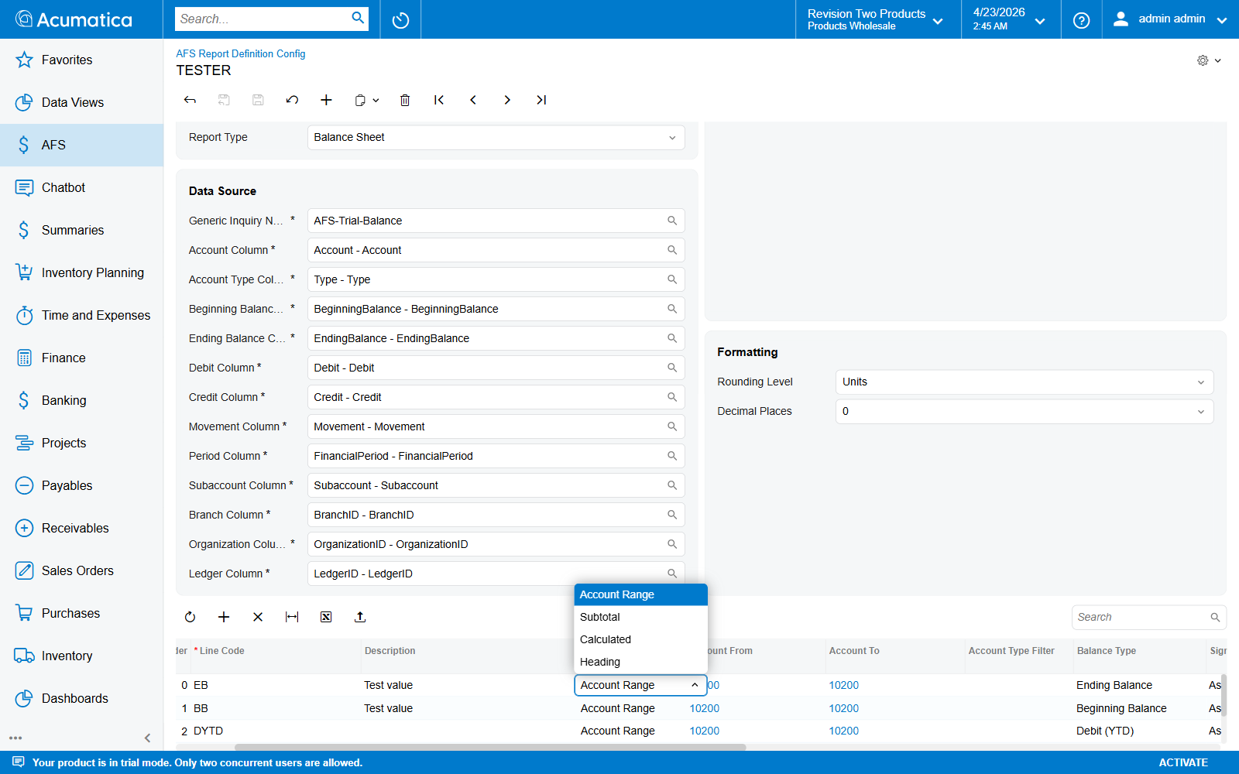
Line Type dropdown open — 4 values

Balance Type values
Applies only to ACCOUNT lines. Determines which column from the GI mapping is read. All movement figures (DEBIT, CREDIT, MOVEMENT) are fiscal-year-to-date — they accumulate from the FY start through the selected period end. There is no single-month balance type.
Code | Label | Column used | Typical use
ENDING | Ending Balance (default) | Ending Balance Column | Balance Sheet lines (point-in-time snapshot at period end).
BEGINNING | Beginning Balance | Beginning Balance Column | Opening-balance columns, capital roll-forwards.
DEBIT | Debit (YTD) | Debit Column | Gross debit activity FY-to-date.
CREDIT | Credit (YTD) | Credit Column | Gross credit activity FY-to-date.
MOVEMENT | Movement (YTD) | Debit Column − Credit Column (derived; the Movement Column mapping is fetched but not consumed) | P&L lines — revenue, expenses, net movement FY-to-date.
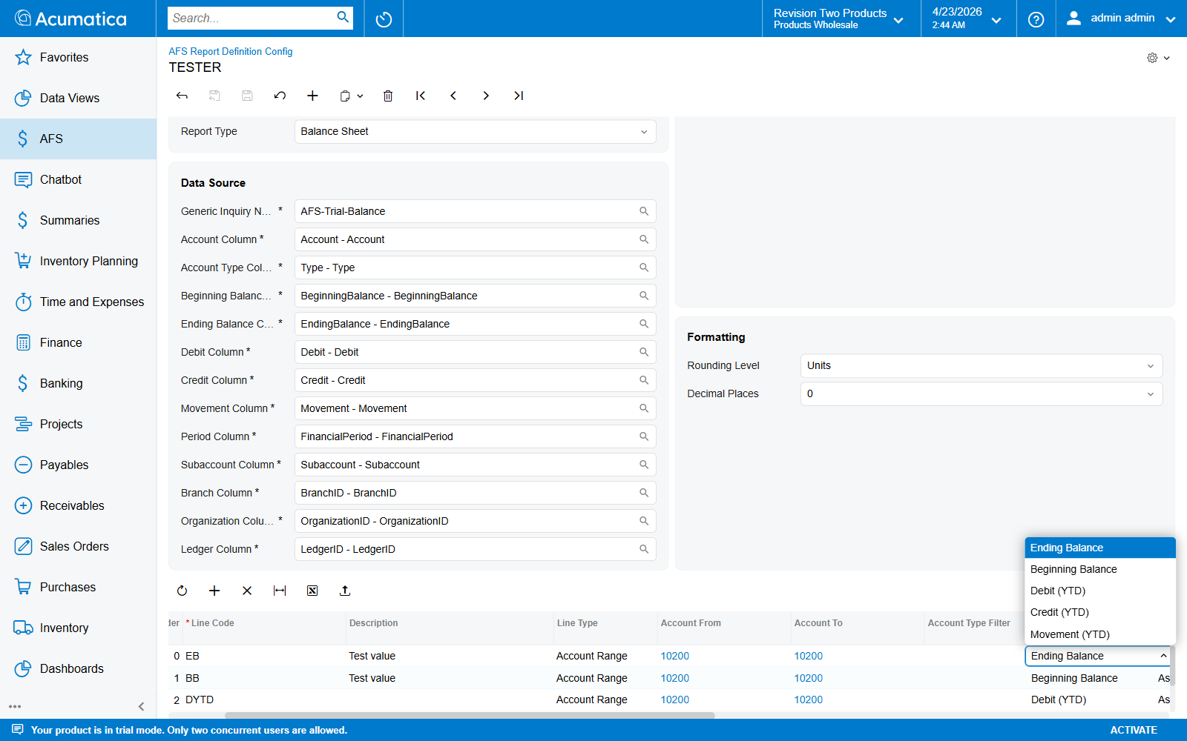
Balance Type dropdown open — 5 values
Why no single-period (month-only) balance type? The stock AFS workflow reports fiscal-year performance (CY vs prior-year CY). If you need a month-only view, filter the underlying GI by period, or compute the delta in the template ({{BS_X_CY}} - {{BS_X_PY}}).

Sign Rule values
Sign handling is two-stage inside the engine:
- Automatic account-type normalization (ApplyAccountTypeSign). When the GI row has an Account Type (A/L/E/I) in the mapped type column, the engine multiplies the raw GL value by −1 for credit-normal types (L, I). Asset/Expense values pass through unchanged. This turns credit-normal GL values (Acumatica stores them negative) into the positive figures expected on a financial statement.
- User-controlled Sign Rule (this column). Applied after the automatic normalization.
Code | Label | Math | When to use
ASIS | As-Is | no extra multiply | Default — correct for nearly every line. The engine has already normalized credit-normal types for you.
FLIP | Flip Sign | × −1 | Use only when (a) the GI’s type column is blank/unmapped so automatic normalization did not fire, or (b) you specifically want the opposite of the normal sign.
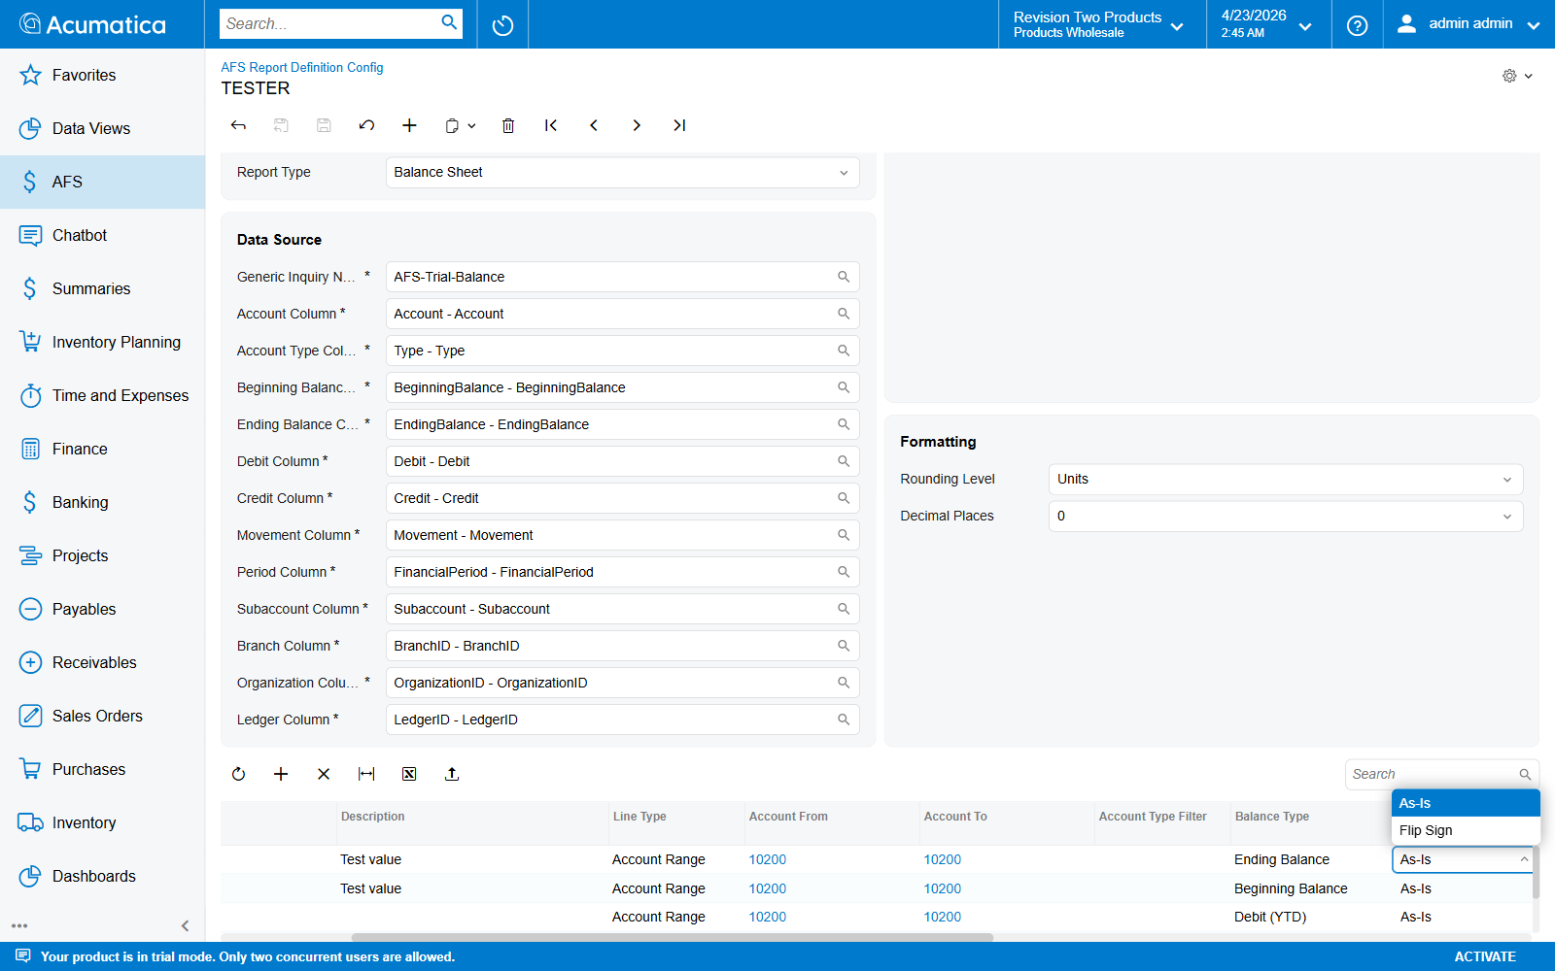
Sign Rule dropdown open — As-Is / Flip Sign
Gotcha. Setting FLIP on a Liability/Income line when the type column is populated will double-flip (−1 × −1 = +1 relative to raw, i.e. a negative value on the statement). If liabilities show up negative after generation, check this column first.

Account Type Filter values
Optional hard-filter on the GL account type. Uses the column mapped in Account Type Column.
Code | Label
(blank) | All Types
A | Asset
L | Liability
E | Expense
I | Income
Leave blank unless you want to clamp a range that spans multiple account types.

Worked Examples
Below are the minimum column values for each LineType.

ACCOUNT line — sum a range
Sort Order : 10
Line Code : CASH
Description : Cash and Cash Equivalents
Line Type : Account Range
Account From : 10100
Account To : 10199
Sign Rule : As-Is
Balance Type : Ending Balance
Visible : ✓

SUBTOTAL line — sum child lines
Sort Order : 100
Line Code : CURRENT_ASSETS
Description : Total Current Assets
Line Type : Subtotal
Group / Parent Line : (leave blank — this IS the parent)
Visible : ✓
…and on the rows above, set Group / Parent Line = CURRENT_ASSETS for each child you want rolled up.

CALCULATED line — formula over other codes
Sort Order : 200
Line Code : NET_INCOME
Description : Net Income
Line Type : Calculated
Formula : REVENUE - COGS - OPEX - TAX
Visible : ✓
Unqualified tokens (REVENUE, COGS, …) resolve within this definition. Prefix the token (PL_REVENUE, BS_CASH) to pull from another definition linked on the same Financial Report — see Cross-Definition Formulas.

HEADING line — section divider
Sort Order : 5
Line Code : HDR_ASSETS
Description : ASSETS
Line Type : Heading
Visible : ✓ (unchecked headings are discarded silently)

Placeholder Key Format
Each visible line emits two placeholders into the report:
{{<Prefix>_<LineCode>_CY}} → current year, fiscal-year-to-date through selected period
{{<Prefix>_<LineCode>_PY}} → previous year, same fiscal-year-to-date window
Example — with Prefix = DB and Line Code = CASH:
{{DB_CASH_CY}}
{{DB_CASH_PY}}
See Appendix A — Placeholder Reference for the full placeholder catalogue.

End-to-End Example — Mini Balance Sheet
This example walks through a complete Balance Sheet definition: the raw GL data that lands in the GI, the Line Items grid rows, and the placeholder values that come out the other end.

1 — Raw GI data (input)
Assume the AFS-Trial-Balance GI returns the following rows as at end of April 2026 (Branch = MAIN, Ledger = ACTUAL):
Account | Type | BeginningBalance | EndingBalance | Debit (YTD) | Credit (YTD) | Movement (YTD)
10100 | A | 40,000.00 | 52,500.00 | 18,000 | 5,500 | 12,500
10200 | A | 80,000.00 | 96,000.00 | 30,000 | 14,000 | 16,000
10300 | A | 25,000.00 | 31,500.00 | 10,000 | 3,500 | 6,500
20100 | L | −20,000.00 | −28,000.00 | 2,000 | 10,000 | −8,000
20200 | L | −50,000.00 | −60,000.00 | 5,000 | 15,000 | −10,000
Liabilities carry negative signs at the GL level (credit-normal). The engine’s automatic account-type normalization (see Sign Rule values) converts these to positive for presentation before Sign Rule is applied. All lines below use Sign Rule = ASIS — the engine has already done the sign work.

2 — Definition header
Definition Code : DEMO-BS
Prefix : DB
Description : Demo Balance Sheet
Report Type : Balance Sheet
Active : ✓
Generic Inquiry : AFS-Trial-Balance
Account Column : Account
Account Type Col : Type
Beginning Bal Col : BeginningBalance
Ending Bal Col : EndingBalance
Debit Column : Debit
Credit Column : Credit
Movement Column : Movement
Period Column : FinancialPeriod
Subaccount Column : Subaccount
Branch Column : BranchID
Organization Column : OrganizationID
Ledger Column : LedgerID
Rounding Level : UNITS
Decimal Places : 0

3 — Line Items grid
Sort | Line Code | Description | Line Type | Acct From | Acct To | Sign Rule | Balance Type | Parent | Formula | Visible
5 | HDR_ASSETS | ASSETS | Heading |  |  |  |  |  |  | ✓
10 | CASH | Cash and Cash Equivalents | Account | 10100 | 10100 | ASIS | ENDING | CURRENT_ASSETS |  | ✓
20 | AR | Accounts Receivable | Account | 10200 | 10200 | ASIS | ENDING | CURRENT_ASSETS |  | ✓
30 | INVENTORY | Inventory | Account | 10300 | 10300 | ASIS | ENDING | CURRENT_ASSETS |  | ✓
100 | CURRENT_ASSETS | Total Current Assets | Subtotal |  |  |  |  |  |  | ✓
105 | HDR_LIAB | LIABILITIES | Heading |  |  |  |  |  |  | ✓
110 | AP | Accounts Payable | Account | 20100 | 20100 | ASIS | ENDING | TOTAL_LIAB |  | ✓
120 | LOAN | Long-Term Loan | Account | 20200 | 20200 | ASIS | ENDING | TOTAL_LIAB |  | ✓
200 | TOTAL_LIAB | Total Liabilities | Subtotal |  |  |  |  |  |  | ✓
300 | NET_ASSETS | Net Assets (A − L) | Calculated |  |  |  |  |  | CURRENT_ASSETS - TOTAL_LIAB | ✓

4 — How each row computes
Line Code | Computation (auto type-sign × ASIS) | Value (CY)
CASH | EndingBalance[10100] × type-sign(A)=+1 × ASIS = 52,500 × +1 × +1 | 52,500
AR | EndingBalance[10200] × type-sign(A)=+1 × ASIS | 96,000
INVENTORY | EndingBalance[10300] × type-sign(A)=+1 × ASIS | 31,500
CURRENT_ASSETS | Subtotal of children where Parent = CURRENT_ASSETS | 180,000
AP | EndingBalance[20100] × type-sign(L)=−1 × ASIS = −28,000 × −1 × +1 | 28,000
LOAN | EndingBalance[20200] × type-sign(L)=−1 × ASIS = −60,000 × −1 × +1 | 60,000
TOTAL_LIAB | Subtotal of children where Parent = TOTAL_LIAB | 88,000
NET_ASSETS | CURRENT_ASSETS − TOTAL_LIAB | 92,000
NET_ASSETS is the residual after liabilities — useful as a tie-out figure for downstream placeholder mappings.

5 — Placeholders emitted
With Prefix = DB, the engine writes the following key/value pairs into the placeholder dictionary:
Placeholder | Value (April-2026 CY / FY-to-date)
{{DB_CASH_CY}} | 52,500
{{DB_AR_CY}} | 96,000
{{DB_INVENTORY_CY}} | 31,500
{{DB_CURRENT_ASSETS_CY}} | 180,000
{{DB_AP_CY}} | 28,000
{{DB_LOAN_CY}} | 60,000
{{DB_TOTAL_LIAB_CY}} | 88,000
{{DB_NET_ASSETS_CY}} | 92,000
Each key is also emitted with a _PY suffix — same formula evaluated against the prior-year GI rows (April 2025, same FY-to-date window).
Heading rows (HDR_ASSETS, HDR_LIAB) do not emit placeholders — they only print the description as a section header in the markdown.

Cross-Definition Formulas
A CALCULATED line is not restricted to Line Codes declared inside its own definition. When two or more definitions are linked on the same report record (child grid on Financial Report Generation), the engine concatenates all of their placeholder dictionaries into one namespace before evaluating formulas. That means a line in one definition can reference a line in another simply by qualifying the token with the other definition’s Prefix.

Reference syntax
Form | Resolved against | Example
LINE_CODE (unqualified) | The current definition only. | REVENUE - COGS
PREFIX_LINE_CODE | The definition whose Prefix matches the leading token. | PL_NI + BS_RECV
The separator is a single underscore (the same one used in placeholder keys — {{PL_NI_CY}} becomes PL_NI inside a formula). Prefixes and Line Codes are matched case-insensitively on the parsed token.
Rule of thumb. If you would spell the placeholder {{PL_NI_CY}} in the Word template, you write PL_NI in the formula. Drop the {{ }} and the period suffix.

Automatic CY / PY evaluation
Each CALCULATED line’s formula is evaluated twice — once against the Current-Year dictionary, once against the Previous-Year dictionary. Same formula, two different input dictionaries. That is how the two placeholder forms are produced:
Placeholder | Which dictionary is used
{{PREFIX_LINE_CY}} | _cyGlobal
{{PREFIX_LINE_PY}} | _pyGlobal
Consequence: you cannot mix periods inside a single formula. A formula like DB_CASH - DB_CASH_PY does not work — DB_CASH_PY is not a valid global key and resolves to 0.

Requirements & caveats
- All referenced definitions must be linked on the same Financial Report record. If a formula token cannot be resolved, the engine logs a warning via PXTrace and returns 0 — the run still completes, but the affected placeholders will be wrong.
- Unique prefixes. Two definitions with the same Prefix cannot be linked to the same record. The save-time uniqueness check on FR101002 already prevents two definitions sharing a Prefix tenant-wide.
- No circular references. The engine runs topological sort (Kahn’s algorithm) at the start of evaluation and raises a CircularDependencyDetected error.
- Sort Order across definitions. Sort Order is a pure presentation field — it never drives evaluation order.
- Rounding is applied only at the final placeholder step. The dictionaries store raw decimal values; rounding only affects what the template prints, never what downstream formulas consume.

Save and Validate
Save (Ctrl+S) to persist the definition and all line items. The graph runs the following validations in RowPersisting:
Header — FLRTReportDefinition
Check | Error message
Definition Code required. | DefinitionCodeRequired
Definition Code unique across all definitions. | DefinitionCodeMustBeUnique
Prefix required. | DefinitionPrefixRequired
Prefix matches ^[A-Za-z0-9]+$. | DefinitionPrefixMustBeAlphanumeric
Prefix unique across all definitions. | DefinitionPrefixMustBeUnique
Line items — FLRTReportLineItem
Check | Error message
Line Code required. | LineCodeRequired
Line Code unique within the definition. | LineCodeMustBeUnique
ACCOUNT lines — Account From required. | AccountFromRequired
ACCOUNT lines — Account To required. | AccountToRequired
CALCULATED lines — Formula required. | FormulaRequired

Chapter 4: MBR Definition Setup (FR101004)
This chapter describes how to create an MBR Definition (Monthly Board Report data source). An MBR Definition tells the AFS Financial Report engine how to pull values from any Acumatica Generic Inquiry — not just the GL Trial Balance — and exposes the results as named placeholders that the MBR Report Generation screen and Word templates can consume.
Where Chapter 3 — Report Definition Setup is hard-wired to GL balance concepts (Account / EndingBalance / Debit / Credit), an MBR Definition is fully generic: you map any GI column to any output placeholder, with your own filters, aggregation, and formatting.
Screen ID: FR101004 Screen Title: AFS MBR Config Menu path: AFS → Configuration → AFS MBR Config MBR = Monthly Board Report — the executive-summary presentations that consume these data sources live on FR101003 (AFS Monthly Board Report).

Prerequisites
- Tenant credentials saved in Chapter 2 — Tenant Credentials Setup (FR101001). The Detect Columns and Test Fetch actions both call OData using these credentials.
- A published Generic Inquiry that returns the data you want to surface (e.g. PO-PurchaseOrder, AR-CustomerSummary, a custom GI). The GI must be reachable via OData under the same tenant.
- A unique Prefix (2–10 alphanumeric chars) for namespacing this data source’s placeholders. Must be unique across all MBR Definitions.

Concepts
Term | What it is
Data Source | One row in this screen — a header configuring the GI plus the filter columns.
Column | A child row defining one output placeholder. Four LineType flavours: VALUE (read + aggregate from GI), MULTIROW (expand top-N rows), CALCULATED (formula over other columns), HEADING (label only).
Prefix | Short alphanumeric tag prepended to every placeholder this data source emits — e.g. PO_TOTAL_ORDERS, HR_HEADCOUNT.
Placeholder | The token that lands in the merge dictionary: {{<Prefix>_<ColumnAlias>}} for VALUE / CALCULATED rows, {{<Prefix>_<ColumnAlias>_<N>_<GIColumn>}} for MULTIROW rows.

Steps
The walkthrough below builds a fresh data source from scratch — code DEMODOCS, prefix DD, GI PO-PurchaseOrder. Pick whatever values fit your scenario; the flow is the same.

Step 1 — Navigate to AFS MBR Config
In the top search bar type MBR and select AFS MBR Config under AFS → Configuration. The second search hit, AFS Monthly Board Report, is the FR101003 presentation-generation screen — that’s where you’ll consume the placeholders later.
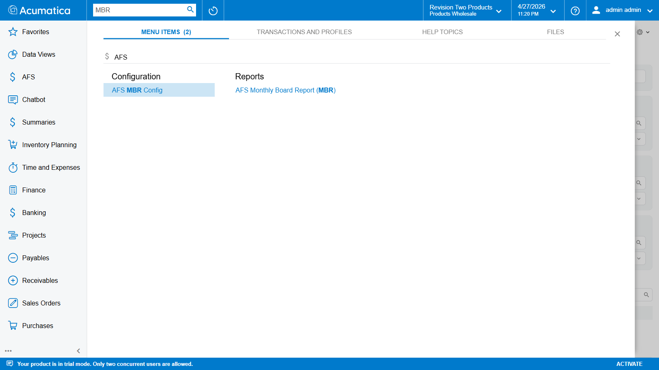
Top search showing AFS MBR Config and AFS Monthly Board Report results
The screen opens in New Record mode with an empty header and an empty Columns grid. Two screen-specific buttons sit above the grid:
- Detect Columns — disabled until Generic Inquiry is set. Calls OData against the chosen GI, captures the runtime column list, and stores it on the record so the column selectors below show real OData property names.
- Test Fetch — runs the full data source against live data using a year / month / branch / org / ledger filter you provide in a dialog, prints every resulting placeholder + value to the trace log and an in-screen dialog. Use it to sanity-check the configuration before wiring it into a presentation.
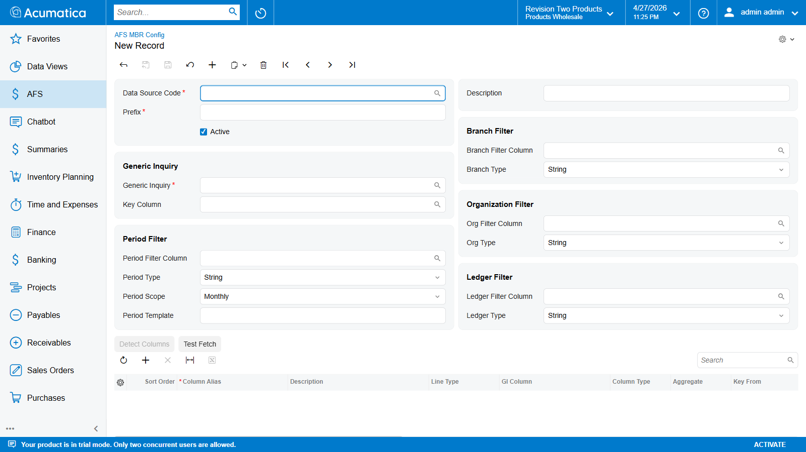
FR101004 landing — empty New Record with all field groups visible

Step 2 — Fill the Identity & Description
Type values into the four identity-group fields:
Field | Required | Notes
Data Source Code | yes (key) | Unique identifier, max 50 chars. Locked after first save.
Prefix | yes | 2–10 alphanumeric chars. Namespaces every placeholder this row emits. Must be globally unique across all MBR Definitions and Report Definitions.
Active | default ✓ | Uncheck to hide the data source from downstream screens without deleting it.
Description | no | Free-text label, max 255 chars. Shown in the selector.
Once filled the screen breadcrumb updates to show the new code (DEMODOCS):
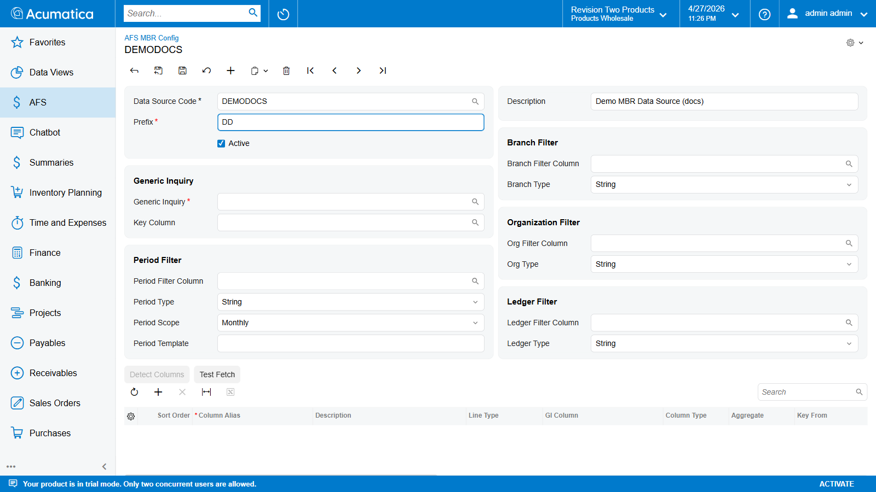
Header — Data Source Code, Prefix, Description filled

Step 3 — Pick the Generic Inquiry
Click the magnifier next to Generic Inquiry (or focus the field and press F3). The selector lists every published GI in the tenant; type into the Search box at the top to narrow the list.
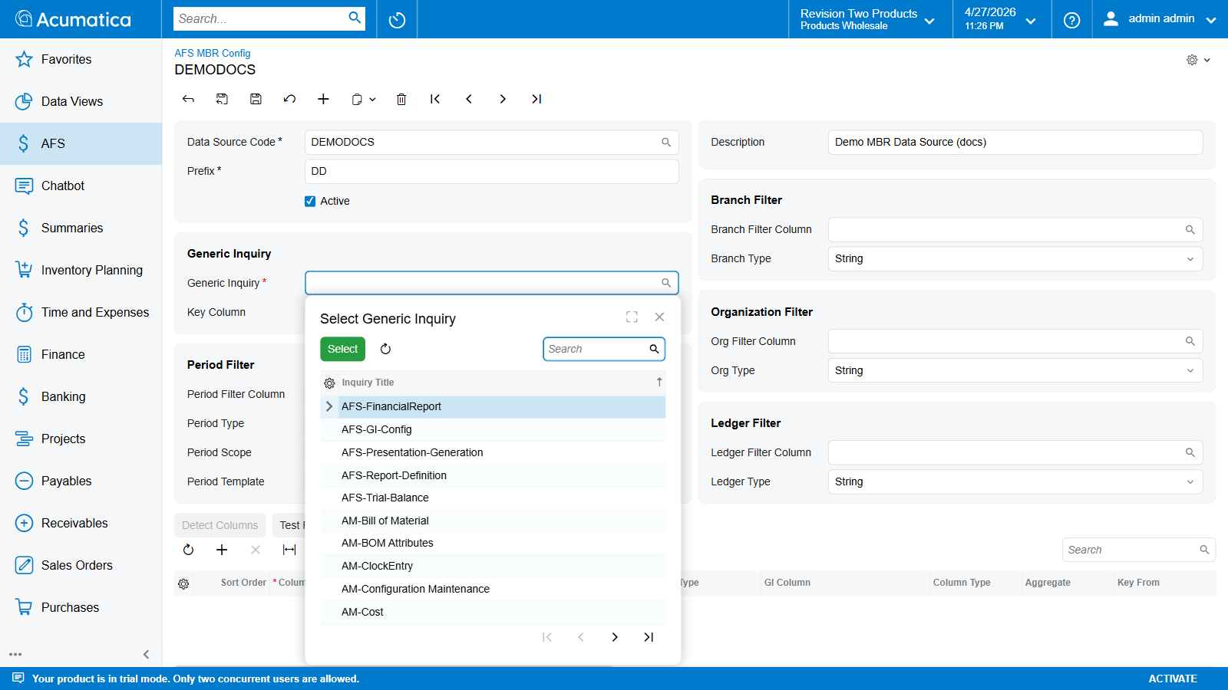
Generic Inquiry selector — search filter “PO-Purchase” showing matching GIs
Double-click the GI you want — for the example we pick PO-PurchaseOrder. The header now shows it bound to that GI, and Detect Columns turns on:
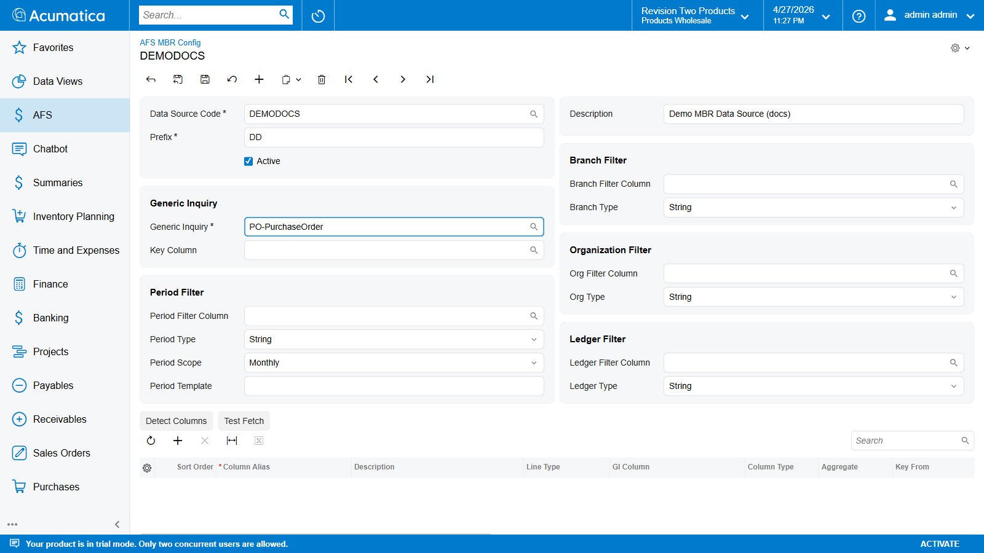
Generic Inquiry picked — Detect Columns now enabled
Key Column is optional and identifies which GI column is the row “key” (analogue of Account in Trial Balance). It only matters if column rows below set Key From / Key To ranges.

Step 4 — Detect Columns
Click Detect Columns. The graph opens an OData connection to the chosen GI, captures the runtime column list, stores it on the hidden DetectedColumns field, saves the record, and shows the result in a dialog:
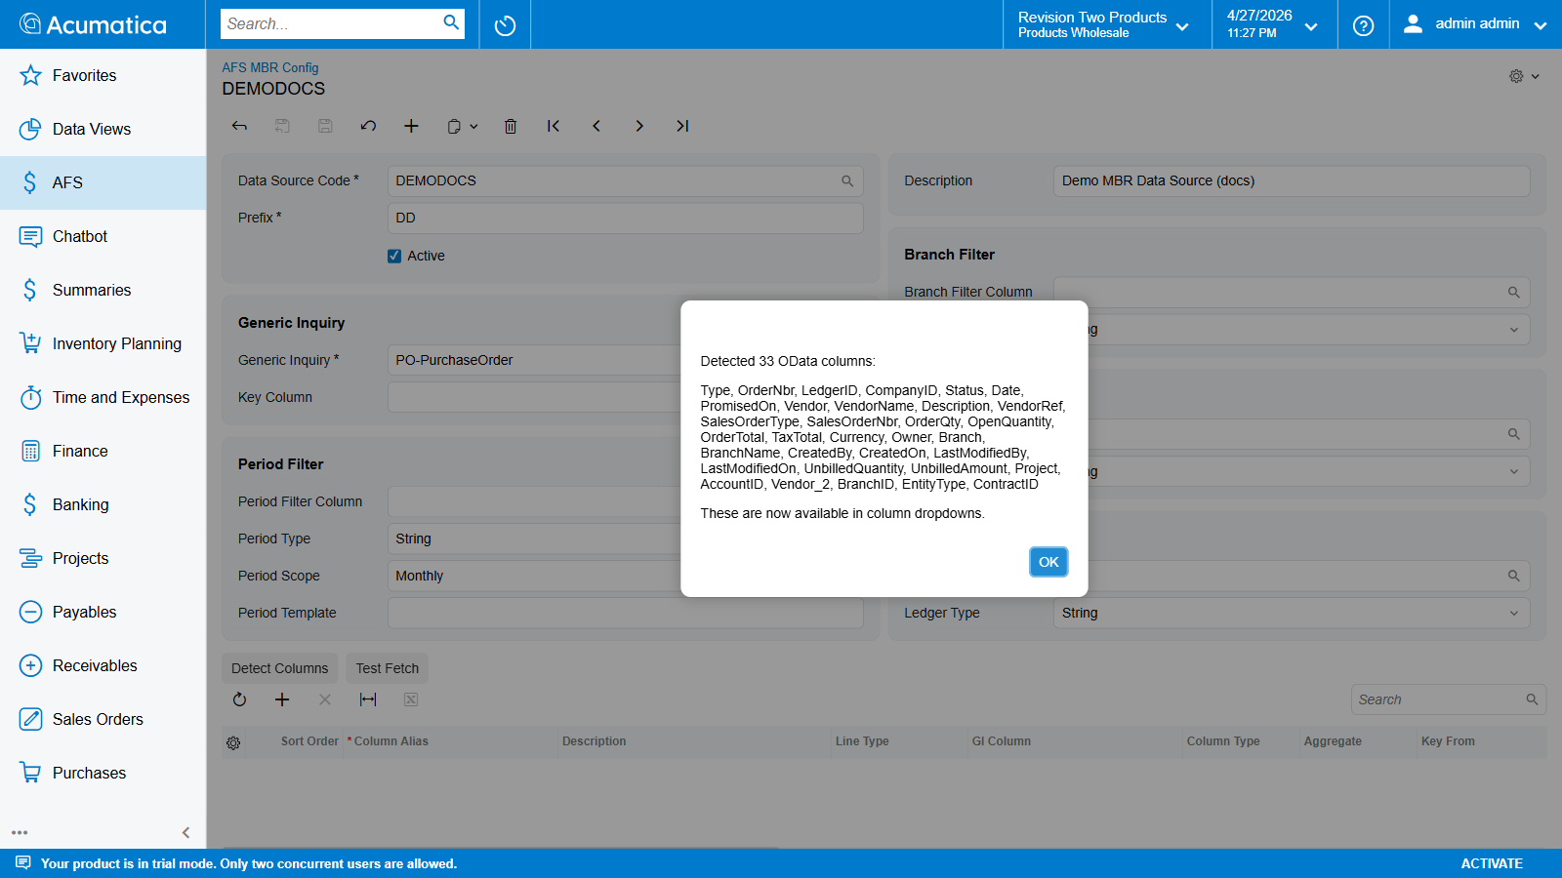
Detect Columns dialog — 33 OData columns from PO-PurchaseOrder
After clicking OK, every “GI Column” / “Filter Column” selector below now shows the real OData property names captured from the live GI.
Note: the action also persists the record — Data Source Code and Prefix are key-locked from this point on. If you need to change either, delete the record and recreate it.

Step 5 — Configure the Period Filter
The Period Filter group tells the engine which GI column carries the period and how to format the OData predicate when the presentation fires. All four fields are optional — leave Period Filter Column blank to skip period filtering entirely.
Field | Notes
Period Filter Column | The GI column the engine adds to the OData $filter clause. Selector lists the columns Detect Columns captured.
Period Type | How to format the OData predicate value. String / Integer / Decimal / Date / Boolean.
Period Scope | How wide a window the period covers. Exact = eq <value> (Trial Balance-style strings like "012025"); Monthly = ge first-of-month and lt first-of-next-month (Date columns); Yearly = whole-year range.
Period Template | Builds the value from the presentation header. Tokens: {YEAR}, {MONTH}. Examples: {MONTH}{YEAR} → "012025", {YEAR}-{MONTH} → "2025-01", {YEAR} → "2025". For a Date column with Monthly scope the engine ignores the template and uses the period boundaries.
For a PO-PurchaseOrder example the Date column with Period Type = Date and Period Scope = Monthly is the right shape:
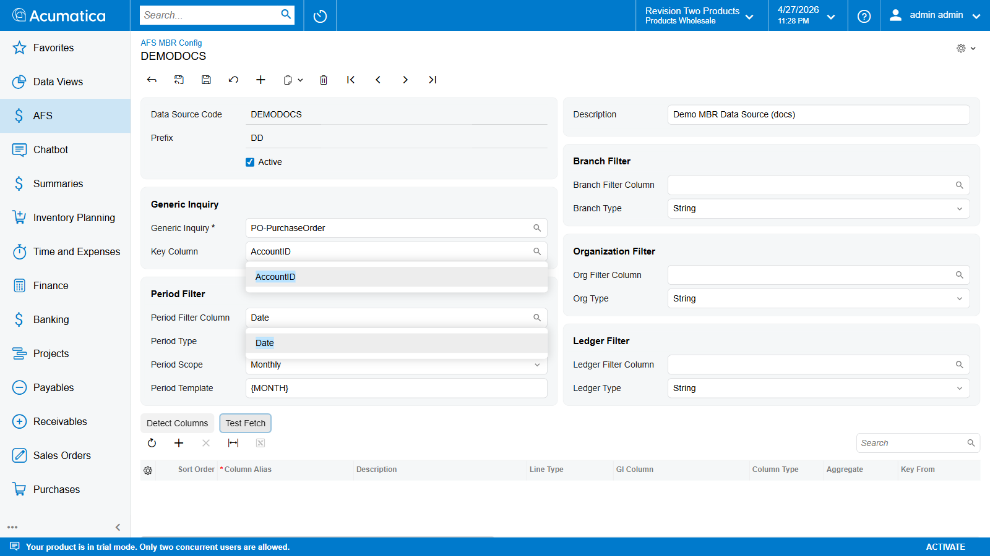
Configuring Period Filter — Date column, Date type, Monthly scope, autocomplete dropdowns

Step 5b — Configure the Dimension Filters (Branch / Organization / Ledger)
Three companion groups on the right side of the header — Branch Filter, Organization Filter, Ledger Filter — narrow the GI rows by dimension. They are independent of the Period Filter and of each other.

What each field does
Each group has the same two-field shape:
Field | Purpose
<X> Filter Column | The GI column the engine adds to the OData $filter clause for this dimension. Blank = no $filter predicate is added for this dimension.
<X> Type | How to format the predicate value when the engine substitutes the user-supplied value. String (wraps in single quotes — eq 'HQ'), Integer / Decimal (no quotes — eq 2), Date (ISO literal — eq 2026-04-01T00:00:00), Boolean (true/false). Pick the type that matches the OData property’s actual type — wrong type produces a 400 from OData.

Where the run-time values come from
The Filter Column and Type are configuration only — they declare the schema. The actual value to filter on is supplied at run time:
Caller | Source
Test Fetch dialog (this screen) | The Branch / Organization / Ledger text boxes you fill in the dialog.
Generate Presentation on FR101003 | The presentation header’s Branch / Organization / Ledger fields.
Whichever dimension fields the caller leaves blank become inactive for that run — the engine simply omits the predicate.

How the predicates combine
Every active filter is AND-combined into the single $filter clause sent to the GI:
($filter = <PeriodPredicate>
and <BranchPredicate>
and <OrgPredicate>
and <LedgerPredicate>
and <Per-row Key Range from each Column row>
and <Per-row Row Filter from each Column row>)
Worked example — Test Fetch supplies Branch = MAIN, Organization = CENSOF, Ledger = 2; the column row also sets Status eq 'Closed' as its Row Filter:
$filter=Date ge 2026-04-01T00:00:00 and Date lt 2026-05-01T00:00:00
and BranchID eq 'MAIN'
and OrganizationID eq 'CENSOF'
and LedgerID eq 2
and Status eq 'Closed'
Type-mismatch trap. Setting Branch Type = Integer but pointing Branch Filter Column at a string column produces an OData 400 error at fetch time, not a save-time validation error. If Test Fetch fails with Bad Request — Invalid filter expression, the wrong Type dropdown is the first thing to check.

Step 6 — Add Column Rows
Each column row in the grid produces one output placeholder (or a set of placeholders for MULTIROW lines). Click + on the grid toolbar to add a row. The new row appears with default values: Sort Order = 0, Line Type = Value (from GI), Column Type = Decimal, Aggregate = Sum, Visible = ✓.
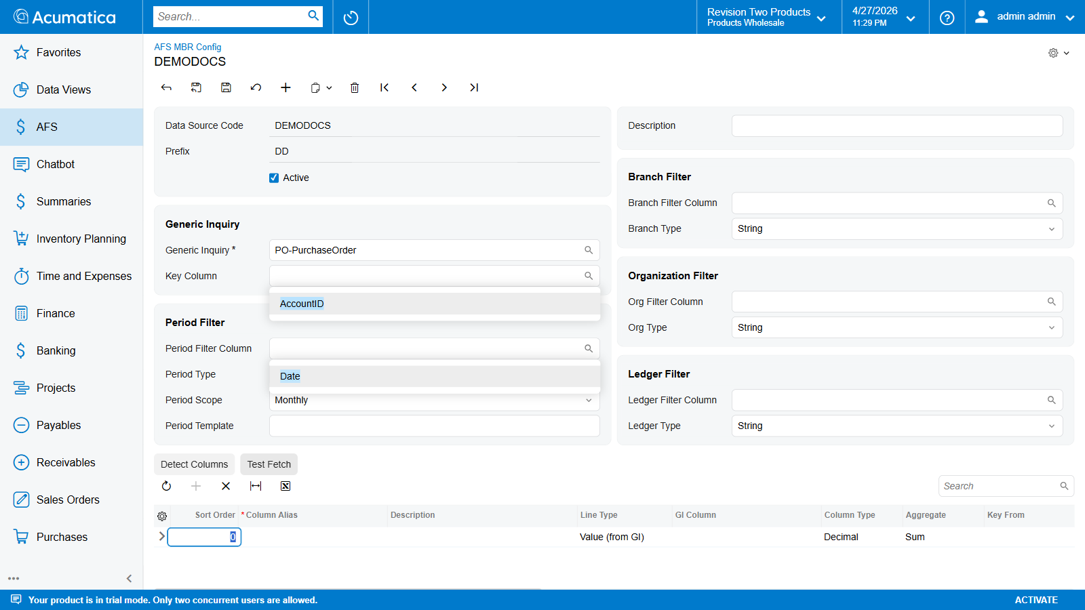
Empty column row inserted with defaults
The grid has 17 columns. Their relevance depends on LineType — fields that don’t apply to the current type are auto-disabled by the graph.

Common columns
Column | Required | Notes
Sort Order | default 0 | Display order in the grid and in the markdown preview. Does not drive evaluation order — that uses topological sort.
Column Alias | yes | Unique within the data source. Allowed chars: letters, digits, underscore. Forms the placeholder key.
Description | optional | Human-readable label. Shown as the row label in the markdown preview.
Line Type | yes | One of four — see table below.
Visible | default ✓ | Uncheck to calculate but not emit. Useful for intermediate VALUE rows that only exist as inputs to a CALCULATED row. Disabled (and forced false) on HEADING rows.
Format String | optional | Standard .NET format string applied at the final write step. See Format String reference below.

Line Type values
Click the Line Type cell to open the dropdown:
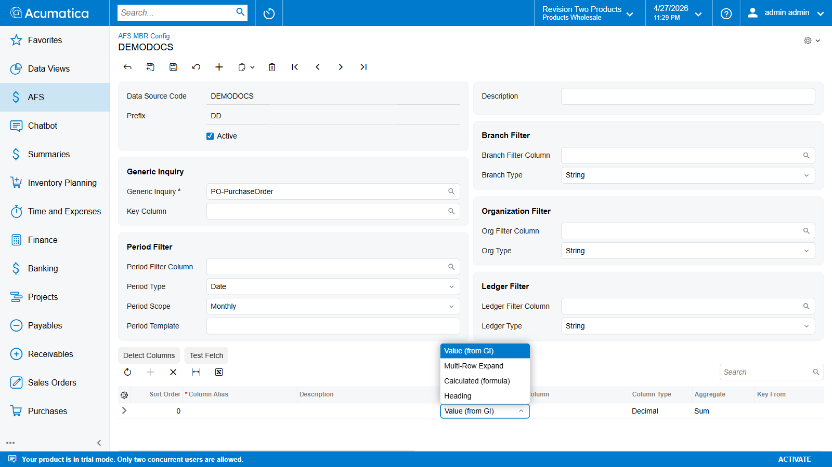
Line Type dropdown — Value (from GI) / Multi-Row Expand / Calculated (formula) / Heading
Code | Label | What it does
VALUE | Value (from GI) | Read GI Column, aggregate matching rows with Aggregate. Single placeholder.
MULTIROW | Multi-Row Expand | Sort rows by Order By Column, take the top Row Limit, expand each row into placeholders keyed {{<Prefix>_<ColumnAlias>_<N>_<GICol>}}.
CALCULATED | Calculated (formula) | Evaluate Formula at run time — arithmetic over other Column Aliases (+ - * /, parentheses).
HEADING | Heading | Label only. Emits no placeholder; sets Visible = false; disables every value-related field.

VALUE-line columns
Editable when LineType = VALUE:
Column | Notes
GI Column | The OData property to read. After Detect Columns runs, the dropdown shows the real GI columns.
Column Type | How to parse the JSON value. Decimal / Integer / Boolean / Date / String.
Aggregate | How to combine multiple matching rows — see Aggregate table below.
Key From / To | Inclusive range over the parent’s Key Column.
Row Filter (OData) | Free-text OData predicate AND-combined with header filters.
Click the Aggregate cell — 6 functions:
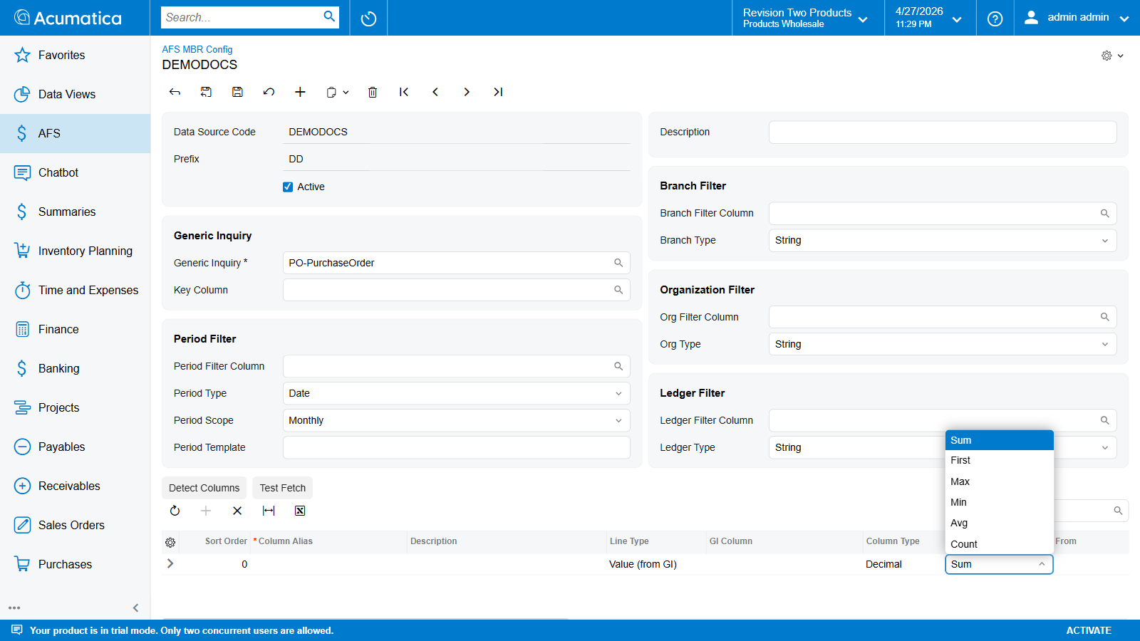
Aggregate dropdown — Sum / First / Max / Min / Avg / Count
Code | Works on | Returns
SUM | Decimal / Integer / Boolean (counts trues) | Total of values across matching rows. Empty result set → 0.
FIRST | any | First matching row’s value.
MAX | Decimal / Integer / Date | Largest value.
MIN | Decimal / Integer / Date | Smallest value.
AVG | Decimal / Integer | Arithmetic mean.
COUNT | any | Number of matching rows. The column value is ignored.

Row Filter (OData) — common patterns
Goal | Row Filter
Only closed orders | Status eq 'Closed'
Open orders above $1,000 | Status eq 'Open' and OrderTotal gt 1000
Multiple statuses | Status eq 'Open' or Status eq 'Pending'
Vendor name contains “Acme” | contains(VendorName,'Acme')
Created since a date | CreatedOn ge 2025-01-01T00:00:00
Field is null | Description eq null
Boolean true | IsActive eq true
Operators supported: eq, ne, lt, le, gt, ge, and, or, not, plus contains / startswith / endswith / tolower / toupper.
Quoting rules: - String literals: single quotes — 'Closed'. Embed a single-quote by doubling it ('O''Brien'). - Numeric literals: bare — 1000, 4.5. - Date literals: ISO format with no quotes — 2025-01-01T00:00:00. - Boolean literals: true / false (lowercase, no quotes). - Column names: bare (no quotes around the property name).

MULTIROW-line columns
Editable when LineType = MULTIROW. Key From / To and Row Filter also apply.
Column | Notes
Order By Column | GI column to sort rows by before slicing. Required for MULTIROW.
Sort Direction | Descending (default) or Ascending.
Row Limit | How many top rows to expand. Default 10. Keep ≤ 50 for templates.
Display Columns (markdown) | Comma-separated GI column names to include in the markdown preview only.
A MULTIROW row produces one set of placeholders per ranked row:
{{PO_TOPVEND_1_Vendor}} → "ACME-001"
{{PO_TOPVEND_1_OrderTotal}} → "150,000"
{{PO_TOPVEND_2_Vendor}} → "BIGCO-002"
{{PO_TOPVEND_2_OrderTotal}} → "120,000"
{{PO_TOPVEND_3_Vendor}} → "WIDGET-003"
{{PO_TOPVEND_3_OrderTotal}} → "98,500"

CALCULATED-line columns
Editable when LineType = CALCULATED:
Column | Notes
Formula | Arithmetic over other Column Aliases in this same data source. Operators: +, −, *, /, parentheses. Cross-data-source references are not supported on FR101004 — keep the formula scoped to one data source.
Examples:
REVENUE - COST → gross margin
(REVENUE - COST) / REVENUE → margin ratio
TOTAL_OPEN + TOTAL_PENDING → backlog rolling total

Format String reference
Format String is a standard .NET ToString(format) string applied to the final value just before it lands in the placeholder dictionary.
Type | Format | Input → Output
Numeric | N0 | 1234567.89 → 1,234,568
Numeric | N2 | 1234567.89 → 1,234,567.89
Numeric | #,##0 | 1234567.89 → 1,234,568
Numeric | C0 | 1234567.89 → $1,234,568
Numeric | P0 | 0.42 → 42 %
Numeric | P1 | 0.425 → 42.5 %
Date | yyyy-MM-dd | → 2026-04-28
Date | dd MMM yyyy | → 28 Apr 2026
Date | MMM yyyy | → Apr 2026

Step 7 — Save and Test Fetch
Press Ctrl+S (or click the toolbar Save button). The graph runs validation; persistence is blocked until the offending field is fixed.
After save, click Test Fetch to verify the configuration end-to-end against live data. A dialog asks for the period plus optional dimension filters:
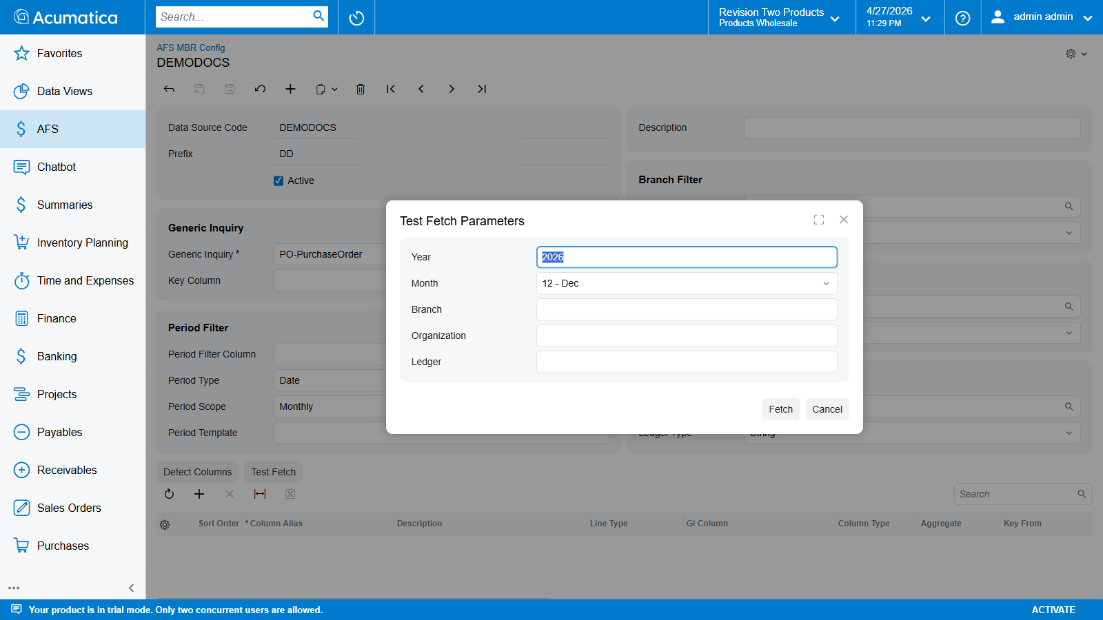
Test Fetch Parameters dialog — Year / Month / Branch / Organization / Ledger
Field | Default | Notes
Year | 2026 | Required. Fed into the {YEAR} token in Period Template.
Month | 12 - Dec | Optional. Fed into {MONTH} (zero-padded).
Branch | blank | Optional value for the Branch Filter Column.
Organization | blank | Optional value for the Org Filter Column.
Ledger | blank | Optional value for the Ledger Filter Column.
Click Fetch. The engine builds the OData query, calls the GI, aggregates per VALUE column, evaluates CALCULATED formulas, expands MULTIROW rows, then displays every resulting {{Placeholder}} = value pair in a dialog (also written to the trace log).

Step 8 — (Optional) Discard / Delete
To remove a record, click the Delete icon on the toolbar. Acumatica asks for confirmation: “The current FLRT GI Data Source record will be deleted.” — click Confirm. The screen returns to New Record mode:
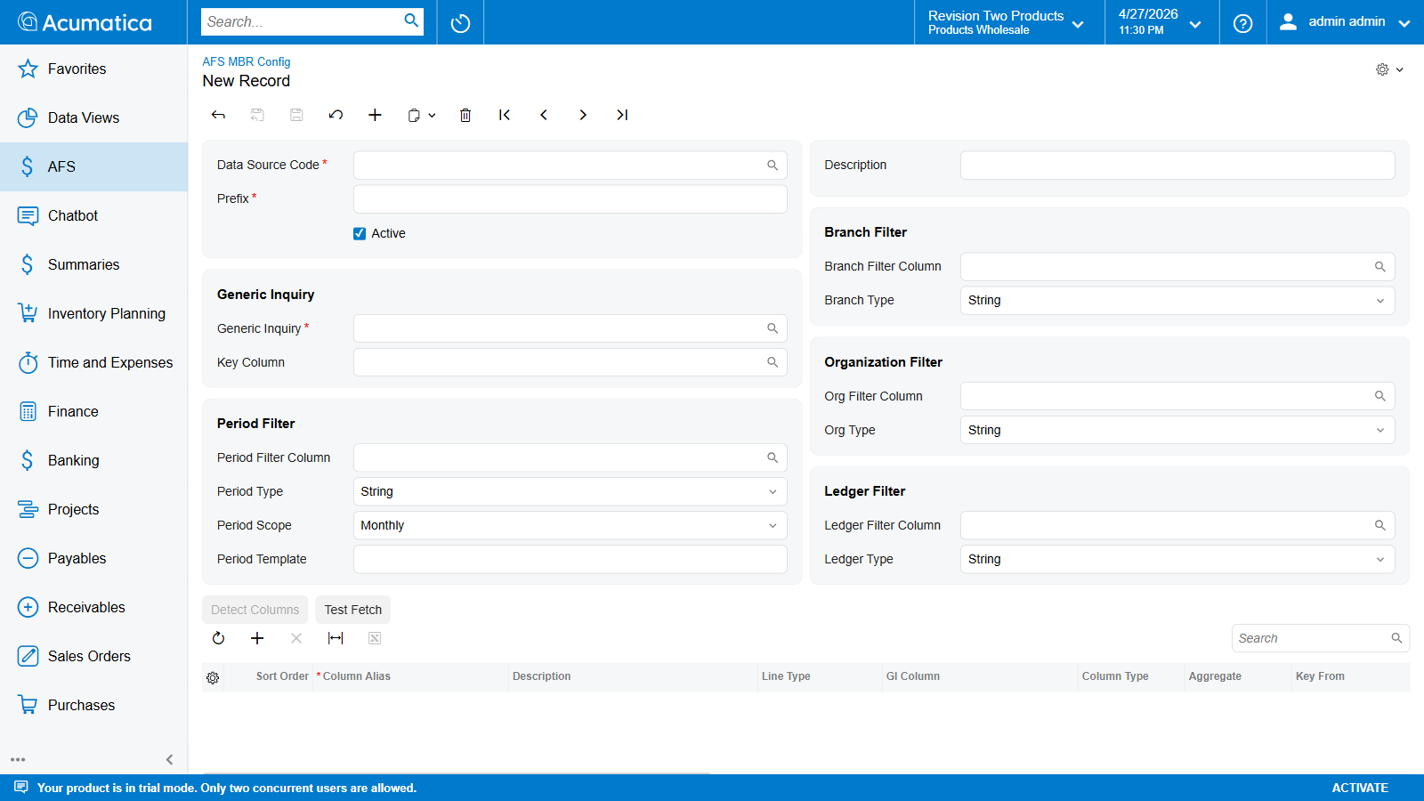
Clean state after delete — New Record with empty fields

Validation Errors

Header (FLRTGIDataSource)
Check | Error message
Data Source Code required | Data Source Code is required.
Prefix required | Prefix is required.
Prefix must match ^[A-Za-z0-9]+$ | Prefix must contain only letters and digits.
Prefix unique across all MBR Definitions | Prefix must be unique across all GI Data Sources.

Columns (FLRTGIDataSourceColumn)
Check | Error message
Column Alias required | Column Alias is required.
VALUE lines must have a GI Column | GI Column is required for Value lines.
CALCULATED lines must have a Formula | Formula is required for Calculated lines.
Column Alias unique within the data source | Column Alias must be unique within the data source.

Chapter 5: Financial Report Generation (FR101000)
This chapter describes how to generate a financial report from the AFS Financial Report screen. Each record on this screen represents a single run of the Word-template merge engine: you pick a period, a Word template with {{PLACEHOLDER}} tokens, one or more Report Definitions (built in Chapter 3), and the engine fills every placeholder with the calculated GL figure and produces a downloadable .docx.
One record = one generated file. Status on the header tells you where the run is in its lifecycle.

Prerequisites
- Tenant credentials saved in Chapter 2 — Tenant Credentials (FR101001). The generator uses them to read GL data through the same tenant the screen is opened in.
- At least one Report Definition created in Chapter 3 — AFS Report Definition (FR101002). The definition supplies the placeholders ({{<Prefix>_<LineCode>_CY}} and {{<Prefix>_<LineCode>_PY}}) that the template file will reference.
- A Word template (.docx) whose filename contains the literal token FRTemplate (for example AFS-SalesDemo-Test_FRTemplate.docx). The loader matches on that substring when resolving which attached file to merge.
- Fiscal periods open for the Current Year you intend to report on. The selector only lists years that exist in FinPeriod.

Steps

Step 1 — Navigate to the Financial Report screen
In the top search bar type Financial Report and select AFS Financial Report under the AFS workspace. The landing page opens in New Record mode with an empty header and an empty Report Definitions grid.
Screen ID: FR101000
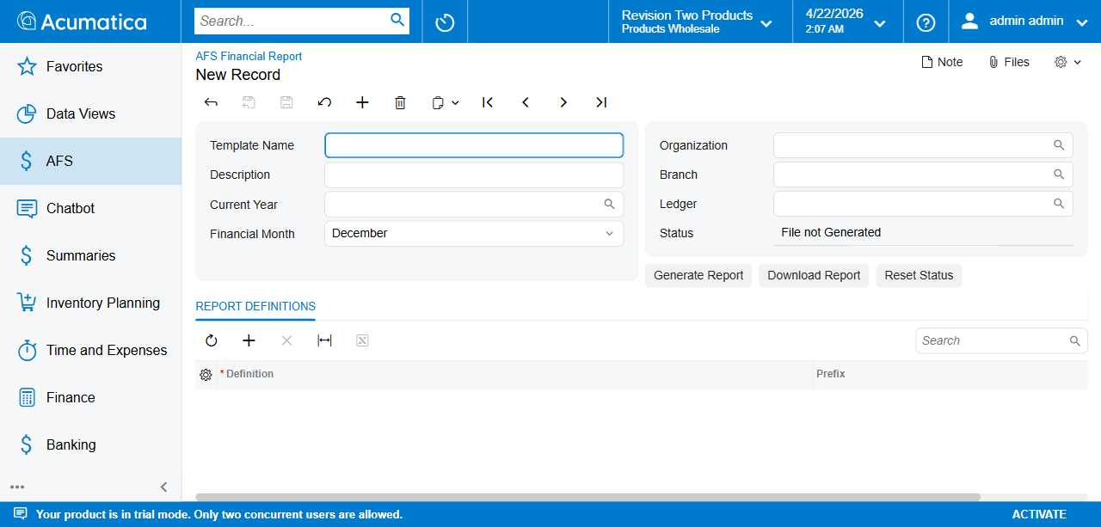
AFS Financial Report landing screen
The toolbar at the top carries the standard Acumatica navigation. Directly underneath are the three action buttons wired on this screen:
- Generate Report — kicks off the background merge job.
- Download Report — returns the most recently produced .docx.
- Reset Status — clears a stuck In Progress or a Failed run back to Pending so it can be re-run.

Step 2 — Create a new record
Click + (Add) in the toolbar. All header fields clear; Status defaults to File not Generated (the UI label for Pending). Nothing is committed until you save.

Step 3 — Fill the header
The header is split into two column groups. The left group identifies the report and the period; the right group scopes the GL data and carries the run state.
Field | Required | Example | Notes
Template Name | yes | BS Annual Report 2024 | Free-text code identifying this report run, up to 225 chars. Shown in the FR401000 list. Not the Word filename — this is the record name.
Description | no | Balance Sheet for December 2024 | Free-text label, up to 50 chars.
Current Year | yes | 2024 | Fiscal year the report runs for. The dropdown is populated from distinct FinPeriod.FinYear values, sorted descending.
Financial Month | yes | December | Month-of-year (01–12). Defaults to 12 (December). Sets the period end for the FY-to-date window every linked Definition reads. Same window is used for the _PY pass against the prior year.
Organization | no | PRODUCTS | Optional filter. Blank = all organizations the tenant can see.
Branch | no | PRODWHOLE | Optional filter. Blank = all branches.
Ledger | no | ACTUAL | Optional filter. Blank = all ledgers.
Status | — | read-only | Lifecycle field, managed by the engine — see the Status lifecycle section below.

Step 4 — Pick the Current Year
Click the magnifier next to Current Year to open the selector. It shows every distinct FinYear on file (latest first). Double-click a row, or type the year directly into the field and press Tab.
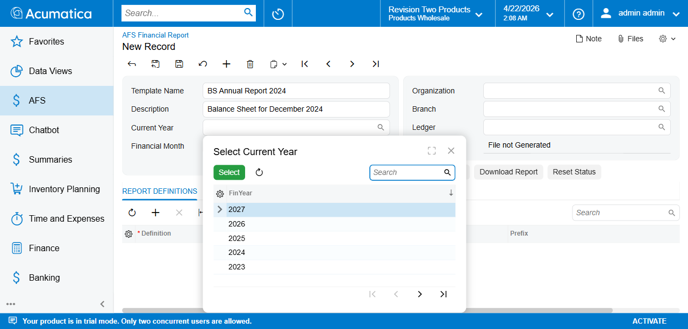
Current Year selector — 2023 through 2027

Step 5 — Pick the Financial Month
Financial Month is a fixed dropdown (January … December). It defines the period end of the fiscal-year-to-date window the engine reads. Every line item in every linked Definition resolves twice — once for _CY, once for _PY — against this same FY-to-date window:
- _CY — fiscal-year-to-date through end of the selected month, in the Current Year.
- _PY — fiscal-year-to-date through end of the same month, in the previous fiscal year.
There is no single-period (month-only) placeholder. If a month-only delta is needed, compute it inside the Word template ({{PFX_X_CY}} - {{PFX_X_PY}}) — formulas inside a Definition cannot mix periods.
Default is December (month 12) so annual statements need no change.
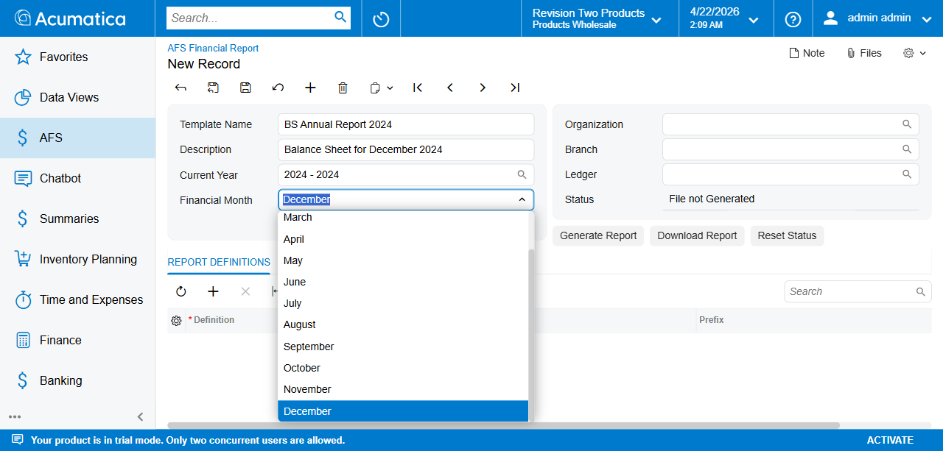
Financial Month dropdown open

Step 6 — Scope the GL data (Organization / Branch / Ledger)
The right-hand column group narrows which GL rows the linked Report Definitions see. Each field is optional.
Field | Selector source | Example
Organization | Organization.OrganizationCD | PRODUCTS
Branch | Branch.BranchCD | PRODWHOLE
Ledger | Ledger.LedgerCD | ACTUAL
The three filters are AND-combined with any per-line filters set inside the Report Definition. The header values act as a hard upper bound; per-line filters may further narrow, never widen.
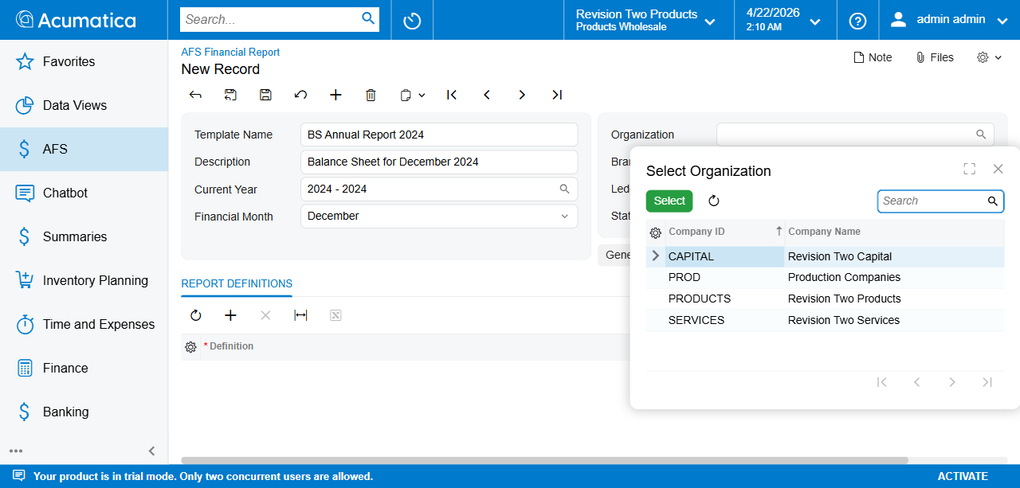
Organization selector
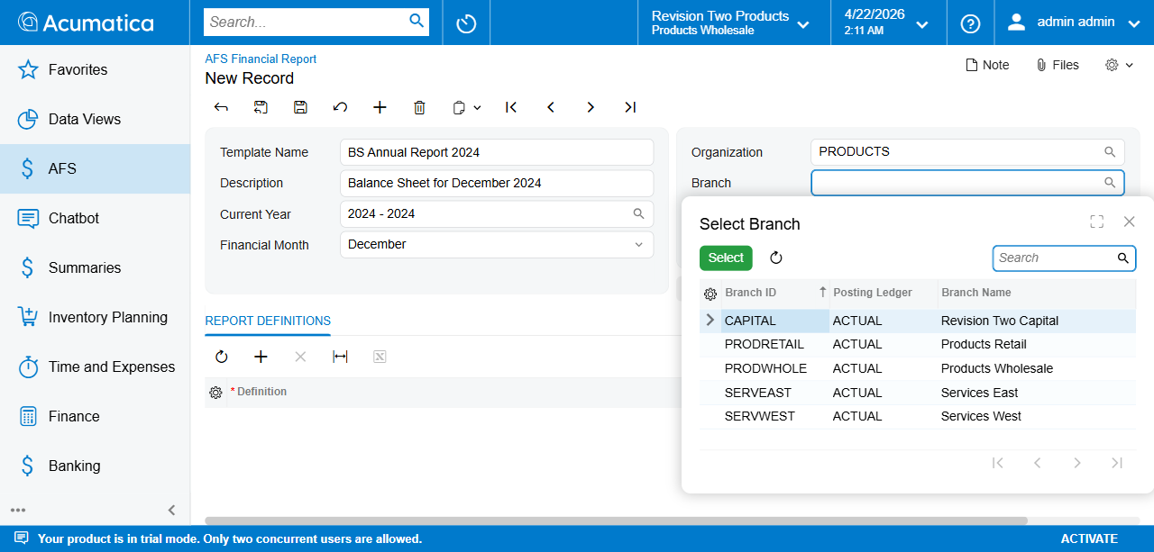
Branch selector
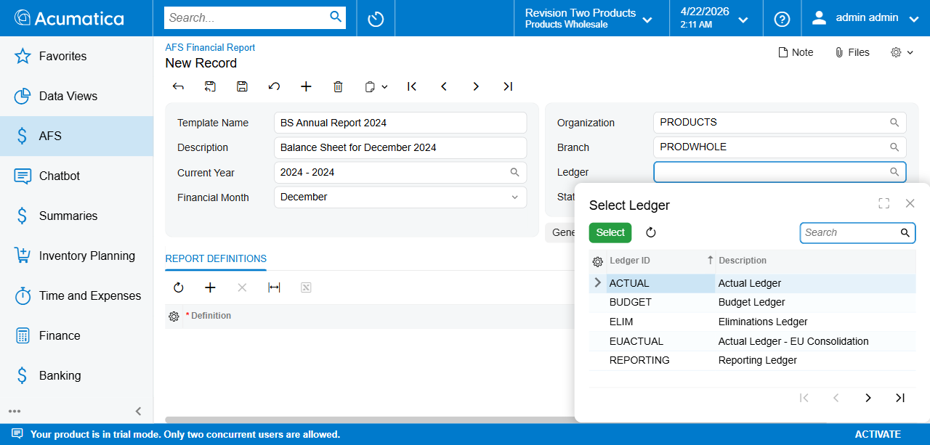
Ledger selector
Once all header fields are populated the form looks like the below. Save (Ctrl+S) before attaching files or adding definitions:
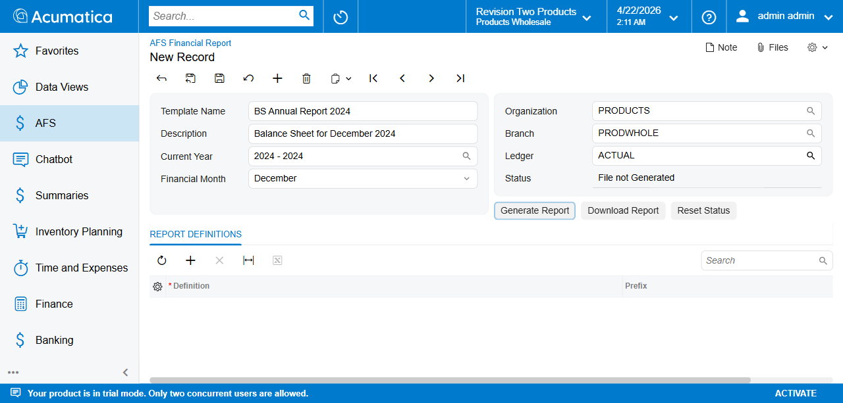
Header fully filled

Step 7 — Attach the Word template
Click the Files button (paperclip icon, top-right). An empty Files dialog opens.
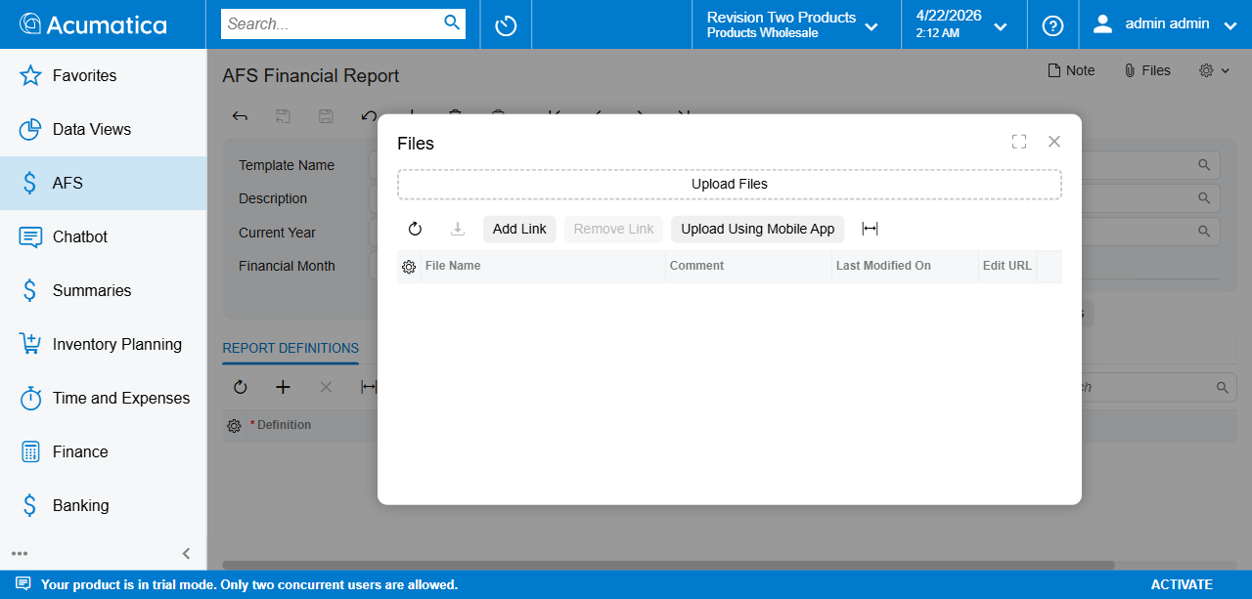
Empty Files panel
Click Browse (or drag-drop), pick your .docx, and upload. The filename must contain the substring FRTemplate — the generator scans the attached files on this record and picks the first one whose name matches. Example: DemoTemplate_FRTemplate.docx or BS2024_FRTemplate.docx.
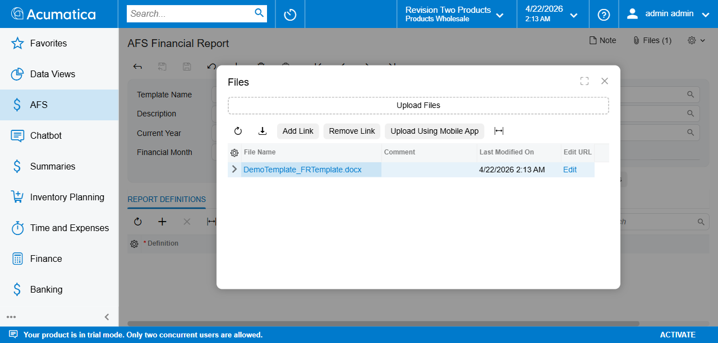
Files panel populated with the FRTemplate docx
The Files button badge shows the attachment count (Files(1)). You can upload additional supporting files — only the one matching FRTemplate is merged; others are ignored.

Step 8 — Link one or more Report Definitions
Switch to the REPORT DEFINITIONS tab below the header. This child grid is what tells the engine which definitions to run against the Word template. Every row adds another block of placeholders to the merge dictionary.
Click + on the grid toolbar to add a blank row.
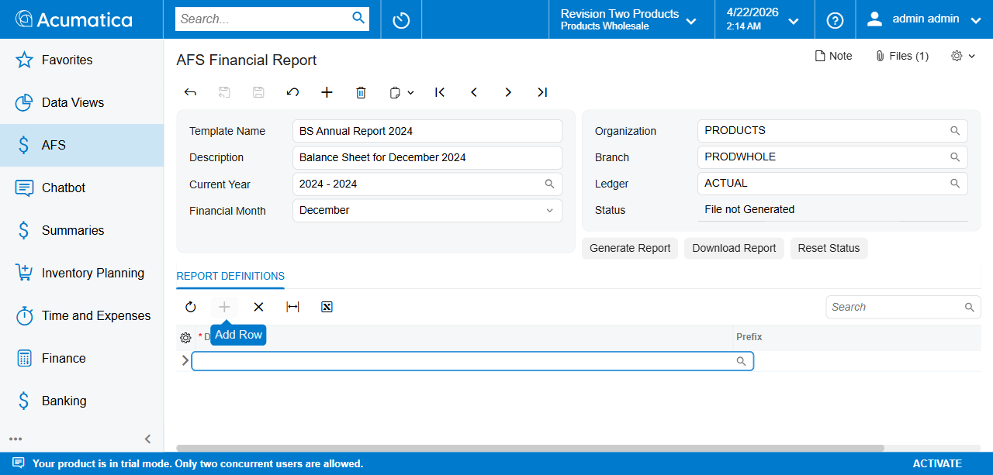
Empty grid row added — Add Row action highlighted
With the row focused, press F3 (or click the magnifier) in the Definition cell. The selector opens and lists every definition marked Active on FR101002.
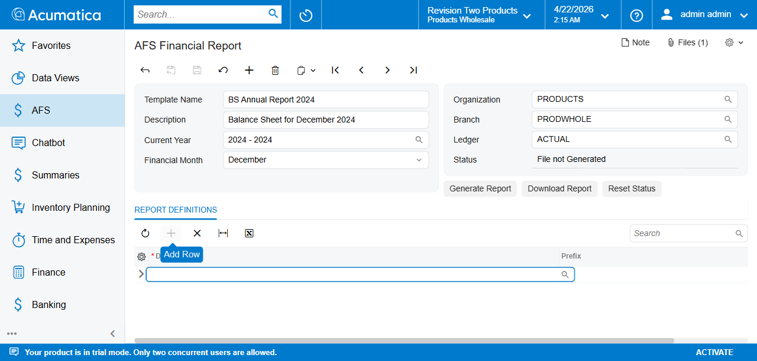
Definition selector — GENERIC (GC) and MON-REP (MR)
Pick the definition you want. The Prefix column on the grid fills automatically and is read-only here.

Why link more than one definition?
The merge engine concatenates the placeholder dictionaries from every linked definition before scanning the template. That means a single report can mix, say, a Balance Sheet definition and a P&L definition — the template just references both prefixes ({{BS_CASH_CY}} and {{PL_REVENUE_CY}}). Cross-definition CALCULATED lines are supported.

Step 9 — Save
Press Ctrl+S. The graph does not validate header completeness at save time. Validation is deferred to Generate Report, which throws if Template Name is missing, no Definition is linked, or no *FRTemplate*.docx file is attached. Fill the header before clicking Generate to avoid an immediate failure.

Header actions
The three buttons below the header are the only way to drive the lifecycle of a report record.

Generate Report
Queues a background job that reads the GL data for the chosen period, evaluates every Line Item in every linked Definition, merges the resulting dictionary into the attached FRTemplate Word document, and writes the output back onto the record.
Status immediately transitions to In Progress. The job runs under PXLongOperation with a 15-minute timeout; you can navigate away from the screen and come back — Status will update on refresh.

Download Report
Returns the last successfully generated .docx attached to this record. The button is hard-disabled only while a generation is In Progress; in all other states it is clickable but throws “No generated file is available for download.” if no file has ever been produced. Effectively this means: only useful when Status = Ready to Download.

Reset Status
Clears a stuck or failed run so the record can be re-queued. The button opens a confirmation dialog showing the current status:
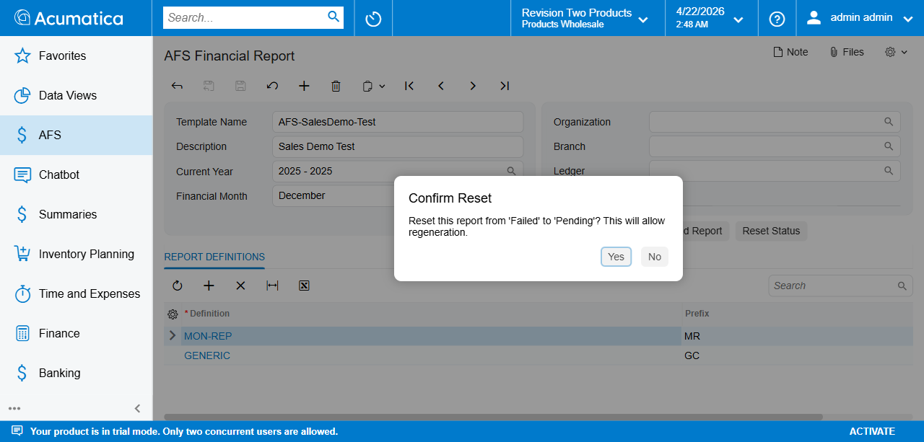
Reset Status confirmation dialog
Dialog message — Reset this report from '<Current Status>' to 'Pending'? This will allow regeneration.
- Yes — Status moves to Pending (File not Generated) and GeneratedFileID is cleared. The previously generated .docx is detached from the record so it cannot be downloaded; the next successful run produces a fresh file. Files panel attachments are not affected.
- No — Status is unchanged.

Status lifecycle
Status is a one-character field on the DAC (FLRTFinancialReport.Status) rendered with user-friendly labels:
DB value | UI label | Meaning
N | File not Generated | Initial state. No .docx attached yet. Generate Report is allowed; Download Report is disabled.
P | In Progress | PXLongOperation job is running. While in this state every header field plus Generate Report and Download Report is disabled — only Reset Status is clickable.
C | Ready to Download | Job finished; merged .docx is stored on the record. Download Report now returns the file.
F | Failed | Job threw — typically a missing placeholder, malformed formula, or template parse error. Check the trace log, fix the cause, then Reset Status → Generate Report.
Note: the DB code for In Progress is P, not IP. The N/P/C/F codes are what land in the Status column on the database; the UI labels above are the user-facing strings.
Pending ──Generate──► In Progress ──success──► Ready to Download
└──error──► Failed ──Reset──► Pending

Worked Example — BS Annual Report 2024
A complete walkthrough of a typical run.

1 — Load or create the record
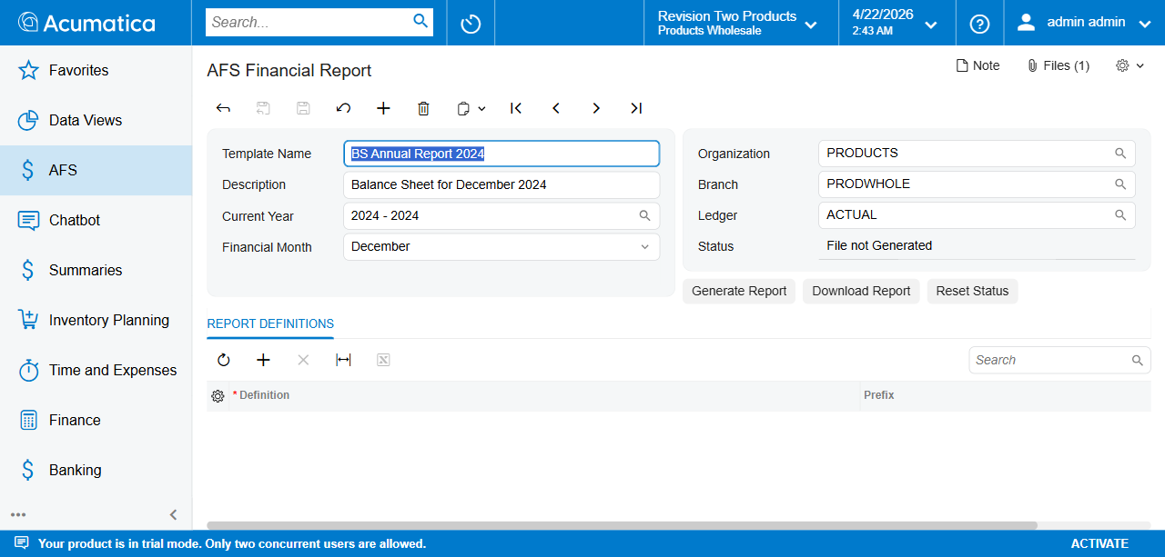
Loaded record — BS Annual Report 2024
Field | Value
Template Name | BS Annual Report 2024
Description | Balance Sheet for December 2024
Current Year | 2024 - 2024
Financial Month | December
Organization | PRODUCTS
Branch | PRODWHOLE
Ledger | ACTUAL
Status | File not Generated

2 — Link the definition
In the Report Definitions grid, add a row and pick GENERIC (Prefix GC):
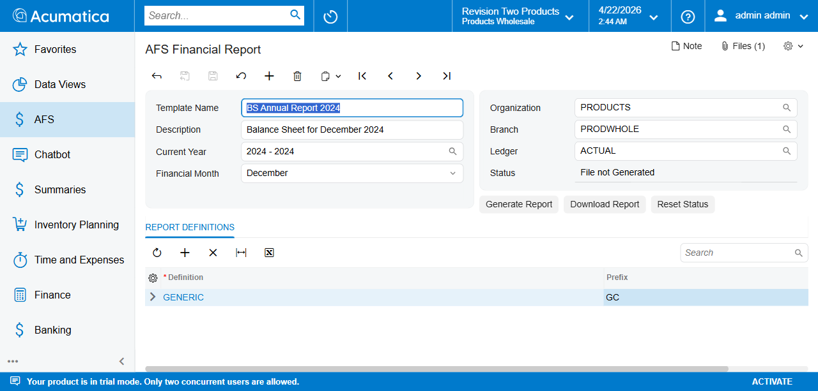
GENERIC definition linked in grid

3 — Attach the template
Open the Files panel and upload BS2024_FRTemplate.docx (or similarly named file containing the FRTemplate token). The Files badge becomes Files(1).

4 — Generate and download
Click Generate Report. Status flips to In Progress. Within a minute or two Status lands on Ready to Download:
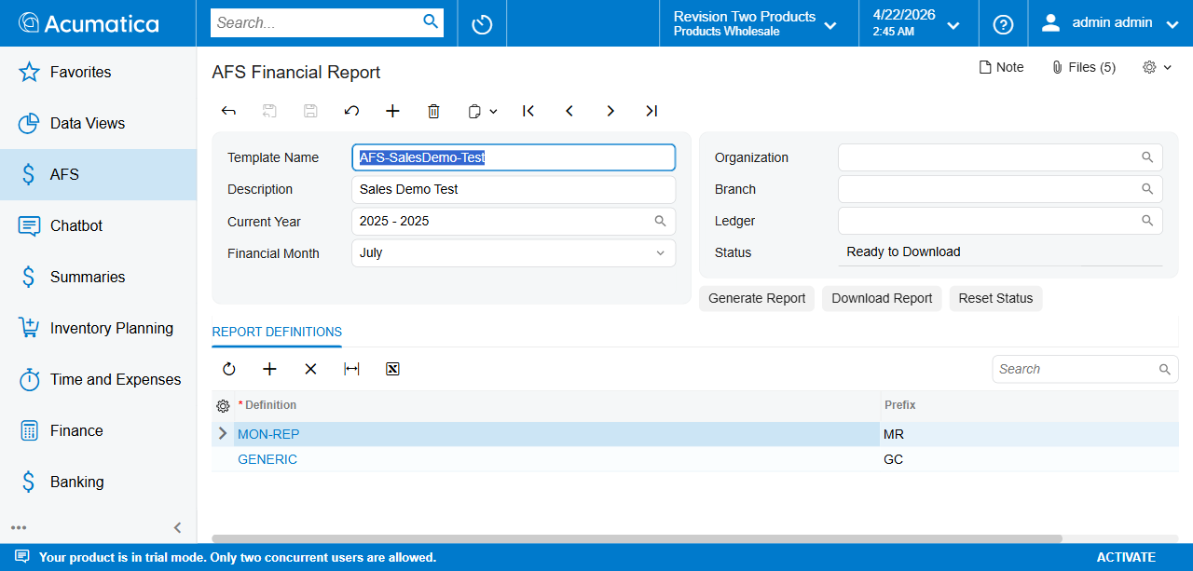
Ready to Download — AFS-SalesDemo-Test example with 2 linked definitions
Click Download Report to pull the merged .docx. Every {{GC_*_CY}} and {{GC_*_PY}} placeholder in the template is now replaced with its calculated figure, rounded per the definition’s Rounding Level / Decimal Places settings.

Worked Example — Recovering from a Failed run
The example below shows a record that threw during generation.
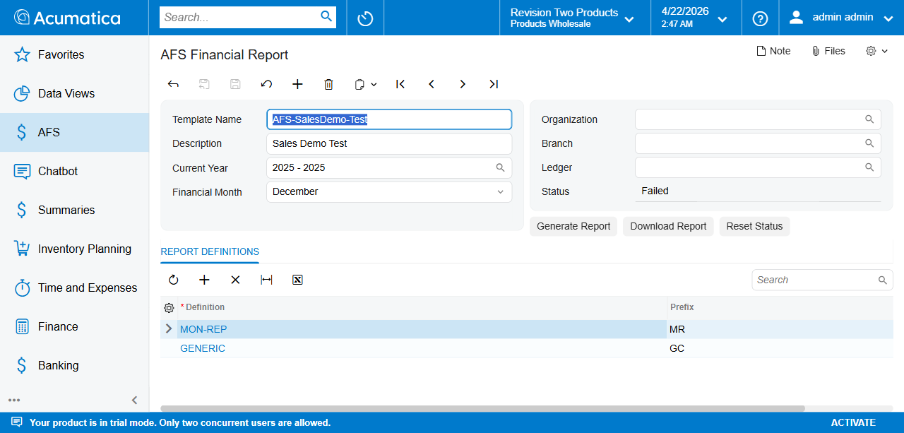
Failed record — AFS-SalesDemo-Test December 2025
To recover:
- Open the record. Read the trace log to identify the error — typical causes are a {{PREFIX_LINECODE_CY}} (or _PY) placeholder in the template with no matching Line Code on any linked definition, or a CALCULATED formula referencing an unknown Line Code.
- Fix the root cause in either the template or the definition.
- Click Reset Status and confirm Yes in the dialog. Status returns to File not Generated.
- Click Generate Report to re-run.

The Records List — FR401000
The companion list screen AFS-Financial-Report (FR401000) shows every record on the system at a glance, grouped by status column.
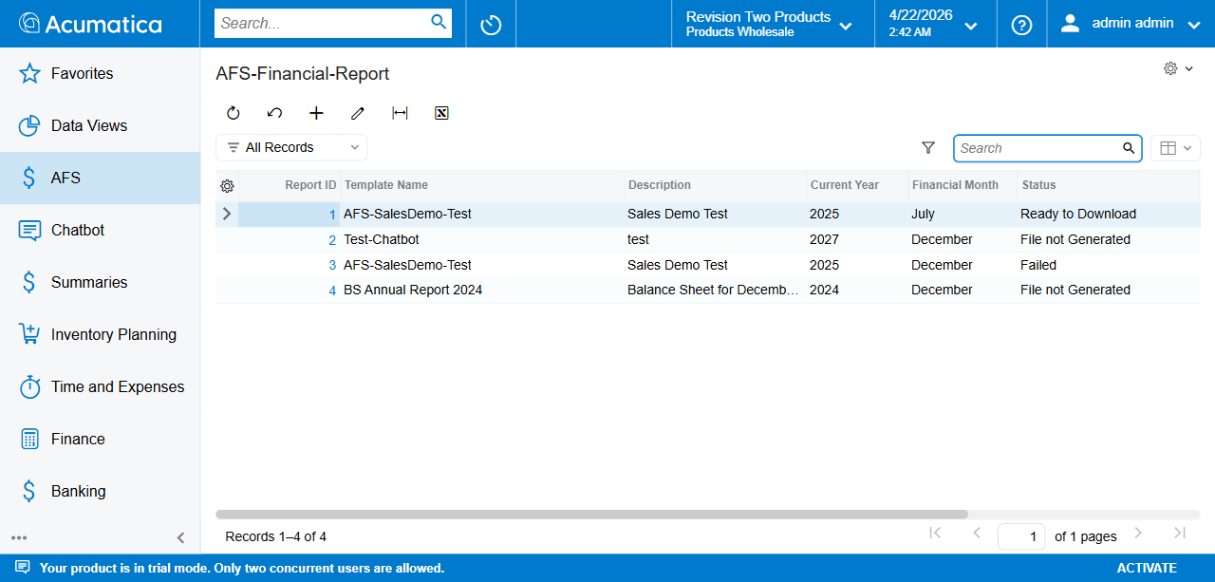
FR401000 records list — all four lifecycle states visible

Chapter 6: MBR Report Generation (FR101003)
This chapter describes how to generate an AI-driven Monthly Board Report (MBR) from one or more linked MBR Definitions (data sources) using the Gamma presentation API. Each record on this screen represents a single run of the markdown-builder + Gamma pipeline:
- The engine resolves every linked MBR Definition (FR101004) against live OData data for the chosen period and dimensions.
- It builds a structured markdown prompt containing the resolved values, audience hints, and the user-supplied title / description.
- It POSTs the markdown to the Gamma API, which returns a generated .pptx file.
- The file is stored on the record and surfaced via the Download Presentation action.
Screen ID: FR101003 Screen Title: AFS Monthly Board Report (MBR) Menu path: AFS → Reports → AFS Monthly Board Report (MBR)

Prerequisites
- Tenant credentials saved in Chapter 2 — Tenant Credentials Setup (FR101001), including the Presentation API Key (Gamma) field. The Generate Presentation action throws Presentation API Key is not configured if it’s blank.
- At least one MBR Definition (FR101004) marked Active, with at least one column row that produces a placeholder.
- Fiscal periods open for the Current Year you intend to report on. The selector only lists years that exist in FinPeriod.

Steps

Step 1 — Navigate to AFS Monthly Board Report (MBR)
In the top search bar type Monthly Board and select AFS Monthly Board Report (MBR) under AFS → Reports. Note the related AFS MBR Config under AFS → Configuration — that’s FR101004, where the data sources you’ll link here are defined.
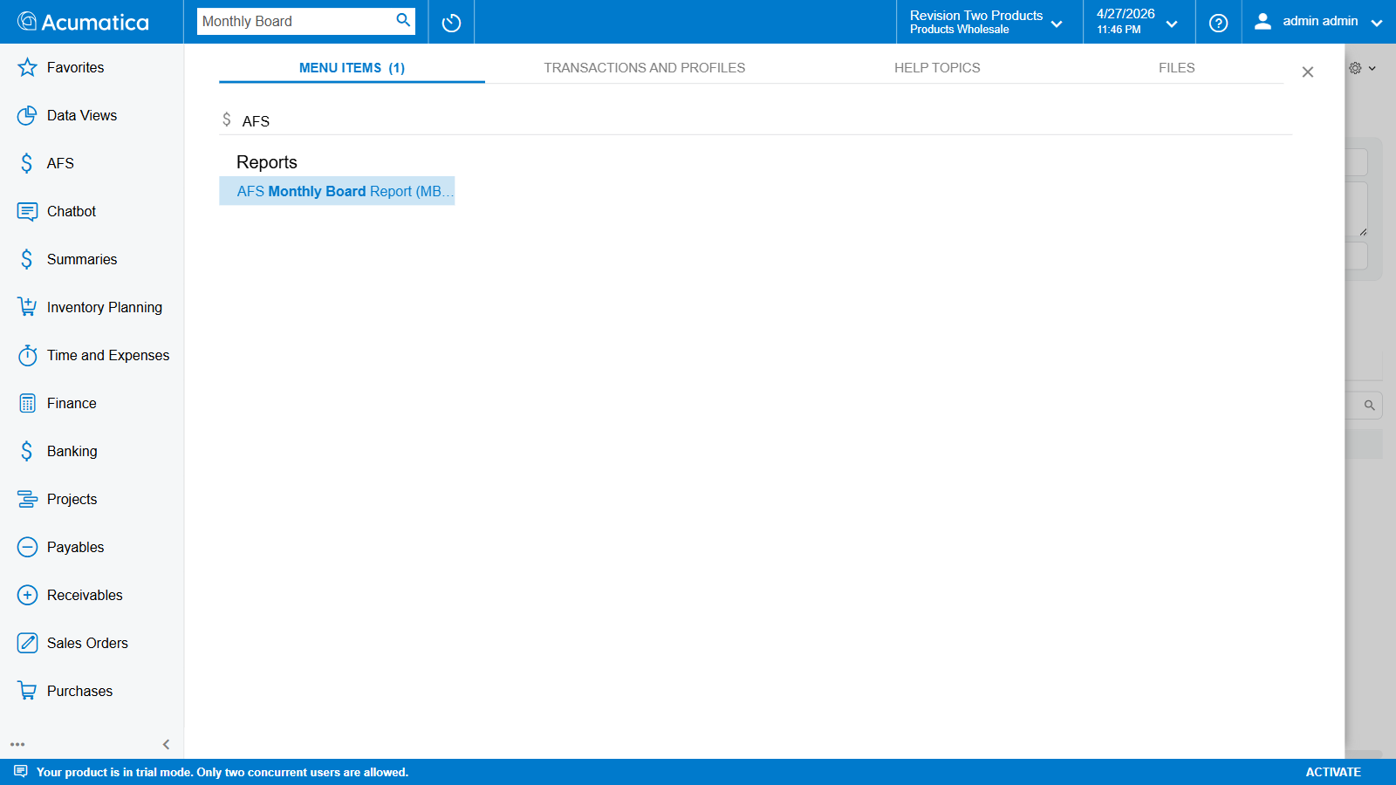
Top search showing AFS Monthly Board Report (MBR) result
The screen opens in New Record mode with three header column groups, two tabs (GI DATA SOURCES / PRESENTATION MARKDOWN), and four action buttons.
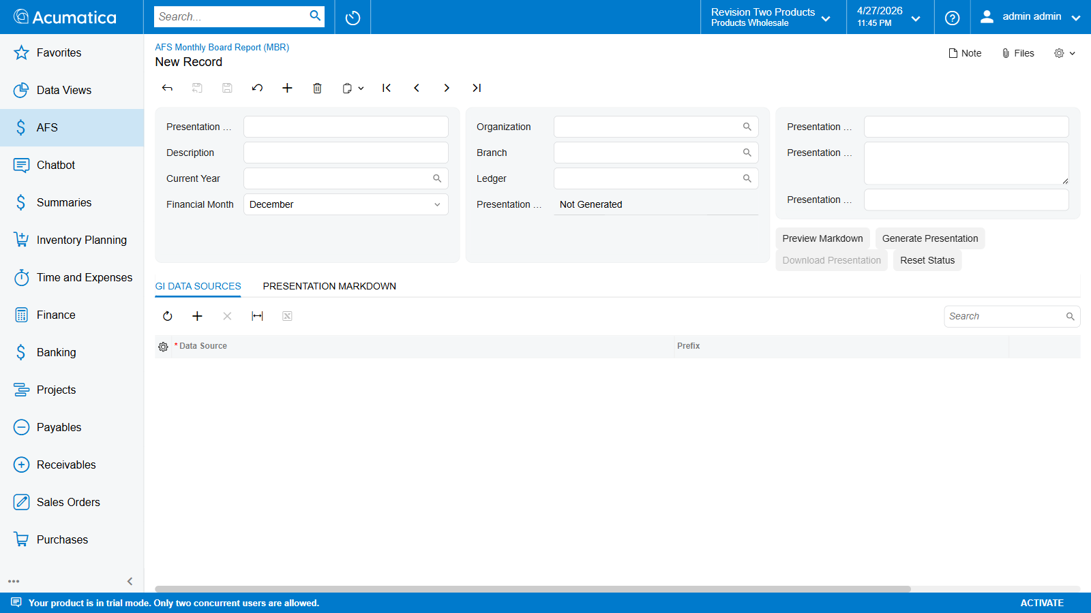
FR101003 landing — empty New Record

Toolbar + actions overview
The standard Acumatica record-navigation toolbar sits across the top of the form. Four screen-specific actions live in the right-hand action panel:
Button | Behaviour
Preview Markdown | Resolves every linked data source against live OData, builds the Gamma prompt, persists it to the Presentation Markdown field. Does not call Gamma — use it to inspect what the model will see before incurring an API cost. Status doesn’t change.
Generate Presentation | Same resolve-and-build step, then POSTs the markdown to Gamma. Saves the returned .pptx to the record. Status: Pending → In Progress → Ready to Download. 15-minute timeout. If PresentationMarkdown is already populated by a prior Preview Markdown, the engine skips the rebuild and submits the stored markdown unchanged.
Download Presentation | Returns the most recently generated .pptx. Hard-disabled until SlideGeneratedFileID is populated.
Reset Status | Confirmation dialog → clears SlideStatus to Pending and nulls SlideGeneratedFileID. Use after a stuck In Progress run, or after Failed, before re-running Generate.
While Status = In Progress, every header field is disabled and Preview Markdown + Generate Presentation are greyed out. Reset Status stays clickable so you can recover from a stuck run.

Step 2 — Fill the Header
The header is split into three column groups.

Identity (left)
Field | Required | Notes
Presentation Name | yes | Free-text identifier, max 225 chars. Shown in the records list and on the breadcrumb.
Description | no | Short label, max 50 chars.
Current Year | yes | Fiscal year. Selector lists distinct FinYear values from FinPeriod (latest first).
Financial Month | yes | Month-of-year (01–12). Default 12 (December). Sets the period end of the FY-to-date window every linked Report Definition reads, and is fed into the {MONTH} token of every linked MBR Definition’s Period Filter Template.

Scope (middle)
Field | Required | Notes
Organization | optional | Optional dimension filter. Fills the OrgFilterColumn of every linked MBR Definition that has one configured.
Branch | optional | Fills BranchFilterColumn.
Ledger | optional | Fills LedgerFilterColumn.
Presentation Status | — | Read-only lifecycle field.

Gamma prompt fields (right)
Field | Required for Generate | Notes
Presentation Title | yes | Up to 500 chars. Becomes the title of the generated .pptx. Required by Generate Presentation — the action throws Presentation Title is required if blank. Preview Markdown does not require it.
Presentation Description | no | Up to 2000 chars. Optional context paragraph the markdown builder includes in the Gamma prompt’s audience / framing block.
Presentation Template ID | no | Optional Gamma template ID. If set, GeneratePresentationFromTemplate is used instead of GeneratePresentation — the deck inherits the visual style of the named Gamma template. Leave blank for default Gamma styling.
After filling, the form looks like the screenshot below:
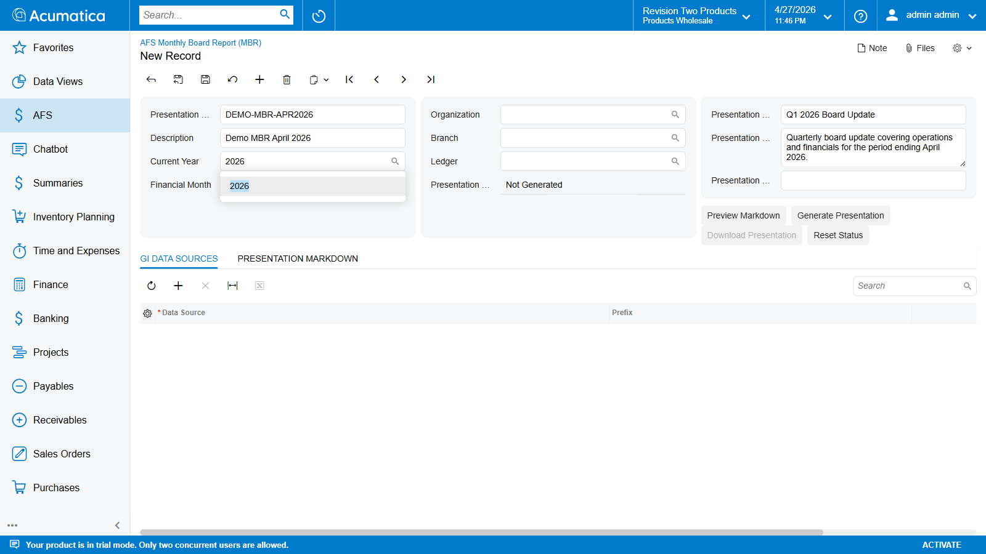
Header — identity, scope, and Gamma prompt fields filled
Save (Ctrl+S) before opening the GI Data Sources tab — the child grid needs a saved parent record before it can attach links.

Step 3 — Link MBR Definitions (GI Data Sources)
Switch to the GI DATA SOURCES tab below the header. This child grid is what tells the engine which MBR Definitions to resolve when building the prompt.
Click + on the grid toolbar to add a row, then click the magnifier in the Data Source cell (or press F3) — the selector opens listing every active MBR Definition:
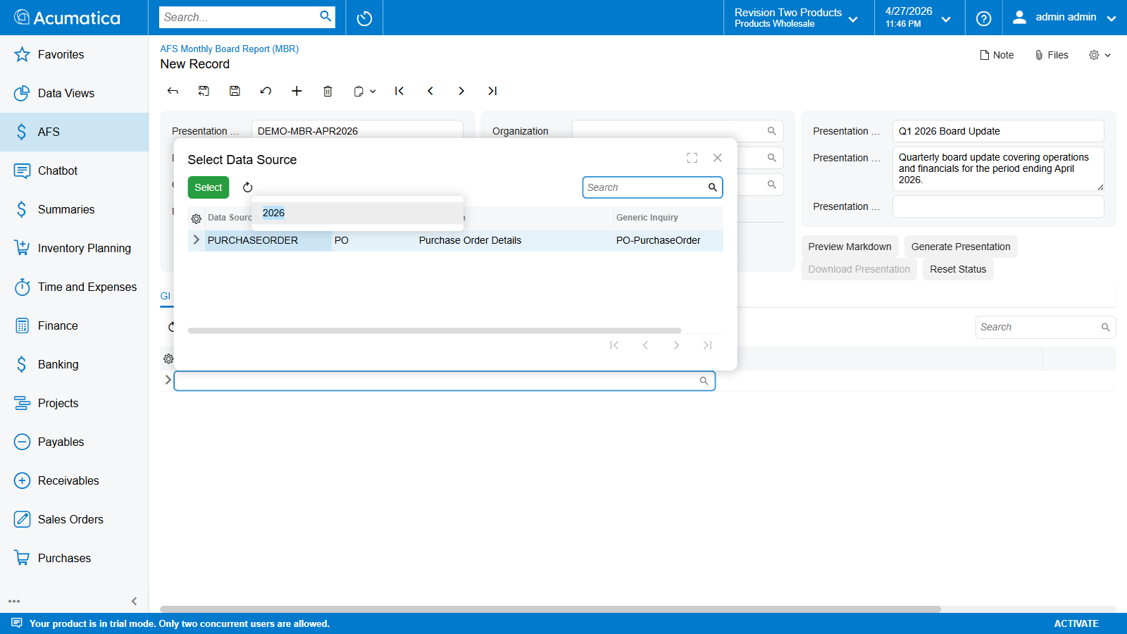
Data Source selector — PURCHASEORDER (PO) is the only active MBR Definition in this tenant
Double-click the data source you want. The grid populates with three columns:
Column | Source | Purpose
Data Source | FLRTGIDataSource.dataSourceCD | Key of the link row. One MBR Definition can be linked at most once per presentation.
Prefix | FLRTGIDataSource.Prefix (read-only display) | Convenience copy of the data source’s prefix.
Display Order | integer (default 0) | Sort order in the markdown preview’s Data section.
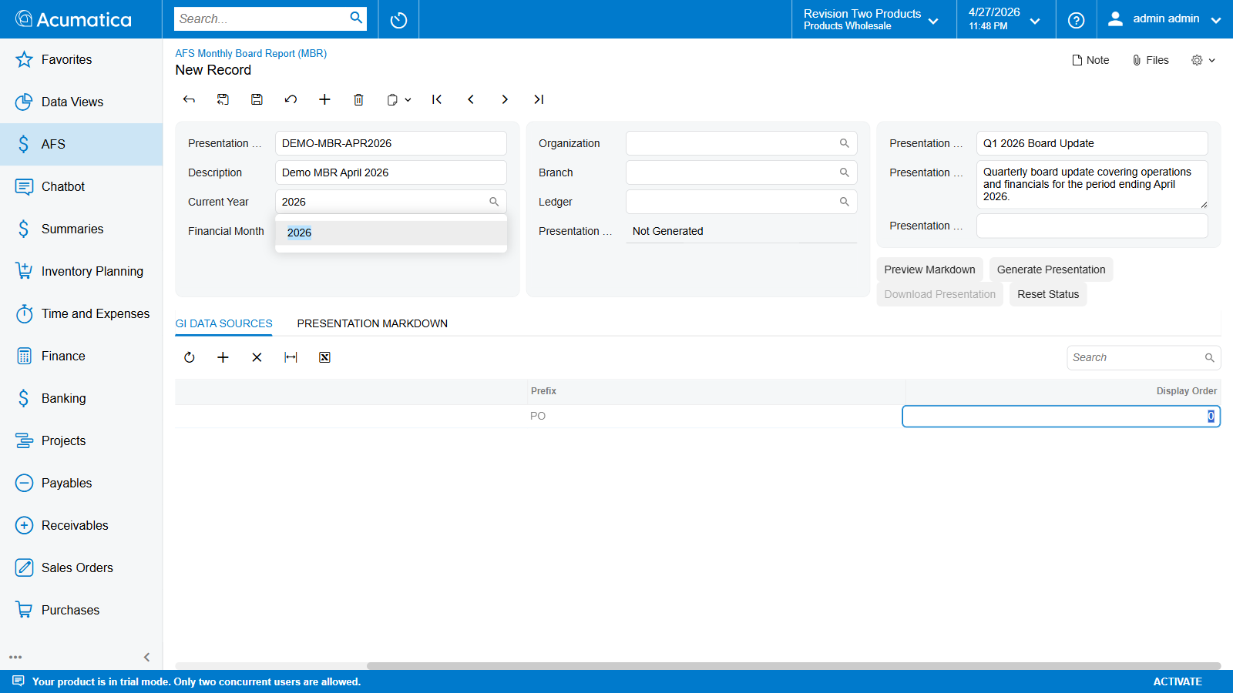
PURCHASEORDER linked — grid shows Prefix = PO, Display Order = 0
Multi-source presentations. The markdown builder concatenates the placeholder dictionaries from every linked data source before composing the Gamma prompt. Two data sources cannot share the same Prefix; the link save fails with Prefix '<PO>' is already used by another linked definition in this report if you try.

Step 4 — Preview the Markdown (optional but recommended)
Switch to the PRESENTATION MARKDOWN tab. It starts empty:
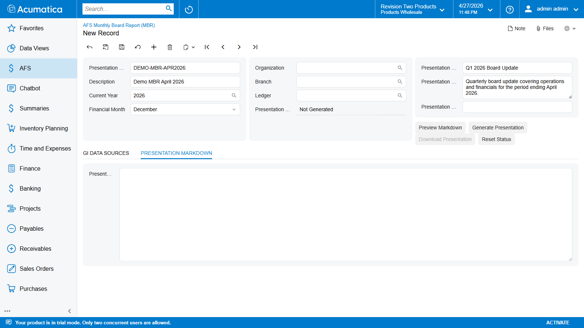
Empty Presentation Markdown tab
Click Preview Markdown in the action panel. The engine:
- Authenticates against the tenant’s OData endpoint.
- Resolves every linked MBR Definition (full fetch + aggregate + format for VALUE rows, top-N expansion for MULTIROW rows, formula evaluation for CALCULATED rows).
- Builds the Gamma prompt — a markdown document with header context (period, scope), the user-supplied audience/framing block, and a Data section listing every placeholder produced.
- Persists the markdown to PresentationMarkdown and saves the record.
The whole step is wrapped in a 15-minute PXLongOperation. The textarea on the tab populates with the generated markdown:
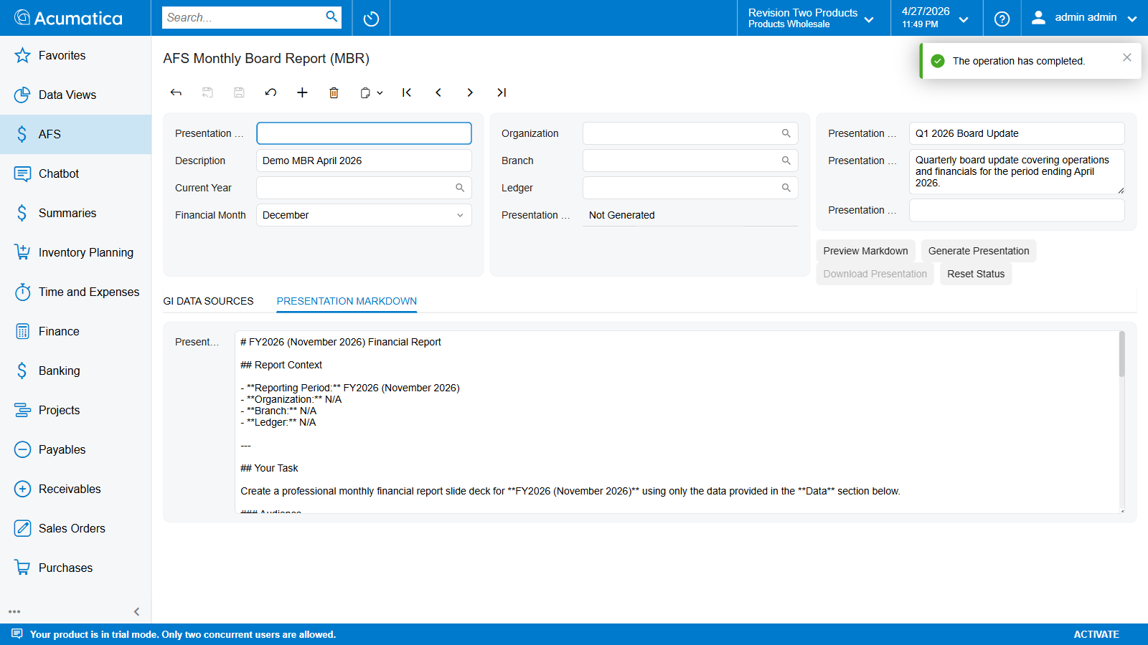
Presentation Markdown tab populated with the generated Gamma prompt
Why preview before generating?
- Verifies every data source resolves without OData errors.
- Lets you spot empty placeholders (data source mis-configured, period filter wrong, etc.) before incurring a Gamma API call.
- The persisted markdown is reused by the next Generate Presentation — Generate skips the rebuild step entirely if PresentationMarkdown is already populated. So a clean preview is also a way to “freeze” the prompt before committing it to Gamma.
The textarea is editable — you can hand-tweak the markdown before clicking Generate Presentation. Useful for adding extra prompt instructions Gamma should see, but be aware that the next Preview Markdown overwrites your edits.

Step 5 — Generate the Presentation
Click Generate Presentation. The engine:
- Validates: presentation selected, Status not already In Progress, Presentation Title set, tenant GammaApiKey configured.
- If PresentationMarkdown is already populated (from Step 4), it’s reused unchanged. Otherwise the markdown builder runs in-flight.
- Status flips to In Progress. Header fields and Preview / Generate buttons disable.
- Markdown is POSTed to the Gamma API. If a Presentation Template ID is set, GeneratePresentationFromTemplate is called instead of the default endpoint.
- Gamma returns a .pptx byte stream. The engine saves it as <PresentationName>_Presentation_<yyyyMMdd_HHmm>.pptx and stores the file’s GUID on SlideGeneratedFileID.
- Status flips to Ready to Download.
You can navigate away from the screen during the run — Status updates the next time you reload the record. The 15-minute timeout produces a Failed status (and a trace error) rather than hanging the screen.

Step 6 — Download the Presentation
Once Status = Ready to Download, click Download Presentation. The browser downloads the merged .pptx. The Gamma deck is fully editable in PowerPoint — Gamma generates the slide layouts, charts, and bullet structure from the markdown prompt, but doesn’t lock the output.

Step 7 — (Optional) Reset Status
Open the record and click Reset Status — a confirmation dialog appears showing the current status:
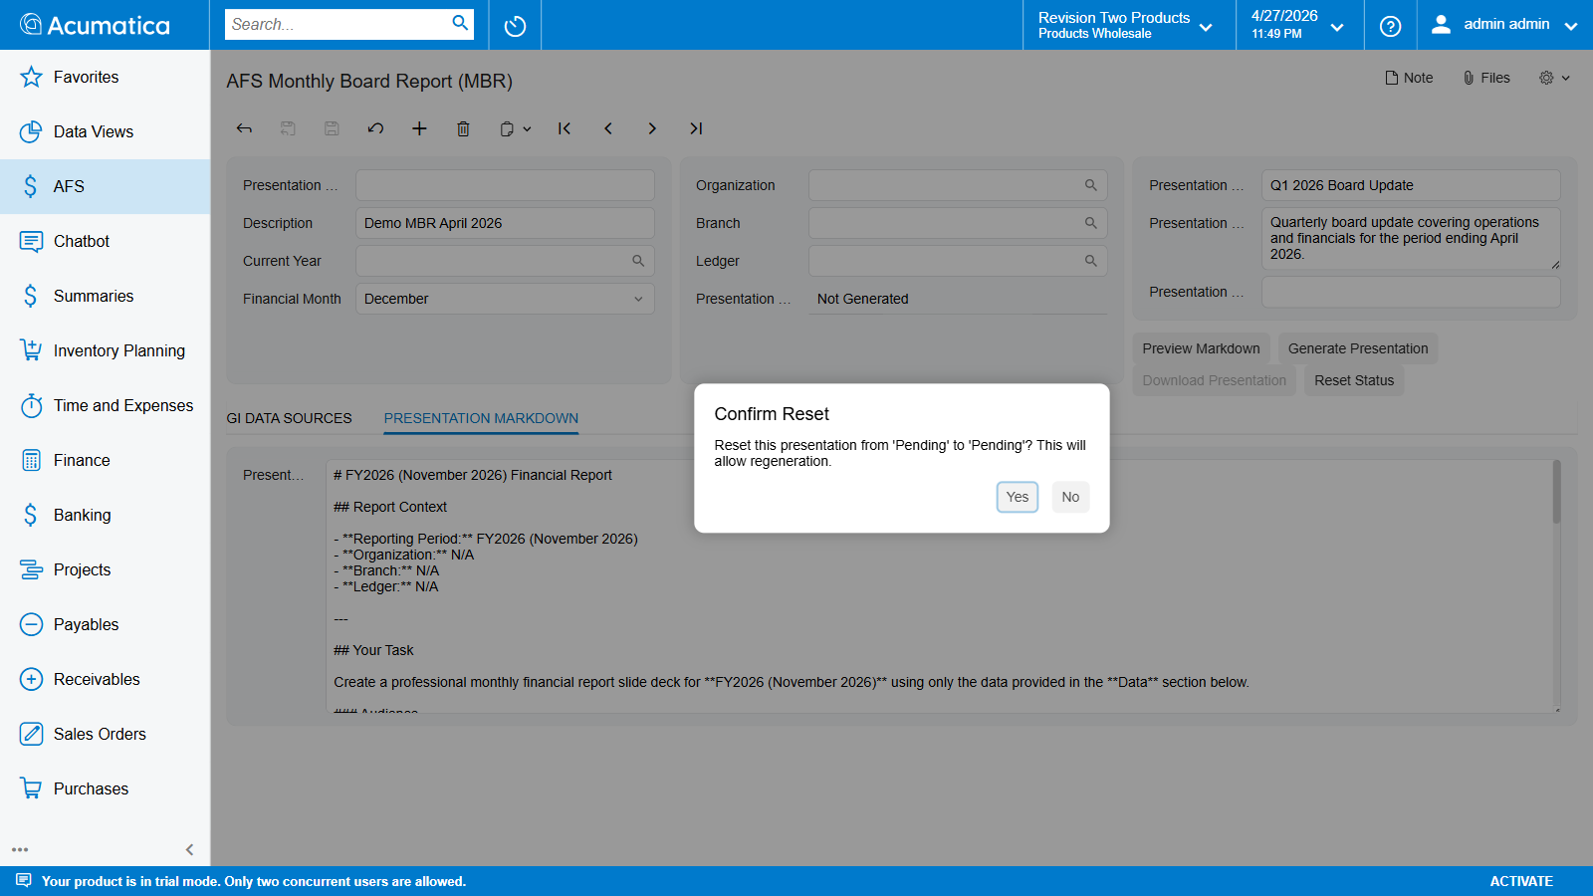
Reset Status confirmation dialog
Dialog message: Reset this presentation from '<Current Status>' to 'Pending'? This will allow regeneration.
- Yes — Status moves to Pending and SlideGeneratedFileID is cleared. The previously generated .pptx is detached from the record. The next Generate Presentation rebuilds from scratch (or from the stored PresentationMarkdown if you preserved it).
- No — Status is unchanged.

Step 8 — (Optional) Delete the Record
Click the Delete icon on the toolbar and confirm. Deletes the presentation record plus its child Data Source / Definition Link rows. The screen returns to New Record mode:
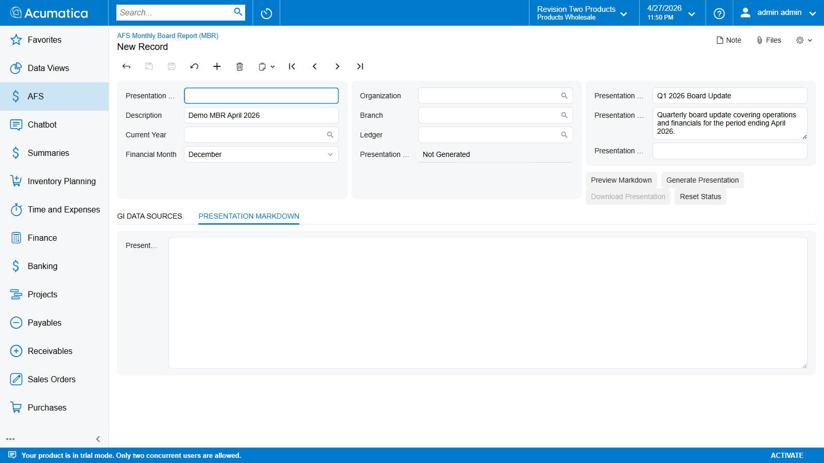
Clean state after delete — New Record with empty fields

Status lifecycle
SlideStatus is a one-character field on the DAC (FLRTPresentationGeneration.SlideStatus):
DB value | UI label | Meaning
N | Not Generated | Initial state. No .pptx attached. Generate Presentation is allowed; Download Presentation is disabled.
P | In Progress | PXLongOperation is running. Header + Generate buttons disable; only Reset Status remains clickable.
C | Ready to Download | Job finished; merged .pptx is stored on the record. Download Presentation now returns the file.
F | Failed | Job threw — typically a Gamma API error, a data source resolution failure, or a 15-minute timeout. Read the trace log, fix the cause, then Reset Status → Generate Presentation.
Not Generated ──Generate──► In Progress ──success──► Ready to Download
└──error──► Failed ──Reset──► Not Generated

How the Engine Builds the Markdown
For reference — what SlideGenerationService.BuildMarkdownPreview actually emits:
- Header context block — fiscal year, financial month formatted as “FY{Year} ({MonthName} {Year})”, plus the Org / Branch / Ledger scope (or N/A when blank).
- Audience / framing block — the user-supplied PresentationDescription, plus a hard-coded set of “Generate a professional monthly financial report slide deck…” instructions for Gamma.
- Data block — one section per linked data source, with a heading per Column row. For VALUE rows: **<Description>:** <formatted value>. For MULTIROW rows: a markdown table with the configured DisplayColumns. For CALCULATED rows: **<Description>:** <formula result>. HEADING rows print as ### <Description>.
The full markdown is what goes to Gamma — it’s also what you can hand-edit on the Presentation Markdown tab.

Appendix A: Placeholder Reference
Complete catalogue of every placeholder type the AFS Financial Report module emits into the Word merge dictionary or the Gamma markdown prompt.
v2.1.x model. Every placeholder is keyed by exactly one of two period suffixes: _CY (current FY-to-date) or _PY (previous FY same window). The legacy _PM (previous-month) suffix was removed in the v2.1.x refactor. Compute month-only deltas inside the Word template ({{PFX_X_CY}} − {{PFX_X_PY}}); a Definition formula cannot mix periods.

A.1 Report Definition Placeholders
Produced by every visible line item on a Report Definition (FR101002). One pair per visible line:
{{<Prefix>_<LineCode>_CY}}
{{<Prefix>_<LineCode>_PY}}
Component | Source | Examples
<Prefix> | FLRTReportDefinition.DefinitionPrefix | BS, PL, CF, EQ, DEMO
<LineCode> | FLRTReportLineItem.LineCode | CASH, TOTAL_ASSETS, NI, GROSS_PROFIT
Period suffix | _CY or _PY (constants in Helper/Constants.cs) | _CY, _PY

Period suffixes
Suffix | Meaning
_CY | Current Year — fiscal-year-to-date through the end of the selected month, in the year picked on FR101000 / FR101003.
_PY | Previous Year — fiscal-year-to-date through the same month, in the previous fiscal year.
No _PM suffix exists. If a template inherited from the v2.0 era still has {{X_X_PM}} tokens, they resolve to 0 in the Word document (and warn in the trace log).

Examples
Placeholder | Meaning
{{BS_CASH_CY}} | Balance Sheet definition (BS), Line Code CASH, current FY-to-date.
{{BS_CASH_PY}} | Same line, previous FY same window.
{{PL_REVENUE_CY}} | P&L definition, Line Code REVENUE, current period.
{{PL_NI_PY}} | P&L Net Income, prior year.
{{CF_OP_CASH_CY}} | Cash Flow definition, OP_CASH line, current.

Lines that do not emit placeholders
- HEADING lines — display-only.
- Lines with Visible = false — still calculated but no _CY / _PY keys are written.
- SUBTOTAL / CALCULATED lines with Visible = false — same: internal value only.

A.2 Year-Label Placeholders
Two convenience tokens added to the dictionary at the end of every report run by ReportGenerationService:
Placeholder | Resolves to | Example
{{CY}} | The current year as a 4-digit string | 2026
{{PY}} | The previous year as a 4-digit string | 2025
Use in column headers and section labels:
| Account | As at December {{CY}} | As at December {{PY}} |
|---------------------|-----------------------|-----------------------|
| Cash | {{BS_CASH_CY}} | {{BS_CASH_PY}} |

A.3 MBR Definition Placeholders
Produced by every visible column row on an MBR Definition (FR101004). Three flavours, one per LineType.

A.3a Single Value (LineType = VALUE)
One placeholder per visible Column Alias:
{{<Prefix>_<ColumnAlias>}}
Component | Source | Example
<Prefix> | FLRTGIDataSource.Prefix | PO, HR, SO
<ColumnAlias> | FLRTGIDataSourceColumn.ColumnAlias | TOTAL_AMOUNT, HEADCOUNT, OPEN_ORDERS

Placeholder | Meaning
{{PO_TOTAL_AMOUNT}} | PO data source, TOTAL_AMOUNT column, aggregate result.
{{HR_HEADCOUNT}} | HR data source, HEADCOUNT column.
{{SO_OPEN_ORDERS}} | Sales Order data source, count of open orders.
No _CY / _PY suffix on MBR Definition placeholders. The MBR pipeline runs once per record against a single user-supplied period (Year + Month + dimensions on FR101003), not against two periods like Report Definitions do.

A.3b Multi-Row Expand (LineType = MULTIROW)
Each ranked row produces one placeholder per GI column:
{{<Prefix>_<ColumnAlias>_<Rank>_<GIColumn>}}
Placeholder | Meaning
{{PO_TOP_VENDORS_1_VendorName}} | Rank-1 row of TOP_VENDORS MULTIROW, value of VendorName.
{{PO_TOP_VENDORS_1_OrderTotal}} | Rank-1 row, value of OrderTotal.
{{PO_TOP_VENDORS_2_VendorName}} | Rank-2 row.
{{PO_TOP_VENDORS_10_OrderTotal}} | Rank-10 row, OrderTotal column.
Rank goes from 1 to the Row Limit configured on the column row (default 10). Word templates referencing a rank higher than Row Limit get an empty string.

A.3c Calculated (LineType = CALCULATED)
Same shape as a VALUE placeholder — {{<Prefix>_<ColumnAlias>}} — but the value comes from evaluating the row’s Formula against the other Column Aliases in the same data source.
{{PO_GROSS_MARGIN}} ← Formula: REVENUE - COGS
{{PO_NET_MARGIN_PCT}} ← Formula: NET / REVENUE (with Format String = P1)

A.4 Cross-Definition Formula Placeholders
A CALCULATED line in one Report Definition can reference Line Codes in another Report Definition, provided both are linked to the same FR101000 / FR101003 record. Tokens use the qualified <Prefix>_<LineCode> form (no period suffix — the engine substitutes _CY and _PY automatically on each evaluation pass).
Formula in Definition (Prefix) | Token resolution | Placeholders emitted
BS_TA - PL_NI (in CF, prefix CF) | BS.TA + PL.NI from linked defs | {{CF_RESULT_CY}}, {{CF_RESULT_PY}}
PL_REVENUE * 0.3 (in CU, prefix CU) | PL.REVENUE from linked def | {{CU_TAX_EST_CY}}, {{CU_TAX_EST_PY}}
(REVENUE - COGS) / REVENUE (in PL) | implicit prefix → PL.REVENUE, PL.COGS | {{PL_GROSS_MARGIN_CY}}, {{PL_GROSS_MARGIN_PY}}
The formula is evaluated twice — once against the CY dictionary, once against the PY dictionary — producing both _CY and _PY placeholders automatically.

A.5 Placeholder Resolution Rules
Rule | Source
Case-insensitive lookup — {{BS_CASH_CY}} matches {{bs_cash_cy}} and {{Bs_Cash_Cy}}. | WordTemplateService does case-insensitive Replace at merge time.
Unmatched placeholders → 0 for numeric tokens, empty string for {{CY}} / {{PY}} when the year is null. The token text is replaced regardless. | Helper/Messages.UnknownFormulaLineCode (warning emitted to trace).
Maximum 1,000 placeholders per template — enforced by Constants.MaxPlaceholdersPerTemplate. Templates exceeding this throw Messages.TooManyPlaceholders at generation time. | Helper/Constants.cs:49.
Document scope — placeholders work in the document body, headers, footers, and all table cells. The merge service walks every paragraph. | WordTemplateService.cs.
Type each placeholder in one go in Word — Word’s auto-correct / spell-check sometimes splits {{ or the underscore mid-typing, breaking the merge token. If a placeholder isn’t replacing, retype the whole {{...}} token without pausing. | Word behaviour.
HEADING and invisible lines emit no placeholder. | FLRTReportLineItem.IsVisible.

A.6 Quick Lookup — Where Each Placeholder Comes From
Placeholder shape | Producer | Suffix (period)
{{<Prefix>_<LineCode>_CY}} / _PY | Report Definition line item (FR101002) | _CY / _PY
{{<Prefix>_<LineCode>_CY}} / _PY from CALCULATED | Report Definition formula (cross-def OK) | _CY / _PY (2-pass)
{{<Prefix>_<ColumnAlias>}} | MBR Definition VALUE / CALCULATED column (FR101004) | none
{{<Prefix>_<ColumnAlias>_<N>_<GICol>}} | MBR Definition MULTIROW column (FR101004) | none
{{CY}} / {{PY}} | ReportGenerationService year-label injector | year string itself

A.7 Diagnosing a Stale or Wrong Placeholder
Symptom | Likely cause | Fix
{{X_Y_PM}} left untouched in output | Legacy _PM token; engine doesn’t emit it. | Replace with {{X_Y_CY}} and {{X_Y_PY}} columns.
Placeholder shows 0 instead of expected value | Line Code typo, Prefix mismatch, or referenced definition not linked to record. | Verify the <Prefix>_<LineCode> matches a line on a linked definition.
Placeholder shows - (single dash) | The line was calculated but the value rounded to zero. | Expected — zero values render as - for readability.
Placeholder shows (1,234) (parentheses) | The line evaluated to a negative number. | Expected — negatives render in parentheses, accounting style.
Trace warning: 'Formula references unknown key' | Cross-definition reference where the other definition isn’t linked. | Add the missing definition to the FR101000 / FR101003 grid.

Appendix B: Troubleshooting
Common errors and how to fix them. Error message text matches Helper/Messages.cs verbatim where applicable — search the trace log for the exact string.

B.1 Authentication & Tenant Errors
Error message | Cause | Fix
Failed to authenticate | OAuth2 call to {BaseURL}/identity/connect/token returned an error. | Re-paste credentials on Tenant Credentials (FR101001). All five values are encrypted at rest — overwrite by typing again, then Save.
Failed to authenticate. Please check credentials. | Same as above, friendlier wording for invalid credentials. | Same fix.
Access token not found in response. | Connected Application’s OAuth2 Flow is wrong — must be Resource Owner Password Credentials. | On Connected Application Setup (SM303010), confirm Flow = Resource Owner Password Credentials.
Token expiration not found in response. | Same Connected App misconfiguration as above. | Same fix.
Failed to refresh token | Refresh token expired and the renewal call failed. | Logout / Login again will re-issue. If persistent, regenerate the Connected Application’s Shared Secret.
Tenant Name is required. | Saving FR101001 with a blank Tenant Name. | Fill the Tenant Name (must match the tenant segment in the Acumatica URL).
Tenant Name must be unique. | Two FR101001 rows share a Tenant Name. | Edit the existing row instead of inserting; or pick a unique Tenant Name.
Company Number is required. | Saving FR101001 with a blank Company Number. | Fill the integer Company Number from System → Manage → Companies.
Tenant mapping not found. | A report / presentation was created under a Company that has no row in FLRTTenantCredentials. | Add a Tenant Credentials row for that company on FR101001.

B.2 Report Generation Errors (FR101000)
Error message | Cause | Fix
Please select a template to generate the report. | Generate Report clicked with no record loaded. | Open or insert a record first.
No report selected or report ID is missing. | The header didn’t save before Generate Report was clicked. | Save the record first (Ctrl+S), then Generate.
The selected template does not have any attached files. | Generate Report clicked but no .docx is attached. | Open Files (paperclip icon), upload a .docx whose filename contains FRTemplate.
No files are associated with this record. | Same — no attachments at all. | Same fix.
Failed to retrieve the file content. | Attachment exists but file content can’t be loaded. | Re-upload the file via the Files panel.
The selected template file is empty or could not be retrieved. | Attached file is 0 bytes. | Replace with a real .docx.
Word document main part is null. | The attached file is corrupted or not a valid .docx. | Re-create the Word template.
Unable to save the generated file. | File system write failed. | Check Acumatica server’s App_Data permissions; check disk space.
A report generation process is already running for this template. | Generate clicked while Status = In Progress. | Wait, or click Reset Status if the run is stuck.
Report generation timed out after 15 minutes. | The merge or OData fetch exceeded the timeout. | Simplify the template or split the report.
Template contains {0} placeholders. Maximum allowed is {1}. | The template has more than 1,000 placeholders. | Split the template into multiple report records.
No generated file is available for download. Please generate the report first. | Download Report clicked but GeneratedFileID is null. | Run Generate Report and wait for Ready to Download.
Status codes are N / P / C / F, not P / IP / C / F. The UI label “File not Generated” maps to DB code N.

B.3 Report Definition Errors (FR101002)
Validation runs in FLRTReportDefinitionMaint.RowPersisting.
Error message
Definition Code is required.
Definition Code must be unique.
Definition Prefix is required. Enter a short alphanumeric code (e.g. BS, PL, CF).
Definition Prefix must contain letters and digits only — no spaces, underscores, or special characters.
Definition Prefix must be unique across all definitions. Another definition already uses this prefix.
Line Code is required.
Line Code must be unique within the same definition.
Account From is required for Account Range line types.
Account To is required for Account Range line types.
Formula is required for Calculated line types.
Formula references unknown Line Code '{0}'. Ensure it is defined with a lower Sort Order.
Formula evaluation failed for line '{0}': {1}
Circular dependency detected in report definitions. The following line codes form a cycle and cannot be resolved: {0}.
Duplicate line code(s) detected: {0}. Each definition prefix and line code combination must be unique across all linked definitions.

B.4 MBR Report Generation Errors (FR101003)
Error message
Please enter a Presentation Title before generating a presentation.
Presentation API Key is not configured. Please enter your API Key in the Tenant Credentials screen.
A presentation generation process is already running for this report.
No report definitions linked. Please add at least one definition on the Report Definitions tab before generating a presentation.
The following visible line items are missing descriptions: {0}. Please fill in all descriptions before generating a presentation.
No presentation is available for download. Please generate a presentation first.
Presentation generation timed out after {0} minutes.

B.5 MBR Definition Errors (FR101004)
Validation in FLRTGIDataSourceMaint.RowPersisting.
Error message
Data Source Code is required.
Prefix is required.
Prefix must contain only letters and digits.
Prefix must be unique across all GI Data Sources.
Column Alias is required.
GI Column is required for Value lines.
Formula is required for Calculated lines.
Column Alias must be unique within the data source.
Generic Inquiry name is required before detecting columns.
No API credentials found. Configure tenant credentials first.
No columns detected from GI '{0}'. Verify the GI name and API credentials.

FormatException: Input string was not in a correct format (most common runtime error)
Means the engine tried to parse a non-numeric value as a decimal.
Root cause: The GI Column name on a VALUE row doesn’t match the actual OData property name returned at run time, so the JSON path picks up a different column (often a string) and fails the cast.
Fix:
- Open FR101004, load the data source.
- Click Detect Columns — note the exact OData column names in the dialog.
- Update each Column row’s GI Column cell using the dropdown.
- Save, retry Test Fetch.
Example:
- You typed: Order Total (with space)
- OData actual name: OrderTotal (no space)
- Result: VALUE row reads a non-existent column, gets a default text response, can’t cast to decimal → FormatException.

B.6 “All values come back as 0”
Likely cause | Diagnostic
Period filter excluded every row | Click Test Fetch with a known-good period. Drop the dimension filters first.
Wrong Column Type / Aggregate combination (e.g. Sum on a String column) | Open the data source, change Column Type to match the GI property’s actual type.
Header dimension filters too narrow | Test Fetch with all four blank — values appearing means the filters are the problem.
Wrong Period Template for the column type | Date columns with Monthly scope ignore the template; the engine uses period boundaries. Set Type = Date.
Account-type sign normalization flipped the value | Check the underlying GL data — credit-normal account types (L / I) get auto-flipped to positive.
Cross-definition formula references a definition not linked | Trace log shows Formula references unknown key 'PFX_LINE'. Add the missing definition to the FR101000 / FR101003 link grid.

B.7 Reset Status
If a record is stuck in In Progress or Failed:
- Open the record on FR101000 (Financial Report) or FR101003 (MBR Report).
- Click Reset Status in the action panel.
- Confirm the dialog.
- Status returns to Pending (UI label: File not Generated on FR101000, Not Generated on FR101003 — both DB code N).
- Important: GeneratedFileID / SlideGeneratedFileID is also cleared by Reset — the previously generated .docx / .pptx is detached. The next Generate run produces a fresh file.

B.8 Where to Find Logs
All operations write detailed trace information.
Location: System → Management → Trace

Trace prefix catalogue
Prefix | Subsystem
[Step N] | Report generation pipeline phases (FR101000 Generate Report).
[Pipeline] | Report Definition link resolution.
[Pipeline/Presentation] | Same as [Pipeline] but for FR101003 paths.
[Engine] | ReportCalculationEngine warnings.
[Slide] | Markdown builder for FR101003.
[Gamma] | Gamma API communication (FR101003 Generate Presentation).
[GIDataFetch] | MBR Definition OData fetch + aggregation.
[GIDataFetchService] | Lower-level fetch service warnings.
[GIDataSource] | Detect Columns action on FR101004.
[GIDataSource TestFetch] | Test Fetch action result on FR101004.
[Cache] | Credential cache (in-memory).
[Decrypt] | Credential loading from FLRTTenantCredentials (RSA decrypt).
[GIColumnSelector] | OData column-list cache feeding the GI Column dropdowns on FR101004.

Useful trace entries
Entry | What it tells you
[GIDataFetch] Available OData columns: <list> | Exact runtime column names — copy from here when fixing FormatException.
[GIDataFetch] Filter=<odata> | The exact $filter clause sent to OData.
[GIDataFetch] Fetched N rows from '<GIName>' | Confirms data was retrieved.
[Step 7] Final placeholder count: N | End-of-pipeline placeholder total for FR101000.
[Engine] No match: range A:B filters Sub='X' | A line item’s account range / dimension filter combo matched zero GL rows.

About This Manual

Producing this Word document
This manual is generated from a single Markdown source (AFSCPFinancialReport_UserManual.md) plus the images/ folder. To convert to .docx:
pandoc AFSCPFinancialReport_UserManual.md \
-o AFSCPFinancialReport_UserManual.docx \
--toc --toc-depth=3 \
--reference-doc=reference.docx
- --toc --toc-depth=3 generates a Word-style table of contents covering Chapter, Section, and Sub-section headings.
- --reference-doc=reference.docx is optional — supply a Word file with your house styles (fonts, page margins, header/footer) and Pandoc will use them.
- Pandoc embeds every images/... reference automatically — keep the images/ folder alongside the markdown file when running the command.
The \newpage directives between chapters become Word page breaks. Tables convert to native Word tables. Code blocks (```) become Word “code” paragraphs. Bullet and numbered lists keep their hierarchy.

Source code references
Every error message, status code, and DAC field cited in this manual is sourced from the AFSCPFinancialReportv213032026 codebase as of v2.1.3. Key reference files inside the customization project:
Concern | File
Status codes (N / P / C / F) | Helper/Constants.cs (ReportStatus)
Placeholder suffixes (CY / PY) | Helper/Constants.cs (Constants.CurrentYearSuffix / PreviousYearSuffix)
Error messages | Helper/Messages.cs
Validation rules — Report Definition | Graph/FLRTReportDefinitionMaint.cs (RowPersisting)
Validation rules — MBR Definition | Graph/FLRTGIDataSourceMaint.cs (RowPersisting)
Generation pipeline — Word | Services/ReportGenerationService.cs
Generation pipeline — Gamma | Graph/FLRTFinancialPresentationMaint.cs (Generate Presentation action)
Markdown builder for Gamma | Services/SlideGenerationService.cs
OData fetch + aggregation | Services/GIDataFetchService.cs
Engine arithmetic + topological sort | Services/ReportCalculationEngine.cs

