Connected Application Setup — OAuth2 Client Credentials
This document describes how to create a Connected Application in Acumatica to obtain the Client ID and Client Secret required by the AFS Financial Report module.

Prerequisites
- Acumatica 2025 R2 or later
- Administrator access to the Acumatica instance
- AFS Financial Report customization published

Steps

Step 1 — Navigate to Connected Applications
- Log in to Acumatica as an administrator.
- In the top search bar, type Connected and select Connected Applications under Integration > Preferences.
Screen ID: SM303010
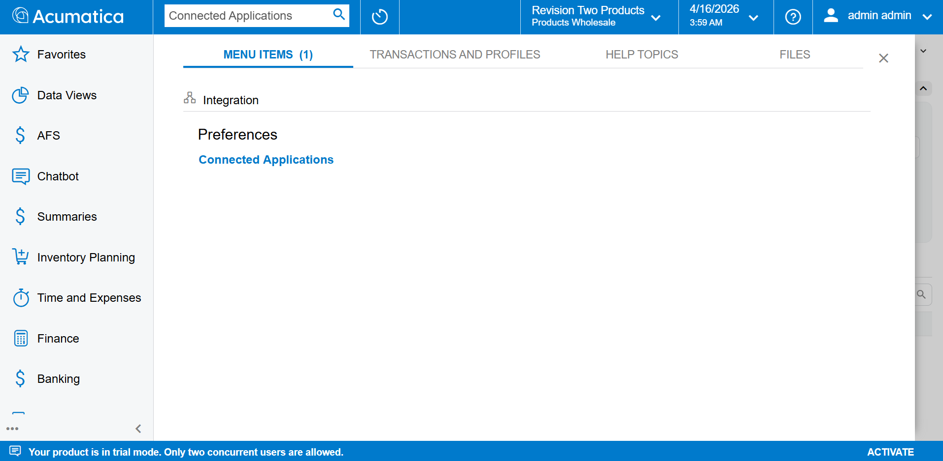
Connected Applications screen

Step 2 — Create a New Record
Click the + (Add) button in the toolbar to create a new record. The Client ID field will show <NEW> until saved.

Step 3 — Enter Client Name
In the Client Name field, enter a meaningful name that identifies this application.
Example: AFS Financial Report API
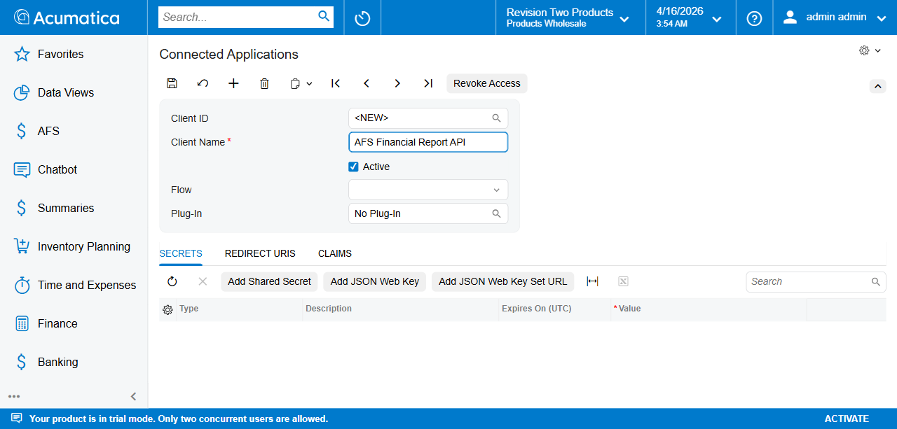
Enter Client Name

Step 4 — Set the Flow
Click the Flow dropdown and select Resource Owner Password Credentials.
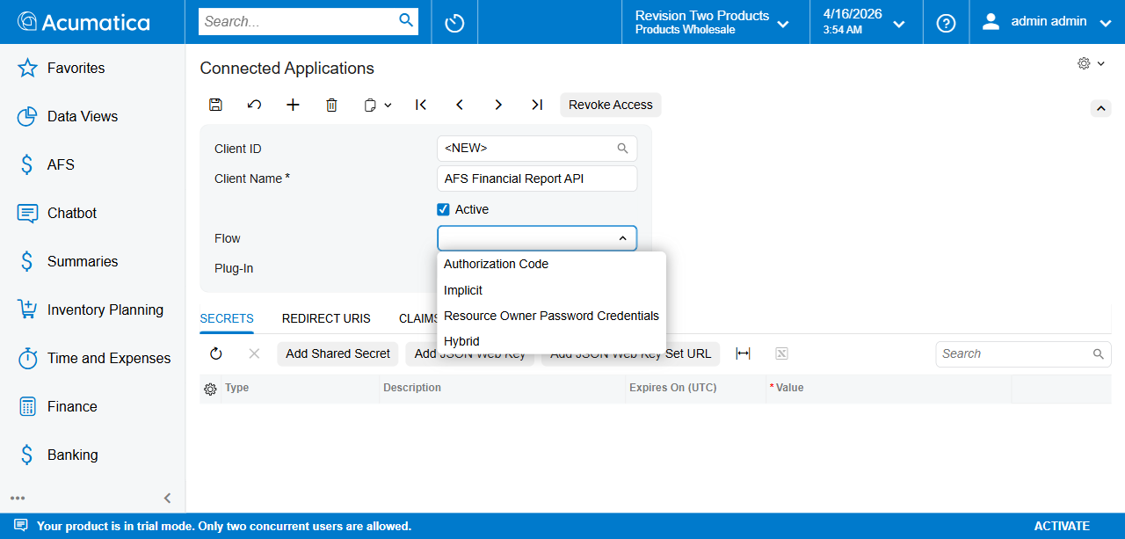
Flow dropdown open
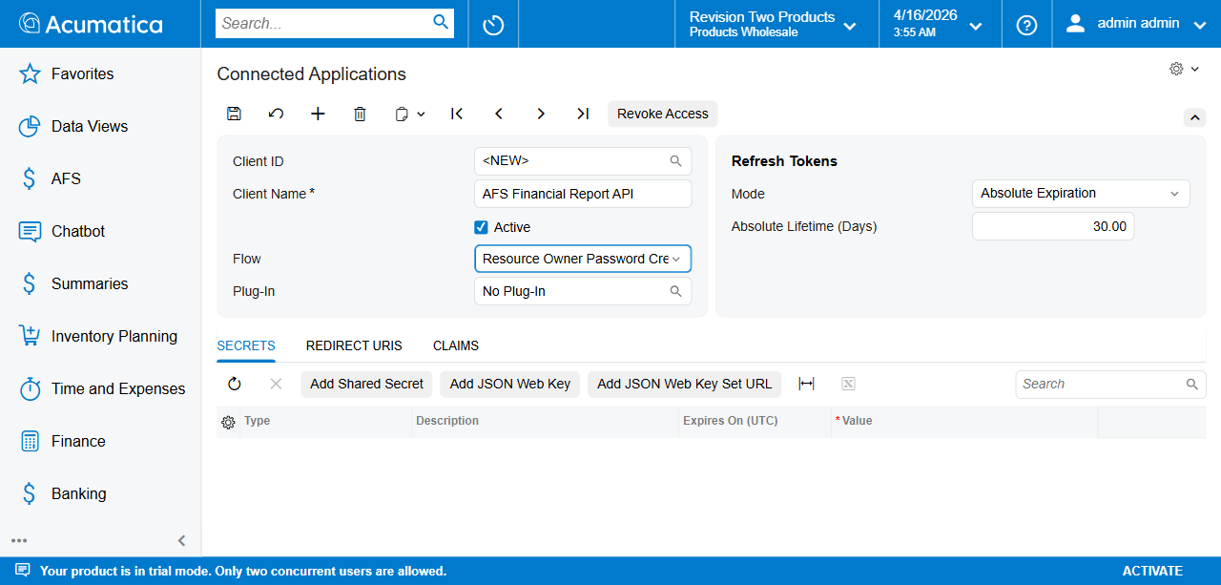
Flow selected
Selecting this flow automatically reveals the Refresh Tokens section on the right.

Step 5 — Configure Refresh Tokens
The Refresh Tokens section appears automatically with these defaults:
Field | Default Value
Mode | Absolute Expiration
Absolute Lifetime (Days) | 30.00
Adjust the Absolute Lifetime (Days) if a longer token validity is required (e.g. 365 for 1 year).

Step 6 — Save the Record
Click Save (or press Ctrl+S). Acumatica generates a unique Client ID.
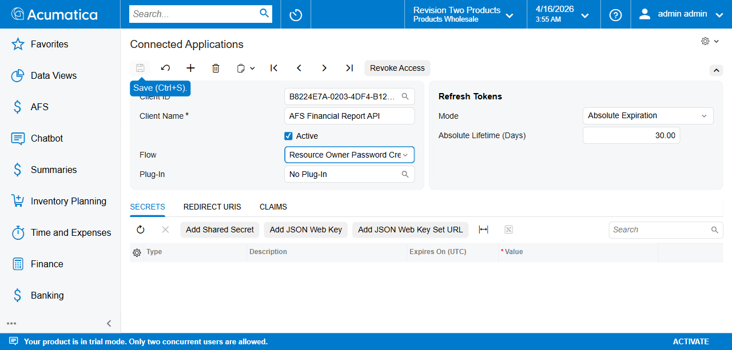
Saved with Client ID
Important: Copy and store the full Client ID value. It will be needed in the Tenant Credentials screen (FR101001).
The Client ID format is: {GUID}@{TenantName} Example: B8224E7A-0203-4DF4-B12B-7990E65C4524@SalesDemo

Step 7 — Add a Shared Secret
In the Secrets tab, click Add Shared Secret. A popup appears with an auto-generated secret value.
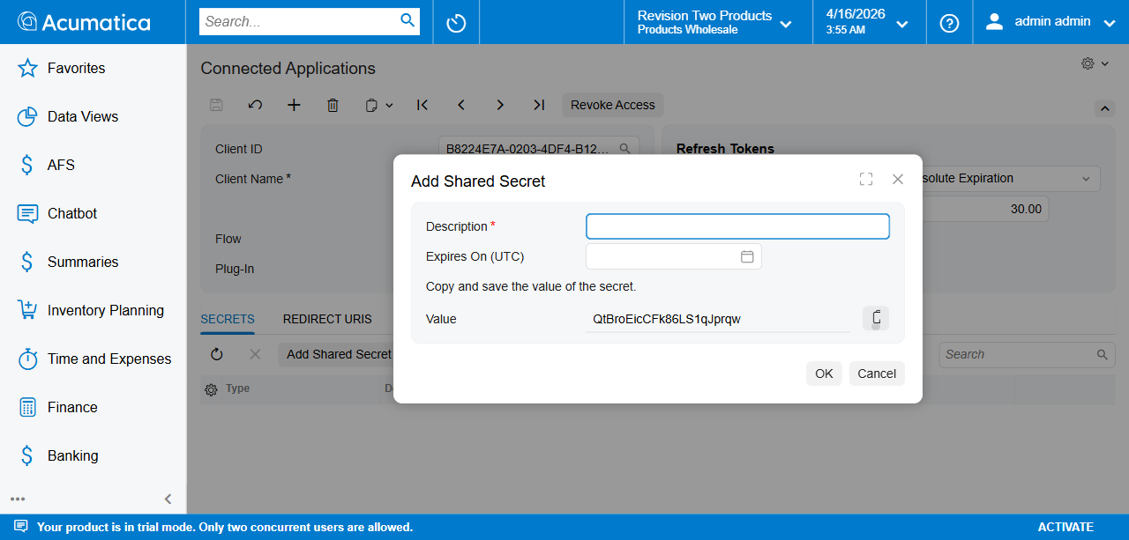
Add Shared Secret popup
Important: The secret value is shown only once. Copy it now before clicking OK.

Step 8 — Fill in Secret Details
- Description — Enter a meaningful label. Example: AFS Financial Report Secret
- Expires On (UTC) — Set an expiry date.
- Value — The secret is auto-generated. Copy this value and store it securely.
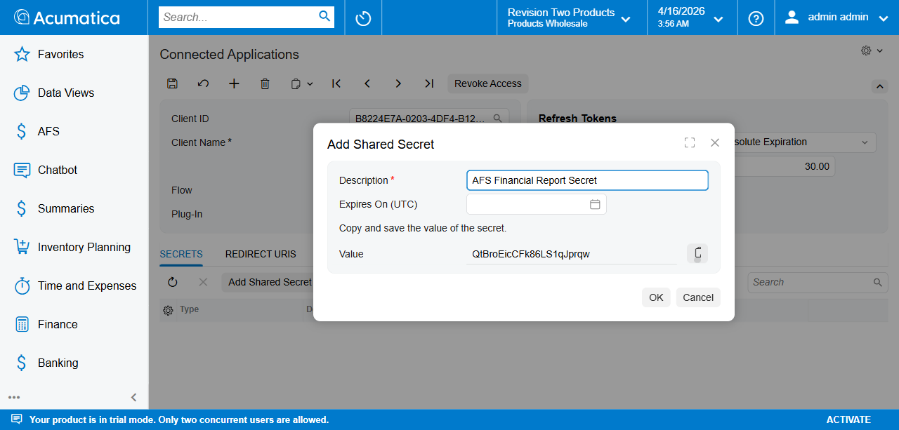
Secret details filled
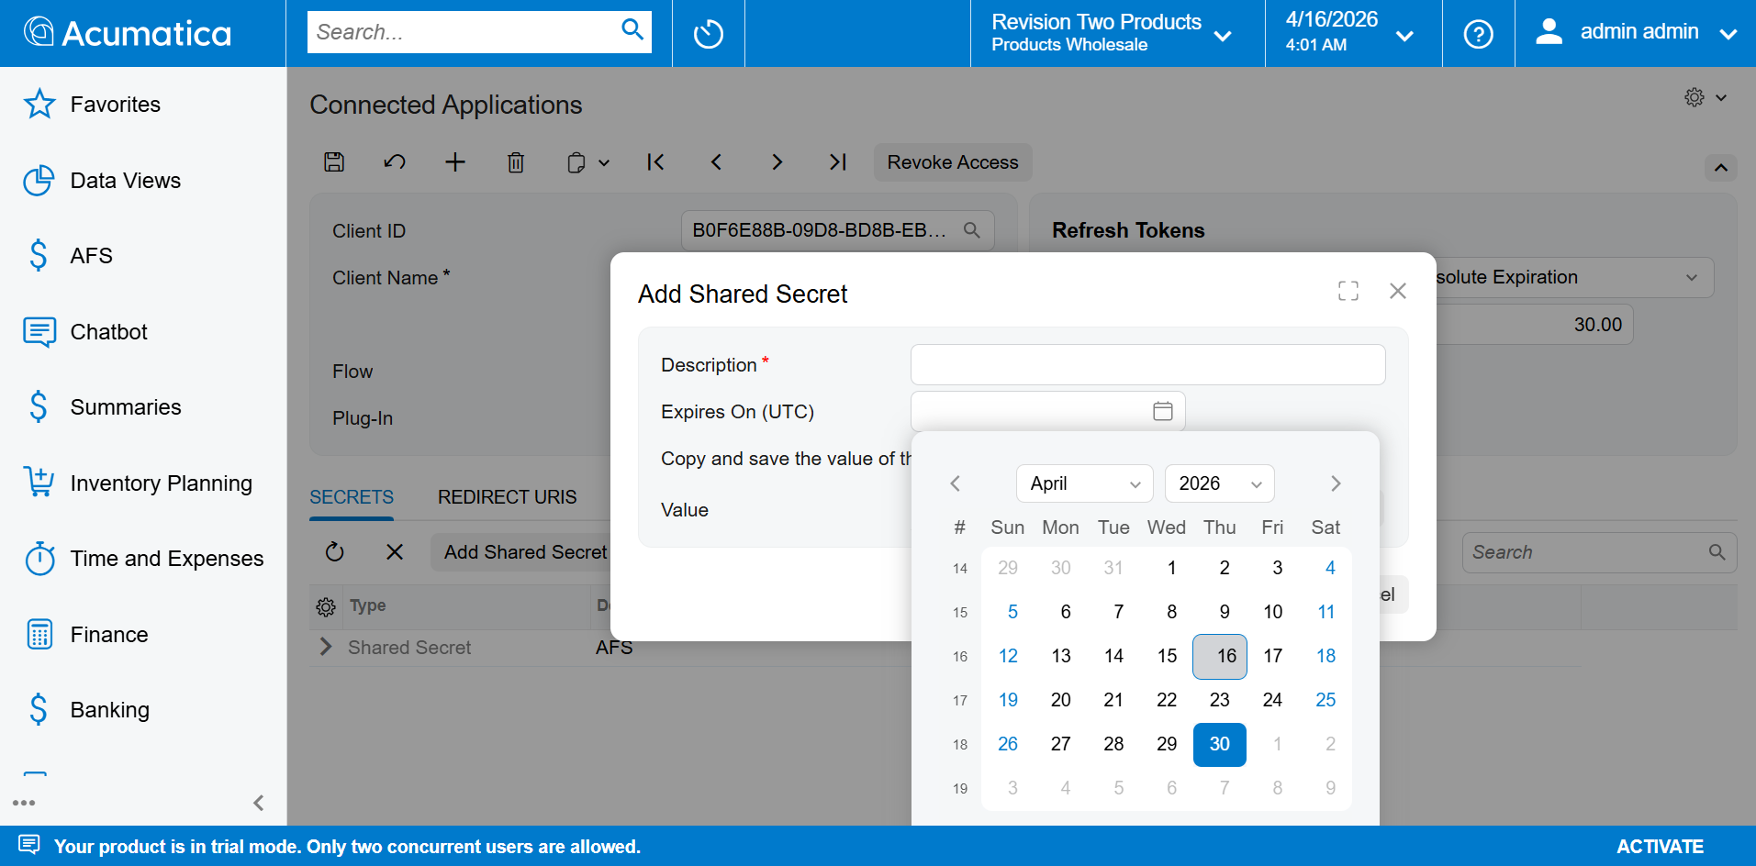
Secret expiry and value

Step 9 — Click OK
Click OK to confirm. The secret appears in the Secrets grid with the value masked as ********.
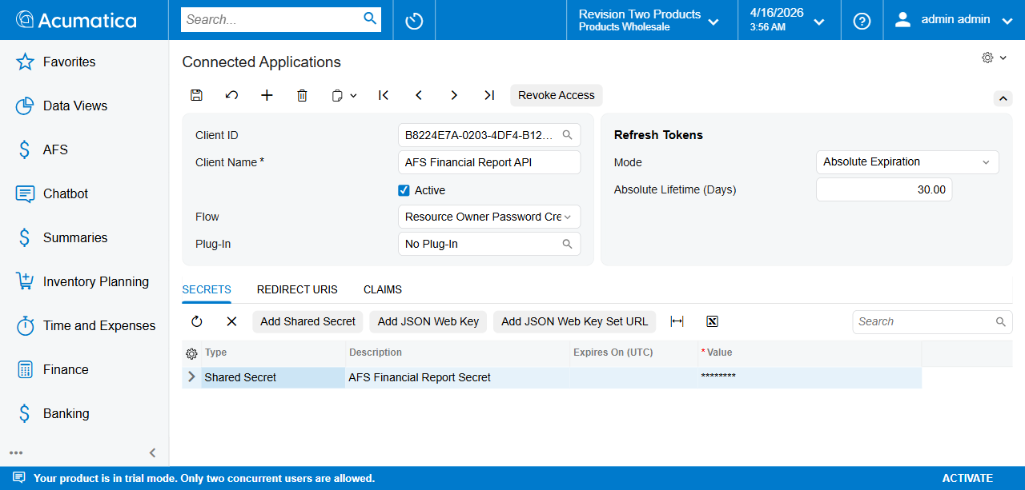
Secret added to grid

Step 10 — Final Save
Click Save again to persist the secret.
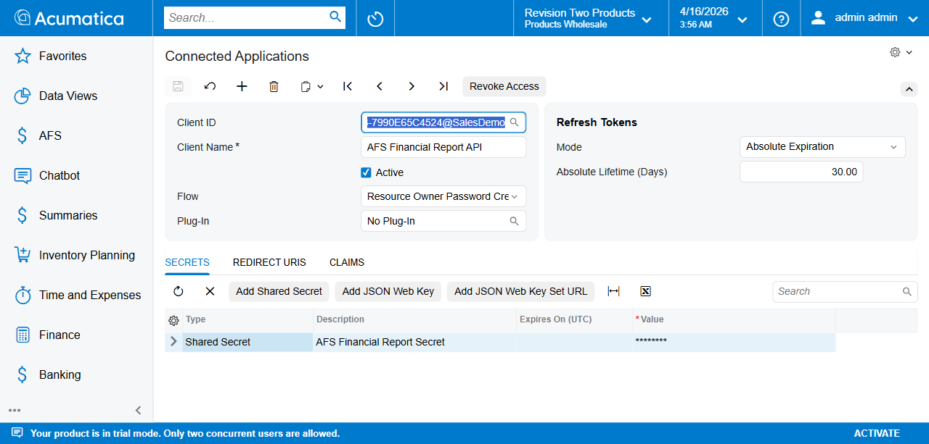
Final saved state

Summary of Values to Record
After completing setup, note down:
Field | Where to Find
Client ID | Client ID field (full value with @TenantName)
Client Secret | Copied from Add Shared Secret popup (Step 8)
Acumatica URL | Base URL of your instance, e.g.http://localhost/2025R2
Username | Acumatica user with API access
Password | Password of above user
These values are entered in Tenant Credentials (FR101001) during AFS Financial Report setup.

Next Step
Proceed to Tenant Credentials Setup and enter the Client ID and Secret obtained above.

