**CS 5600 Group Project Assignment: Database Description (20 Points)**

The database description and business rules are very important for design the database system. Your group should work together to create the database description and design a draft of NoSQL Database model. The submission includes with

* Database description.
* A NoSQL Database model (Document, Graph, Key-value, Column-based).
* Sample data.

**Note.**

You can submit this group assignment in the document files such as .doc, .docx, .pdf, …, etc. and upload on the Black Board.

**For example: CS5600DESIGN_XXXXX_YYYYY.doc, where XXXXX is CRN and YYYYY is your group number.**

***Sample***

**Database Description and Business Rules for DVDs’ rental (10 Points)**

The movies are rented out in stores and there are several stores. Each store has a unique distributor that supplies the store with disks. A distributor may supply more than one store. Each distributor has a name, an address, and a phone number. Each store has a name, an address, and a phone number. For each employee we must keep the following information: working store, a name, a supervisor, an address, a phone number, SSN (social security number). For each customer we keep the following information: a name, an address, and a phone number.

For each rental, we must keep track of which employee served the customer, which movie and which copy (i.e. disk) the customer rented, information about payment, the date and time of the rental, the status (rented, returned in time, returned late), the rate (i.e. the price), and if applicable, due date and overdue charges. About the payment we keep which of the employees accepted the payment (does not have to be the same employee who rented the disk), the type of payment (i.e. cash, check, credit card, direct debit), the amount of the payment, date and time of the payment, payment status

About each disk, we keep information in what condition the disk is and what movie is on the disk. About each movie we keep its title, director’s name, simple description, the name of a (single) major star, the movie’s rating.

**NoSQL Database Model (10 Points)**

**Document Database Model**

**Document-Based Store(JSON File): All data is stored in a document, so there’s no need for cross-referencing and instead of storing information in a table, it’s stored in a document.**

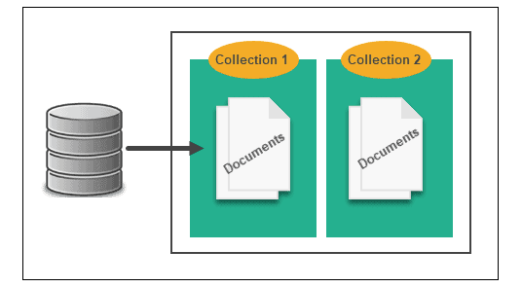

**Sample: Amazon Earphones Review**

**Collection 1- Product Info contains:**

**MRP**

**Price**

**Product Full Name**

**Product Short Name**

**Id**

**Collection 2- All Product Reviews contains:**

**Review Title**

**Review Body**

**Review Star (Rating)**

**Product (Product Short Name)**

**Sample data: Amazon Earphones Review**

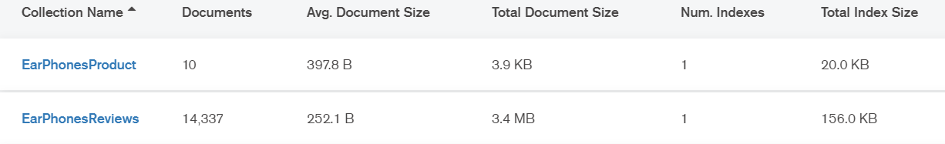

**EarPhonesProduct:**

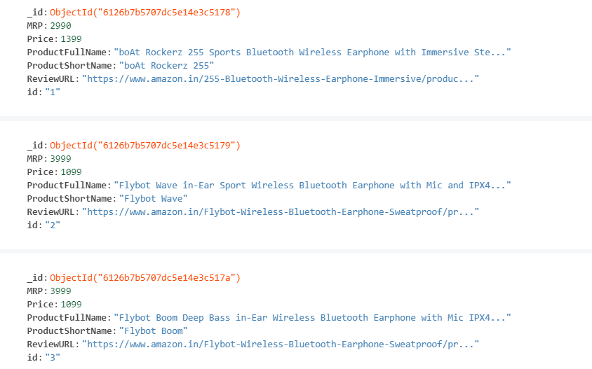

**EarPhonesReviews:**

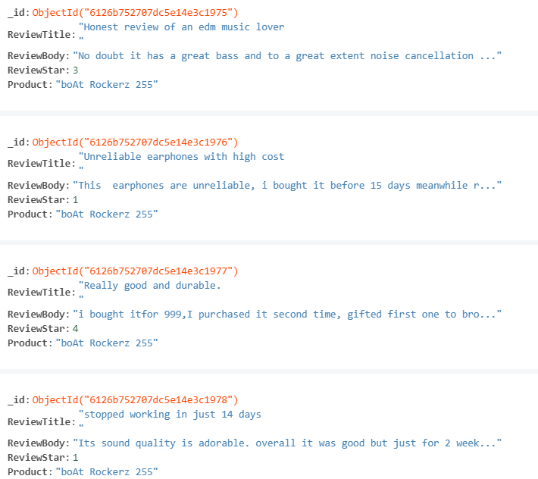

**Document Data Model(1)**

Product

Prod_id

Prod_name

Prod_stock

Prod_reorder

Prod_desc

Prod_price

Prod_cost

Order

Ord_id

Ord_date

Ord_amount

Ord_payment

Cust_name

Items[

Prod_name

Qty

]

Customer

Cust_id

Cust_name

Cust_address

Cust_phone

**Document Data Model(2) for DVDs rental**

**Distributor**

dist_id

dist_name

address

phone

**Store**

store_id

store_name

address

phone

dist_id

**Customer**

cus_id

cus_name

address

phone

**Employee**

emp_id

emp_name

address

phone

supervisor

SSN

store_id

**Copy(DVD)**

copy_id

title

genre

description

length

rating

director

[List of Actors]

**Rental**

rental_id

emp_id

cus_id

rental_date

return_date

fines

[List of Copies]

phone

amount

**Payment**

Payment_id

rental_id

payment_type

amount

emp_id

cus_id

payment_date

**Graph Database Model (1)**

**Users publishing posts (:User)-[:PUBLISHED]->(:Post)**

**Tags tagging posts (:Tag)-[:TAGGED]->(:Post)**

**Users liking posts (:User)-[:LIKED]->(:Post)**

**Nodes: User, Tag, and Post.**

**Relationships: PUBLISHED, TAGGED, LIKED, UNLIKED.**

**Properties:**

**User (user id, user name, password, status)**

**Post (post id, title, content, tags, number of like, number of unlike)**

**Tag (tag id, tag name)**

**PUBLISHED (publish_date)**

**LIKED (like_date)**

**UNLIKED (unlike_date)**

**Graph Database Model (2)**

**User loves user (:User)-[:LOVES]->(:User)**

**User dislikes user (:User)-[:DISLIKES]->(:User)**

**User friends of user (:User)-[:FRIENDS_OF]->(:User)**

**…**

**Nodes: User**

**Relationships: LOVES, DISLIKES, FRIEND_OF, MARRIED_TO, COLLEAGUE_OF, ….**

**Properties: ….**