A cross-sectional study of serum prolactin levels and their association with symptom severity and mental well-being in patients with depressive, anxiety and stress-related disorders
Sharma Bhawana¹, Murthy Vasantmeghna¹, Mangot Ajish^{1*}, Kshirsagar Sharad¹

¹Department of Psychiatry, Krishna Institute of Medical Sciences, Krishna Vishwa Vidyapeeth (Deemed to be University), Karad, District Satara, Maharashtra, India – 415110

*Corresponding Author

Correspondence to
Dr Mangot Ajish
Department of Psychiatry,
Krishna Institute of Medical Sciences,
Krishna Vishwa Vidyapeeth (Deemed to be University), Karad, Maharashtra, India
Email: dr.ajish@outlook.com

ABSTRACT
Background: Prolactin has been implicated in neuroendocrine mechanisms underlying stress and mood regulation; however, its relationship with psychological symptom severity and mental well-being in depressive, anxiety and stress-related disorders remains unclear.
Aims: To investigate the association between serum prolactin levels, psychological symptom severity, and mental well-being in patients with depressive, anxiety and stress-related disorders.
Methods: This is a cross-sectional observational study conducted in a tertiary Psychiatry clinic between November 2022 to June 2024 in Karad, Maharashtra, India. Participants were assessed using the Depression, Anxiety and Stress Scale-42 (DASS-42) and Warwick–Edinburgh Mental Well-being Scale (WEMWBS). Pearson's correlation and independent Student's t-tests were used to assess associations.
Results: Among 113 participants, mean age was 35.3 ± 10.7 years and 76 (67.2%) were women. Mean serum prolactin was 11.32 ± 9.71 ng/mL. Mean DASS-42 depression, anxiety, and stress scores were 11.81 ± 11.33, 11.87 ± 10.23, and 14.47 ± 10.76, respectively. No significant relationships were found between prolactin and depression, anxiety, stress, total DASS-42, or WEMWBS scores (mental well-being: r = 0.005, p = 0.96). Women had higher prolactin levels than men (p = 0.01), while married participants had higher WEMWBS scores than unmarried participants (p = 0.02).
Conclusions: Prolactin levels in serum did not turn out to be significantly linked with the severity of psychological symptoms or mental well-being, which means there is little value in using this as a single marker in this diverse clinical population.
KEYWORDS: Serum prolactin; Depression; Anxiety; Stress; Mental well-being

1. INTRODUCTION:
Depressive and anxiety disorders are prevalent mental health conditions that impact individuals across all age groups, sexes/genders and socioeconomic strata [1]. The global prevalence of depression ranges from 3.2% to 4.7%, while the lifetime prevalence in India is estimated at 5.25% [2]. According to the National Mental Health Survey (NMHS 2015-16), approximately 3.5% (nearly 40 million) Indians experience an anxiety or stress-related disorder [3].
The endocrine system significantly influences mood and human behaviour. Mood and behaviour have been known to have a very close connection with the working of the endocrine system, especially through the activity of the hypothalamic-pituitary-adrenal (HPA) Axis [4], [5], with chronic stress also linked to structural changes in brain regions implicated in mood regulation [6]. Prolactin has elicited significant interest due to its role in a variety of physiological functions. Traditionally, psychiatric interest in prolactin has focused on antipsychotic induced hyperprolactinemia and sexual dysfunction. However, more recent research indicates that prolactin also affects cognition and behaviour, most likely by modulating the hypothalamic-pituitary-gonadal (HPG) axis [2].
Prolactin also regulates appetite and food consumption. Depressive and anxiety disorders are known to be associated with disturbances in sleep and appetite. Recent studies have identified prolactin dysregulation in major depressive disorder (MDD), and the role of prolactin in stress response and adaptation is being investigated as a possible mechanism in the development of MDD, potentially exacerbating symptom severity [7].
Additionally, it has been discovered that prolactin also helps in the regulation of the body's stress response via its role in the HPA axis, where animal experiments have proven that central prolactin administration reduces the activation of the HPA axis due to stress responses, an action that is believed to be due to the effects of prolactin on the corticotropin-releasing hormone neurons in the hypothalamus (Faron-Górecka et al., 2023), with animal studies further showing prolactin can mitigate stress induced behavioral and physiological changes [9]. Overall, it is evident that stress and prolactin dysregulation share similar neuroendocrine pathways. In patients with prolactinomas who were diagnosed with anxiety and stress-related illnesses, prolactin seems to have some relationship with the intensity of symptoms and subjective well-being when compared to their counterparts. Individuals who suffered from anxiety, low self-efficacy and insomnia demonstrated elevated levels of prolactin over a year-long period. This indicates that prolactin dysregulation could be more connected with anxiety and stress symptoms than depression symptoms [10].
Some experimental and clinical studies have suggested associations between prolactin dysregulation and emotional processing, stress responses and affective symptoms, although findings remain inconsistent [11]. The role of prolactin in these disorders is further complicated by gender differences, with evidence indicating that sex hormones influence prolactin secretion and that prolactin levels physiologically differ between males and females. Moreover, the contribution of prolactin to such conditions becomes more complex due to differences in hormonal regulation, as sex hormones influence prolactin secretion and physiological differences in prolactin concentrations between males and females [12].
Estrogen has been recognised as one of the main factors controlling prolactin secretion by the pituitary gland, as it acts via both classical intracellular and membrane estrogen receptors, inducing rapid signalling through the PI3K/Akt pathway. Experiments on female rat pituitary cells have demonstrated the possibility of the enhancement of the effect of thyrotropin-releasing hormone (TRH) by estradiol because of the membrane pathway of estrogen receptors. Since estrogen concentration differs between males and females and changes depending on the stage of the menstrual cycle, pregnancy and menopause in females, this regulatory system of prolactin secretion may contribute to the variability in the baseline prolactin concentration and its association with mood and stress symptoms [13], [14].
Despite numerous studies exploring the impact of prolactin disorders on psychotic illnesses, prolactinoma and major depressive disorder, there is still insufficient data concerning the relationship between prolactin and the severity of symptoms in different types of depressive, anxiety and stress disorders [7]. Indeed, all the previous studies have concentrated either on distinct diagnostic categories, hormonal diseases, or hyperprolactinemia caused by particular medications. Such research has generated conflicting findings regarding the effect of prolactin on the severity of affective symptoms. Additionally, the number of scientific papers that have considered both serum prolactin concentration and psychological measures of subjective mental well-being in psychiatric outpatients is rather small [10], [15]. For this reason, it remains unclear if the level of serum prolactin indicates the severity of symptoms or subjective well-being in depressive, anxiety and stress disorders.
Although several studies have investigated the relationship between serum prolactin and psychiatric disorders, most have focused on single diagnostic populations such as major depressive disorder, prolactinoma, schizophrenia, or medication-induced hyperprolactinemia. Consequently, little is known about whether prolactin demonstrates a consistent relationship with symptom severity across the broader spectrum of depressive, anxiety and stress-related disorders encountered in routine psychiatric practice. In addition, previous studies have primarily examined psychopathology, whereas the relationship between prolactin and positive mental health constructs, such as subjective well-being, has received considerably less attention. Therefore, the present study aimed to simultaneously examine serum prolactin concentrations, symptom severity (depression, anxiety and stress) and subjective mental well-being in a heterogeneous outpatient psychiatric population using standardized assessment tools. By integrating multiple DSM-5 diagnostic categories and evaluating both psychopathology and positive well-being within the same cohort, this study seeks to provide a broader understanding of the potential relationship between prolactin and mental health.

2. MATERIAL AND METHODS:
2.1 Study design and setting
This cross-sectional observational study was conducted at the Department of Psychiatry at Krishna Vishwa Vidyapeeth, a tertiary-level hospital in Karad, Maharashtra, between November 2022 and June 2024. Participants were recruited using consecutive sampling from the psychiatry outpatient department (OPD).
2.2 Sample size
The sample size for the study was estimated based on data from a previously published study by A. Elgellaie et al., which reported a mean (± SD) serum prolactin level of 8.79 ± 5.16 ng/ml among individuals diagnosed with major depressive disorder (MDD) [7]. The sample size was calculated using the standard formula for estimating a mean with specified precision:
$n=\frac{Z^{2} {SD}^{2}}{{(M x E)}^{2}}$ ​

Where Z is the value for the selected confidence level (assumed to be 2 for 95% confidence interval approximation), SD is the standard deviation of the prolactin concentration (5.16 ng/ml), M is the mean prolactin concentration (8.79 ng/ml), and E is the relative precision that can be tolerated (20% or 0.20). Therefore, at least 35 participants were needed per diagnostic category. As this study was designed to evaluate three diagnostic groups independently (depressive, anxiety, and stress-related disorders), the number of participants was allocated equally among the groups, resulting in 105 participants in total.
2.3 Inclusion/exclusion criteria
A total of 136 participants with depressive, anxiety and stress-related disorders clinically diagnosed according to the Diagnostic and Statistical Manual of Mental Disorders, Fifth Edition, Text Revision (DSM-5-TR) criteria were enrolled after obtaining written informed consent. During screening, 20 participants were excluded due to abnormal thyroid function, leaving 116 participants eligible for further assessment. Of these, 3 participants were excluded from the analysis due to incomplete data. Therefore, 113 participants were included in the final analysis. Participants were clinically stable and able to complete self-report questionnaires. The exclusion criteria included conditions that could affect serum prolactin levels, such as renal dysfunction, thyroid dysfunction, pregnancy, lactation, endocrine disorders, known neurological disease, use of antipsychotic medications and recent traumatic brain or anterior chest wall trauma. Participants underwent clinical assessment before recruitment from the outpatient department, and sample collection was deferred if they had masturbated or had coitus within the previous 24 hours, as these factors may confound prolactin estimation.
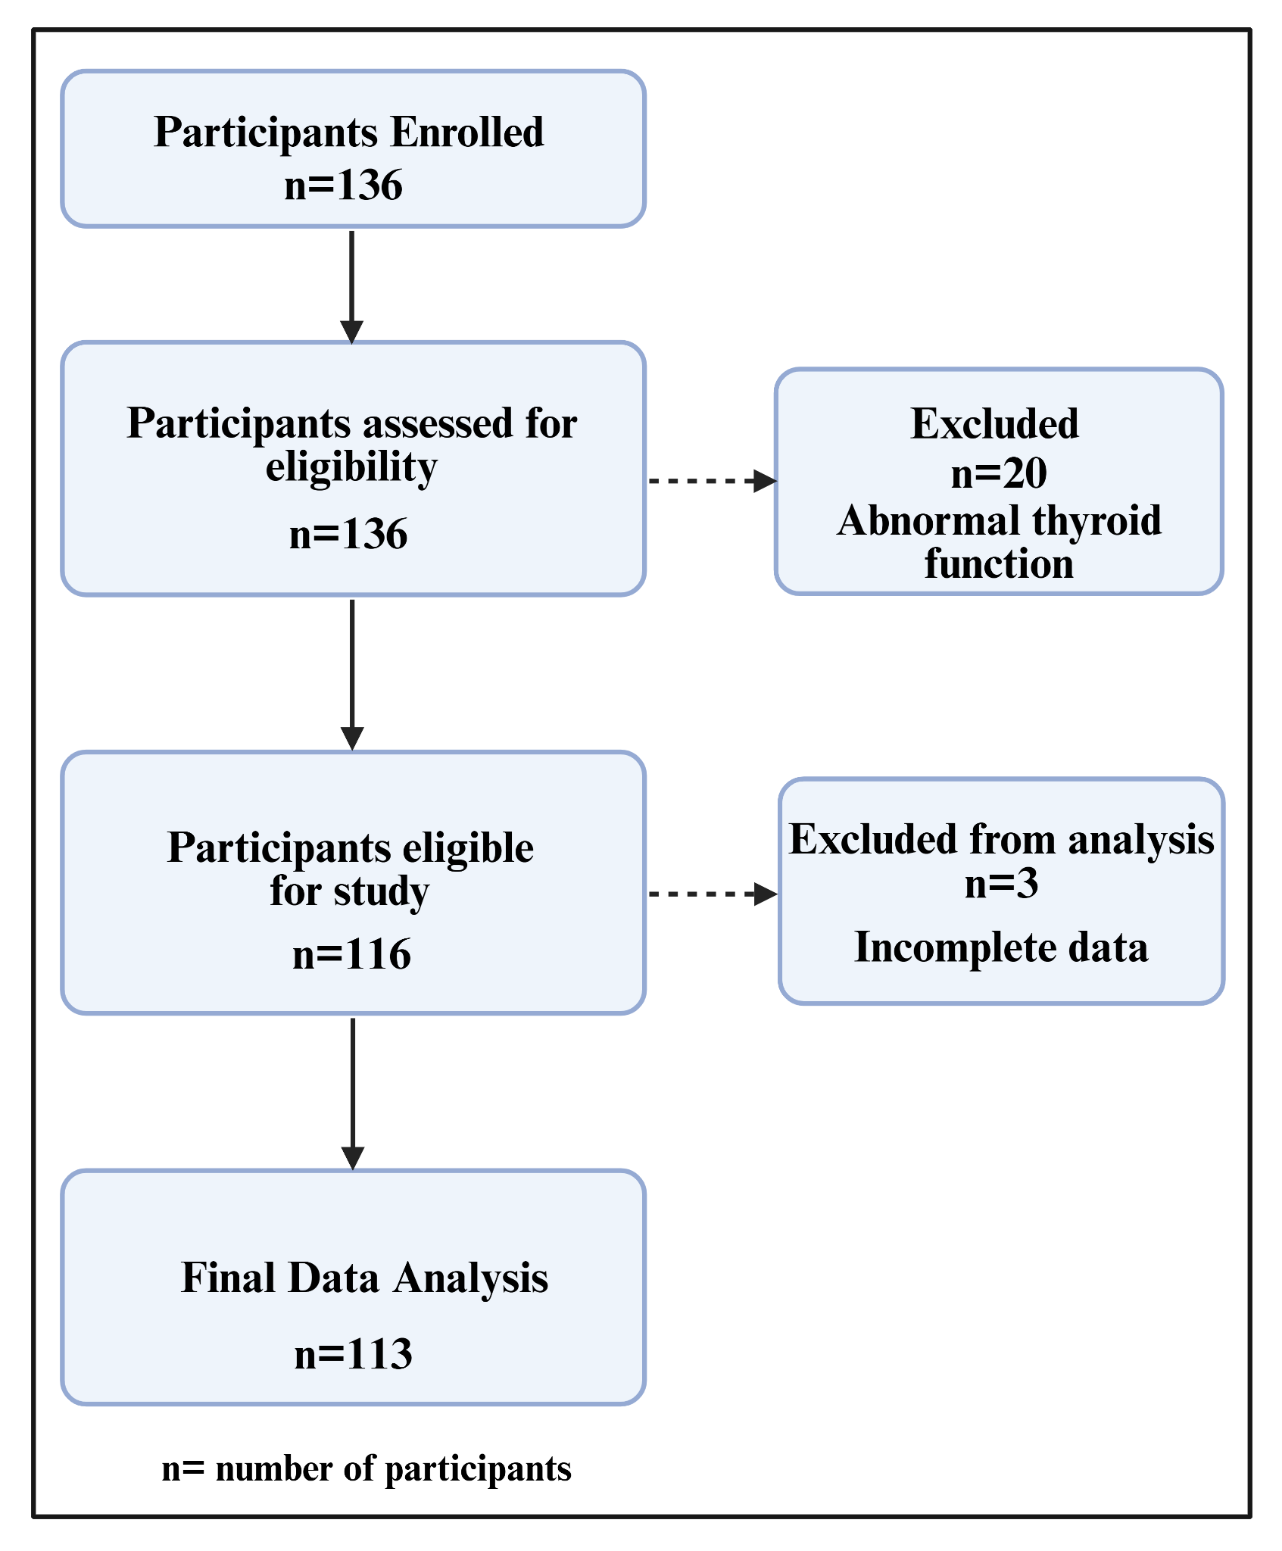

Fig. 1 Schematic representation of participant disposition throughout the study. Of the 136 participants initially enrolled, 20 were excluded after the identification of abnormal thyroid function, and a further 3 eligible participants were excluded due to incomplete data. Consequently, 113 participants met the predefined eligibility criteria and were included in the final analysis.
2.4 Ethical considerations
Participants were enrolled after providing written informed consent in their preferred language and receiving ethical committee approval. Ethical Approval Certificate Number KIMSDU/IEC/07/2022, dated 09 July 2022, was obtained from the Institutional Ethics Committee of Krishna Vishwa Vidyapeeth (Deemed to be University), Karad, District Satara, Maharashtra, India. The study was conducted in accordance with the principles of the World Medical Association Declaration of Helsinki for research involving human participants. Data confidentiality was maintained by restricting access to research and clinical data to the authors and mental health professionals directly involved in the study or treatment [16].
2.5 Assessment tools
Socio-demographic, medical and treatment-related data were recorded using a semi-structured proforma. The Depression Anxiety Stress Scale-42 (DASS-42) assessed symptom severity across the domains of depression, anxiety and stress. The DASS-42 has been validated across a range of cultural contexts and translated into various linguistic and cultural contexts [17], [18]. The DASS-42 was selected because it provides separate quantitative measures of depression, anxiety and stress symptom severity within a single validated instrument, making it particularly suitable for studies involving mixed psychiatric populations.
The Warwick-Edinburgh Mental Well-Being Scale (WEMWBS) is a standardised scale for evaluating self-reported mental well-being, with a focus on positive mental health indicators. The WEMWBS was chosen because it measures positive aspects of mental health and psychological functioning rather than psychological distress alone, thereby complementing symptom-based assessments and allowing evaluation of subjective well-being. Higher scores indicate better well-being [19] and have also been validated in other populations such as those in Norway [20]. English and Hindi versions were used with permission from the authors of the translated versions [21].
2.6 Serum prolactin estimation
To account for variations in hormone levels throughout the day, a serum tube containing 2-3 mL of blood was collected after overnight fasting and used to measure serum prolactin between 9:00 and 11:00 a.m. using a two-site immune-enzymometric assay. Participants completed the DASS-42 and WEMWBS questionnaires during their initial visit and underwent prolactin estimation the following morning. Information on demographic and clinical variables that may influence serum prolactin concentrations was collected wherever available. These included age, sex, menopausal status, substance use, medication status and treatment.
2.7 Statistical analysis
Data were entered into Microsoft Excel, and Jamovi version 2.6.44 from the Jamovi project in Sydney, Australia, was used for analyses. Descriptive statistics were reported as means and standard deviations (SD) for continuous variables and percentages for categorical data. Correlations between prolactin, symptom severity (DASS-42) and well-being (WEMWBS) were assessed using Pearson’s correlation coefficient. An independent Student's t-test was employed to compare groups. A significant p-value was defined as less than 0.05.

3. RESULTS:
The mean age of the participants was 35.3 ± 10.7 years. Of the 113 participants included in the final analysis, 76 (67.2%) were female, and 37 (32.7%) were male. Most of them were married (61.9%), employed (72.6%) and had a graduation level of education or above (73.5%). The socio-demographic characteristics of the study participants are presented in Figure 2. Out of the study participants, 82 (72.6%) were employed. Employed participants had higher mental well-being and lower DASS-42 scores than unemployed participants. As far as substance use was concerned, 17 participants (15%) were occasional consumers of alcohol, 13 (11.5%) used tobacco, while the remaining 83 (73.5%) did not consume any substance. 63 participants (56%) were not on psychotropic drugs at the time of recruitment. Among those receiving psychotropic treatment, serum prolactin levels did not differ significantly compared with participants who were not on psychotropic medication (p = 0.65). The DASS-42 scores, serum prolactin levels and WEMWBS scores of the study participants are presented in Table 2. Clinical characteristics indicated that menopausal status was unavailable for most participants, with 98 (86.72%) records lacking documentation and only 15 (13.27%) documenting menopausal status. The duration since formal diagnosis was less than 1 month for 66 (58.40%) participants, followed by 1 to <6 months for 27 (23.89%), 6–12 months for 11 (9.73%) and more than 12 months for 9 (7.96%). Regarding treatment duration, nearly half of the participants (56; 49.55%) were not receiving treatment at the time of assessment. Among those receiving treatment, 16 (14.15%) had been on treatment for less than 1 month, 21 (18.58%) for 1 to <6 months, 4 (3.53%) for 6–12 months and 14 (12.38%) for more than 12 months, while treatment duration information was unavailable for 2 (1.76%) participants. Substance use was infrequently reported, with alcohol use documented in 17 (15.00%) participants and tobacco use in 13 (11.50%), whereas information on substance use was unavailable for 83 (73.50%) participants Table 1.
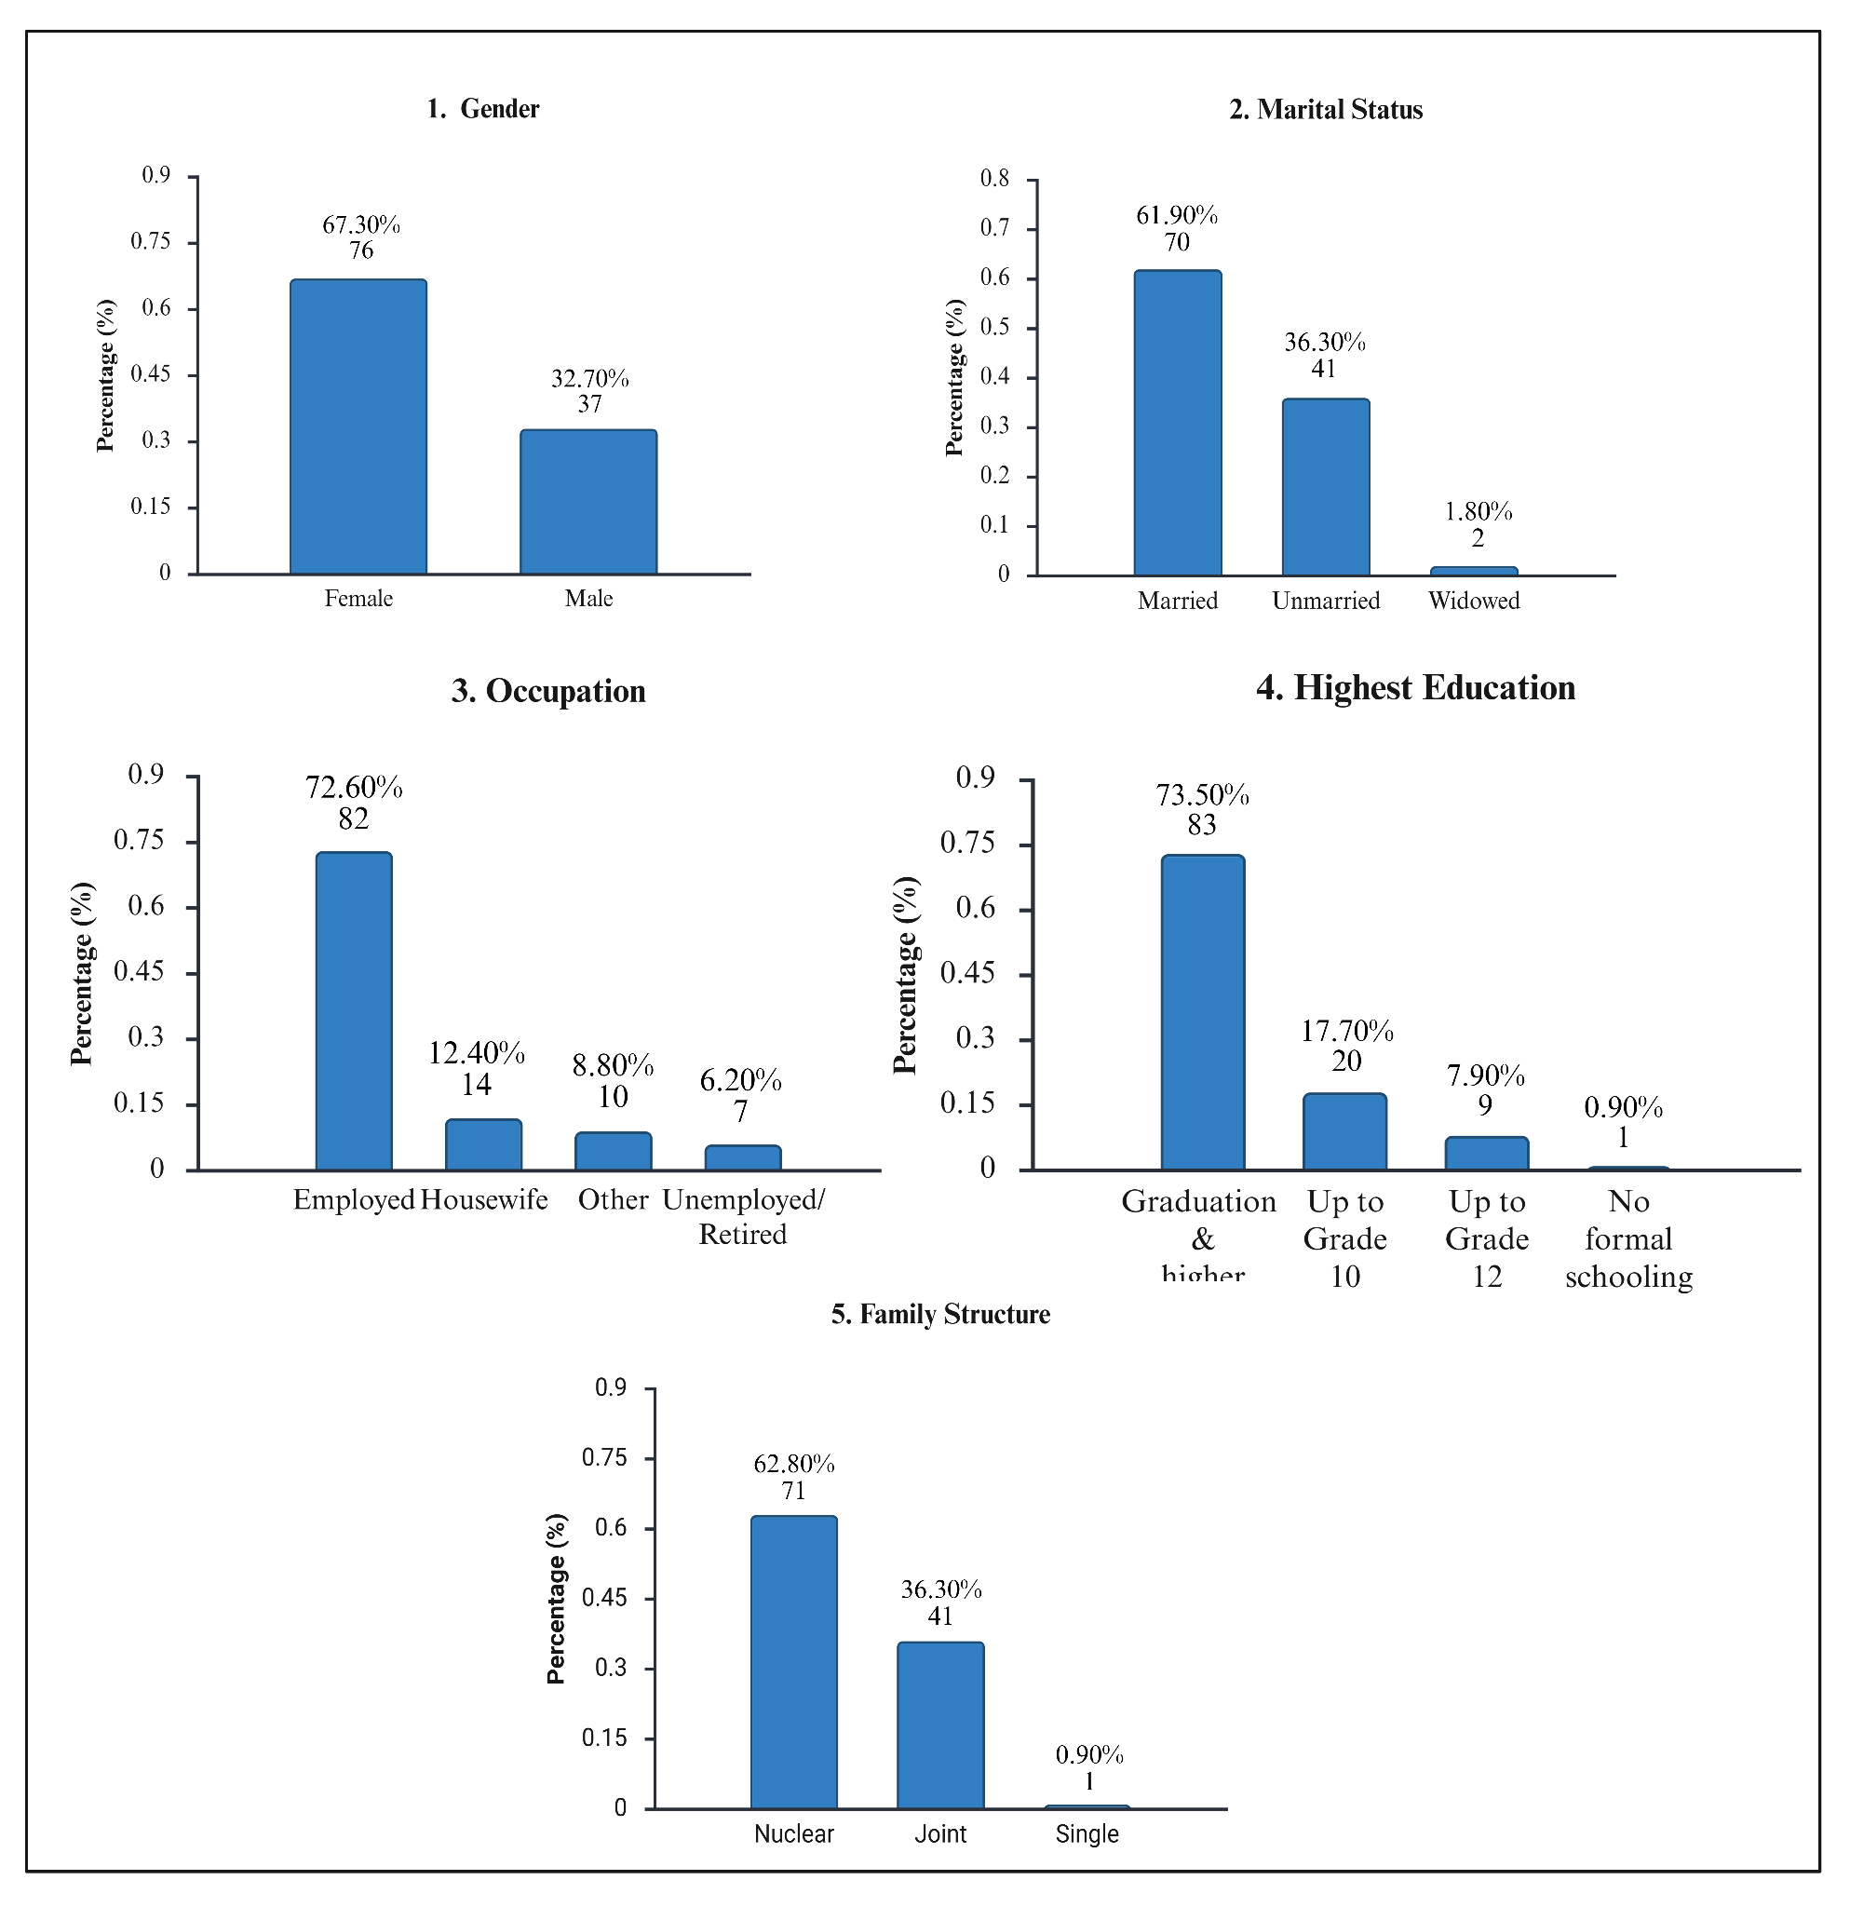
Fig. 2 Socio-demographic profile of participants. Distribution of participants according to (1) gender, (2) marital status, (3) occupation, (4) highest educational attainment and (5) family structure. Bars represent the percentage and number of participants in each category.

Table 1: Demographic and clinical characteristics of the study participants (n = 113)
Variable | Category | n (%)
Menopausal status | Recorded | 15 (13.27)
Menopausal status | NA | 98 (86.72)
Duration since formal diagnosis | <1 month | 66 (58.40)
Duration since formal diagnosis | 1 to <6 months | 27 (23.89)
Duration since formal diagnosis | 6–12 months | 11 (9.73)
Duration since formal diagnosis | >12 months | 9 (7.96)
Duration of treatment | Not receiving treatment | 56 (49.55)
Duration of treatment | <1 month | 16 (14.15)
Duration of treatment | 1 to <6 months | 21 (18.58)
Duration of treatment | 6–12 months | 4 (3.53)
Duration of treatment | >12 months | 14 (12.38)
Duration of treatment | NA | 2 (1.76)
Substance use | Alcohol | 17 (15.00)
Substance use | Tobacco | 13 (11.50)
Substance use | NA | 83 (73.50)

Table 2: Descriptive statistics of symptom severity (DASS-42 scores), serum prolactin and mental well-being (WEMWBS score)
Variable | Mean ± SD | 95% Confidence Intervals
Depression | 11.81 ± 11.33 | 9.72, 13.89
Anxiety | 11.87 ± 10.23 | 9.98, 13.75
Stress | 14.47 ± 10.76 | 12.49, 16.45
Total DASS-42 score | 38.15 ± 30.83 | 32.47, 43.83
Serum Prolactin | 11.32 ± 9.71 | 9.52, 13.11
WEMWBS score | 48.62 ± 13.32 | 46.19, 51.11

Serum prolactin showed negligible, non-significant correlations with the DASS-42 domains and total score. The correlations between serum prolactin, DASS-42 scores and WEMWBS are presented in Figures 3 and 4. Figure 3 shows the correlation matrix, while Figure 4 presents scatter plots of the associations between serum prolactin and the psychological measures. There was a very weak positive correlation between serum prolactin and mental well-being (WEMWBS) (r = 0.005, p = 0.96). DASS-42 domains correlated positively with each other. The mean serum prolactin level was significantly higher in women (12.94 ± 11.26 ng/mL) compared to men (8 ± 3.6 ng/mL, p = 0.01). There was no gender difference in DASS-42 domain and total scores. The differences in mental well-being (50.86 and 44.98) between the married and unmarried groups were significant (p=0.02). Employed participants had better mental well-being, with significantly lower DASS-42 scores than unemployed participants (p < 0.01), although no significant differences in prolactin levels were observed.

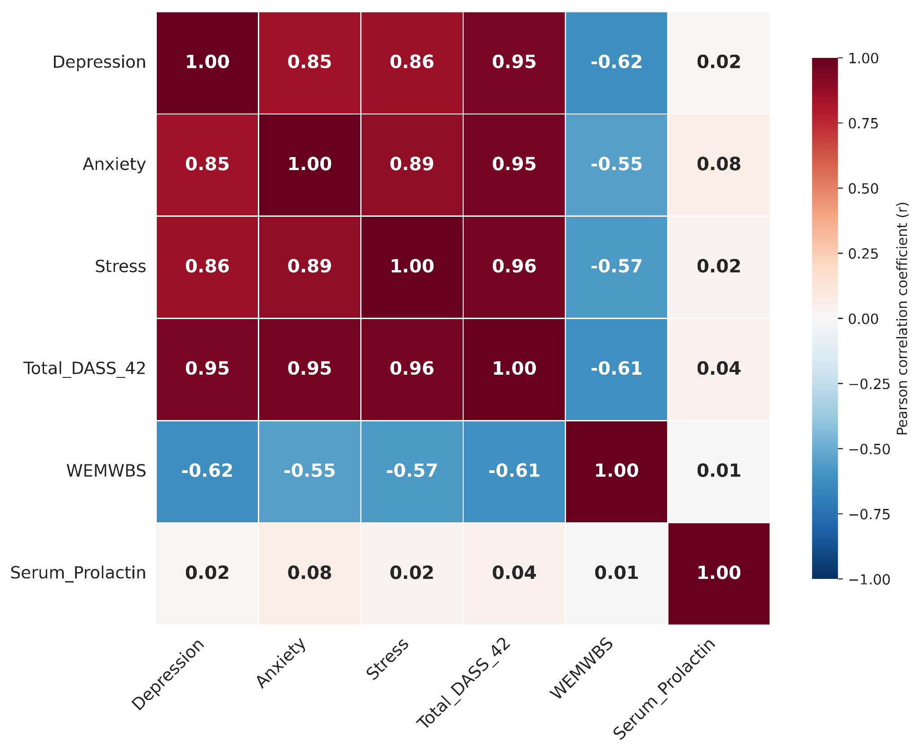
Fig. 3 Correlation matrix of DASS-42 domains, total DASS-42 score, WEMWBS, and serum prolactin levels. Heatmap illustrating Pearson correlation coefficients (r) among depression, anxiety, stress, total DASS-42 score, WEMWBS score, and serum prolactin levels. Red indicates positive correlations, blue indicates negative correlations, and colour intensity represents the strength of the correlation.

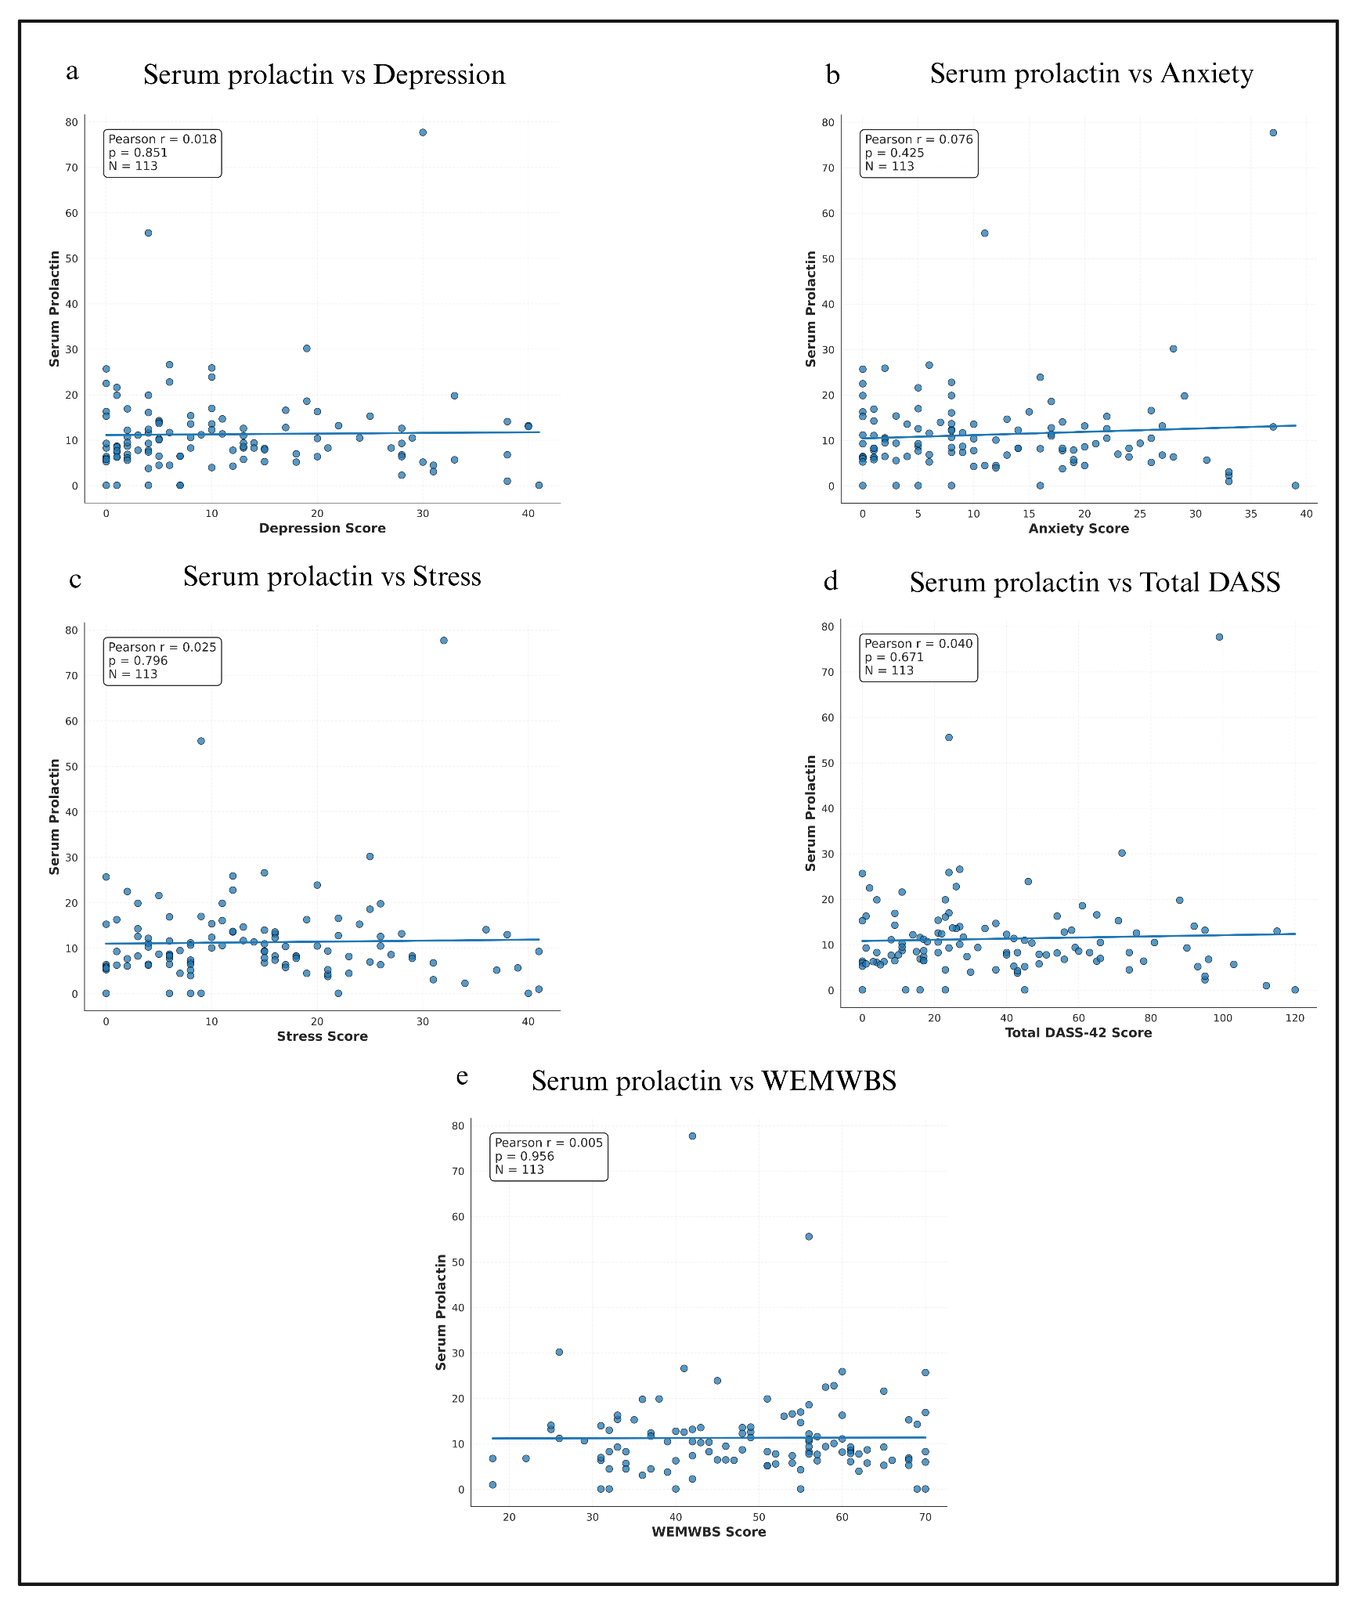

Fig. 4 Correlations between serum prolactin levels and psychological symptom severity and well-being. Scatter plots illustrating the associations between serum prolactin levels and (A) depression, (B) anxiety, (C) stress, (D) total Depression, Anxiety and Stress Scale-42 (DASS-42) scores, and (E) Warwick–Edinburgh Mental Well-being Scale (WEMWBS) scores. Pearson’s correlation coefficient (r) and corresponding p-values are shown for each association (n = 113). Solid regression lines represent the linear trend between serum prolactin levels and the respective outcome measures.

4. DISCUSSION:
Experimental studies suggest a modulatory role of prolactin in stress response, primarily through inhibitory effects on the hypothalamo-pituitary-adrenal (HPA) axis. Evidence suggests that lactation in female animals helps reduce stress and immune response and confers neuroprotective benefits in part via prolactin elevations [22]. A systematic review also reported a possible anxiolytic and anti-depressive action of hyperprolactinaemia in rodent models [23], consistent with earlier experimental evidence of anxiolytic effects of brain prolactin [24]. A small number of human studies examining the association between prolactin and mood changes have reported no clear association [25]. Our findings do not demonstrate an association between prolactin and mood state. These findings partially align with an earlier study, which reported higher prolactin levels in untreated MDD compared with controls but found no association with stress, as assessed using the DASS-21 and Brief Symptom Inventory scales. A study of 49 depressed adolescents with 39 controls showed no difference in 24-hour prolactin secretion pattern between the two groups [26]. The inconsistent findings across studies are likely attributable to important methodological differences. Several previous investigations recruited patients with a single diagnosis, such as major depressive disorder or prolactinoma, whereas the present study included a heterogeneous outpatient population with depressive, anxiety and stress-related disorders. Differences in medication exposure may also contribute, as some studies included drug-naive participants while others enrolled patients receiving antidepressants or other psychotropic medications known to influence prolactin secretion. Furthermore, prolactin assays, timing of blood sampling, fasting status and laboratory methodologies differed substantially across studies, limiting direct comparison. Variations in sample characteristics, including age, sex distribution, illness chronicity and severity, may also account for discrepancies. The methodological differences should be considered when interpreting the conflicting literature and may partly explain the lack of a significant association observed in the present study.
A meta-analytic review of hypoprolactinemia in men showed that low prolactin is associated with somatising anxiety and depressive symptom severity [27]. Among women, interesting findings show that prolactin elevations were partly associated with hostility, although this did not reach statistical significance [28]. A study of negative affectivity (as a global indicator of depression and anxiety) measured using Beck Depression Inventory, Hamilton Depression Rating Scale (HAM-D), Hospital Anxiety and Depression Scale and 12-item Well-Being Questionnaire among 102 young women attending a gynaecological endocrinology clinic with diagnoses such as polycystic ovarian syndrome and hypothalamic amenorrhoea found a significant positive correlation between prolactin with HAM-D in univariate analysis but not in multivariate analysis [29], consistent with broader evidence linking hormonal fluctuations, including prolactin to depressive symptoms in specific populations such as the peripartum period [30]. So, there is a need for continued study of prolactin’s role in depression and anxiety. Various biological factors may explain the lack of a significant correlation between prolactin levels and symptom severity in this group. First, prolactin is secreted in a pulsatile manner with a circadian rhythm; thus, a single morning measurement is likely insufficient to determine individual prolactin levels. Second, the effect of prolactin on symptoms can be influenced by prolactin receptor sensitivity and the signalling process itself, both of which are independent of prolactin levels. Third, diagnostic diversity of the sample, including patients suffering from depression, anxiety and stress disorders with different degrees of chronicity, along with the fact that some of the patients were under medication that changes prolactin levels, might have affected the results.
The prolactin hormone showed no significant relationship with the self-assessed mental well-being. Nevertheless, the increase in prolactin and oxytocin levels in lactating women has been reported to result in enhanced feelings of positivity, improved relationships between mothers and infants, increased relaxation and alertness, and decreased chances of depression and anxiety in mothers [31]. This implies prolactin's impact on maternal well-being. A vast number of studies were reviewed, but no information about the correlation between prolactin and well-being was found in the literature. Prolactin may be involved in the regulation of depressive and anxiety states through neuroadaptations. Yet, there is no evidence for its correlation with well-being among people with depression and anxiety disorders [32].
Most of our participants were in the productive years of life, with an average age of 35.3 ± 10.7 years. Female participants predominated in our study (76 females and 37 males), consistent with trends reported in the epidemiological literature [3]. Gender differences in prolactin levels were significant (mean prolactin: 12.94 ng/mL in females and 8 ng/mL in males, p = .01), a finding that is not unexpected. Mental well-being and DASS-42 scores did not differ significantly with respect to gender, suggesting men and women both appeared to experience almost similar levels of depression, anxiety and stress [33]. The NMHS data also reported two-to-three times greater prevalence of depression among widowed, separated and divorced people than unmarried or married people, but the adjusted odds ratio for developing anxiety disorders was almost similar for married and separated/ widowed people [34]. In our study, although statistically significant differences in well-being were observed according to marital and employment status, these findings should be interpreted with caution. The cross-sectional study precludes causal inference, and the observed differences may reflect broader psychosocial factors such as social support, financial security and functional status rather than independent effects of marital or employment status. Therefore, while these findings may be clinically meaningful in highlighting vulnerable groups, they should not be interpreted as evidence of causal relationships.
Eighty-two participants (72.6%) were employed in our study, and this group reported better mental well-being and lower distress, which was associated with higher mental well-being and lower psychological distress. 15% reported occasional alcohol use, about 11.5% used tobacco, while a majority (73.5%) didn’t report any substance use. At recruitment, 63 (56%) weren’t on psychotropic medications. Among those who were receiving psychotropic treatment, no significant difference in serum prolactin levels was observed compared to those who were not on treatment (p = 0.65).
We observed a significant positive correlation between DASS-42 domains, anxiety and depression (r = 0.85), stress and anxiety (r =0.89) and stress and depression (r =0.86). These findings are also supported by previous studies proving stress as a major contributing factor to anxiety and depression, which are closely related to each other [35], [36]. This overlap suggests these domains cannot be studied in isolation. Unlike our findings, some authors have reviewed published literature and reported that anxiety is one of the early symptoms in hyperprolactinaemic individuals and reported some evidence of reduced anxiety with a reduction in prolactin [37]. Taken together, the data generated until now, including that from our study, reflect a more complex association of prolactin with mood and anxiety symptoms. Some authors report that the prolactin response to stress is unpredictable and appears to be modulated by various factors, including heredity [38], [39]. We did not specifically examine the duration of stress, although the DASS-42 assesses mood state over the preceding week.
Lastly, we found significant negative correlations between well-being and depression, anxiety, stress and overall distress (DASS-42) scores (r = -0.62, -0.55, -0.57 and -0.61, respectively), which indicates that emotional distress and well-being are inversely related, aligning with findings reported elsewhere [40], [41]. The relationship between prolactin and mood regulation is biologically complex, particularly because prolactin secretion is influenced by dopaminergic pathways involved in affective regulation.
The cross-sectional design limits causal conclusions. The hormone prolactin was evaluated with a single measurement, taking into account fluctuations in its level. Several important biological confounders that influence prolactin secretion, such as gender variation, stage of menstrual cycle, menopause status, stress situation and psychotropic drug use, were not completely controlled. Although information on age, sex, menopausal status, medication status, treatment and substance use was collected, several important biological and lifestyle factors known to influence prolactin secretion, including menstrual cycle phase, body mass index, caffeine intake, sleep quality, acute psychological stress immediately before blood sampling and physical activity, were not recorded. Another limitation is the absence of a healthy control group, and the study was conducted at a single centre using consecutive outpatient samples. Moreover, the evaluation of subjective well-being was performed in a population suffering from mental disorders.

5. CONCLUSION
The findings from the current cross-sectional study showed that there was no correlation between serum prolactin concentration and mood symptom severity or mental well-being in patients with depressive illness, anxiety disorders and stress. Given the single-centre, cross-sectional design and the number of biological confounders of prolactin secretion that could not be fully controlled, the present findings should not be interpreted as evidence that prolactin has no role in mood regulation; rather, they did not demonstrate a significant association in this cohort. These findings contribute to the inconsistent data in the existing literature on the use of prolactin as a peripheral biomarker of affective disturbance and suggest that single-point measurements of prolactin may not be sufficiently sensitive to capture the dynamic, pulsatile interactions between the HPA and HPG axes that underlie mood disturbances. Future longitudinal, multicentre studies with larger, more diagnostically homogeneous cohorts, healthy control groups, and adjustment for hormonal confounders are needed before any conclusion can be drawn regarding prolactin's utility as a biomarker in this population.
Indeed, mental well-being was significantly inversely correlated with depression, anxiety and stress levels, highlighting the critical role of the tight connection between psychological distress and well-being, irrespective of prolactin level. Such an inverse relationship confirms that well-being is a construct directly affected by the psychological symptom burden, irrespective of peripheral hormone levels, and implies that attention to mental well-being at the clinical level might be better achieved by managing the symptoms themselves rather than through biomarker measures.
Even though no correlation was found, this does not mean that prolactin is not linked to mood regulation, because of the complex interactions involving factors such as sex, reproductive state, disease chronicity, and pharmacotherapy that were not taken into account in cross-sectional research. In particular, antipsychotics and antidepressants, which increase prolactin levels via dopaminergic modulation, may interfere with the connection between spontaneous changes in the level of prolactin and mood state. The diurnal fluctuations, stress-induced prolactin secretion, and phase of the menstrual cycle in female subjects are other variables that can be sources of variance in cross-sectional samples.
The future longitudinal study will allow understanding whether prolactin has any clinical and pathogenetic value in mood and anxiety disorders. It includes serial prolactin testing, stratifying by patients treatment and reproductive status, and examining HPA axis function. Until such data is collected, prolactin should not be regarded as the biomarker for the degree of severity or mood.

6. DECLARATIONS
6.1 Acknowledgement
We thank the Institutional Ethics Committee of Krishna Vishwa Vidyapeeth (Deemed to be University), Karad, Maharashtra, India for providing the necessary infrastructure and research facilities that enabled the completion of this study.
6.2 Funding
No funding was received for conducting this study.
6.3 Competing Interests
The authors report there are no competing interests to declare.
6.4 Ethics approval
Ethical Approval Certificate Number KIMSDU/IEC/07/2022 dated 09 July 2022 received from the Institutional Ethics Committee of Krishna Vishwa Vidyapeeth (Deemed to be University), Karad, District Satara, Maharashtra, India.
6.5 Consent to participate
Informed consent was obtained from all individual participants included in the study.
6.6 Data availability
Not applicable
6.7 Author Contribution
Sharma Bhawana: Formal Analysis, Writing, review and editing; Murthy Vasantmeghna: Interpretation, Writing, review and editing; Mangot Ajish: Conceptualization, supervision, original draft-writing, review and editing; Kshirsagar Sharad: Review and editing, Revising.
6.8 AI Statement Generative AI Disclosure
Generative AI tools were used only for language refinement; all academic analysis and commentary were produced by the authors. No AI tools were used for data analysis, interpretation, or scientific content generation. These tools were not used to generate ideas, analyze data, interpret results, or produce original content. All scientific content, interpretations, and conclusions are the authors' own. The author(s) reviewed and edited all tool-assisted output and took full responsibility for the content of this publication.

7. REFERENCES
[1] Z. Li, M. Ruan, J. Chen, and Y. Fang, “Major Depressive Disorder: Advances in Neuroscience Research and Translational Applications,” Neurosci. Bull., vol. 37, no. 6, pp. 863–880, Jun. 2021, doi: 10.1007/s12264-021-00638-3.
[2] B. A. Arvind et al., “Prevalence and socioeconomic impact of depressive disorders in India: multisite population-based cross-sectional study,” BMJ Open, vol. 9, no. 6, p. e027250, Jun. 2019, doi: 10.1136/bmjopen-2018-027250.
[3] Rs. Murthy, “National mental health survey of India 2015–2016,” Indian J. Psychiatry, vol. 59, no. 1, p. 21, 2017, doi: 10.4103/psychiatry.IndianJPsychiatry_102_17.
[4] A.-M. Bao and D. F. Swaab, “The human hypothalamus in mood disorders: The HPA axis in the center,” IBRO Rep., vol. 6, pp. 45–53, Jun. 2019, doi: 10.1016/j.ibror.2018.11.008.
[5] G. P. Chrousos, “Stress and disorders of the stress system,” Nat. Rev. Endocrinol., vol. 5, no. 7, pp. 374–381, Jul. 2009, doi: 10.1038/nrendo.2009.106.
[6] E. L. Belleau, M. T. Treadway, and D. A. Pizzagalli, “The Impact of Stress and Major Depressive Disorder on Hippocampal and Medial Prefrontal Cortex Morphology,” Biol. Psychiatry, vol. 85, no. 6, pp. 443–453, Mar. 2019, doi: 10.1016/j.biopsych.2018.09.031.
[7] A. Elgellaie, T. Larkin, J. Kaelle, J. Mills, and S. Thomas, “Plasma prolactin is higher in major depressive disorder and females, and associated with anxiety, hostility, somatization, psychotic symptoms and heart rate,” Compr. Psychoneuroendocrinology, vol. 6, p. 100049, May 2021, doi: 10.1016/j.cpnec.2021.100049.
[8] A. Faron-Górecka, K. Latocha, P. Pabian, M. Kolasa, I. Sobczyk-Krupiarz, and M. Dziedzicka-Wasylewska, “The Involvement of Prolactin in Stress-Related Disorders,” Int. J. Environ. Res. Public. Health, vol. 20, no. 4, p. 3257, Feb. 2023, doi: 10.3390/ijerph20043257.
[9] J. Medina, R. M. De Guzman, and J. L. Workman, “Prolactin mitigates chronic stress-induced maladaptive behaviors and physiology in ovariectomized female rats,” Neuropharmacology, vol. 258, p. 110095, Nov. 2024, doi: 10.1016/j.neuropharm.2024.110095.
[10] X. Miao et al., “A study on the correlations of PRL levels with anxiety, depression, sleep, and self-efficacy in patients with prolactinoma,” Front. Endocrinol., vol. 15, p. 1369729, Mar. 2024, doi: 10.3389/fendo.2024.1369729.
[11] I. M. H. Hamers, B. A. Brand, M. J. H. Begemann, C. S. Weickert, T. W. Weickert, and I. E. C. Sommer, “The association of prolactin and gonadal hormones with cognition and symptoms in men with schizophrenia spectrum disorder: Divergent effects of testosterone and estrogen,” Schizophr. Res., vol. 270, pp. 273–280, Aug. 2024, doi: 10.1016/j.schres.2024.06.022.
[12] A. Abeledo-Machado, M. Peña-Zanoni, D. Bornancini, and G. Díaz-Torga, “Revealing Sexual Dimorphism in Prolactin Regulation From Early Postnatal Development to Adulthood in Murine Models,” J. Endocr. Soc., vol. 8, no. 1, p. bvad146, Dec. 2023, doi: 10.1210/jendso/bvad146.
[13] J. H. Gutzman, S. E. Nikolai, D. E. Rugowski, J. J. Watters, and L. A. Schuler, “Prolactin and estrogen enhance the activity of activating protein 1 in breast cancer cells: role of extracellularly regulated kinase 1/2-mediated signals to c-fos,” Mol. Endocrinol., vol. 19, no. 7, pp. 1765–1778, Jul. 2005, doi: 10.1210/me.2004-0339.
[14] L. D. V. Sosa et al., “17β-Estradiol modulates the prolactin secretion induced by TRH through membrane estrogen receptors via PI3K/Akt in female rat anterior pituitary cell culture,” Am. J. Physiol.-Endocrinol. Metab., vol. 302, no. 10, pp. E1189–E1197, May 2012, doi: 10.1152/ajpendo.00408.2011.
[15] S. Melmed et al., “Diagnosis and Treatment of Hyperprolactinemia: An Endocrine Society Clinical Practice Guideline,” J. Clin. Endocrinol. Metab., vol. 96, no. 2, pp. 273–288, Feb. 2011, doi: 10.1210/jc.2010-1692.
[16] R. A. Tariq and P. B. Hackert, “Patient Confidentiality,” in StatPearls, Treasure Island (FL): StatPearls Publishing, 2026. Accessed: Jul. 17, 2026. [Online]. Available: http://www.ncbi.nlm.nih.gov/books/NBK519540/
[17] B. Meena, S. Gupta, and K. P. S. Shakya, “Psychological Distress and Disability in Patients with Primary Headache: A Cross-Sectional Study Using DASS-42 and IDEAS Scale,” Int. J. Curr. Pharm. Rev. Res., vol. 18, no. 06, Jun. 2026, doi: 10.25258/ijcpr.18.6.114.
[18] N. A. Shayan, A. Rahimi, A. M. Waseq, O. Dag, and H. Özcebe, “Translation, validation and reliability of depression, anxiety, and stress 42 (DASS-42) among Herat University students,” Discov. Ment. Health, vol. 5, no. 1, p. 199, Dec. 2025, doi: 10.1007/s44192-025-00335-x.
[19] R. Tennant et al., “The Warwick-Edinburgh Mental Well-being Scale (WEMWBS): development and UK validation,” Health Qual. Life Outcomes, vol. 5, no. 1, p. 63, Dec. 2007, doi: 10.1186/1477-7525-5-63.
[20] O. R. F. Smith, D. E. Alves, M. Knapstad, E. Haug, and L. E. Aarø, “Measuring mental well-being in Norway: validation of the Warwick-Edinburgh Mental Well-being Scale (WEMWBS),” BMC Psychiatry, vol. 17, no. 1, p. 182, Dec. 2017, doi: 10.1186/s12888-017-1343-x.
[21] S. Grover and D. Dua, “Hindi Translation and Validation of Scales for Subjective Well-being, Locus of Control and Spiritual Well-being,” Indian J. Psychol. Med., vol. 43, no. 6, pp. 508–515, Nov. 2021, doi: 10.1177/0253717620956443.
[22] M. E. Freeman, B. Kanyicska, A. Lerant, and G. Nagy, “Prolactin: Structure, Function, and Regulation of Secretion,” Physiol. Rev., vol. 80, no. 4, pp. 1523–1631, Jan. 2000, doi: 10.1152/physrev.2000.80.4.1523.
[23] N. Monasterio, E. Vergara, and T. Morales, “Hormonal influences on neuroimmune responses in the CNS of females,” Front. Integr. Neurosci., vol. 7, 2014, doi: 10.3389/fnint.2013.00110.
[24] L. Torner, N. Toschi, A. Pohlinger, R. Landgraf, and I. D. Neumann, “Anxiolytic and Anti-Stress Effects of Brain Prolactin: Improved Efficacy of Antisense Targeting of the Prolactin Receptor by Molecular Modeling,” J. Neurosci., vol. 21, no. 9, pp. 3207–3214, May 2001, doi: 10.1523/JNEUROSCI.21-09-03207.2001.
[25] L. Torner, “Actions of Prolactin in the Brain: From Physiological Adaptations to Stress and Neurogenesis to Psychopathology,” Front. Endocrinol., vol. 7, Mar. 2016, doi: 10.3389/fendo.2016.00025.
[26] G. Scott Waterman et al., “The 24-hour pattern of prolactin secretion in depressed and normal adolescents,” Biol. Psychiatry, vol. 35, no. 7, pp. 440–445, Apr. 1994, doi: 10.1016/0006-3223(94)90041-8.
[27] G. Corona, G. Rastrelli, C. Sparano, L. Vignozzi, and M. Maggi, “Acquired hypoprolactinemia in men, possible phenotype,” Rev. Endocr. Metab. Disord., vol. 25, no. 6, pp. 1109–1119, Dec. 2024, doi: 10.1007/s11154-024-09895-9.
[28] J. A. Barry, E. Moran, M. Thomas, and P. J. Hardiman, “Prolactin and hostility in hospitalised patients and healthy women: A systematic review and meta-analysis,” J. Obstet. Gynaecol., vol. 35, no. 5, pp. 499–507, Jul. 2015, doi: 10.3109/01443615.2014.970523.
[29] R. Watrowski, A. Rohde, M. Maciejewska-Jeske, and B. Meczekalski, “Hormonal and psychosocial correlates of psychological well-being and negative affectivity in young gynecological-endocrinological patients,” Gynecol. Endocrinol., vol. 32, no. 1, pp. 21–24, Jan. 2016, doi: 10.3109/09513590.2015.1062869.
[30] M. J. Szpunar and B. L. Parry, “A systematic review of cortisol, thyroid-stimulating hormone, and prolactin in peripartum women with major depression,” Arch. Womens Ment. Health, Oct. 2017, doi: 10.1007/s00737-017-0787-9.
[31] A. Modak, V. Ronghe, and K. P. Gomase, “The Psychological Benefits of Breastfeeding: Fostering Maternal Well-Being and Child Development,” Cureus, Oct. 2023, doi: 10.7759/cureus.46730.
[32] T. Georgescu, J. M. Swart, D. R. Grattan, and R. S. E. Brown, “The Prolactin Family of Hormones as Regulators of Maternal Mood and Behavior,” Front. Glob. Womens Health, vol. 2, p. 767467, Dec. 2021, doi: 10.3389/fgwh.2021.767467.
[33] N. Holzapfel, “A Depression, Anxiety, and Stress Scale ( DASS ‐42) Study on the Mental Health Conditions of Japanese Employees,” Jpn. Psychol. Res., p. jpr.12587, Feb. 2025, doi: 10.1111/jpr.12587.
[34] N. Manjunatha et al., “Prevalence and its correlates of anxiety disorders from India’s National Mental Health Survey 2016,” Indian J. Psychiatry, vol. 64, no. 2, pp. 138–142, Mar. 2022, doi: 10.4103/indianjpsychiatry.indianjpsychiatry_964_21.
[35] C. G. Davey et al., “The effects of stress–tension on depression and anxiety symptoms: evidence from a novel twin modelling analysis,” Psychol. Med., vol. 46, no. 15, pp. 3213–3218, Nov. 2016, doi: 10.1017/S0033291716001884.
[36] I.-B. Kim, J.-H. Lee, and S.-C. Park, “The Relationship between Stress, Inflammation, and Depression,” Biomedicines, vol. 10, no. 8, p. 1929, Aug. 2022, doi: 10.3390/biomedicines10081929.
[37] J. Gomes, A. Sousa, and G. Lima, “Hyperprolactinemia: Effect On Mood?,” Eur. Psychiatry, vol. 30, p. 714, Mar. 2015, doi: 10.1016/S0924-9338(15)30564-2.
[38] S. Levine and O. Muneyyirci-Delale, “Stress-Induced Hyperprolactinemia: Pathophysiology and Clinical Approach,” Obstet. Gynecol. Int., vol. 2018, pp. 1–6, Dec. 2018, doi: 10.1155/2018/9253083.
[39] P. J. Newey et al., “Mutant Prolactin Receptor and Familial Hyperprolactinemia,” N. Engl. J. Med., vol. 369, no. 21, pp. 2012–2020, Nov. 2013, doi: 10.1056/NEJMoa1307557.
[40] F. Grant, C. Guille, and S. Sen, “Well-Being and the Risk of Depression under Stress,” PLoS ONE, vol. 8, no. 7, p. e67395, Jul. 2013, doi: 10.1371/journal.pone.0067395.
[41] L. Iani, R. M. Quinto, M. Lauriola, M. L. Crosta, and G. Pozzi, “Psychological well-being and distress in patients with generalized anxiety disorder: The roles of positive and negative functioning,” PLOS ONE, vol. 14, no. 11, p. e0225646, Nov. 2019, doi: 10.1371/journal.pone.0225646.

