# BMW WEBSITE USING HTML, CSS, JAVASCRIPT (FRONT-END PROJECT)

## A MINI PROJECT REPORT

***Submitted by***

**ARVIND.V (312422104022)**

***in partial fulfillment for the requirement of award of the degree***

***of***

**BACHELOR OF ENGINEERING**

**IN**

**COMPUTER SCIENCE AND ENGINEERING**



**St. JOSEPH’S INSTITUTE OF TECHNOLOGY ::CHENNAI-119**

**(Autonomous Institution)**



**ANNA UNIVERSITY: CHENNAI 600 025**

## JULY - 2024

**ACKNOWLEDGEMENT**

We also take this opportunity to thank our respected and honorable Chairman **Dr.**

**B. Babu Manoharan M.A., M.B.A., Ph.D.** for the guidance he offered during our tenure in this institution.

We extend our heartfelt gratitude to our respected and honorable Managing Director **Mr.**

**B. Sashi Sekar M.Sc.** for providing us with the required resources to carry out this project.

We express our deep gratitude to our honorable Executive Director **Mrs. S. Jessie**

**Priya M.Com** for the constant guidance and support for our project.

We are indebted to our Principal **Dr. P. Ravichandran M. Tech., Ph.D.** for granting us permission to undertake this project.

We would like to express our earnest gratitude to our Head of the Department **Dr. J. Dafni Rose M.E., Ph.D.** for her commendable support and encouragement for the completion of the project with perfection.

We wish to convey our sincere thanks to all the teaching and non- teaching staff of the department of **COMPUTER SCIENCE AND ENGINEERING** without whose cooperation this venture would not have been a success.

# ABSTRACT

The BMW M3 CS project explores the epitome of automotive excellence through the lens of BMW's iconic sports sedan, combining performance, innovation, and luxury into a limited-edition masterpiece. This study delves into the technological advancements, design philosophy, market impact, and enthusiast reception surrounding the BMW M3 C decisions.

The BMW M3 CS represents a pinnacle in BMW's M performance lineup, embodying a blend of high-performance engineering and luxurious refinement. Introduced as a limited-production variant of the renowned M3 model, the M3 CS showcases BMW's commitment to pushing the boundaries of automotive design and technology. This project aims to dissect the various elements that contribute to its allure and market appeal, offering insights into BMW's strategy for creating exclusive, high-performance vehicles.

# 

# At the heart of the BMW M3 CS lies an advanced twin-turbocharged inline-six engine, meticulously engineered to deliver exceptional power and torque. Producing 543 horsepower and 479 lb-ft of torque, this engine propels the M3 CS from 0 to 60 mph in just 3.7 seconds, showcasing its track-ready capabilities. The integration of lightweight materials, such as carbon fiber-reinforced plastic (CFRP), in critical components like the roof and hood, enhances performance while reducing overall weight.

# The BMW M3 CS project includes a comprehensive analysis of market trends and consumer preferences within the sports sedan segment. Through qualitative and quantitative research methods, this study examines the factors influencing consumer decisions to purchase high-performance, limited-production vehicles like the M3 CS. Insights gleaned from market data and consumer feedback provide valuable feedback for automakers seeking to align product offerings with enthusiast expectations and market demand.

# Design plays a crucial role in the appeal of the BMW M3 CS. Its aerodynamic enhancements, including an aggressive front splitter and rear diffuser, optimize airflow and improve stability at high speeds. Distinctive M-specific elements, such as lightweight forged alloy wheels and exclusive paint finishes, contribute to its visual appeal and exclusivity. The interior combines luxurious materials with advanced driver-centric features, including M-specific digital displays, ergonomic M sports seats, and intuitive infotainment systems, enhancing comfort and driving pleasure.

# From an educational perspective, the BMW M3 CS project serves as a case study in automotive engineering excellence. It provides valuable insights into the integration of advanced technologies, materials science, and aerodynamic principles in high-performance vehicle design. Automotive enthusiasts, students, and professionals alike can benefit from studying the M3 CS to understand BMW's approach to balancing performance, luxury, and sustainability in automotive manufacturing.

# In addition to performance and luxury, sustainability is increasingly becoming a focal point in automotive design. The BMW M3 CS incorporates eco-friendly practices, such as efficient engine technologies and recyclable materials, to minimize its environmental footprint without compromising performance. This shows BMW's commitment to future automotive developments, advancements in Eco-conscious manufacturing processes and renewable energy integration.

# 

# CHAPTER 1

**Introduction:-**

The BMW M3 CS represents a pinnacle in BMW's M performance lineup, embodying a blend of high-performance engineering and luxurious refinement.

This study delves into the technological advancements, design philosophy, market impact, and enthusiast reception surrounding the BMW M3 CS.

Introduced as a limited-production variant of the renowned M3 model, the M3 CS showcases BMW's commitment to pushing the boundaries of automotive design and technology.

At its core, the BMW M3 CS features an advanced twin-turbocharged inline-six engine, meticulously engineered to produce 543 horsepower and 479 lb-ft of torque.

This powerhouse propels the M3 CS from 0 to 60 mph in just 3.7 seconds, underscoring its track-ready capabilities.

Lightweight materials, including carbon fiber-reinforced plastic (CFRP) in components like the roof and hood, not only enhance performance but also reduce overall weight, contributing to its agility and responsiveness on the road.

**Overview:-**

The BMW M3 CS project includes a comprehensive analysis of market trends and consumer preferences within the sports sedan segment. Through qualitative and quantitative research methods, this study examines the factors influencing consumer decisions to purchase high-performance, limited-production vehicles like the M3 CS.

Insights gleaned from market data and consumer feedback provide valuable feedback for automakers seeking to align product offerings with enthusiast expectations and market demand.Design plays a crucial role in the appeal of the BMW M3 CS. Its aerodynamic enhancements, aggressive front splitter, and rear diffuser optimize airflow and stability at high speeds.

Distinctive M-specific elements, such as lightweight forged alloy wheels and exclusive paint finishes, contribute to its visual appeal and exclusivity.

Inside, the interior blends luxurious materials with advanced driver-centric features, including M-specific digital displays, ergonomic M sports seats, and intuitive infotainment systems, enhancing comfort and driving pleasure.

From an educational perspective, the BMW M3 CS serves as a case study in automotive engineering excellence. It provides insights into the integration of advanced technologies, materials science, and aerodynamic principles in high-performance vehicle design.

Automotive enthusiasts, students, and professionals alike can benefit from studying the M3 CS to understand BMW's approach to balancing performance, luxury, and sustainability in automotive manufacturing.

In addition to performance and luxury, sustainability is increasingly becoming a focal point in automotive design.

The BMW M3 CS incorporates eco-friendly practices, such as efficient engine technologies and recyclable materials, to minimize its environmental footprint without compromising performance.

This reflects BMW's commitment to future automotive developments, advancements in eco-conscious manufacturing processes, and the integration of renewable energy sources.

# CHAPTER -2

## TECHNOLOGIES

**Technologies and Tools Used:-**

1. **HTML, CSS, JavaScript:** These foundational technologies drive the interactive and dynamic elements of the BMW M3 CS's official website, enhancing user engagement and navigation.
2. **Swiper.js:** Integrated for seamless image and video carousel functionalities, enhancing visual storytelling and showcasing detailed car features effectively.
3. **Locomotive Scroll:** Enables smooth scrolling effects, providing a fluid and immersive user experience while exploring specifications, videos, and immersive visual content of the BMW M3 CS.
4. **GSAP (GreenSock Animation Platform):** Utilized for creating engaging animations and transitions throughout the website, enhancing user interaction and visual appeal.
5. **Web Fonts (Rejouice and NB International Pro):** Custom fonts are employed to maintain brand consistency and readability across different sections of the website
6. **Cursor Interaction:** The BMW M3 CS website features a dynamic circular cursor that enhances user engagement and navigation with its responsive design and subtle animations. It reflects BMW's commitment to blending advanced technology with intuitive user interface elements.
7. **Hover Effects:** Hover effects on the BMW M3 CS website provide interactive visual feedback, enhancing user interaction by dynamically highlighting navigation links and multimedia content. These effects contribute to a polished and engaging browsing experience, emphasizing BMW's dedication to craftsmanship and innovation in web design.
8. **Development Environment:** The BMW M3 CS website is developed using modern tools and practices, ensuring efficient coding and seamless integration of design elements. This setup allows for continuous updates and enhancements to reflect the latest advancements in automotive technology and user interface design principles.
9. **Front-end Design:** The front-end of the website is meticulously crafted to prioritize user experience, employing innovative techniques such as cursor effects, integrated video content, and interactive elements. These features aim to provide visitors with an immersive and informative exploration of the BMW M3 CS's performance capabilities, design aesthetics, and technological innovations.

**Conclusion:** The BMW M3 CS website serves as a comprehensive online platform, offering enthusiasts and potential buyers detailed insights into its exceptional performance, luxurious design, and cutting-edge technology. Through a blend of advanced engineering and user-centric design, the website ensures that every interaction with the BMW M3 CS is as thrilling and engaging as the driving experience itself.

# CHAPTER -3

# RESULT

**FRONTEND:-**

1. **LOADING SCREEN:-**



1. **LANDING PAGE ( VIDEO PLAY AT BACKGROUND ):-**

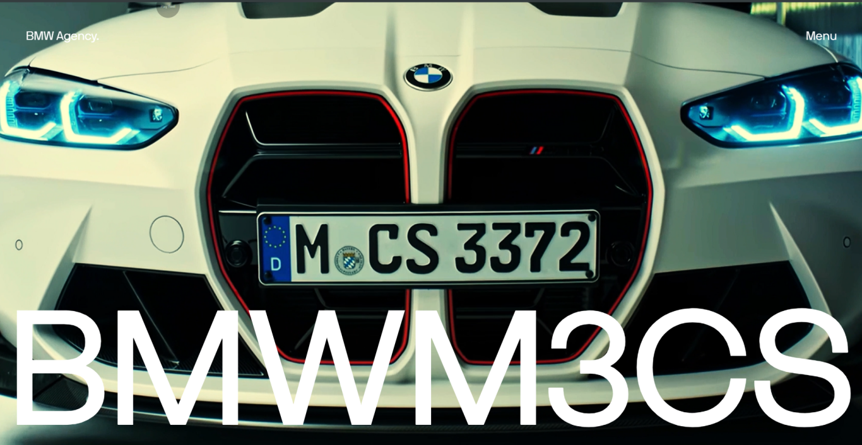

1. **DETAIL PAGE:-**

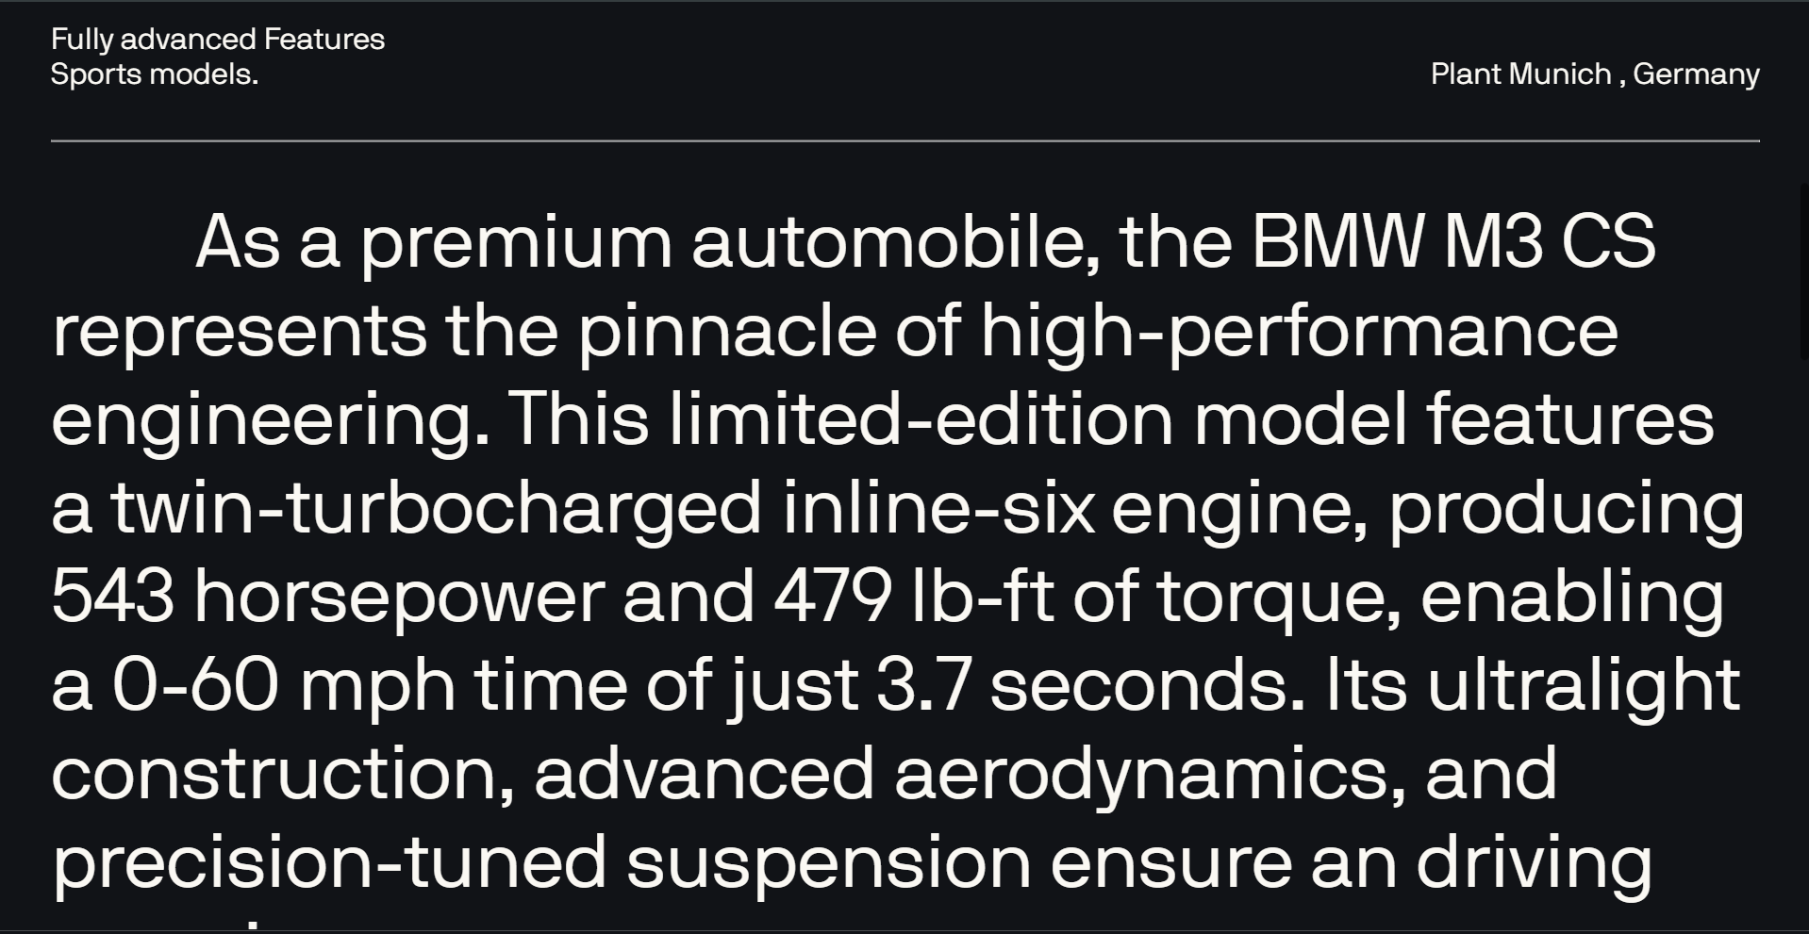

1. **FEATURES PAGE (HOVER ANIMATION AND VIDEO ):-**

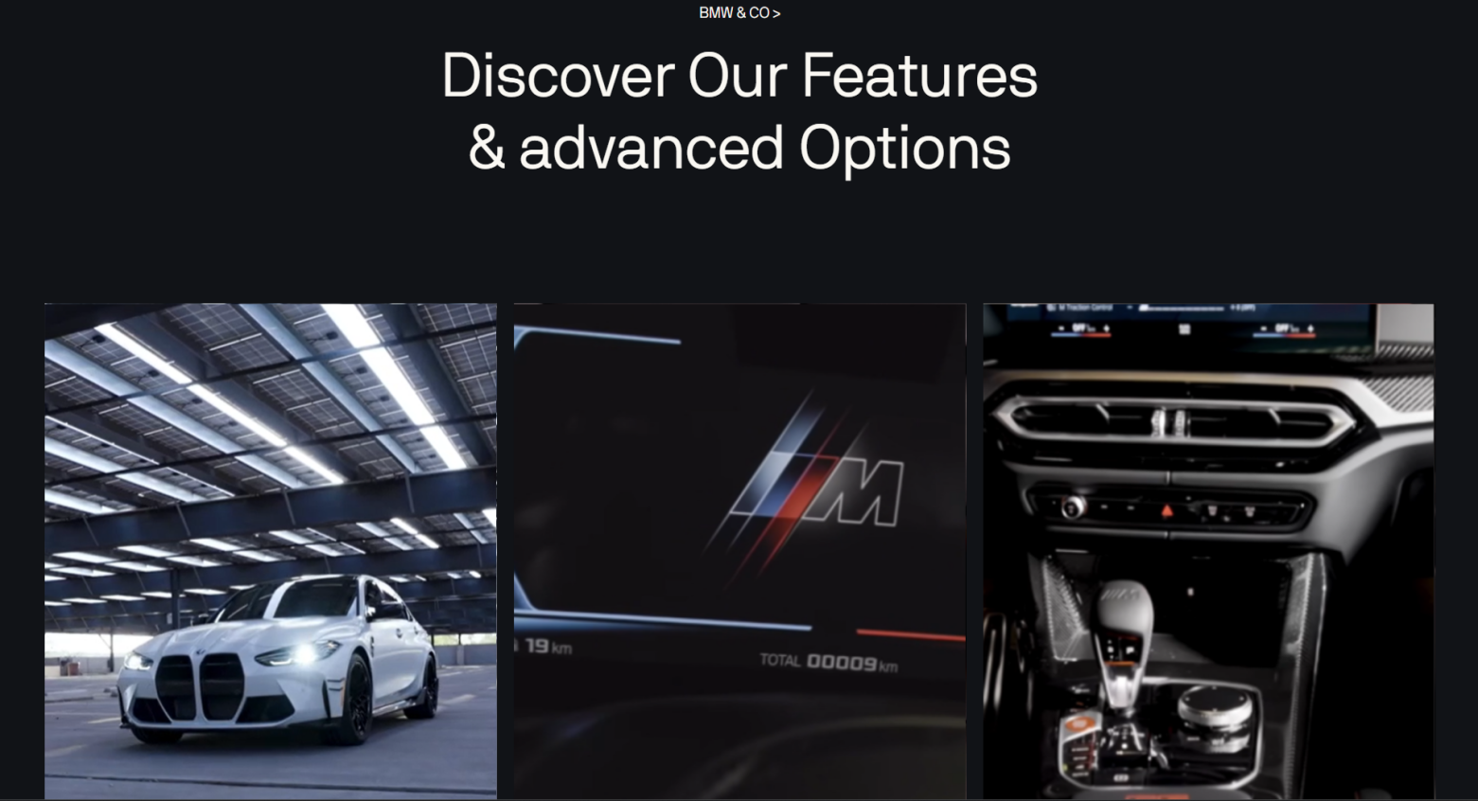

1. **LINKING PAGE ( RADIENT ANIMATION ):-**

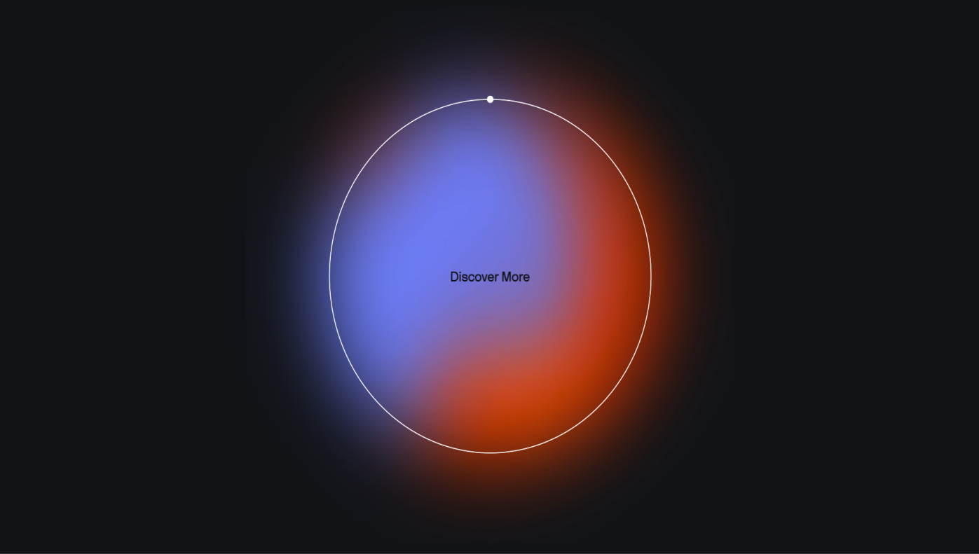

1. **IMAGE SCROLLING PAGE :-**

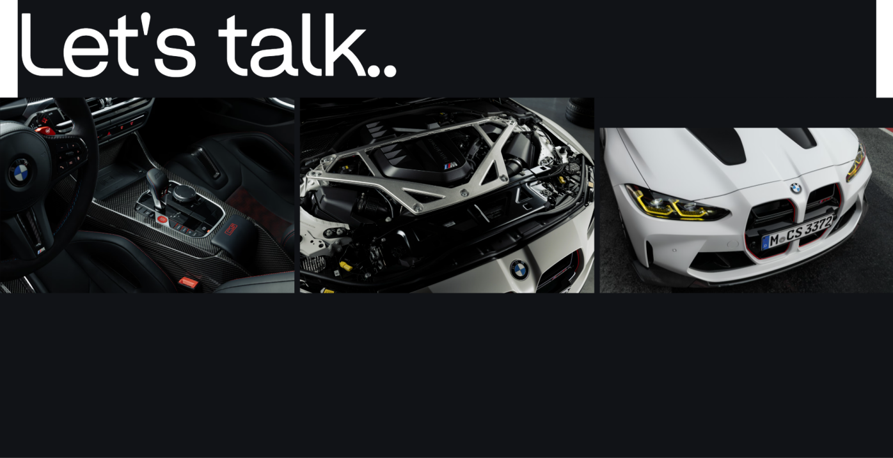

**Project Demo Link**: **<https://bmwm3cs.netlify.app/>**

# CHAPTER -4

**CONCLUSION:-**

I selected the BMW M3 CS project for its exceptional blend of cutting-edge automotive technology and unparalleled driving experience. The M3 CS exemplifies BMW's commitment to innovation, featuring a powerful twin-turbocharged inline-six engine that produces 543 horsepower, propelling it from 0 to 60 mph in just 3.7 seconds.

Its lightweight carbon fiber components and precision-tuned suspension system not only enhance performance but also ensure agile handling and responsiveness on both road and track.

The integration of advanced technologies such as BMW's iDrive system, adaptive M suspension, and carbon ceramic brakes underscores its status as a high-performance sports car. These innovations not only elevate driving dynamics but also prioritize safety and comfort, making the M3 CS suitable for both spirited driving and daily usability.

Moreover, the M3 CS project highlights BMW's continuous pursuit of automotive excellence through rigorous research and development. By leveraging technologies like Unity for virtual prototyping, JavaScript for interactive web applications, and GSAP for animation, the project demonstrates BMW's prowess in integrating digital innovation with mechanical precision.

In conclusion, the BMW M3 CS stands as a testament to BMW's legacy of engineering prowess and commitment to delivering exceptional driving experiences. It represents a harmonious fusion of performance, luxury, and technological advancement, setting benchmarks in the realm of high-performance sports cars

## INTERNSHIP:-

Our internship experience at LearnSmasher EduTech LLP has proven to be profoundly enlightening and fulfilling. During our tenure thus far, we have garnered invaluable insights into the education technology sector and observed firsthand the organization's unwavering commitment to innovation and excellence.

Throughout our ongoing internship, we have collaborated closely with a team of seasoned professionals who have generously shared their expertise and provided invaluable mentorship.

Their guidance has empowered us to sharpen our technical acumen and broaden our understanding of various facets within the industry.

We have actively contributed to diverse projects, applying theoretical knowledge acquired during our academic pursuits to practical, real-world challenges.

Engaging in product development, testing, and troubleshooting has significantly bolstered our problem-solving capabilities.

Furthermore, LearnSmasher EduTech LLP's dedication to customer satisfaction has left an indelible mark on us.

Witnessing their steadfast focus on delivering exceptional post-sales service and technical support has underscored the importance of prioritizing customer needs and cultivating robust client relationships.

The company's proactive stance on sustainability and environmental stewardship has also resonated deeply with us.

Their initiatives aimed at reducing environmental impact align seamlessly with our personal values, inspiring us to integrate sustainability considerations into our future endeavors.

In conclusion, our ongoing internship at LearnSmasher EduTech LLP continues to be a transformative journey. It has ignited a deeper passion for educational technology, honed our professional competencies, and laid a solid foundation for our prospective careers