DR. HARISINGH GOUR UNIVERSITY, SAGAR
DEPARTMENT OF COMPUTER SCIENCE AND APPLICATION

PROJECT REPORT
MASTER OF COMPUTER APPLICATION
2020-2021
TOPIC
HOSPITAL BED BOOKING SYSTEM

Submitted To
Prof. Diwakar Shukla (Head Of Department)

Guidance By: Submitted By:
Girish Kumar Singh Shrikant Dwivedi
Y18271032
MCA VI Sem
COMPANY CERTIFICATE

DECLARATION

I hereby declare that the work contained in this project entitled “Hospital Bed Booking System” towards the partial fulfillment of the requirements for the award of the Degree of Master of Computer Applications in Department of Computer Science and Application, Dr. Harisingh Gour Vishwavidyalaya, Sagar (M.P.), of my own work and performed by me. It is an original and authentic record.
I have not submitted the matter embodied in the project for the award of any other degree or diploma to any other institute or University.

 Signature of Student
Name: Shrikant Dwivedi
Registration No: Y18271032

ACKNOWLEDGEMENT

We have taken efforts in this project. However, it would not have been possible without the kind support and help of many Faculties. We would like to extend my sincere thanks to all of them. We highly indebted to Dr. Harisingh Gour University, Sagar University for their guidance and constant supervision as well as for providing necessary information regarding the project & also for their support in completing the project. We would like to express my gratitude towards my parents & member of their kind co-operation and encouragement which help us in completion of this project. Last but not least, many thanks go to the head of the project, Prof. Diwakar Shukla (Head of Department), whose have invested his full effort in guiding the team in achieving the goal. We have to appreciate the guidance given by other supervisor as well as the panels especially in our project presentation that has improved our presentation skills thanks to their comment and advises. We would like to express our special gratitude and thanks to all above mentioned people for giving us such attention and time. Our thanks and appreciations also go to our colleague in developing the project and people who have willingly helped us out with their abilities.
Shrikant Dwivedi
Roll No: Y18271032

INDEX

Company Certificate …………………………………………………… I
Declaration …………………………………………………….………… II
Acknowledgement ………………………………………………………. III

CHAPTER 1 INTRODUCTION ….…………………………………….1
1.1 Introduction …………………………………………………….2
1.2 Overview …………………………….4
1.3 Objectives ……………………………………………6
1.4 Existing System ………………………...8
1.5 Proposed System ……………………………………….9
1.6 Modules
CHAPTER 2 TECHNOLOGY DESCRIPTION ……………………...11
2.1 Technology Used ……………………...12
2.2 Tools Used ……………………………………………….12
CHAPTER 3 SYSTEM REQUIREMENTS ………………………..28
3.1 Hardware Requirement …………29
3.2 Software Requirement ………………………………………..31
CHAPTER 4 SYSTEM ANALYSIS ………………………...38
4.1 Introduction ……………………………………...39
4.2 Requirement and analysis specifications……………………...44
4.3 Process model with justification ……………………………...46
4.4 Feasibility Study ……………………………………….55
4.5 Technical Feasibility ……………………………………….55
4.6 Operational Feasibility ……………………………………….55
4.7 Economic Feasibility ……………………………………….55
CHAPTER 5 METHODOLOGY …………………..................................61
5.1 Methodology Flow …………………………………………….62
5.2 Front End Development ………………………...67
5.3 Database Development …………………………………………87
5.3.1 ER Diagram …………………………………………….87
5.3.2 Creating models…………………89
5.4 Backend Development ………………………………97

CHAPTER 6 SCREENSHOTS & OUTPUT SCREEN……………….107
CHAPTER 7 APPLICATIONS ………………………………………...116
CHAPTER 8 CONCLUSION & FUTURE SCOPES …........................120
8.1 Conclusion …………………………………………………….121
8.2 Future Scope …………………………………………………..123
CHAPTER 9 BIBLOGRAPHY ………………………………………...124

CHAPTER 1
INTRODUCTION

1.1 Introduction:

“Hospital Bed Booking System” is the system where the patient/user book their bed for the patient. In Hospital lots of people gets treatment, they need beds for the rest so need to book the bed for the patient. This system will help management by making their work easy. They can easily analyze which hospital near patients is empty and also show the beds, wards and doctors details so the new patient can use it. The application is implemented in Reactjs , GraphQL, Nodejs, Expressjs and Mongodb. Continuously, it consists of one main models of users, hospital and admin side.
User needs to login to the system with the username and password. In this system employee which is admin can add the new patients with their name, gender, age, blood group, phone number.
Admin can view all the patients that have book the bed for them. To get the bed employee needs to assign for the bed. They can even see all the beds that are available. Eventually, they can add a new bed too. Admin Login Details for username:ada password: ada.
For the database connection in Hospital Bed Management System first, you need to create the database named hbms.sql in the localhost/phpmyadmin/ and then you can import the database which is found inside the system folder hbms.sql file.

One of the major problems within a hospital environment is dealing with the bottleneck of patient allocation and the availability of beds (Ward 2004). Through increased public scrutiny there is also a greater degree of accountability required from health care professionals with regard to facilities management and information administration. Our hospitals are running at peak capacity which almost guarantees queuing in the emergency department for available beds and other critical inpatient services (Richardson 2003). Bed availability is significant as a bed can be viewed as “one of the most fundamental inputs in the provision of acute health care” (Walsh 1998). Queensland Health is currently managing major restructuring changes and resource difficulty within budget constraints. It also faces an increasingly higher level of demand from an ageing population, community health needs and emergency services. Substantial increases in the 2006 Federal Government Health budget acknowledge these resource shortages within the medical arena and the need for efficiencies. Consequently, there is a critical need to develop a more efficient and suitable universal technique, compatible with existing data systems, to manage the bed allocation issues affecting hospital staff on a daily basis. There are a number of health care companies in Australia providing a variety of health administration systems to both public and private hospitals. These include such systems as iPAS, HBCIS, ibaPAS, OACIS, FastTrak, and AusPAS, which are all electronic based, some web enabled, but all lacking the visual display and spatial location advantages available from the ubiquitous GIS. Hence, the main focus of this study was to investigate how the application of GIS can benefit the health care industry and provide a simple universal graphical output system applicable and useful to all levels of medical careers in the hospital environment.

“Hospital Bed Management System” is the system where the Employee registers the bed for the patient. In Hospital lots of people gets treatment, they need beds for the rest so need to book the bed for the patient. This system will help management by making their work easy.
They can easily analyze which bed is empty so the new patient can use it. The application is implemented in PHP and MYSQL. Continuously, it consists of one main component Admin side. User needs to login to the system with the username and password. In this system employee which is admin can add the new patients with their name, gender, age, blood group, phone number.
Admin can view all the patients that have book the bed for them. To get the bed employee needs to assign for the bed. They can even see all the beds that are available. Eventually, they can add a new bed too. Admin Login Details for username:ada password: ada.
For the database connection in Hospital Bed Management System first, you need to create the database named hbms.sql in the localhost/phpmyadmin/ and then you can import the database which is found inside the system folder hbms.sql file.

In the highly developed medical information environment, how to make full use of information technology to optimize the hospital's internal business processes and management processes has to be the important task for each hospital[1] . HIS has been considered as one of the most important branch of the Medical Informatics by international academia community, with the essence of integrating all the hospital departments into a large information network to make the make the whole hospital system run better.Nowadays,people’needs for health care are no longer limited to treatment,but also for prevention of disease and improvement of health process.Thus,the proportion of hospitalized patients has been increased year by year in recent years,while the patients put forward higher requirements on conditions, environment, physicians and nurses.So how to reduce the average hospitalized stay of patients as well as improve the bed turnover by doing a reasonable and scientific management of bed resourse is an urgent problem to be solved. Many Japanese hospital started using HIS to deal information in 1980s with the rapid development and large scale[2]. They put forward the concept of HER(Electronic Health Records),which combine the EMR(Electronic Medical Records) with CPOE(Computerized Physician order entry)closely.And it means the Japanese government pays the increasingly attention on the spread of computerized method,such as Telemedicine[3]. In our country, it has become an essential infrastructure for the operation of the hospital management business because of the widespread establishment of HIS in many advanced hospital However, literatures on hospital bed information management is extremely limited.How to combine the bed management with computerized method perfectly is still to be a problem.

The project Hospital Management system includes registration of patients, storing their details into the system, and also computerized billing in the pharmacy, and labs. The software has the facility to give a unique id for every patient and stores the details of every patient and the staff automatically. It includes a search facility to know the current status of each room. User can search availability of a doctor and the details of a patient using the id. The Hospital Management System can be entered using a username and password. It is accessible either by an administrator or receptionist. Only they can add data into the database. The data can be retrieved easily. The interface is very user-friendly. The data are well protected for personal use and makes the data processing very fast. Hospital Management System is powerful, flexible, and easy to use and is designed and developed to deliver real conceivable benefits to hospitals. Hospital Management System is designed for multispeciality hospitals, to cover a wide range of hospital administration and management processes. It is an integrated end-toend Hospital Management System that provides relevant information across the hospital to support effective decision making for patient care, hospital administration and critical financial accounting, in a seamless flow. Hospital Management System is a software product suite designed to improve the quality and management of hospital management in the areas of clinical process analysis and activity-based costing. Hospital Management System enables you to develop your organization and improve its effectiveness and quality of work. Managing the key processes efficiently is critical to the success of the hospital helps you manage your processes

CHAPTER 2
TECHNOLOGY DESCRIPTION

2.1 Technology Used

It describes the technology required during development of Design and Implementation of Online Buying, Selling and Bidding Application. In the development of the proposed system, following tools and technologies are used. “MERN stack”, It comprises advanced technologies used to develop both the server-side and the client-side of a web application in a JavaScript environment. The components of the MEAN stack include the MongoDB Database, Express.js (a web framework), ReactJS (a front-end framework), and the Node.js runtime environment. Taking control of the MEAN stack and familiarizing different JavaScript technologies during the process will help you in becoming a full-stack JavaScript developer. JavaScript’s sphere of influence has dramatically grown over the years and with that growth, there’s an ongoing desire to keep up with the latest trends in programming. New technologies have emerged and existing technologies have been rewritten from the ground up.

2.1.1 ReactJS:

ReactJS is JavaScript library used for building reusable UI components. According to React official documentation, following is the definition −
React is a library for building composable user interfaces. It encourages the creation of reusable UI components, which present data that changes over time. Lots of people use React as the V in MVC. React abstracts away the DOM from you, offering a simpler programming model and better performance. React can also render on the server using Node, and it can power native apps using React Native. React implements one-way reactive data flow, which reduces the boilerplate and is easier to reason about than traditional data binding.

React Features
- JSX − JSX is JavaScript syntax extension. It isn't necessary to use JSX in React development, but it is recommended.
- Components − React is all about components. You need to think of everything as a component. This will help you maintain the code when working on larger scale projects.
- Unidirectional data flow and Flux − React implements one-way data flow which makes it easy to reason about your app. Flux is a pattern that helps keeping your data unidirectional.
- License − React is licensed under the Facebook Inc. Documentation is licensed under CC BY 4.0.

React Advantages
- Uses virtual DOM which is a JavaScript object. This will improve apps performance, since JavaScript virtual DOM is faster than the regular DOM.
- Can be used on client and server side as well as with other frameworks.
- Component and data patterns improve readability, which helps to maintain larger apps.

React Limitations
- Covers only the view layer of the app, hence you still need to choose other technologies to get a complete tooling set for development.
- Uses inline templating and JSX, which might seem awkward to some developers.

2.1.1.1 Environment Setup

In this chapter, we will show you how to set up an environment for successful React development. Notice that there are many steps involved but this will help speed up the development process later. We will need NodeJS, so if you don't have it installed, check the link from the following.

NodeJS and NPM
NodeJS is the platform needed for the ReactJS development. Checkout our NodeJS Environment Setup.

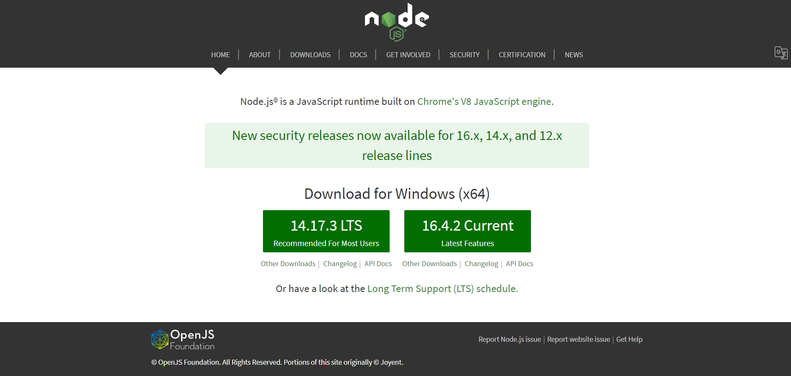

After successfully installing NodeJS, we can start installing React upon it using npm. You can install ReactJS in two ways
- Using webpack and babel.
- Using the create-react-app command.

Installing ReactJS using webpack and babel

Webpack is a module bundler (manages and loads independent modules). It takes dependent modules and compiles them to a single (file) bundle. You can use this bundle while developing apps using command line or, by configuring it using webpack.config file.
Babel is a JavaScript compiler and transpiler. It is used to convert one source code to other. Using this you will be able to use the new ES6 features in your code where, babel converts it into plain old ES5 which can be run on all browsers.

Step 1 - Create the Root Folder
Create a folder with name reactApp on the desktop to install all the required files, using the mkdir command.
C:\Users\username\Desktop>mkdir reactApp
C:\Users\username\Desktop>cd reactApp
To create any module, it is required to generate the package.json file. Therefore, after Creating the folder, we need to create a package.json file. To do so you need to run the npm init command from the command prompt.
C:\Users\username\Desktop\reactApp>npm init
This command asks information about the module such as packagename, description, author etc. you can skip these using the –y option.
C:\Users\username\Desktop\reactApp>npm init -y
Wrote to C:\reactApp\package.json:
{
"name": "reactApp",
"version": "1.0.0",
"description": "",
"main": "index.js",
"scripts": {
"test": "echo \"Error: no test specified\" && exit 1"
},
"keywords": [],
"author": "",
"license": "ISC"
}

Step 2 - install React and react dom
Since our main task is to install ReactJS, install it, and its dom packages, using install react and react-dom commands of npm respectively. You can add the packages we install, to package.json file using the --save option.
C:\Users\Tutorialspoint\Desktop\reactApp>npm install react --save
C:\Users\Tutorialspoint\Desktop\reactApp>npm install react-dom --save
Or, you can install all of them in single command as −
C:\Users\username\Desktop\reactApp>npm install react react-dom --save

Step 3 - Install webpack
Since we are using webpack to generate bundler install webpack, webpack-dev-server and webpack-cli.
C:\Users\username\Desktop\reactApp>npm install webpack --save
C:\Users\username\Desktop\reactApp>npm install webpack-dev-server --save
C:\Users\username\Desktop\reactApp>npm install webpack-cli --save
Or, you can install all of them in single command as −
C:\Users\username\Desktop\reactApp>npm install webpack webpack-dev-server webpack-cli --save

Step 4 - Install babel
Install babel, and its plugins babel-core, babel-loader, babel-preset-env, babel-preset-react and, html-webpack-plugin
C:\Users\username\Desktop\reactApp>npm install babel-core --save-dev
C:\Users\username\Desktop\reactApp>npm install babel-loader --save-dev
C:\Users\username\Desktop\reactApp>npm install babel-preset-env --save-dev
C:\Users\username\Desktop\reactApp>npm install babel-preset-react --save-dev
C:\Users\username\Desktop\reactApp>npm install html-webpack-plugin --save-dev
Or, you can install all of them in single command as −
C:\Users\username\Desktop\reactApp>npm install babel-core babel-loader babel-preset-env
babel-preset-react html-webpack-plugin --save-dev

Step 5 - Create the Files
To complete the installation, we need to create certain files namely, index.html, App.js, main.js, webpack.config.js and, .babelrc. You can create these files manually or, using command prompt.
C:\Users\username\Desktop\reactApp>type nul > index.html
C:\Users\username\Desktop\reactApp>type nul > App.js
C:\Users\username\Desktop\reactApp>type nul > main.js
C:\Users\username\Desktop\reactApp>type nul > webpack.config.js
C:\Users\username\Desktop\reactApp>type nul > .babelrc

Step 6 - Set Compiler, Server and Loaders
Open webpack-config.js file and add the following code. We are setting webpack entry point to be main.js. Output path is the place where bundled app will be served. We are also setting the development server to 8001 port. You can choose any port you want.
webpack.config.js
const path = require('path');
const HtmlWebpackPlugin = require('html-webpack-plugin');

module.exports = {
entry: './main.js',
output: {
path: path.join(__dirname, '/bundle'),
filename: 'index_bundle.js'
},
devServer: {
inline: true,
port: 8001
},
module: {
rules: [
{
test: /\.jsx?$/,
exclude: /node_modules/,
loader: 'babel-loader',
query: {
presets: ['es2015', 'react']
}
}
]
},
plugins:[
new HtmlWebpackPlugin({
template: './index.html'
})
]
}
Open the package.json and delete "test" "echo \"Error: no test specified\" && exit 1" inside "scripts" object. We are deleting this line since we will not do any testing in this tutorial. Let's add the start and build commands instead.
"start": "webpack-dev-server --mode development --open --hot",
"build": "webpack --mode production"

Step 7 - index.html
This is just regular HTML. We are setting div id = "app" as a root element for our app and adding index_bundle.js script, which is our bundled app file.
<!DOCTYPE html>
<html lang = "en">
<head>
<meta charset = "UTF-8">
<title>React App</title>
</head>
<body>
<div id = "app"></div>
<script src = 'index_bundle.js'></script>
</body>
</html>

Step 8 − App.jsx and main.js
This is the first React component. We will explain React components in depth in a subsequent chapter. This component will render Hello World.
App.js
import React, { Component } from 'react';
class App extends Component{
render(){
return(
<div>
<h1>Hello World</h1>
</div>
);
}
}
export default App;
We need to import this component and render it to our root App element, so we can see it in the browser.
main.js
import React from 'react';
import ReactDOM from 'react-dom';
import App from './App.js';

ReactDOM.render(<App />, document.getElementById('app'));
Note − Whenever you want to use something, you need to import it first. If you want to make the component usable in other parts of the app, you need to export it after creation and import it in the file where you want to use it.
Create a file with name .babelrc and copy the following content to it.
{
"presets":["env", "react"]
}

Step 9 - Running the Server
The setup is complete and we can start the server by running the following command.
C:\Users\username\Desktop\reactApp>npm start

It will show the port we need to open in the browser. In our case, it is http://localhost:8001/. After we open it, we will see the following output.
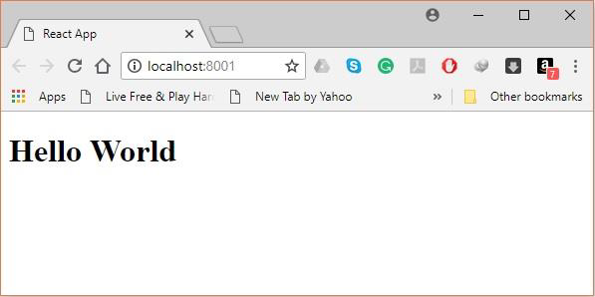

Step 10 - Generating the bundle
Finally, to generate the bundle you need to run the build command in the command prompt as −
C:\Users\Tutorialspoint\Desktop\reactApp>npm run build
This will generate the bundle in the current folder as shown below.
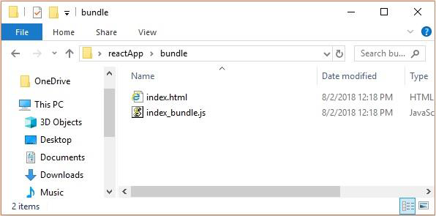

Using the create-react-app command
Instead of using webpack and babel you can install ReactJS more simply by installing create-react-app.

Step 1 - install create-react-app
Browse through the desktop and install the Create React App using command prompt as shown below −
C:\Users\Tutorialspoint>cd C:\Users\Tutorialspoint\Desktop\
C:\Users\Tutorialspoint\Desktop>npx create-react-app my-app
This will create a folder named my-app on the desktop and installs all the required files in it.

Step 2 - Delete all the source files
Browse through the src folder in the generated my-app folder and remove all the files in it as shown below −
C:\Users\Tutorialspoint\Desktop>cd my-app/src
C:\Users\Tutorialspoint\Desktop\my-app\src>del *
C:\Users\Tutorialspoint\Desktop\my-app\src\*, Are you sure (Y/N)? y

Step 3 - Add files
Add files with names index.css and index.js in the src folder as −
C:\Users\Tutorialspoint\Desktop\my-app\src>type nul > index.css
C:\Users\Tutorialspoint\Desktop\my-app\src>type nul > index.js
In the index.js file add the following code
import React from 'react';
import ReactDOM from 'react-dom';
import './index.css';

Step 4 - Run the project
Finally, run the project using the start command.
npm start
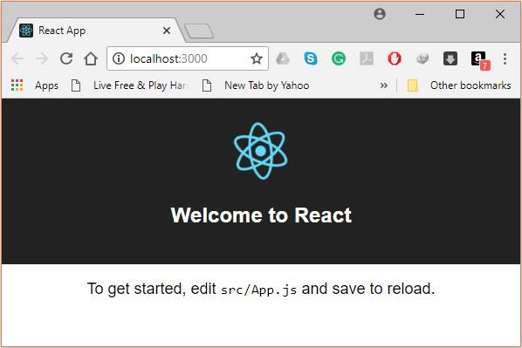

2.1.1.2 GraphQL

GraphQL is an open-source data query and manipulation language for APIs, and a runtime for fulfilling queries with existing data. GraphQL was developed internally by Facebook in 2012 before being publicly released in 2015. On 7 November 2018, the GraphQL project was moved from Facebook to the newly-established GraphQL Foundation, hosted by the non-profit Linux Foundation. Since 2012, GraphQL's rise has followed the adoption timeline as set out by Lee Byron, GraphQL's creator, with accuracy. Byron's goal is to make GraphQL omnipresent across web platforms.
It provides an approach to developing web APIs and has been compared and contrasted with REST and other web service architectures. It allows clients to define the structure of the data required, and the same structure of the data is returned from the server, therefore preventing excessively large amounts of data from being returned, but this has implications for how effective web caching of query results can be. The flexibility and richness of the query language also adds complexity that may not be worthwhile for simple APIs. Despite the name, GraphQL does not provide the richness of graph operations that one might find in a full-fledged graph database such as Neo4j, or even in dialects of SQL that support transitive closure. For example, a GraphQL interface that reports the parents of an individual cannot return, in a single query, the set of all their ancestors.
GraphQL consists of a type system, query language and execution semantics, static validation, and type introspection. It supports reading, writing (mutating), and subscribing to changes to data (realtime updates – most commonly implemented using Websockets).^{[10]} GraphQL servers are available for multiple languages, including Haskell, JavaScript, Perl, Python, Ruby, Java, C++, C#, Scala, Go, Rust, Elixir, Erlang, PHP, R, D and Clojure.

POST request:
{
orders {
id
productsList {
product {
name
price
}
quantity
}
totalAmount
}
}

Response:
{
"data": {
"orders": [
{
"id": 1,
"productsList": [
{
"product": {
"name": "orange",
"price": 1.5
},
"quantity": 100
}
],
"totalAmount": 150
}
]
}
}

2.1.1.3 Leaflet

Leaflet is the leading open-source JavaScript library for mobile-friendly interactive maps. Weighing just about 39 KB of JS, it has all the mapping features most developers ever need.
Leaflet is designed with simplicity, performance and usability in mind. It works efficiently across all major desktop and mobile platforms, can be extended with lots of plugins, has a beautiful, easy to use and well-documented API and a simple, readable source code that is a joy to contribute to.
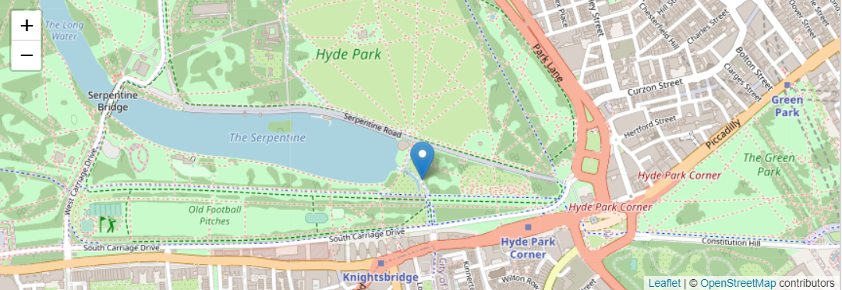
Here we create a map in the 'map' div, add tiles of our choice, and then add a marker with some text in a popup:
var map = L.map('map').setView([51.505, -0.09], 13);

L.tileLayer('https://{s}.tile.openstreetmap.org/{z}/{x}/{y}.png', {
attribution: '&copy; <a href="https://www.openstreetmap.org/copyright">OpenStreetMap</a> contributors'
}).addTo(map);

L.marker([51.5, -0.09]).addTo(map)
.bindPopup('A pretty CSS3 popup.<br> Easily customizable.')
.openPopup();

2.1.1.4 Json Web Token (JWT)

JSON Web Token (JWT) is an open standard (RFC 7519) that defines a compact and self-contained way for securely transmitting information between parties as a JSON object. This information can be verified and trusted because it is digitally signed. JWTs can be signed using a secret (with the HMAC algorithm) or a public/private key pair using RSA or ECDSA.
Although JWTs can be encrypted to also provide secrecy between parties, we will focus on signed tokens. Signed tokens can verify the integrity of the claims contained within it, while encrypted tokens hide those claims from other parties. When tokens are signed using public/private key pairs, the signature also certifies that only the party holding the private key is the one that signed it.

When should you use JSON Web Tokens?
Here are some scenarios where JSON Web Tokens are useful:
- Authorization: This is the most common scenario for using JWT. Once the user is logged in, each subsequent request will include the JWT, allowing the user to access routes, services, and resources that are permitted with that token. Single Sign On is a feature that widely uses JWT nowadays, because of its small overhead and its ability to be easily used across different domains.
- Information Exchange: JSON Web Tokens are a good way of securely transmitting information between parties. Because JWTs can be signed—for example, using public/private key pairs—you can be sure the senders are who they say they are. Additionally, as the signature is calculated using the header and the payload, you can also verify that the content hasn't been tampered with.

2.2 Tools Used
2.2.1 Visual Studio Code
Visual Studio Code is a lightweight but powerful source code editor which runs on your desktop and is available for Windows, macOS and Linux. It comes with built-in support for JavaScript, TypeScript and Node.js and has a rich ecosystem of extensions for other languages (such as C++, C#, Java, Python, PHP, Go) and runtimes (such as .NET and Unity). Begin your journey with VS Code with these introductory.

2.2.2 Installing Visual Studio Code

1) Downloading VSCode Executable
- Go to Visual Studio Code website.
- Click on Download for Windows

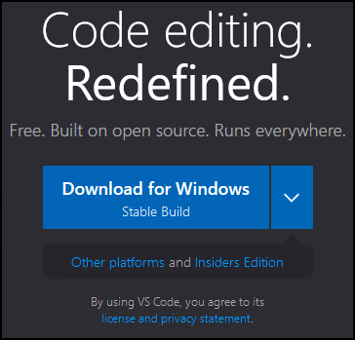

- Click on Save File.

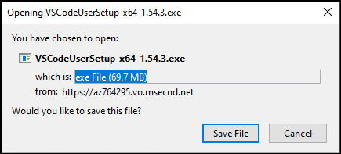

2) Running VSCode Executable
- In your Downloads directory, right click on the VSCode executable and select Open.

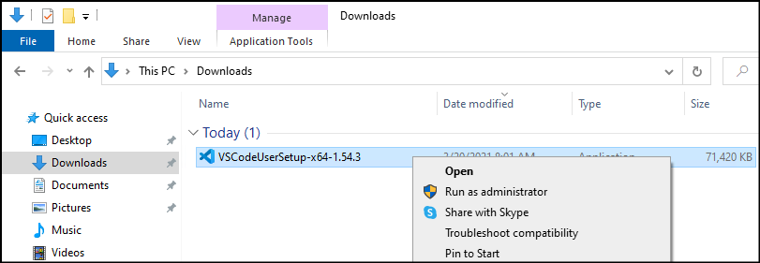

3) Completing the VSCode Setup
- Accept the agreement.

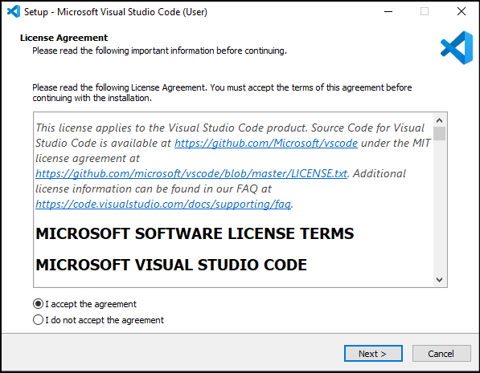
- Select Destination folder and click on Next.

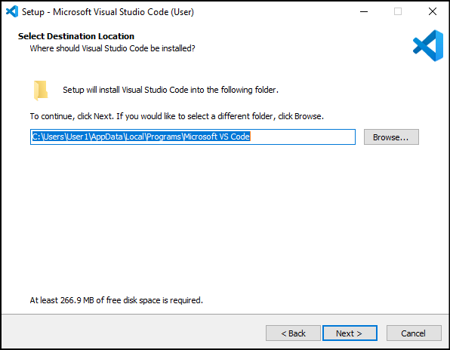

- Select Start Menu folder and click on Next.

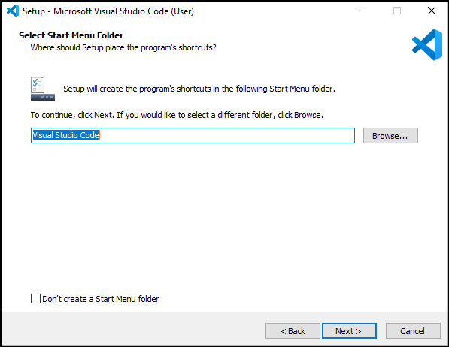
- Select Additional Tasks as desired and click on Next.

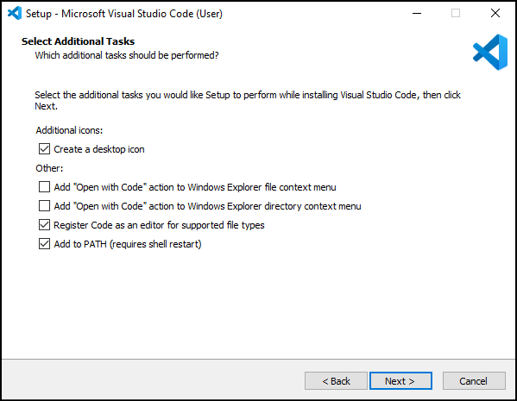

- Click on Install.

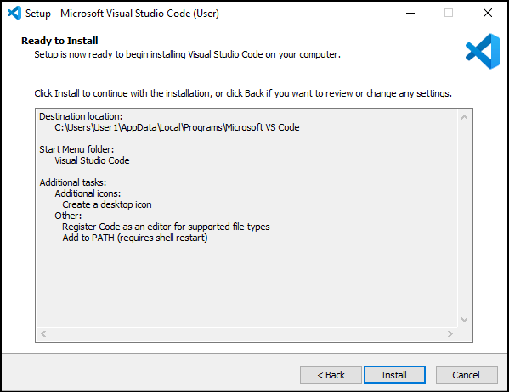
- Wait for the installation process to complete.

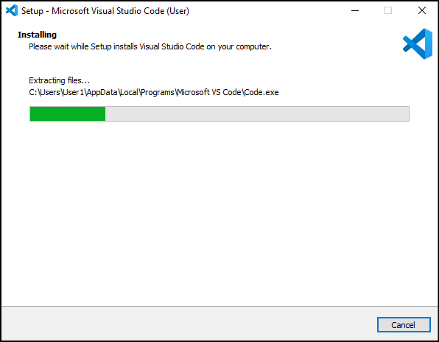

- Check the Launch Visual Studio Code box and click on Finish.
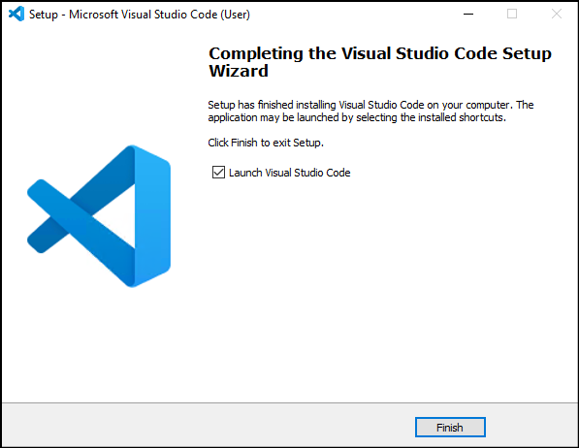
2.2.3 MongoDB Atlas
MongoDB Atlas is a cloud service by MongoDB. It is built for developers who'd rather spend time building apps than managing databases. This service is available on AWS, Azure, and GCP.
It is the worldwide cloud database service for modern applications that give best-in-class automation and proven practices guarantee availability, scalability, and compliance with the foremost demanding data security and privacy standards. We can use MongoDB's robust ecosystem of drivers, integrations, and tools to create faster and spend less time managing our database.

Advantages of MongoDB Atlas
- Global clusters for world-class applications: Using MongoDB Atlas, we are free to choose the cloud partner and ecosystem that fit our business strategy.
- Secure for sensitive data: It offers built-in security controls for all our data. It enables enterprise-grade features to integrate with our existing security protocols and compliance standard.
- Designed for developer productivity: MongoDB Atlas moves faster with general tools to work with our data and a platform of services that makes it easy to build, secure, and extend applications that run on MongoDB.
- Reliable for mission-critical workload: It is built with distributed fault tolerance and automated data recovery.
- Built for optimal performance: It makes it easy to scale our databases in any direction. We can get more out of our existing resources with performance optimization tools and real-time visibility into database metrics.
- Managed for operational efficiency: It comes with built-in operational best practices, so we can focus on delivering business value and accelerating application development instead of managing databases.

2.2.4 Create an Atlas Account and deploying a Free Tier Cluster

Step 1: Go to https://www.mongodb.com/cloud/atlas to register for an Atlas account to host your data.
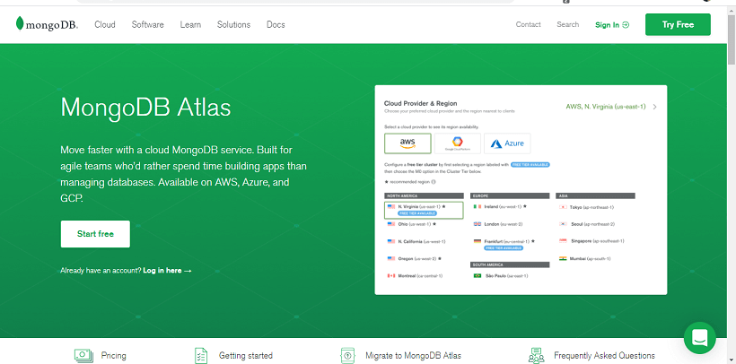
Step 2: When you click on Start Free, you will be redirected to the Registration form for an account on the MongoDB Atlas.
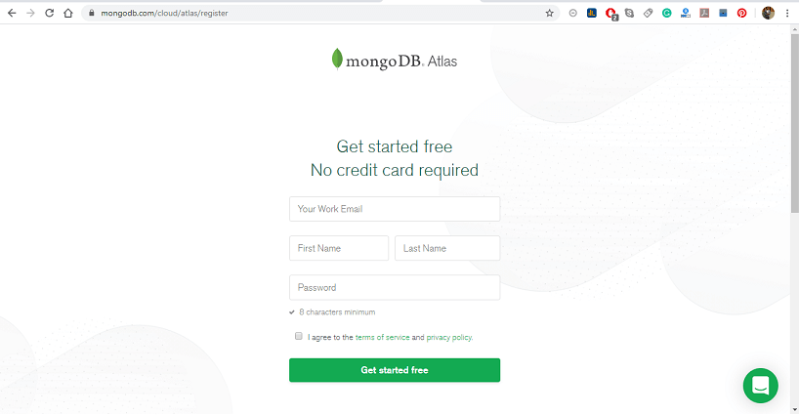
Step 3: Select Starter Clusters and click create a Cluster. The Starter cluster includes the M0, M2, and M5 cluster tiers. These low-cost clusters are suitable for users who are learning MongoDB or developing small proof -of- concept applications.
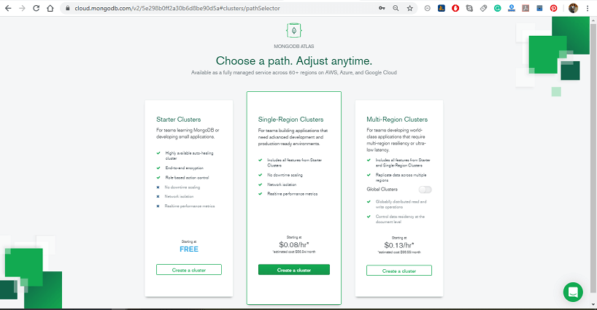

Step 4: Select your preferred Cloud Provider & Region. It supports M0 Free Tier clusters on Amazon Web Services (AWS), Google Cloud Platform (GCP), and Microsoft Azure. The regions that support M0 Free tier clusters are marked with the "Free Tier Available" label.
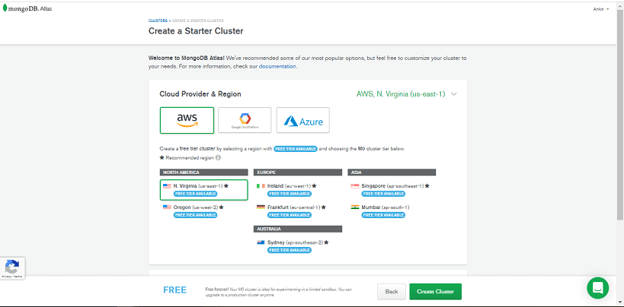
Step 5: Select M0 Sandbox for cluster tier: Selecting M0 automatically locks the remaining configuration options. If you can't select the M0 cluster tier, return to the previous step and choose a Cloud Provider & Region that supports M0 Free Tier clusters.
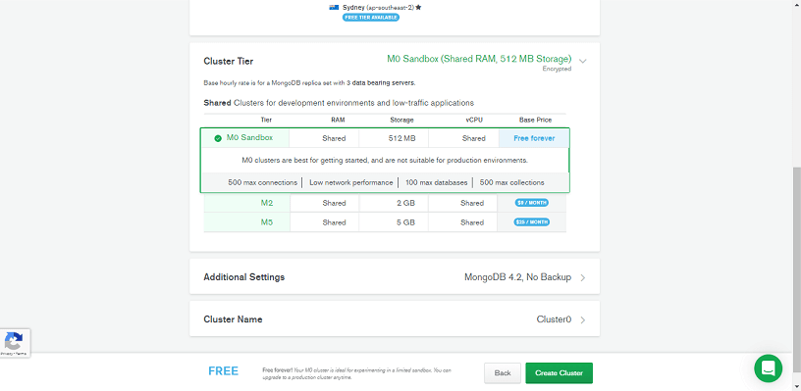
Step 6: Enter a name for your cluster in the Cluster Name field; you can enter any name for your cluster. The cluster name contains ASCII letters, numbers, and hyphens.
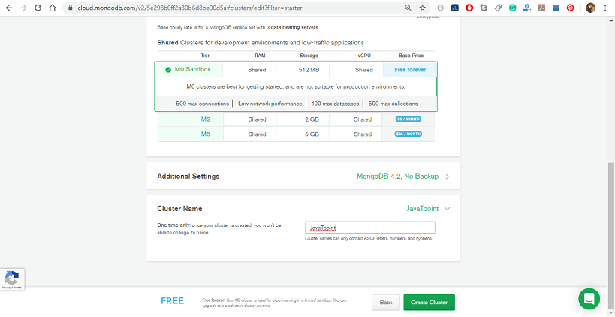
Step 7: Click on Create Cluster to deploy the cluster. Once you deploy your cluster, it can take up to 5-10 min for your cluster to provision and become ready to use.
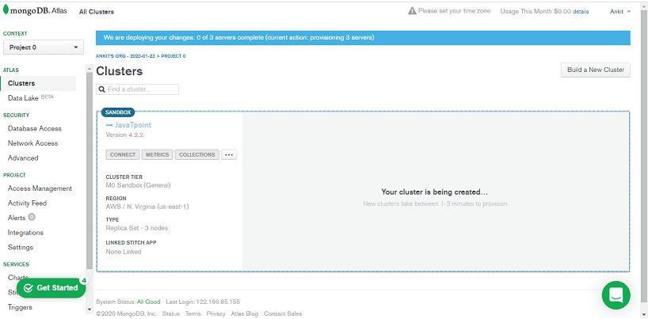
Step 8: Once we register, Atlas automatically creates a default organization and project where we can deploy our first cluster. We can add additional organizations and projects later.
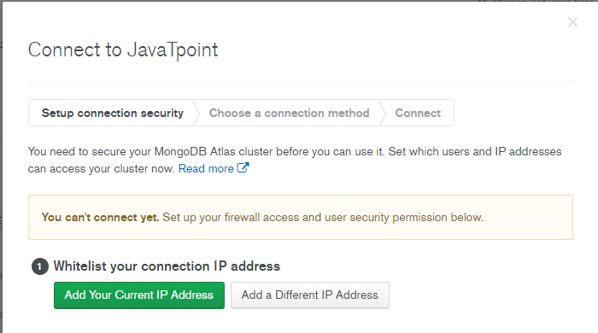

CHAPTER 3
SYSTEM REQUIREMENTS

3.1 Hardware Requirements

- Window 7 or above
- Processor Base Frequency 1.8 GHz or higher
- 2 GB Ram or higher
- 500 GB available disk space or more
- Minimum Screen Resolution: 1366x768

3.2 Software Requirements

- Nodejs 5.2 or higher version
- Visual Studio Code or other IDE for development
- Web Browser - Google Chrome/Mozilla Firefox/Internet Explorer

3.3 Introduction of Front-End

Front End and Back End: Frontend and Backend are the two most popular terms used in web development. These terms are very crucial for web development but are quite different from each other. Each side needs to communicate and operate effectively with the other as a single unit to improve the website’s functionality.
Front End Development: The part of a website that the user interacts with directly is termed the front end. It is also referred to as the ‘client side’ of the application. It includes everything that users experience directly: text colors and styles, images, graphs and tables, buttons, colors, and navigation menu. HTML, CSS, and JavaScript are the languages used for Front End development. The structure, design, behavior, and content of everything seen on browser screens when websites, web applications, or mobile apps are opened up, is implemented by front End developers. Responsiveness and performance are two main objectives of the Front End. The developer must ensure that the site is responsive i.e. it appears correctly on devices of all sizes no part of the website should behave abnormally irrespective of the size of the screen.
Front end Languages: The front-end portion is built by using some languages which are discussed below:
- HTML: HTML stands for Hypertext Markup Language. It is used to design the front-end portion of web pages using a markup language. HTML is the combination of Hypertext and Markup language. Hypertext defines the link between the web pages. The markup language is used to define the text documentation within the tag which defines the structure of web pages.
- CSS: Cascading Style Sheets fondly referred to as CSS is a simply designed language intended to simplify the process of making web pages presentable. CSS allows you to apply styles to web pages. More importantly, CSS enables you to do this independent of the HTML that makes up each web page.
- JavaScript: JavaScript is a famous scripting language used to create magic on the sites to make the site interactive for the user. It is used to enhancing the functionality of a website to running cool games and web-based software.
There are many other languages through which one can do front-end development depending upon the framework for example Flutter user Dart, React uses JavaScript and Django uses Python, and much more.

Front End Frameworks and Libraries:
- AngularJS: AngularJs is a JavaScript open-source front-end framework that is mainly used to develop single-page web applications(SPAs). It is a continuously growing and expanding framework which provides better ways for developing web applications. It changes the static HTML to dynamic HTML. It is an open-source project which can be free. It extends HTML attributes with Directives, and data is bound with HTML.
- React.js: React is a declarative, efficient, and flexible JavaScript library for building user interfaces. ReactJS is an open-source, component-based front-end library responsible only for the view layer of the application. It is maintained by Facebook.
Bootstrap: Bootstrap is a free and open-source tool collection for creating responsive websites and web applications. It is the most popular HTML, CSS, and JavaScript framework for developing responsive, mobile-first websites.
- jQuery: jQuery is an open-source JavaScript library that simplifies the interactions between an HTML/CSS document, or more precisely the Document Object Model (DOM), and JavaScript. Elaborating the terms, jQuery simplifies HTML document traversing and manipulation, browser event handling, DOM animations, Ajax interactions, and cross-browser JavaScript development.
- SASS: It is the most reliable, mature, and robust CSS extension language. It is used to extend the functionality of an existing CSS of a site including everything from variables, inheritance, and nesting with ease.
- Flutter: Flutter is an open-source UI development SDK managed by google. It is powered by Dart programming language. It builds performant and good-looking natively complied applications for mobile (Ios, Android), web, and desktop from a single code base. The key selling point of flutter is flat development is made easier, expressive, and flexible UI and native performance. In march 2021 flutter announce Flutter 2 which upgrades flutter to build release applications for the web, and the desktop is in beta state.
- Some other libraries and frameworks are Semantic-UI, Foundation, Materialize, Backbone.js, Ember.js, etc.

3.4 Introduction of Back-End

Backend Development: Backend is the server-side of the website. It stores and arranges data, and also makes sure everything on the client-side of the website works fine. It is the part of the website that you cannot see and interact with. It is the portion of software that does not come in direct contact with the users. The parts and characteristics developed by backend designers are indirectly accessed by users through a front-end application. Activities, like writing APIs, creating libraries, and working with system components without user interfaces or even systems of scientific programming, are also included in the backend.
Back end Languages: The back end portion is built by using some languages which are discussed below:
- PHP: PHP is a server-side scripting language designed specifically for web development. Since PHP code executed on the server-side, so it is called a server-side scripting language.
- C++: It is a general-purpose programming language and widely used nowadays for competitive programming. It is also used as a backend language.
- Java: Java is one of the most popular and widely used programming languages and platforms. It is highly scalable. Java components are easily available.
- Python: Python is a programming language that lets you work quickly and integrate systems more efficiently.
- JavaScript: JavaScript can be used as both (front end and back end) programming languages.
- Node.js: Node.js is an open-source and cross-platform runtime environment for executing JavaScript code outside a browser. You need to remember that NodeJS is not a framework, and it’s not a programming language. Most people are confused and understand it’s a framework or a programming language. We often use Node.js for building back-end services like APIs like Web App or Mobile App. It’s used in production by large companies such as Paypal, Uber, Netflix, Wallmart, and so on.
Back End Frameworks:
- The list of back-end frameworks are: Express, Django, Rails, Laravel, Spring, etc.
- The other back-end program/scripting languages are C#, Ruby, REST, GO, etc.

CHAPTER 4
SYSTEM ANALYSIS

4.1 Introduction

The entire project has been developed keeping in view of the distributed client server computing technology, in mind. The specification have been normalized up to 3NF to eliminate all the anomalies that may arise due to the database transaction that are executed by the general users and the organizational administration. The user interfaces are browser specific to give distributed accessibility for the overall system. The internal database has been selected as MongoDB. The basic constructs of table spaces, clusters and indexes have been exploited to provide higher consistency and reliability for the data storage. The MongoDB was a choice as it provides the constructs of high-level reliability and security. The total front end was dominated using the c#.net technologies. At all proper levels high care was taken to check that the system manages the data consistency with proper business rules or validations. The authentication and authorization was crosschecked at all the relevant stages.

4.2 Requirement analysis and specification

Requirements analysis involves frequent communication with the system users to determine specific feature exceptions, resolution of conflict or ambiguity in requirements as demand by the various users or groups of users, avoidance of feature creep and documentation of all aspects of the project development process from start to finish. Energy should be directed towards ensuring tat the final system or product conforms to client needs rather than attempting to meld user expectations to fit the requirements. Requirements analysis is a team effort that demands a combination of hardware, software and human engineering expertise as well as skills in dealing with people. Requirements of this project were to secure the user data from unauthorized users with respect to read and writes. Beside the core process, it also should have a very user-friendly interface to handle all the operations of the project very easily.
4.2.1 Functional Requirement

Functional requirements define what a system is supposed to do. It defines the function of a system and its components. A function is described as a set of inputs, the behavior and outputs.

The system must provide following functionalities:

- Admin
  - See all registered request from hospitals
  - Active their login functionality
  - Deactivate any hospital
- Hospital
  - Verify OTP generated by patient / user
  - Register / admit patient
  - Discharge patient
  - Enter hospital profile
  - Add / delete / edit hospital’s wards
  - Add / delete / edit hospital’s doctors
  - Add / delete / edit hospital’s beds
- User / patient
  - Search nearest hospitals list
  - Show map
  - Show wards availability in that hospital
  - Show doctors availability in that hospital
  - Show beds availability in that hospital
  - Book bed (hold for 2 hours)

4.2.2 Non-Functional Requirement

Non-functional requirement is a requirement that specifies criteria that can be used to judge the operation of a system, rather than specific behaviors. They are contrasted with functional requirements that define specific behavior or functions.

4.2.2.1 Performance Requirement

Response Time:
System should provide quick response while generation of the report as well as while modifying the data.

Robustness:
System should be able to cope with errors during execution and cope with erroneous input.

Data Integrity:
System should provide consistent data insertion.

4.2.2.1 Software Requirement

Adaptability:
Software should be adaptable on different operating system.

Availability:
System should be available 24 x 7.

Backup/Recovery:
Backup/Recovery of software is provided.

Maintenance:It’s easy to maintain and affordable.
4.3 Technical Feasibility

The technical feasibility assessment is focused on gaining an understanding of the present technical resources of the organisation and their applicability to the expected needs of the proposed system.

It is an evolution of the hardware and software and how it meets the need of the proposed system. So, after being ensured, we can say yes, the project is technically feasible. Because in development of the project, core concepts of TypeScript and JavaScript are used. Angular framework is licence free, platform independent and the project can be completed within limited resources.

Technical feasibility also performs the following tasks.

- Analyzes the technical skills and capabilities of the software development team members

- Determines whether the relevant technology is stable and established

- Ascertains that the technology chosen for software development has a large number of users so that they can be consulted when problems arise or improvements are required.

4.4 Operational Feasibility

Operational feasibility is a measure of how well a proposed system solves the problems and takes advantage of the opportunities identified during scope definition and how it specifies the requirements identified in the requirement analysis phase of system development.

The operations like registration of new user, management of categories, sub categories, users, management of bidding and advertising and receipt generation, all such modules work properly and produce the desired result accurately without any ambiguities.

Operational feasibility also performs the following tasks.

- Determines whether the problems anticipated in user requirements are of high priority

- Determines whether the solution suggested by the software development team is acceptable

- Analyzes whether users will adapt to a new software

- Determines whether the organization is satisfied by the alternative solutions proposed by the software development team

4.5 System Planning

Planning is the act of thinking about actions before they are carried out. Specific details are decided before carrying out the plan, as well as organizing the steps of the plan.

4.5.1 Software Project Planning

The software project management process begins with a set of activities that are collectively called project planning that involves estimation. Software cost and effort estimation will never become an exact but can be transformed from indistinguishable to a series of systematic steps. Following things have been estimated before the software development:

Project Complexity:
It has strong effort on uncertainty that is inherent in planning. Our project belongs to the Category of evolutionary project, as the requirements are very large. An expert team usually develops such system.

Project Size:
It is another factor that can affect the accuracy of estimates. As the project size increases; the Interdependency among various elements of the software grows rapidly. Therefore, it is essential to estimate the project size in lines of code.

Structural Uncertainty:
The structure refers to the degree to which requirements have been solidified, the case with which functions can be compartmentalized, and the hierarchical nature of information that must be processed.

Risk:
Risk is measured by the degree by the degree of certainty in the quantitative estimates established for resources, cost and schedule.

