**JUDGEMENT-DAY-2**

**PROBLEM :**

**TOUGHNESS: HARD**

**TAGS: DP**

The problem can be broken down into four parts

1. Interpretation as graphs
2. Conversion to an array of arrays data structure
3. Identification of the problem
4. Solving the dynamic programming problem.

**PART 1: INTERPRETATION (Easy)**

* The interpretation of the problem statement as a graph problem is straightforward.
* Each island is considered as a node, and each path between the islands is considered as edges.
* Since it’s a two-way path, the graph is undirected.

**PART 2: CONVERSION (Moderate)**

* It’s given that there an island is connected to at max two other islands. That means there is no branching in the graph. 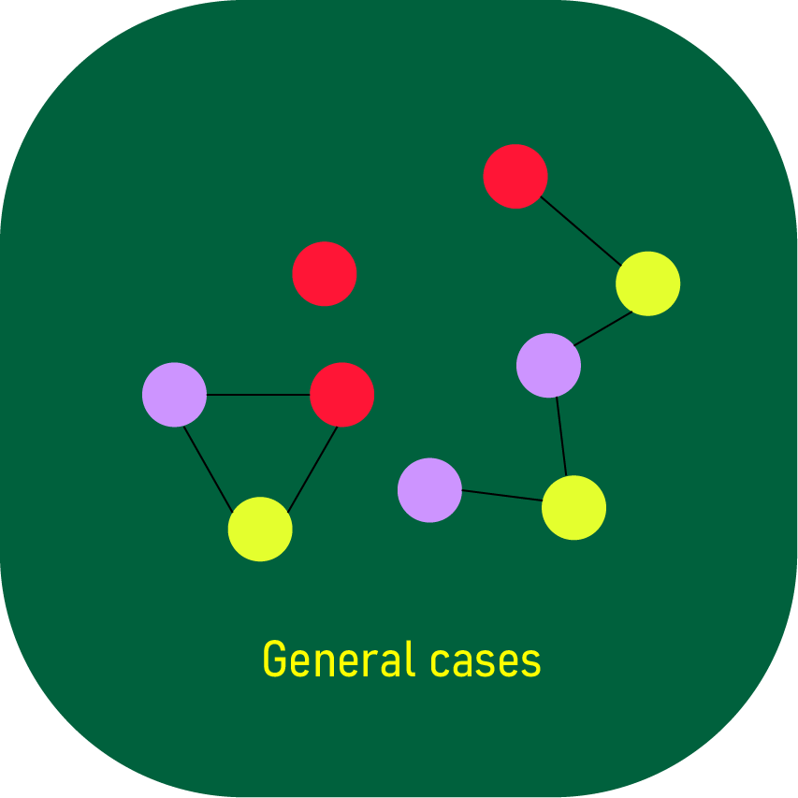
* The above illustration shows all possible cases. A general graph can contain many connected components.
* If a connected component doesn’t contain any cycle, it can be represented in an array.
* It’s mentioned that you can’t visit an island more than once. In that case, even if a connected component is cyclic, you can’t reach a node twice. So a cyclic component can also effectively represented as an array by slicing at any arbitrary edge.
* There’s no path between nodes belonging to different connected components. So one has to start and end in the same connected component.
* So, we have an array of arrays. Traversal is allowed only within an array.

**PART 3: IDENTIFICATION(Moderate)**

* Since traversal is allowed only within an array, we iterate through all the arrays one at a time and find the start and stop indices that maximise the virtue level.
* The sum of the virtue level of the group will be equal to the product of the number of islands visited, and the minimum virtue level of the islands visited.
* Suppose the **virtue level of islands is plotted as a histogram** (virtue vs island). Then the solution to the sum of the maximum virtue level of the group is the same as the [Largest Rectangular Area in a Histogram](https://www.geeksforgeeks.org/largest-rectangle-under-histogram/). The number of followers, which is effectively the number of islands visited, is the width of the rectangle and virtue level is the height of the rectangle

**PART 4: SOLVING DP(MODERATE)**

* Solving the [Largest Rectangular Area in a Histogram](https://www.geeksforgeeks.org/largest-rectangle-under-histogram/) problem