**Doubts**

Week 2 - Significance vs. Confidence Level

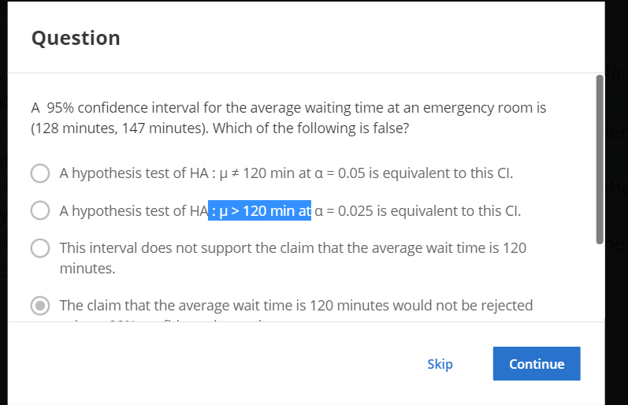

Answer option d). How options a and b are true. The mean is 137.5. How these alternate tests at μ ≠ 120 and μ > 120 are equivalent to this CI?

# Equivalent null Hypothesis H0 will be true if the absolute difference between the original mean

# and the observed mean is within 2 confidence intervals

# This implies this is equivalent to null hypothesis H0: μ = 128 or HA: μ ≠ 128 for α = 0.05 or μ > 128 for α = 0.025