Electronics Store Management System
CEN 215 – Object Oriented Programming
Team Leader: Arvin Pinari
Team Members: Devi Alika, Dejvi Karaj
Store name:Melpi

Final UML Diagram

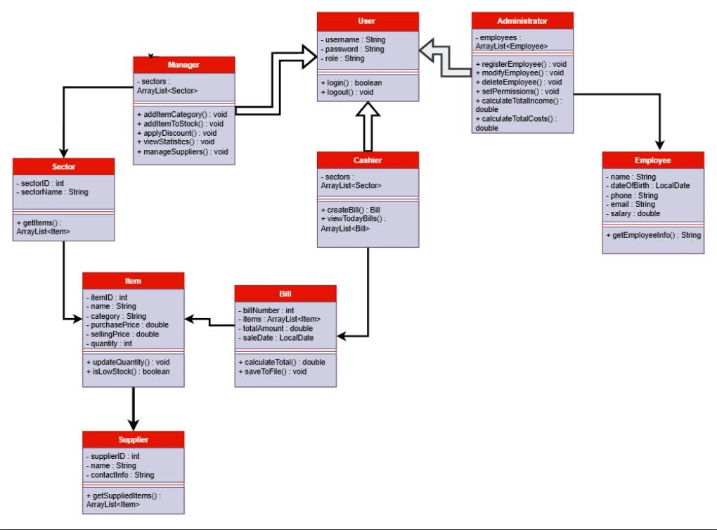

1. Team Contributions & Responsibilities
Arvin Pinari (Team Leader)
- System Architecture: Established the core MVC (Model-View-Controller) framework to ensure the separation of data, logic, and interface.
- OOP Design: Designed the class hierarchy, including the abstract User class and its specific implementations for Administrators, Managers, and Cashiers.
- System Integration: Managed the final assembly of all source files and coordinated the report submissions.
Devi Alika
- JavaFX UI Design: Developed the entire graphical interface using pure Java code, adhering to the requirement that FXML and Scene Builder were not permitted.
- Event Handling: Programmed the interactive elements, including menu navigation and role-based dashboard transitions.
- Input Validation: Implemented Regular Expression (Regex) checks to validate user data like emails, phone numbers, and pricing formats.
Dejvi Karaj
- File Handling (Binary & Text): Used data storage using .dat binary files for store objects and .txt files for printable bills.
- Billing Logic: Created an automated system for generating bills, calculating totals, and updating inventory levels after each sale.
- Financial Reporting: Administrator can calculate total income vs. total costs, including staff salaries and purchase expenses.

2. Key Application Features
Multi-Level Login System
The application features a secure, three-level access system:
- Administrator: Full authority to manage employee profiles (register, modify, delete) and review global financial reports.
- Manager: Oversees specific sectors, manages inventory categories, applies discounts, and monitors cashier performance.
- Cashier: Handles customer transactions, checks stock availability, and generates printable bills.
Inventory + Sales Management
- Stock Alerts: The system automatically notifies the Manager when item numbers are in a category below 3,and timely restocking.
- Printable Receipts: Bills are generated in a standardized in [BillNrDate].txt format for customer records.
- Real-time Updates: Respective data files are automatically updated upon every sale to make sure inventory accuracy.
Data Persistence + Architecture
- MVC Architecture: The code is strictly organized into model, view, and controller packages for scalability.
- Dual File Handling: Uses Binary IO for object management and Text IO for transaction logging and billing.
Advanced Financial Analytics
- Administrator Reports: Provides summaries of total revenue versus total expenses (salaries and stock purchases) over specified periods.
- Performance Metrics: Managers can track the total number of bills and revenue generated by individual cashiers.

3. Mandatory README Information
- Default Information :
- Administrator: admin / admin123
  - Manager: manager / manager123
  - Cashier: cashier / cashier123
- Design Decisions: JavaFX was used for all UI components

