# VIT University Research Platform

# Fall Semester 2023-24

**MDI3001 – Advances in Web Technologies**

**Lab Digital Assessment**

**Ajax and JSON**

**NAME :** Aravind S

**REG. NO. :** 21MID0229

**SLOT :** C1+TC1 / L45+L46

**DATE :** 12.11.2023

**FACULTY :** Mukku Nisanth Kartheek

**CLASS NO. :** VL2023240104226

**Task:**

# Asynchronously loading JSON data.

**Deployment Link:**

<https://arvnd147.github.io/Ajax-and-JSON/>

(Deployed in GitHub Pages)

**Screenshots of the webpage:**

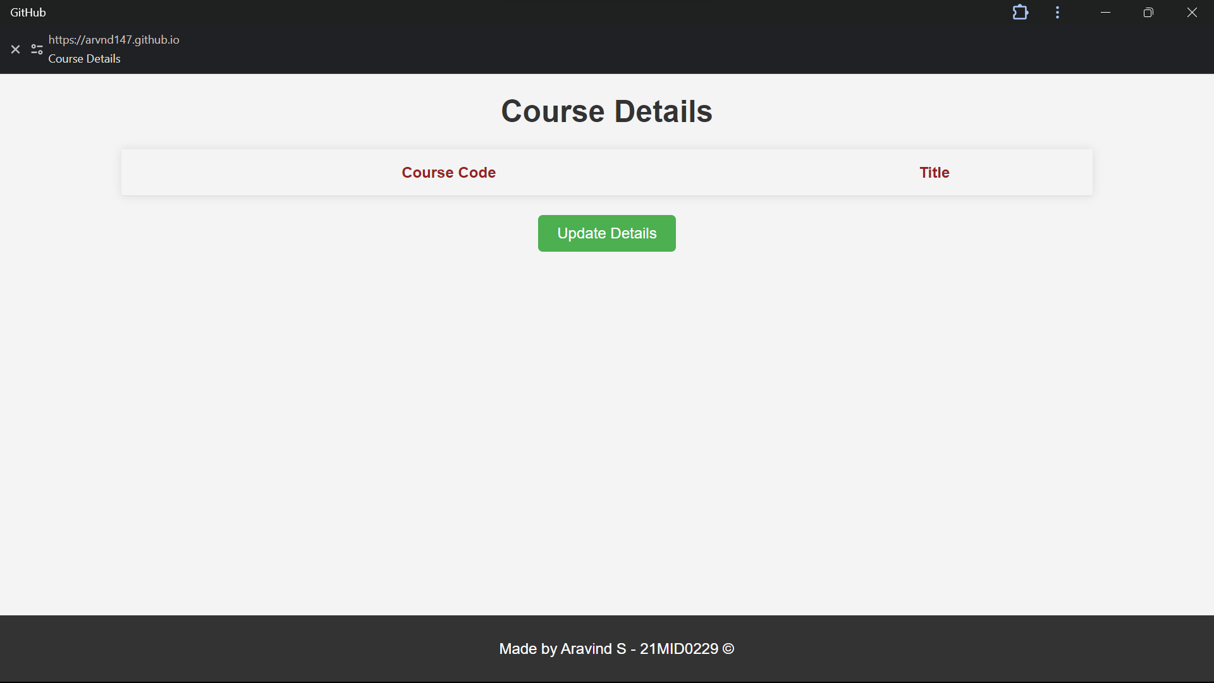

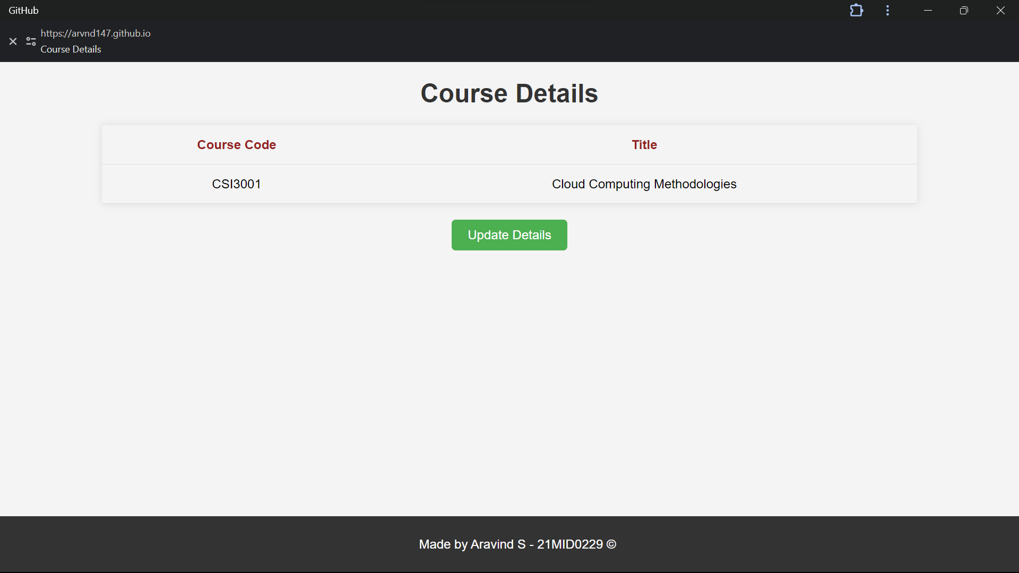

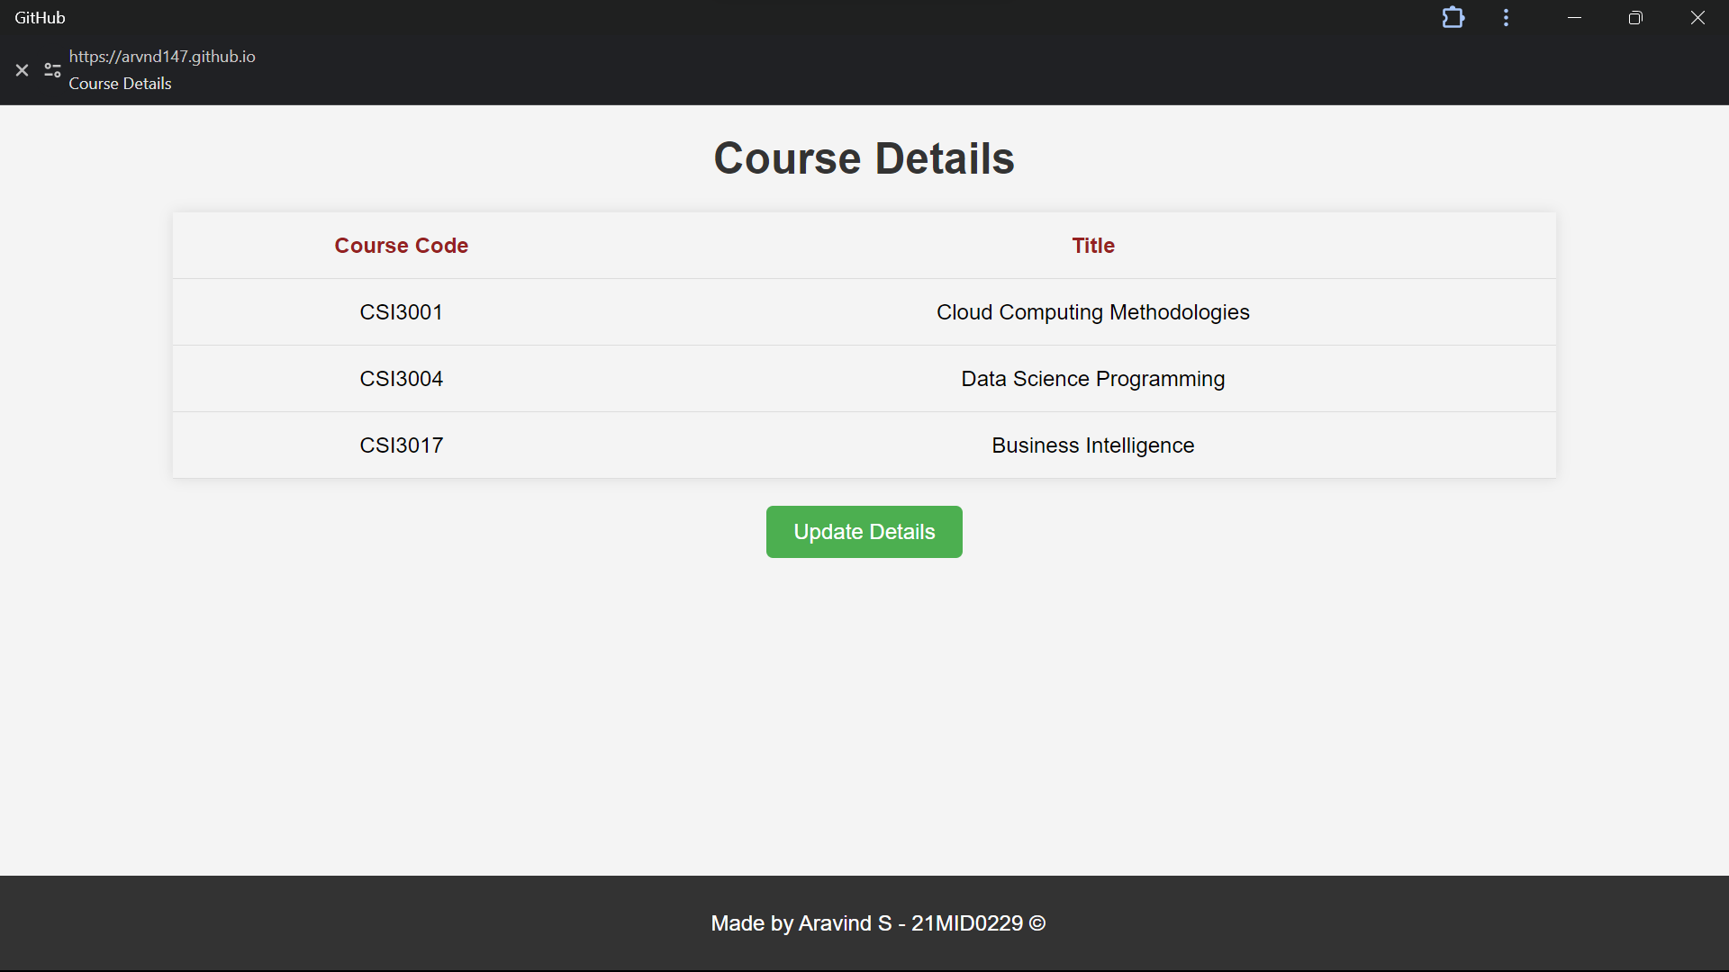

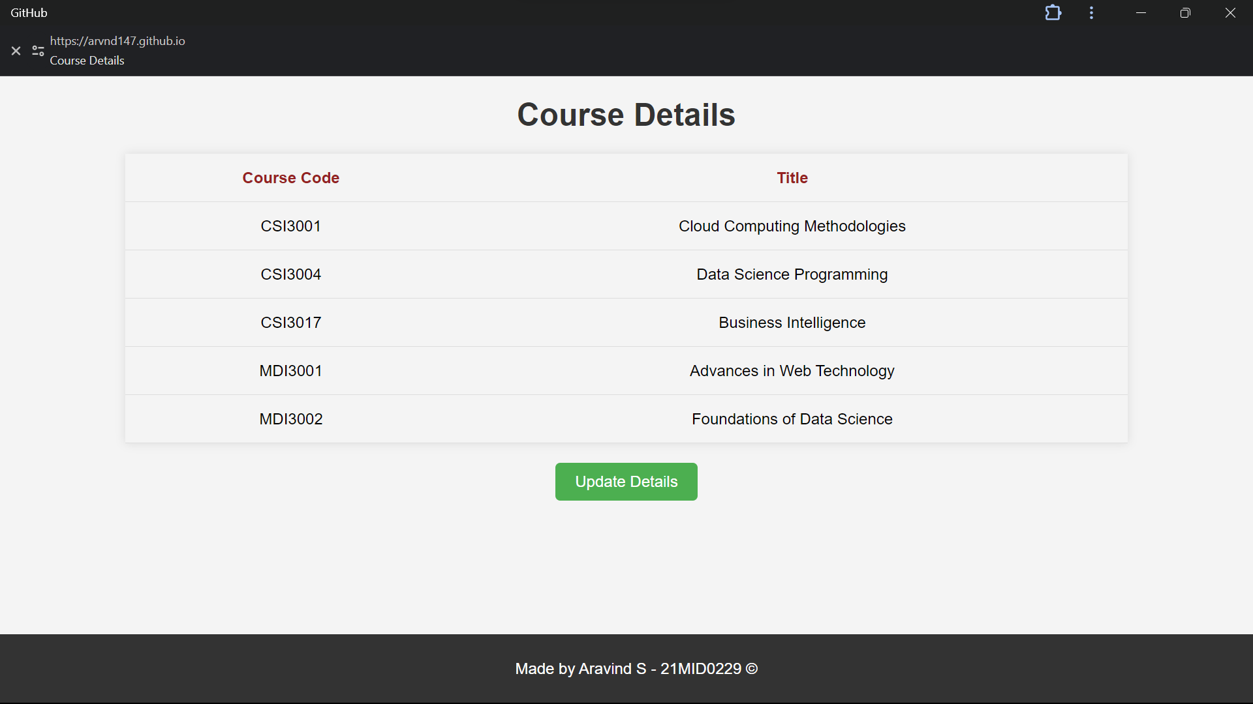

**HTML code: (index.html)**

<!DOCTYPE *html*>

<html *lang*="en">

<head>

    <meta *charset*="UTF-8">

    <meta *name*="viewport" *content*="width=device-width, initial-scale=1.0">

    <title>Course Details</title>

    <script *src*="script.js"></script>

    <link *rel*="stylesheet" *href*="style.css">

</head>

<body>

    <h1>Course Details</h1>

    <table *class*="src">

        <tr>

            <th *id*="code">Course Code</th>

            <th *id*="title">Title</th>

        </tr>

        <tbody *id*="courseDetails"></tbody>

    </table>

    <div *class*="central">

        <button *type*="button" *onclick*="loadJSON()">Update Details</button>

    </div>

    <footer>

        <p>Made by Aravind S - 21MID0229 &copy;</p>

    </footer>

</body>

</html>

**CSS code: (styles.css)**

body {

    font-family: Arial, sans-serif;

    background-color: #f4f4f4;

    margin: 0;

    padding: 0;

}

footer {

    background-color: #333;

    color: white;

    text-align: center;

    padding: 10px;

    position: fixed;

    bottom: 0;

    width: 100%;

}

h1 {

    color: #333;

    text-align: center;

}

table {

    width: 80%;

    margin: 20px auto;

    border-collapse: collapse;

    box-shadow: 0 0 10px rgba(0, 0, 0, 0.1);

}

th,

td {

    padding: 15px;

    text-align: center;

    border-bottom: 1px solid #ddd;

}

tr:hover {

    background-color: #f5f5f5;

}

.central {

    text-align: center;

    margin-top: 20px;

}

button {

    padding: 10px 20px;

    font-size: 16px;

    cursor: pointer;

    background-color: #4caf50;

    color: white;

    border: none;

    border-radius: 5px;

}

button:hover {

    background-color: #45a049;

}

#code,

#title {

    font-weight: bold;

    color: #942121;

}

*/* Media Query for responsiveness */*

@media (max-width: 600px) {

    table {

        width: 100%;

    }

}

**JavaScript: (script.js)**

var currentIndex = 0;

function loadJSON() {

  var data_file = "./data.json";

  var xhr = new XMLHttpRequest();

*// Define the AJAX request*

  xhr.open("GET", data_file, true);

*// Set the callback function to handle the response*

  xhr.onreadystatechange = function () {

    if (xhr.readyState == 4) {

*// Javascript function JSON.parse to parse JSON data*

      var courses = JSON.parse(xhr.responseText);

*// player variable now contains the data structure and can*

*// be accessed as player.name and player.country.*

*// Get the tbody element to append the rows*

      var tbody = document.getElementById("courseDetails");

*// Loop through the players and dynamically generate rows*

      if (currentIndex < courses.length) {

        var player = courses[currentIndex];

        var row = tbody.insertRow();

        var cellCode = row.insertCell(0);

        var cellTitle = row.insertCell(1);

        cellCode.textContent = player.code;

        cellTitle.textContent = player.title;

        currentIndex++;

      }else{

        tbody.innerHTML = "";

        currentIndex = 0;

      }

    }

  };

*//send the request*

  xhr.send();

}

**JSON: (data.json)**

[

    {"code": "CSI3001", "title": "Cloud Computing Methodologies"},

    {"code": "CSI3004", "title": "Data Science Programming"},

    {"code": "CSI3017", "title": "Business Intelligence"},

    {"code": "MDI3001", "title": "Advances in Web Technology"},

    {"code": "MDI3002", "title": "Foundations of Data Science"}

]

**Aravind S – 21MID0229**