Pentago Rules & Basic Strategy



The game starts with an empty game board, consisting of the base
and the four twistable game blocks. Choose marble color of each player. White goes first.

The goal is to get five marbles in a row before your opponent does. Each player will also twist one of the four game blocks as part of each turn.


Players take turns at placing marbles on the game board and twisting the game blocks. A player is free to twist any of the game blocks, regardless of which game block the player placed the marble on, clockwise or counter clockwise 90 degrees only. A 180 degree twist is not allowed. The twist is the key to create winning positions in Pentago. A draw can occur if there are no empty spots for marbles left or if the player twists their marbles into row of five also creating a row of five for the opponent.

A winning row of five marbles can occur vertically, horizontally or diagonally, anywhere on the board.

There are several techniques that you can use to defeat our opponent easily and beautifully.

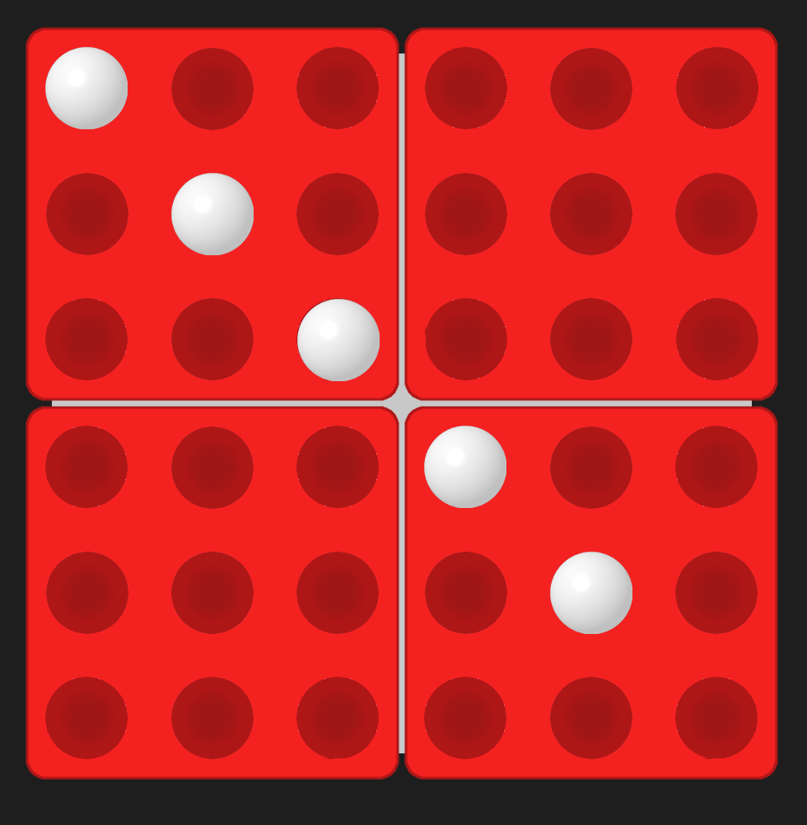

First one is called “Monica’s five”.

It is a play on the longest diagonal.

This strategy is really easy to recognize and takes little effort to counter-play. However, considered
an obvious play one can find it useful in certain
situations.

The main advantage of this technique is ability to perform an “Opened four” play, which leads to
obvious victory.

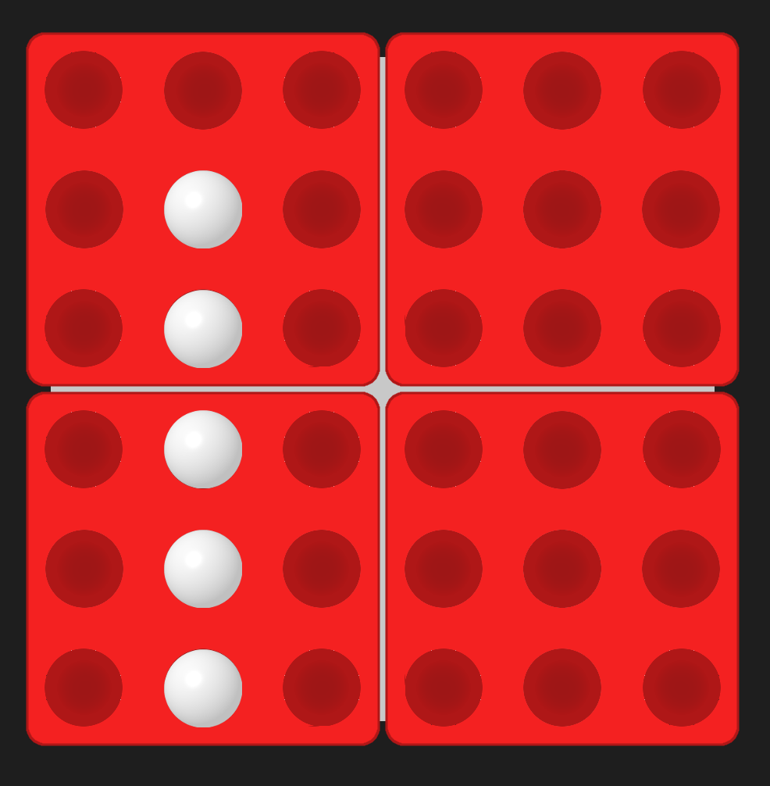

Second one is called “The middle five”.

This play uses middle row to position marbles. It is much more powerful than “Monica’s five” technique because not only you can initiate an “Opened four” situation (discussed before), but also a “Big cross” situation (having a cross/plus occupying a block and a marble in the center of any adjacent block) which leads to an obvious victory.

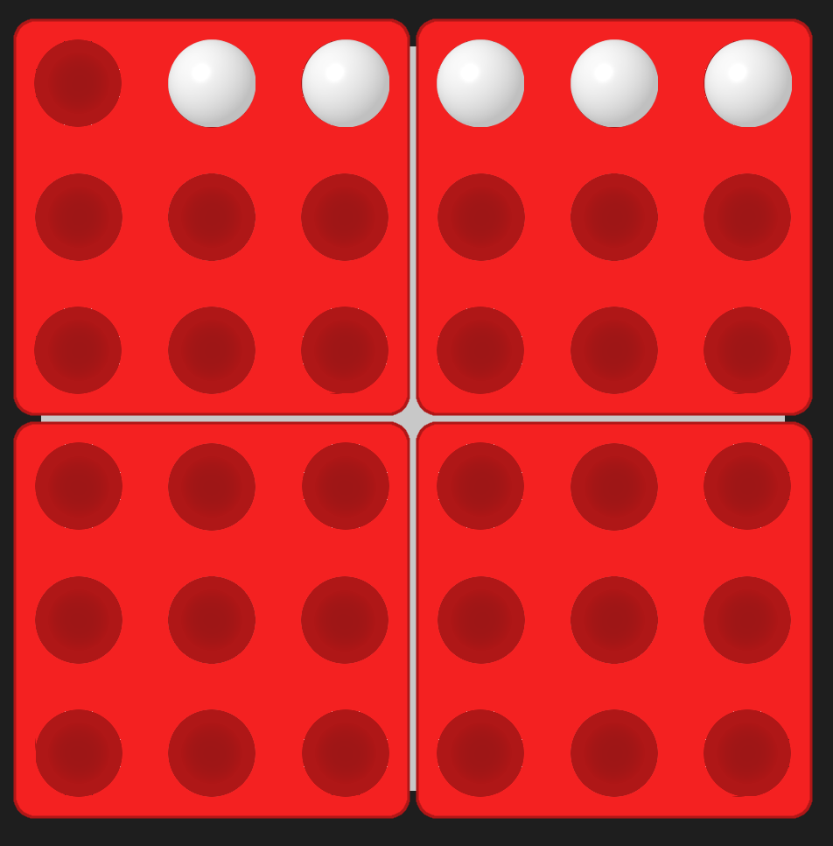

Third one is called “The straight five”.

This play uses board’s edges to position marbles. Seeming not strong at the first look can become a weapon in right hands.

Its main advantage is versatility. You can easily turn
“The straight five” into “The middle five” or rotate a block to move the game closer to the center.

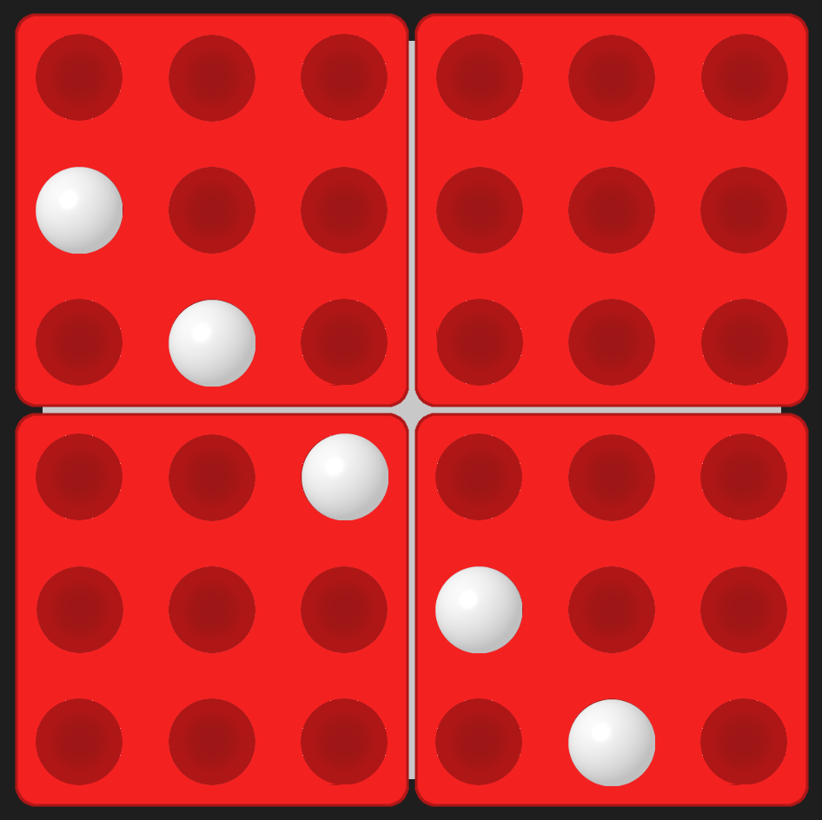

Fourth one is called “The triple power play”.

This one is the most powerful technique of all. This play doesn’t require any three-in-a-rows to accomplish. It is really hard to defend against and has several different ways to set it up.

Bot Implementation

All the aforementioned plays can easily be used while playing the game by humans, but not by machines. As far as it is known there is no “winning” strategy in Pentago – you can only guess opponent future moves and prevent them using any of the techniques, choosing the best available option.

The bot always goes second (at least for now). His first move would always be made into the center of randomly chosen game block. This is done on purpose: the first move already blocks one of two “Monica’s five” plays, as well as “Big cross” situation in the move area. It also blocks an “Opened four” situation while performing “The middle five” technique leaving an opponent with broken plans just after the first turn.

Second turn is made not randomly at all. The bot checks current playing field and comes up with the move (including rotation) that will give him the longest line of marbles. Because the first move was made into the center of game block, he will proceed building the line -into- the board center, leaving an empty space behind the marbles to accomplish “Opened four” play in the future.

Third turn is way more complicated than others mentioned before. Here could appear a situation called “Opened three” and if it is left untouched, the next turn will flow into “Opened four” play which leads to losing the game. So the bot determines the conditions and moves respectively, including making the longest line.
The longest line algorithm is way smarter you might have thought. It prioritizes opened lines to closed lines, so the “Opened two” is respected more than “Closed four”. And if there are two or more identical longest lines, it chooses the one that will give the biggest coverage area.

All next turns are done in this way: bot checks whether he is able to win (get five-in-a-row) and just makes the move if possible. Then he comes up with a set of moves (including rotation) that block either player’s next-move-five-in-a-row or next-move “Opened four” situations, so the player will be unable to win on the next turn. The bot chooses the optimal move using the longest line algorithm on this set of moves. In the end of turn the player is left with broken strategy that requires having a preset pattern of marbles to win in one turn.

But how am I suppose to win if all my strategies are not working?
There is a way. Just try to force the bot to make useless moves while attempting to build a “fork” situation. There are some plays that bot is unable to “see” and if you have made one, bot will just move randomly, this usually happens on late game stage. Those situations cannot be written because of randomness in the game. You have to build them individually, depending on current in-game conditions.

