Чистяков Артем

1. Вычисление вектора стационарных состояний регулярной цепи Маркова

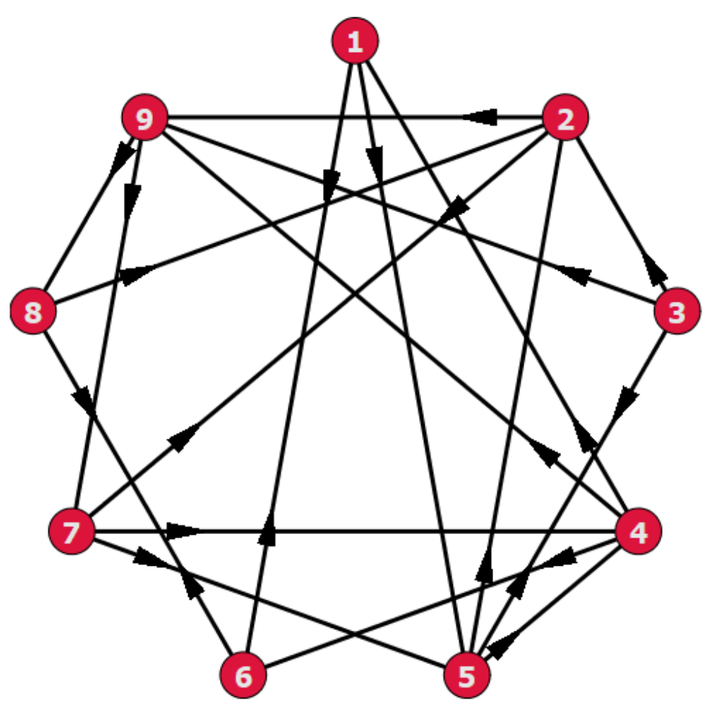

Решение

Матрица P:

[ 0 0 0 0 1/2 1/2 0 0 0 ]
[ ]
[ 0 0 0 0 0 0 1/2 0 1/2]
[ ]
[ 0 1/3 0 0 1/3 0 0 0 1/3]
[ ]
[1/3 0 0 0 0 1/3 0 0 1/3]
[ ]
[ 0 1/3 1/3 1/3 0 0 0 0 0 ]
[ ]
[1/2 0 0 0 0 0 0 1/2 0 ]
[ ]
[ 0 1/3 0 1/3 1/3 0 0 0 0 ]
[ ]
[ 0 1/2 0 0 1/2 0 0 0 0 ]
[ ]
[ 0 0 0 0 0 0 1/2 1/2 0 ]

Минимальное значение К, при котором все элементы положительные — 5.

[ 37 541 35 305 229 95 17 23 ]
[--- ---- 1/54 --- ---- ---- --- --- --- ]
[648 2592 432 1296 2592 864 288 162 ]
[ ]
[ 53 119 19 13 49 ]
[5/72 --- 2/81 ---- --- 5/72 5/32 -- --- ]
[ 324 1296 108 96 432 ]
[ ]
[ 67 317 23 31 151 67 103 581 ]
[--- ---- --- --- --- --- --- 5/48 ----]
[972 1944 648 324 972 972 648 3888]
[ ]
[ 95 175 11 13 91 95 77 59 193 ]
[---- ---- --- --- --- ---- --- --- ----]
[1296 1296 324 162 648 1296 432 432 1296]
[ ]
[ 287 161 209 61 25 235 ]
[5/72 ---- ---- ---- --- 5/72 --- 2/27 ----]
[ 1944 1944 1944 648 144 1296]
[ ]
[ 133 53 31 17 ]
[7/96 --- 2/27 --- --- 1/24 -- 5/32 3/32]
[ 864 432 288 96 ]
[ ]
[137 347 23 275 137 179 623 ]
[---- ---- 5/72 --- ---- ---- ---- 7/108 ----]
[1944 1944 216 1944 1944 1296 3888]
[ ]
[ 43 121 23 47 209 43 119 11 371 ]
[--- --- --- --- ---- --- --- --- ----]
[648 648 432 432 1296 648 864 144 2592]
[ ]
[ 13 505 31 149 53 13 17 35 ]
[--- ---- --- ---- --- --- 5/36 --- --- ]
[216 2592 648 1296 288 216 144 432 ]
При К = 20, столбцы матрицы практически не отличатся.

[ 0.0678 0.1695 0.0509 0.1017 0.1525 0.0678 0.1526 0.1017 0.1356 ]
[ ]
[ 0.0678 0.1695 0.0509 0.1017 0.1525 0.0678 0.1525 0.1017 0.1356 ]
[ ]
[ 0.0678 0.1695 0.0509 0.1017 0.1525 0.0678 0.1525 0.1017 0.1356 ]
[ ]
[ 0.0678 0.1695 0.0509 0.1017 0.1525 0.0678 0.1525 0.1017 0.1356 ]
[ ]
[ 0.0678 0.1695 0.0508 0.1017 0.1526 0.0678 0.1525 0.1017 0.1356 ]
[ ]
[ 0.0678 0.1695 0.0508 0.1017 0.1525 0.0678 0.1525 0.1017 0.1356 ]
[ ]
[ 0.0678 0.1695 0.0508 0.1017 0.1526 0.0678 0.1525 0.1017 0.1356 ]
[ ]
[ 0.0678 0.1695 0.0508 0.1017 0.1525 0.0678 0.1525 0.1017 0.1356 ]
[ ]
[ 0.0678 0.1695 0.0508 0.1017 0.1525 0.0678 0.1526 0.1017 0.1356 ]

Вектор стационарных состояний:
W = { 0.0678, 0.1695, 0.0508, 0.1017, 0.1525, 0.0678, 0.1525, 0.1017, 0.1356 }

