Q5. Use superpages (easy)
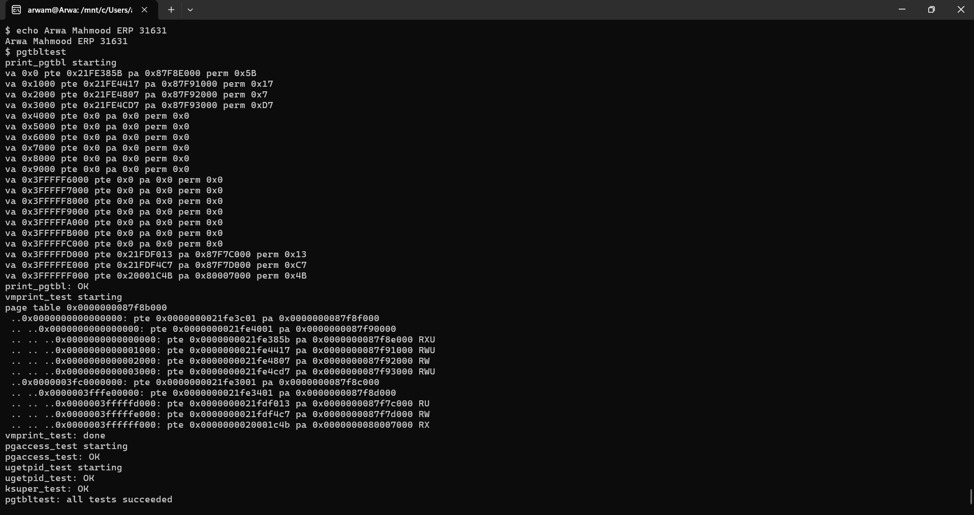
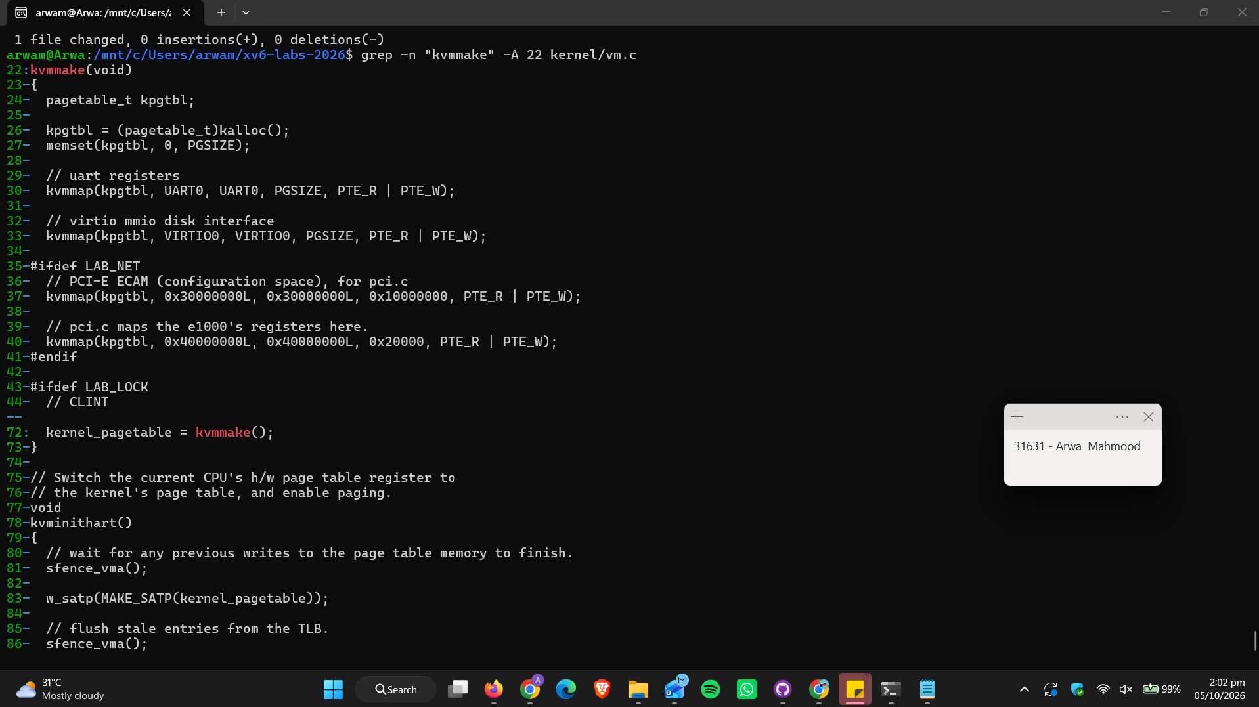
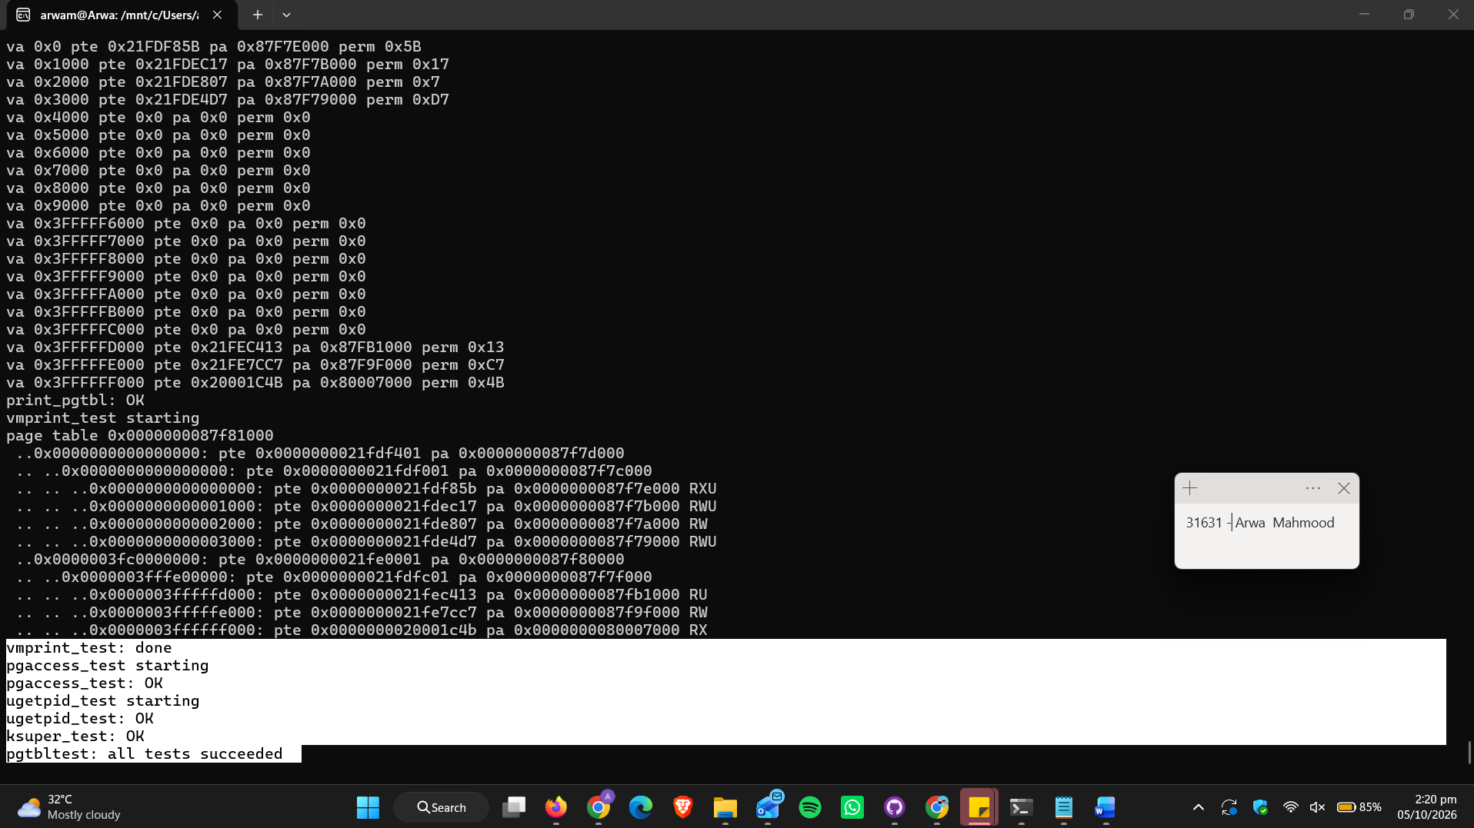

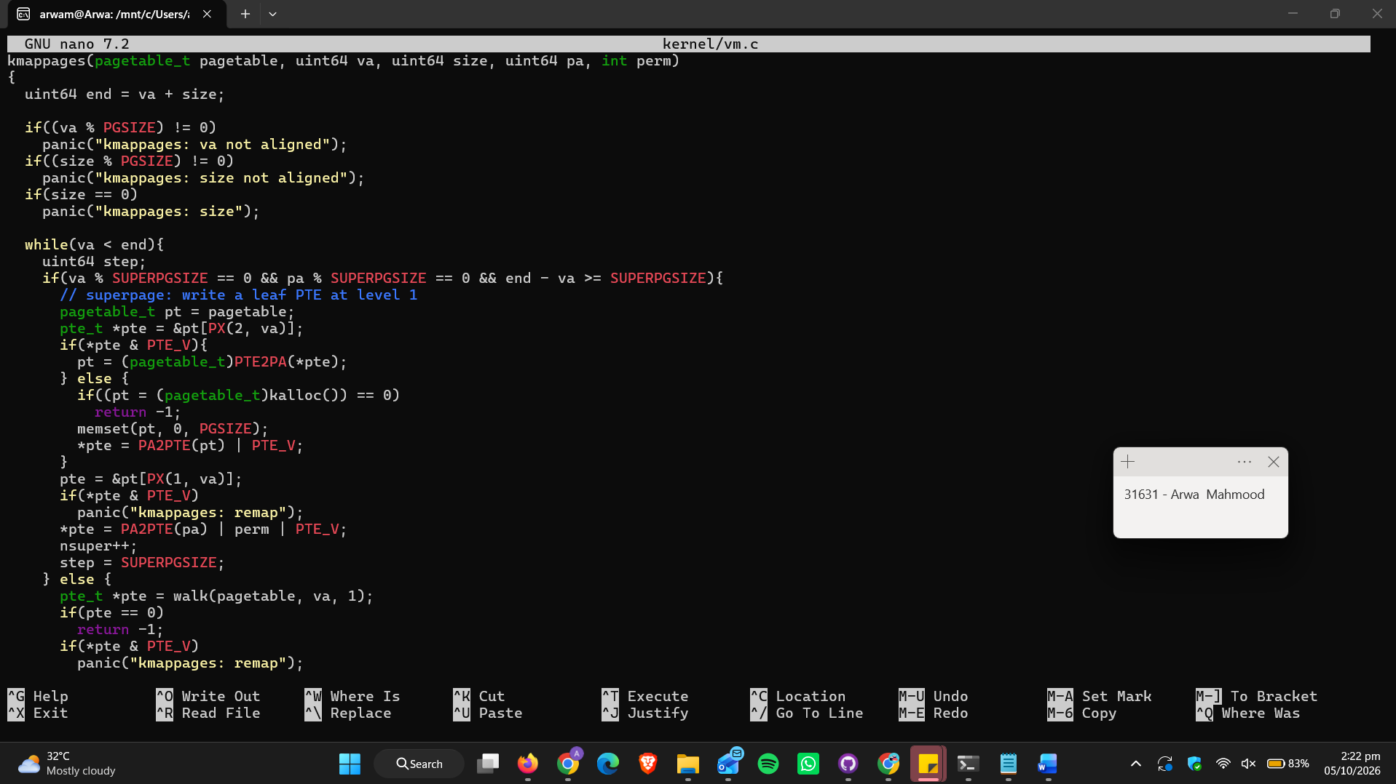
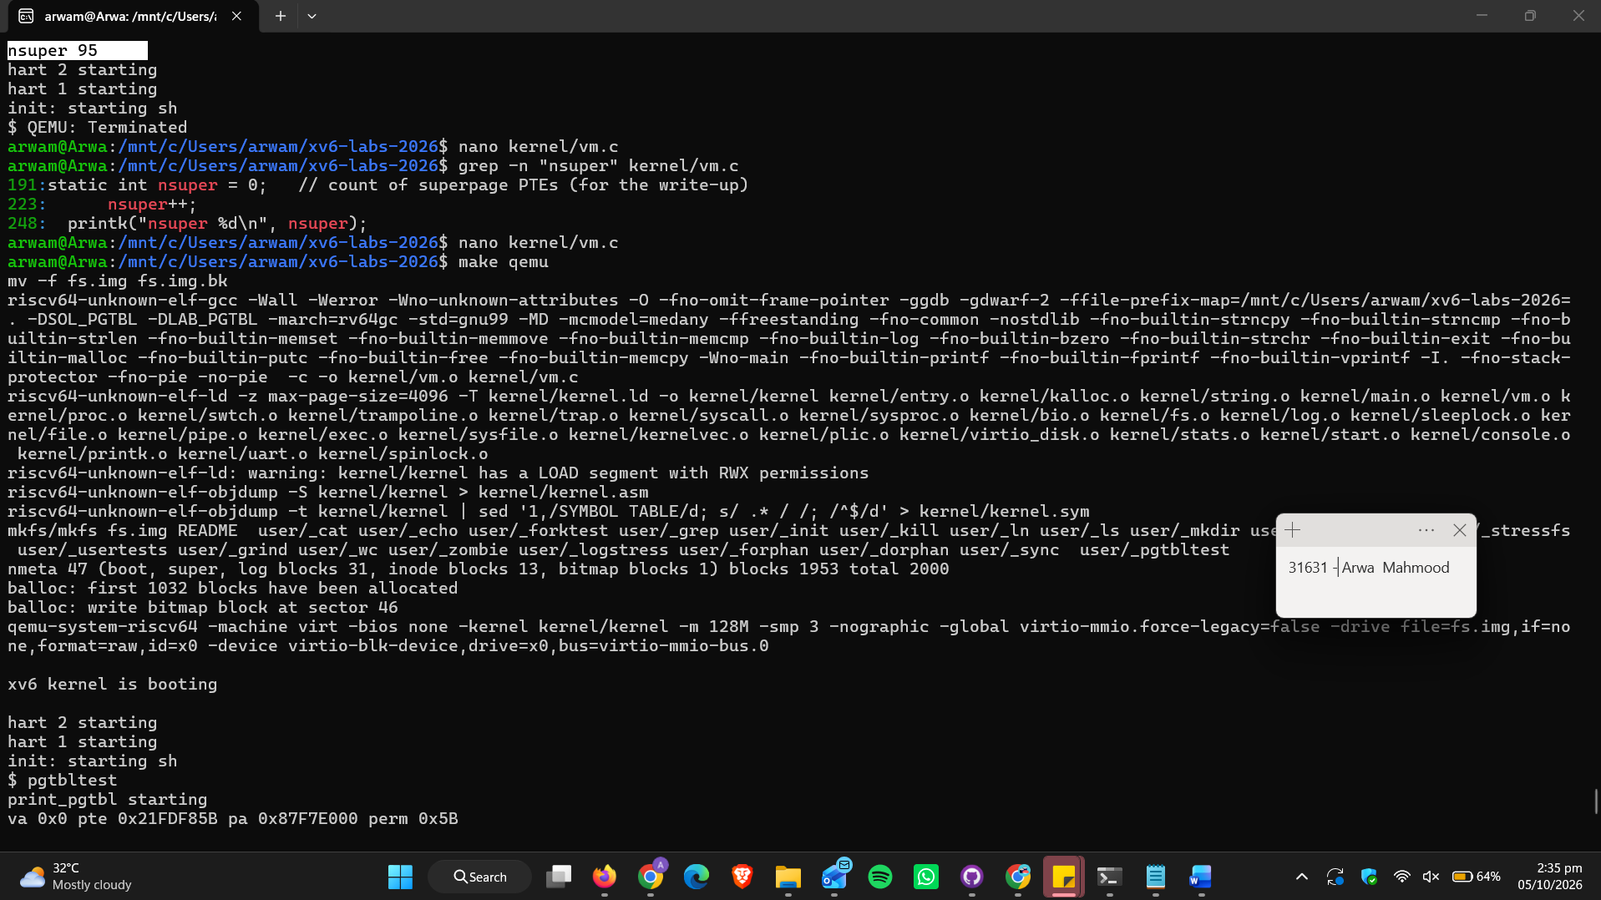
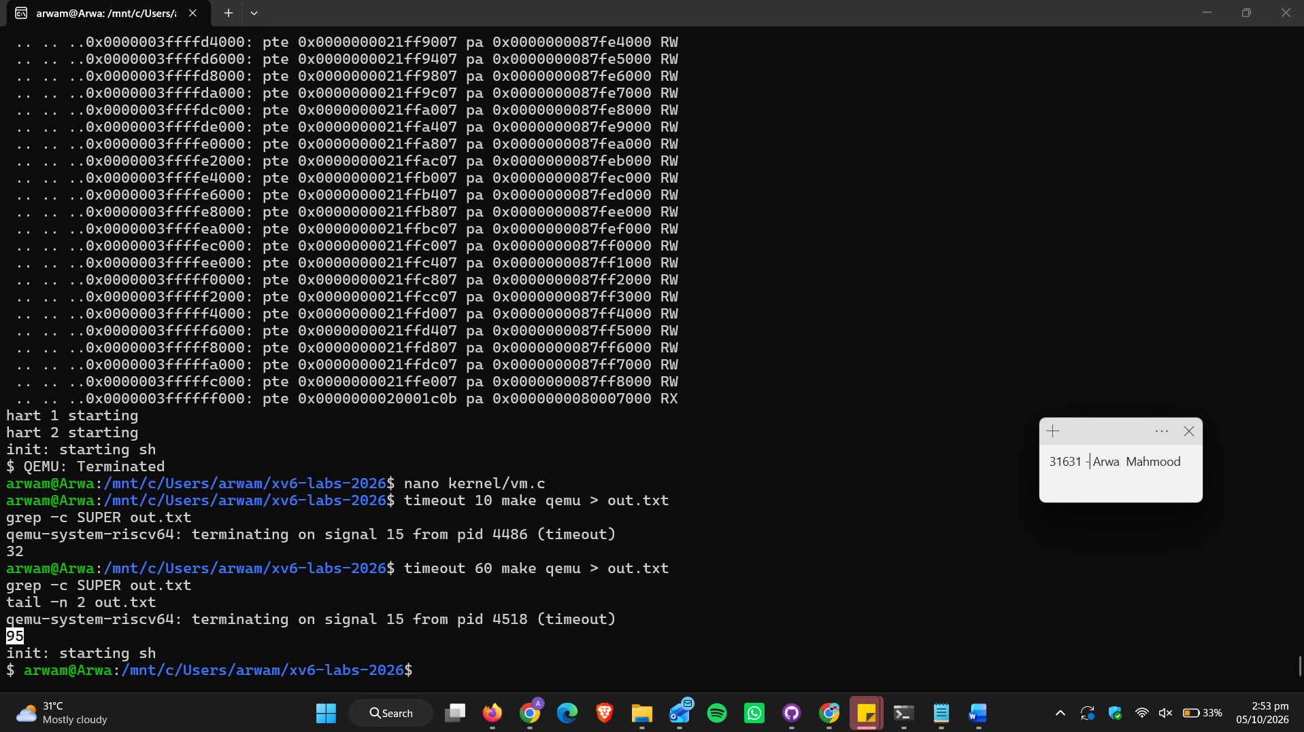
Q. How many superpage PTEs does your solution use? How many bottom-level pages do these superpage PTEs save?
Ans. My solution uses 95 superpage PTEs (level-1 leaf PTEs). 32 come from the 64 MB PLIC mapping and 63 come from the kernel data/RAM mapping up to PHYSTOP. The UART, VIRTIO, kernel text, trampoline and kernel stacks are smaller than 2 MB, so they still use 4 KB pages.
Each superpage maps 2 MB directly, so it replaces a bottom-level page table of 512 PTEs (512 x 4 KB = 2 MB).
Saved: 95 x 512 = 48,640 bottom-level pages (PTEs), which is 95 bottom-level page-table pages, or 95 x 4 KB = 380 KB of page-table memory. It also reduces TLB misses, since one TLB entry covers 2 MB instead of 4 KB.

