// Name: Arwa Salujiwala Roll no: 23555 Batch: S3
// DSA Assignment 06
// Implement In-order Threaded Binary Tree and traverse it in In-order and Pre-order.

#include <iostream>
using namespace std;

// Node structure for Threaded Binary Tree
struct ThreadedBinaryTreeNode {
int data;
ThreadedBinaryTreeNode* left;
ThreadedBinaryTreeNode* right;
bool leftThread;
bool rightThread;

ThreadedBinaryTreeNode(int val) : data(val), left(nullptr), right(nullptr), leftThread(false), rightThread(false) {}
};

// Threaded Binary Tree class
class ThreadedBinaryTree {
private:
ThreadedBinaryTreeNode* root;

// Helper function to insert a node
void insert(ThreadedBinaryTreeNode* &node, int val) {
if (node == nullptr) {
node = new ThreadedBinaryTreeNode(val);
return;
}

if (val < node->data) {
if (!node->leftThread) {
insert(node->left, val);
} else {
ThreadedBinaryTreeNode* temp = new ThreadedBinaryTreeNode(val);
temp->left = node->left;
temp->right = node;
node->left = temp;
node->leftThread = true;
}
} else {
if (!node->rightThread) {
insert(node->right, val);
} else {
ThreadedBinaryTreeNode* temp = new ThreadedBinaryTreeNode(val);
temp->right = node->right;
temp->left = node;
node->right = temp;
node->rightThread = true;
}
}
}

// In-order Traversal using threads
void inOrder(ThreadedBinaryTreeNode* node) {
if (node == nullptr) return;

// Find the leftmost node
while (node && !node->leftThread)
node = node->left;

// Traverse in-order using threads
while (node) {
cout << node->data << " ";

// If there is a thread to the right, follow the thread
if (node->rightThread)
node = node->right;
else
break;
}
}

// Pre-order Traversal (recursive method)
void preOrder(ThreadedBinaryTreeNode* node) {
if (node == nullptr) return;
cout << node->data << " ";
if (!node->leftThread)
preOrder(node->left);
if (!node->rightThread)
preOrder(node->right);
}

public:
ThreadedBinaryTree() : root(nullptr) {}

void insert(int val) {
insert(root, val);
}

void inOrderTraversal() {
inOrder(root);
cout << endl;
}

void preOrderTraversal() {
preOrder(root);
cout << endl;
}
};

// Main function
int main() {
ThreadedBinaryTree tree;

tree.insert(50);
tree.insert(30);
tree.insert(70);
tree.insert(20);
tree.insert(40);
tree.insert(60);
tree.insert(80);

cout << "In-order Traversal (Threaded): ";
tree.inOrderTraversal();

cout << "Pre-order Traversal: ";
tree.preOrderTraversal();

return 0;
}
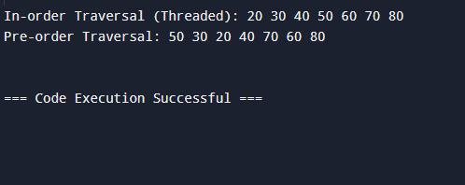
Github repository Link: https://github.com/ArwaSaluji/DSA-Assignment

