// Name: Arwa Salujiwala Roll no: 23555 Batch: S3

// DSA Assignment 08

//Represent a graph of city using adjacency matrix /adjacency list. Nodes should represent the various //landmarks and links should represent the distance between them. Find the shortest path using //Dijkstra's algorithm from single source to all destinations.

#include <iostream>
#include <climits>

using namespace std;

#define V 6 // Number of landmarks (nodes)

class CityGraph {
public:
int adjMatrix[V][V]; // Adjacency matrix to represent distances between landmarks

// Constructor to initialize the adjacency matrix
CityGraph() {
// Initialize the adjacency matrix with 0 (no distances) and maximum values (infinity)
for (int i = 0; i < V; i++) {
for (int j = 0; j < V; j++) {
adjMatrix[i][j] = (i == j) ? 0 : INT_MAX;
}
}
}

// Function to add an edge between two landmarks
void addEdge(int u, int v, int weight) {
adjMatrix[u][v] = weight;
adjMatrix[v][u] = weight; // Since the graph is undirected
}

// Dijkstra's Algorithm to find the shortest path from source to all landmarks
void dijkstra(int src) {
int dist[V]; // Array to store the shortest distance from the source to each landmark
bool visited[V]; // Boolean array to check if a landmark has been processed

// Initialize distances and visited status
for (int i = 0; i < V; i++) {
dist[i] = INT_MAX;
visited[i] = false;
}

dist[src] = 0; // Distance to the source itself is 0

// Find the shortest path for all landmarks
for (int count = 0; count < V - 1; count++) {
// Pick the landmark with the minimum distance that has not been processed
int u = -1;
for (int i = 0; i < V; i++) {
if (!visited[i] && (u == -1 || dist[i] < dist[u])) {
u = i;
}
}

// Mark the picked landmark as processed
visited[u] = true;

// Update the distance of the adjacent landmarks of the picked landmark
for (int v = 0; v < V; v++) {
if (adjMatrix[u][v] != INT_MAX && !visited[v] && dist[u] + adjMatrix[u][v] < dist[v]) {
dist[v] = dist[u] + adjMatrix[u][v];
}
}
}

// Output the shortest distances
cout << "Shortest distances from source landmark " << src << ":\n";
for (int i = 0; i < V; i++) {
if (dist[i] == INT_MAX) {
cout << "Landmark " << i << ": INF\n";
} else {
cout << "Landmark " << i << ": " << dist[i] << " km\n";
}
}
}
};

int main() {
CityGraph city;

// Add edges (u, v, distance in km)
city.addEdge(0, 1, 7); // A-B: 7 km
city.addEdge(0, 2, 9); // A-C: 9 km
city.addEdge(1, 2, 10); // B-C: 10 km
city.addEdge(1, 3, 15); // B-D: 15 km
city.addEdge(2, 3, 11); // C-D: 11 km
city.addEdge(2, 5, 2); // C-F: 2 km
city.addEdge(3, 4, 6); // D-E: 6 km
city.addEdge(4, 5, 9); // E-F: 9 km
city.addEdge(0, 5, 14); // A-F: 14 km

// Find shortest paths from landmark A (source = 0)
city.dijkstra(0);

return 0;
}
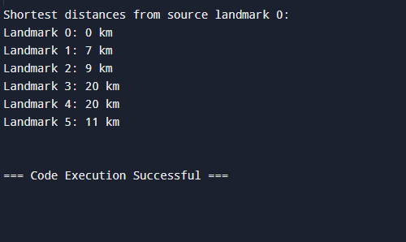
Github repository Link: https://github.com/ArwaSaluji/DSA-Assignment

