// Name: Arwa Salujiwala Roll no: 23555 Batch: S3

// DSA Assignment 09
// Implement Heap sort to sort given set of values using max or min heap.

#include <iostream>
using namespace std;

class HeapSort {
public:
// Function to heapify the subtree rooted at index i
void heapify(int arr[], int n, int i) {
int largest = i; // Initialize largest as root
int left = 2 * i + 1; // Left child index
int right = 2 * i + 2; // Right child index

// If left child is larger than root
if (left < n && arr[left] > arr[largest]) {
largest = left;
}

// If right child is larger than root
if (right < n && arr[right] > arr[largest]) {
largest = right;
}

// If largest is not root, swap them and continue heapifying
if (largest != i) {
swap(arr[i], arr[largest]);
heapify(arr, n, largest); // Heapify the affected subtree
}
}

// Main function to perform heap sort
void heapSort(int arr[], int n) {
// Build max heap
for (int i = n / 2 - 1; i >= 0; i--) {
heapify(arr, n, i);
}

// Extract elements one by one from the heap
for (int i = n - 1; i > 0; i--) {
// Move current root to the end (swap the root with the last element)
swap(arr[0], arr[i]);

// Call heapify on the reduced heap
heapify(arr, i, 0);
}
}

// Function to print the array
void printArray(int arr[], int size) {
for (int i = 0; i < size; i++) {
cout << arr[i] << " ";
}
cout << endl;
}
};

int main() {
int arr[] = {12, 11, 13, 5, 6, 7};
int n = sizeof(arr) / sizeof(arr[0]);

HeapSort hs;
hs.heapSort(arr, n);

cout << "Sorted array: \n";
hs.printArray(arr, n);

return 0;
}
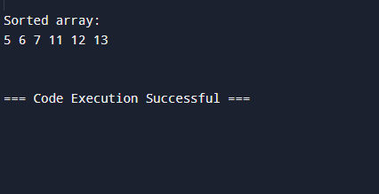
Github repository Link: https://github.com/ArwaSaluji/DSA-Assignment

