// Name: Arwa Salujiwala Roll no: 23555 Batch: S3

// DSA Assignment 10

//Department maintains student’s database. The file contains roll number, name, division and address.
//Write a program to create a sequential file to store and maintain student data. It should allow the user
//to add, delete information of student. Display information of particular student. If record of student
//does not exist an appropriate message is displayed. If student record is found it should display the
//student details.

#include <iostream>
#include <fstream>
#include <cstring>
using namespace std;

struct Student {
int rollNo;
char name[50];
char division;
char address[100];
};

// Function to add a new student record
void addStudent() {
ofstream file("students.txt", ios::app); // Open file in append mode

if (!file) {
cout << "Error opening file!" << endl;
return;
}

Student student;
cout << "Enter roll number: ";
cin >> student.rollNo;
cin.ignore(); // To consume the newline left in the buffer

cout << "Enter name: ";
cin.getline(student.name, 50);

cout << "Enter division: ";
cin >> student.division;
cin.ignore();

cout << "Enter address: ";
cin.getline(student.address, 100);

file.write(reinterpret_cast<char*>(&student), sizeof(student));
file.close();
cout << "Student record added successfully!" << endl;
}

// Function to display student information based on roll number
void displayStudent() {
ifstream file("students.txt", ios::in); // Open file in read mode

if (!file) {
cout << "Error opening file!" << endl;
return;
}

int rollNo;
cout << "Enter roll number to display: ";
cin >> rollNo;

Student student;
bool found = false;

while (file.read(reinterpret_cast<char*>(&student), sizeof(student))) {
if (student.rollNo == rollNo) {
found = true;
cout << "\nStudent Information:\n";
cout << "Roll Number: " << student.rollNo << endl;
cout << "Name: " << student.name << endl;
cout << "Division: " << student.division << endl;
cout << "Address: " << student.address << endl;
break;
}
}

if (!found) {
cout << "Student record not found!" << endl;
}

file.close();
}

// Function to delete a student record
void deleteStudent() {
ifstream file("students.txt", ios::in); // Open file in read mode
ofstream tempFile("temp.txt", ios::out); // Temporary file to store the new records

if (!file || !tempFile) {
cout << "Error opening file!" << endl;
return;
}

int rollNo;
cout << "Enter roll number to delete: ";
cin >> rollNo;

Student student;
bool found = false;

while (file.read(reinterpret_cast<char*>(&student), sizeof(student))) {
if (student.rollNo == rollNo) {
found = true;
cout << "Student record with roll number " << rollNo << " has been deleted." << endl;
} else {
tempFile.write(reinterpret_cast<char*>(&student), sizeof(student));
}
}

if (!found) {
cout << "Student record not found!" << endl;
}

file.close();
tempFile.close();

// Remove original file and rename temporary file to original file name
if (remove("students.txt") != 0) {
cout << "Error deleting file!" << endl;
} else if (rename("temp.txt", "students.txt") != 0) {
cout << "Error renaming file!" << endl;
}
}

// Function to display menu options and process user choice
void menu() {
int choice;

do {
cout << "\nStudent Database Menu:\n";
cout << "1. Add Student\n";
cout << "2. Display Student Information\n";
cout << "3. Delete Student Record\n";
cout << "4. Exit\n";
cout << "Enter your choice: ";
cin >> choice;

switch (choice) {
case 1:
addStudent();
break;
case 2:
displayStudent();
break;
case 3:
deleteStudent();
break;
case 4:
cout << "Exiting program..." << endl;
break;
default:
cout << "Invalid choice. Please try again." << endl;
}
} while (choice != 4);
}

int main() {
menu(); // Start the menu-driven program
return 0;
}
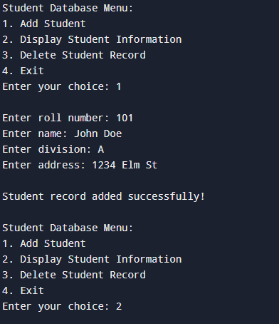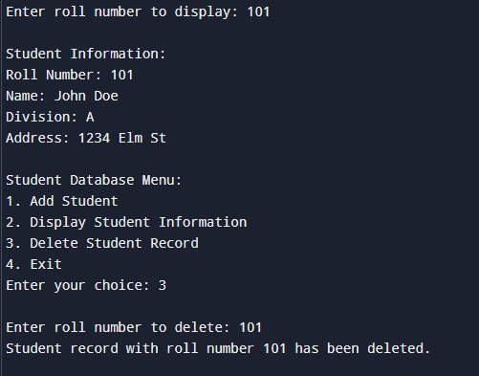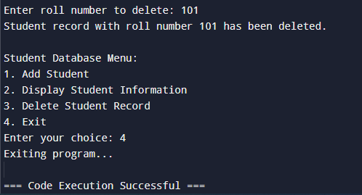
Github repository Link: https://github.com/ArwaSaluji/DSA-Assignment

