Database System for a Smart Healthcare Clinic Network

As healthcare services expand across multiple cities, the need for a unified and intelligent system becomes more important than ever. The main idea behind this project is to design a database that supports a smart clinic network, where patient information, appointments, medical records, and billing can all be managed smoothly and securely under one system.
The goal is to build a database that connects all clinics within the network so that a patient can register once and receive services from any branch. With this system, daily operations such as booking appointments, issuing prescriptions, updating doctor schedules, and tracking medicine stock become more organized and efficient. An important part of the design is ensuring that sensitive health data is protected by implementing role-based access, allowing each user to access only what they are authorized to see.
Working on this project helped me understand how real-life healthcare processes translate into database entities and relationships. I focused on creating a structure that is practical, clear, and secure — one that supports the workflow of medical staff and ensures reliable services for patients.

ER Diagram Description (Entities and Relationships)

The database design is built around several core entities that represent different aspects of the clinic network. Each entity plays a specific role, and the relationships between them show how information flows inside the system.

1-Patient Entity
Represents individuals receiving healthcare services. Key attributes:
- PatientID
- FullName
- Gender
- Phone
- Email
- City
A single patient can have multiple appointments, forming a one-to-many relationship.

2. Doctor Entity
Represents medical staff working across the clinics. Attributes include:
- DoctorID
- FullName
- Specialty
- Phone
- Email
- ClinicID
Each doctor belongs to one clinic but may see many patients and issue multiple prescriptions.

3. Clinic Entity
Represents each clinic within the network:
- ClinicID
- ClinicName
- City
- Address
A clinic hosts multiple doctors and handles appointments, prescriptions, and billing records.

4. Appointment Entity
Serves as the link between patients, doctors, and clinics. Attributes:
- AppointmentID
- PatientID
- DoctorID
- ClinicID
- AppointmentDate
- StartTime / EndTime
- Status
It is the central entity that connects most of the system’s activities.

5. Prescription Entity
Records medications provided to patients during their appointments:
- PrescriptionID
- AppointmentID
- DoctorID
- PatientID
- IssueDate
Each prescription is always tied to a single appointment.

6. Medicine Entity
Lists all medication types available in the system:
- MedicineID
- MedicineName
- Type
- Description

7. Inventory Entity
Tracks medicine stock for each clinic:
- InventoryID
- ClinicID
- MedicineID
- Quantity
- ExpiryDate
This entity handles the many-to-many relationship between clinics and medicines.

8. Billing Entity
Documents payments for services provided:
- BillID
- AppointmentID
- PatientID
- ClinicID
- Amount
- BillDate
Used to generate revenue reports for each clinic.

9. User & Role Entities (Security Layer)
To enforce access control and protect sensitive information:

User:
- UserID
- Username
- Password
- RoleID

Role:
- RoleID
- RoleName
This structure supports role-based permissions, ensuring secure and controlled access to medical data.
The following diagram illustrates the relationships between the main entities in the system:
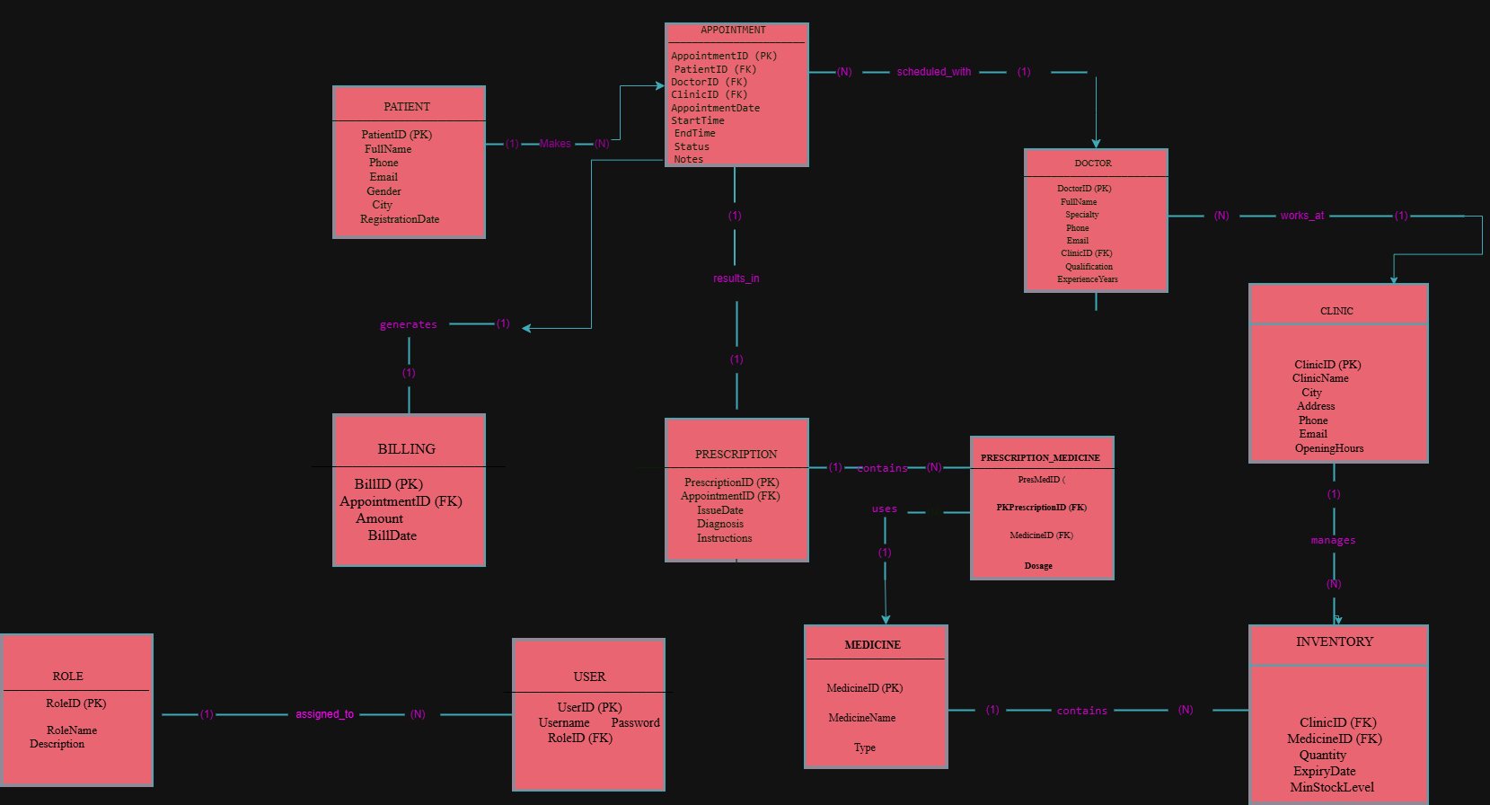

Patient → Appointment (1:N) - A patient can have multiple appointments
Doctor → Appointment (1:N) - A doctor can handle multiple appointments
Clinic → Doctor (1:N) - A clinic can have multiple doctors
Appointment → Prescription (1:1) - Each appointment generates one prescription
Clinic → Inventory (1:N) - A clinic manages multiple inventory items
Medicine → Inventory (1:N) - A medicine can be stocked in multiple clinics

UNNORMALIZED TABLES (UNF):

Unnormalized tables are the raw, initial tables that mix all data together, often with lots of redundancy and repeating groups.

Example: Unnormalized Healthcare Data

PatientID | PatientName | DoctorID | DoctorName | ClinicID | ClinicName | AppointmentID | MedicineID | MedicineName | BillID
1 | Nora saud | 101 | Dr. Wilson | 1 | Central | 1001 | 201 | Aspirin | 3001
1 | Nora saud | 101 | Dr. Wilson | 1 | Central | 1002 | 202 | Lisinopril | 3002
... | ... | ... | ... | ... | ... | ... | ... | ... | ...
Redundancy Issues:

Issues in UNF:
- Repeating groups: MedicineList, QuantityList
- Redundancy: Patient, Doctor, Clinic repeated for every appointment
- Multi-topic table: patients, appointments, doctors, clinics, billing, prescriptions all mixed
- No clear primary key
- Update, insert, delete anomalies

Key Finding:
Unnormalized tables are inefficient and error-prone due to data duplication and lack of structure.

First Normal Form (1NF):
Rules of 1NF:
- All values must be atomic
- No repeating groups
- A primary key must be defined

1NF Table Design:
Table | Primary Key | Key Attributes (Sample)
Patient | PatientID | FullName, Gender, Phone, Email, City
Doctor | DoctorID | FullName, Specialty, Phone, Email, ClinicID
Clinic | ClinicID | ClinicName, City, Address
Appointment | AppointmentID | PatientID, DoctorID, ClinicID, Date, StartTime, EndTime, Status
Prescription | PrescriptionID | AppointmentID, DoctorID, PatientID, MedicineID, IssueDate
Medicine | MedicineID | MedicineName, Type, Description
Inventory | InventoryID | ClinicID, MedicineID, Quantity, ExpiryDate
Billing | BillID | AppointmentID, PatientID, ClinicID, Amount, BillDate
User | UserID | Username, Password, RoleID
Role | RoleID | RoleName, RoleDescription
Example: Patient Table (1NF)
PatientID | FullName | Gender
----------- | -------------- | --------
1 | Nawaf saad | Male
2 | Amal badr | Female
3 | Abdulaziz | Male

Key Finding:
1NF separates data into clear, atomic tables with unique primary keys, eliminating repeating groups.

1NF → 2NF (Remove Partial Dependencies)
A table must be in 2NF when:
- It is already in 1NF
- No non-key attribute depends on part of a composite key

Functional Dependency Analysis
Table | Functional Dependencies (FDs) | 2NF Status
Patient | PatientID → FullName, Gender, Phone, Email, City | ✓ Already in 2NF
Doctor | DoctorID → FullName, Specialty, Phone, Email, ClinicID | ✓ Already in 2NF
Clinic | ClinicID → ClinicName, City, Address | ✓ Already in 2NF
Appointment | AppointmentID → PatientID, DoctorID, ClinicID, ... | ✓ Already in 2NF
Prescription | PrescriptionID → AppointmentID, DoctorID, PatientID, ... | ❌ Partial dependencies (DoctorID, PatientID)
Billing | BillID → AppointmentID, PatientID, ClinicID, ... | ❌ Partial dependencies (PatientID, ClinicID)

2NF Transformation
- Prescription Table: Remove DoctorID and PatientID (can be derived from AppointmentID).
- Billing Table: Remove PatientID and ClinicID (can be derived from AppointmentID).

Example: Prescription Table (2NF)
PrescriptionID | AppointmentID | MedicineID | IssueDate
2001 | 1001 | 201 | 2025-01-15
2002 | 1002 | 202 | 2025-02-20
Example: Billing Table (2NF)
BillID | AppointmentID | Amount | BillDate
-------- | --------------- | -------- | ------------
3001 | 1001 | 150.0 | 2025-01-15
3002 | 1002 | 200.0 | 2025-02-20
Key Finding:
2NF removes partial dependencies, reducing redundancy and improving data integrity.

Third Normal Form (3NF)

3NF Rules
- Must be in 2NF.
- Eliminate transitive dependencies (non-key attributes should not depend on other non-key attributes).

3NF Analysis & Adjustments
- All tables after 2NF: No transitive dependencies remain, as all non-key attributes depend only on the primary key.

Table | Primary Key | Key Attributes (Final)
Patient | PatientID | FullName, Gender, Phone, Email, City
Doctor | DoctorID | FullName, Specialty, Phone, Email, ClinicID
Clinic | ClinicID | ClinicName, City, Address
Appointment | AppointmentID | PatientID, DoctorID, ClinicID, Date, StartTime, EndTime, Status
Prescription | PrescriptionID | AppointmentID, MedicineID, IssueDate
Medicine | MedicineID | MedicineName, Type, Description
Inventory | InventoryID | ClinicID, MedicineID, Quantity, ExpiryDate
Billing | BillID | AppointmentID, Amount, BillDate
User | UserID | Username, Password, RoleID
Role | RoleID | RoleName, RoleDescription
Final 3NF Table Structure:

Final Relational Schema:

Entity Relationships
- Patient (1) — (N) Appointment
- Doctor (1) — (N) Appointment
- Clinic (1) — (N) Doctor
- Appointment (1) — (1) Prescription
- Clinic (1) — (N) Inventory
- Medicine (1) — (N) Inventory
- Appointment (1) — (1) Billing
- User (N) — (1) Role
Roles Table
CREATE TABLE Role (
RoleID INT PRIMARY KEY,
RoleName VARCHAR(50),
RoleDescription VARCHAR(200)
);
INSERT INTO Role (RoleID, RoleName, RoleDescription) VALUES
(1, 'Admin', 'Has full access to all system '),
(2, 'Doctor', 'Can manage patients, appointments, and prescriptions'),
(3, 'Receptionist', 'Can manage appointments'),
(4, 'Pharmacist', 'Can manage medicine inventory and prescriptions'),
(5, 'Patient', 'Can view own appointments and medical records');

Users Table
CREATE TABLE UserAccount (
UserID INT PRIMARY KEY,
Username VARCHAR(50) UNIQUE,
Password VARCHAR(200),
RoleID INT,
FOREIGN KEY (RoleID) REFERENCES Role(RoleID)
);
INSERT INTO UserAccount (UserID, Username, Password, RoleID) VALUES
(1, 'admin1', 'adminpass', 1),
(2, 'admin2', 'pass123', 2),
(3, 'adman3', 'pass123', 2),
(4, 'adman4', 'receppass', 3),
(5, 'user5', 'pharmapass', 4),
(6, 'user6', 'patientpass', 5),
(7, 'user7', 'patientpass', 5),
(8, 'user8', 'pass123', 2),
(9, 'user9', 'receppass', 3),
(10, 'user10', 'patientpass', 5);
Clinics Table
CREATE TABLE Clinic (
ClinicID INT PRIMARY KEY,
ClinicName VARCHAR(100),
City VARCHAR(50),
Address VARCHAR(255)
);
INSERT INTO Clinic (ClinicID, ClinicName, City, Address) VALUES
(1, 'Riyadh Central Clinic', 'Riyadh', '10 King Fahd St'),
(2, 'Riyadh Eastside Clinic', 'Riyadh', '22 Olaya St'),
(3, 'Riyadh Westside Clinic', 'Riyadh', '35 Prince Sultan St'),
(4, 'Jeddah Downtown Clinic', 'Jeddah', '15 Tahlia St'),
(5, 'Jeddah North Clinic', 'Jeddah', '28 Prince Majed St'),
(6, 'Jeddah South Clinic', 'Jeddah', '40 King Abdulaziz St'),
(7, 'Al Khobar Central Clinic', 'Al Khobar', '5 Prince Turki St'),
(8, 'Al Khobar East Clinic', 'Al Khobar', '12 King Fahd Rd'),
(9, 'Al Khobar West Clinic', 'Al Khobar', '20 Prince Nayef St'),
(10, 'Al Khobar Uptown Clinic', 'Al Khobar', '30 King Abdullah St');

Patients Table
CREATE TABLE Patient (
PatientID INT PRIMARY KEY,
FullName VARCHAR(100),
Gender VARCHAR(10),
Phone VARCHAR(20),
Email VARCHAR(100),
City VARCHAR(50)
);
INSERT INTO Patient (PatientID, FullName, Gender, Phone, Email, City) VALUES
(1, 'Reem Ahmed', 'Female', '5555', 'reem@example.com', 'Riyadh'),
(2, 'Huda Saad', 'Female', '5551', 'huda@example.com', 'Riyadh'),
(3, 'Lama Khalid', 'Female', '5552', 'lama@example.com', 'Al Khobar'),
(4, 'Ahmed Fares', 'Male', '5553', 'ahmed@example.com', 'Al Khobar'),
(5, 'Abdullah Mohammed', 'Male', '5554', 'abdullah@example.com', 'Al Khobar'),
(6, 'Hadi Fahad', 'Male', '5556', 'hadi@example.com', 'Jeddah'),
(7, 'Sara Mohammed', 'Female', '5557', 'sara@example.com', 'Jeddah'),
(8, 'Maryam Yousif', 'Female', '5558', 'maryam@example.com', 'Al Khobar'),
(9, 'Dima Abdullah', 'Female', '5559', 'dima@example.com', 'Al Khobar'),
(10, 'Noura Abdulrahman', 'Female', '5510', 'noura@example.com', 'Al Khobar');
Doctors Table
CREATE TABLE Doctor (
DoctorID INT PRIMARY KEY,
FullName VARCHAR(100),
Specialty VARCHAR(100),
Phone VARCHAR(20),
Email VARCHAR(100),
ClinicID INT,
FOREIGN KEY (ClinicID) REFERENCES Clinic(ClinicID)
);
INSERT INTO Doctor (DoctorID, FullName, Specialty, Phone, Email, ClinicID) VALUES
(101, 'Dr. Khaled Mansour', 'Cardiology', '600000001', 'khaled@example.com', 1),
(102, 'Dr. Lina Luay', 'Dermatology', '600000002', 'lina@example.com', 2),
(103, 'Dr. Faisal Salah', 'Pediatrics', '600000003', 'faisal@example.com', 3),
(104, 'Dr. Rana Fahad', 'Orthopedics', '600000004', 'rana@example.com', 4),
(105, 'Dr. Majed Rashed', 'Neurology', '600000005', 'majed@example.com', 5),
(106, 'Dr. Sara Omar ', 'General Medicine', '600000006', 'sara@example.com', 6),
(107, 'Dr. Salim Saad', 'ENT', '600000007', 'salim@example.com', 7),
(108, 'Dr. Huda Omar', 'Ophthalmology', '600000008', 'huda@example.com', 8),
(109, 'Dr. Omar Mourad', 'Gastroenterology', '600000009', 'omar@example.com', 9),
(110, 'Dr. Maha Yaseer', 'Cardiology', '600000010', 'maha@example.com', 10);
Appointments Table
CREATE TABLE Appointment (
AppointmentID INT PRIMARY KEY,
PatientID INT,
DoctorID INT,
ClinicID INT,
AppointmentDate DATE,
StartTime TIME,
EndTime TIME,
Status VARCHAR(50),
FOREIGN KEY (PatientID) REFERENCES Patient(PatientID),
FOREIGN KEY (DoctorID) REFERENCES Doctor(DoctorID),
FOREIGN KEY (ClinicID) REFERENCES Clinic(ClinicID)
);
INSERT INTO Appointment (AppointmentID, PatientID, DoctorID, ClinicID, AppointmentDate, StartTime, EndTime, Status) VALUES
(1001, 1, 101, 1, '2025-12-01', '08:30', '09:00', 'Scheduled'),
(1002, 2, 102, 2, '2025-12-02', '09:15', '09:45', 'Completed'),
(1003, 3, 103, 3, '2025-12-03', '10:00', '10:30', 'Scheduled'),
(1004, 4, 104, 4, '2025-12-04', '11:00', '11:30', 'Cancelled'),
(1005, 5, 105, 5, '2025-12-05', '12:30', '13:00', 'Scheduled'),
(1006, 6, 106, 6, '2025-12-06', '13:15', '13:45', 'Scheduled'),
(1007, 7, 107, 7, '2025-12-07', '14:00', '14:30', 'Completed'),
(1008, 8, 108, 8, '2025-12-08', '15:00', '15:30', 'Scheduled'),
(1009, 9, 109, 9, '2025-12-09', '16:00', '16:30', 'Scheduled'),
(1010, 10, 110, 10, '2025-12-10', '17:00', '17:30', 'Scheduled');
Medicines Table
CREATE TABLE Medicine (
MedicineID INT PRIMARY KEY,
MedicineName VARCHAR(100),
Type VARCHAR(50),
Description VARCHAR(255)
);
INSERT INTO Medicine (MedicineID, MedicineName, Type, Description) VALUES
(211, 'Vitamin C', 'Tablet', 'Boosts immunity'),
(212, 'Buscopan', 'Tablet', 'Relieves abdominal pain'),
(213, 'Panadol', 'Tablet', 'Pain reliever & fever reducer'),
(214, 'Aspirin', 'Tablet', 'Pain reliever'),
(215, 'Omeprazole', 'Capsule', 'Reduces stomach acid'),
(216, 'Amoxicillin', 'Capsule', 'Antibiotic'),
(217, 'Artelac', 'Eye Drops', 'Moisturizes eyes'),
(218, 'Duspatalin', 'Capsule', 'Relieves gastrointestinal pain'),
(219, 'Stfal Cream', 'Cream', 'Moisturizes facial skin'),
(220, 'Cetirizine', 'Tablet', 'Relieves allergy symptoms');

Prescriptions Table
CREATE TABLE Prescription (
PrescriptionID INT PRIMARY KEY,
AppointmentID INT,
MedicineID INT,
IssueDate DATE,
FOREIGN KEY (AppointmentID) REFERENCES Appointment(AppointmentID),
FOREIGN KEY (MedicineID) REFERENCES Medicine(MedicineID)
);

INSERT INTO Prescription (PrescriptionID, AppointmentID, MedicineID, IssueDate) VALUES
(2001, 1001, 211, '2025-12-01'),
(2002, 1002, 212, '2025-12-02'),
(2003, 1003, 213, '2025-12-03'),
(2004, 1004, 214, '2025-12-04'),
(2005, 1005, 215, '2025-12-05'),
(2006, 1006, 216, '2025-12-06'),
(2007, 1007, 217, '2025-12-07'),
(2008, 1008, 218, '2025-12-08'),
(2009, 1009, 219, '2025-12-09'),
(2010, 1010, 220, '2025-12-10');

Inventory Table
CREATE TABLE Inventory (
InventoryID INT PRIMARY KEY,
ClinicID INT,
MedicineID INT,
Quantity INT,
ExpiryDate DATE,
FOREIGN KEY (ClinicID) REFERENCES Clinic(ClinicID),
FOREIGN KEY (MedicineID) REFERENCES Medicine(MedicineID)
);

INSERT INTO Inventory (InventoryID, ClinicID, MedicineID, Quantity, ExpiryDate) VALUES
(1001, 1, 211, 30, '2026-12-20'),
(1002, 2, 212, 25, '2026-11-20'),
(1003, 3, 213, 40, '2026-11-20'),
(1004, 4, 214, 15, '2026-11-20'),
(1005, 5, 215, 60, '2026-11-20'),
(1006, 6, 216, 35, '2026-11-20'),
(1007, 7, 217, 50, '2026-11-20'),
(1008, 8, 218, 20, '2026-11-20'),
(1009, 9, 219, 45, '2026-11-20'),
(1010, 10, 220, 30, '2026-11-20');
Billing Table
CREATE TABLE Billing (
BillID INT PRIMARY KEY,
AppointmentID INT,
Amount DECIMAL(10,2),
BillDate DATE,
FOREIGN KEY (AppointmentID) REFERENCES Appointment(AppointmentID)
);

INSERT INTO Billing (BillID, AppointmentID, Amount, BillDate) VALUES
(4001, 1001, 150.00, '2025-11-20'),
(4002, 1002, 200.00, '2025-11-21'),
(4003, 1003, 180.00, '2025-11-22'),
(4004, 1004, 250.00, '2025-11-23'),
(4005, 1005, 160.00, '2025-11-24'),
(4006, 1006, 220.00, '2025-11-25'),
(4007, 1007, 190.00, '2025-11-26'),
(4008, 1008, 210.00, '2025-11-27'),
(4009, 1009, 230.00, '2025-11-28'),
(4010, 1010, 170.00, '2025-11-29');

Queries
Patients with more than one appointment
SELECT p.FullName, COUNT(a.AppointmentID) AS NumAppointments
FROM Patient p
JOIN Appointment a ON p.PatientID = a.PatientID
GROUP BY p.FullName
HAVING COUNT(a.AppointmentID) > 1;

Doctors by specialty
SELECT Specialty, COUNT(DoctorID) AS NumDoctors
FROM Doctor
GROUP BY Specialty;

Medicines with low stock < 20
SELECT m.MedicineName, i.Quantity, c.ClinicName
FROM Inventory i
JOIN Medicine m ON i.MedicineID = m.MedicineID
JOIN Clinic c ON i.ClinicID = c.ClinicID
WHERE i.Quantity < 20;

appointments
SELECT a.AppointmentID, p.FullName AS Patient, d.FullName AS Doctor, a.AppointmentDate
FROM Appointment a
JOIN Patient p ON a.PatientID = p.PatientID
JOIN Doctor d ON a.DoctorID = d.DoctorID
WHERE a.AppointmentDate >= CURRENT_DATE;
Authentication
SELECT * FROM UserAccount WHERE Username='admin1' AND Password='adminpass';
Encryption
INSERT INTO UserAccount (UserID, Username, Password, RoleID)
VALUES (11, 'newuser', SHA2('mypassword', 256), 5);
*There is note at the end*

Available Tables
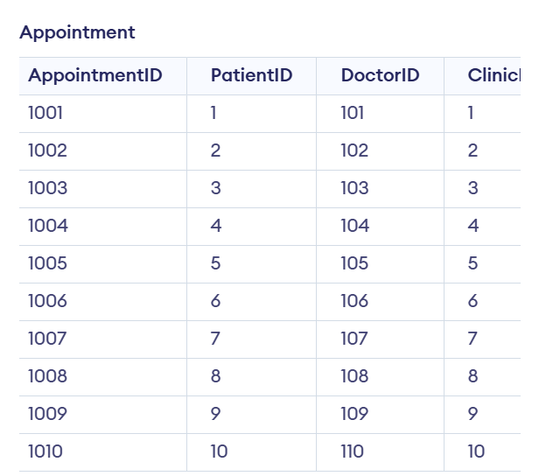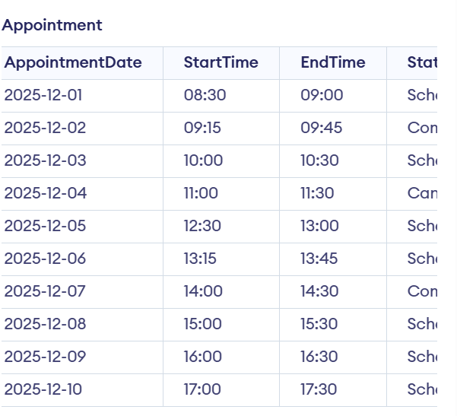
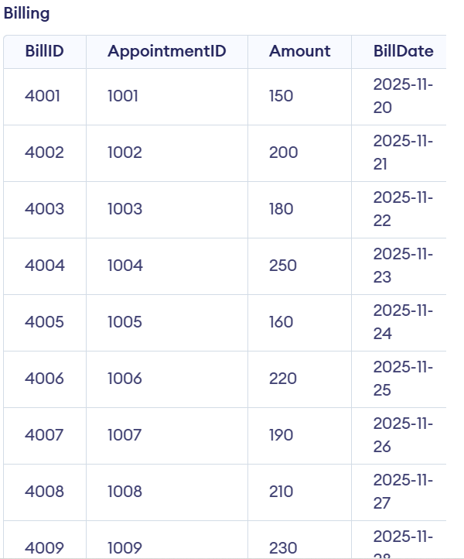

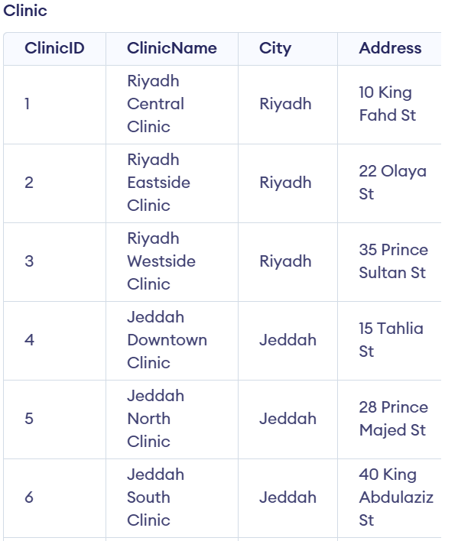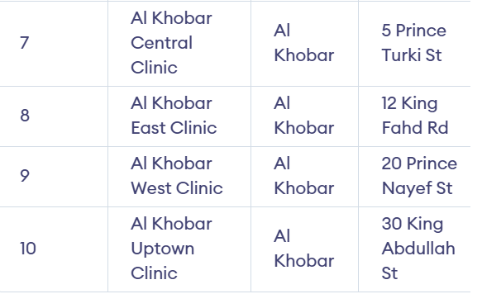

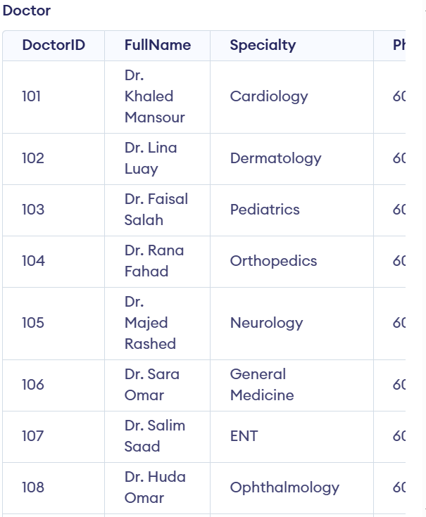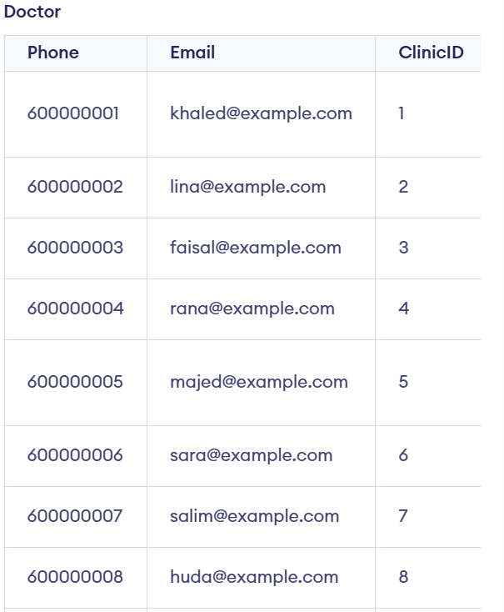
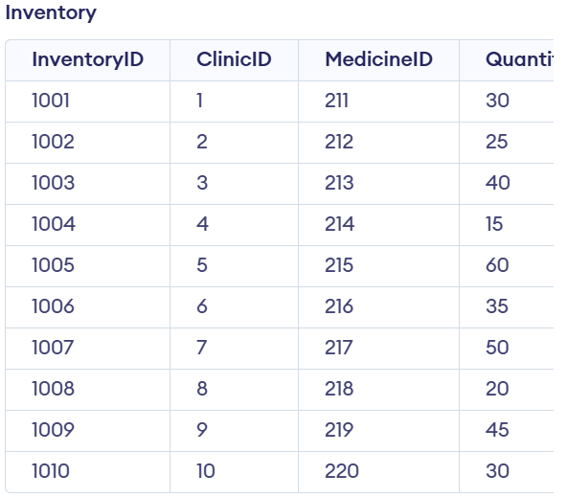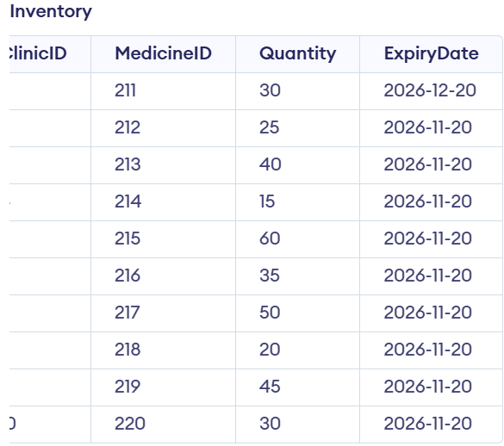
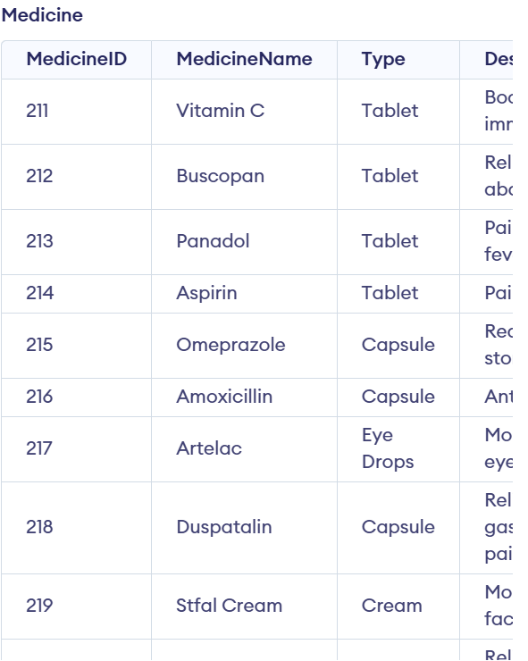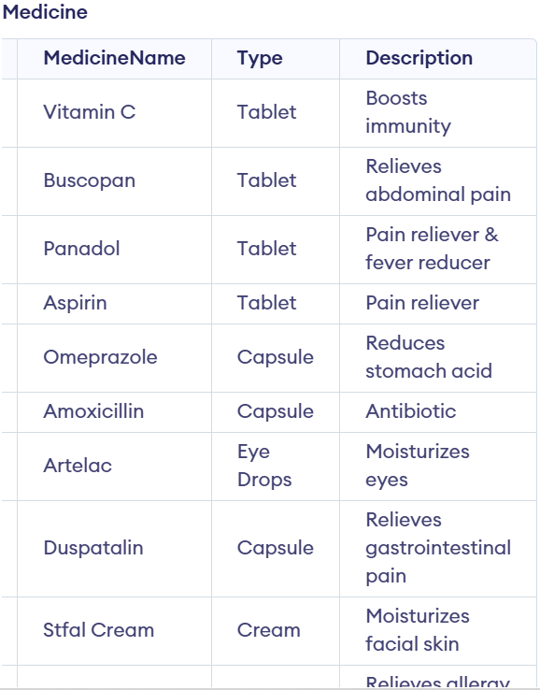
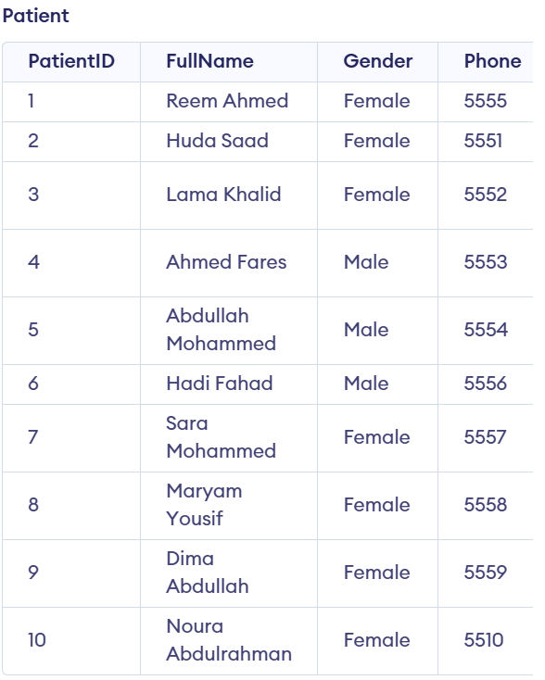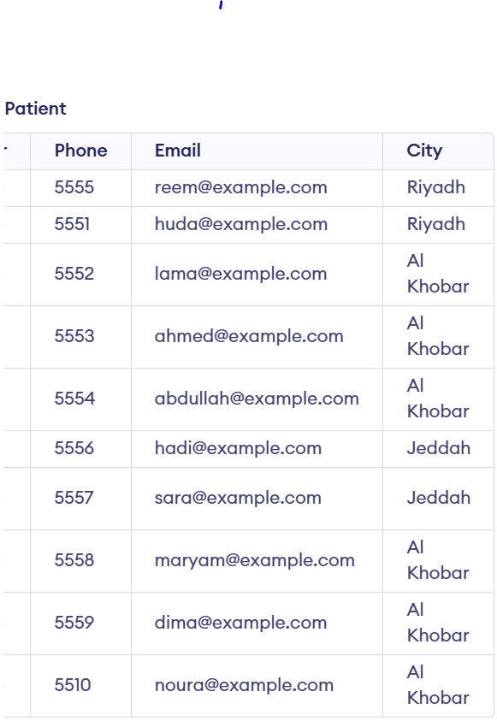
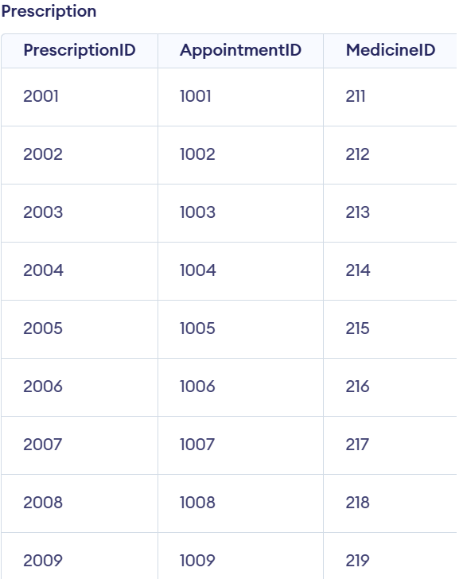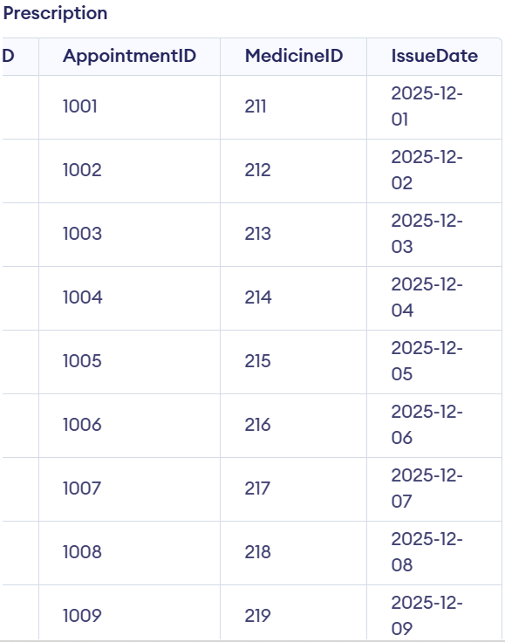

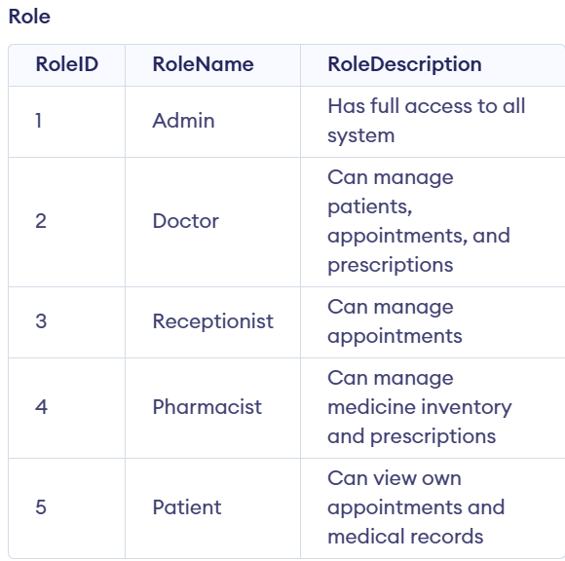
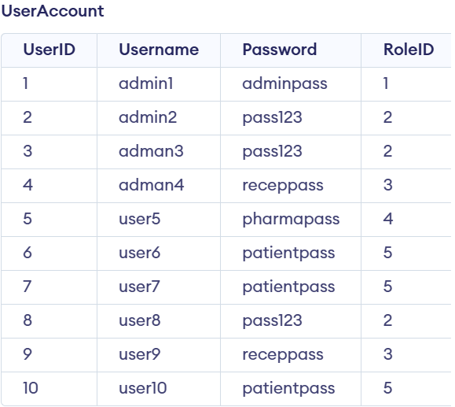

Output
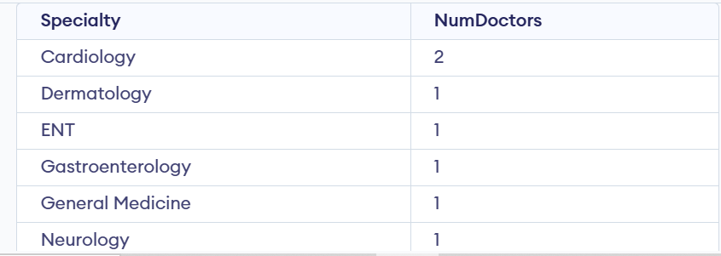
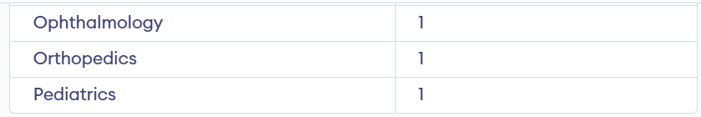
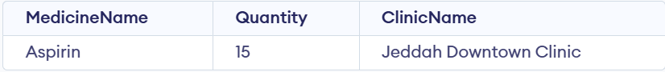
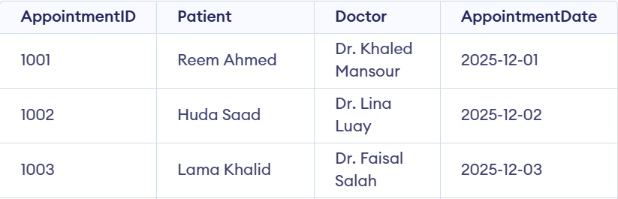
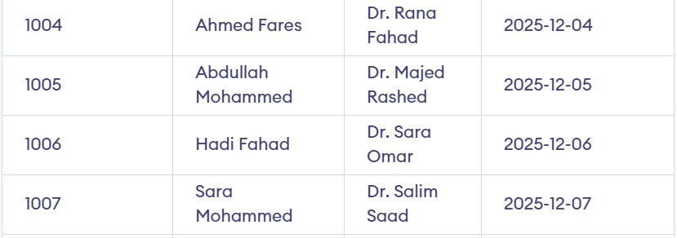
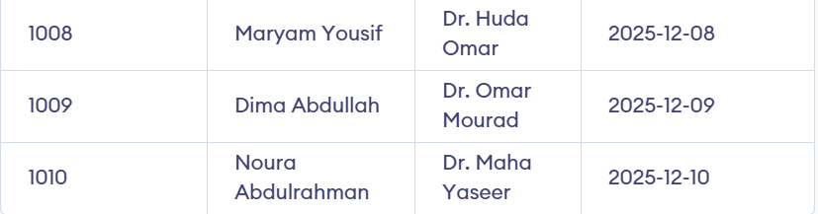
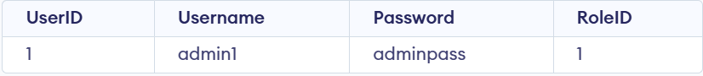

Notes:
I am Using SQLite Online, so SHA2 function is not supported.
It should be:
INSERT INTO UserAccount (UserID, Username, Password, RoleID)
VALUES (11, 'newuser', SHA2('mypassword', 256), 5);
But I wrote it in SQLite Online:
INSERT INTO UserAccount (UserID, Username, Password, RoleID)
VALUES (11, 'newuser', 'mypassword', 5);

