Notes on user feed back

General themes throughout all or most users:

* Very few people used the sliders for prices, most just tabbed through the form and typed a number
* There were issues with the birthdate date picker if it was used, in that is was slow to navigate and started from the current date.
* The scroll bars when used were slow, there also wasn’t much indication that the form did extend beyond the page.
* Ordered item changes (voids and replaces) need more significant indicators, such as colour changes to the text and the new item appearing in the list.
* All student users said the program was in general as very easy to use.

User 1

Issue when trying to see the details of an order on the order screen. Needs direction to select an order and then push button to enter the order details page.

Once a change has been made to an ordered item a colour change or other indicator would be useful.

User 2

Issue with a staff name. might have been too long.

Requested the lists be ordered better, or indeed at all.

User 3

User thought the pizza button for entering the pizza based menu was for add pizza. Became confused for a little while before seeing the add pizza button.

Requested allergy advice to be more visible, even when creating a pizza. Felt it didn’t belong in the description.

Used the date picker and had the issue mentioned above.

Different format for the date picker suggested by interviewer and positive feedback was given. (3 different number inputs that are glued together for the date)

Prompts needed after a refund was given and once again more clarity as to what changes have been made with those commands.

User 4

Slight issue on editing a pizza, didn’t at first realise he had to select from the list. (Changes made to lists by dan in the new interface might already address this.)

A currency indicator was missing (£ and P) and was added after request.

User requested that image previews would be better than a drop down.

User found that due to the system (top buttons rather than tabbed pane) we were using not being clear and our forms lacking titles it was difficult to tell where in the program you were and what State the program was in.

The user didn’t realise that there were more fields to fill out on the add staff page and didn’t see the scroll bar.

Fields with max length need to be clear to the user when inputting.

There was no validation or stated validation rules on the input forms.

Expert User John

No error message on log in when the fields were empty

Tab to enter/log in when on the log in page

When trying to add pizza he clicked the pizza sub-menu button expecting an add pizza form.   
It wasn’t clear to him where he was in the program.

Fullscreen has autosizing fields that were the length of the screen.

Lists weren’t clear enough. Headers needed aswell as better data structure and some form of sorting, searching and filtering.

He didn’t like the image drop down selection, and recommended we use the image menu layout for image selection on products.

He liked that you could navigate away from a form and not lose your progress on it, however he didn’t like that you could begin other processes or actions without completing the current task. Recommended we lock a user to a form until completion.

He constantly wanted double click and click and hold to have different actions and uses.

Error messages in places such as pizza forms weren’t satisfactory (they were more developer messages than user error messages)

More imagery, better formatting in general.

Coloured buttons, as well as different colours for different states.

Definition of the different menus, so that you know where you are and they all look different. (as it was all of our menus looked vastly the same, even lacking titles. He suggested colours, background colours or different layouts to make each very distinguishable.)

Expert User Liz

Liz wasn’t overly happy with our design choices. After all was said and done she recommended using a tab layout, and maybe using one of the these designs.

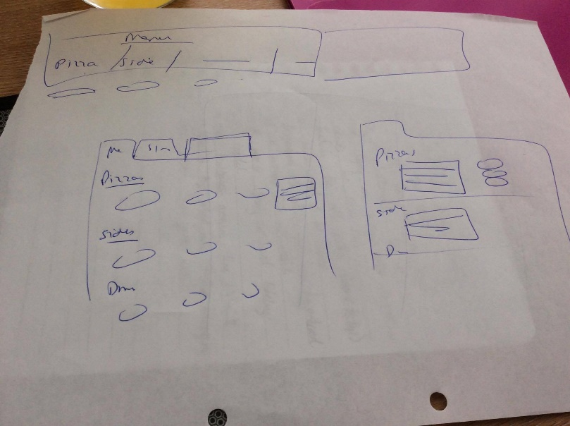

The log in text was too small, the window was also to small. Scale the entire thing up.

Labels needed to be right justified on log in.

When selecting the chef view the window moves from the center of screen and repositioned itself. The user didn’t like this.

Chef view was lacking all the timers that the user felt would be needed in the environment. Current time, time elapsed and time waiting to be delivered?

Chef view was missing a clear title in the program title bar.

Felt that a possible 4 digit password was insecure.

Was disappointed in the lack of colours. Complained about it all being gray. Requested that a colour scheme that aided user understanding was developed.

Had issue finding add pizza, requested we move our menus to all be below each other. This was before the total overhaul was suggested.

Titles like menu and admin aren’t clear and don’t give enough information.

Large issues with the lists. Mainly that the basic to string we were using didn’t give enough information or wasn’t clear. A table might work better. This issue was most prominent on the orderline list.

More “pizzazz” needed.

Requested we not use “line 1” and “line 2” even on manager forms.

Also requested that we make sure all text boxes are uniform (same size and shape) as well as grouping them into information groups. Like “personal information”, ”delivery information”, “billing information” being all separated or at least distinguishable on the form.

Questionnaire results (including expert user liz. Guess which her’s are) on a scale of 1-5

Placement of elements such as buttons or text boxes – 5, 2, 5, 5, 5. Avg 4.4

Size of elements such as forms, buttons or text boxes – 5, 5, 5, 2, 4. Avg 4.2

Text used to represent objects in lists – 5, 5, 5, 3, 3. Avg 4.2

Feedback when an action is performed – 4, 4, 5, 4, 5. Avg 4.6

Feedback when an erroneous action is performed – 5, 5, 3, N/a, N/a. Avg 4.3

Flow and structure of the program – 3, 5,5, 5, 5. Avg 4.6

The state of the application is clear – 5, 4, 4, 4. Avg 4.25

The quality and clarity of the HCI session – 4, 4, 4, 5, 5. Avg 4.4

Overall quality of the application – 5, 3, 4, 5, 4. Avg 4.2