A STRATEGIST'S READ OF THE DATA
Combined-Dataset Analysis, 2015-2024

Formula 1 Strategic Analysis: What Actually Impacts a Race Result, and How Much
Eight data-driven stories built by joining Race Results, Qualifying, Pit Stops, Lap Times, Sprint Results and Standings across ten F1 seasons

Companion analysis to the Primary Review submission
August 2026

Executive Summary
Put yourself in the strategist's chair on the pit wall. Every one of these eight stories was built by combining two or more of the eight data sheets — race results, qualifying, pit stops, lap-by-lap timing, sprint results, and both championship standings tables — because no single sheet answers a strategist's real question: not “what happened”, but “what caused it, and how much did it matter.”
The findings below range from strong and structural (which team you drive for still explains most of the variance in outcome) to subtle and tactical (stopping early costs four places immediately but wins back two and a half of them within ten laps). Some expected effects turned out to be weaker than folklore suggests — lap-time consistency correlates only weakly with points; pit-crew speed differences between teams are smaller than most fans assume. Where an effect is confounded rather than causal, that is stated plainly rather than dressed up as proof.
A one-line summary for each story, with its supporting evidence, follows in Sections 1-8. Section 9 pulls all eight into a single “what impacts what” reference table.

1. Where Qualifying Really Matters
Every strategist knows track position is valuable. The question a data-driven strategist asks is: valuable by how much, and where? Combining Race Results with Qualifying/Grid data across every circuit run between 2015 and 2024 gives a direct answer: the correlation between grid position and final position is 0.75 pooled across all circuits — strong, but not absolute, and it varies meaningfully by track.
Monaco sits alone at the top (r = 0.88): on a circuit where overtaking is nearly impossible, where you qualify is close to where you finish. At the other end, even the most overtaking-friendly circuit in the dataset (Hockenheim, r = 0.52, though it hosted only 50 classified finishes across four appearances before dropping off the calendar) still shows a positive, non-trivial relationship. The field median across 27 circuits with at least 40 classified finishes is 0.74 — meaning grid position is never a minor factor, only a bigger or smaller one.
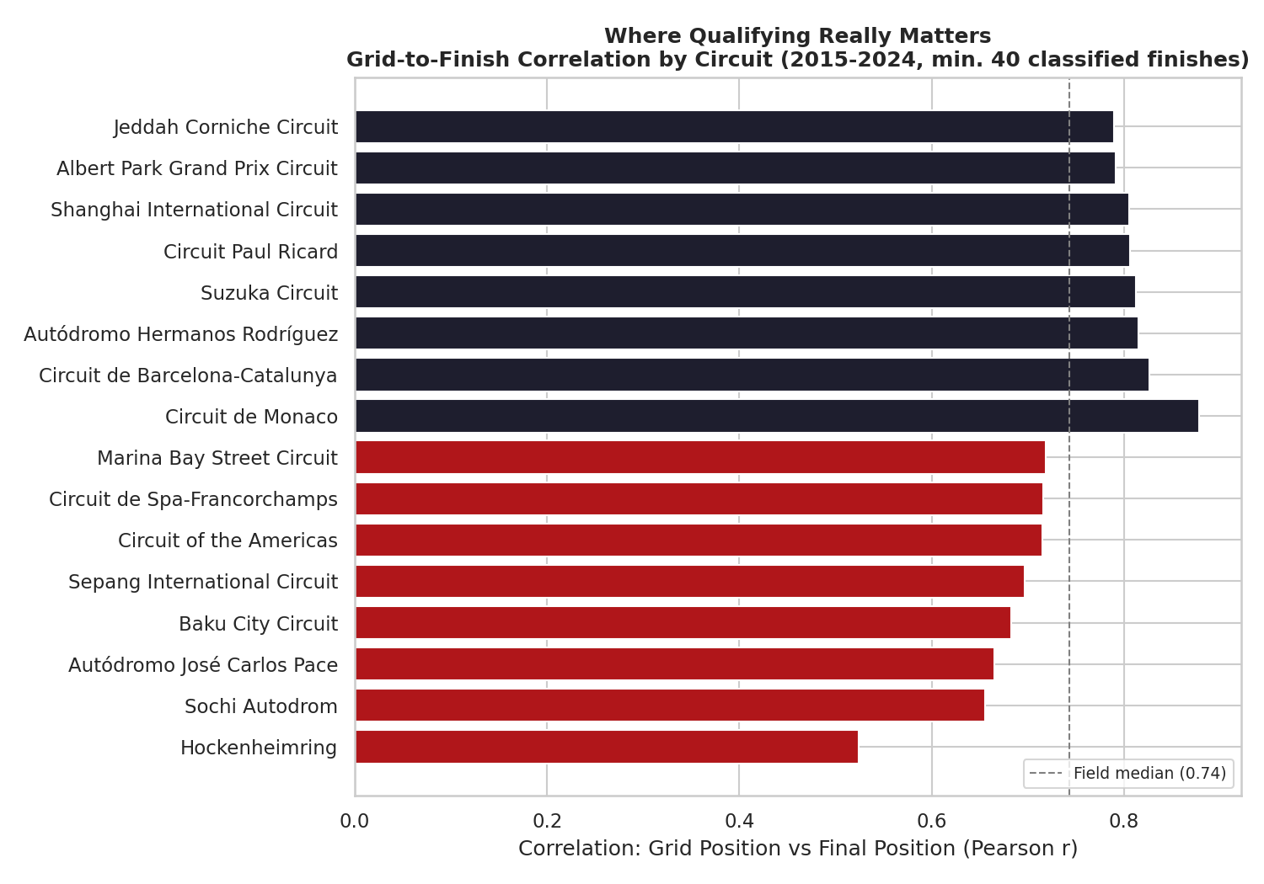
Correlation between grid position and final position, by circuit (min. 40 classified finishes, 2015-2024).
Strategist's takeaway: Qualifying resources are not equally valuable everywhere. At Monaco, Barcelona, Mexico City and Suzuka, a strategist should treat Saturday as close to a must-win session. At Hockenheim-, Sochi- and Interlagos-type circuits, a strong race strategy can still overturn a mediocre grid slot — track-position value should shape how aggressively a team risks a car in Q3.

2. How Many Stops Should You Plan For?
Joining Pit Stops with Race Results lets us count each driver's stops per race and compare outcomes. Two-stop strategies were the most common choice in the dataset (1,409 driver-races, 33%), narrowly ahead of one-stop (1,357, 32%) and three-or-more-stop races (790, 19%); true zero-stop races were vanishingly rare (22 cases, mostly wet or red-flag-shortened events).
On raw averages, one-stop races finish better: an average final position of 8.5 versus 9.3 for two stops and 10.0 for three-plus. That gap narrows but does not disappear once grid position is controlled for — restricting to drivers who started P6-P15 (a genuine midfield strategy battle, not a front-runner cruising to an easy one-stopper), one-stop finishes still average P9.2 versus P10.0 for two stops and P10.1 for three-plus.
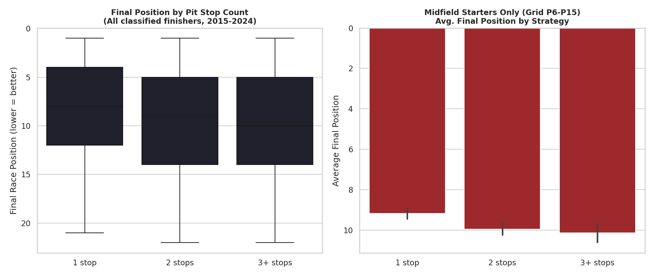
Left: final position distribution by stop count, all classified finishers. Right: average final position by stop count, midfield starters (grid P6-P15) only.
Strategist's takeaway: Treat this as a caution, not a green light: cars that only need one stop are disproportionately cars already running in clean air with light tyre stress, so “fewer stops → better finish” is partly a symptom of already being fast, not a free lever any car can pull. The honest strategic read is narrower but still useful: when tyre and traffic conditions genuinely allow it, a one-stop plan should be the default hypothesis to disprove, not the aggressive outlier.

3. Is Pit Crew Speed Actually a Differentiator?
Pit-stop duration in this dataset measures total time lost in the pits (entry to exit), not just the stationary wheel-gun time chased in televised world-record clips. Aggregated by constructor, the spread is real but modest: Mercedes leads at a median 23.15 seconds, with Red Bull (23.22s) and Ferrari (23.33s) close behind; the tail end (Sauber 24.33s, Manor Marussia 25.37s, both smaller or defunct outfits) sits roughly two seconds slower.
Two seconds across a whole season of stops matters, but it is a second-order lever compared to the undercut timing effect in Story 4 below, which moves multiple car-lengths of track position on a single stop. Looking at the field median over time, pit-lane duration has drifted down only slightly (24.2s in 2015 to 23.3s in 2024), with a visible anomaly in the COVID-shortened 2020 season (24.16s) where reduced practice time and unfamiliar back-to-back-race logistics briefly reversed the trend.
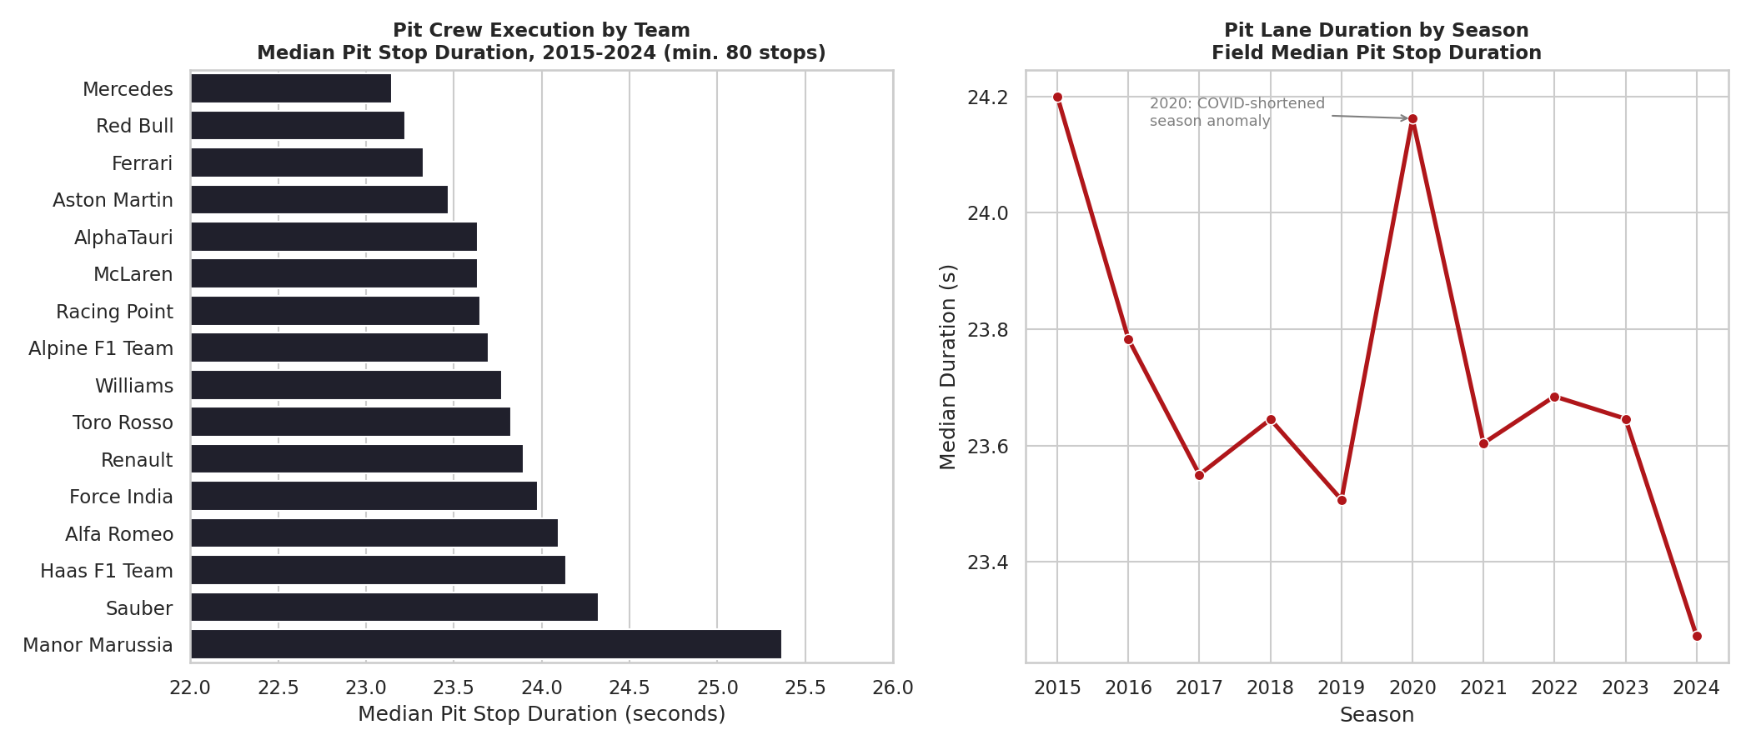
Left: median pit stop duration by constructor (min. 80 stops). Right: field-wide median duration by season.
Strategist's takeaway: Do not over-invest strategic attention in shaving another quarter-second off the crew's median performance relative to a rival — the team-to-team gap here is worth roughly 0.1-0.2 places on average, far smaller than a single well-timed undercut. Where pit-crew execution does matter enormously is in the tail: a single botched stop (which this median-based view deliberately smooths over) can cost far more than the average gap between any two teams.

4. The Undercut Effect: Real-Time Track Position Around a Pit Stop
This is the story that most rewards combining sheets: by joining each driver's first pit stop (Pit Stops) with their lap-by-lap track position (Lap Times), it's possible to measure the undercut directly rather than take it on faith. For 3,490 first pit stops with usable lap-position data on both sides, the analysis tracks each driver's position the lap before pitting, two laps after rejoining (“immediate”), and ten laps later (“recovered”) — then splits stops into early/mid/late thirds of that race's pit-stop window.
Early stoppers lose the most ground immediately — an average of 4.0 track positions, because most rivals haven't pitted yet and are still ahead on old tyres. But by ten laps later, once those rivals have cycled through their own stops, early stoppers have recovered to a net loss of only 1.7 positions — a recovery of 2.4 places. Late stoppers, by contrast, lose less immediately (3.3 positions, since fewer cars are still out ahead of them) but recover less afterward (down to a net 2.2, a recovery of only 1.1 places), because their rivals already banked the fresh-tyre advantage earlier.
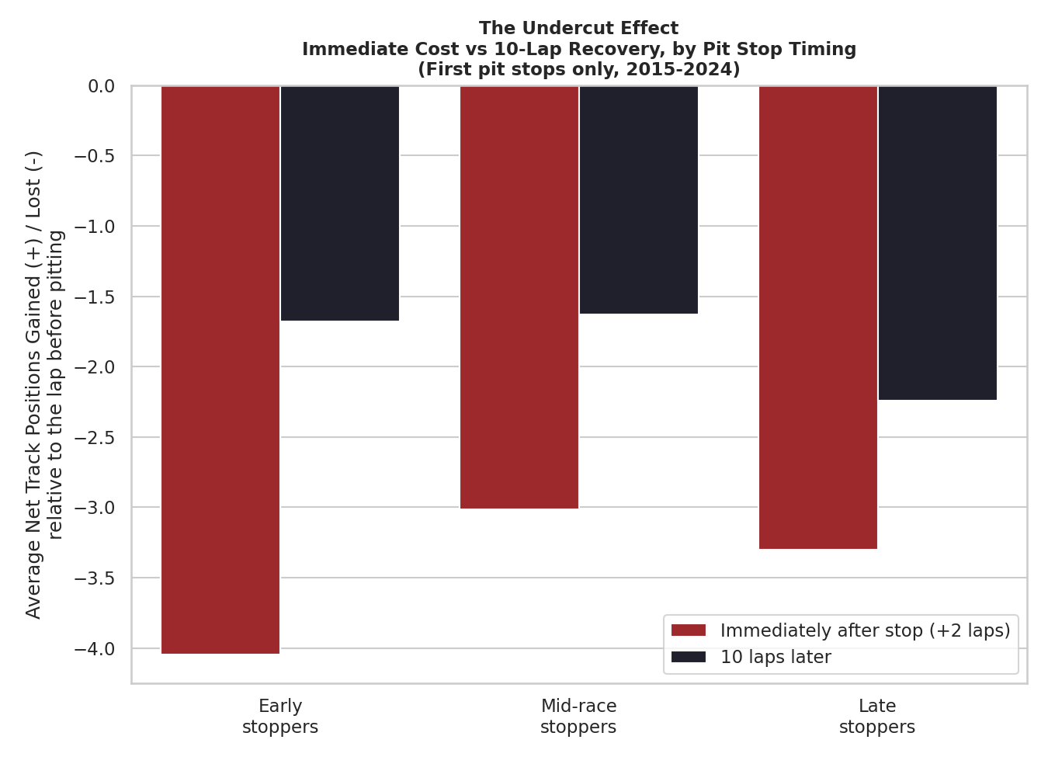
Average net track-position change from the lap before pitting, measured immediately after the stop and again ten laps later, by stop timing (first stops only).
Strategist's takeaway: This is the clearest actionable lever in the whole analysis. If two cars are close on pace and both need to stop, the data says the one who pits first should expect to be down the most places for a few laps — and that is not a strategy failure, it's the undercut working as intended. The strategic call is whether the team has the track position and pace margin to survive those few exposed laps; if it does, stopping first recovers roughly twice as much ground over the following ten laps as stopping last.

5. Consistency vs Peak Pace: Does Steadiness Win Championships?
Using the Lap Times sheet, each driver-race was reduced to a coefficient of variation (CV) of lap time — outlier laps (pit laps, safety-car laps, and other extreme values) removed via an IQR filter — then averaged to a driver-season figure and matched against that season's championship points from the Driver Standings sheet, across 201 driver-seasons with at least 10 races of usable data.
The relationship is real but modest: -0.18 correlation between lap-time variability and season points (less variability, i.e. more consistency, associates with more points), and +0.24 between variability and final championship position (more variability associates with a worse, higher-numbered position). Among the most consistent individual driver-seasons in the dataset are Max Verstappen's 2018 (CV 0.0115) and Kimi Räikkönen's 2017 (0.0121) — seasons that were strong but not championship-winning, underlining that consistency alone does not overpower a season-defining car deficit.
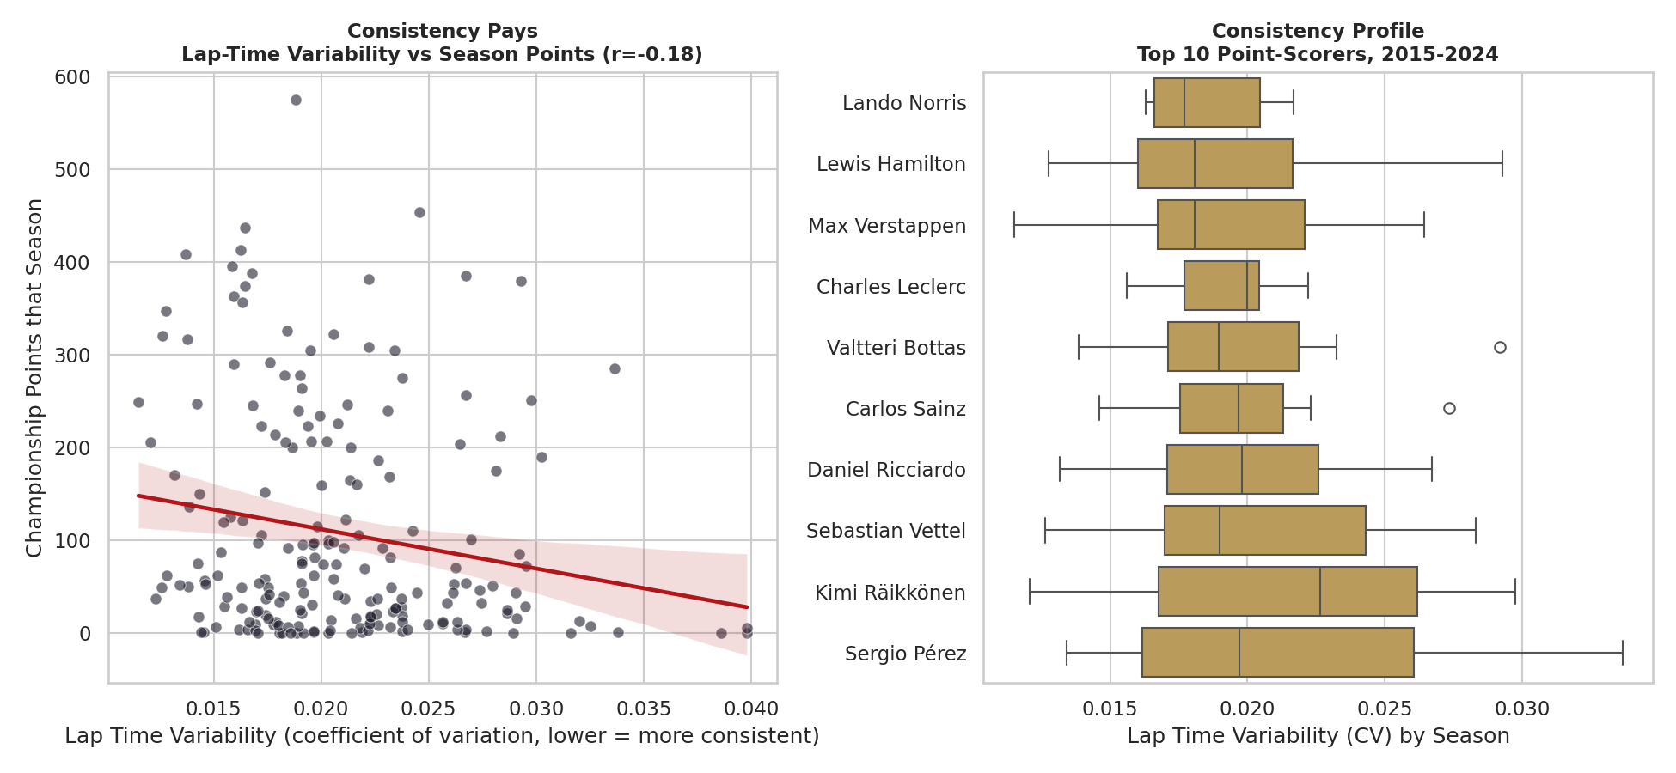
Left: lap-time variability vs season points, all driver-seasons with 10+ races. Right: consistency distribution (by season) for the ten highest point-scorers of the period.
Strategist's takeaway: Don't oversell consistency coaching as a title-winning lever on its own — the correlation is real but weak, meaning car and team pace still dominate the outcome. Its practical value is as a tie-breaker and a risk-reduction tool: among drivers in comparable equipment, the steadier one banks more points over a season, even if steadiness alone can't close a large car-performance gap.

6. The Power Shifts: How Much Does the Team You're At Matter?
Combining Constructor Standings across all ten seasons and computing each team's share of that season's total constructor points makes the era transitions visible and measurable, not just a narrative. Mercedes held 31-37% of all points on the table every season from 2015 to 2020, cratering to 16.6% by 2023 as Red Bull's share rose from 9.7% (2015) to a peak of 35.0% (2023) — a near-total swap in the sport's competitive order. McLaren's rise is the sharpest of all: from a marginal 1.4% share in 2015 to 25.0% in 2024, overtaking every rival that year including Red Bull (22.1%) and Ferrari (24.5%).
The scale of these swings dwarfs every other lever examined in this report. A 20-percentage-point points-share shift over three seasons represents a strategic and engineering transformation, not a single-race decision — which is precisely why it belongs in a strategist's long-range planning, not race-day calls.
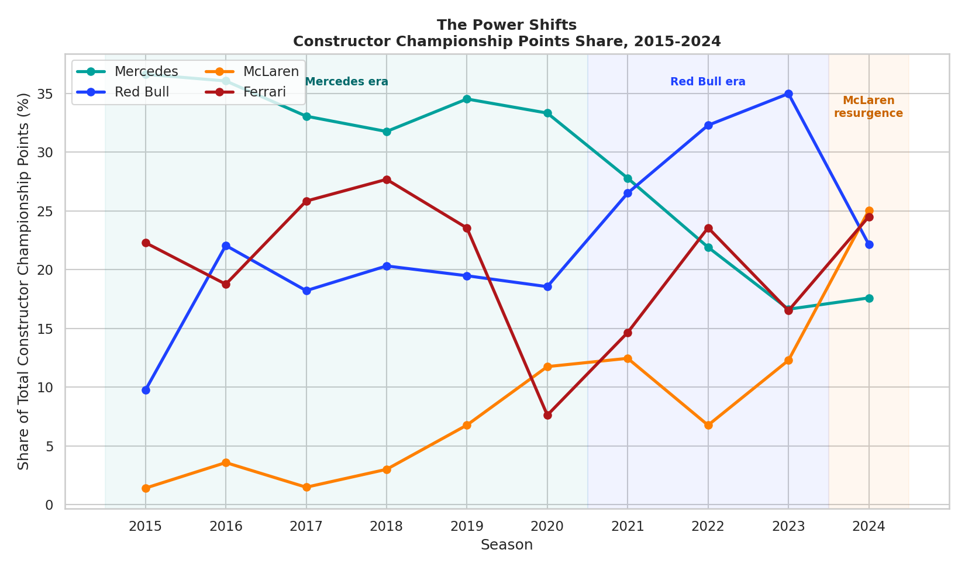
Constructor championship points share by season, Mercedes / Red Bull / McLaren / Ferrari, 2015-2024.
Strategist's takeaway: Every tactical lever in this report — undercut timing, stop counts, pit-crew execution — operates inside whatever performance window the car provides that season. A team executing every tactical story in this report perfectly still could not have out-scored 2023 Red Bull from a 2023 Mercedes chassis. Strategists should read Stories 1-5 as “how to maximise what the car allows”, and this story as the ceiling that sets what's actually achievable.

7. Reliability as a Strategic Asset
Genuine retirements (excluding cars merely a lap down but still classified) were tagged in Race Results and aggregated by constructor. Mercedes shows the lowest genuine DNF rate of the period at 7.4% of starts (min. 60 starts) — well clear of the field and a real contributor to their sustained points hauls in Story 6. Toro Rosso (25.5%) and Renault (24.5%) sit at the other extreme.
Weighting each constructor's retirements by their own average points-per-finish gives a rough estimate of championship points left on the table to unreliability. Red Bull's estimate is the largest in the dataset (≈869 points) — not because their reliability was worst (it was mid-pack at 15.3%), but because when a Red Bull does retire, it is disproportionately a high-points-potential result being thrown away. Ferrari (≈744) and Mercedes (≈481) follow. Field-wide, reliability has genuinely improved: the average genuine DNF rate fell from 21.4% in 2015 to 11.3% in 2024, though not on a smooth line — 2017 (23.8%) and 2022 (16.8%) both interrupted the downward trend, plausibly reflecting new technical-regulation cycles introducing fresh reliability risk.
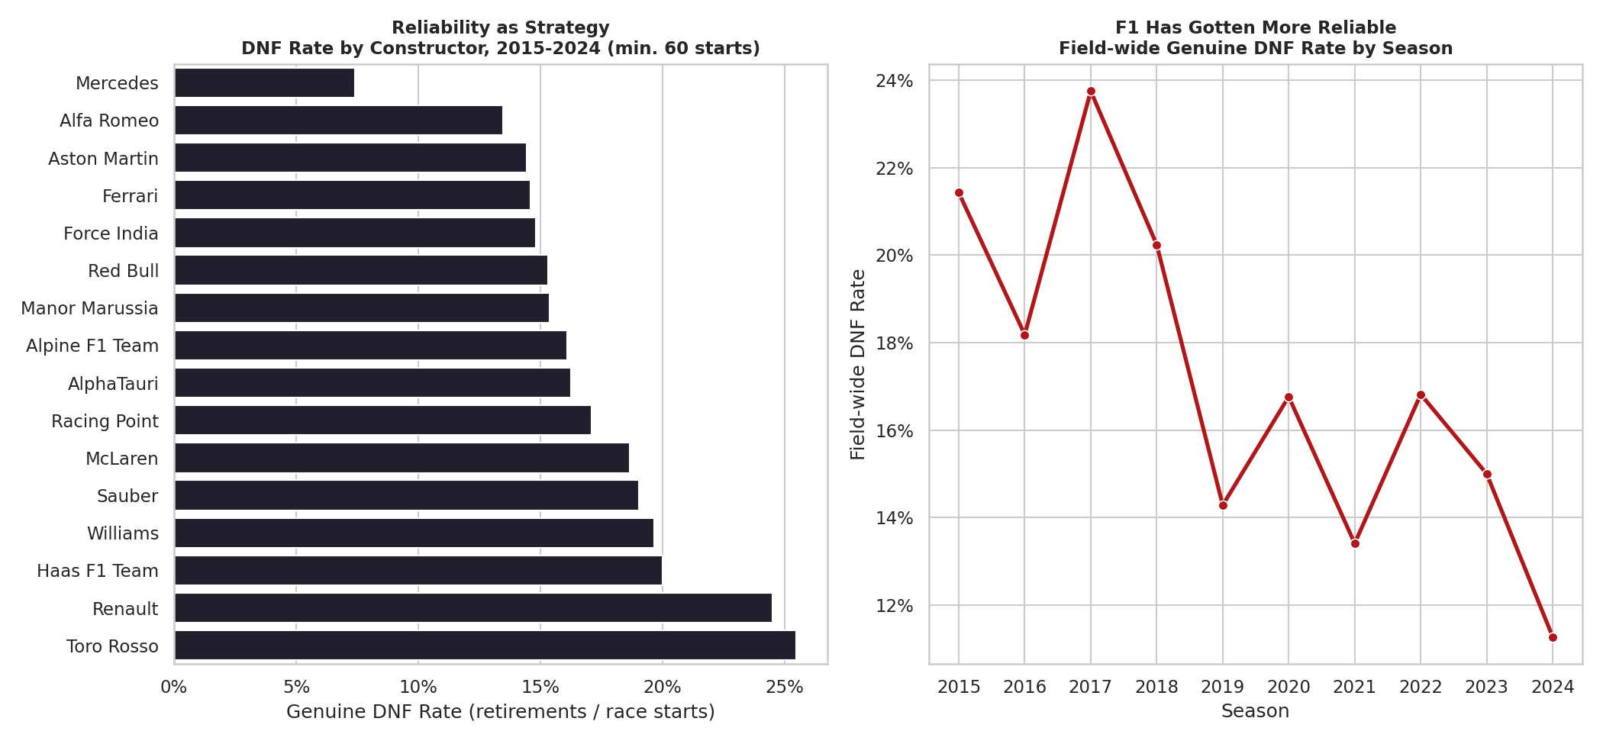
Left: genuine DNF rate by constructor (min. 60 starts). Right: field-wide genuine DNF rate by season.
Strategist's takeaway: For a front-running team, reliability is not a background engineering metric — it is a championship lever of comparable size to several tactical decisions combined, because every DNF for a fast car forfeits a large, near-guaranteed points haul. A strategist advising a top team should weight reliability investment by the team's own points-per-finish, not by a generic reliability target.

8. Does Saturday Predict Sunday? The Value of a Sprint Result
The Sprint Results sheet — covering 2021-2024, since the format did not exist before then — was matched against the same weekend's main Race Results for 296 driver-weekends. The correlation between Sprint finishing position and main-race finishing position is 0.71, close to the 0.73 correlation between that same weekend's race grid position and race result.
That closeness is itself the finding: a Sprint result predicts the main race almost as well as grid position does, which suggests both are picking up the same underlying signal — that weekend's true car-and-driver pace — rather than the Sprint being a noisy, low-information side event.
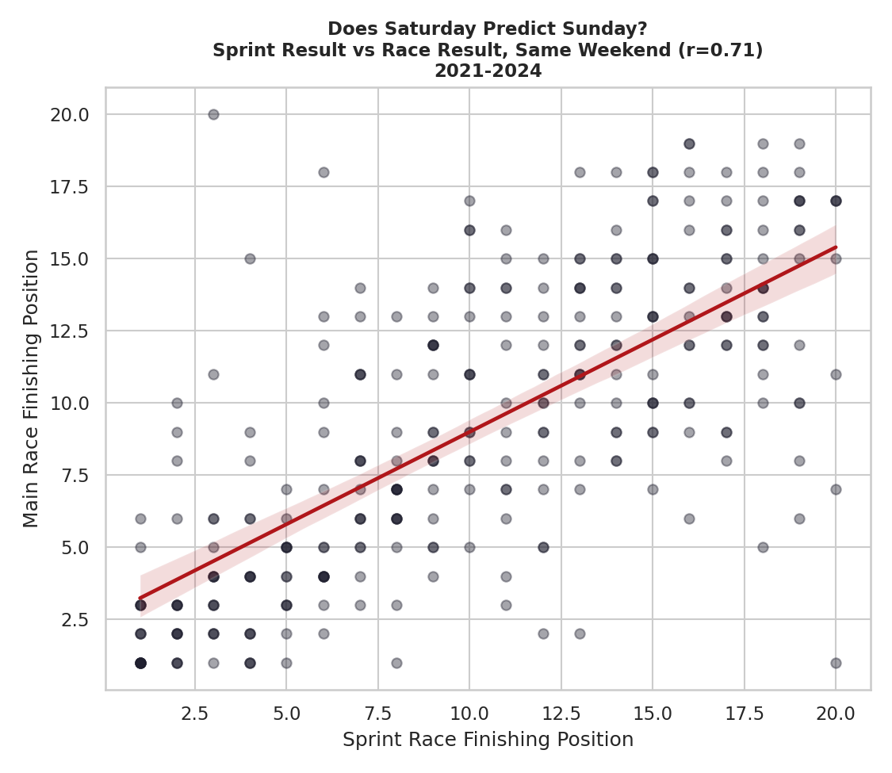
Sprint finishing position vs main race finishing position, same weekend, 2021-2024 (r = 0.71).
Strategist's takeaway: A poor Sprint result is a genuine early-warning signal for the main race, not noise to be dismissed — a strategist should treat a bad Saturday sprint as reason to review the race setup before Sunday, not assume it will self-correct.

9. Synthesis: What Impacts What, and How Much
Pulling all eight stories into one reference table, ranked roughly by how directly a strategist can act on each lever:
Factor | Impacts | Strength of Relationship (this dataset) | Strategic Implication
Grid/qualifying position | Final race position | Strong (pooled r = 0.75; up to 0.88 at Monaco, down to 0.52 at the most overtaking-friendly circuit) | Weight qualifying investment by circuit — highest payoff at street/technical tracks
Number of pit stops | Final race position | Moderate, confounded (1-stop averages ~0.8-1.0 places better even mid-field, but partly reflects cars already in clean air) | Default to the fewest stops tyre/traffic conditions genuinely allow — don't treat the raw gap as a free lever
Pit stop timing (early vs late) | Track position, 10-lap window | Strong and tactical (early stops: -4.0 immediate, -1.7 after 10 laps; late stops: -3.3 immediate, -2.2 after 10 laps) | The single clearest actionable lever in this analysis — stopping first recovers ~2x the ground of stopping last, if track position can survive the exposed laps
Pit crew execution speed | Time lost per stop | Small (team medians span 23.1-25.4s, a ~2s range) | Second-order relative to timing — matters most in the tail (a single bad stop), not the average
Lap-time consistency | Season championship points | Weak (r = -0.18 for variability vs points) | Real but secondary — a tie-breaker among comparable cars, not a substitute for pace
Constructor era / car performance | Championship points share | Very strong and structural (up to 20-point-share swings across 3 seasons) | Sets the ceiling every tactical lever above operates within — belongs in long-range, not race-day, planning
Reliability (genuine DNF rate) | Points retained over a season | Strong for front-running teams (Red Bull's estimated ~869 points lost to DNFs is larger than several teams' total output) | Weight reliability investment by the team's own points-per-finish, not a flat target
Sprint race result | Main race result (same weekend) | Strong (r = 0.71, comparable to grid position's own r = 0.73) | Treat a bad Sprint as an early warning for the main race, not noise
Read top to bottom, the table separates the levers a strategist actually pulls race-to-race (pit timing, stop count, Sprint-informed setup review) from the structural factors that set the boundaries those tactical calls operate within (car/constructor era, reliability programme, and season-long qualifying investment). The clearest single tactical insight — the undercut recovery pattern in Story 4 — only became visible by joining Pit Stops to Lap Times; none of the individual sheets would have shown it alone.

10. Methodology and Honest Caveats
All figures in this report were computed directly from the six core sheets plus Lap Times and Sprint Results in the accompanying workbook — no number here is estimated or sourced externally. That said, several limitations apply and should travel with any of these findings if reused elsewhere:
- Correlation, not causation. Every relationship in this report is observational. Story 2 (stop count) and Story 5 (consistency) are explicitly confounded with underlying car pace — faster cars both need fewer stops and lap more consistently, which inflates the apparent effect of both.
- Sample sizes vary considerably by story — from 3,490 pit-stop windows (Story 4) down to 201 driver-seasons (Story 5) and 296 matched Sprint weekends (Story 3, 2021-2024 only). Circuit-level splits in Story 1 were restricted to a minimum of 40 classified finishes to avoid single-season noise driving the result.
- The undercut analysis (Story 4) uses lap-position data, which reflects track position, not gapped race time — it captures whether a driver moved up or down the order, not by how many seconds.
- Pit-stop duration (Story 3) measures total pit-lane time, which is heavily influenced by each circuit's pit-lane length and speed limit; comparing durations across different circuits without controlling for this would be misleading, so the season and constructor comparisons pool across circuits rather than isolating one.
- DNF point-loss estimates (Story 7) are a rough proxy (retirements × that constructor's average points when classified) and do not account for the specific race situation each retirement occurred in.

References
Formula 1 World Championship dataset (1950-2024), Ergast-lineage CSV extract, as supplied for this analysis.
Jolpica F1 API — community-run successor to the Ergast Developer API. https://github.com/jolpica/jolpica-f1

