FINAL REVIEW · DESCRIPTIVE REPORT
Formula 1 Performance Analytics
Drivers, Constructors, Race Strategy and Performance Trends, 2015–2024
A race, read as a chain of cause and effect
Student: Arwindh C N
Roll No.: CB.SC.U4CSE24207
Course: 23CSE353 Data Visualisation
Submission: Final Review, October 2026

Companion files: F1_Story_Notebook.ipynb (analysis, every number), F1_Dashboard.html (interactive dashboard), F1_Final_Presentation.pptx (slides), verification_log.md, Viva_Cheatsheet.md.

Contents
1. Introduction and objectives
2. Dataset
3. Data preparation
4. Analytical approach
5. Visualization techniques
6. Insights: the story in five acts
7. Tool selection and usage
8. Dashboard design
9. The misleading visualization
10. Ethical reflection
11. Limitations
12. Conclusion
Appendix A. Consistency with the Primary Review
Appendix B. Verification of earlier findings

How to read the numbers. Every number in this report was produced by a cell in F1_Story_Notebook.ipynb. The cell is named in brackets, for example (Cell A2.1). The notebook saves all of these numbers to facts.json, and this report is generated from that file, so the two cannot disagree.

1. Introduction and objectives
Most people watch a Formula 1 race as a result: who won. A strategist on the pit wall watches something else: a chain of events. Saturday's qualifying sets the order. Every pit stop trades places now for places later. An unplanned extra stop is an alarm bell. And the car sets a ceiling on all of it. This project uses ten seasons of data to make that chain visible, so that a reader who has never watched F1 can follow it, and a reader who has watched for years sees a race differently.

1.1 Problem statement
F1 race outcomes depend on many interacting factors: driver skill, constructor competitiveness, qualifying position, pit-stop execution, circuit characteristics and reliability. A single results table does not show how these factors relate to each other. This case study uses ten seasons of historical data (2015–2024) to find and visualize those relationships, and arranges the findings as one story rather than a collection of charts.

1.2 Objectives (unchanged from the Primary Review)
Objective (Primary Review) | Where it is answered
Analyse driver performance across seasons using points, wins and podiums | Act 4: Figures 11 and 12 (Cells A4.3, A4.4)
Compare constructor performance across seasons using points and wins | Act 4: Figure 9 (Cell A4.1); Act 5 (Cell A5.1)
Analyse the relationship between qualifying position and final race position | Act 1: Figures 2 and 3 (Cells A1.1, A1.2)
Analyse pit-stop strategy (stop count, duration) and its relationship with race outcome | Act 2: Figure 4 (Cell A2.2); Act 3: Figures 5–8 (Cells A3.2–A3.5)
Compare driver performance across different circuits | Act 4: Figure 13 (Cell A4.5)
Analyse DNF/retirement patterns over time | Act 4: Figure 10 (Cell A4.2)

2. Dataset
The data is the Ergast-lineage Formula 1 dataset, the same data family now served by the Jolpica F1 API (the community successor to the Ergast Developer API). It comes as 14 linked CSV tables covering 1950–2024. We keep the ten seasons 2015–2024: 209 races, 53 drivers and 18 constructors (Cell P.12). There is no 2025 data in the source.
Table | Rows (2015–2024) | What one row is | Used for
results | 4,219 | One driver in one race: grid, finish, points, status | Every act
qualifying | 4,205 | One driver's qualifying session: position, Q1/Q2/Q3 times | Act 3 (teammate link)
pit_stops | 7,544 | One pit stop: lap, total pit-lane time | Acts 2 and 3, hook
lap_times | 227,123 | One driver on one lap: position and lap time | Hook, Act 2, Act 4
races, circuits | 209 / 32 | Race calendar and circuit details | Every act
drivers, constructors, status | lookup | Names and finishing-status labels | Every act
driver_standings, constructor_standings | 223 / 101 (final) | Championship table after every race | Act 4
sprint_results, constructor_results, seasons | 360 / – / – | Sprint races (2021–2024 only) and season list | Row-count checks

The tables link through ID numbers (raceId, driverId, constructorId, statusId). The Primary Review used a cleaned 8-sheet Excel workbook built from these files. For the final stage we rebuilt everything from the raw CSVs, because the workbook's constructor sheet stores team names but not constructor IDs, and joining on names is unsafe (Toro Rosso became AlphaTauri and then RB, each with a different ID). The rebuilt tables match every row count in the approved workbook (Cell P.10).

2.1 Important attributes
- Grid position: the starting slot (1 = pole). A value of 0 in the source means a pit-lane start.
- Finishing position: blank if the driver was not classified.
- Status: "Finished", "+N Lap(s)" (finished but lapped) or a retirement reason such as "Engine" or "Collision".
- Pit-stop duration: total time in the pit lane in seconds, entry to exit. It is not the stationary tyre change shown on TV.
- Lap position: where each car ran at the end of each lap, the basis of the hook chart and the undercut analysis.
- Standings points: cumulative after each race, so the season's final table is the last round.

3. Data preparation
All cleaning is in f1_prep.py and repeated cell by cell in the notebook (Cells P.0–P.11). Each step is numbered:
Step | What we did | Why
P1 | Read the 14 CSVs, treating the two characters \N as missing | The source writes missing values as \N
P2 | Kept seasons 2015–2024 (209 races); joined circuits; built readable race and circuit labels | Scope of the study
P3 | Joined results to status, drivers, constructors on IDs; grid 0 → missing; two flags: classified and genuine DNF | A lapped car is not a DNF; a pit-lane start has no grid slot
P4 | Converted Q1/Q2/Q3 text times ("1:26.572") to seconds | Times are stored as text
P5 | Pit-stop duration from the exact milliseconds column | The text column switches to m:ss for long stops
P6–P7 | Kept lap positions and sprint results for the period | Inputs for Acts 2–4
P8 | Final standings = the table after the last round of each season | Standings are cumulative
P9 | One merged driver-race table: results + qualifying + stop count, first-stop lap | Lets us chain qualifying, pit stops and results (Act 3)
P10 | Asserted every row count equals the Primary Review workbook | Proves the rebuild matches the approved data
P11 | Saved clean tables to data/clean/ | Reuse by the dashboard and checks

Data quality. Of 4,219 race entries, 641 were not classified and 715 were genuine DNFs. These two numbers differ because 74 cars retired late but had covered 90% of the race, so they still received a finishing position. We therefore keep two separate flags: classified (used for grid-versus-finish) and genuine DNF (used for reliability). There were 79 pit-lane starts. 484 pit stops lasted 60 seconds or more (red flags and repairs); the median pit-lane time of normal stops is 23.7 s. The 2021 Belgian GP has no pit-stop data, so its stop counts are left unknown rather than set to zero (Cell P.12).

4. Analytical approach

4.1 One story, one reader
The analysis is written for one reader, the strategist on the pit wall, and arranged as five acts. Each act asks one question, answers it with one main chart, and ends with "the call you would make". Act 3 is built as a plot twist: it shows what everyone assumes first, tests the assumption, and only then shows the real finding.
Part | Headline | Question
Hook | One race, lap by lap | What does a race look like as a chain of events?
Act 1 | Saturday decides more than you think | How much does the starting position fix the result, and where?
Act 2 | The stop that costs four places and wins back two | What does a pit stop cost, and does timing matter?
Act 3 | The hidden alarm | Is an extra pit stop a gamble, or a sign that something went wrong?
Act 4 | The car sets the ceiling | How much is decided by which team you drive for?
Act 5 | What the data cannot tell you | How can a chart lie, and where are the limits?

4.2 Methods, in plain words
- Choosing the hook race. For every race we added up how many places every car gained or lost from one lap to the next. The 2016 Chinese GP scored highest of all 209 races (844; the typical race has 275), so it was chosen by a rule, not by taste (Cell H.1).
- Correlation (r). A number from −1 to 1 that measures how closely two things move together in a straight line. 0 means no link, 1 a perfect link. We give each circuit's r a 95% confidence range (Fisher method), so a circuit with few races shows a wide range.
- The undercut measure. For each driver's first pit stop at lap L, we read their position on lap L−1, L+2 and L+10 from the lap table. Stops are split into early, middle and late thirds of that race's first stops.
- The derived teammate link. The source has no "teammate" column. We derived it: two drivers in the same constructor in the same race, both with a qualifying position. The one who qualified behind is the "slower qualifier". StopDiff = stops by the slower qualifier − stops by the faster one. This chains three tables: Qualifying, Pit Stops and Race Results.
- Two-proportion z-test. Checks whether two percentages differ by more than chance. |z| above 2 is already unusual; our main result has z = -7.3.
- Lap-time consistency. The coefficient of variation (spread of lap times ÷ average lap time) per driver per race, after removing pit, safety-car and crash laps with an interquartile-range filter.

4.3 Checking the earlier findings first
Before building any chart, every finding from the earlier Strategic Analysis was recomputed from the raw data and logged in verification_log.md (Appendix B). The rule was: if a number does not reproduce, report the real number and change the story. 25 of 25 checks reproduce, but three needed a decision to be made explicit: "both finished" means both cars classified; the qualifying-gap buckets are 1–3, 4–7 and 8+ places; and the consistency result reproduces only if driver-races with fewer than 10 laps are dropped. Section 6 shows how fragile that last one is.

5. Visualization techniques
The notebook draws 15 charts (15 static Matplotlib and Seaborn charts and 0 interactive Plotly charts) in more than ten different chart types, plus the interactive dashboard. Each chart carries one idea, and its title states the conclusion, not just the topic.
Fig. | Chart | Type | Tool | Why this form
1 | The hook race, lap by lap | Bump chart with event markers | Matplotlib | Shows order and every swap; dots mark pit stops
2 | Grid vs finish, pooled | 2D histogram + mean line | Seaborn | 3,518 points would overplot as a scatter
3 | Grid-finish r by circuit | Lollipop / dot plot with CIs | Seaborn | Ranks 27 circuits; ranges show reliability
4 | Undercut | Slope chart with error bars | Matplotlib | Before → after change is the whole message
5 | Stops vs finish | Strip plot + point estimate | Seaborn | Shows the naive view with its full spread
6 | Qualifying gap vs StopDiff | Point plot with CIs + expected line | Seaborn | Assumption vs reality on one axis
7 | Teammate duel | Dodged point plot with CIs | Seaborn | Compares two groups across gap buckets
8 | Distress signal | Step histograms + bar chart | Seaborn | Distribution and the 3-group contrast
9 | Points share eras | Small-multiple area charts | Plotly | Four teams on one scale; hover for values
10 | Genuine DNF rate | Line with reference line | Matplotlib | Trend against the best team's level
11 | Wins by driver | Stacked bar + outline bar | Matplotlib | Wins split by champion car, with podiums
12 | Season points by driver | Interactive line chart | Plotly | Ten seasons, many drivers; hover for names
13 | Driver × circuit | Annotated heatmap | Seaborn | Compares rows (drivers) with columns (circuits)
14 | Consistency vs points | Scatter + regression band | Seaborn | Shows a weak link honestly
15 | Dashboard | Linked interactive charts | Plotly | Explore any season, team, driver, circuit
16 | Misleading vs honest | Paired bar charts | Matplotlib | Exact control of the axis being manipulated

Design rules used everywhere. One colour meaning across the whole project: black, white and greys for context, and one red accent for the thing to look at. Annotations sit on the chart, so the reader does not decode a legend. Every bar chart starts at zero. Charts that do not start at zero (dot and line charts) encode position, not length. Confidence ranges are drawn where a number is an estimate, and small samples are labelled as such. Every chart has a footer naming the notebook cell that drew it.

6. Insights: the story in five acts

6.1 Hook: 844 position changes in one race, and the pole-sitter still won
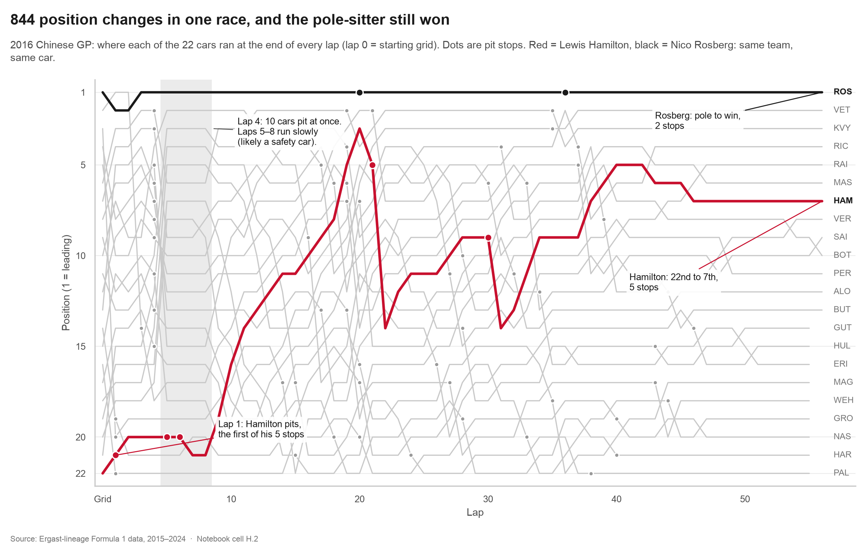
Figure 1. 2016 Chinese GP: every car's position at the end of every lap, pit stops as dots (Cell H.2).
Under the result (Rosberg first) sits a chain of events. Hamilton started 22nd, stopped on lap 1, and made 5 stops in total to climb to 7th. On lap 4, 10 cars pitted at once, just before laps 5–8 ran slowly (most likely a safety car; the data has no safety-car field, so this is inferred from lap times). The lines cross most where pit stops cluster: a pit stop moves a car through the order. Every car finished, so every one of the 22 lines is complete.
The call you would make: do not read a race from the result. Read it from the moves.

6.2 Act 1: Saturday decides more than you think
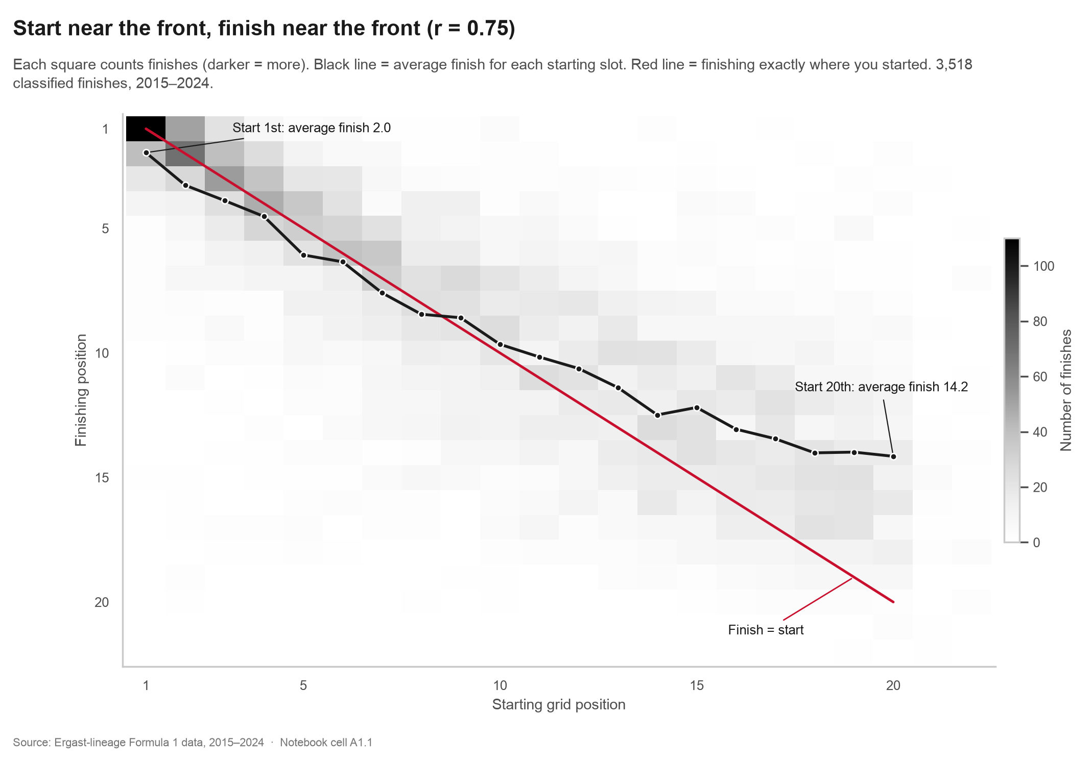
Figure 2. Grid vs finish for 3,518 classified finishes; black = average finish per grid slot (Cell A1.1).
Across all races, where a driver starts and where they finish are strongly linked: r = 0.75 (Cell A1.1). Pole position won 53% of races, and 88% of winners started in the top three. But the average line is flatter than the diagonal: a car starting 1st finishes 2.0 on average, a car starting 20th finishes 14.2. Part of that is real overtaking, and part is that retirements ahead lift everyone behind.
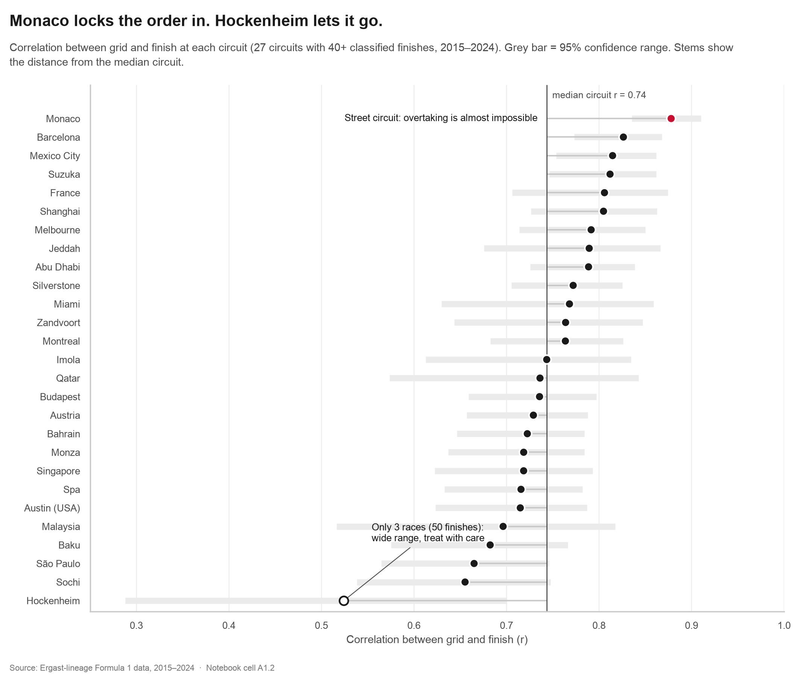
Figure 3. Grid-finish correlation at 27 circuits with 40+ classified finishes, with 95% ranges (Cell A1.2).
The link is not the same everywhere. At Monaco (r = 0.88) the narrow street circuit makes overtaking almost impossible; Barcelona (0.83) and Mexico City (0.81) follow. At the other end sit São Paulo (0.67), Sochi (0.66) and Hockenheim (0.52). The median circuit is 0.74. Hockenheim hosted only 3 races in this period (50 finishes), so its range runs from 0.29 to 0.70: its exact rank is not reliable.
The call you would make: at Monaco, Barcelona and Mexico City, treat qualifying as the race. At Sochi or São Paulo, a poor grid slot can still be fixed on Sunday.

6.3 Act 2: The stop that costs four places and wins back two
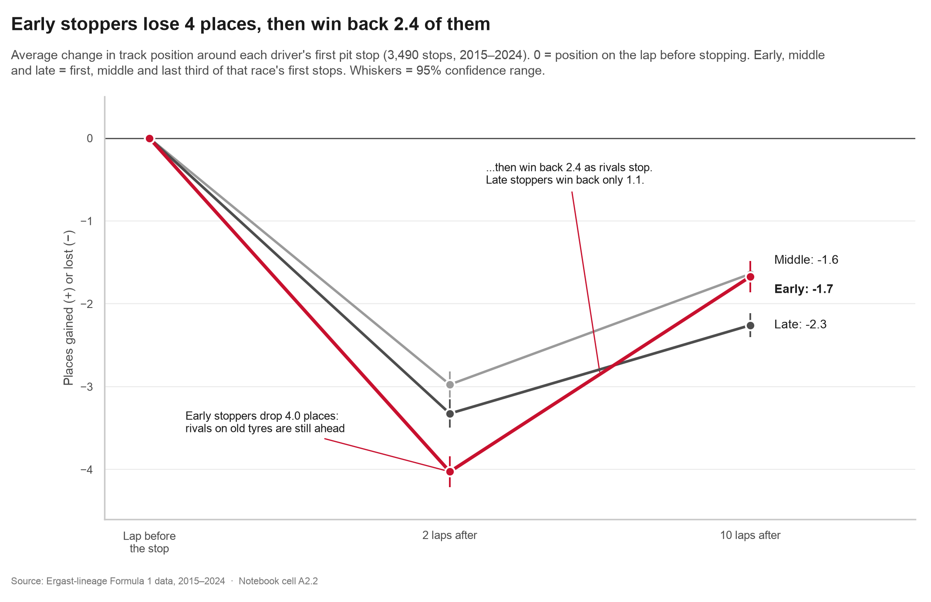
Figure 4. Average change in track position around 3,490 first pit stops, by timing within the race (Cells A2.1–A2.2).
Every first stop costs places at once: early stoppers drop 4.0, middle 3.0 and late 3.3 places two laps later. The difference is what happens next. As their rivals make their own stops, early stoppers win back 2.4 places and end at -1.7; late stoppers win back only 1.1 and end worst, at -2.3 (Cell A2.1). This is the undercut in numbers: the early stop looks bad on the TV screen for a few laps, and that is the strategy working. Removing first stops in the first five laps, which are often forced by damage, leaves the pattern unchanged: early -4.0 then -1.7, late -3.3 then -2.2 (Cell A2.3).
The call you would make: if your car can survive two or three exposed laps in traffic, stop first.

6.4 Act 3: The hidden alarm
This act chains Qualifying, Pit Stops and Race Results through the derived teammate link (2,085 team-race pairs, Cell A3.1). Teammates drive the same car, so comparing them removes the car from the picture.

What everyone sees
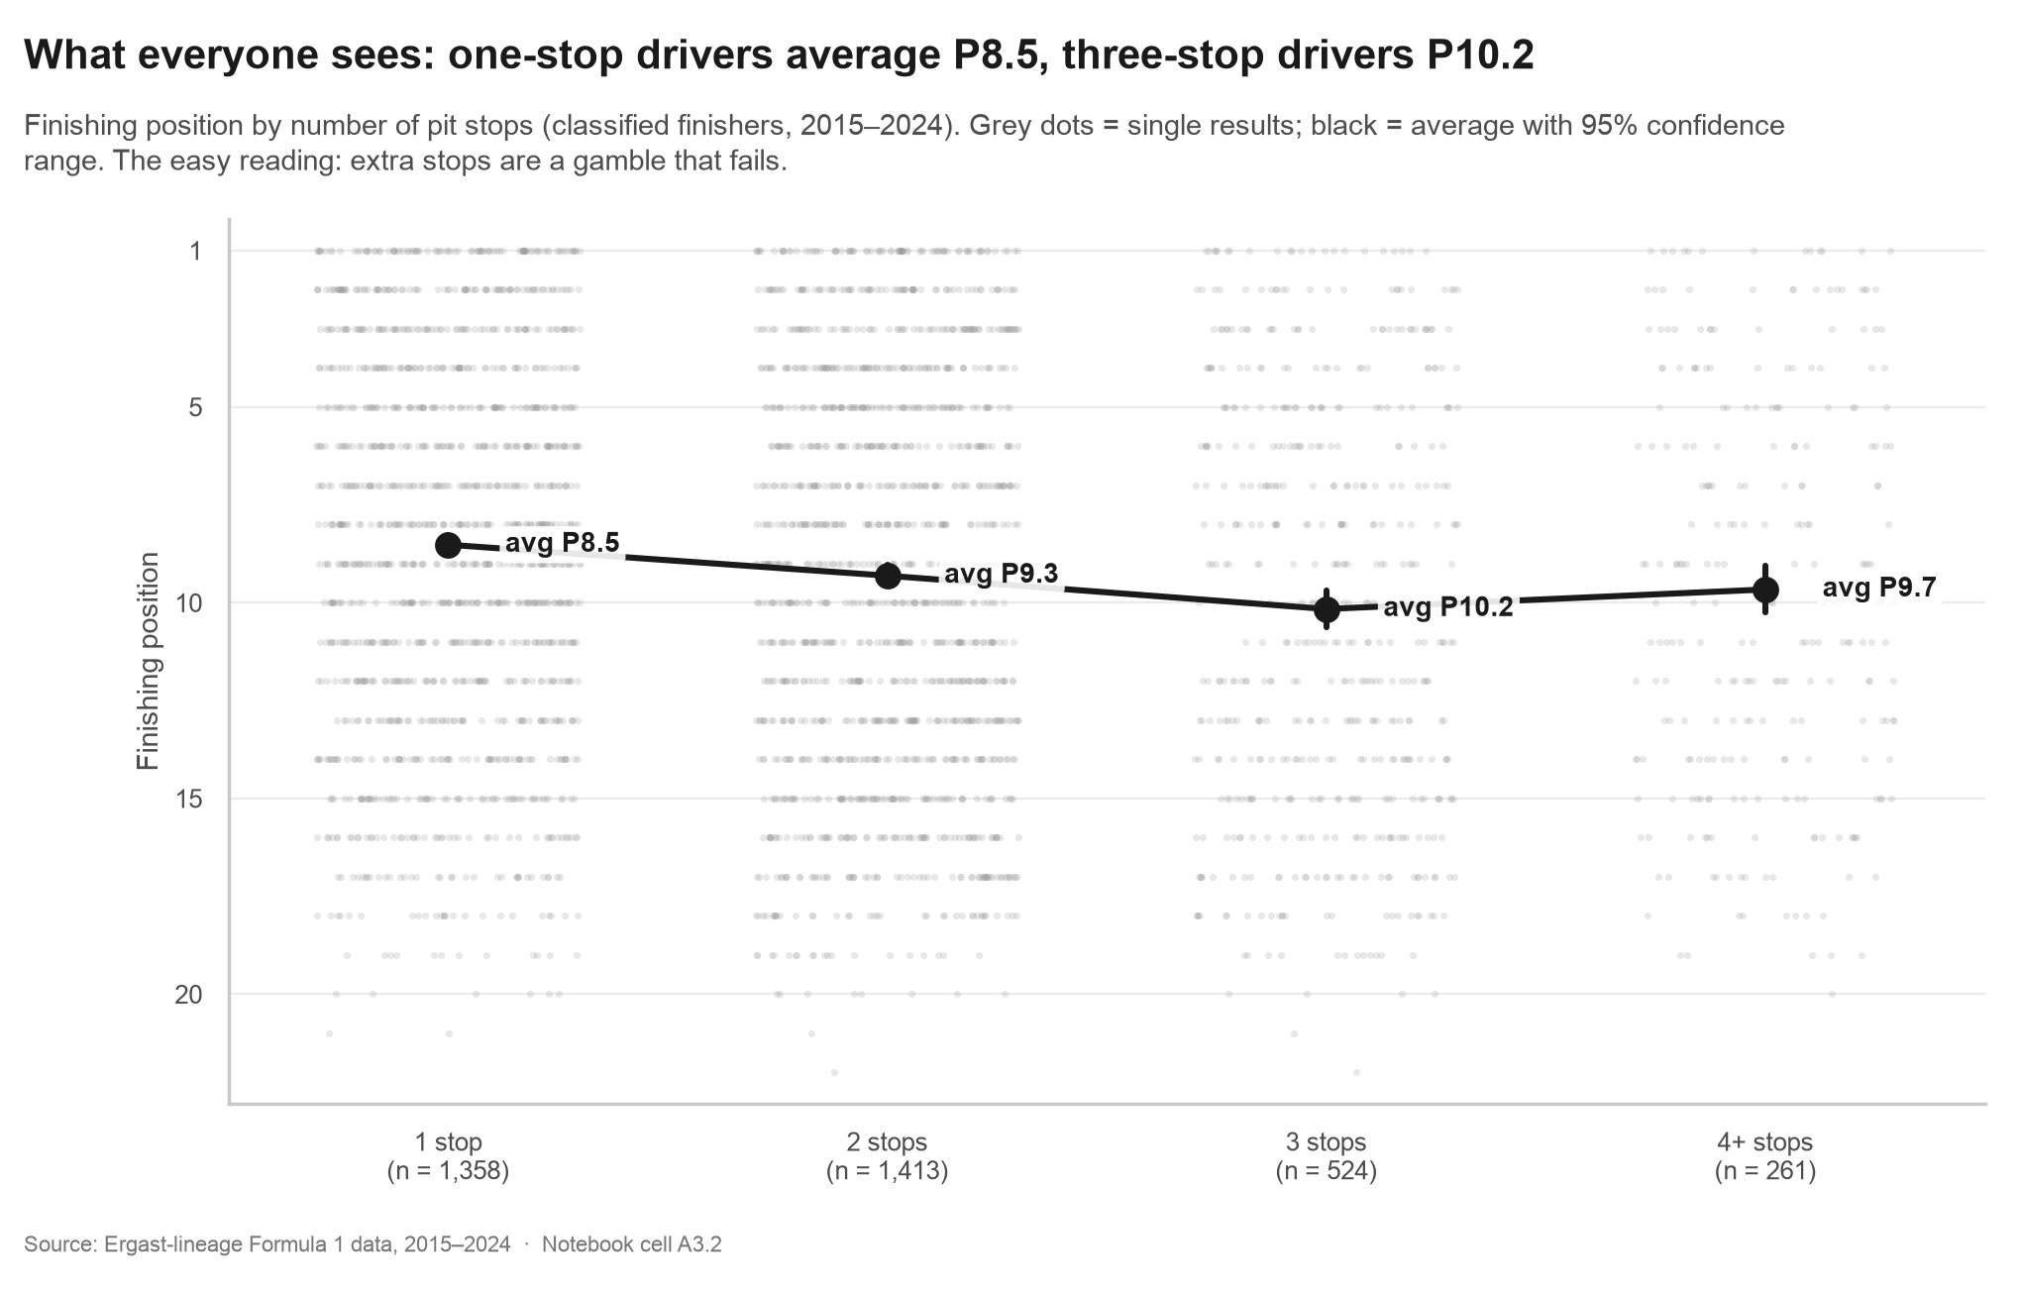
Figure 5. Finishing position by number of pit stops (Cell A3.2).
One-stop drivers average P8.5, two-stop P9.3, three-stop P10.2. (Four or more stops is slightly better, P9.7, probably because those are rain or red-flag races where everyone stops a lot.) The usual reading is: a driver who is far behind gambles on an extra stop, and the gamble fails. If that were true, the driver who qualified further behind the teammate should stop more often.

The assumption, tested
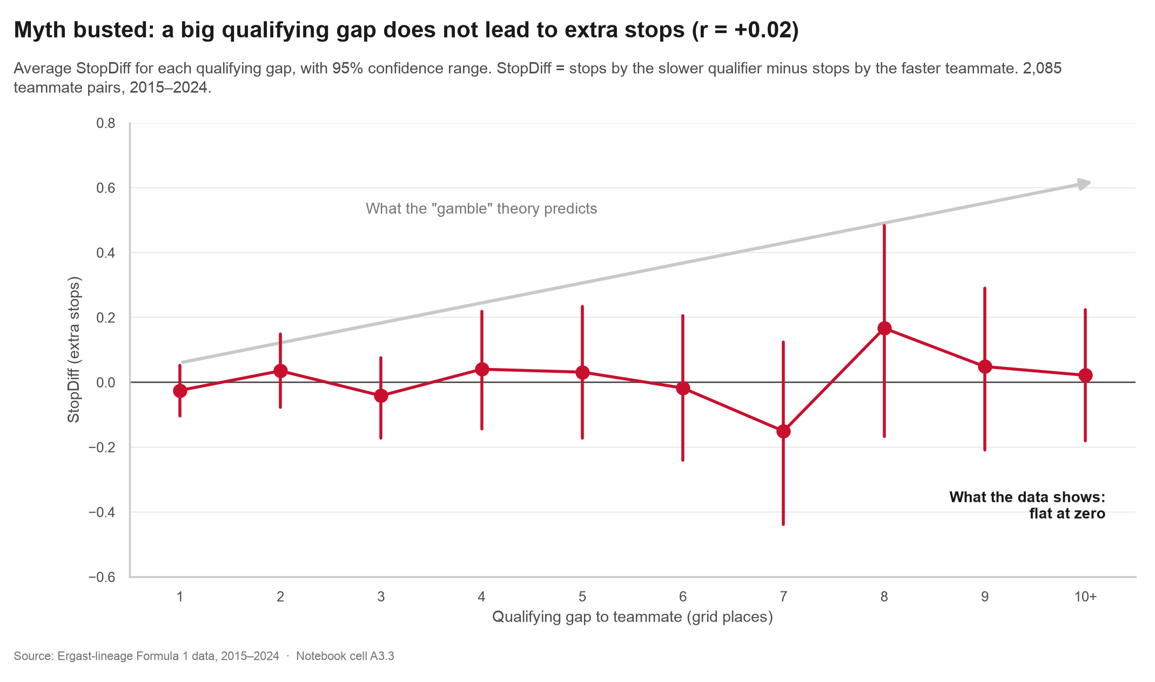
Figure 6. Average StopDiff by qualifying gap to the teammate, with 95% ranges (Cell A3.3).
The assumption is dead. The correlation between qualifying gap and StopDiff is r = +0.02 (p = 0.34): no link at all. A driver ten places behind the teammate on Saturday is no more likely to make an extra stop than one who was a single place behind.

The real finding
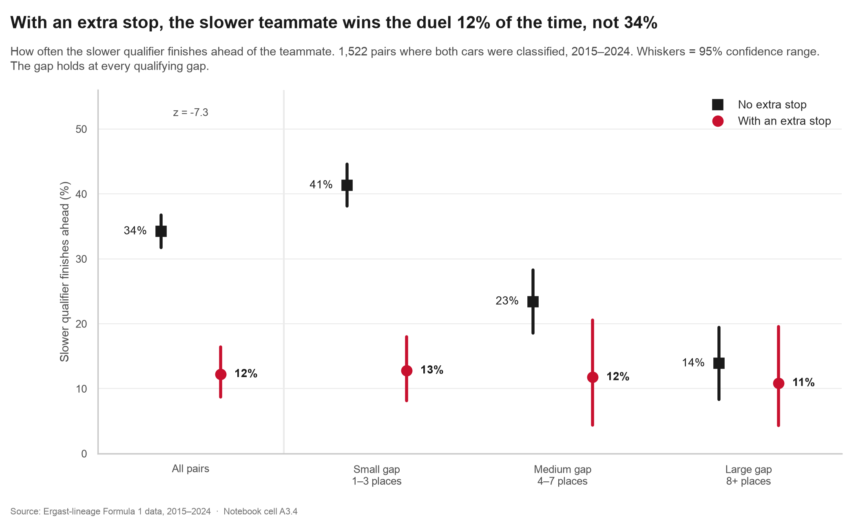
Figure 7. How often the slower qualifier finishes ahead, with and without an extra stop; 1,522 pairs with both cars classified (Cell A3.4).
With an extra stop, the slower qualifier finished ahead of the teammate only 12.2% of the time (n = 286). Without one: 34.2% (n = 1,236). The two-proportion test gives z = -7.3, far beyond chance. The pattern holds for small qualifying gaps (13% vs 41%), medium gaps (12% vs 23%) and large gaps (11% vs 14%). In the large-gap bucket only 46 pairs made an extra stop and the difference is not significant (p = 0.6): the direction holds, the strength does not.
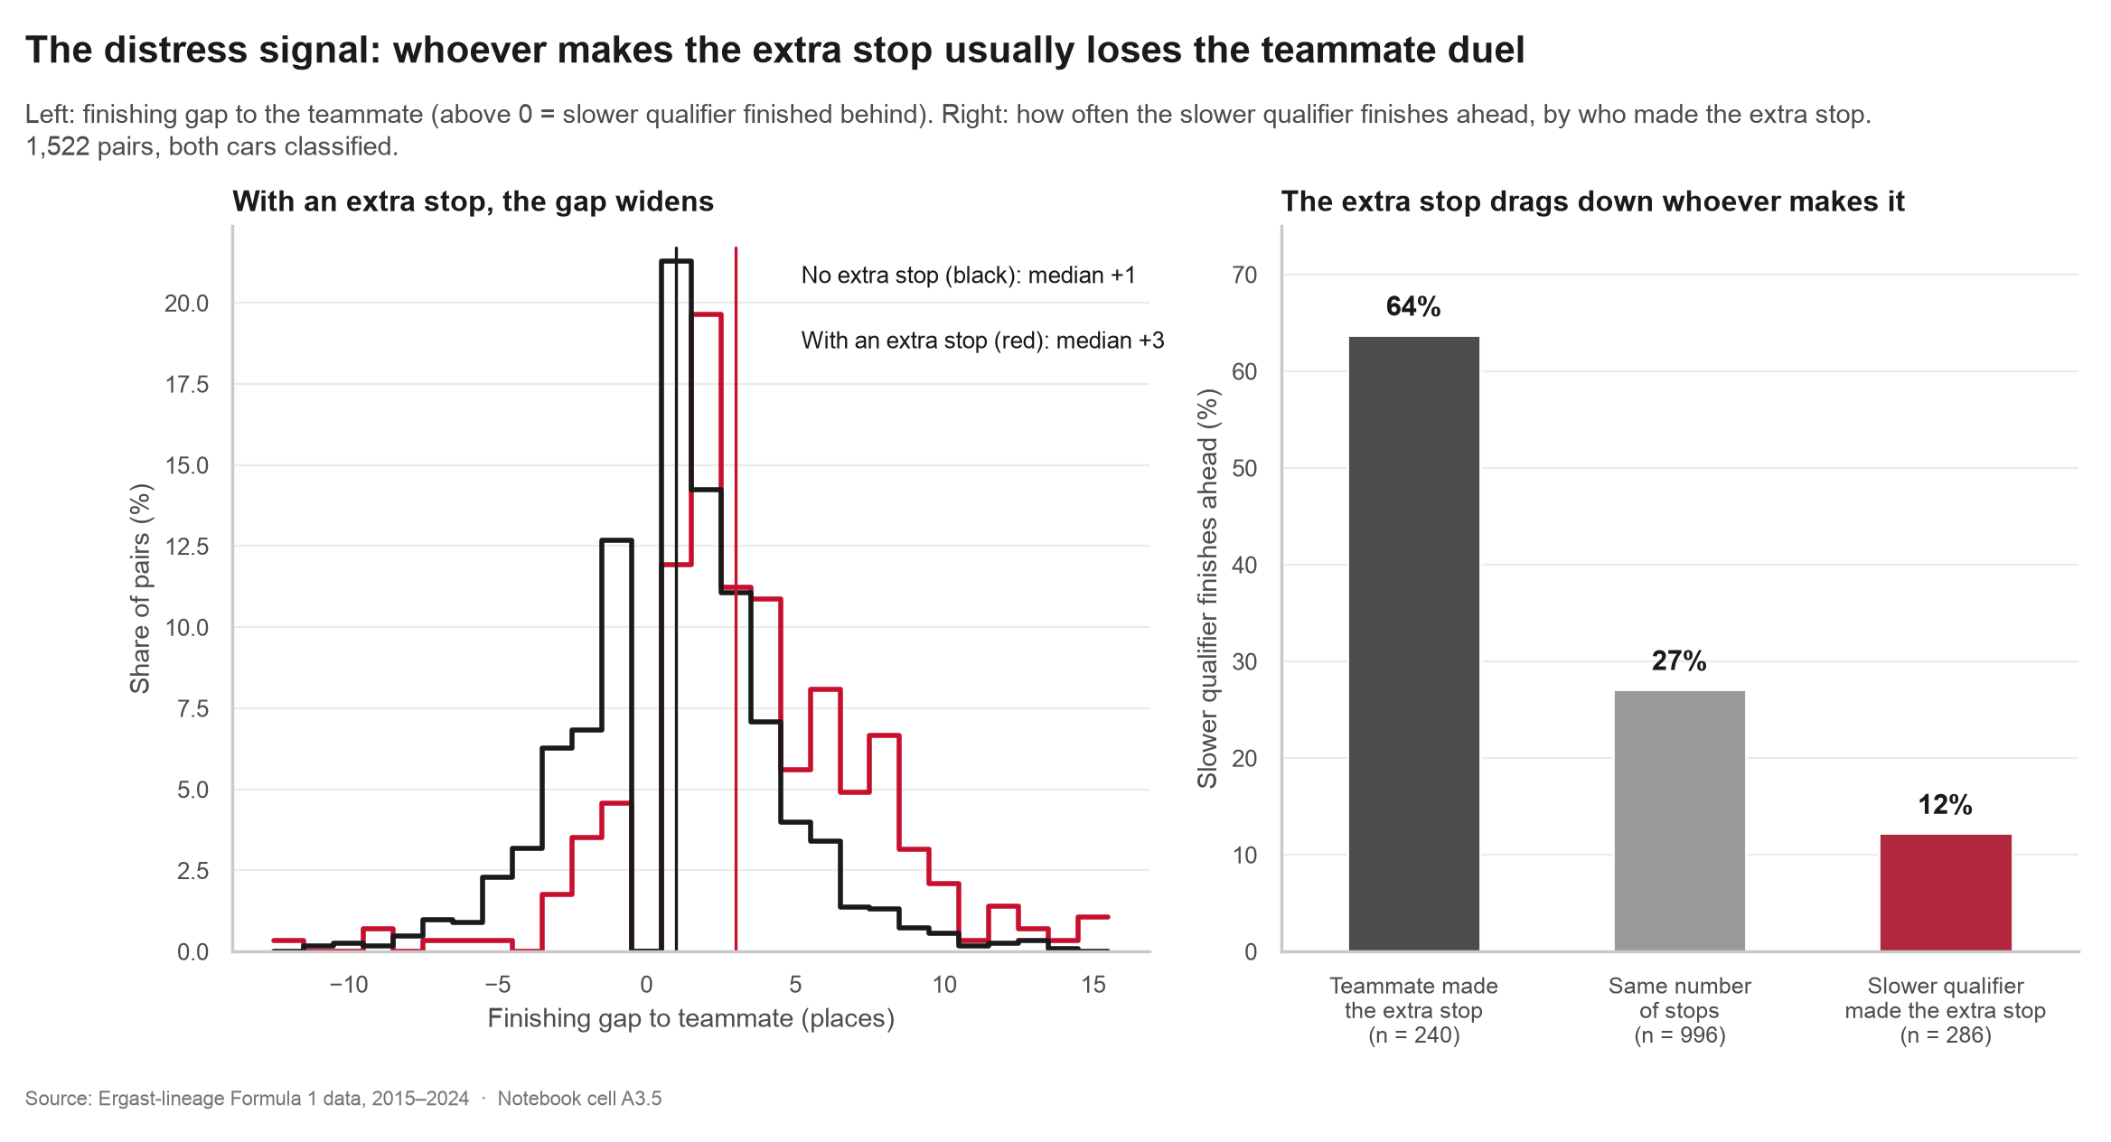
Figure 8. Left: finishing gap to the teammate. Right: who made the extra stop (Cell A3.5).
The extra stop drags down whoever makes it. When the teammate made the extra stop, the slower qualifier finished ahead 64% of the time; with equal stops 27%; when the slower qualifier made it, 12%. The median finishing gap widens from +1 to +3 places. There is also a clue about why: 27% of extra-stop drivers made their first stop in laps 1–3, against 9% of the others. Stopping that early is rarely a plan.
Honest framing. The extra stop is a symptom of trouble (damage, a puncture, a spin, bad safety-car timing). It is not a weapon, and it is not the cause of the lost result. Telling a driver to make fewer stops would fix nothing, because the trouble came first. This is a correlation in observational data, and we treat it as a warning light, not as a lever.
The call you would make: when your second car suddenly needs a stop the plan did not have, treat it as an alarm: something has gone wrong. Do not expect that stop to win places back. Protect the other car's result.

6.5 Act 4: The car sets the ceiling
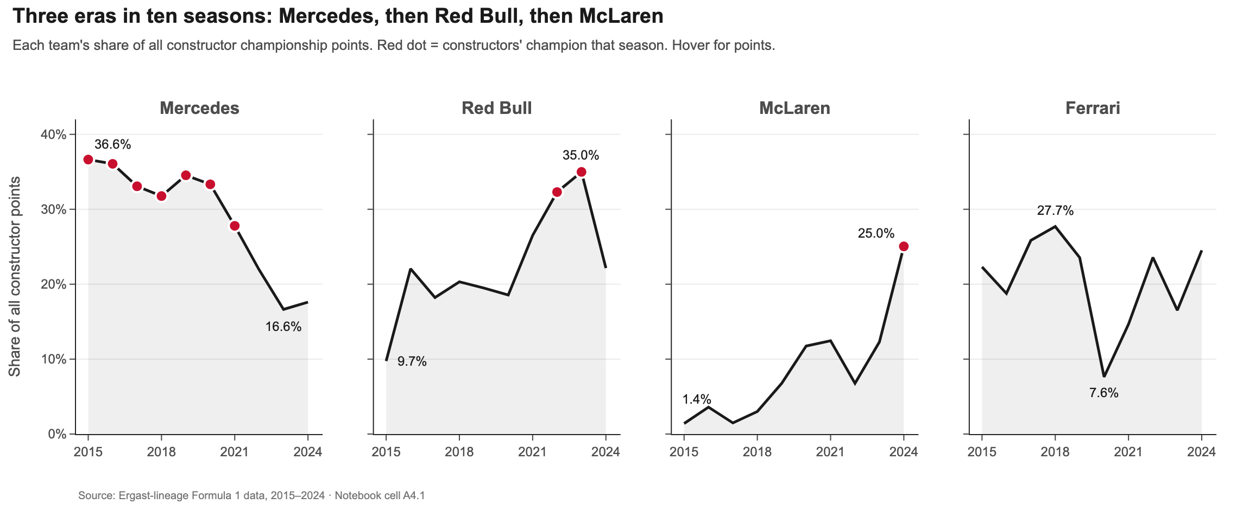
Figure 9. Share of all constructor points, four leading teams; red dots = constructors' champion (Cell A4.1, Plotly).
Mercedes took 36.6% of all points in 2015 and won 7 constructors' titles in a row, then fell to 16.6% by 2023. Red Bull rose from 9.7% to 35.0%. McLaren climbed from 1.4% to 25.0% and won 2024, just ahead of Ferrari (24.5%). Ferrari peaked at 27.7% in 2018 but never won a title. The biggest three-season swing: Ferrari's share fell by 18 percentage points between 2017 and 2020. Changes that size are an engineering story, not a race-day decision.
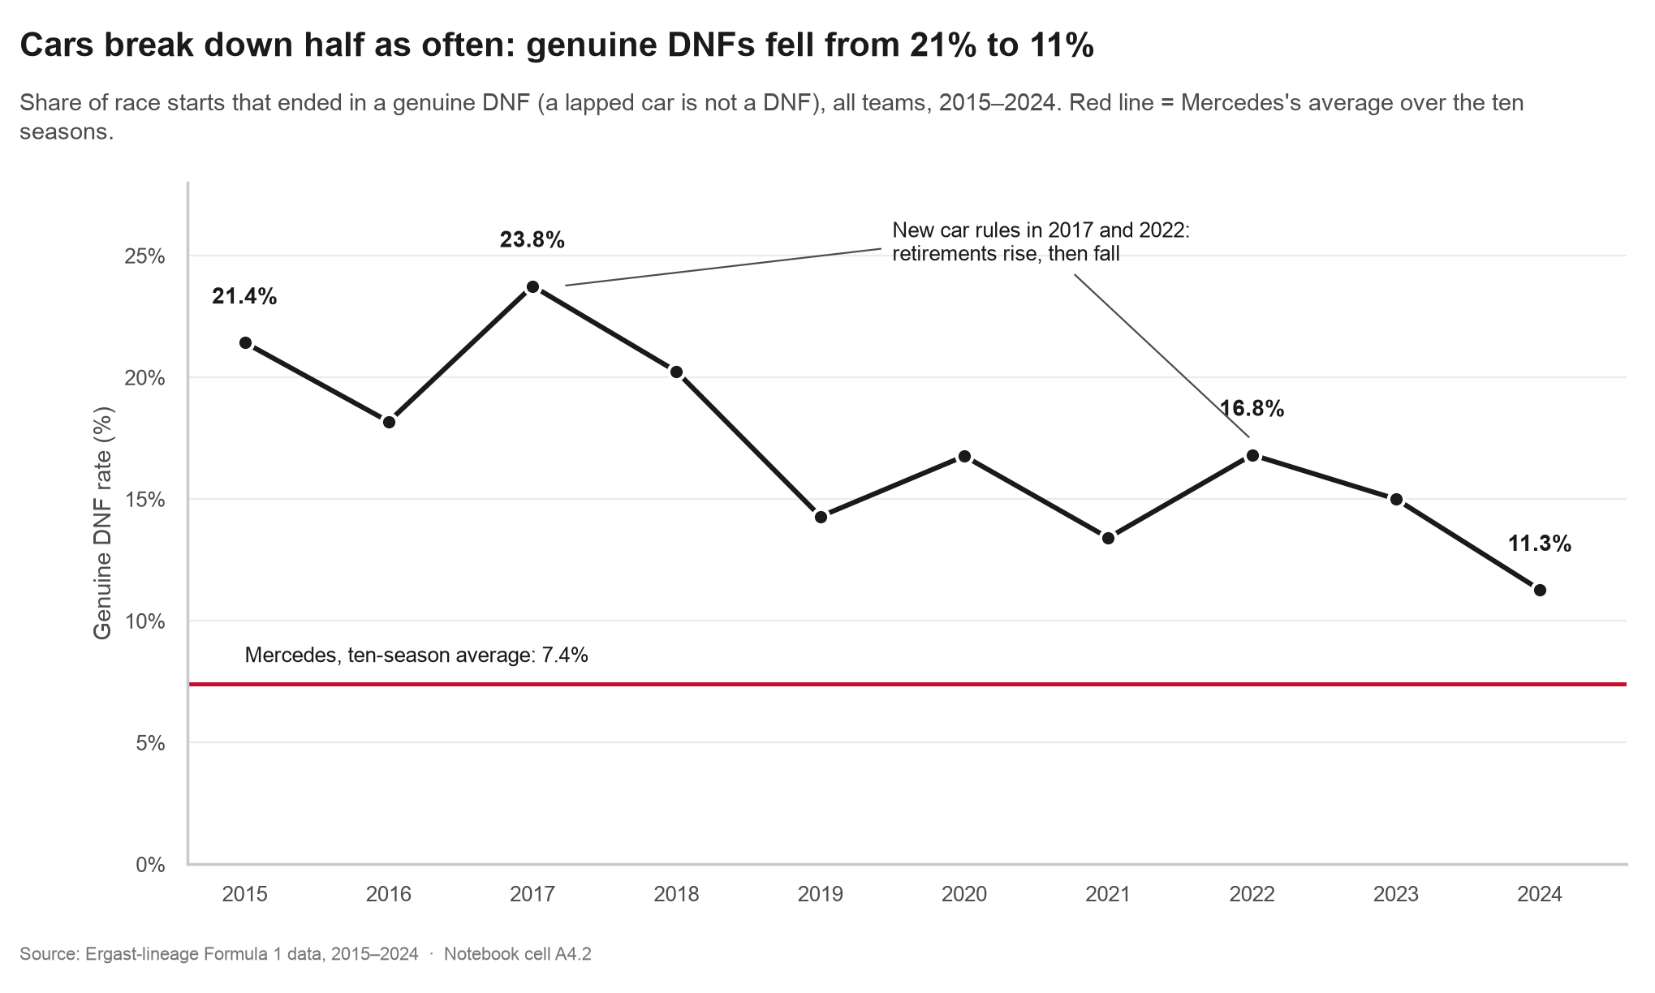
Figure 10. Genuine DNF rate by season; red line = Mercedes' ten-season average (Cell A4.2).
Reliability improved: in 2015, 21.4% of starts ended in a genuine retirement; in 2024, 11.3%. The fall is not smooth: 2017 (23.8%) and 2022 (16.8%) were both years of new technical rules. Mercedes retired only 7.4% of the time, the best of any team with 60+ starts (Toro Rosso was worst at 25.5%).
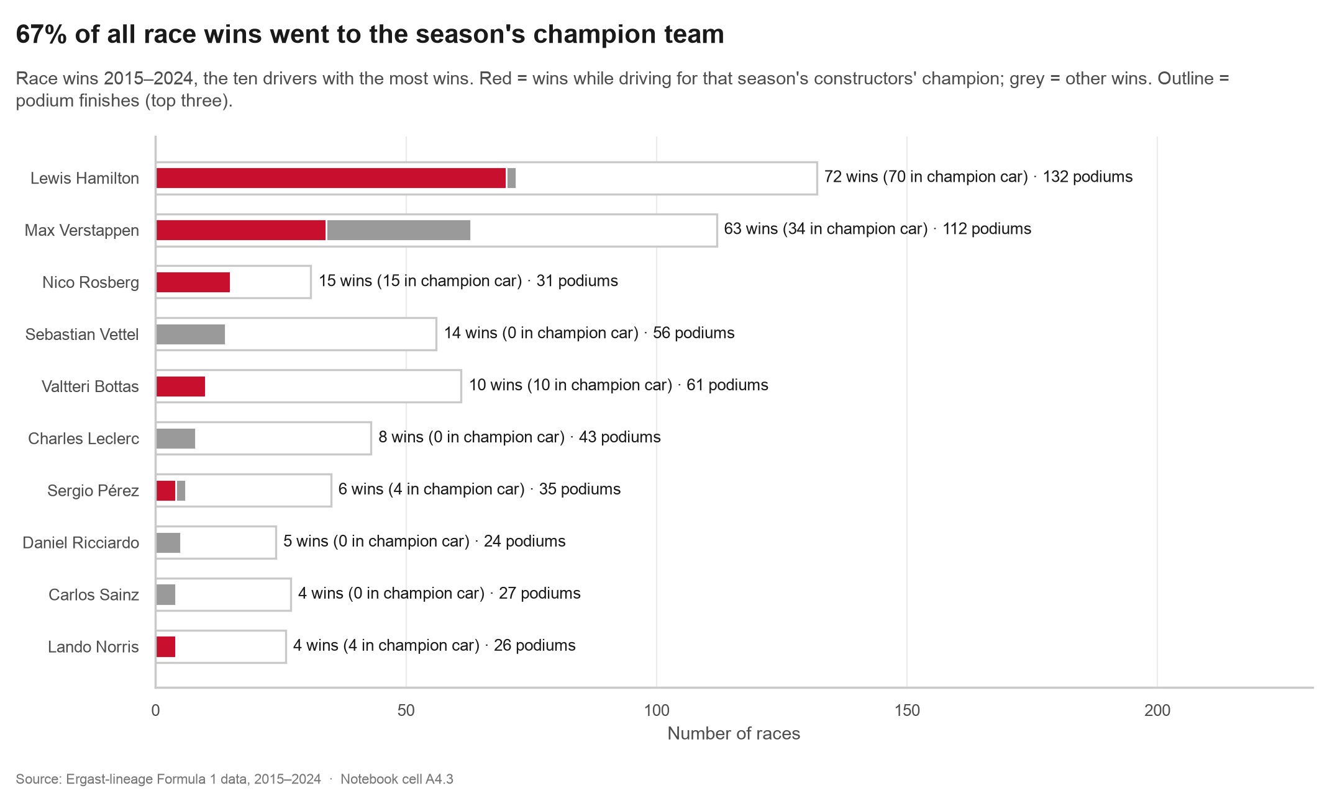
Figure 11. Race wins by driver, split by whether the car was that season's champion (Cell A4.3).
67% of all race wins went to the season's constructors' champion. Hamilton won 72 races, 70 of them in the champion car; Verstappen won 63, 34 in the champion car. His wins outside the best car are what a great driver looks like in this chart. Driver titles follow the same eras: Hamilton won 5, Verstappen 4 (Figure 12).
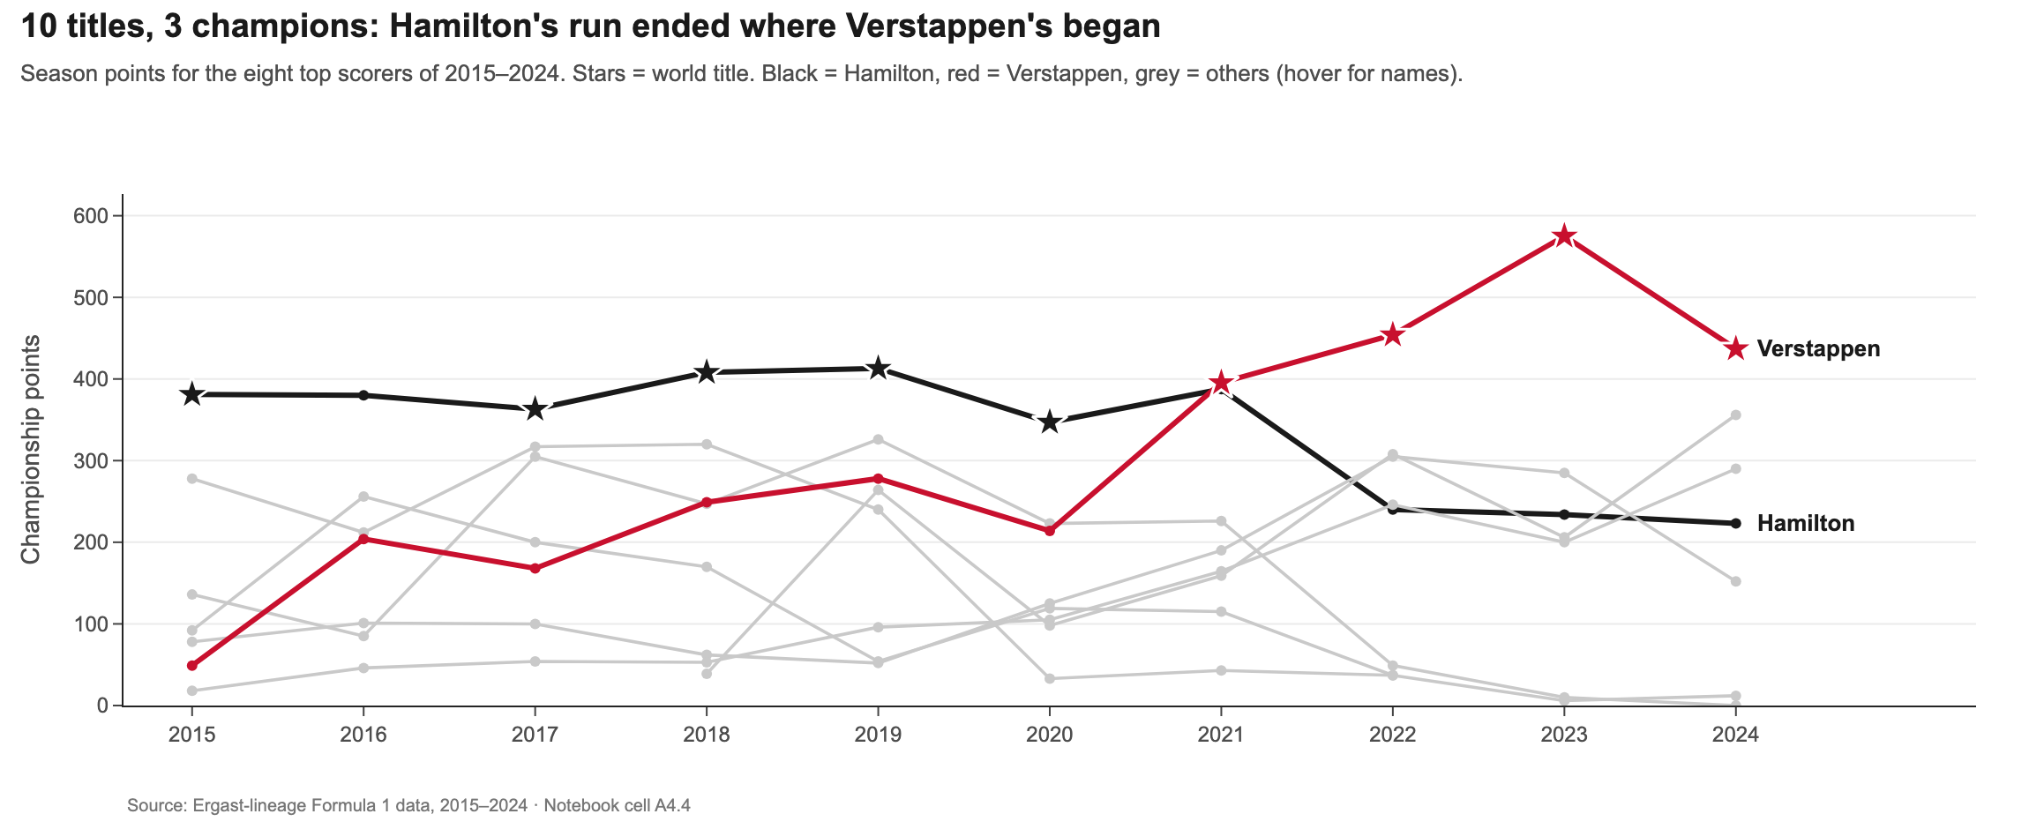
Figure 12. Season points for the eight top scorers; stars = world title (Cell A4.4, Plotly).
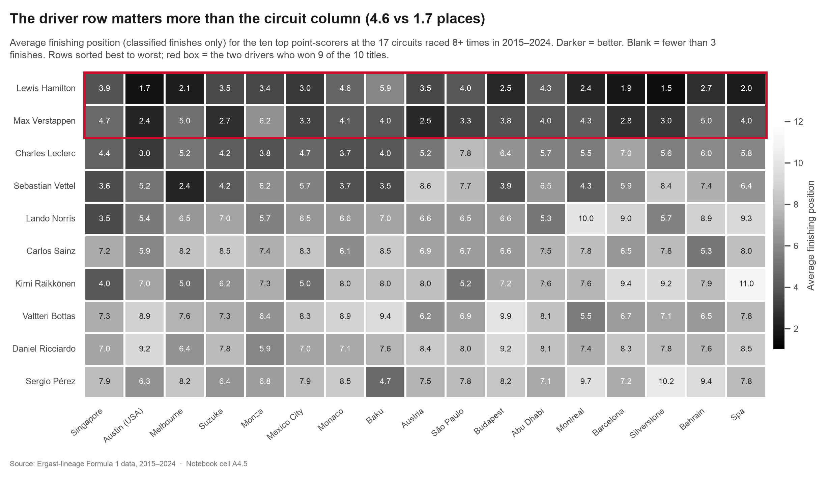
Figure 13. Average finishing position for the ten top point-scorers at circuits raced 8+ times (Cell A4.5).
Read the heatmap across a row and the shade barely changes; read down a column and it changes a lot. Driver rows differ by 4.6 places on average, circuit columns by only 1.7. Lewis Hamilton averages P3.1 almost everywhere. Circuit specialists are mostly a myth at this level: the driver and the car set the level, and the circuit nudges it.
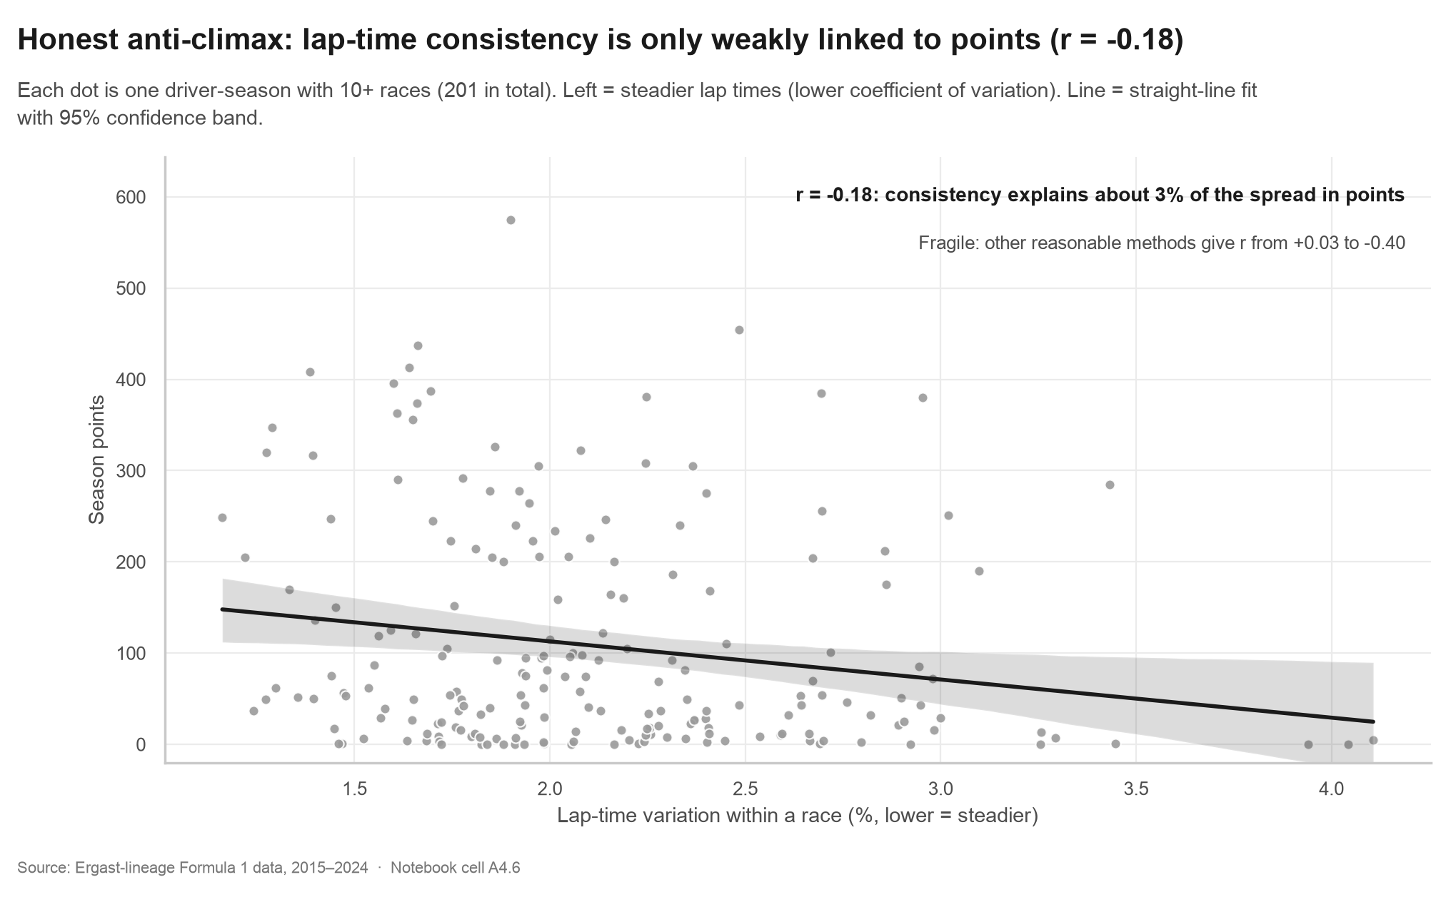
Figure 14. Lap-time consistency vs season points, one dot per driver-season (Cell A4.6).
An honest anti-climax. Steadier drivers score slightly more (r = -0.18, 201 driver-seasons), but consistency explains only about 3% of the spread in points. The result is also fragile: keeping races where a driver completed fewer than 10 laps gives -0.16, using each driver's median race gives -0.40, and filtering outlier laps per race gives +0.03. Even the strongest version is partly a car effect, because a fast car runs in clean air and laps more steadily. It is included because a story that only shows its strong results is not honest.
The call you would make: every edge from Acts 1–3 lives inside the ceiling the car sets. Fight for every place, but plan the season around the car, not the race.

6.6 Back to the hook race
Read the 2016 Chinese GP again as a strategist. Act 1: Rosberg started on pole and won; at Shanghai the grid-finish correlation is 0.80 over 6 races. Act 2: on lap 4, 10 cars pitted at once and the order reshuffled. Act 3: Hamilton, the slower qualifier in the same car, made 3 more stops than his teammate and finished 7th; his first stop came on lap 1, the alarm rather than the plan. Act 4: both drove the 2016 Mercedes, the car that took 36.1% of all points that season. The 844 position changes were never random. They were a chain of cause and effect.

7. Tool selection and usage
The final stage needs three visualization tools. All three run inside one Jupyter notebook, so a single "Restart and Run All" rebuilds every chart, number and the dashboard. This is the one deliberate change from the Primary Review, which planned Python and Power BI: Plotly replaced Power BI so the whole analysis stays reproducible in a single notebook. Everything else (objectives, dataset, visualization plan) is unchanged.
Tool | The job it does better than the others | Used for | Why not the other two
Matplotlib | Pixel-level control: custom marks, per-line annotation, exact axis limits | Hook bump chart, undercut slope, DNF trend, wins bars, misleading/honest pair | Seaborn's statistical defaults get in the way of hand-built story charts; Plotly's static export is less precise for print
Seaborn | Statistical charts straight from tidy data, with built-in aggregation and bootstrap confidence intervals | Grid-finish density, circuit dot plot, stops strip plot, StopDiff and teammate point plots, distress histograms, heatmap, regression | Matplotlib needs many lines for each CI; Plotly does not compute statistical summaries
Plotly | Interactivity: hover values, zoom, linked filters, and a single self-contained HTML export | Points-share eras, driver points lines, the five-act dashboard | Matplotlib and Seaborn produce static images; nobody can filter a PNG

Supporting libraries: pandas (cleaning and joins), SciPy (correlations and tests), Kaleido (static PNG export of the Plotly charts for this report and the slides).

8. Dashboard design
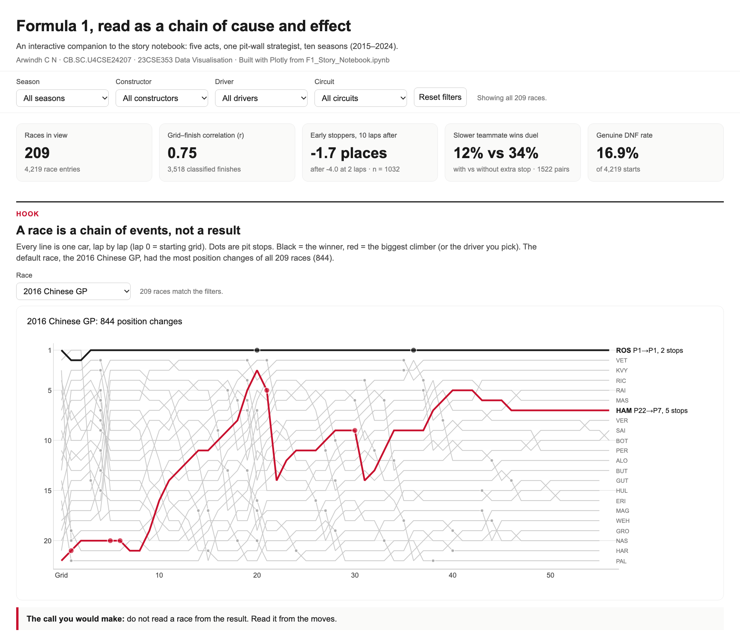
Figure 15. F1_Dashboard.html: title, filter row, headline numbers and the hook (screenshot).
The dashboard is one self-contained HTML file (5.9 MB, works offline) written by Cell D.1 of the notebook. It follows the same five-act order as the story, from top to bottom:
- One filter row. Season, constructor, driver and circuit filters sit in a single sticky row above everything, and every chart re-draws for the same slice of data. The current selection is stored in the page address, so a filtered view can be shared as a link.
- Headline numbers. Five tiles (races in view, grid-finish r, early-stopper net change, teammate duel, genuine DNF rate) re-compute for the selection.
- Hook. A race selector shows the lap-by-lap chart for any race. Black is the winner; red is the biggest climber, or the chosen driver.
- Acts 1–4. The circuit dot plot highlights the chosen circuit; the grid-vs-finish scatter, the undercut slope and the teammate bars re-compute for the filters; the points-share, DNF and season-points charts draw the chosen team or driver in red.
- Act 5. A toggle switches the same bar chart between the misleading and the honest axis, for the top two teams of any season, with the lie factor calculated live.
- Honesty built in. Small selections are labelled "small sample", empty selections say so, and grey reference lines show the all-data result behind a filtered one.

9. The misleading visualization
The ethics demonstration uses constructor championship points with a truncated y-axis, added at the final stage as the course requires. The data is real and correct; only the axis changes. It is clearly labelled MISLEADING (for ethics demonstration) wherever it appears.
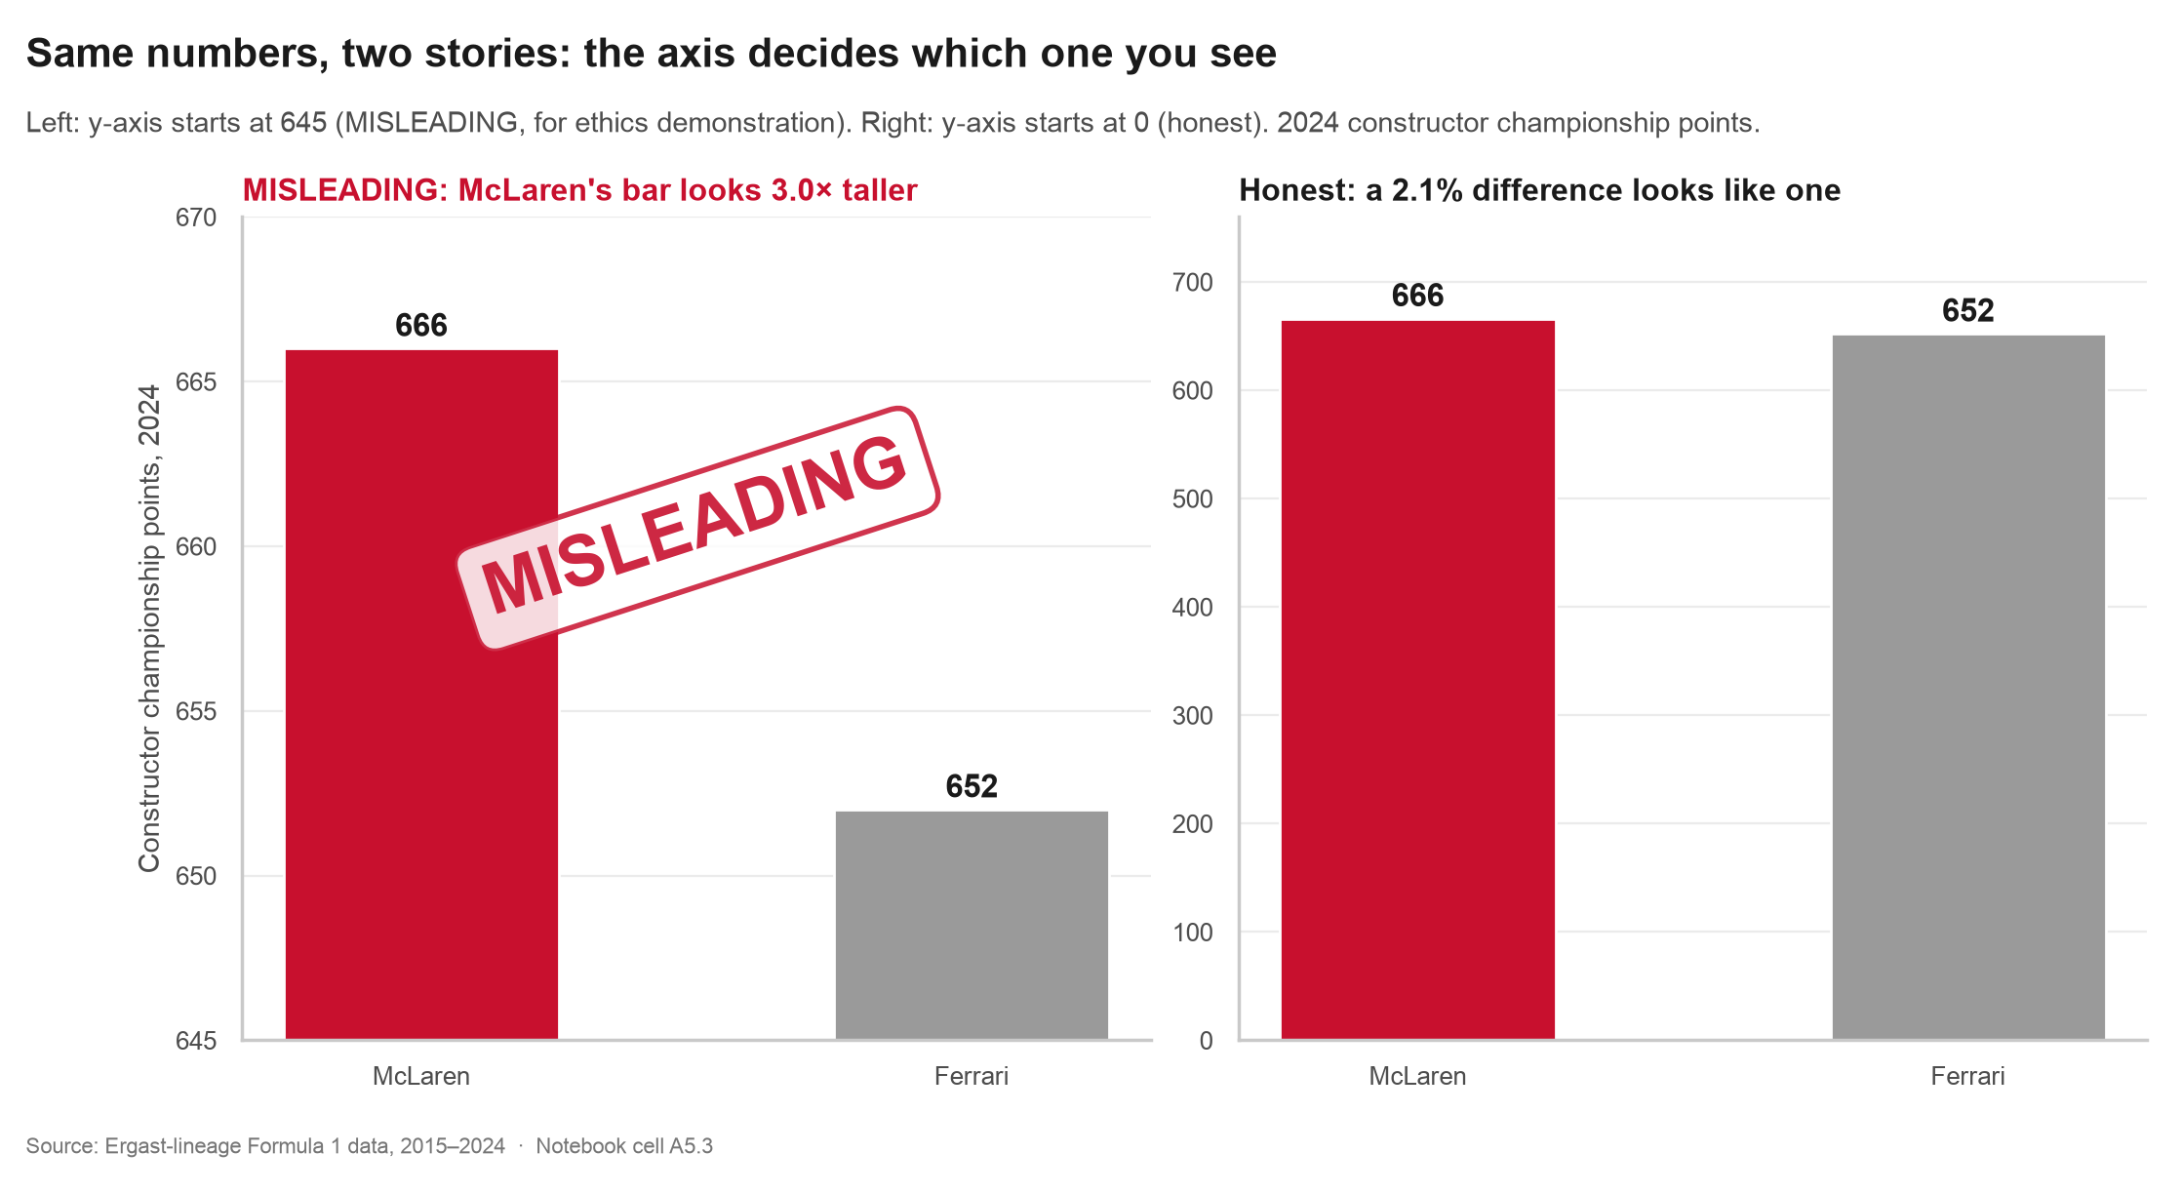
Figure 16. Left: MISLEADING, for ethics demonstration (axis starts at 645). Right: honest version (axis starts at 0). Cells A5.1–A5.3.
Question | Answer
What was manipulated? | Only the y-axis. It starts at 645 points instead of 0. The values are real: McLaren 666, Ferrari 652 (2024).
Why does it mislead? | A bar chart encodes value as bar length. With the axis cut at 645, we only see the top of each bar, so McLaren's bar looks 3.0 times taller than Ferrari's, while the real difference is 2.1%.
What false impression does it create? | That McLaren "crushed" Ferrari. In reality the 2024 constructors' title was the closest of the ten seasons: 14 points over a whole season.
How was it fixed? | The y-axis starts at zero, the exact values are printed on the bars, and the title states the real size of the gap (14 points, 2.1%).
Which principle does the fix follow? | Truthful scaling and proportional ink (Tufte): the size of a mark must be proportional to the number it shows. Tufte's lie factor = size of effect in the graphic ÷ size of effect in the data. An honest chart has a lie factor near 1; the misleading one has a lie factor of about 93.

10. Ethical reflection
The misleading chart contains no false number. That is what makes it dangerous: it would pass a fact-check of its labels. Close fights are common in F1, like the 2024 constructors' title, so the temptation to zoom an axis is constant. The same care was applied to the rest of the project:
- Axes. Every bar chart starts at zero. Line and dot charts that do not start at zero say what they show (position, not length).
- Uncertainty. Confidence ranges are drawn wherever a number is an estimate. Small samples are named: Hockenheim's three races, the large-gap bucket's 46 pairs, small dashboard selections.
- Not bending the data. When a recomputed number disagreed with the earlier analysis, the real number was used and the story changed. The four-or-more-stops group finishing better than three-stoppers was reported, not hidden.
- Showing weak results. The consistency finding is weak and fragile, and is shown as exactly that.
- Causation. Act 3 could easily be told as "extra stops lose races". It is told the honest way: the extra stop is a symptom of trouble that already happened, and a team that tried to "fix" it by stopping less would gain nothing.
- Choosing examples. The hook race was chosen by a rule (most position changes of all 209 races), not because it fitted the story.
- People. Drivers are named because these are public sporting results. The analysis judges race situations, not people: an extra stop is treated as bad luck or damage, not as a driver's failure.

11. Limitations
Finding | Type of evidence | What could be behind it | What we can honestly say
Grid predicts finish (Act 1) | Correlation | Fast cars qualify well and race well | The two move together, more at some tracks
Undercut (Act 2) | Before/after average | Safety cars, tyre choices, forced stops | Early first stops lose more at once and recover more
Extra stop = alarm (Act 3) | Strong correlation (z = -7.3) | Damage, punctures, spins, timing | An extra stop is a warning sign, not a cause and not a tactic
Car sets the ceiling (Act 4) | Descriptive | Budget, rules, engine supply | Points share swings by era far more than by any race decision
Consistency (Act 4) | Weak, fragile correlation | Car pace | Little link with points; depends on method

- Correlation is not causation. Nothing here is an experiment; every result shows that two things moved together over ten seasons.
- Missing variables: the dataset has no tyre compounds, weather, safety-car periods, penalties or team radio, so the reason behind any single event is outside the data.
- Track position is not time: the undercut measure counts places, not the gap in seconds.
- Grid-versus-finish uses classified finishers only, which flatters drivers who start at the back.
- Some circuits and buckets have small samples; their exact values should not be over-read.

12. Conclusion
Ten seasons of data turn the race result into a chain. Saturday sets the order, more at Monaco than anywhere else. A pit stop is a loan of places that early stoppers repay and late stoppers do not. An unplanned extra stop is an alarm, and whoever makes it usually loses the duel with the teammate. And all of it plays out under a ceiling set by the car, which moved from Mercedes to Red Bull to McLaren in ten years. Read the 2016 Chinese GP with those four ideas and its 844 position changes stop being chaos: they become cause and effect.
- Pit wall call 1: weight qualifying effort by circuit.
- Pit wall call 2: if the car can survive a few exposed laps, stop first.
- Pit wall call 3: treat an unplanned stop as an alarm, not a strategy.
- Pit wall call 4: plan the season around the car; race-day edges live inside its ceiling.

Appendix A. Consistency with the Primary Review
Every chart planned in the Primary Review is delivered. Where the form changed, the reason is given. To reproduce everything from the 14 raw CSVs, run make_all.sh (see README.md in the submission folder).
Planned (Primary Review) | Delivered | Change and reason
1. Driver championship performance: line chart | Figure 12, season points by driver (Plotly) | Same form; made interactive
2. Constructor performance: bar chart | Figure 9, points-share eras; Figure 16 bars | Share by season shows the eras better than one total bar
3. Qualifying vs race finish: scatter plot | Figures 2 and 3 | 3,518 points overplot, so a 2D histogram; plus circuit-level r
4. Driver wins and podiums: bar chart | Figure 11 | Same form; wins split by champion car
5. Pit-stop strategy vs result: scatter plot | Figures 4–8 | Strip plot for stop count, then the undercut and teammate analyses
6. Circuit-level driver performance: heatmap | Figure 13 | Same form

Additions at the final stage: the hook bump chart, the derived teammate link (Act 3), the DNF trend, the consistency check, the misleading/honest pair and the dashboard. The only change of tool is Plotly in place of Power BI (Section 7).

Appendix B. Verification of earlier findings
Generated by verify_seeds.py from the raw CSVs; the full table with notes is in verification_log.md.
ID | Finding | Seed | Recomputed | Match
D1 | Races in 2015-2024 | 209 | 209 | Yes
D2 | Median pit-lane time (s) | ~23.7 | 23.73 (stops < 60 s) / 23.98 (all 7,544 stops) | Yes
S1a | Grid vs finish, pooled Pearson r | ~0.75 | 0.746 (n = 3,518) | Yes
S1b | Monaco r (highest) | ~0.88 | 0.878 (n = 151, 9 races) | Yes
S1c | Median circuit r (40+ classified finishes) | ~0.74 | 0.744 across 27 circuits | Yes
S1d | Lowest circuit r | ~0.52 Hockenheim | 0.524 Hockenheim (n = 50, 3 races) | Yes
S2a | First stops usable (lap before, +2, +10 all known) | 3,490 | 3,490 | Yes
S2e | Undercut, early third: places at +2 laps, then at +10 laps | -4.0 then -1.7 | -4.03 then -1.67 (n = 1,032) | Yes
S2m | Undercut, middle third: places at +2 laps, then at +10 laps | -3.0 then -1.6 | -2.98 then -1.64 (n = 1,291) | Yes
S2l | Undercut, late third: places at +2 laps, then at +10 laps | -3.3 then -2.2 | -3.32 then -2.26 (n = 1,167) | Yes
S2r | Places won back between +2 and +10 laps (early vs late) | 2.4 vs 1.1 | 2.35 vs 1.07 | Yes
S3a | Corr(qualifying gap, StopDiff) | ~-0.01 | +0.021 (n = 2,085 pairs) | Yes (both ~0)
S3b | Slower qualifier beats teammate WITH an extra stop | 12.2% (n = 287) | 12.2% (n = 286) | Yes
S3c | Slower qualifier beats teammate WITHOUT an extra stop | 34.0% (n = 1,245) | 34.2% (n = 1,236) | Yes
S3d | Two-proportion z | ~-7.3 | -7.31 | Yes
S3e | Median finishing gap to teammate (extra vs none) | +3 vs +1 | +3 vs +1 | Yes
S3f | Sensitivity: 'both finished' by status (no late retirements) | - | 11.0% (n = 272) vs 33.7% (n = 1,192), z = -7.41 | n/a
S3s | Bucket small gap (1-3 grid places): with vs without extra stop | 12.7% vs 41.2% | 12.8% (n = 172) vs 41.3% (n = 823) | Yes
S3m | Bucket medium gap (4-7 grid places): with vs without extra stop | 11.8% vs 23.1% | 11.8% (n = 68) vs 23.4% (n = 269) | Yes
S3l | Bucket large gap (8+ grid places): with vs without extra stop | 10.9% vs 13.6% | 10.9% (n = 46) vs 13.9% (n = 144) | Yes
S4a | Mercedes points share 2015 -> 2023 | 36.6% -> 16.6% | 36.6% -> 16.6% | Yes
S4b | Red Bull points share 2015 -> 2023 | 9.7% -> 35.0% | 9.7% -> 35.0% | Yes
S4c | McLaren points share 2015 -> 2024 | 1.4% -> 25.0% | 1.4% -> 25.0% | Yes
S5a | Genuine DNF rate 2015 -> 2024 | 21.4% -> 11.3% | 21.4% -> 11.3% | Yes
S5b | Lowest genuine DNF rate (team, 60+ starts) | Mercedes ~7.4% | Mercedes 7.4% (418 starts) | Yes
S6 | Lap-time variability (CV) vs season points | r ~ -0.18 (n = 201) | r = -0.184 (n = 201) | Yes

