**EX:No.6**

**221501010 MOVING AVERAGE SMOOTHING**

**AND FORECASTING**

**AIM :** To implement moving average and smoothing on a time series dataset.

**PROCEDURE:**

• Read the dataset and convert the date column to datetime format.

• Set the date column as the index for time series analysis.

• Aggregate the data by calculating the monthly mean.

• Apply a 12-month moving average for smoothing.

• Plot the original data, aggregated data, and smoothed data.

• Display the graph to visualize trend estimation and elimination.

**IMPLEMENTATION :**

**# Step 1: Import necessary libraries**

import pandas as pd

import numpy as np

import matplotlib.pyplot as plt

from statsmodels.tsa.arima.model import ARIMA

from sklearn.metrics import mean_squared_error

from math import sqrt

# Step 2: Load the dataset

df = pd.read_csv('/content/ch3_airline_passengers.csv')

df.columns = ['Month', 'Passengers']

df['Month'] = pd.to_datetime(df['Month'])

df.set_index('Month', inplace=True)

# Step 3: Visualize original data

plt.figure(figsize=(12, 6))

plt.plot(df, label='Original Data')

plt.title('Airline Passengers Over Time')

plt.xlabel('Date')

plt.ylabel('Number of Passengers')

plt.legend()

plt.show()

# Step 4: Apply Moving Average Smoothing

df['Smoothed'] = df['Passengers'].rolling(window=12).mean()

plt.figure(figsize=(12, 6))

plt.plot(df['Passengers'], label='Original')

plt.plot(df['Smoothed'], label='12-month Moving Average', color='orange')

plt.title('Smoothed vs Original')

plt.legend()

plt.show()

# Step 5: Drop NaN values from smoothing

df_clean = df.dropna()

# Step 6: Split into training and test sets

train_size = int(len(df_clean) * 0.8)

train, test = df_clean['Smoothed'][:train_size], df_clean['Smoothed'][train_size:]

# Step 7: Fit an ARIMA model

model = ARIMA(train, order=(2, 1, 2))  # You can tune this

model_fit = model.fit()

# Step 8: Forecast

forecast = model_fit.forecast(steps=len(test))

forecast = pd.Series(forecast, index=test.index)

# Step 9: Plot actual vs predicted

plt.figure(figsize=(12, 6))

plt.plot(train, label='Training')

plt.plot(test, label='Test')

plt.plot(forecast, label='Forecast', color='red')

plt.title('Forecast vs Actuals – Airline Passengers')

plt.legend()

plt.show()

# Step 10: Evaluate forecast

rmse = sqrt(mean_squared_error(test, forecast))

print(f"RMSE: {rmse:.2f}")

**OUTPUT:**

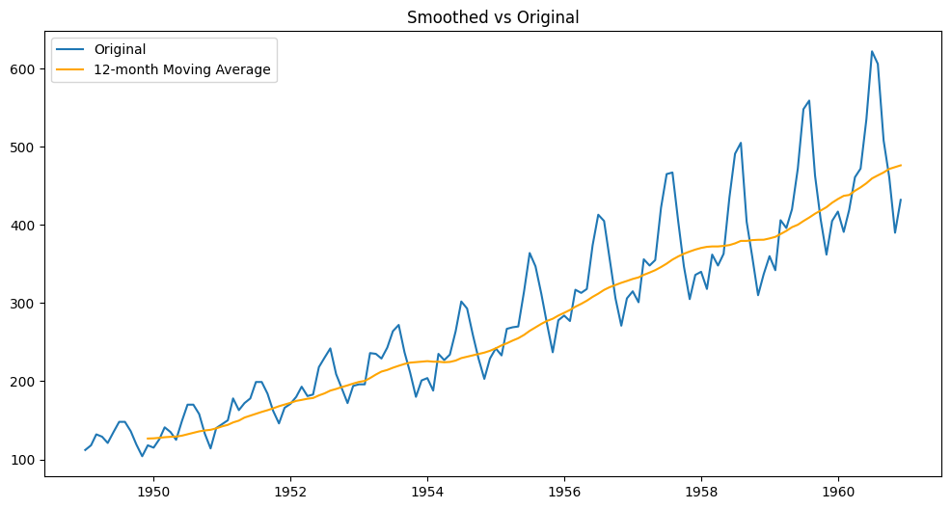

**RESULT :** Thus moving average and smoothing has been implemented.