**EX:No.7 DECOMPOSING TIME SERIES FOR TRENDS AND SEASONALITY**

**221501010**

**AIM :** To decompose time series for trends and seasonality.

**PROCEDURE:**

• Read the dataset and convert the date column to datetime format.

• Set the date column as the index for time series analysis.

• Aggregate the data to a uniform time frequency (e.g., monthly mean).

• Apply seasonal decomposition using seasonal_decompose.

• Plot the decomposition result.

• Interpret the components to understand the structure of the time series.

**IMPLEMENTATION :**

**# Step 1: Import necessary libraries**

import pandas as pd

import matplotlib.pyplot as plt

from statsmodels.tsa.seasonal import seasonal_decompose

# Step 2: Load the dataset

df = pd.read_csv('/content/ch3_airline_passengers.csv')

df.columns = ['Month', 'Passengers']

df['Month'] = pd.to_datetime(df['Month'])

df.set_index('Month', inplace=True)

# Step 3: (Optional) Resample monthly if needed

# The dataset is already monthly, so this step is not required

# Step 4: Apply seasonal decomposition

result = seasonal_decompose(df['Passengers'], model='additive', period=12)

# Step 5: Plot the decomposition

plt.figure(figsize=(14, 10))

result.plot()

plt.suptitle('Seasonal Decomposition of Airline Passengers', fontsize=16)

plt.tight_layout()

plt.show()

**OUTPUT:**

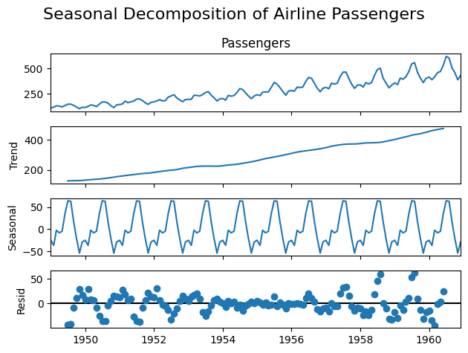

**RESULT :** Thus decomposition for trends and seasonality has been executed successfully.