**EX:No.3 LINEAR REGRESSION 221501010 21/01/25**

**AIM :** To implement linear regression on a time series data .

**IMPLEMENTATION :**

import pandas as pd

from sklearn.model_selection import train_test_split

from sklearn.linear_model import LinearRegression

import matplotlib.pyplot as plt

import pandas as pd

import matplotlib.pyplot as plt

from sklearn.model_selection import train_test_split

from sklearn.linear_model import LinearRegression

**#Load the dataset**

file_path = "ch3_airline_passengers.csv"

df = pd.read_csv("/content/ch3_airline_passengers.csv")

**#Convert 'Month' to a numerical format**

df["Month"] = pd.to_datetime(df["Month"])

df["Month_Ordinal"] = df["Month"].map(pd.Timestamp.toordinal)

#Define features (X) and target variable (y)

X = df[["Month_Ordinal"]]

y = df["AirPassengers"]

#Split data into training and testing sets

X_train, X_test, y_train, y_test = train_test_split(X, y, test_size=0.2, random_state=42)

#Train the linear regression model

model = LinearRegression()

model.fit(X_train, y_train)

#Model coefficients

slope = model.coef_[0]

intercept = model.intercept_

print(f"Slope: {slope}")

print(f"Intercept: {intercept}")

#Make predictions

y_pred = model.predict(X_test)

#Plot the regression line

plt.scatter(X_test, y_test, color='blue', label='Actual Data')

plt.plot(X_test, y_pred, color='red', linewidth=2, label="Regression Line")

plt.xlabel("Date (Ordinal)")

plt.ylabel("Number of Airline Passengers")

plt.title("Simple Linear Regression on Airline Passengers Data")

plt.legend()

plt.show()

**OUTPUT:**

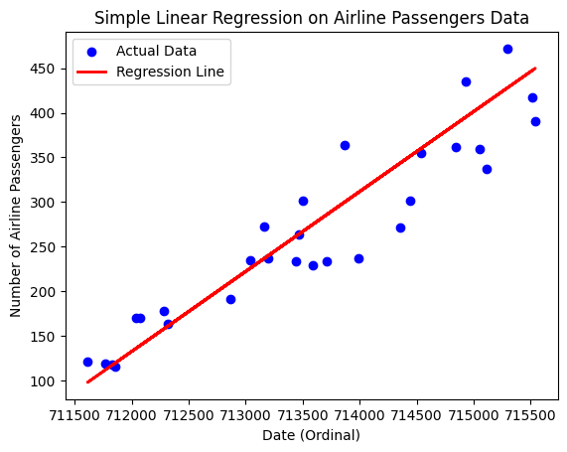

**RESULT :** Thus linear regression has been implemented on a time series data.