**EX:No.5 ESTIMATING AND ELIMINATING TREND 25/3/25 221501010 USING AGGREGATING AND SMOOTHING**

**AIM :** To implement aggregation and smoothing to estimate and eliminate trend in time series analysis.

**PROCEDURE:**

1. Read the dataset and convert the date column to datetime format.

2. Set the date column as the index for time series analysis.

3. Aggregate the data by calculating the monthly mean.

4. Apply a 12-month moving average for smoothing.

5. Plot the original data, aggregated data, and smoothed data.

6. Display the graph to visualize trend estimation and elimination.

**IMPLEMENTATION :**

import pandas as pd

import matplotlib.pyplot as plt

# Load the dataset

df = pd.read_csv("/content/ch3_airline_passengers.csv")

# Check actual column names

print("Columns:", df.columns)

# Rename for consistency (optional but useful)

df.columns = [col.strip().replace("#", "") for col in df.columns]

# Convert Month to datetime and set as index

df["Month"] = pd.to_datetime(df["Month"])

df.set_index("Month", inplace=True)

# Resample safely with 'ME' (Month End)

df_monthly = df.resample("ME").mean()

# Use correct column name after renaming

column_name = df.columns[0]  # Assuming the column is now just "Passengers"

df["SMA_12"] = df[column_name].rolling(window=12).mean()

# Plotting

plt.figure(figsize=(12, 6))

plt.plot(df[column_name], label="Original Data", color="blue", alpha=0.5)

plt.plot(df_monthly, label="Monthly Aggregated", color="red")

plt.plot(df["SMA_12"], label="12-Month Moving Average", color="green")

plt.legend()

plt.title("Trend Estimation & Elimination – Airline Passengers")

plt.xlabel("Year")

plt.ylabel("Number of Passengers")

plt.grid(True)

plt.tight_layout()

plt.show()

**OUTPUT:**

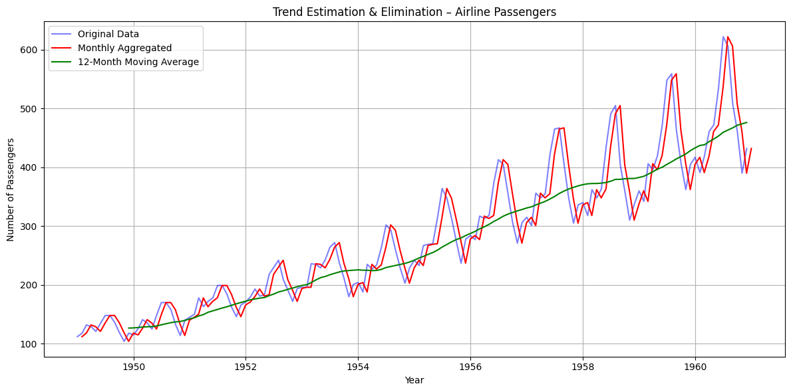

**RESULT :** Thus trends has been estimated and eliminated using aggregating and smoothing techniques.