**Mixed Bag II** (60 points)

This is the second in the series of monthly problem sets. The rules and regulations have been clearly enlisted in the site and mailed to you as well. Some general points and additional instructions are enumerated below:

1. This entire set can be attempted in **2.5 hours**. The form shall get automatically submitted thereafter.

2. THIS FORM SHALL BE EVALUATED AUTOMATICALLY. Hence, ensure that all the SPELLINGS ARE CORRECT. Otherwise, your answer shall be considered wrong.

3. All the answers MUST be written in UPPER CASE. Not adhering to this may cause your responses to be considered incorrect.

4. In case some answer requires usage of chemical symbols, you can use the symbols as they are (Ca for calcium). There's no need to capitalize them. Also, writing ionic charges is not mandatory. As Google Forms doesn't allow superscripts, in case you want to mention ionic charges for the sake of completeness, write them using Stock notation in brackets. e.g. - Au(III), Ca(II), etc. Instead of using the symbols, you can use the full names of the elements as well.

5. For scientific names of biological organisms, follow standard conventions (Genus name in capitals and species name in lower case). No need to italicize. Also, WRITE FULL SCIENTIFIC NAMES (e.g. Staphylococcus aureus and NOT S. aureus).

6. DO NOT put punctuation marks after your answers (Answers to all the questions in the present set are one word answers, so the trouble with sentences in a paragraph doesn't arise)

6. In case you lose Internet connectivity during the span of 2.5 hours, follow the instructions as mentioned in the rules and regulations. SCREENSHOT OF THE WINDOW MUST BE ATTACHED AS AN EVIDENCE TO SUBSTANTIATE YOUR CLAIM. Ensure that you have taken the screenshot (with the TIME AND DATE clearly visible) before closing this window in such a scenario.

7. We expect fairness and honesty from you. Just because all the forms shall be evaluated automatically doesn't mean that we will not monitor the responses from time to time. Plagiarized answers shall be cancelled and no appeals against it shall be entertained.

**Warm Up Questions (21 points)**

This comprises a set of relatively easy questions. Try to score as best you can!

1. Unscramble the word: ROLEPOPIYT *(2 points)*

Ans. PLEIOTROPY

1. Unscramble the word: RIOTHECKENO *(2 points)*

Ans. KINETOCHORE

1. I keep the sisters attached, but often let them seperate. The event of separation may lead to division (surprisingly, you people call it multiplication!). Who am I?*(1 point)*

Ans. CENTROMERE

1. I am omnivorous. The colourful stripes on the lateral sides of my body might amaze you. In addition to this, scientists consider me as a superb model organism for studying development and gene regulation. My larvae has the remarkable property of organ regeneration! I have even visited space! Tell my scientific name please.

*(1 point)*

Ans. Danio rerio/DANIO RERIO

1. Since my early days, I have been fond of natural history. Thesis work on embryology of the sea spiders earned me a Ph.D. from Johns Hopkins. Then, I probed into regeneration. Later, I focused on the genetics of common fruit fly and my groundbreaking findings were recognised with probably the most prestigious award in physiology! I invited Beadle, Tatum, Pauling, Went, Fox, Bridges and Sturtevant to help me establish the Caltech Department of Biology as one of the most distinguished ones in the world. Please write my full name.

*(1 point)*

Ans. THOMAS HUNT MORGAN

1. I am a technique for separating the components of a mixture. The separation is based on differential partitioning between two distinct phases. I can be used for both purification and analytical purposes. My origin can be traced back to Russia in 1900. The basic principle remains the same, but a plethora of varieties have been developed since then. Tell my name. *(1 point)*

Ans. CHROMATOGRAPHY

1. We are asocial herbivorous marsupials native to Australia. Our diet is so poor in nutrients that we sleep upto 20 hours a day! We might look cuddly but beware of our razor-sharp teeth and claws! Due to the destruction of our natural habitat and poaching, we have been listed as 'Vulnerable' by the IUCN. Who are we? *(1 point)*

Ans. KOALA/PHASCOLARCTOS CINEREUS/Phascolarctos cinereus

1. Find the odd one out: deletion, insertion, transition, translocation, transversion *(1 point)*

Ans. TRANSLOCATION

1. Gregor Johann Mendel : Genetics :: Frederick Sanger : ? *(1 point)*

Ans. GENOMICS

1. "Cut and paste" mechanism : Type II transposons :: "Copy and paste" mechanism : ?*(2 points)*

Ans. TYPE I TRANSPOSONS/RETROTRANSPOSONS/L1 RETROTRANSPOSONS

1. The members of the family Channichthyidae (composed of crocodile icefishes) are the only known vertebrates to lack hemoglobin in their blood as adults! That's why we often call them "white-blooded fishes". Even myoglobin is absent from all icefish skeletal muscles. RBCs are usually absent too and the blood plasma carries oxygen throughout the body. During their evolution, the heightened levels of nitric oxide (that followed as an inevitable consequence of the loss of hemoglobin and myoglobin) may have actually provided an automatic compensation (e.g. enhanced angiogenesis).

Which of the following options is compatible with this unique mode of living? *(2 points)*

1. The members have high metabolic rates.
2. Oxygen is highly soluble in water under the environmental conditions they live.
3. They have lower blood volumes, smaller hearts, and lower cardiac output compared to other fish.
4. Their ventricle muscles (in heart) are hypertrophic and very spongy (enabling them to absorb oxygen directly from the blood).
5. They possess decreased mitochondrial density, and rudimentary microvasculature.
6. Both A and B.
7. Both C and D.
8. Both B and D.
9. A, B and E are correct.
10. A, B and D are correct.

Ans. H

1. The vermiform appendix of the human caecum has a bad reputation — it can cause a lot of trouble and even threatens a person’s life in the cases of inflammation. Traditionally it was considered that the appendix was a vestigial organ that didn’t actually have any practical benefits. However, according to modern notions it might have important role(s) like: *(2 points)*
2. It houses cellulolytic microbes which help us in digesting lignocellulosic biomass.
3. It serves as a haven for beneficial gut microflora when illness flushes those friendly microbes from the rest of the intestines.
4. It helps in immune defence against invading pathogens.
5. Both options A and B.
6. Both options B and C.
7. Both options A and C.
8. All A, B and C are correct.

Ans. E

1. After pollination, one of the compatible pollens will germinate into a tube-like structure. The pollen tube develops a defined tip growth area that promotes directional growth and elongation of the tube due to a calcium gradient along the style. This particular phenomenon is an example of: *(1 point)*
2. Thigmotropism
3. Skototropism
4. Thermotropism
5. Apheliotropism
6. Gravitropism
7. Chemotropism
8. Hygrotropism
9. Hydrotropism

Ans. F

1. Which of the following organisms look like a member of the Kingdom Fungi to you? *(2 points)*

A)

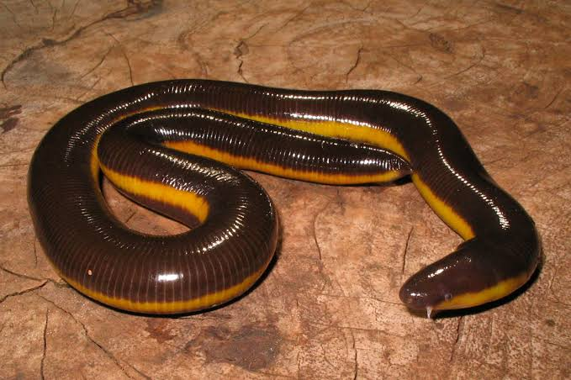

B)

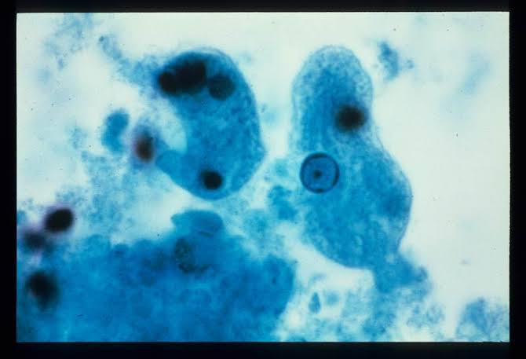

C)

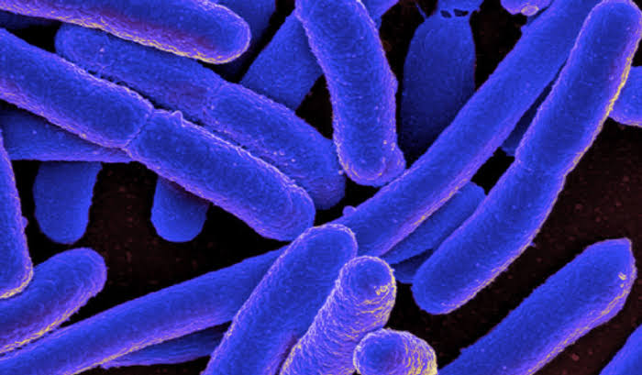

D)

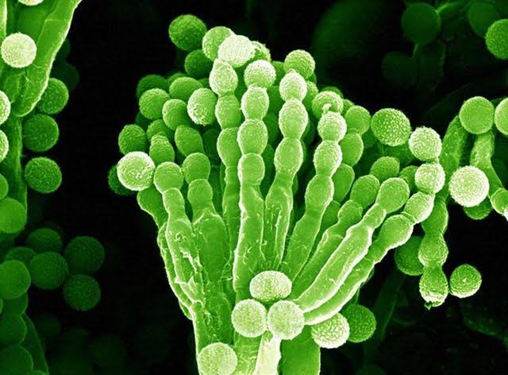

Ans. D

1. The pedigree chart shown below is that for a non-lethal disease. What pattern of inheritance does this trait follow? *(1 point)*

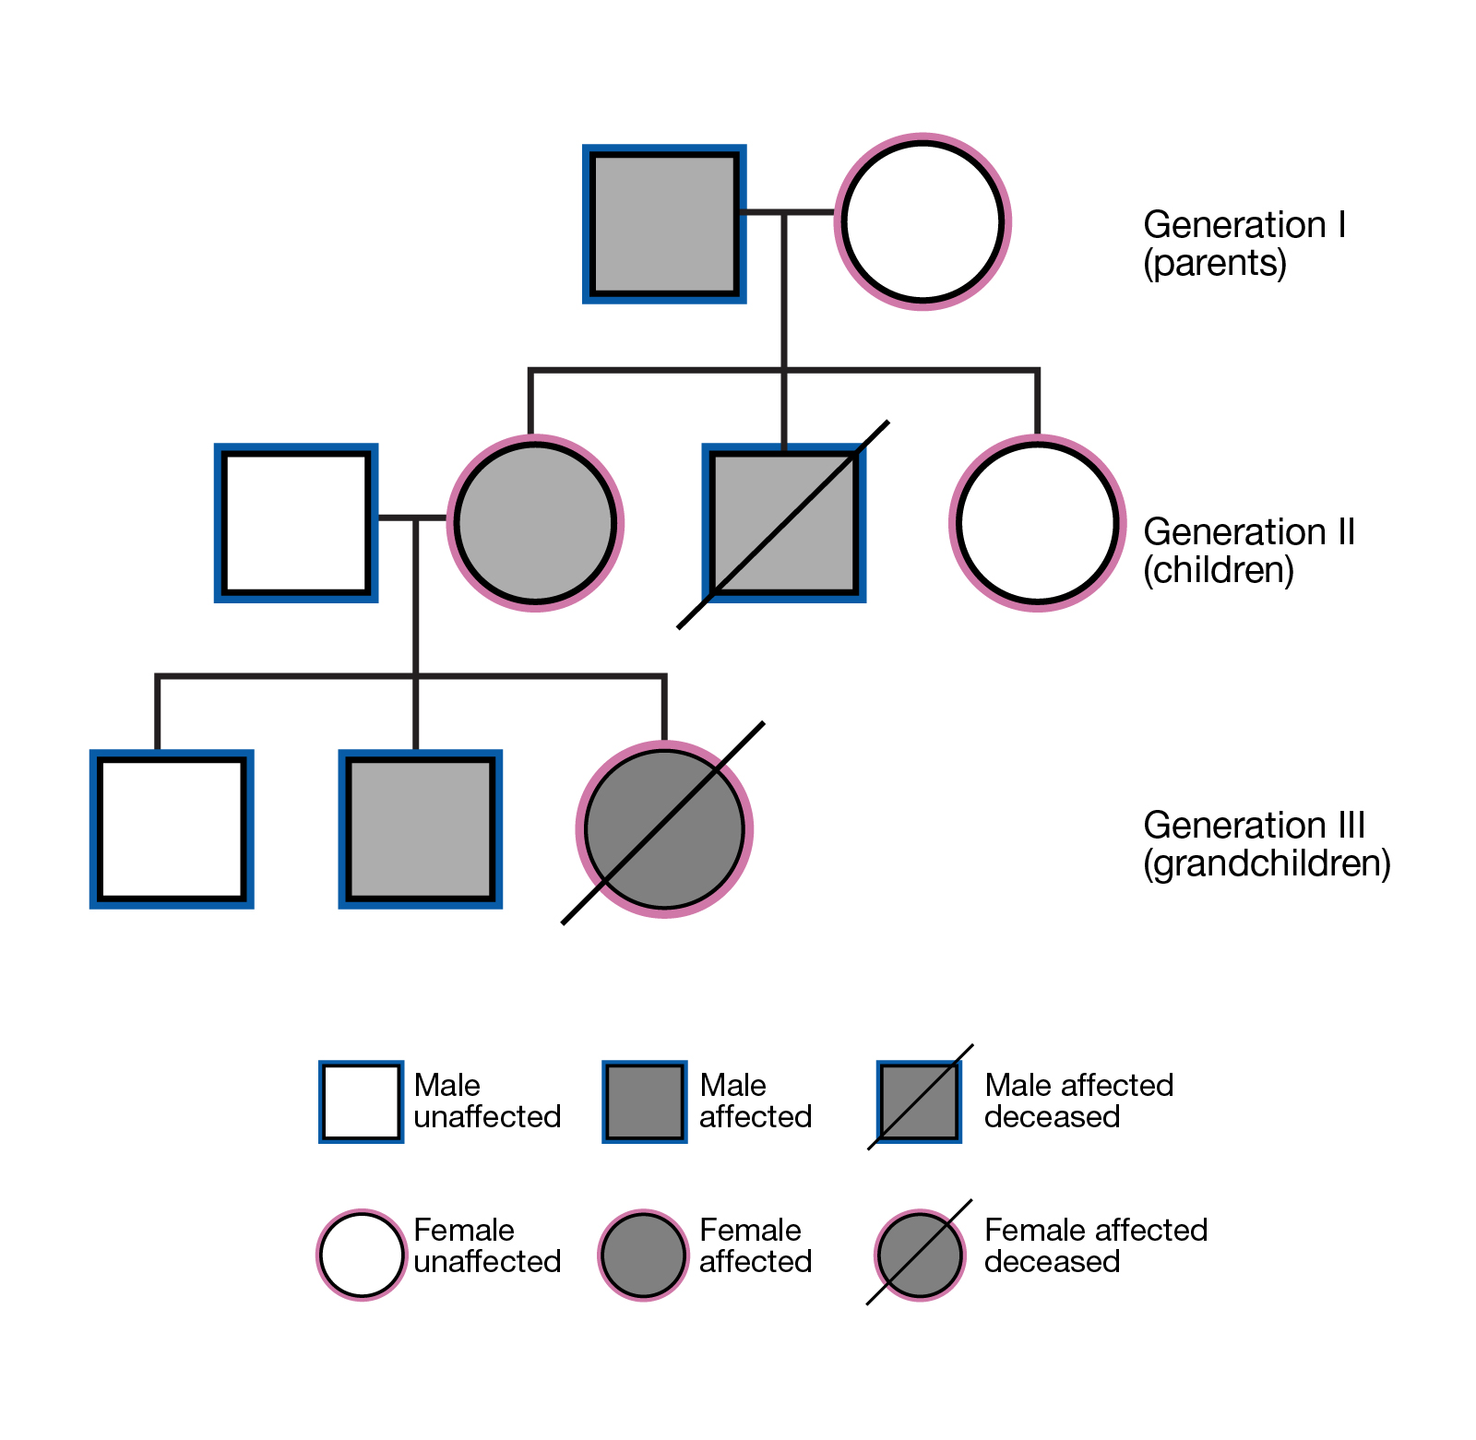

1. Autosomal dominant
2. Autosomal recessive
3. X-linked dominant
4. X-linked recessive
5. Y-linked
6. Maternal

Ans. A/C

**Buzz Your Brains** (39 points)

This section comprises more involved and thought provoking questions than the previous ones. Best of Luck!

1. A population grows in continuous time according to the logistic model. The rate of population growth per individual *(2 points)*

A) declines more slowly with population size (N) after the carrying capacity (K) is increased

B) at first increases, and then decreases, as population size increases

C) increases with an increase in the intrinsic rate r for all N < K

D) A & C are true

E) B & C are true

**Answer: D**

1. A density-dependent population grows according to

dN/dt = 0.4*N* – 0.002, where *N* is the population size at time t.

The carrying capacity is: *(3 points)*

A) 50

B) 80

C) 200

D) 800

E) need further information

**Answer: C**

1. As a geneticist studying the transmission of human genetic traits, you collected the following data from the families of some of your friends

|  |  |  |
| --- | --- | --- |
| Mating | Number of offspring who are tasters | Number of offsprings who are non-tasters |
| taster x taster | 654 | 76 |
| taster x non-taster | 354 | 205 |
| non-taster x non-taster | 7 (?) | 98 |

Here taster refers to the ability to taste PTC. The non-taster allele is recessive. The phenotype is controlled by a single Mendelian gene. Is the population in Hardy-Weinberg equilibrium (while calculating frequencies pertaining to the progeny, assume that all parents are dead, and hence only progeny constitute the gene pool at that instant)? While doing your calculations, kindly note that your conclusion must be made solely from an experimentalist’s point of view using just the available data. Do not try to account for human social dynamics, etc. (For example, everyone knows humans don’t mate randomly. But that is NOT a criterion to say that the given population will not be in Hardy Weinberg equilibrium. Your answer must be based solely on trite mathematical logic. Also note that anomalies do occur in real life. Here, such an anomaly is indicated by a question mark. While working as an experimentalist, it’s best to ignore such anomalous phenotypes, or to use them while calculating total population size, but NOT to use them individually, isolated from the rest of the data, to make **any** conclusions. Also note that the question is absolutely correct and doable, and is not the result of any typographical error, any counting error by a drunken researcher or the lunacy of any crazy question setter framing problem sets in his/her sleep.) *(4 points)*

1. Yes
2. No
3. Can’t comment as data inconclusive
4. Hardy-Weinberg equilibrium doesn’t hold for humans

**Answer:B**

**4.**

Raman and Sheetal are both diagnosed with Down’s syndrome. What is the probability that the offspring produced by them will be affected by Down’s syndrome? Enter your answer in decimals correct to 3 decimal places. Assume that 3+0 segregation of chromosomes is NOT taking place. Also note that tetrasomy of the 21st chromosome also leads to Down’s syndrome. Assume, for the sake of this question, that pentasomy and hexasomy of chromosome 21 do NOT lead to Down’s syndrome, and die ***IN UTERO***. *(4 points)*

**Answer: 0.399**

**5.**

In a vast majority of lower vertebrates, environment holds the sex determining switch. However it can be altered and superseded by the injection of hormones. Answer the following questions on the basis of the modes of sex determination:

***i)*** Some fishes are bought from a market. Karyotyping them reveals that their genotype is XY. However, growing them in waters having estradiol leads to female sex. This exemplifies environmental mode of sex determination *(2 points)*

1. True
2. False
3. Data inconclusive

**Answer: a**

***ii)*** In a species of reptile, lower temperature (~20 ℃) leads to development of femaleness and higher temperature (~45 ℃) leads to development of maleness. Embryos growing at 45 ℃ are treated with estradiol. The embryos were observed to be female. However, when embryos growing at 20 ℃ are administered testosterone, the embryos are strangely found to be females. Which of the following statement(s) is/are **correct**? *(2 points)*

1. This proves that the mode of sex determination is NOT environmental in this species
2. This proves that sex development is completely random in this species.
3. This confirms environmental mode of sex determination. Aromatase enzyme present in the embryos leads to the development of femaleness even on being treated with testosterone
4. Genetic mode of sex determination is the most possible hypothesis under the given experimental conditions

**Answer: c**

**6.**

***i)*** The speaker of the last Biocognizance talk, Dr. TNC Vidya, was speaking about her work on the social behaviour of Asian Elephants in the Kabini project. Now imagine that you are surveying a population of Kabini elephants for your thesis. You are tasked with finding the total number of elephants in the area. You mark 100 elephants with a yellow mark of indelible paint on their right forelimb. Your colleague marks 115 different (not marked by you) elephants with a blue paint on their left hindlimb. After a week, out of a total sighting of 90 elephants, you find 35 tagged with yellow paint and 42 with blue paint. What can be the best “estimate” of the total number of elephants in the area? *(4 points)* Hint: Take mean for best estimate. Do note that fractional elephants **do not** exist!

**Answer: 250/251/252**

***ii)*** During the day, you use a drone to survey the area. During the day, when elephants are busy foraging, there are as many as 58 groups of elephants. At night however, you find only 10 groups. What does this tell you about the structure of elephant society? *(4 points)*

1. Elephants are asocial
2. Elephants have a fission-fusion based society
3. Mating activity is restricted to mostly nights and hence elephants form large groups of males and females together, while in the day time males and females get fragmented into small groups and forage in unisexual groups of a particular number of individuals.
4. Elephant social hierarchy dictates that each caste of elephants must forage only with members of the same caste, while at night all castes of a large herd come together with the food gathered.

**Answer: B**

**7.**

The red bread mold *Neurospora crassa* grows well on a cultural plate with "minimal" medium which is a fluid containing only a few simple sugars, inorganic salts, and vitamins. *Neurospora* that grows normally in nature (wild type) has enzymes that convert these simple substances into the amino acids necessary for growth. Mutating any one of the genes that makes an enzyme can produce a *Neurospora* strain that cannot grow on minimal medium. The mutant would only grow if the enzyme product were to be added as a supplement. On the other hand, if a "complete" medium is provided, containing all required amino acids, then *Neurospora* would grow, with or without mutation.

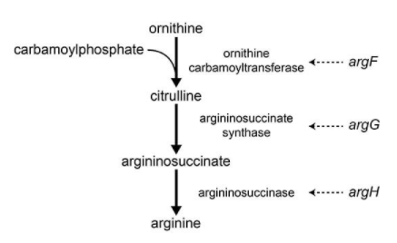

A synthesis pathway for the amino acid arginine. Each gene in italics in the diagram produces one enzyme necessary for the synthesis of this essential amino acid required for growth

Two mutants are produced in the laboratory. Growth response of mutant strains in "minimal" media with supplements as indicated. Growth is indicated by (+), and no growth is indicated by (-):

|  |  |  |  |  |  |
| --- | --- | --- | --- | --- | --- |
| Mutant strain | “Nothing” (no supplement added to minimal media) | Ornithine  added | Citrulline  added | Argininosuccinate  added | Arginine  added |
| A | - | - | - | + | + |
| B | - | - | - | + | + |

Answer the following questions based on this:

***i)*** According to the information provided, which enzyme is **not** defective in either of the mutant strains? (*2 points)*

1. Ornithine carbamoyltransferase
2. Argininosuccinase
3. Argininosuccinate synthase
4. ALL enzymes in the arginine biosynthesis pathway are defective in both the strains.

**Answer: B**

***ii)*** Experiments using the two mutant strains A and B, reveal that strain A accumulates citrulline, but strain B does not. Which of the following statements is most consistent with the data provided? *(2 points)*

1. Strain B has a single mutation in its genome.
2. Strain A has mutation in *argF* only.
3. Strain A has mutation in all the genes encoding enzymes of the given pathway.
4. Strain A has mutation in *argG* only.

**Answer: D**

**8.**

Several mutants of a fungus are isolated, all of which require compound G for growth. The compounds A, B, C, D and E in the biosynthetic pathway to G are known, but their order in the pathway is not. Each compound is tested for its ability to support the growth of each mutant (1, 2, 3, 4, 5; assume each of them are mutants for only one gene). Growth response of the mutants in minimal media supplemented with the indicated compound is provided in the following table:

|  |  |  |  |  |  |  |
| --- | --- | --- | --- | --- | --- | --- |
| Mutant | A added | B added | C added | D added | E added | G added |
| 1 | - | - | - | + | - | + |
| 2 | - | + | - | + | - | + |
| 3 | - | - | - | - | - | + |
| 4 | - | + | + | + | - | + |
| 5 | + | + | + | + | - | + |

Answer the following questions using the given information:

***i)*** What is the order of compounds A to E in the pathway? Enter your answer in the space provided below. In your answer, the first compound from the left must be the first compound in this metabolic pathway. Write the remaining compounds in order, from left to right. Do not separate the compounds by comma, space etc. For example, if the order of compounds is , enter AEBCD. Be very careful, the answer IS CASE SENSITIVE. *(5 points)*

**Answer: EACBD**

***ii)*** Would a heterokaryon of mutants 1 and 3 survive in a minimal media? *(5 points)*

1. Yes
2. No
3. Can’t comment

**Answer: A**