
Latent In-Room Occupancy from Hotel Booking Telemetry: Evidence for Dynamic HVAC Load Prediction
https://jurnal.uns.ac.id/ijas
E-ISSN: 2621-086X

Aryanto 1 ¹ , Meyhard B. Sitorus 2 ¹*
¹ Mathematics, Cenderawasih University, Jayapura, Indonesia
² Electro, Institut Teknologi PLN, DKI Jakarta, Indonesia
* Corresponding Author. E-mail: meyhard.sitorus@itpln.ac.id

Abstract
Hotel property-management systems report sales occupancy that overstates how many rooms are physically in use, which distorts the weather-and-occupancy baselines used to predict and verify HVAC energy. This study quantifies that divergence and tests whether in-room presence improves HVAC load prediction, using 19 monthly billing cycles from a commercial hotel retrofitted with an IoT automation platform. A two-stage workflow was evaluated with leave-one-out and nested cross-validation: Stage 1 forecasts physical occupancy from sales occupancy, season and cooling degree days, and Stage 2 predicts HVAC energy with and without presence features. Physical occupancy averaged 0.637 against 0.874 for sales occupancy, so 26.4% of sold rooms were not physically occupied, and the two series were essentially uncorrelated (r = 0.21). Stage 1 did not generalise (nested R² = −0.79; MAE = 0.082), indicating that latent presence must be sensed rather than inferred at this data scale. In Stage 2, adding sensed presence and the occupancy gap raised the best leave-one-out R² from 0.549 to 0.723 and reduced MAE from 45,525 to 34,580 kWh, but with ten observations the improvement is not statistically established (bootstrap 95% interval of the MAE reduction: −7.0 to 27.8 MWh). Vendor-claimed savings of 296 MWh could not be verified from the data. The paper closes with evidence-graded statements on dynamic HVAC efficiency and practical recommendations: sensor-first deployment, sub-metering, daily-resolution baselines and independent measurement and verification.
Keywords: latent occupancy; hotel HVAC; IoT telemetry; energy load prediction; measurement and verification


This is an open access article under the Creative Commons Attrribution-ShareAlike 4.0 International License
How to Cite:
Aryanto, Sitorus Meyhard B., “Latent In-Room Occupancy from Hotel Booking Telemetry: Evidence for Dynamic HVAC Load Prediction,” Indonesian Journal of Applied Statistics, vol. 12, no. 1, pp. 1-15, 2027, doi: 10.13057/ijas.v8i1.xxxxx.

- INTRODUCTION
Hotels are among the most energy-intensive commercial building types, and heating, ventilation and air-conditioning (HVAC) typically represents the largest single end use, especially in warm climates where cooling dominates [1], [2]. Hotel energy demand is shaped by two families of drivers: outdoor weather, which sets the thermal load on the building envelope, and guest behaviour, which determines when and where conditioned space is actually needed. A substantial body of research shows that occupant presence and behaviour are first-order determinants of building energy use and of the savings that energy conservation measures can deliver [3], [4], [5], [6].
Dynamic HVAC control exploits this fact. Instead of following a fixed schedule, a dynamic controller adjusts set-points, schedules and airflow to measured or predicted conditions, most commonly weather and occupancy. Occupancy-based set-back strategies [7], [8], activity-aware intelligent buildings [9] and model predictive control with weather forecasts [10] have all been proposed to reduce conditioning of unoccupied space. Advances in occupancy sensing [11] and low-cost Internet-of-Things (IoT) devices, such as in-room presence sensors, connected thermostats and sub-meters, now make room-level telemetry available at scale, so that hotels can condition rooms according to physical presence rather than according to bookings.
The occupancy variable that energy analysts usually have at hand is, however, the sales occupancy reported by the hotel property-management system (PMS): the share of rooms that are booked or sold. A sold room is not necessarily an occupied room. Guests leave for sightseeing, business or events, arrive late or leave early, and rooms held for groups may stay empty for long periods. Because the PMS cannot observe presence, physical in-room occupancy is a latent variable from the point of view of booking telemetry. When sales occupancy is used as a covariate in HVAC baseline models, the load driver is mis-specified, and so is any savings estimate derived from the baseline. This matters in practice: IoT automation vendors often report savings against a baseline, and the credibility of such claims depends on how the baseline is built, which is the concern of measurement and verification (M&V) guidance [12], [13].
This paper studies that problem on a real, vendor-anonymised dataset of 19 monthly billing cycles from a commercial hotel undergoing an IoT automation retrofit. We formulate a two-stage predictive workflow in which Stage 1 forecasts latent physical occupancy from booking, seasonal and weather information, and Stage 2 uses presence information to predict HVAC energy. The study is deliberately small-sample, so the validation design, the reporting of uncertainty and the treatment of negative results are part of its contribution. It addresses four research questions:
RQ1. How large and how seasonal is the divergence between sales occupancy and physical presence?
RQ2. Can latent physical occupancy be forecast out of sample from sales occupancy, season and cooling degree days?
RQ3. Does presence information improve HVAC load prediction relative to the traditional baseline that uses weather and sales occupancy?
RQ4. What can be said, and what cannot, about the efficiency of IoT-enabled dynamic HVAC, and what should smart-building operators do with the findings?
The contributions are threefold. First, we quantify the occupancy divergence and show that it is large, seasonal and almost uncorrelated with the booking signal. Second, we provide a transparent two-stage evaluation with leave-one-out and nested cross-validation, a paired bootstrap and an explicit account of selection bias, including a negative result for Stage 1. Third, we translate the evidence into graded scientific statements about dynamic HVAC energy and IoT efficiency, and into concrete recommendations for companies operating smart buildings.
- METHODS
2.1 Study site and data
The data come from one commercial hotel whose HVAC was retrofitted with an IoT automation platform by an energy-analytics vendor. All vendor, product and automation-mode names were replaced by neutral descriptors, and the property is not identified. The dataset has 19 monthly billing cycles from June 2024 to December 2025. Occupancy sensing data are available from November 2024 (14 cycles), whereas HVAC sub-metering and the full automation platform cover March to December 2025 (10 cycles). Cooling degree days (CDD) with an 18 °C base temperature are available for all cycles. The set-back set-point was 25 °C until June 2025 and 24 °C from July 2025. Table 1 lists the variables.
Table 1. Variables used in the study (anonymised schema).
Symbol | Variable | Unit | n | Role in the workflow
$$E^{tot}$$ | Total metered energy | kWh/cycle | 19 | Descriptive; reconciliation
$$E^{HVAC}$$ | HVAC sub-metered energy | kWh/cycle | 10 | Stage-2 target
$$E^{non}$$ | Non-HVAC energy | kWh/cycle | 10 | Reconciliation
$$S^{claimed}$$ | Savings claimed by the vendor | kWh/cycle | 10 | Benchmark only, never a model input
$$O^{sales}$$ | PMS sales occupancy | ratio (0–1) | 19 | Stage-1 input; Pipeline A input
$$O^{phys}$$ | IoT-derived physical occupancy | ratio (0–1) | 14 | Stage-1 target; Pipeline B input
$$ΔO$$ | Occupancy gap | ratio | 14 | Derived, Eq. (2)
CDD | Cooling degree days, base 18 °C | °C·day/cycle | 19 | Weather driver, Eq. (5)
$$θ$$ | Cyclical month encoding | — | 19 | Seasonality, Eq. (4)
— | Automation-mode shares (standard, deep, disabled) | ratio | 14 | Context and correlation analysis

The physical occupancy ratio is the platform-derived share of rooms with presence detected, expressed on the same 0–1 scale as sales occupancy. Its exact aggregation (room-nights or room-hours) is defined by the platform and was not available to the authors; this is acknowledged as a limitation in Section 3.12.
2.2 Data preparation (Steps 1 to 5)
Step 1 – Schema harmonisation. Raw column names were mapped to a vendor-neutral schema, numeric fields were coerced, the set-point strings (for example, "24c") were converted to degrees Celsius and automation-mode shares were set to zero where missing.
Step 2 – Energy reconciliation. For every sub-metered cycle, the identity in (1) was verified. The residual was exactly zero in all ten cycles, so total, HVAC and non-HVAC series are mutually consistent.
$E_{t}^{tot}=E_{t}^{HVAC}+E_{t}^{non}$ (1)
Step 3 – Occupancy divergence. The absolute gap and the gap ratio between booked and physically present rooms are defined in (2) and (3). A ratio of 0.26 means that 26% of sold rooms were not physically occupied.
$ΔO_{t}=O_{t}^{sales}-O_{t}^{phys}$ (2)
$ρ_{t}=\frac{ΔO_{t}}{O_{t}^{sales}}$ (3)
Step 4 – Seasonality. The calendar month m_{t} is encoded cyclically, so that December and January are neighbours, using (4). Months are also mapped to four tropical regimes: cool-dry (November to February), hot-dry (March to May), monsoon (June to September) and post-monsoon (October).
$sinθ_{t}=sin\left(\frac{2πm_{t}}{12}\right), cosθ_{t}=cos\left(\frac{2πm_{t}}{12}\right)$ (4)
Step 5 – Weather driver. Cooling degree days accumulate the daily mean outdoor temperature excess above the 18 °C base over the days d in each billing cycle, as in (5) [14]. Weather-normalised HVAC intensity is then defined in (6), together with a presence-normalised variant.
CDDt=d∈t​maxTd-18, 0 (5)
$I_{t}=\frac{E_{t}^{HVAC}}{{CDD}_{t}}, I_{t}^{phys}=\frac{E_{t}^{HVAC}}{{CDD}_{t}⋅O_{t}^{phys}}$ (6)
2.3 Two-stage formulation
The workflow in Figure 1 has two stages. Stage 1 treats physical occupancy as a latent quantity to be forecast from information that is available without sensors, as in (7). Stage 2 predicts HVAC energy from weather and from the Stage-1 or sensed presence signal, as in (8). The functions f₁ and f₂ are learned with the estimators of Section 2.4, and every feature is standardised by (9) inside the cross-validation loop so that no test information leaks into training.
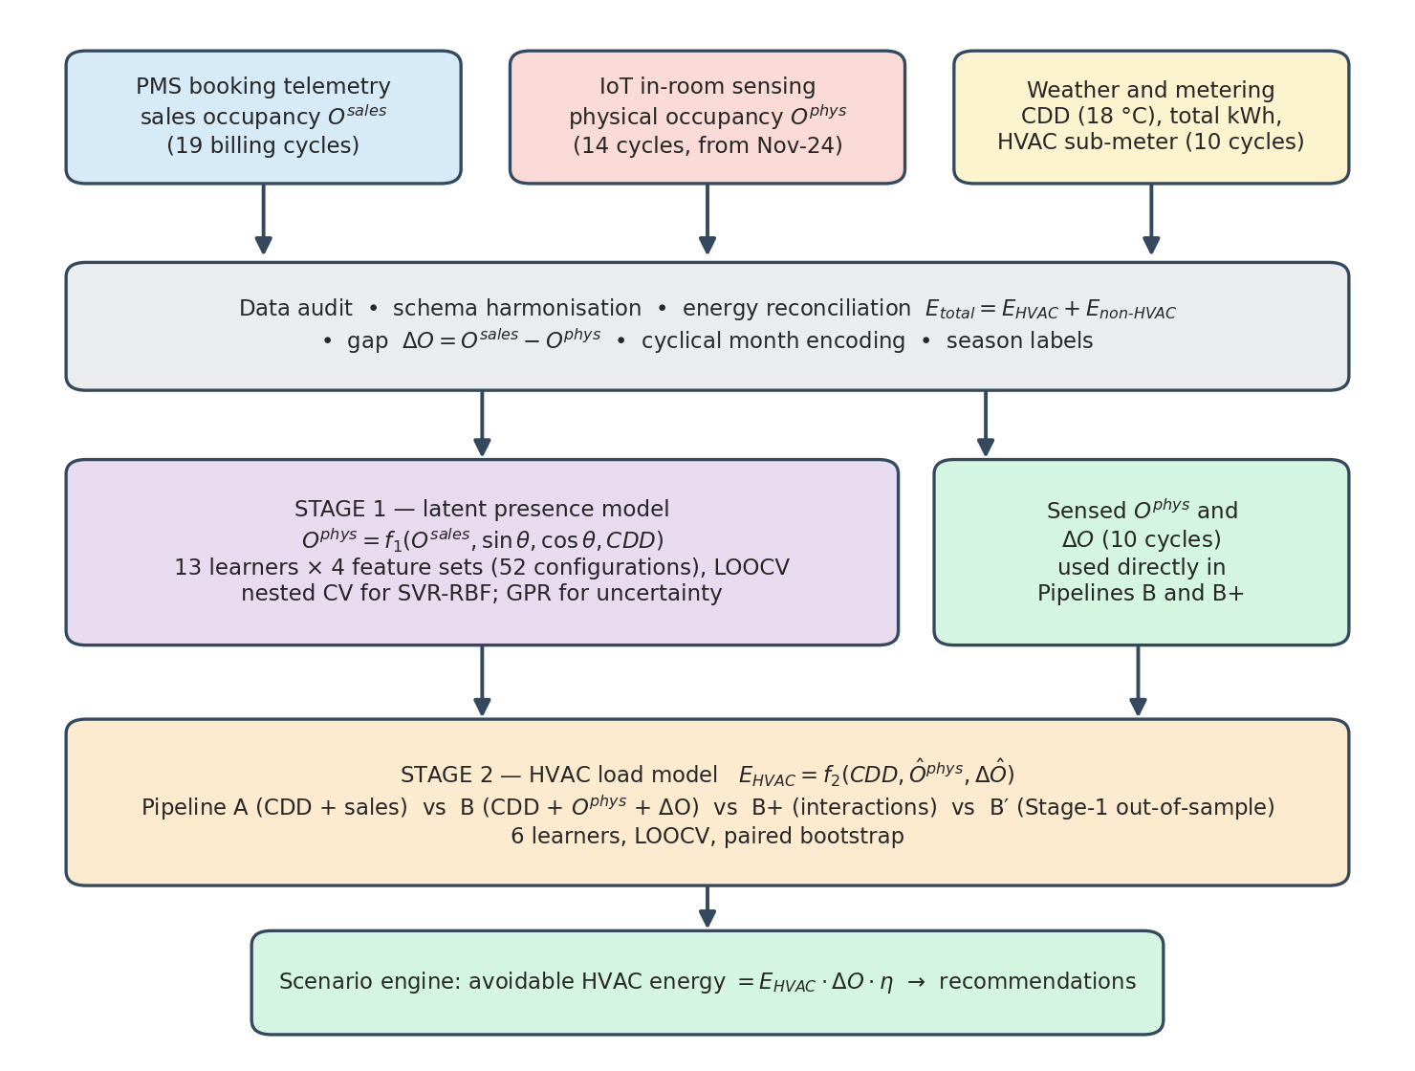
Figure 1. Two-stage workflow used in this study: data audit, Stage 1 latent presence model, Stage 2 HVAC load model and scenario engine.
$O_{t}^{phys}=f_{1}\left(O_{t}^{sales}, sinθ_{t}, cosθ_{t}, {CDD}_{t}\right)+ε_{t}$ (7)
$E_{t}^{HVAC}=f_{2}\left({CDD}_{t}, {\hat{O}}_{t}^{phys}, Δ{\hat{O}}_{t}\right)+u_{t}$ (8)
$z_{tj}=\frac{x_{tj}-{\overset{‾}{x}}_{j}}{s_{j}}$ (9)
Four Stage-1 feature sets were compared: F1 (sales occupancy only), F2 (sales occupancy plus cyclical month), F3 (sales occupancy plus CDD) and F4 (sales occupancy, cyclical month and CDD). Four Stage-2 pipelines were compared and are defined in Table 2. Pipeline A is the traditional baseline. Pipeline B replaces sales occupancy by sensed physical occupancy and the gap. Pipeline B+ adds the weather interactions of (10). Pipeline B′ feeds Stage-2 with the out-of-sample Stage-1 forecast, which tests the complete end-to-end chain without sensors.
$x_{t}^{\left(1\right)}={CDD}_{t} O_{t}^{phys}, x_{t}^{\left(2\right)}={CDD}_{t} ΔO_{t}$ (10)
Table 2. Stage-2 pipelines and their input features (n = 10 cycles).
Pipeline | Description | Input features | No. of features
A | Traditional baseline | CDD, $O^{sales}$ | 2
B | Latent-presence architecture | CDD, $O^{phys}$, $ΔO$ | 3
B+ | Latent presence with weather interaction | CDD, $O^{phys}$, $ΔO$, CDD·$O^{phys}$, CDD·$ΔO$ | 5
B′ | End-to-end with Stage-1 out-of-sample forecast | CDD, ${\hat{O}}_{oos}^{phys}$, $Δ{\hat{O}}_{oos}$ | 3

2.4 Learners
Stage 1 benchmarked 13 learners: a mean-only baseline, ridge, lasso, elastic net, Bayesian ridge, Huber regression, k-nearest neighbours (k = 3), support vector regression (SVR) with RBF and linear kernels, Gaussian process regression (GPR), random forest, extra trees and gradient boosting. Combined with the four feature sets this gives 52 configurations. Stage 2 used six learners with strong regularisation because only ten observations are available: ridge, lasso, SVR-RBF, GPR, random forest and gradient boosting.
Ridge [15] and lasso [16] solve the penalised least-squares problems in (11) and (12), where α controls shrinkage. Elastic net [17] mixes the two penalties, and Huber regression [18] replaces the squared loss by a robust loss.
${\hat{β}}^{ridge}=arg\min_{β} ∥y-Xβ∥_{2}^{2}+α∥β∥_{2}^{2}$ (11)
${\hat{β}}^{lasso}=arg\min_{β} \frac{1}{2n}∥y-Xβ∥_{2}^{2}+α∥β∥_{1}$ (12)
Support vector regression [19], [20] finds a function that deviates from the targets by at most ε while remaining as flat as possible. The primal problem is given in (13), where C trades flatness against violations and ξ, ξ* are slack variables. The dual solution yields the prediction function and the RBF kernel in (14), with kernel width γ.
$\min_{w,b,ξ,ξ^{*}} \frac{1}{2}∥w∥^{2}+C\sum_{t=1}^{n}{\left(ξ_{t}+ξ_{t}^{*}\right)}$ (13)
$\hat{f}\left(x\right)=\sum_{t=1}^{n}{\left(α_{t}-α_{t}^{*}\right)}K\left(x_{t},x\right)+b, K\left(x,x'\right)=exp\left(-γ∥x-x'∥^{2}\right)$ (14)
Gaussian process regression [21] places a prior over functions and returns, for a new input, both a predictive mean and a predictive variance, as in (15), where K is the kernel matrix of the training inputs, k* the vector of kernel values between the new and the training inputs and σ_{n}² the noise variance. The Stage-1 uncertainty model used a Matérn kernel with smoothness 3/2 [22], given in (16), plus a white-noise term; r is the distance between inputs, ℓ the length scale and σ_{f}² the signal variance.
$μ_{*}=k_{*}^{⊤}{\left(K+σ_{n}^{2}I\right)}^{-1}y, σ_{*}^{2}=k\left(x_{*},x_{*}\right)-k_{*}^{⊤}{\left(K+σ_{n}^{2}I\right)}^{-1}k_{*}$ (15)
$k\left(r\right)=σ_{f}^{2}\left(1+\frac{\sqrt{3} r}{l}\right)exp\left(-\frac{\sqrt{3} r}{l}\right)$ (16)
Random forests [23], extra trees and gradient boosting [24] were run with shallow trees (maximum depth 2 or 3) and minimum leaf sizes chosen to limit variance. All models were implemented in scikit-learn [25] with a fixed random seed of 42.
2.5 Validation protocol and uncertainty
With 14 and 10 observations, a single train-test split would be unreliable, so every reported score is a leave-one-out cross-validated (LOOCV) estimate [26], [27]. For each observation i, the model is trained on the remaining n − 1 observations and predicts the held-out one. The scores are the cross-validated coefficient of determination, the mean absolute error (MAE), the root mean squared error (RMSE) and the mean absolute percentage error (MAPE), given in (17), (18) and (19). A negative R² means that the model predicts worse than the mean of the target.
$R_{cv}^{2}=1-\frac{\sum_{i=1}^{n}{{\left(y_{i}-{\hat{y}}_{-i}\right)}^{2}}}{\sum_{i=1}^{n}{{\left(y_{i}-\overset{‾}{y}\right)}^{2}}}$ (17)
$MAE=\frac{1}{n}\sum_{i=1}^{n}{\left|y_{i}-{\hat{y}}_{-i}\right|}, RMSE=\sqrt{\frac{1}{n}\sum_{i=1}^{n}{{\left(y_{i}-{\hat{y}}_{-i}\right)}^{2}}}$ (18)
$MAPE=\frac{100}{n}\sum_{i=1}^{n}{\left|\frac{y_{i}-{\hat{y}}_{-i}}{y_{i}}\right|}$ (19)
Choosing hyper-parameters on the same folds that are used for reporting inflates performance [28], [29]. The tuned Stage-1 SVR was therefore evaluated by nested cross-validation: for each held-out observation i, hyper-parameters are selected on the remaining data by a six-fold grid search over C, γ and ε, as in (20), and only then is the held-out point predicted. The grid had 7 × 7 × 6 = 294 combinations.
${\hat{θ}}_{-i}=arg\min_{θ∈Θ} \frac{1}{6}\sum_{k=1}^{6}{{MAE}_{k}}\left(θ; D_{-i}\right)$ (20)
Comparing many learners and pipelines and then quoting the best one introduces a second, selection-related optimism [30]. We therefore report, next to the best learner of each pipeline, its median and mean over learners. To quantify sampling uncertainty of the Stage-2 gain, the per-month absolute LOOCV errors of the two champion models, e^{A} and e^{B}, were resampled with replacement 10,000 times [31], giving the bootstrap distribution of the MAE reduction in (21), where I* is a resampled index set. The gain in explained variance and the relative MAE reduction are given in (22).
ΔMAE*=1ni∈I*​eiA-eiB (21)
$ΔR^{2}=R_{B}^{2}-R_{A}^{2}, δ_{MAE}=\frac{{MAE}_{A}-{MAE}_{B}}{{MAE}_{A}}$ (22)
2.6 Statistical diagnostics and scenario engine
Associations are described with Pearson correlation in (23). Because weather drives both HVAC energy and, as will be shown, the occupancy gap, the association between HVAC energy and a presence variable x is also reported after removing a linear CDD effect through the partial correlation in (24), where z = CDD, and collinearity is checked with the variance inflation factor in (25), where R_{j}² comes from regressing predictor j on the others. A simple weather-only baseline is (26).
rxy=i​xi-xyi-yi​xi-x2 i​yi-y2 (23)
$r_{xy⋅z}=\frac{r_{xy}-r_{xz} r_{yz}}{\sqrt{\left(1-r_{xz}^{2}\right)\left(1-r_{yz}^{2}\right)}}$ (24)
${VIF}_{j}=\frac{1}{1-R_{j}^{2}}$ (25)
$E_{t}^{HVAC}=β_{0}+β_{1} {CDD}_{t}+u_{t}$ (26)
Finally, an illustrative scenario engine propagates the occupancy gap into avoidable HVAC energy. For a set-back curtailment efficiency η, the fraction of the HVAC load of unoccupied rooms that a set-back schedule can remove, the avoidable energy and its share of total HVAC energy are given by (27) and (28). The vendor-claimed saving is compared with the implied counterfactual through (29). The scenario sweeps η instead of estimating it, so its output is a sensitivity band and not a verified saving.
Aη=t​EtHVAC⋅minmaxΔOt, 0, 1⋅η (27)
πη=Aηt​EtHVAC×100% (28)
$κ=\frac{S^{claimed}}{E^{HVAC}+S^{claimed}}$ (29)
2.7 Reproducibility
The analysis was executed in a Python notebook (numpy 2.1.3, pandas 2.2.3, scikit-learn 1.6.1). Re-executing the Stage-2 benchmark in a newer environment (scikit-learn 1.8.0) reproduced all 24 LOOCV scores to four decimals. The supplementary statistics in Sections 3.3 and 3.8, the paired bootstrap and the corrected champion diagnostics in Figure 10 were computed from the same embedded dataset and the same fitted predictions.
- RESULTS AND DISCUSSION
This section follows the workflow of Figure 1. Each claim is paired with the table or figure that supports it, so that the reader can check the evidence directly. Sections 3.1 to 3.3 describe the data and answer RQ1, Sections 3.4 and 3.5 address Stage 1 (RQ2), Sections 3.6 to 3.9 address Stage 2 and the scenario analysis (RQ3), and Sections 3.10 to 3.12 answer RQ4 with graded scientific statements, recommendations and limitations.
3.1 Energy composition, weather and HVAC intensity
Table 3 summarises the eight quantitative variables. Total metered energy averaged 256,857 kWh per cycle with a coefficient of variation (CV) of 32.8%, while the sub-metered HVAC energy was more variable (CV 56.3%) than the non-HVAC load (CV 25.5%). Physical occupancy had a low CV (13.3%) compared with sales occupancy (25.3%), an early sign that presence is a smoother signal than bookings.
Table 3. Descriptive statistics of the study variables.
Variable | n | Mean | SD | Min | Median | Max | CV (%)
Total energy (kWh) | 19 | 256,857 | 84,159 | 152,774 | 239,303 | 441,808 | 32.8
HVAC energy (kWh) | 10 | 150,831 | 84,890 | 37,307 | 135,493 | 274,747 | 56.3
Non-HVAC energy (kWh) | 10 | 135,111 | 34,462 | 88,952 | 136,044 | 187,241 | 25.5
Sales occupancy | 19 | 0.807 | 0.204 | 0.220 | 0.876 | 0.979 | 25.3
Physical occupancy | 14 | 0.637 | 0.085 | 0.510 | 0.635 | 0.780 | 13.3
Occupancy gap | 14 | 0.237 | 0.114 | 0.044 | 0.220 | 0.409 | 48.2
CDD (base 18 °C) | 19 | 242.1 | 130.1 | 18.8 | 288.9 | 399.7 | 53.8
Vendor-claimed savings (kWh) | 10 | 29,612 | 8,229 | 14,554 | 30,426 | 41,505 | 27.8

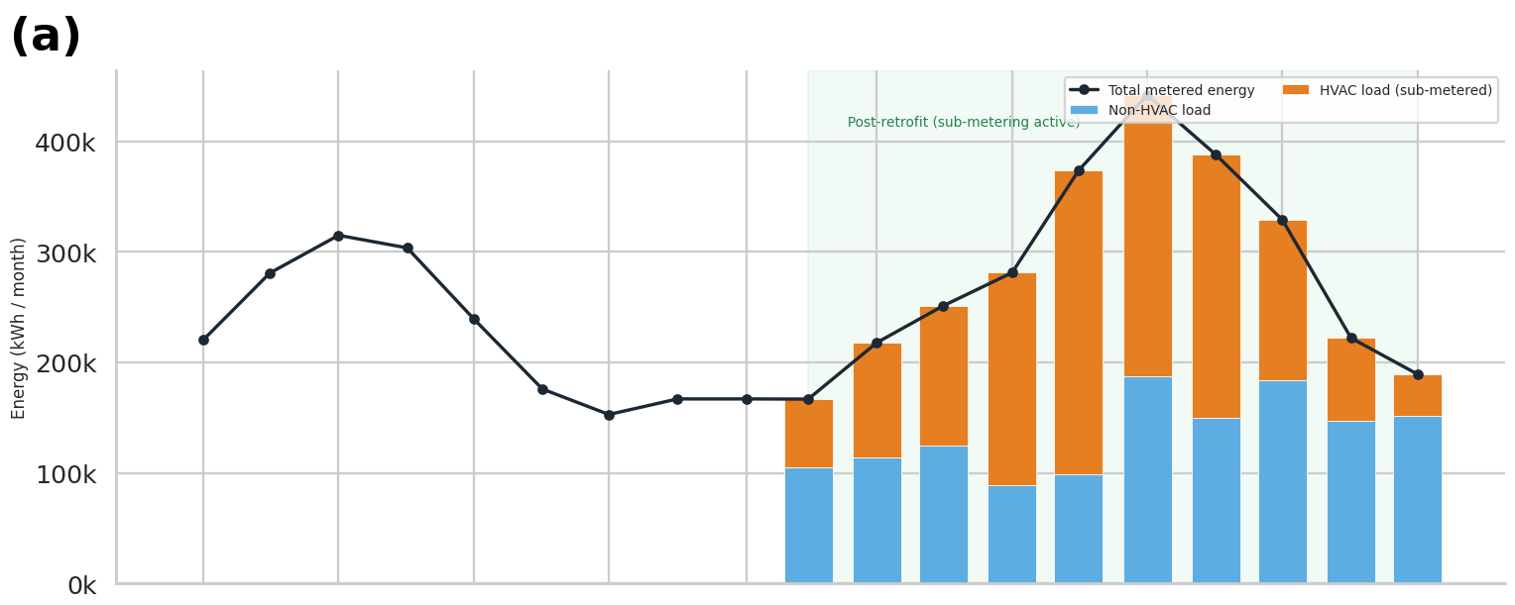
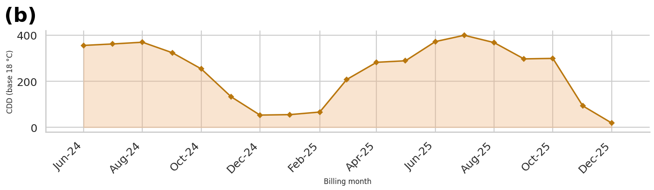
Figure 2. Energy and weather time series. (a) Monthly total, HVAC and non-HVAC energy, with the post-retrofit sub-metering window shaded. (b) Cooling degree days (base 18 °C).
Figure 2a shows that the HVAC component rises and falls with the cooling season and reaches its maximum in July 2025 (274,747 kWh), while the total energy peaks in August 2025 (441,808 kWh). Figure 2b shows the matching CDD profile, which peaks at 399.7 °C·day in July 2025 and falls to 18.8 °C·day in December 2025. Over the ten sub-metered cycles HVAC accounted for 52.7% of total energy, with a monthly share between 19.7% (December 2025) and 73.6% (July 2025).
A weather-only baseline, (26), explains much of the HVAC variation. The ordinary least squares fit has a slope of 578.7 kWh per CDD, an intercept of −1,216 kWh and R² = 0.706 (p = 0.0023), as drawn in Figure 4b. Weather normalisation is, however, not sufficient. Table 4 shows that the intensity I of (6) is far from constant: it rises from 299 kWh/CDD in March 2025 to 1,984 kWh/CDD in December 2025, when the cooling demand is small but ventilation, dehumidification and other fixed loads continue. A model that is proportional to CDD therefore cannot be correct at the cool end of the season, which motivates non-linear learners and additional drivers.
Table 4. HVAC energy metrics per billing cycle: share of total, weather-normalised intensity I, presence-normalised intensity I^{phys} (Eq. (6)) and vendor-claimed share κ_{t} of the implied counterfactual (Eq. (29)).
Cycle | Total (kWh) | HVAC (kWh) | HVAC share (%) | CDD | I (kWh/CDD) | I^{phys} (kWh/CDD) | κ_{t} (%)
Mar-25 | 166,697 | 62,073 | 37.2 | 207.6 | 299 | 475 | 27.9
Apr-25 | 217,823 | 103,763 | 47.6 | 282.4 | 367 | 565 | 24.6
May-25 | 251,150 | 126,260 | 50.3 | 288.9 | 437 | 728 | 19.3
Jun-25 | 281,019 | 192,067 | 68.3 | 372.3 | 516 | 874 | 13.7
Jul-25 | 373,382 | 274,747 | 73.6 | 399.7 | 687 | 1,074 | 10.0
Aug-25 | 441,808 | 254,567 | 57.6 | 368.0 | 692 | 1,017 | 12.7
Sep-25 | 387,664 | 238,120 | 61.4 | 297.2 | 801 | 1,068 | 14.8
Oct-25 | 328,791 | 144,727 | 44.0 | 299.3 | 484 | 620 | 19.5
Nov-25 | 221,875 | 74,678 | 33.7 | 93.2 | 801 | 1,041 | 20.4
Dec-25 | 189,208 | 37,307 | 19.7 | 18.8 | 1,984 | 3,053 | 28.1
The cycle-level κ_{t} uses the vendor-claimed saving of the same cycle; it is a claim, not a measured saving.
3.2 Occupancy divergence (RQ1)
Table 5 and Figure 3 give the central result of the descriptive analysis. Over the 14 cycles with presence sensing, mean sales occupancy was 0.874 and mean physical occupancy was 0.637. The mean gap was 0.237 occupancy points, and on average 26.4% of sold rooms were not physically occupied. The gap was never negligible: it ranged from 0.044 (July 2025) to 0.409 (December 2024).
Table 5. Sales occupancy, physical occupancy and the occupancy gap per billing cycle (Eqs. (2) and (3)).
Cycle | Season | O^{sales} | O^{phys} | ΔO | ρ (%)
Nov-24 | Cool-dry | 0.929 | 0.530 | 0.399 | 42.9
Dec-24 | Cool-dry | 0.969 | 0.560 | 0.409 | 42.2
Jan-25 | Cool-dry | 0.917 | 0.580 | 0.337 | 36.8
Feb-25 | Cool-dry | 0.875 | 0.510 | 0.365 | 41.7
Mar-25 | Hot-dry | 0.876 | 0.630 | 0.246 | 28.1
Apr-25 | Hot-dry | 0.866 | 0.650 | 0.216 | 24.9
May-25 | Hot-dry | 0.825 | 0.600 | 0.225 | 27.3
Jun-25 | Monsoon | 0.722 | 0.590 | 0.132 | 18.3
Jul-25 | Monsoon | 0.684 | 0.640 | 0.044 | 6.4
Aug-25 | Monsoon | 0.750 | 0.680 | 0.070 | 9.3
Sep-25 | Monsoon | 0.920 | 0.750 | 0.170 | 18.5
Oct-25 | Post-monsoon | 0.978 | 0.780 | 0.198 | 20.2
Nov-25 | Cool-dry | 0.979 | 0.770 | 0.209 | 21.3
Dec-25 | Cool-dry | 0.942 | 0.650 | 0.292 | 31.0
Mean |  | 0.874 | 0.637 | 0.237 | 26.4

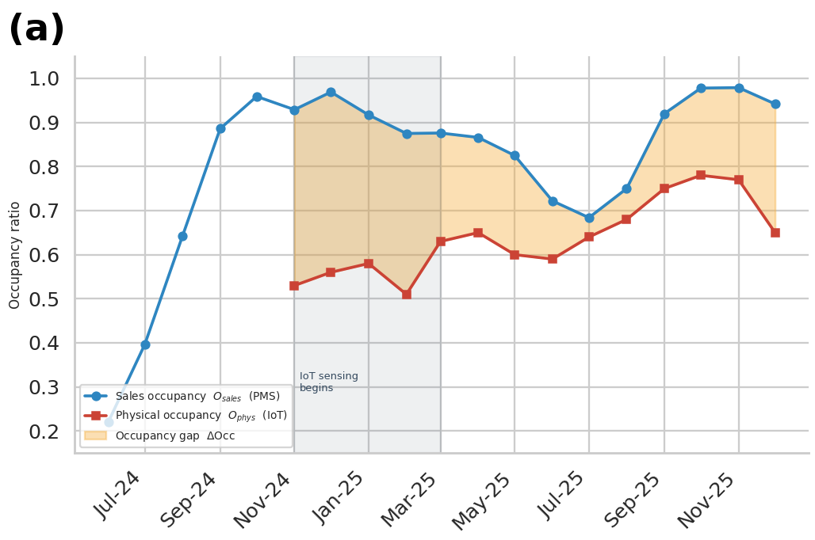
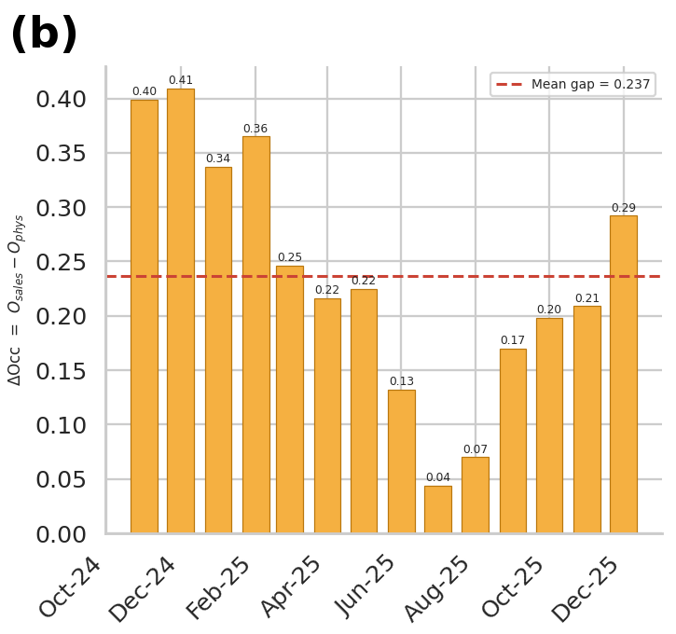
Figure 3. Occupancy divergence. (a) Sales occupancy from the property-management system versus physical occupancy from IoT sensing; the shaded band between the curves is the gap ΔO. (b) Monthly gap with its mean (dashed line).
The gap is strongly seasonal. It averaged 0.378 in the cool-dry cycles (November to February), 0.229 in the hot-dry cycles (March to May) and 0.104 in the monsoon cycles (June to September), with 0.198 in October 2025. In the final three cycles sales occupancy was 0.978, 0.979 and 0.942, yet physical occupancy was only 0.78, 0.77 and 0.65. The booking signal and the presence signal are almost unrelated: their Pearson correlation is r = 0.21 (p = 0.47, n = 14), so sales occupancy explains only about 4% of the variance of physical occupancy. This is the quantitative meaning of the word latent in the title, and it is the reason why a baseline that uses sales occupancy as its occupancy covariate mis-specifies the load driver. Possible contributors, such as group or event bookings with long absences from the room, late arrivals and early departures, cannot be tested with monthly data and are left to future work.
3.3 Correlation structure and confounding
Figure 4a shows the correlation matrix of the main variables and Figure 4b shows HVAC energy against CDD, coloured by physical occupancy. The Pearson correlations of HVAC energy with each candidate driver are collected in Table 6. CDD is the strongest and the only unambiguous positive driver (r = +0.84). Physical occupancy is not correlated with HVAC energy in the raw data (r = +0.02, p = 0.95) and sales occupancy is negatively correlated (r = −0.66, p = 0.038).
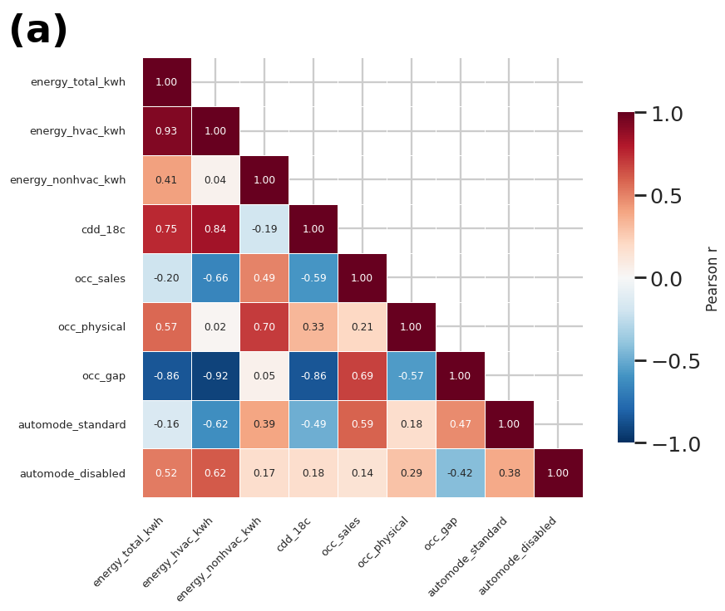
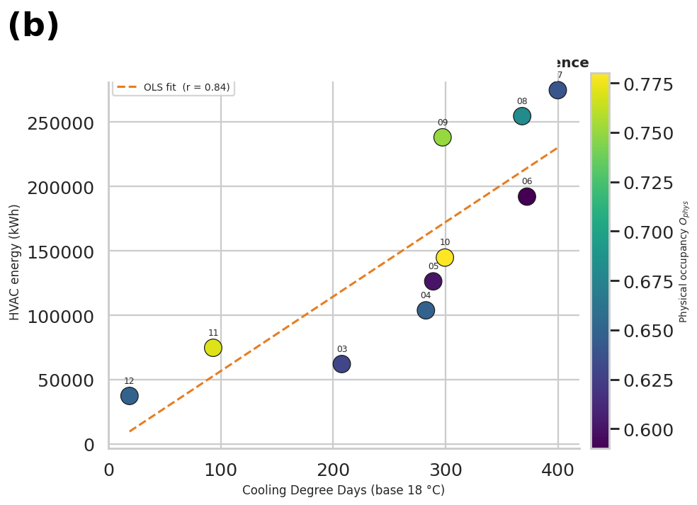
Figure 4. Correlation structure. (a) Pearson correlation matrix of energy, weather, occupancy and automation variables. (b) HVAC energy versus CDD coloured by physical occupancy, with the OLS fit of Eq. (26) (r = 0.84).
Table 6. Association of HVAC energy with candidate drivers (n = 10 sub-metered cycles): raw Pearson correlation (Eq. (23)) and partial correlation controlling for a linear CDD effect (Eq. (24)).
Driver | Pearson r | p | Partial r | CDD | p
CDD | +0.840 | 0.0023 | — | —
Sales occupancy | -0.660 | 0.0378 | -0.123 | 0.754
Physical occupancy | +0.023 | 0.9504 | +0.398 | 0.289
Occupancy gap | -0.923 | 0.0001 | -0.769 | 0.015
Automation share (standard mode) | -0.623 | 0.0542 | -0.158 | 0.685

The strongest raw association is a negative one with the occupancy gap (r = −0.92, p = 0.0001), which would naively suggest that more vacant sold rooms mean less HVAC energy. This is a confounding effect and not a causal one. The gap is itself strongly and negatively correlated with CDD (r = −0.80 over the ten sub-metered cycles and r = −0.86 over all 14 sensed cycles): large gaps occur in the cool-dry season, when bookings are high and cooling demand is low. After removing a linear CDD effect, the gap remains negatively associated with HVAC energy (partial r = −0.77, p = 0.009), while physical occupancy shows a positive but non-significant partial association (+0.40, p = 0.25) and sales occupancy none (−0.12, p = 0.74). Variance inflation factors were 3.1 for CDD, 3.0 for the gap and 1.1 for physical occupancy, so moderate collinearity exists between weather and the gap. The reading we adopt is cautious: the gap works as a seasonal and regime indicator that complements CDD in prediction, but its coefficient should not be read as the effect of vacancy on energy.
Figure 5 adds the control context. The automation platform was in standard set-back mode on average 94.1% of the time, in deep set-back mode 0.5% and disabled 4.7%; the disabled share peaked at 20.2% in September 2025, a month with high HVAC energy. The set-point moved from 25 °C to 24 °C in July 2025, which coincides with the highest HVAC load of the sample. Control policy and weather therefore change together, a structural break that limits causal interpretation (Section 3.12). The seasonal distribution in Figure 5b confirms that the monsoon cycles carry the highest total energy. Figure 6 shows the pairwise structure of the modelling feature space, in which the seasons form visibly separate clusters.
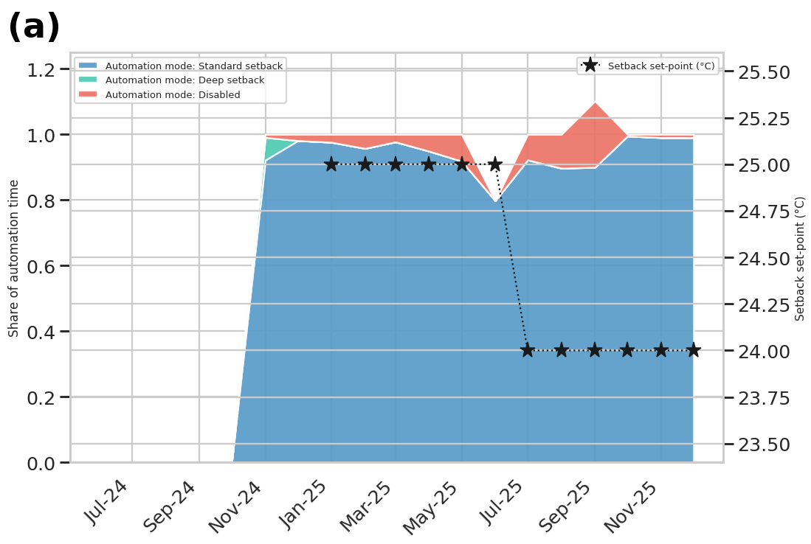
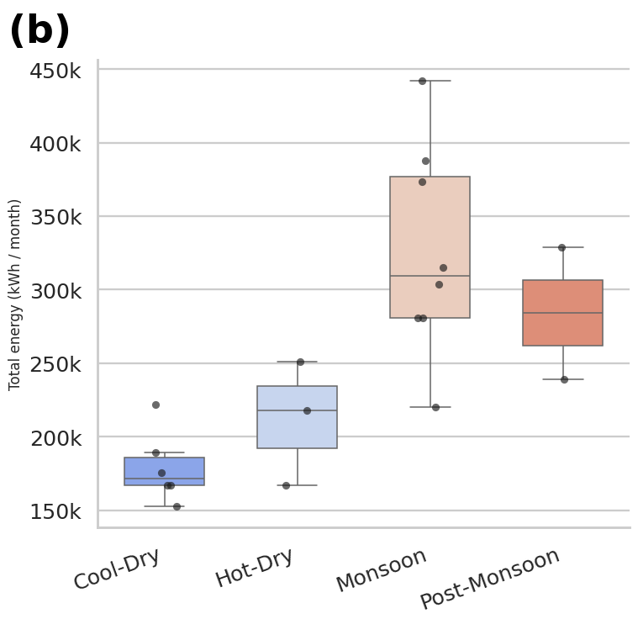
Figure 5. Automation strategy and seasonal behaviour. (a) Share of automation time in standard set-back, deep set-back and disabled modes, with the set-back set-point (right axis). (b) Distribution of total energy by season.
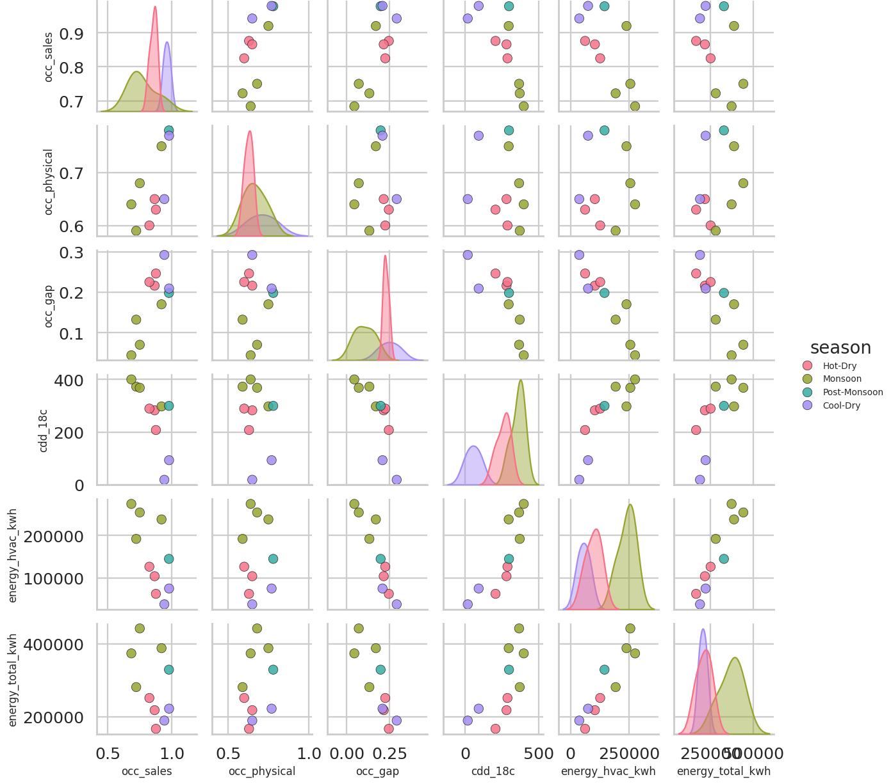
Figure 6. Pairwise diagnostics of the modelling feature space, coloured by season.
3.4 Stage 1: benchmark of latent-occupancy forecasts (RQ2)
Stage 1 asks whether physical occupancy can be forecast from information that exists without sensors. Table 7 lists the ten best of the 52 LOOCV configurations and Figure 7 shows all of them as heat maps. The best configuration is a linear SVR on sales occupancy and CDD (feature set F3) with R² = 0.366 and MAE = 0.052, that is, about 5 occupancy points. Regularised linear models dominate the top of the ranking, and no configuration exceeds R² = 0.37. Flexible learners such as the RBF SVR, GPR and boosting score negative R² in most cells of Figure 7a, which is the expected behaviour of high-capacity models with 14 observations.
Table 7. Stage-1 LOOCV benchmark: ten best of 52 configurations (target: physical occupancy, n = 14).
Rank | Feature set | Learner | No. of features | R² | MAE | RMSE
1 | F3 · Sales + CDD | SVR (linear) | 2 | 0.3655 | 0.0517 | 0.0651
2 | F2 · Sales + month (cyc) | SVR (linear) | 3 | 0.3479 | 0.0567 | 0.0660
3 | F4 · Sales + month + CDD | Ridge (L2) | 4 | 0.3338 | 0.0542 | 0.0667
4 | F3 · Sales + CDD | Huber (robust) | 2 | 0.3118 | 0.0553 | 0.0678
5 | F4 · Sales + month + CDD | Lasso (L1) | 4 | 0.3019 | 0.0552 | 0.0683
6 | F2 · Sales + month (cyc) | Ridge (L2) | 3 | 0.2997 | 0.0578 | 0.0684
7 | F4 · Sales + month + CDD | Elastic net | 4 | 0.2985 | 0.0554 | 0.0684
8 | F3 · Sales + CDD | Ridge (L2) | 2 | 0.2807 | 0.0586 | 0.0693
9 | F2 · Sales + month (cyc) | Huber (robust) | 3 | 0.2651 | 0.0611 | 0.0701
10 | F3 · Sales + CDD | Bayesian ridge | 2 | 0.2586 | 0.0598 | 0.0704

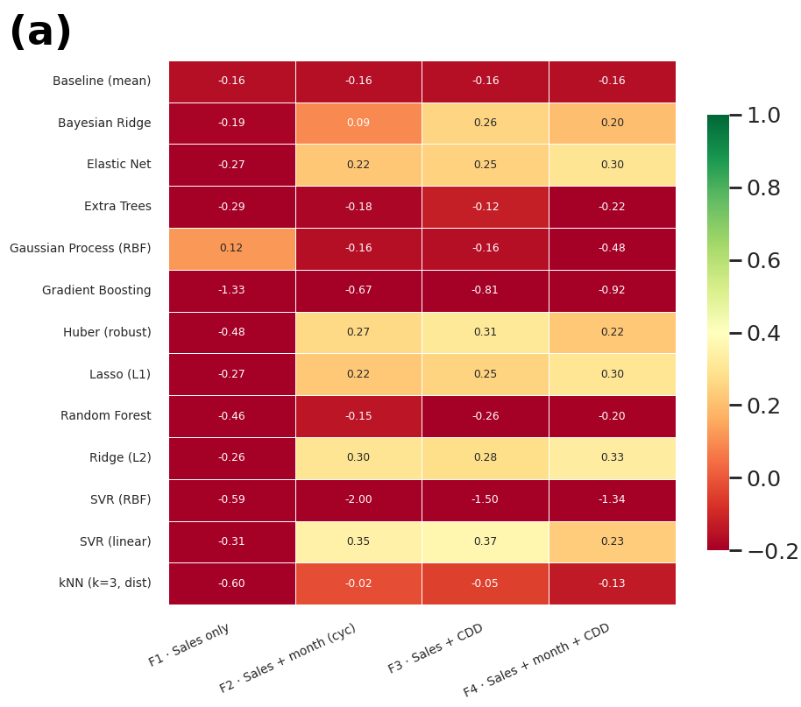
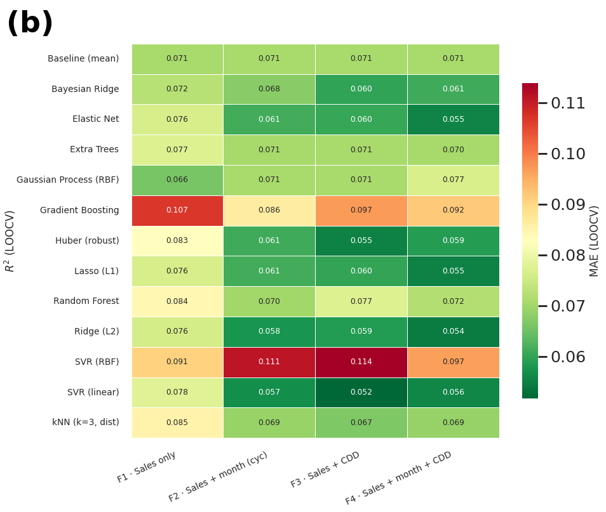
Figure 7. Stage-1 benchmark. (a) LOOCV R² and (b) LOOCV MAE for every learner and feature set.
Two structural observations follow. First, the best R² of 0.37 means that, even in the most favourable case, almost two thirds of the variance of physical occupancy is unexplained by sales occupancy, season and weather, which agrees with the weak correlation of Section 3.2. Second, the feature-set ablation in Figure 8d shows that adding month or CDD to sales occupancy helps the linear learners (Ridge improves from negative to about +0.3) but does not rescue the non-linear ones.
3.5 Stage 1: nested validation, uncertainty and the failed reconstruction
The champion non-linear learner, an RBF SVR on feature set F4, was tuned by grid search. The selected hyper-parameters were C = 0.5, γ = 0.05 and ε = 0.05, with an inner six-fold MAE of 0.0524. When the same tuning was embedded in an outer leave-one-out loop (nested validation, (20)), the honest performance was R² = −0.787, MAE = 0.082 and RMSE = 0.109 (Table 8). The nested MAE is 57% larger than the inner-CV MAE, which is a direct measurement of the optimism that un-nested tuning would have introduced. A model that predicts worse than the mean (R² < 0) cannot support operational forecasts of physical occupancy.
Table 8. Stage-1 performance of the tuned SVR-RBF and the Gaussian process, under different protocols (feature set F4 unless noted).
Model and protocol | R² | MAE | RMSE
Best untuned configuration (SVR linear, F3), LOOCV | 0.3655 | 0.0517 | 0.0651
Tuned SVR-RBF, inner six-fold CV (optimistic) | — | 0.0524 | —
Tuned SVR-RBF, nested CV (outer LOOCV) – honest estimate | −0.7865 | 0.0820 | 0.1092
Tuned SVR-RBF, in-sample refit | 0.5214 | 0.0458 | —
Gaussian process (Matérn 3/2 + white noise), in-sample | 0.9901 | 0.0065 | —
In-sample scores measure memorisation, not forecast skill, and are shown only to expose over-fitting.
The Gaussian process illustrates the same point from another angle. Its in-sample R² is 0.990, but the learned kernel has a length scale of 0.01, at the lower bound of the search range, and a noise level of 0.099, close to the upper bound. In other words, the process concluded that the targets are essentially independent across inputs. It memorises the 14 observed values and reverts to its prior mean elsewhere. This is exactly what happens when it is asked to reconstruct the five cycles before sensing started (Table 9 and Figure 8c): every imputed value equals 0.637 with a standard deviation of 0.082, regardless of the sales occupancy, and the implied gap becomes negative (−0.417 in June 2024), which is physically implausible because it would mean more rooms occupied than sold. The reconstruction of the pre-sensing period is therefore not credible and must not be used as a baseline.
Table 9. Gaussian-process imputation for the five cycles without presence sensing.
Cycle | O^{sales} | Imputed O^{phys} (GPR mean) | GPR SD | Implied ΔO
Jun-24 | 0.220 | 0.637 | 0.082 | -0.417
Jul-24 | 0.396 | 0.637 | 0.082 | -0.241
Aug-24 | 0.642 | 0.637 | 0.082 | +0.005
Sep-24 | 0.886 | 0.637 | 0.082 | +0.249
Oct-24 | 0.959 | 0.637 | 0.082 | +0.322

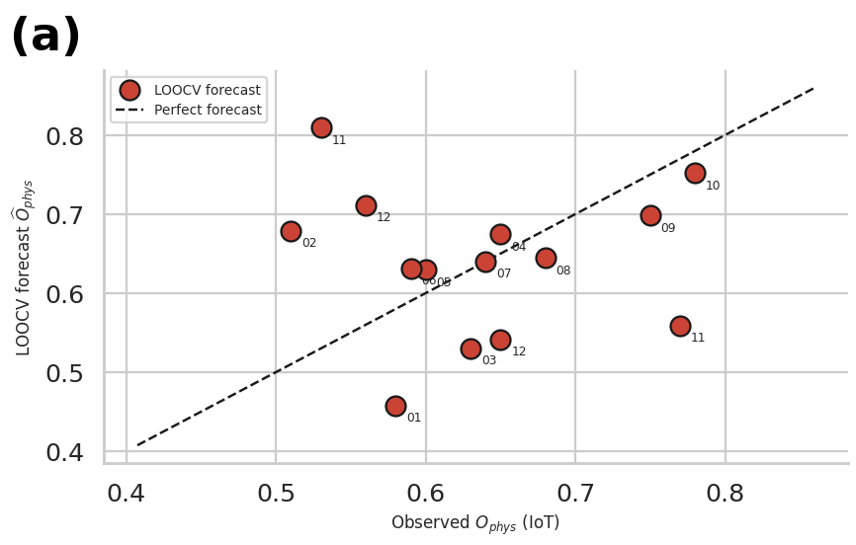
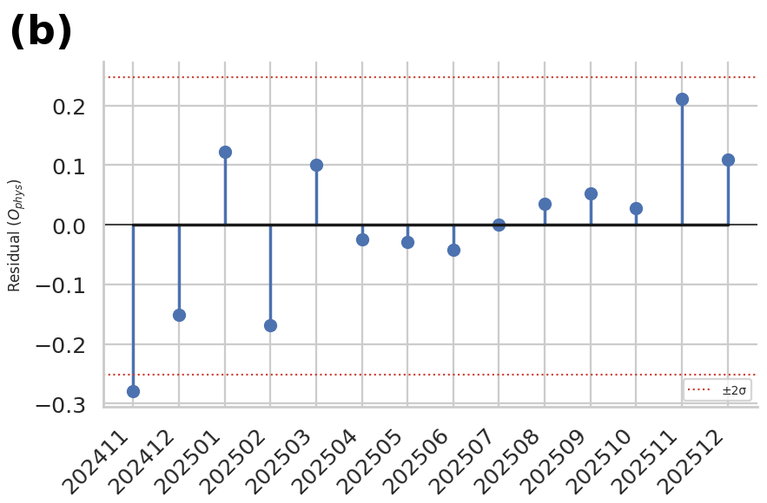
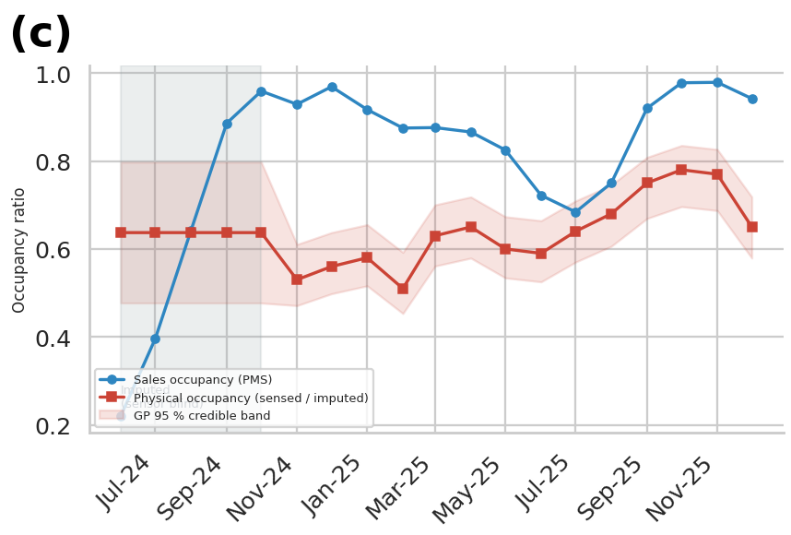
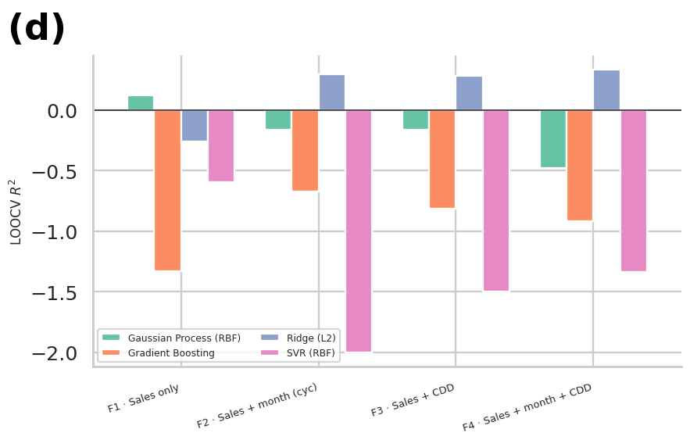
Figure 8. Stage-1 diagnostics. (a) LOOCV parity plot of the RBF SVR on feature set F4. (b) LOOCV residuals with ±2σ limits. (c) Reconstructed latent-occupancy timeline with the Gaussian-process 95% credible band; the shaded period is the imputed, sensor-blind interval, where the forecast is flat. (d) Feature-set ablation of the LOOCV R² for four learners.
The diagnostics in Figure 8 agree. The parity plot (Figure 8a) scatters widely around the diagonal; the residuals (Figure 8b) reach about −0.28 in November 2024 and +0.21 in November 2025, outside the ±2σ band in the extreme months; and the credible band in Figure 8c is wide and flat before sensing. Answer to RQ2: with 14 monthly observations, physical occupancy cannot be reliably forecast out of sample from sales occupancy, season and CDD. At this data scale latent presence has to be measured.
3.6 Stage 2: HVAC load prediction with and without presence (RQ3)
Stage 2 compares the four pipelines of Table 2 with six learners each, 24 LOOCV configurations in total (Table 10, Figure 9). Pipeline A, the traditional baseline, reaches its best R² of 0.549 and MAE of 45,525 kWh per cycle with a random forest. Pipeline B, which replaces sales occupancy by sensed physical occupancy and the gap, reaches R² = 0.723 and MAE = 34,580 kWh with a Gaussian process. The gain is therefore ΔR² = +0.174 and a relative MAE reduction of δ_{MAE} = 24.0% (10,945 kWh per cycle), as in (22).
Table 10. Stage-2 LOOCV benchmark of all 24 pipeline–learner configurations (target: HVAC energy per cycle, n = 10). Shaded rows are the best learner of each pipeline.
Rank | Pipeline | Learner | R² | MAE (kWh) | RMSE (kWh) | MAPE (%)
1 | B′ | Lasso (L1) | 0.8843 | 23,115 | 27,391 | 17.9
2 | B′ | Gaussian Process | 0.8736 | 23,392 | 28,634 | 17.4
3 | B+ | Gaussian Process | 0.7737 | 30,630 | 38,313 | 32.9
4 | B′ | Ridge (L2) | 0.7488 | 35,702 | 40,361 | 28.3
5 | B | Gaussian Process | 0.7228 | 34,580 | 42,403 | 40.9
6 | B+ | Ridge (L2) | 0.7137 | 36,170 | 43,092 | 30.0
7 | B | Lasso (L1) | 0.6692 | 35,797 | 46,316 | 45.4
8 | B | Random Forest | 0.6674 | 39,647 | 46,447 | 38.4
9 | B | Ridge (L2) | 0.6624 | 39,712 | 46,790 | 34.5
10 | B+ | Gradient Boosting | 0.6481 | 40,316 | 47,771 | 37.1
11 | B+ | Random Forest | 0.6333 | 43,262 | 48,766 | 44.6
12 | B | Gradient Boosting | 0.5986 | 45,391 | 51,021 | 40.2
13 | B′ | Random Forest | 0.5899 | 45,795 | 51,572 | 42.7
14 | B′ | Gradient Boosting | 0.5599 | 45,952 | 53,427 | 34.1
15 | A | Random Forest | 0.5487 | 45,525 | 54,099 | 42.1
16 | A | Gaussian Process | 0.5284 | 47,061 | 55,306 | 37.9
17 | A | Lasso (L1) | 0.4647 | 55,710 | 58,923 | 54.0
18 | A | Ridge (L2) | 0.4361 | 51,285 | 60,478 | 46.0
19 | A | Gradient Boosting | 0.3734 | 59,495 | 63,748 | 55.4
20 | B′ | SVR (RBF) | -0.2398 | 78,905 | 89,670 | 76.4
21 | B | SVR (RBF) | -0.2406 | 78,945 | 89,700 | 76.5
22 | B+ | SVR (RBF) | -0.2414 | 78,969 | 89,730 | 76.5
23 | A | SVR (RBF) | -0.2450 | 79,146 | 89,860 | 76.7
24 | B+ | Lasso (L1) | -0.5971 | 72,824 | 101,776 | 99.3

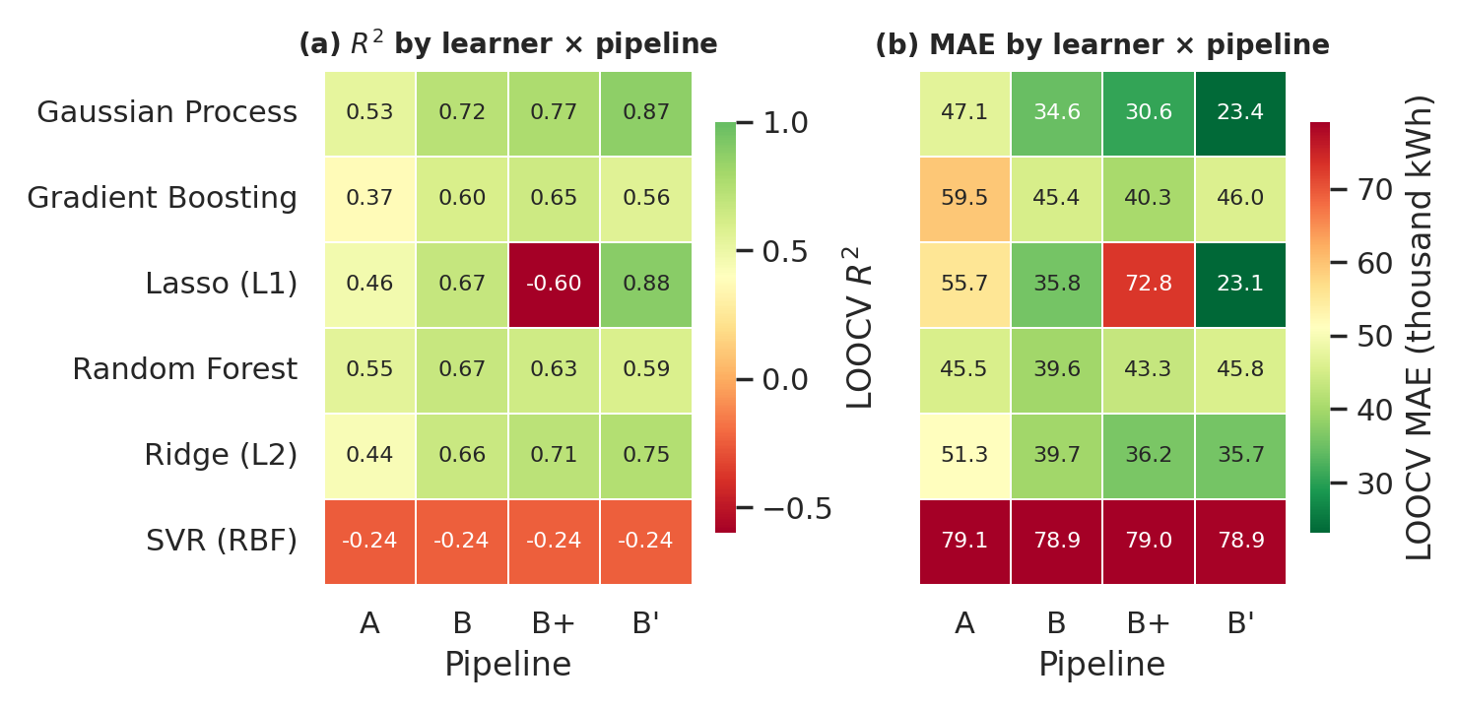
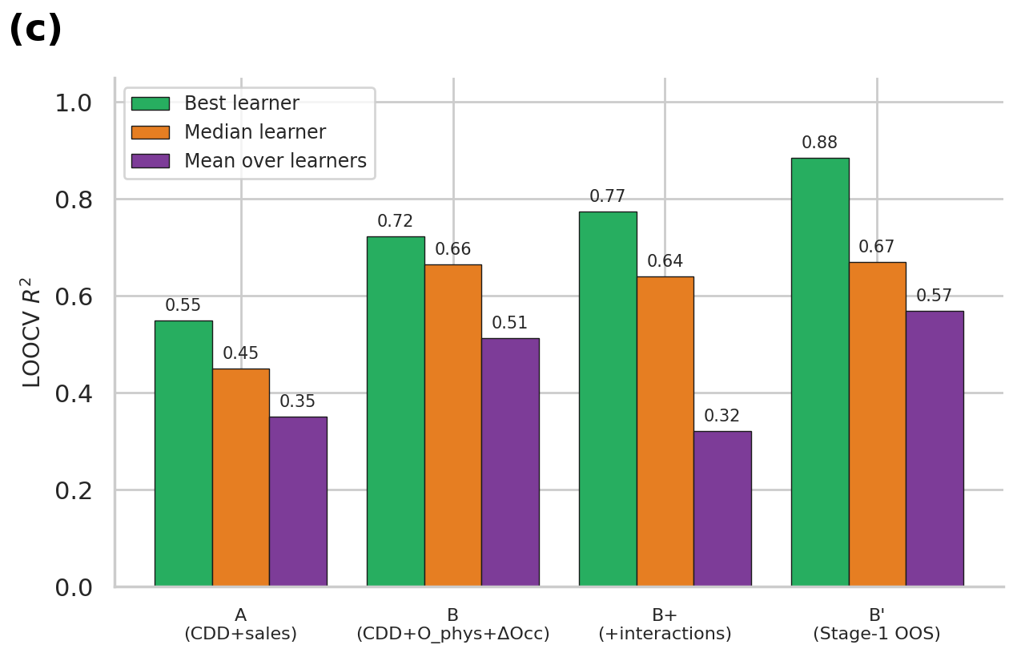
Figure 9. Stage-2 benchmark. (a, b) LOOCV R² and MAE for every learner and pipeline. (c) Best, median and mean LOOCV R² over learners for each pipeline; the gap between best and mean quantifies selection optimism.
Table 11. Pipeline-level summary over the six learners (LOOCV).
Pipeline | Best R² | Median R² | Mean R² | Best MAE (kWh) | Mean MAE (kWh)
A | 0.549 | 0.450 | 0.351 | 45,525 | 56,370
B | 0.723 | 0.665 | 0.513 | 34,580 | 45,679
B+ | 0.774 | 0.641 | 0.322 | 30,630 | 50,362
B′ | 0.884 | 0.669 | 0.569 | 23,115 | 42,144

Because only ten observations are used and 24 configurations were compared, the maximum alone overstates the benefit. We therefore also look at the whole learner distribution (Table 11). The mean R² over learners rises from 0.351 (A) to 0.513 (B), a gain of 0.162, and the mean MAE falls from 56,370 to 45,679 kWh. More convincingly, the direction of the effect is consistent across learner families: moving from A to B raises the R² of ridge (0.436 → 0.662), lasso (0.465 → 0.669), Gaussian process (0.528 → 0.723), random forest (0.549 → 0.667) and gradient boosting (0.373 → 0.599), an average gain of 0.19 across five learners. The only exception is the RBF SVR, which scores about −0.24 in all four pipelines; with ε = 8,000 kWh and C = 200 on an unscaled target its insensitive tube swallows most of the signal, so it predicts an almost constant value and cannot discriminate between pipelines.
Pipeline B+, which adds the two weather interactions of (10), has the best R² for Gaussian processes (0.774) but the worst mean R² (0.322) and a lasso score of −0.597, because five features are too many for ten observations. The end-to-end Pipeline B′, which feeds Stage 2 with out-of-sample Stage-1 forecasts, has the highest best score (R² = 0.884 for lasso, MAE = 23,115 kWh) and the highest mean R² (0.569). This result must not be read as a validation of Stage 1. The Stage-1 forecasts have R² < 0 against the true presence, so the Stage-2 gain of B′ cannot come from accurate presence information. It most plausibly arises because the B′ features are smooth non-linear transformations of month, CDD and sales occupancy that encode seasonality, combined with the winner’s-curse effect of selecting the best of 24 configurations on ten points. In addition, the Stage-1 forecasts used for training months were produced by models that had seen the held-out month’s occupancy label, a mild leakage that can favour B′. We therefore do not claim that sensors can be dispensed with, and the headline comparison uses Pipeline B.
3.7 Forecast diagnostics and statistical uncertainty
Figure 10 gives the visual proof for the headline comparison, using the best learner of Pipeline A (random forest) and of Pipeline B (Gaussian process). In Figure 10a the Pipeline-B forecast follows the observed HVAC curve closely during the cooling peak from June to September 2025, where the baseline under-predicts. The parity plot in Figure 10b shows the high-load months of Pipeline B close to the diagonal. The per-month errors in Figure 10c show that Pipeline B has the smaller absolute error in six of the ten months, with the largest improvements in June (38,009 to 6,076 kWh), July (70,393 to 12,594 kWh) and August 2025 (43,941 to 8,919 kWh). It does worse in November 2025 (8,693 to 56,453 kWh) and, notably, forecasts a negative HVAC energy of −24,164 kWh in December 2025, when CDD is at its minimum of 18.8. This is an extrapolation failure of the Gaussian process at the edge of the training range and shows why physical constraints (non-negativity and monotonicity in CDD) are needed.
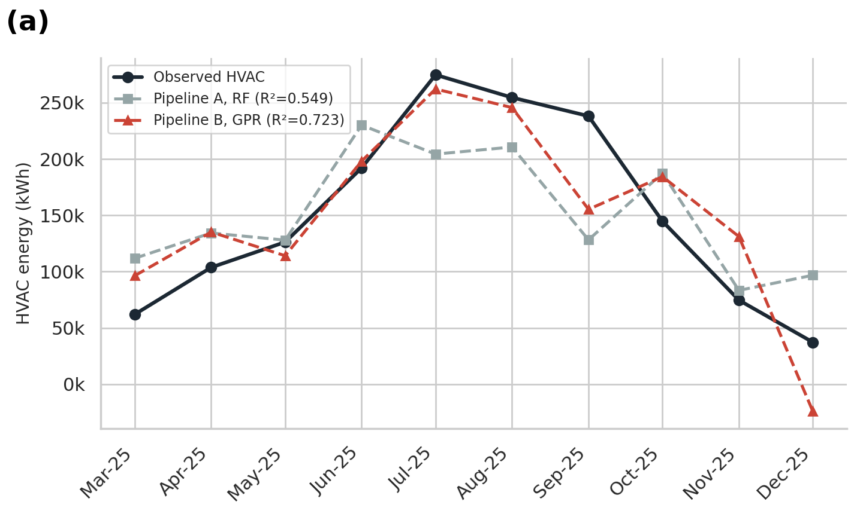
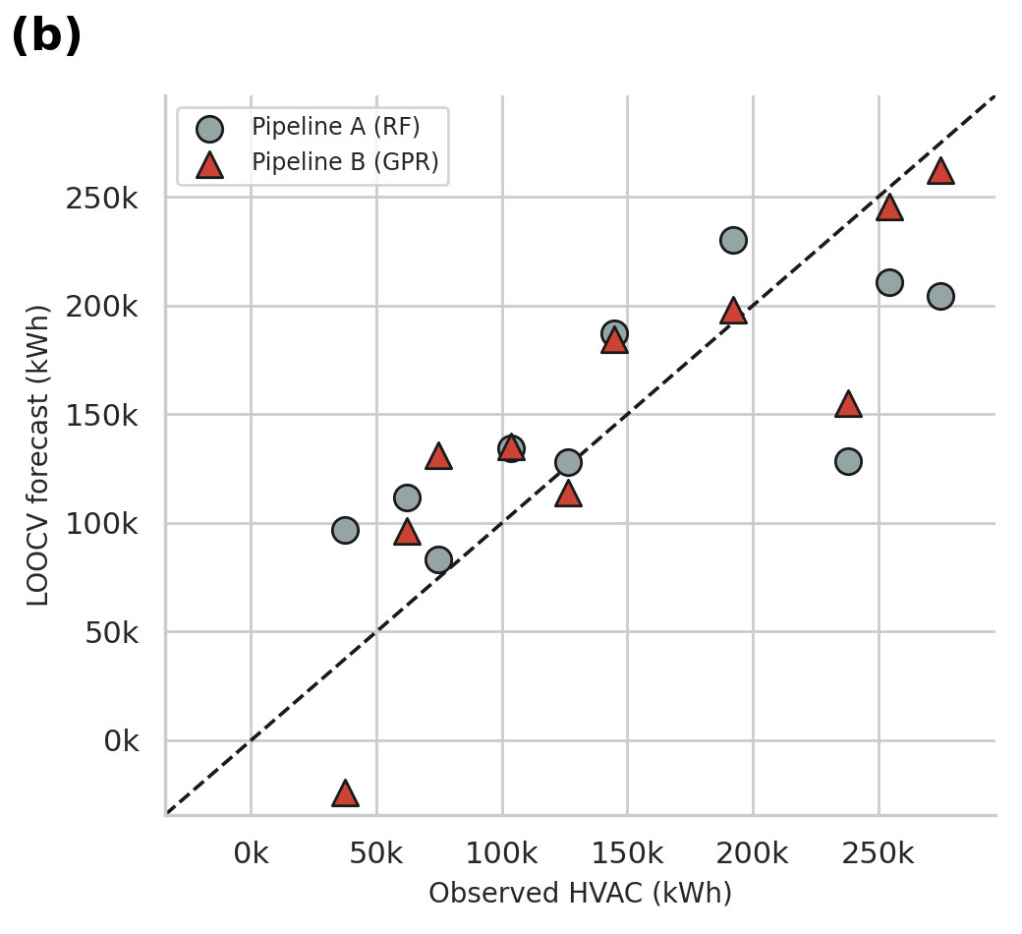
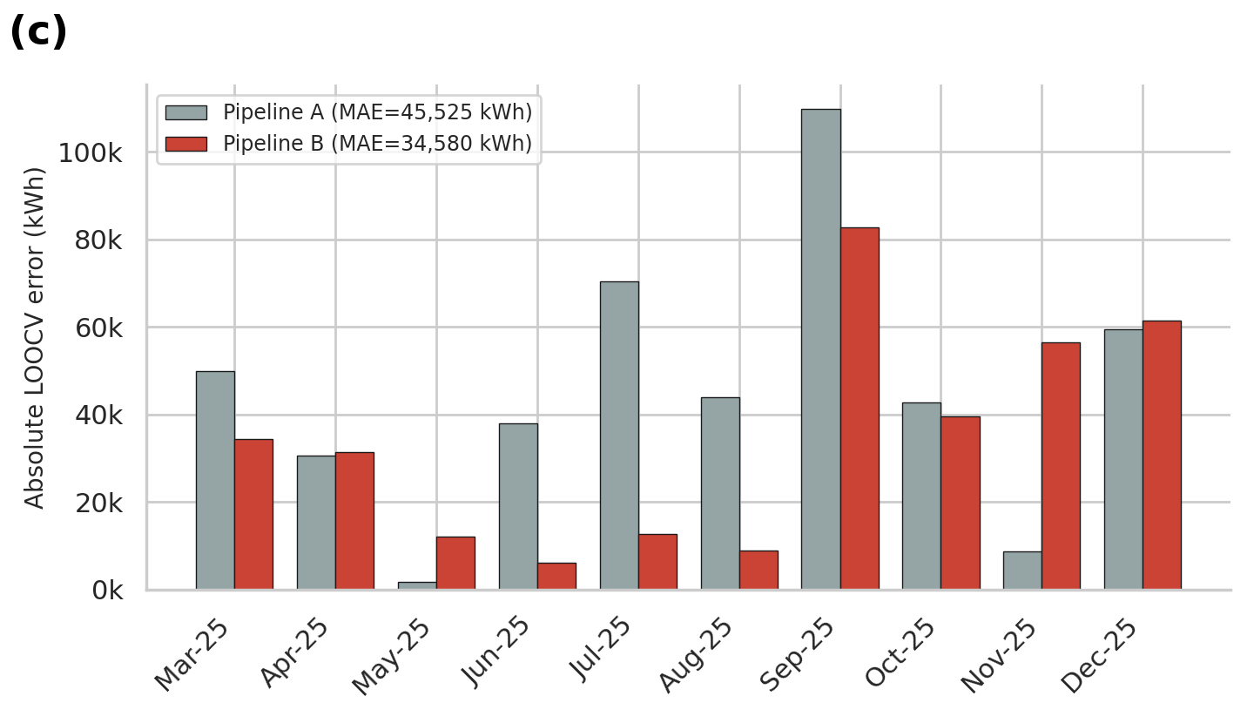
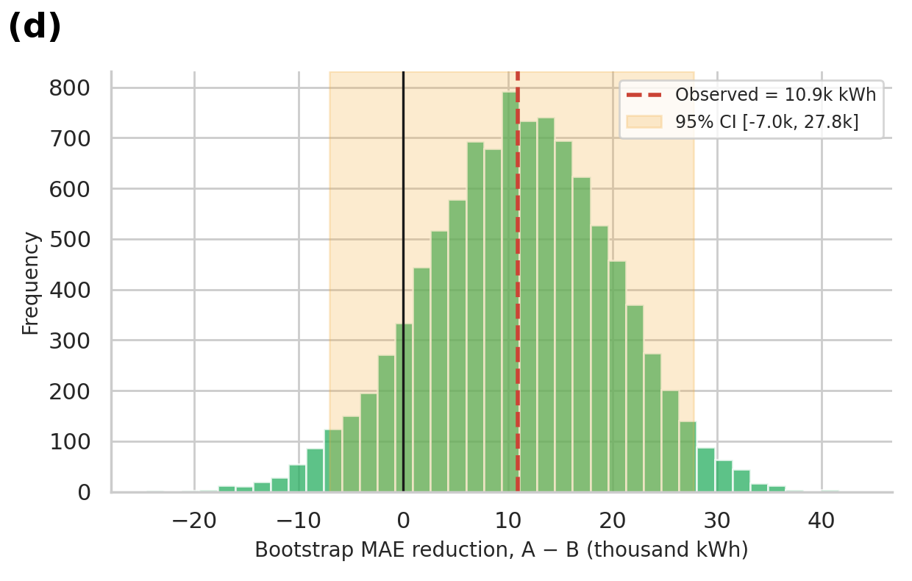
Figure 10. Stage-2 champion diagnostics. (a) Observed HVAC energy and LOOCV forecasts of Pipeline A (random forest) and Pipeline B (Gaussian process). (b) Parity plot. (c) Absolute LOOCV error per month. (d) Bootstrap distribution (10,000 resamples) of the MAE reduction, A − B, with its 95% interval.
The decisive question is whether the improvement could be due to chance. The paired bootstrap of (21) (Figure 10d) gives a mean MAE reduction of 10,945 kWh per cycle with a 95% interval of −7,041 to +27,751 kWh. The interval includes zero, and the bootstrap probability that the reduction is not positive is 0.11. For R², the 95% bootstrap interval of the gain is −0.069 to +0.522, with a probability of 0.058 that the gain is not positive. A Wilcoxon signed-rank test of the paired absolute errors gives p = 0.28. Answer to RQ3: sensed presence improves HVAC load prediction in direction and size, consistently across five learner families, but with ten monthly observations the improvement is suggestive and not statistically established. A conclusive test needs daily or hourly telemetry and more than one site.
It is worth placing these errors in the context of M&V practice. Normalised by the mean HVAC load of 150,831 kWh, the LOOCV RMSE is 35.9% for the best baseline and 28.1% for the best presence-aware model. Both are well above the monthly CV(RMSE) threshold of 15% that is commonly cited in ASHRAE Guideline 14 for calibrated baselines [12], although a LOOCV error on ten points is a much stricter test than an in-sample calibration. The practical message is that neither model is yet accurate enough to settle a savings claim on its own.
Table 12. Headline results (reconciled with the notebook export).
Component | Validation protocol | R² | MAE
Stage 1 – latent occupancy (SVR-RBF) | Nested CV, outer LOOCV | −0.787 | 0.082
Stage 2 – Pipeline A (baseline, random forest) | LOOCV | 0.549 | 45,525 kWh
Stage 2 – Pipeline B (latent presence, Gaussian process) | LOOCV | 0.723 | 34,580 kWh
Difference (B − A) | — | +0.174 | −10,945 kWh (−24.0%)

3.8 Latent vacancy, weather-normalised intensity and year-on-year comparison
Figure 11 relates the occupancy gap to the weather-normalised HVAC intensity of (6). There is no clean monotonic relationship. The two cycles with the smallest gaps, July and August 2025 (ΔO = 0.044 and 0.070), have intensities around 690 kWh/CDD, whereas December 2025, with the largest gap in the HVAC window (0.292), has by far the highest intensity (1,984 kWh/CDD) because CDD is almost zero, and March 2025, with a large gap (0.246), has the lowest (299 kWh/CDD). Intensity is thus governed first by the season and the fixed-load floor, and only second by presence, which agrees with the confounding analysis of Section 3.3.
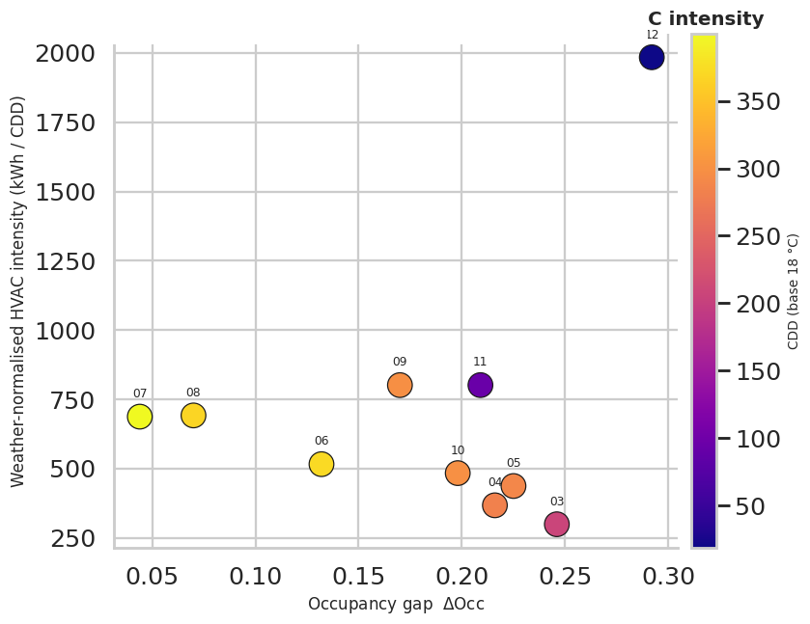
Figure 11. Latent vacancy versus weather-normalised HVAC intensity (kWh/CDD), coloured by CDD; labels are month numbers of 2025.
Table 13. Same-month comparison of total (whole-building) energy before (2024) and after (2025) the retrofit. Intensity is total energy per CDD.
Month | Total 2024 (kWh) | CDD 2024 | O^{sales} 2024 | kWh/CDD 2024 | Total 2025 (kWh) | CDD 2025 | O^{sales} 2025 | kWh/CDD 2025 | Change (%)
Jun | 220,307 | 355.7 | 0.220 | 619 | 281,019 | 372.3 | 0.722 | 755 | +21.9
Jul | 280,690 | 362.0 | 0.396 | 775 | 373,382 | 399.7 | 0.684 | 934 | +20.5
Aug | 314,826 | 369.6 | 0.642 | 852 | 441,808 | 368.0 | 0.750 | 1,201 | +40.9
Sep | 303,458 | 323.9 | 0.886 | 937 | 387,664 | 297.2 | 0.920 | 1,304 | +39.2
Oct | 239,303 | 253.9 | 0.959 | 943 | 328,791 | 299.3 | 0.978 | 1,099 | +16.6
This is a descriptive comparison, not a causal estimate: sales occupancy, non-HVAC loads and the set-point differ between the two years, and HVAC was not sub-metered in 2024.
Table 13 contains an instructive caution. Between June and October, total energy was 27.6% to 40.3% higher in 2025 than in 2024, and whole-building intensity per CDD was 16.6% to 40.9% higher, even though CDD changed only between −8.2% and +17.9% and the vendor reports savings for each of these cycles. This does not contradict the vendor claim, which is defined against a counterfactual that is not observable. It does show that a naive pre/post comparison cannot confirm savings: occupancy was much higher in 2025 (sales occupancy of 0.72 versus 0.22 in June, for example), non-HVAC loads are unknown for 2024, and the set-point policy changed. Any credible verification therefore needs a baseline that is adjusted for weather and for presence, which is the motivation for Pipeline B.
3.9 Illustrative set-back scenario and the vendor claim
The scenario engine of (27) converts the occupancy gap into avoidable HVAC energy for a swept curtailment efficiency η (Table 14, Figure 12). At η = 25%, the avoidable energy over the ten sub-metered cycles is 54,248 kWh, or 3.6% of the metered HVAC energy; across η = 5% to 50% the range is 10,850 to 108,495 kWh (0.72% to 7.19%). The monthly profile in Figure 12b shows that the potential is concentrated where the gap is large and HVAC is substantial (for example, September and October 2025) and is small in July and August, when the gap is small.
Table 14. Illustrative set-back scenario: avoidable HVAC energy over the ten sub-metered cycles (Eqs. (27) and (28)).
Curtailment efficiency η (%) | Avoidable energy A(η) (kWh) | Share of HVAC energy π(η) (%) | Vendor claim ÷ A(η)
5 | 10,850 | 0.72 | 27.3
10 | 21,699 | 1.44 | 13.6
15 | 32,549 | 2.16 | 9.1
20 | 43,398 | 2.88 | 6.8
25 | 54,248 | 3.60 | 5.5
30 | 65,097 | 4.32 | 4.5
35 | 75,947 | 5.04 | 3.9
40 | 86,796 | 5.75 | 3.4
45 | 97,646 | 6.47 | 3.0
50 | 108,495 | 7.19 | 2.7
Vendor-claimed savings over the same cycles: 296,123 kWh. The scenario is a sensitivity band, not a verified saving.
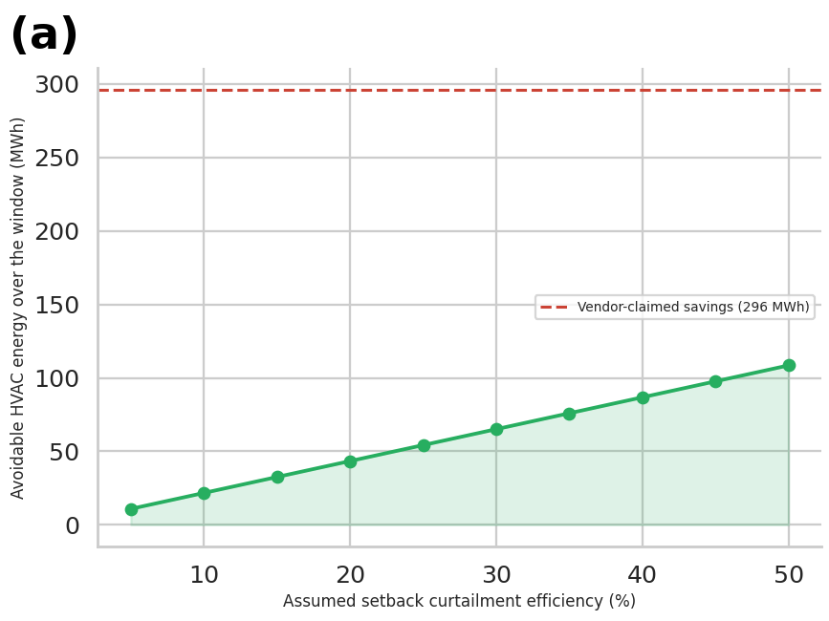
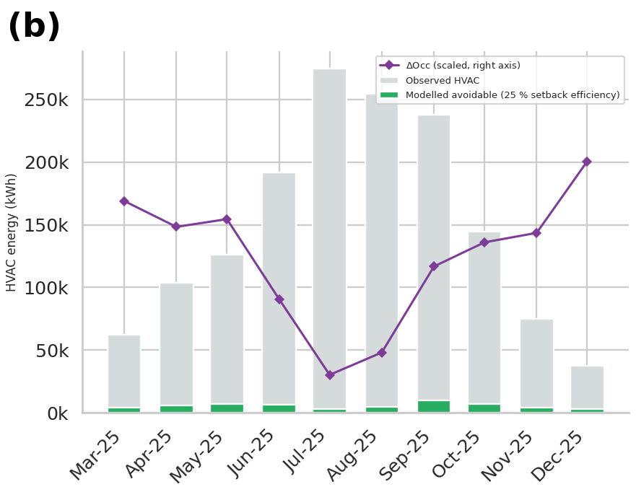
Figure 12. Illustrative set-back scenario. (a) Avoidable HVAC energy versus assumed curtailment efficiency, with the vendor-claimed total (dashed line). (b) Month-by-month observed HVAC load, modelled avoidable load at η = 25%, and the scaled gap (right axis).
The vendor-claimed savings over the same ten cycles total 296,123 kWh. Relative to the implied counterfactual of (29), this is κ = 16.4% of HVAC energy (10.4% of total energy), with a monthly share from 10.0% in July to 28.1% in December. The claim is 2.7 times the avoidable energy of the most generous scenario (η = 50%) and 5.5 times that of the η = 25% case. Three explanations are possible and the data cannot tell them apart: (i) the savings come from mechanisms beyond vacancy-proportional set-back, such as set-point policy, scheduling, ventilation control or the repair of faults; (ii) the claimed baseline is overstated; or (iii) the curtailment efficiency is far higher than 50%. Because the scenario is applied to HVAC energy that is already post-retrofit, the comparison indicates orders of magnitude only. The sound conclusion is that the claim is unverified, not that it is wrong.
3.10 Scientific statements on dynamic HVAC energy and IoT efficiency (RQ4)
The results can be condensed into eight statements about dynamic HVAC energy and about the efficiency that IoT devices deliver. Each statement is tied to its evidence and graded, so that readers can distinguish what the data establish from what they only suggest. The grades are: strong (direct measurement, consistent across checks), moderate (consistent but limited by sample size), suggestive (direction supported, not statistically established) and not established.
Table 15. Evidence-graded scientific statements.
ID | Statement | Evidence | Strength
S1 | HVAC is the dominant and weather-driven load of the hotel: it was 52.7% of metered energy in the sub-metered window, and CDD alone explains 70.6% of its variance (579 kWh per CDD). The relationship is not proportional, because intensity rises from 299 to 1,984 kWh/CDD towards the cool end of the season. | Table 4, Figure 2, Figure 4b | Strong (n = 10)
S2 | Booking telemetry systematically overstates in-room presence. Sold-but-empty rooms averaged 0.237 occupancy points (26.4% of sold rooms), from 0.04 to 0.41, and the gap is largest in the cool-dry season. | Table 5, Figure 3 | Strong (direct sensing, n = 14)
S3 | Sales occupancy is a poor linear proxy for presence (r = 0.21, about 4% of variance), so HVAC baselines that use it as the occupancy covariate mis-specify the load driver. | Table 5, Table 7 | Moderate
S4 | Adding sensed presence and the gap to weather improves LOOCV prediction of HVAC energy in direction and size (best R² 0.549 to 0.723; MAE −24%), consistently across five learner families, but not at a statistically established level. | Table 10, Table 11, Figure 10 | Suggestive
S5 | Latent presence cannot be forecast out of sample from booking, season and weather at this data scale (nested R² = −0.79), and the reconstruction of the pre-sensing period is a constant. Presence must be sensed. | Table 8, Table 9, Figure 8 | Strong (negative result)
S6 | IoT automation was engaged most of the time (94.1% standard mode) but was disabled for 4.7% on average and 20.2% in the worst cycle; overrides are a material leakage path for savings. | Figure 5a | Moderate
S7 | The vendor-claimed saving (296 MWh, 16.4% of the implied counterfactual) cannot be verified from these data: a vacancy-proportional set-back yields 10.8 to 108.5 MWh for 5% to 50% efficiency, and a naive year-on-year comparison shows higher, not lower, whole-building intensity. | Table 14, Table 13, Figure 12 | Not established
S8 | The association between the gap and HVAC energy is confounded with season and with control-policy changes (25 to 24 °C in July 2025), and should be treated as predictive structure, not as a causal effect of vacancy. | Table 6, Figure 5 | Moderate

Taken together, the statements describe what IoT devices contribute to HVAC efficiency in this case. Their most robust contribution is measurement: presence sensing and sub-metering reveal the occupancy divergence (S2) and the structure of HVAC demand (S1), which no booking system can provide, and they make a defensible baseline possible (S4, S5). Their control contribution, the energy actually saved by presence-aware set-back, is plausible in direction, since a quarter of sold rooms are empty on average, but its magnitude is not established by these data (S7). Efficiency claims for dynamic HVAC should therefore be reported as measured, weather- and presence-normalised savings with an uncertainty interval, and not as the difference to an unspecified baseline.
3.11 Recommendations for smart-building operators
The following recommendations are addressed to companies that operate or invest in smart buildings and IoT-based dynamic HVAC. Each recommendation is linked to the finding it rests on and to a key performance indicator (KPI) that makes it auditable. They are based on the evidence above and on established M&V practice [12], [13]; where a recommendation goes beyond the data, it is engineering practice and is labelled as such in the text.
Table 16. Recommendations for companies operating smart buildings.
# | Recommendation | Finding it rests on | KPI
R1 | Sensor first. Install presence sensing and HVAC sub-metering before, or at least together with, any automation retrofit, and keep a clean pre-period of at least 12 months of paired data. | S5: the pre-sensing period cannot be reconstructed; only 10 sub-metered cycles exist. | Months of paired sensor and sub-meter data before go-live
R2 | Use sensed presence, not sales occupancy, as the occupancy covariate in HVAC baselines; keep booking data for arrival and departure timing. | S2, S3, S4: 26.4% of sold rooms are empty; presence features improved all non-degenerate learners. | Baseline CV(RMSE) and NMBE per ASHRAE Guideline 14
R3 | Move to daily or hourly resolution. Combine PMS check-in and check-out events with room-level sensor data. | Section 3.12: ten monthly points cannot support statistical conclusions. | Number of observations; width of bootstrap intervals
R4 | Verify savings causally. Use a staged roll-out with control floors or wings, or an interrupted time-series design, and separate set-point policy changes from occupancy effects. | S7, S8: policy and weather change together; naive pre/post comparison shows higher intensity. | Verified saving with 95% interval; pre-registered baseline
R5 | Require transparent vendor claims. Ask for the baseline model, covariates and uncertainty, and tie payments to verified savings. | S7: 296 MWh (16.4%) is not reproducible from vacancy-proportional set-back. | Claimed versus verified savings ratio
R6 | Presence-aware set-back with comfort safeguards (engineering practice). Limit set-back depth and use pre-conditioning triggered by arrival forecasts, because humidity control is essential in warm climates. | S2: large cool-dry-season gap offers the most room for set-back. | Share of vacant-sold room-hours under set-back; humidity excursions; comfort complaints
R7 | Treat overrides as leakage. Monitor the share of time with automation disabled and investigate peaks. | S6: 4.7% on average, 20.2% in September 2025. | Disabled-mode share per month
R8 | Report normalised efficiency KPIs every month: kWh per CDD, presence-normalised intensity and the occupancy gap. | S1, S2: intensity is not constant and the gap is seasonal. | I, I^{phys} and ΔO dashboard
R9 | Govern the models. Prefer simple regularised models with few features at small n; enforce non-negative forecasts and monotonicity in CDD; publish intervals; retrain when control policy changes. | Section 3.7: a negative forecast of −24,164 kWh; B+ over-fits with five features. | Out-of-sample error; share of constraint violations
R10 | Protect the data pipeline (engineering practice). Use presence-only sensing without personal identification, segment IoT networks and define data retention. | Presence telemetry is guest-related and becomes critical infrastructure. | Audit findings; time to patch

In investment terms, the findings favour a staged approach: first fund sensing, sub-metering and data infrastructure, which pay off regardless of the control strategy because they create an auditable baseline (R1 to R3); then pilot presence-aware set-back with a causal design and comfort safeguards (R4, R6, R7); and only then scale up on the basis of verified savings (R5, R8).
3.12 Limitations and threats to validity
Small samples. Stage 1 uses 14 and Stage 2 only 10 monthly observations, so differences of a few hundredths in R² are within noise, and the best-of-24 selection is optimistic; the bootstrap intervals above are the appropriate summary, not the point estimates. Monthly aggregation. The occupancy gap is a daily and hourly phenomenon; a monthly mean of 0.24 hides a likely bimodal distribution of full and nearly empty periods. Structural break. The set-point, the automation-mode mix and the metering granularity change within the sample, so behavioural vacancy and control policy are conflated. Illustrative scenario. The set-back scenario sweeps η instead of estimating it and is applied to post-retrofit HVAC energy. Metric definition. The aggregation of the physical-occupancy metric is defined by the platform and was not available. Single site. One hotel, one climate and one vendor limit generalisation. Anonymisation. Vendor and site names are withheld, so the platform cannot be assessed individually.
Two further points concern the original analysis. The fixed-learner diagnostics of the notebook (an RBF SVR for Pipeline B and gradient boosting for Pipeline A) were uninformative, because the Stage-2 SVR predicts an almost constant value (R² = −0.24); the champion diagnostics in this paper were therefore regenerated for the best learner of each pipeline, which reproduces the tabulated scores exactly. Finally, the unconstrained Gaussian process can forecast negative energy at the edge of the CDD range, which must be removed by constrained modelling before operational use.
- CONCLUSIONS
This study examined whether in-room presence, which is latent in booking telemetry, can be forecast and whether it improves the prediction of HVAC energy in a hotel with an IoT automation retrofit. Four conclusions follow from the 19 billing cycles analysed.
RQ1. The divergence between sales and physical occupancy is large, seasonal and almost uncorrelated with bookings: 26.4% of sold rooms were not physically occupied on average (gap 0.237; range 0.04 to 0.41; r = 0.21).
RQ2. Latent presence could not be forecast out of sample from sales occupancy, season and weather (nested R² = −0.79, MAE = 0.082), and the pre-sensing reconstruction is a constant. Presence must be measured.
RQ3. Adding sensed presence and the gap raised the best LOOCV R² of HVAC prediction from 0.549 to 0.723 and cut MAE by 24%, consistently across five learner families, but the paired bootstrap interval of the MAE reduction (−7.0 to +27.8 MWh per cycle) includes zero.
RQ4. Vendor-claimed savings of 296 MWh could not be verified, and the efficiency contribution of IoT devices is best supported as a measurement capability. The recommendations R1 to R10 give operators a staged, auditable path: sensors and sub-metering first, daily-resolution presence-aware baselines, causal verification, transparent vendor claims and governed models.
Future work should use daily and hourly telemetry from several sites, hierarchical models that borrow strength across rooms and hotels, causal designs with control zones, physically constrained models, and the integration of calibrated uncertainty into model predictive controllers.
- ACKNOWLEDGEMENTS
The authors thank the hotel operator and the energy-analytics provider for access to the anonymised billing and telemetry data.
- REFERENCES
References follow the IEEE style, in order of first citation.
- S. M. Deng and J. Burnett, “A study of energy performance of hotel buildings in Hong Kong,” Energy Build., vol. 31, no. 1, pp. 7–12, 2000.
- R. Priyadarsini, W. Xuchao, and L. S. Eang, “A study on energy performance of hotel buildings in Singapore,” Energy Build., vol. 41, no. 12, pp. 1319–1324, 2009.
- T. Hong, S. C. Taylor-Lange, S. D’Oca, D. Yan, and S. P. Corgnati, “Advances in research and applications of energy-related occupant behavior in buildings,” Energy Build., vol. 116, pp. 694–702, 2016.
- D. Yan et al., “Occupant behavior modeling for building performance simulation: Current state and future challenges,” Energy Build., vol. 107, pp. 264–278, 2015.
- T. Hong, D. Yan, S. D’Oca, and C.-f. Chen, “Ten questions concerning occupant behavior in buildings: The big picture,” Build. Environ., vol. 114, pp. 518–530, 2017.
- K. Sun and T. Hong, “A framework for quantifying the impact of occupant behavior on energy savings of energy conservation measures,” Energy Build., vol. 146, pp. 383–396, 2017.
- V. L. Erickson and A. E. Cerpa, “Occupancy based demand response HVAC control strategy,” in Proc. 2nd ACM Workshop Embedded Sens. Syst. Energy-Efficiency Build. (BuildSys), Zurich, Switzerland, 2010, pp. 7–12.
- Y. Agarwal, B. Balaji, S. Dutta, R. K. Gupta, and T. Weng, “Occupancy-driven energy management for smart building automation,” in Proc. 2nd ACM Workshop Embedded Sens. Syst. Energy-Efficiency Build. (BuildSys), Zurich, Switzerland, 2010, pp. 1–6.
- T. A. Nguyen and M. Aiello, “Energy intelligent buildings based on user activity: A survey,” Energy Build., vol. 56, pp. 244–257, 2013.
- F. Oldewurtel et al., “Use of model predictive control and weather forecasts for energy efficient building climate control,” Energy Build., vol. 45, pp. 15–27, 2012.
- Z. Chen, C. Jiang, and L. Xie, “Building occupancy estimation and detection: A review,” Energy Build., vol. 169, pp. 260–270, 2018.
- ASHRAE, ASHRAE Guideline 14-2014: Measurement of Energy, Demand, and Water Savings. Atlanta, GA, USA: ASHRAE, 2014.
- Efficiency Valuation Organization, International Performance Measurement and Verification Protocol: Core Concepts. Washington, DC, USA: EVO, 2022.
- ASHRAE, ASHRAE Handbook—Fundamentals. Atlanta, GA, USA: ASHRAE, 2021.
- A. E. Hoerl and R. W. Kennard, “Ridge regression: Biased estimation for nonorthogonal problems,” Technometrics, vol. 12, no. 1, pp. 55–67, 1970.
- R. Tibshirani, “Regression shrinkage and selection via the lasso,” J. R. Stat. Soc. Ser. B, vol. 58, no. 1, pp. 267–288, 1996.
- H. Zou and T. Hastie, “Regularization and variable selection via the elastic net,” J. R. Stat. Soc. Ser. B, vol. 67, no. 2, pp. 301–320, 2005.
- P. J. Huber, “Robust estimation of a location parameter,” Ann. Math. Stat., vol. 35, no. 1, pp. 73–101, 1964.
- C. Cortes and V. Vapnik, “Support-vector networks,” Mach. Learn., vol. 20, no. 3, pp. 273–297, 1995.
- A. J. Smola and B. Schölkopf, “A tutorial on support vector regression,” Stat. Comput., vol. 14, no. 3, pp. 199–222, 2004.
- C. E. Rasmussen and C. K. I. Williams, Gaussian Processes for Machine Learning. Cambridge, MA, USA: MIT Press, 2006.
- B. Matérn, Spatial Variation, 2nd ed. Berlin, Germany: Springer, 1986.
- L. Breiman, “Random forests,” Mach. Learn., vol. 45, no. 1, pp. 5–32, 2001.
- J. H. Friedman, “Greedy function approximation: A gradient boosting machine,” Ann. Stat., vol. 29, no. 5, pp. 1189–1232, 2001.
- F. Pedregosa et al., “Scikit-learn: Machine learning in Python,” J. Mach. Learn. Res., vol. 12, pp. 2825–2830, 2011.
- M. Stone, “Cross-validatory choice and assessment of statistical predictions,” J. R. Stat. Soc. Ser. B, vol. 36, no. 2, pp. 111–147, 1974.
- S. Arlot and A. Celisse, “A survey of cross-validation procedures for model selection,” Stat. Surv., vol. 4, pp. 40–79, 2010.
- S. Varma and R. Simon, “Bias in error estimation when using cross-validation for model selection,” BMC Bioinformatics, vol. 7, Art. no. 91, 2006.
- G. C. Cawley and N. L. C. Talbot, “On over-fitting in model selection and subsequent selection bias in performance evaluation,” J. Mach. Learn. Res., vol. 11, pp. 2079–2107, 2010.
- D. M. Hawkins, “The problem of overfitting,” J. Chem. Inf. Comput. Sci., vol. 44, no. 1, pp. 1–12, 2004.
- B. Efron and R. J. Tibshirani, An Introduction to the Bootstrap. New York, NY, USA: Chapman & Hall, 1993.

