RAMDEOBABA UNIVERSITY, NAGPUR
DEPARTMENT OF COMPUTER SCIENCE AND ENGINEERING
B.Tech. CSE (Artificial Intelligence and Data Science) (AIDS)


SEMESTER V
SI LAB
PROJECT REPORT
Social Media Usage Statistical Analysis and Machine Learning
Submitted by
Student Name | Roll No. | Enrollment No.
Arya Singh | 02 | [To Be Updated]

Academic Year: 2026–27

SOCIAL MEDIA USAGE STATISTICAL ANALYSIS AND MACHINE LEARNING
SI Lab Project Report

1. PROJECT OBJECTIVE
The main objective of this project is to collect and analyze a Social Media Usage dataset using Python, apply statistical methods to understand how much time users spend on different social media platforms and how this relates to their posting, liking and following activity, and evaluate simple predictive models built on these variables.
The specific objectives of the project are:
- Collect the dataset programmatically from its online source using HTTP requests and BeautifulSoup, and load it into a pandas DataFrame.
- Inspect the dataset's dimensions, column names, data types, missing values and duplicate records, and clean the data accordingly.
- Calculate descriptive statistics, including mean, median, mode, range, variance, standard deviation and quartiles, for daily social media usage and the other numeric variables.
- Visualize platform popularity, the distribution of daily usage and the relationship between usage and posting behaviour using a bar chart, histogram, box plot and scatter plot.
- Simulate uniform, normal, Poisson and binomial distributions using parameters estimated from the data.
- Demonstrate random sampling with and without replacement, the sampling distribution of the sample mean and the Central Limit Theorem.
- Examine covariance, Pearson correlation and Spearman correlation, and perform a Pearson correlation test, Z-test, one-sample t-test, Welch's two-sample t-test and Chi-square test of independence.
- Train a Linear Regression model and a Logistic Regression classifier, and evaluate them using MSE, R², accuracy and a classification report.

2. INTRODUCTION
Social media platforms have become part of everyday life. The time users spend on them, and how often they post, like and follow other accounts, is of interest to researchers, marketers and platform designers. Analyzing usage data helps describe user behaviour and test whether commonly assumed relationships, such as heavier users posting more, are supported by the data. This project uses a Social Media Usage dataset of 1,000 user records and 6 columns (User_ID, App, Daily_Minutes_Spent, Posts_Per_Day, Likes_Per_Day and Follows_Per_Day) covering seven platforms. Python in Google Colab is used for data collection, preprocessing, descriptive statistics, probability distributions, sampling, hypothesis testing and visualization. A Linear Regression model and a Logistic Regression classifier are also evaluated.

2.1 Problem Statement
The project aims to describe how much time users spend on social media each day and how this varies across platforms, and to investigate whether daily usage is related to the number of posts, likes and follows per day. It also asks whether the average daily usage differs from a hypothesized value of 240 minutes, whether usage differs between platforms, and whether the usage level (high or low) is associated with the platform. Finally, the project investigates whether simple regression and classification models can predict posting behaviour or usage level from the other recorded variables.

2.2 Scope of the Project
The scope includes data collection from an online CSV source; dataset inspection; checking missing and duplicate values; descriptive statistics; four basic visualizations; uniform, normal, Poisson and binomial distributions; random sampling, sampling distributions and the Central Limit Theorem; covariance, Pearson and Spearman correlation with a correlation heatmap; a Pearson correlation test, Z-test, one-sample t-test, Welch's t-test and Chi-square test; and Linear and Logistic Regression models using an 80:20 train-test split with random_state=42. The analysis is limited to the six columns of the dataset, which contain no demographic, time-of-day or content information, and to the 1,000 records available. The results describe this dataset only and are not claimed to generalize to all social media users.

3. PROJECT METHODOLOGY
The project follows a sequence of data collection, cleaning, descriptive analysis, visualization, simulation of probability distributions, sampling, correlation analysis, hypothesis testing and model building. All values reported below are taken from the executed notebook outputs.

3.1 Dataset Loading and Data Collection
The dataset is collected from an online CSV file hosted as a GitHub Gist raw URL. It was first loaded directly with pandas.read_csv(). It was then retrieved through an HTTP GET request using the requests library (status code 200), passed to BeautifulSoup, and converted back into a DataFrame using StringIO and pandas.read_csv(). Because the resource is a plain-text CSV file rather than an HTML page, BeautifulSoup's get_text() simply returns the raw CSV text, from which the table is built.
- Dataset filename: social_media_usage.csv. Source: GitHub Gist, https://gist.githubusercontent.com/ontipulikesava153/00de7c8bbf6846daef91955970c06e92/raw/social_media_usage.csv
- Dataset dimensions: 1,000 rows × 6 columns.
- Columns: User_ID (identifier), App (platform name), Daily_Minutes_Spent, Posts_Per_Day, Likes_Per_Day and Follows_Per_Day (the last four are integer variables).
- Platforms: seven (Facebook, Instagram, LinkedIn, Pinterest, Snapchat, TikTok and Twitter).
- Quality check: 0 missing values in every column and 0 duplicate rows.
The first five records of the dataset are shown below.
User_ID | App | Daily_Minutes_Spent | Posts_Per_Day | Likes_Per_Day | Follows_Per_Day
U_1 | Pinterest | 288 | 16 | 94 | 0
U_2 | Facebook | 192 | 14 | 117 | 15
U_3 | Instagram | 351 | 13 | 120 | 48
U_4 | TikTok | 21 | 20 | 117 | 8
U_5 | LinkedIn | 241 | 16 | 9 | 21

3.2 Data Preprocessing
- Checked missing values using isnull().sum(): none were found in any column.
- Checked duplicate records using duplicated().sum(): the count was zero.
- Applied drop_duplicates() and dropna() as a safeguard; the dataset shape remained (1000, 6).
- Inspected data types: User_ID and App are text (object) columns and the four usage columns are int64, so no type conversion or encoding was required.
- Set np.random.seed(42) at the start of the notebook so that the simulated distributions are reproducible.

3.3 Feature Extraction / Selection
Daily_Minutes_Spent was selected as the primary variable of interest for descriptive statistics, distribution simulation, sampling and hypothesis testing. For Linear Regression, Daily_Minutes_Spent was the input and Posts_Per_Day the target. For classification, a binary target High_Usage was derived: it is 1 when Daily_Minutes_Spent is above the median usage and 0 otherwise, and Posts_Per_Day, Likes_Per_Day and Follows_Per_Day were used as input features. The same median rule was used to create a High/Low Usage_Level variable for the Chi-square test. User_ID is only an identifier and was not used in any analysis.

3.4 Statistical Analysis and Hypothesis Testing
Descriptive measures included mean, median, mode, minimum, maximum, range, variance, standard deviation and quartiles. Four theoretical distributions (uniform, normal, Poisson and binomial) were simulated with parameters estimated from the data. Sampling work covered simple random sampling with and without replacement, comparison of a sample mean with the population mean, a sampling distribution built from 500 samples of size 10, and a Central Limit Theorem demonstration using 1,000 samples of size 30.
Covariance, Pearson and Spearman correlation matrices were computed for the four numeric variables. The Pearson correlation between Daily_Minutes_Spent and Posts_Per_Day was −0.02397 (p = 0.44900), which is extremely weak and not statistically significant at the 5% level.
Five hypothesis tests were performed at the 5% significance level. The null hypotheses were: no linear correlation between daily minutes and posts per day; mean daily usage equals 240 minutes (Z-test and t-test); equal mean daily usage for the first two platforms in the data, Pinterest and Facebook (Welch's t-test); and independence of platform and usage level (Chi-square test).
Reported test | Statistic | p-value | Decision at 5%
Pearson correlation (minutes vs posts) | r = −0.02397 | 0.44900 | Fail to reject H₀
One-sample Z-test (μ₀ = 240) | z = 1.59181 | 0.11143 | Fail to reject H₀
One-sample t-test (μ₀ = 240) | t = 1.59181 | 0.11174 | Fail to reject H₀
Welch t-test (Pinterest vs Facebook) | t = −0.60859 | 0.54330 | Fail to reject H₀
Chi-square (App × Usage_Level) | χ² = 10.24102; df = 6 | 0.11486 | Fail to reject H₀

None of the five tests rejected its null hypothesis, so the data provide no evidence of a linear relationship between usage and posting, of a mean usage different from 240 minutes, of a difference between the two compared platforms, or of an association between platform and usage level.

3.5 Data Visualization
Thirteen figures were produced: (1) bar chart of users per platform; (2) histogram of daily usage; (3) box plot of daily usage; (4) scatter plot of daily usage versus posts per day; (5) uniform, (6) normal, (7) Poisson and (8) binomial distribution histograms; (9) bar chart of population mean versus sample mean; (10) sampling distribution of the sample mean; (11) Central Limit Theorem histogram; (12) correlation heatmap; and (13) actual versus predicted values for Linear Regression. The figures with short observations are presented in Section 6.

3.6 Training Regression and Classification Models
Two supervised models were trained, each using an 80:20 train-test split with random_state=42 (800 training and 200 test records).
Sr. No. | Model Name | Purpose / Notes
1 | Linear Regression | Predicts Posts_Per_Day from Daily_Minutes_Spent (single input feature); regression task.
2 | Logistic Regression (max_iter=1000) | Classifies High_Usage (daily minutes above the median) from Posts_Per_Day, Likes_Per_Day and Follows_Per_Day; stratified split; classification task.

3.7 Performance Evaluation and Model Comparison
Linear Regression was evaluated with mean squared error (MSE) and the coefficient of determination (R²). Logistic Regression was evaluated with accuracy, precision, recall and F1-score on the test set.
Model | Metric | Value
Linear Regression | Mean Squared Error | 39.4022
Linear Regression | R² score | 0.00073
Logistic Regression | Accuracy | 0.48

3.8 Model Selection and Interpretation
The two models address different tasks (regression and classification), so they cannot be ranked against each other with a single metric. Neither shows useful predictive power. Linear Regression has an R² of about 0.0007, meaning it explains roughly 0.07% of the variation in test-set posts per day. Logistic Regression achieved an accuracy of 0.48 on a balanced test set of 100 low-usage and 100 high-usage users, which is slightly below the 50% expected from guessing. These results agree with the near-zero correlations reported in Section 6.5, and the models are therefore presented as demonstrations of the modelling workflow rather than as predictors suitable for use.

4. PROJECT IMPLEMENTATION
This section describes the implementation recorded in the project notebook, which was executed in Google Colab. The dataset was loaded with 1,000 rows and 6 columns and was not modified in shape at any stage.

4.1 Tools and Technologies
Tool / Technology | Use in the project
Python and Google Colab | Execution of data collection, statistical analysis, visualization and model-training cells, with outputs and plots shown inline.
Requests and BeautifulSoup | HTTP GET request to retrieve the CSV, status-code check and text extraction (web scraping / data collection).
Pandas and NumPy | DataFrame handling, cleaning, descriptive statistics, random sampling and simulation of random variables.
Matplotlib | Bar chart, histograms, box plot, scatter plots, correlation heatmap (imshow) and mean-comparison bar chart.
SciPy (scipy.stats) | pearsonr, ttest_1samp, ttest_ind (Welch), chi2_contingency and norm.sf for the Z-test p-value.
Scikit-learn | train_test_split, LinearRegression, LogisticRegression, mean_squared_error, r2_score, accuracy_score and classification_report.
Social Media Usage dataset | Source: GitHub Gist raw CSV, https://gist.githubusercontent.com/ontipulikesava153/00de7c8bbf6846daef91955970c06e92/raw/social_media_usage.csv

4.2 Module-wise Implementation
- Data collection module: requests.get(url) fetched the CSV text (status code 200); BeautifulSoup(response.text, "html.parser").get_text() displayed the text content; pd.read_csv(StringIO(response.text)) built the DataFrame with shape (1000, 6).
- Data cleaning module: isnull().sum() and duplicated().sum() both returned zero; drop_duplicates() and dropna() left the shape at (1000, 6); data types were inspected with dtypes.
- Descriptive statistics module: calculated mean, median, mode, minimum, maximum, range, variance and standard deviation for Daily_Minutes_Spent, and describe() for all numeric columns.
- Visualization module: produced a platform bar chart, a histogram, a box plot and a scatter plot of daily usage versus posts per day.
- Probability distribution module: generated 1,000 values each from uniform (minimum to maximum of daily usage), normal (mean and standard deviation of daily usage), Poisson (λ = mean posts per day) and binomial (n = 10, p = proportion of users above median usage) distributions.
- Sampling module: drew 10 random records with df.sample(random_state=42) with and without replacement; compared sample and population means; built a sampling distribution from 500 samples of size 10; and demonstrated the Central Limit Theorem with 1,000 samples of size 30.
- Correlation and hypothesis testing module: computed covariance, Pearson and Spearman matrices and a heatmap; ran pearsonr; computed the Z-test manually using norm.sf; and ran ttest_1samp, ttest_ind with equal_var=False and chi2_contingency on a crosstab of App and Usage_Level.
- Model training and evaluation module: trained LinearRegression and LogisticRegression using train_test_split(test_size=0.2, random_state=42), with stratify=y for the classifier, and evaluated them with MSE, R², accuracy and classification_report.
- Model saving/loading module: not performed; models are trained and evaluated within the notebook session.

4.3 GUI Implementation
A graphical user interface was not part of this project. The analysis and models are executed and evaluated directly in the notebook, and results are displayed as printed output and inline plots. As a possible future extension, the trained Linear Regression model could be wrapped in a simple web interface (for example using Gradio) that accepts daily minutes and returns the predicted posts per day; given the very low R², such an interface would serve only as a demonstration.

5. COMPLETE CODE
The following code is reproduced without modification from the project notebook as executed in Google Colab. Cell numbers refer to the position of each cell in the notebook, counting the title cell as cell 0; the notebook's markdown headings are shown as italic labels. The final cell of the notebook is empty and is omitted. Outputs and figures are discussed in Section 6.

5.1 Data Collection, Cleaning and Preprocessing
Colab cell 1:
import numpy as np
import matplotlib.pyplot as plt
from bs4 import BeautifulSoup
from scipy import stats
np.random.seed(42)
Web Scraping / Data Collection
Colab cell 3:
import pandas as pd
url = "https://gist.githubusercontent.com/ontipulikesava153/00de7c8bbf6846daef91955970c06e92/raw/social_media_usage.csv"
df = pd.read_csv(url)
print(df.head())
print(df.shape)
Colab cell 4:
import requests
from bs4 import BeautifulSoup
response = requests.get(url)
print("Status Code:", response.status_code)
print(response.text[:500])
Colab cell 5:
soup = BeautifulSoup(response.text, "html.parser")
print("HTML/Text Data:")
print(soup.get_text()[:500])
Colab cell 6:
from io import StringIO
df = pd.read_csv(StringIO(response.text))
print("Table Data:")
display(df.head())
Colab cell 7:
print("Shape:", df.shape)
print("Columns:")
print(df.columns.tolist())
Data Cleaning & Preprocessing
Colab cell 9:
print("Missing Values:")
print(df.isnull().sum())
Colab cell 10:
print("Duplicate Rows:", df.duplicated().sum())
Colab cell 11:
df = df.drop_duplicates()
df = df.dropna()
print("After Cleaning:", df.shape)
Colab cell 12:
print(df.dtypes)

5.2 Descriptive Statistics and Visualizations
Descriptive Statistics
Colab cell 14:
print(df.columns.tolist())
Colab cell 15:
usage = df["Daily_Minutes_Spent"]
print("Mean:", usage.mean())
print("Median:", usage.median())
print("Mode:", usage.mode()[0])
print("Minimum:", usage.min())
print("Maximum:", usage.max())
print("Range:", usage.max() - usage.min())
Colab cell 16:
print("Variance:", usage.var())
print("Standard Deviation:", usage.std())
Colab cell 17:
print(df.describe())
Data Visualization
Colab cell 19:
import matplotlib.pyplot as plt
df["App"].value_counts().plot(kind="bar")
plt.title("Social Media Platform Usage")
plt.xlabel("Platform")
plt.ylabel("Number of Users")
plt.show()
Colab cell 20:
plt.hist(
df["Daily_Minutes_Spent"],
bins=10,
edgecolor="black"
)
plt.title("Daily Social Media Usage")
plt.xlabel("Minutes Spent Per Day")
plt.ylabel("Frequency")
plt.show()
Colab cell 21:
plt.boxplot(df["Daily_Minutes_Spent"])
plt.title("Daily Social Media Usage")
plt.ylabel("Minutes Spent")
plt.show()
Colab cell 22:
plt.scatter(
df["Daily_Minutes_Spent"],
df["Posts_Per_Day"]
)
plt.title("Daily Usage vs Posts Per Day")
plt.xlabel("Daily Minutes Spent")
plt.ylabel("Posts Per Day")
plt.show()

5.3 Probability Distributions
Uniform Distribution
Colab cell 24:
minimum = df["Daily_Minutes_Spent"].min()
maximum = df["Daily_Minutes_Spent"].max()
uniform_data = np.random.uniform(
minimum,
maximum,
1000
)
print("Minimum:", minimum)
print("Maximum:", maximum)
print("Uniform Mean:", uniform_data.mean())
Colab cell 25:
plt.hist(
uniform_data,
bins=20,
edgecolor="black"
)
plt.title("Uniform Distribution of Social Media Usage")
plt.xlabel("Daily Minutes")
plt.ylabel("Frequency")
plt.show()
Normal Distribution
Colab cell 27:
mean = df["Daily_Minutes_Spent"].mean()
std = df["Daily_Minutes_Spent"].std()
normal_data = np.random.normal(
mean,
std,
1000
)
print("Mean:", mean)
print("Standard Deviation:", std)
print("Generated Mean:", normal_data.mean())
Colab cell 28:
plt.hist(
normal_data,
bins=20,
edgecolor="black"
)
plt.title("Normal Distribution of Social Media Usage")
plt.xlabel("Daily Minutes")
plt.ylabel("Frequency")
plt.show()
Poisson Distribution
Colab cell 30:
lambda_value = df["Posts_Per_Day"].mean()
poisson_data = np.random.poisson(
lambda_value,
1000
)
print("Average Posts Per Day:", lambda_value)
print("Generated Mean:", poisson_data.mean())
Colab cell 31:
plt.hist(
poisson_data,
bins=range(int(poisson_data.max()) + 2),
edgecolor="black"
)
plt.title("Poisson Distribution of Posts")
plt.xlabel("Posts Per Day")
plt.ylabel("Frequency")
plt.show()
Binomial Distribution
Colab cell 33:
median_usage = df["Daily_Minutes_Spent"].median()
p = (df["Daily_Minutes_Spent"] > median_usage).mean()
print("Probability of High Usage:", p)
Colab cell 34:
n = 10
binomial_data = np.random.binomial(
n,
p,
1000
)
print("Number of Users:", n)
print("Probability:", p)
print("Average High-Usage Users:", binomial_data.mean())
Colab cell 35:
plt.hist(
binomial_data,
bins=range(n + 2),
edgecolor="black"
)
plt.title("Binomial Distribution of High-Usage Users")
plt.xlabel("Number of High-Usage Users")
plt.ylabel("Frequency")
plt.show()

5.4 Sampling and Central Limit Theorem
Random Sampling
Colab cell 37:
sample = df.sample(
n=10,
random_state=42
)
display(sample)
Colab cell 38:
sample_without_replacement = df.sample(
n=10,
replace=False,
random_state=42
)
display(sample_without_replacement)
Colab cell 39:
sample_with_replacement = df.sample(
n=10,
replace=True,
random_state=42
)
display(sample_with_replacement)
Population Mean vs Sample Mean
Colab cell 41:
population = df["Daily_Minutes_Spent"]
population_mean = population.mean()
sample = population.sample(
n=10,
random_state=42
)
sample_mean = sample.mean()
print("Population Mean:", population_mean)
print("Sample Mean:", sample_mean)
Colab cell 42:
plt.bar(
["Population Mean", "Sample Mean"],
[population_mean, sample_mean]
)
plt.title("Population Mean vs Sample Mean")
plt.ylabel("Daily Minutes Spent")
plt.show()
Sampling Distribution of Sample Mean
Colab cell 44:
population = df["Daily_Minutes_Spent"].values
sample_size = 10
number_of_samples = 500
sample_means = []
for i in range(number_of_samples):
sample = np.random.choice(
population,
size=sample_size,
replace=True
)
sample_means.append(sample.mean())
sample_means = np.array(sample_means)
print("Population Mean:", population.mean())
print("Mean of Sample Means:", sample_means.mean())
Colab cell 45:
plt.hist(
sample_means,
bins=20,
edgecolor="black"
)
plt.axvline(
population.mean(),
linestyle="--",
label="Population Mean"
)
plt.title("Sampling Distribution of Sample Mean")
plt.xlabel("Sample Mean")
plt.ylabel("Frequency")
plt.legend()
plt.show()
Colab cell 46:
print("Standard Error:", sample_means.std())
Central Limit Theorem
Colab cell 48:
population = df["Daily_Minutes_Spent"].values
sample_size = 30
number_of_samples = 1000
means = []
for i in range(number_of_samples):
sample = np.random.choice(
population,
size=sample_size,
replace=True
)
means.append(sample.mean())
means = np.array(means)
print("Population Mean:", population.mean())
print("Mean of Sample Means:", means.mean())
Colab cell 49:
plt.hist(
means,
bins=25,
edgecolor="black"
)
plt.axvline(
population.mean(),
linestyle="--",
label="Population Mean"
)
plt.title("Central Limit Theorem - Social Media Usage")
plt.xlabel("Sample Means")
plt.ylabel("Frequency")
plt.legend()
plt.show()
Colab cell 50:
print("CLT RESULT")
print("Population Mean:", round(population.mean(), 2))
print("Mean of Sample Means:", round(means.mean(), 2))
print("Standard Deviation:", round(means.std(), 2))

5.5 Correlation and Hypothesis Testing
Colab cell 51:
import pandas as pd
import numpy as np
import matplotlib.pyplot as plt
from scipy import stats
numeric_cols = [
"Daily_Minutes_Spent",
"Posts_Per_Day",
"Likes_Per_Day",
"Follows_Per_Day"
]
# Replaced clean_df with df as defined in previous cells
data = df[numeric_cols].dropna()
# Covariance matrix
print("Covariance Matrix:")
print(data.cov())
# Pearson correlation matrix
print("\nPearson Correlation Matrix:")
print(data.corr(method="pearson"))
# Spearman correlation matrix
print("\nSpearman Correlation Matrix:")
print(data.corr(method="spearman"))
# Correlation heatmap
plt.figure(figsize=(8, 6))
plt.imshow(data.corr(), cmap="coolwarm", vmin=-1, vmax=1)
plt.colorbar(label="Correlation")
plt.xticks(range(len(numeric_cols)), numeric_cols, rotation=45, ha="right")
plt.yticks(range(len(numeric_cols)), numeric_cols)
plt.title("Social Media Usage Correlation Heatmap")
plt.tight_layout()
plt.show()
Colab cell 52:
x = data["Daily_Minutes_Spent"]
y = data["Posts_Per_Day"]
r, p_value = stats.pearsonr(x, y)
print("Pearson Correlation:", r)
print("P-value:", p_value)
if p_value < 0.05:
print("Reject H0: Significant linear correlation exists.")
else:
print("Fail to reject H0: Insufficient evidence of linear correlation.")
Colab cell 53:
x = data["Daily_Minutes_Spent"]
mu0 = 240 # Hypothesized mean in minutes
n = len(x)
sample_mean = x.mean()
sample_std = x.std(ddof=1)
z_stat = (sample_mean - mu0) / (sample_std / np.sqrt(n))
p_value = 2 * stats.norm.sf(abs(z_stat))
print("Sample Mean:", sample_mean)
print("Hypothesized Mean:", mu0)
print("Z-statistic:", z_stat)
print("P-value:", p_value)
if p_value < 0.05:
print("Reject H0: Mean usage differs significantly from 240 minutes.")
else:
print("Fail to reject H0: Insufficient evidence of a difference.")
Colab cell 54:
x = data["Daily_Minutes_Spent"]
t_stat, p_value = stats.ttest_1samp(x, popmean=240)
print("Sample Mean:", x.mean())
print("T-statistic:", t_stat)
print("P-value:", p_value)
if p_value < 0.05:
print("Reject H0: Mean usage differs significantly from 240 minutes.")
else:
print("Fail to reject H0: Insufficient evidence of a difference.")
Colab cell 55:
app_data = df[["App", "Daily_Minutes_Spent"]].dropna()
apps = app_data["App"].unique()
if len(apps) >= 2:
group1 = app_data.loc[
app_data["App"] == apps[0], "Daily_Minutes_Spent"
]
group2 = app_data.loc[
app_data["App"] == apps[1], "Daily_Minutes_Spent"
]
if len(group1) >= 2 and len(group2) >= 2:
t_stat, p_value = stats.ttest_ind(
group1, group2, equal_var=False
)
print("App 1:", apps[0], "| Mean:", group1.mean())
print("App 2:", apps[1], "| Mean:", group2.mean())
print("Welch T-statistic:", t_stat)
print("P-value:", p_value)
if p_value < 0.05:
print("Significant difference in average daily usage.")
else:
print("No statistically significant difference detected.")
else:
print("Not enough observations in both groups.")
else:
print("At least two app categories are required.")
Colab cell 56:
from scipy.stats import chi2_contingency
# Replaced clean_df with df as defined in previous cells
chi_data = df[["App", "Daily_Minutes_Spent"]].dropna().copy()
median_usage = chi_data["Daily_Minutes_Spent"].median()
chi_data["Usage_Level"] = np.where(
chi_data["Daily_Minutes_Spent"] > median_usage,
"High",
"Low"
)
contingency_table = pd.crosstab(
chi_data["App"],
chi_data["Usage_Level"]
)
print("Contingency Table:")
print(contingency_table)
chi2, p_value, dof, expected = chi2_contingency(contingency_table)
print("\nChi-square Statistic:", chi2)
print("Degrees of Freedom:", dof)
print("P-value:", p_value)
if p_value < 0.05:
print("Reject H0: App and usage level are associated.")
else:
print("Fail to reject H0: No significant association detected.")
print("\nExpected Frequencies:")
print(pd.DataFrame(
expected,
index=contingency_table.index,
columns=contingency_table.columns
))

5.6 Regression and Classification Models
Colab cell 57:
from sklearn.model_selection import train_test_split
from sklearn.linear_model import LinearRegression
from sklearn.metrics import mean_squared_error, r2_score
# Corrected variable name from clean_df to df
reg_data = df[
["Daily_Minutes_Spent", "Posts_Per_Day"]
].dropna()
X = reg_data[["Daily_Minutes_Spent"]]
y = reg_data["Posts_Per_Day"]
X_train, X_test, y_train, y_test = train_test_split(
X, y, test_size=0.2, random_state=42
)
model = LinearRegression()
model.fit(X_train, y_train)
y_pred = model.predict(X_test)
print("Intercept:", model.intercept_)
print("Coefficient:", model.coef_[0])
print("R-squared:", r2_score(y_test, y_pred))
print("Mean Squared Error:", mean_squared_error(y_test, y_pred))
plt.figure(figsize=(8, 5))
plt.scatter(X_test["Daily_Minutes_Spent"], y_test, label="Actual")
plt.scatter(X_test["Daily_Minutes_Spent"], y_pred, label="Predicted")
plt.xlabel("Daily Minutes Spent")
plt.ylabel("Posts Per Day")
plt.title("Linear Regression: Usage vs Posts")
plt.legend()
plt.tight_layout()
plt.show()
Colab cell 58:
from sklearn.linear_model import LogisticRegression
from sklearn.metrics import accuracy_score, classification_report
from sklearn.model_selection import train_test_split
# Corrected clean_df to df
log_data = df[
[
"Daily_Minutes_Spent",
"Posts_Per_Day",
"Likes_Per_Day",
"Follows_Per_Day"
]
].dropna().copy()
median_usage = log_data["Daily_Minutes_Spent"].median()
log_data["High_Usage"] = (
log_data["Daily_Minutes_Spent"] > median_usage
).astype(int)
X = log_data[
["Posts_Per_Day", "Likes_Per_Day", "Follows_Per_Day"]
]
y = log_data["High_Usage"]
X_train, X_test, y_train, y_test = train_test_split(
X, y, test_size=0.2, random_state=42, stratify=y
)
log_model = LogisticRegression(max_iter=1000)
log_model.fit(X_train, y_train)
y_pred = log_model.predict(X_test)
print("Accuracy:", accuracy_score(y_test, y_pred))
print("\nClassification Report:")
print(classification_report(y_test, y_pred, zero_division=0))

6. RESULTS AND DISCUSSION

6.1 Dataset and Preprocessing Results
The dataset was retrieved successfully (HTTP status code 200) and contains 1,000 rows and 6 columns. No missing values and no duplicate rows were found, so the cleaning step left the shape unchanged at (1000, 6). User_ID and App are text columns and the other four columns are int64. The App column contains seven platforms; Snapchat has the most users and Facebook the fewest, as shown below (counts obtained by adding the High and Low columns of the contingency table in Section 6.5).
Platform | Number of users
Snapchat | 156
LinkedIn | 147
TikTok | 141
Instagram | 140
Pinterest | 140
Twitter | 140
Facebook | 136
Total | 1000

6.2 Descriptive Statistical Results
Measure | Daily_Minutes_Spent | Posts_Per_Day | Likes_Per_Day | Follows_Per_Day
Count | 1000 | 1000 | 1000 | 1000
Mean | 247.368 | 10.269 | 94.682 | 24.698
Standard deviation | 146.371921 | 6.121774 | 57.560943 | 14.842948
Minimum | 5 | 0 | 0 | 0
Q1 (25%) | 112.75 | 5 | 44.75 | 12
Median (50%) | 246 | 10 | 94 | 24
Q3 (75%) | 380.5 | 16 | 142 | 38
Maximum | 500 | 20 | 200 | 50

For Daily_Minutes_Spent the notebook also reports a mode of 76, a range of 495 (5 to 500) and a variance of 21424.739315. The mean (247.37) and median (246) are almost equal, which indicates a symmetric distribution, and the interquartile range is about 267.75 minutes. The standard deviation of 146.37 minutes is more than half the mean, so usage varies widely between users. On average a user spends about 4.1 hours per day on social media. The mode of 76 is not a meaningful centre because the values are spread across the whole range. Posts per day range from 0 to 20, likes per day from 0 to 200 and follows per day from 0 to 50.

6.3 Data Visualization
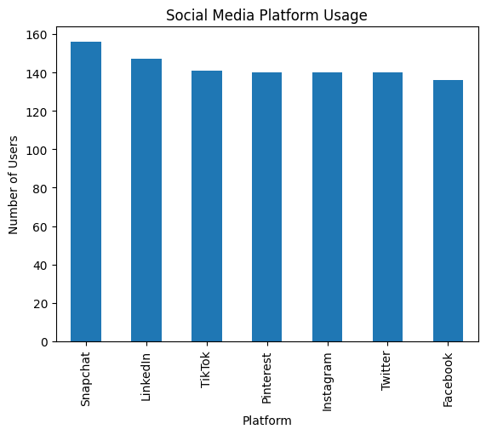
Figure 6.1: Bar Chart of Social Media Platform Usage
Observation: Snapchat has the most users (about 156), followed by LinkedIn (about 147) and TikTok (about 141); Pinterest, Instagram and Twitter have about 140 each and Facebook the fewest (about 136). Users are spread almost evenly across the seven platforms.
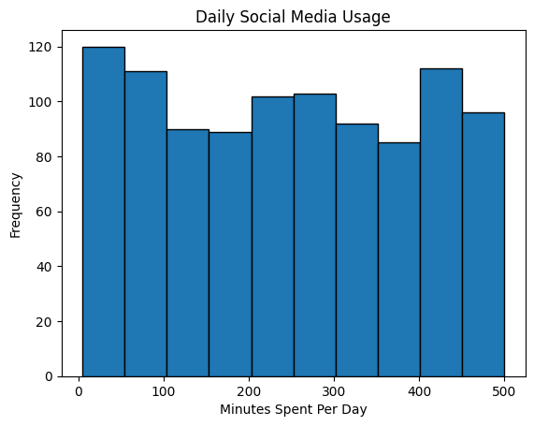
Figure 6.2: Histogram of Daily Social Media Usage
Observation: Across the ten 50-minute bins the frequencies range from roughly 85 to 120 with no pronounced peak, so daily usage is spread nearly evenly between 5 and 500 minutes instead of clustering around the mean.
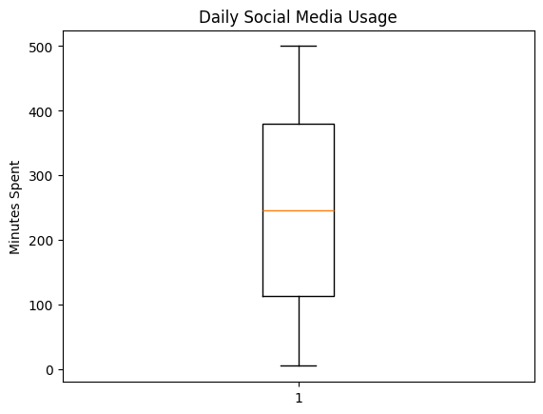
Figure 6.3: Box Plot of Daily Social Media Usage
Observation: The median is about 246 minutes and the box spans about 113 to 380 minutes. The whiskers reach the minimum (5) and maximum (500) values and no outliers are displayed.
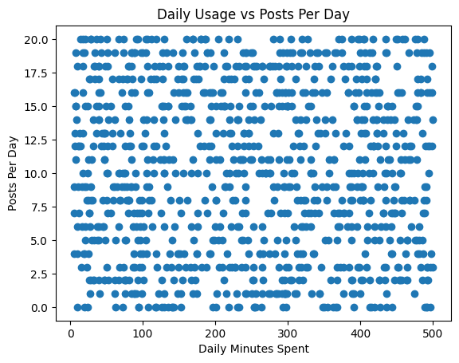
Figure 6.4: Scatter Plot of Daily Usage versus Posts Per Day
Observation: The points cover the whole plotting area with no visible trend, consistent with the near-zero correlation (r = −0.024) between daily minutes and posts per day.

6.4 Probability Distribution, Sampling and Central Limit Theorem Results
The table below summarizes the simulated distributions. Each generated sample contains 1,000 values, and the expected mean is the theoretical mean for the stated parameters.
Distribution | Parameters | Expected mean | Generated mean
Uniform | a = 5, b = 500 | 252.5 | 247.677
Normal | μ = 247.368, σ = 146.372 | 247.368 | 261.844
Poisson | λ = 10.269 (mean posts per day) | 10.269 | 10.18
Binomial | n = 10, p = 0.498 | 4.98 | 5.002

The uniform histogram is roughly flat, which resembles the observed shape of daily usage. The normal histogram is bell shaped but extends from about −200 to 700 minutes, which is impossible for data bounded between 5 and 500, so a normal model is a poor description of this variable; its generated mean (261.84) is also about 14.5 above the target mean, a deviation produced by this single seeded random draw. The Poisson samples are centred near 10 posts per day and the binomial samples near 5 high-usage users out of 10, in line with their parameters.
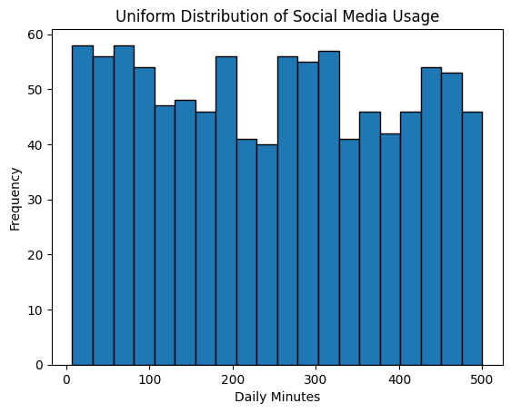
Figure 6.5: Histogram of Uniform Distribution of Social Media Usage
Observation: The generated values are spread almost evenly between 5 and 500 minutes, with bin frequencies of roughly 40 to 58.
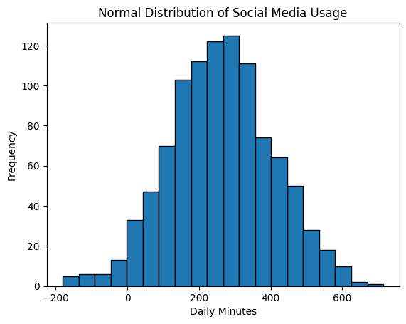
Figure 6.6: Histogram of Normal Distribution of Social Media Usage
Observation: A bell-shaped curve centred near 250 minutes, with simulated values falling below zero and above 600 minutes.
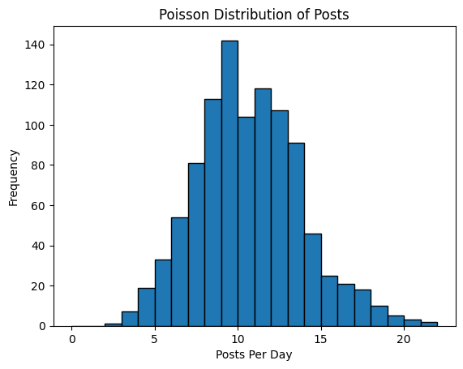
Figure 6.7: Histogram of Poisson Distribution of Posts
Observation: The distribution peaks at around 10 posts per day and tails off to the right, up to about 22 posts.
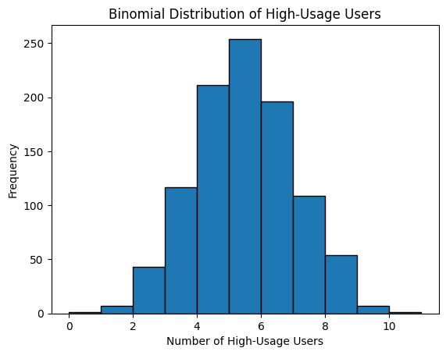
Figure 6.8: Histogram of Binomial Distribution of High-Usage Users
Observation: The distribution is centred around 5 high-usage users out of 10 and is roughly symmetric, because p is close to 0.5.
The sampling experiments are summarized below. The population mean of Daily_Minutes_Spent is 247.368 and its standard deviation is 146.3719.
Experiment | Design | Result
Random sample | 10 records, df.sample(random_state=42) | Sample mean 254.5; difference from population mean 7.132
Sampling distribution | 500 samples of size 10, with replacement | Mean of sample means 249.6126; standard error 45.8003 (σ/√n = 46.29)
Central Limit Theorem | 1,000 samples of size 30, with replacement | Mean of sample means 246.8657; standard deviation 26.27 (σ/√n = 26.72)

The default df.sample() draws without replacement, so the first two sampling outputs in the notebook contain the same 10 users, while the with-replacement sample returns a different set. The sample mean of 10 records (254.5) is close to the population mean (247.37). As the sample size grows from 10 to 30 the standard error falls from about 45.8 to 26.3, and both values are close to the theoretical σ/√n. Although the population is almost uniform rather than bell shaped, the distribution of sample means is bell shaped and centred on the population mean, which illustrates the Central Limit Theorem.
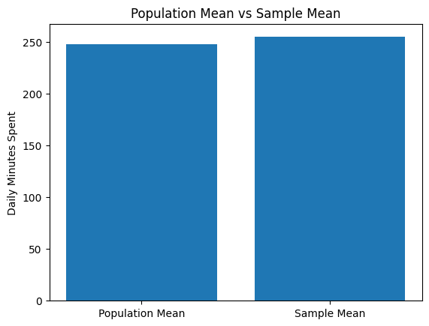
Figure 6.9: Bar Chart of Population Mean versus Sample Mean
Observation: The sample mean (254.5) is slightly higher than the population mean (247.37); the two bars are of nearly equal height.
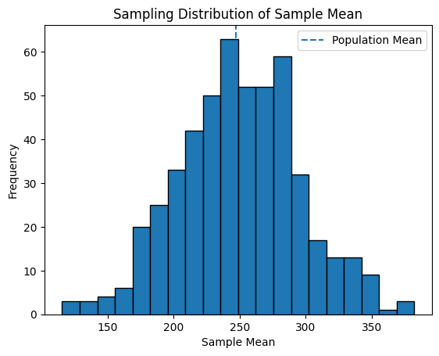
Figure 6.10: Sampling Distribution of the Sample Mean
Observation: Sample means from 500 samples of size 10 form a bell-shaped histogram centred close to the dashed population-mean line, with a wide spread (standard error about 45.8).
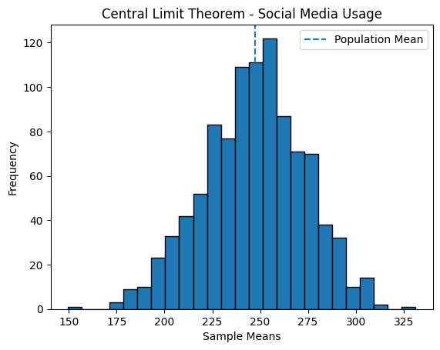
Figure 6.11: Central Limit Theorem: Distribution of Sample Means
Observation: Sample means of size 30 are more tightly concentrated around the population mean than in the previous figure (standard deviation about 26.3) and form a clearer bell shape.

6.5 Correlation and Hypothesis Testing
The covariance, Pearson correlation and Spearman correlation matrices for the four numeric variables are given below (values rounded to four decimal places).
Covariance matrix
 | Daily_Minutes | Posts_Per_Day | Likes_Per_Day | Follows_Per_Day
Daily_Minutes_Spent | 21424.7393 | −21.4765 | 114.1211 | 81.5177
Posts_Per_Day | −21.4765 | 37.4761 | 5.9525 | 1.6459
Likes_Per_Day | 114.1211 | 5.9525 | 3313.2621 | −14.9310
Follows_Per_Day | 81.5177 | 1.6459 | −14.9310 | 220.3131

Pearson correlation matrix
 | Daily_Minutes | Posts_Per_Day | Likes_Per_Day | Follows_Per_Day
Daily_Minutes_Spent | 1.0000 | −0.0240 | 0.0135 | 0.0375
Posts_Per_Day | −0.0240 | 1.0000 | 0.0169 | 0.0181
Likes_Per_Day | 0.0135 | 0.0169 | 1.0000 | −0.0175
Follows_Per_Day | 0.0375 | 0.0181 | −0.0175 | 1.0000

Spearman correlation matrix
 | Daily_Minutes | Posts_Per_Day | Likes_Per_Day | Follows_Per_Day
Daily_Minutes_Spent | 1.0000 | −0.0243 | 0.0111 | 0.0379
Posts_Per_Day | −0.0243 | 1.0000 | 0.0162 | 0.0190
Likes_Per_Day | 0.0111 | 0.0162 | 1.0000 | −0.0182
Follows_Per_Day | 0.0379 | 0.0190 | −0.0182 | 1.0000

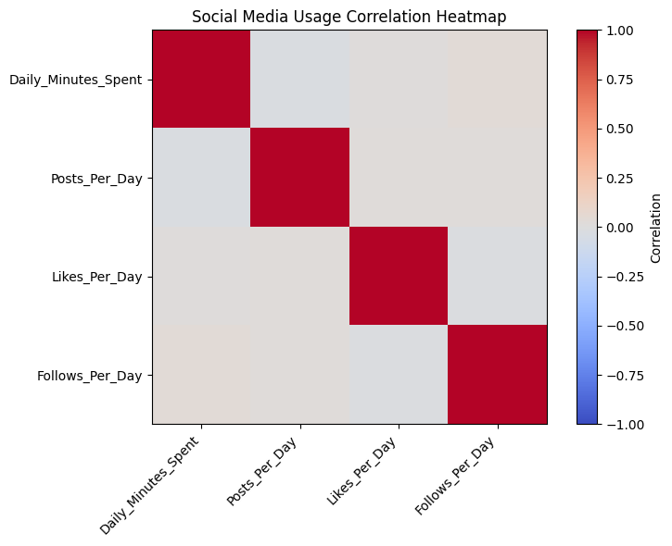
Figure 6.12: Correlation Heatmap of Social Media Usage Variables
Observation: Apart from the diagonal, all cells are close to zero (pale colour). The strongest relationship is between daily minutes and follows per day (Pearson 0.0375), which is still negligible.
All off-diagonal Pearson and Spearman coefficients lie between about −0.024 and 0.038, so there is no meaningful linear or monotonic relationship between any pair of variables. Pearson and Spearman values are nearly identical, which agrees with the absence of any strong pattern.
The hypothesis test results are given below.
Test | Statistic | p-value | Decision at 5%
Pearson correlation (minutes vs posts) | r = −0.02396778 | 0.44899681 | Fail to reject H₀
One-sample Z-test (μ₀ = 240) | z = 1.59181226 | 0.11142690 | Fail to reject H₀
One-sample t-test (μ₀ = 240) | t = 1.59181226 | 0.11174325 | Fail to reject H₀
Welch t-test (Pinterest vs Facebook) | t = −0.60859469 | 0.54330094 | Fail to reject H₀
Chi-square (App × Usage_Level) | χ² = 10.24101848; df = 6 | 0.11486231 | Fail to reject H₀

The Z-test and t-test give the same statistic (1.5918) because the sample of 1,000 records is large; the sample mean of 247.368 is not significantly different from 240 minutes. In the Welch t-test the mean usage of Pinterest users (236.21 minutes) and Facebook users (247.17 minutes) did not differ significantly; note that only the first two platforms in the data were compared, so differences among the other platforms were not tested. For the Chi-square test the observed counts of High and Low users per platform are shown below. All expected counts exceed 67, so the test is valid, and the result gives no evidence of an association between platform and usage level.
App | High usage | Low usage
Facebook | 63 | 73
Instagram | 77 | 63
LinkedIn | 64 | 83
Pinterest | 70 | 70
Snapchat | 87 | 69
TikTok | 61 | 80
Twitter | 76 | 64

6.6 Regression and Classification Model Performance
Linear Regression (Posts_Per_Day from Daily_Minutes_Spent) produced the following results on the test set.
Measure | Value
Intercept | 10.48977854
Coefficient (Daily_Minutes_Spent) | −0.00077918
R² score | 0.00072936
Mean Squared Error | 39.40221573

The fitted line is almost flat: each additional 100 minutes of daily usage is associated with only about 0.078 fewer posts per day, and the intercept (10.49) is close to the average number of posts per day (10.27). An R² of about 0.0007 means that daily usage explains only about 0.07% of the variation in posts per day.
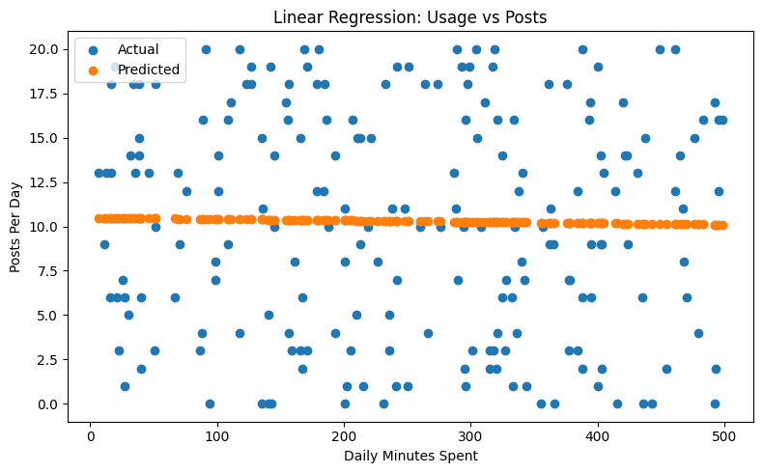
Figure 6.13: Linear Regression: Actual versus Predicted Posts Per Day
Observation: The predicted values form an almost horizontal line near 10 posts per day, while the actual values range from 0 to 20 across all usage levels, showing that the model captures essentially none of the variation.
Logistic Regression (High_Usage from Posts_Per_Day, Likes_Per_Day and Follows_Per_Day) obtained an accuracy of 0.48 on the 200 test records. The classification report is given below.
Class | Precision | Recall | F1-score | Support
0 (Low usage) | 0.48 | 0.52 | 0.50 | 100
1 (High usage) | 0.48 | 0.44 | 0.46 | 100
Accuracy |  |  | 0.48 | 200
Macro average | 0.48 | 0.48 | 0.48 | 200
Weighted average | 0.48 | 0.48 | 0.48 | 200

Precision, recall and F1-score are all close to 0.5 for both classes, so the classifier performs no better than random guessing. Posting, liking and following activity do not help to identify whether a user is a high or low user of social media in this dataset.

7. CONCLUSION
The Social Media Usage Statistical Analysis and Machine Learning project applied data collection, cleaning, descriptive statistics, visualization, probability distributions, sampling, correlation analysis, hypothesis testing and two basic models to a dataset of 1,000 users across seven social media platforms. The data were collected from an online CSV source using requests and BeautifulSoup, and contained no missing values and no duplicate records.
Users spend an average of 247.37 minutes (about 4.1 hours) per day on social media, with values spread almost evenly from 5 to 500 minutes. The seven platforms have similar numbers of users, from 136 (Facebook) to 156 (Snapchat). Sampling experiments showed that sample means are close to the population mean and that the standard error decreases as the sample size increases from 10 to 30, with the sampling distribution becoming bell shaped, as the Central Limit Theorem predicts.
All correlations between daily minutes, posts, likes and follows were close to zero. None of the five hypothesis tests rejected its null hypothesis at the 5% level: mean daily usage (247.37) is not significantly different from 240 minutes (p = 0.111), usage did not differ significantly between Pinterest and Facebook (p = 0.543), and platform and usage level are not significantly associated (p = 0.115).
Linear Regression (R² = 0.00073, MSE = 39.40) and Logistic Regression (accuracy = 0.48) both showed essentially no predictive power, which agrees with the near-zero correlations. The nearly uniform spread of the variables and the absence of relationships suggest that the dataset may be synthetic or randomly generated; its origin is not documented in the notebook, so the conclusions apply only to this dataset.
Future work may use datasets with additional features such as age, time of day, content type and engagement, compare usage across all seven platforms with a one-way ANOVA and post-hoc tests, evaluate other models with cross-validation, and deploy the final model through an interface such as Gradio.

8. GITHUB LINK
Project Repository: [To Be Updated]
Google Colab Notebook: [To Be Updated]
Dataset Source: https://gist.githubusercontent.com/ontipulikesava153/00de7c8bbf6846daef91955970c06e92/raw/social_media_usage.csv

9. REFERENCES
[1] Social Media Usage dataset, GitHub Gist (raw CSV). https://gist.githubusercontent.com/ontipulikesava153/00de7c8bbf6846daef91955970c06e92/raw/social_media_usage.csv
[2] Pandas Documentation. https://pandas.pydata.org/docs/
[3] NumPy Documentation. https://numpy.org/doc/
[4] SciPy Documentation. https://docs.scipy.org/doc/scipy/
[5] Scikit-learn Documentation. https://scikit-learn.org/stable/
[6] Matplotlib Documentation. https://matplotlib.org/stable/
[7] Requests: HTTP for Humans. https://requests.readthedocs.io/
[8] Beautiful Soup Documentation. https://www.crummy.com/software/BeautifulSoup/bs4/doc/

