Amazon Sales Analytics & Customer Insights Project

Business Objective
Analyze sales performance, customer behavior, and profitability trends to identify business insights and improvement opportunities.

1.Top Revenue Categories
select category,
sum(sales) as revenue
from amazon_sales
group by Category
order by revenue asc
limit 3;
OUTPUT:
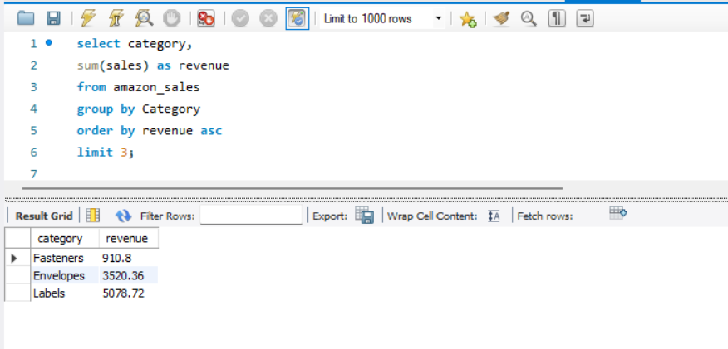
Insight:
Fasteners, Envelopes, and Labels generated the lowest revenue among all categories, indicating lower customer demand or limited sales contribution.
Recommendation:
The business can evaluate marketing strategies, pricing, or inventory planning for low-performing categories to improve sales performance.
2. Regional Profitability Analysis
SELECT region, SUM(profit) AS total_profit
FROM amazon_sales
GROUP BY region
ORDER BY total_profit ASC
LIMIT 5;
OUTPUT:
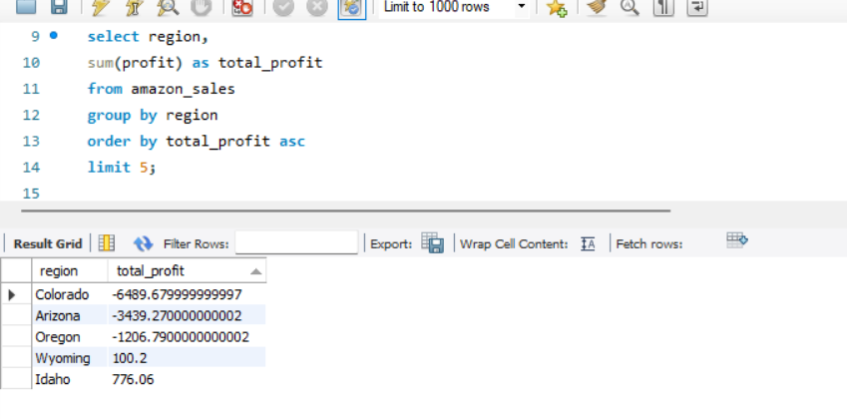
Insight:
Colorado, Arizona, and Oregon generated negative profits, indicating potential issues related to excessive discounting, operational costs, or low-margin product sales. Wyoming and Idaho showed only minimal profitability compared to other regions.
Recommendation:
The company should review pricing strategies, discount policies, and operational expenses in low-performing regions to improve overall profitability.
3.Top Profitable Orders in Seattle
select * from amazon_sales
where city = 'seattle'
order by profit desc
limit 3;
OUTPUT:
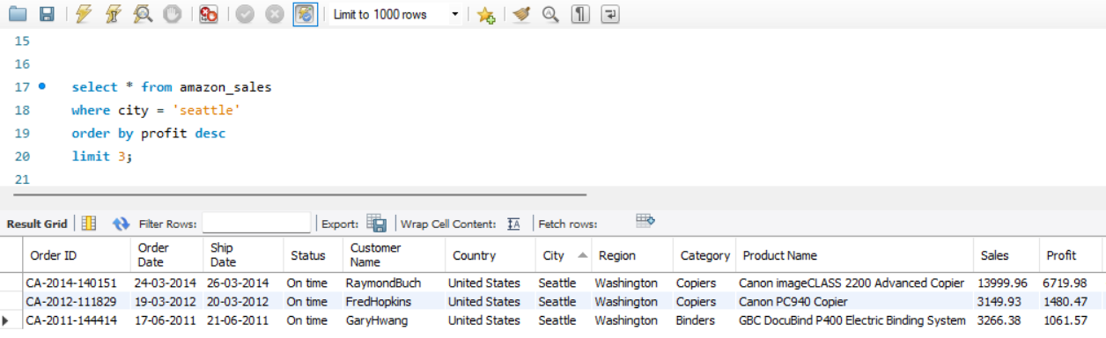
Insight:
High-value products such as copiers and office equipment generated the highest profits in Seattle, indicating strong profitability from premium product categories in this city.
Recommendation:
The business can focus on promoting high-margin office products in Seattle to maximize profitability and customer value.
4. Top Customers by Total Spending
select `Customer Name`,
sum(sales) as total_spent
from amazon_sales
group by `Customer Name`
order by total_spent desc
limit 4;
OUTPUT:
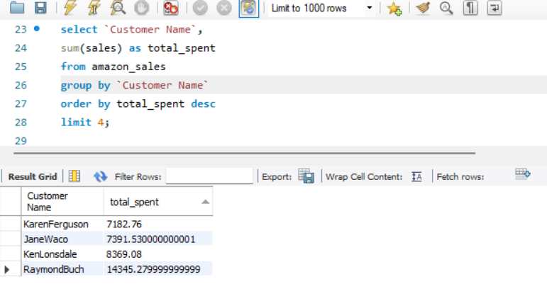
Insight:
A small group of customers contributed significantly to total sales revenue, with Raymond Buch emerging as the highest-spending customer. This indicates the importance of high-value repeat customers to business growth.
Recommendation:
The company should strengthen customer retention strategies and loyalty programs for high-value customers to maximize long-term revenue.

5. Lowest Selling Products Analysis
SELECT `Product Name`,
SUM(quantity) AS total_quantity_sold
FROM amazon_sales
GROUP BY `Product Name`
ORDER BY total_quantity_sold ASC
LIMIT 5;
OUTPUT:
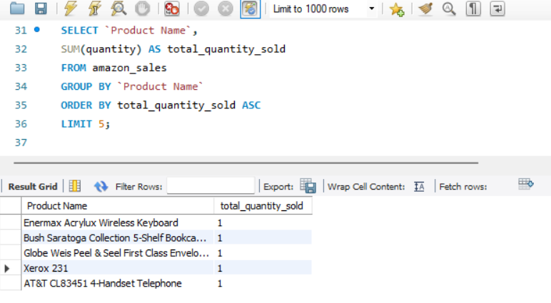
Insight:
Several products showed consistently low sales volumes, indicating weak customer demand or limited market performance.
Recommendation:
The company should evaluate inventory levels, pricing strategies, and marketing efforts for low-performing products.

KPI Calculations
KPI1: Total Revenue
SELECT SUM(sales) AS total_revenue
FROM amazon_sales;
OUTPUT:
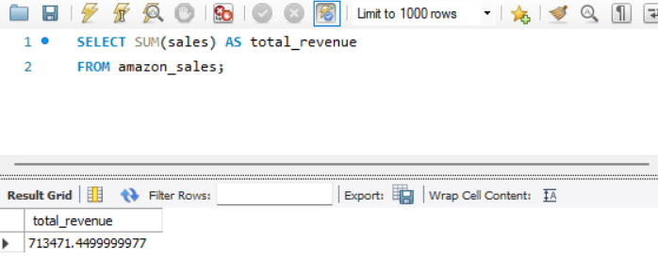
Insight:
The business generated strong overall revenue across all product categories and regions.
KPI2: Total Profit
SELECT SUM(profit) AS total_profit
FROM amazon_sales;
OUTPUT:
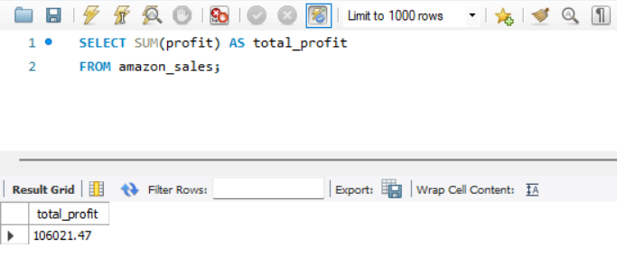
Insight:
The business generated a total profit of 106,021.47, indicating overall profitable sales performance across products and regions.

KPI3: Total Orders
SELECT COUNT('Order ID') AS total_orders
FROM amazon_sales;
OUTPUT:
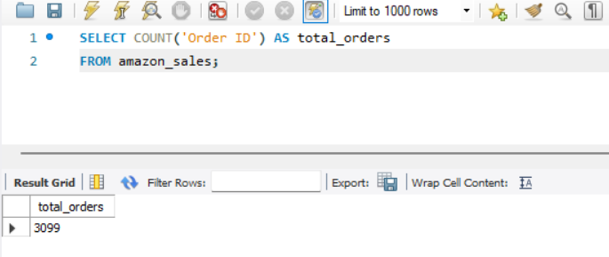
Insight:
The business processed 3,099 unique customer orders during the analyzed period, indicating consistent sales activity and customer engagement.
KPI4: Average Order Value
SELECT
SUM(sales)/COUNT('Order ID') AS avg_order_value
FROM amazon_sales;
OUTPUT:
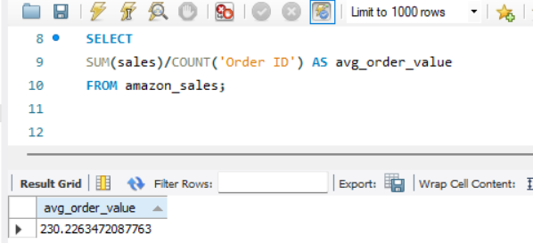

Insight:
The average order value was approximately 230.23, indicating that customers spent around 230 per order on average during the analyzed period.

Final Business Insights
- Technology-related products generated the highest sales revenue.
- Several regions such as Colorado and Arizona generated negative profits.
- High-value customers contributed significantly to total sales.
- Some product categories showed consistently low sales performance.
Recommendations
1.Reduce excessive discounting in low-profit regions.
2.Focus marketing efforts on high-performing categories.
3.Improve customer retention strategies for high-value customers.
4.Review inventory planning for low-selling products.

