**Roll No.16010421063**

**Batch No.G3**

**Name:Arya Nair**

**Experiment 4: COD determination of waste-water**

**Objective:**

To determine chemical oxygen demand (COD) of water samples

**Chemical Oxygen Demand (COD):**

**Theory:**

COD is used as a measure of oxygen equivalent to organic matter content of a sample that is susceptible to oxidation by a strong chemical oxidant. For samples from a specific source, COD can be related empirically to BOD. COD determination has advantage over BOD determination in that the result can be obtained in about 5 hours as compared to 5 days required for BOD test.

The organic matter gets oxidized completely by K2Cr2O7 in the presence of H2SO4 to produce CO2 and H2O. The excess of K2Cr2O7 remained after the reaction is titrated with ferrous ammonium sulphate. The dichromate consumed gives the O2 required for oxidation of organic matter.

**Procedure:**

**Determination of COD of water sample**

1. Select the water sample.
2. To reflux the contents in the RB flask click the "switch on mantle" button.
3. Click "start titration" to titrate the contents.
4. Select the normality of ferrous ammonium sulphate (FAS).
5. Start titration & note the volume of titrant consumed when colour changes from bluish green to wine red. (Let the volume of titrant be V2mL).
6. Repeat the same with the blank (Let the volume of the titrant be V1mL).
7. COD calculated using the equation.

«math xmlns=¨http://www.w3.org/1998/Math/MathML¨»«mi»C«/mi»«mi»O«/mi»«mi»D«/mi»«mo»§nbsp;«/mo»«mo»(«/mo»«mfrac»«mrow»«mi»m«/mi»«mi»g«/mi»«/mrow»«mi»L«/mi»«/mfrac»«mo»)«/mo»«mo»=«/mo»«mfrac»«mrow»«mi»V«/mi»«mi»o«/mi»«mi»l«/mi»«mo».«/mo»«mi»F«/mi»«mi»A«/mi»«mi»S«/mi»«mo»§nbsp;«/mo»«mi»f«/mi»«mi»o«/mi»«mi»r«/mi»«mo»§nbsp;«/mo»«mi»s«/mi»«mi»a«/mi»«mi»m«/mi»«mi»p«/mi»«mi»l«/mi»«mi»e«/mi»«mo»§#215;«/mo»«mi»N«/mi»«mi»o«/mi»«mi»r«/mi»«mi»m«/mi»«mi»a«/mi»«mi»l«/mi»«mi»i«/mi»«mi»t«/mi»«mi»y«/mi»«mo»§nbsp;«/mo»«mi»o«/mi»«mi»f«/mi»«mo»§nbsp;«/mo»«mi»F«/mi»«mi»A«/mi»«mi»S«/mi»«mo»§#215;«/mo»«mn»8000«/mn»«/mrow»«mrow»«mi»V«/mi»«mi»o«/mi»«mi»l«/mi»«mo».«/mo»«mo»§nbsp;«/mo»«mi»o«/mi»«mi»f«/mi»«mo»§nbsp;«/mo»«mi»s«/mi»«mi»a«/mi»«mi»m«/mi»«mi»p«/mi»«mi»l«/mi»«mi»e«/mi»«/mrow»«/mfrac»«/math»

**Observations and Calculations:**

|  |  |  |  |  |  |
| --- | --- | --- | --- | --- | --- |
|  | **Sample**  **Type** | **Vol. of sample (mL)** | **Burette Reading (mL)** | | **Vol. of FAS (mL)** |
| **Initial** | **Final** |
| **Sample**  **(3 h)** | Well water | 20 | 0.0 | 4.8 | 4.8 |
| Tap | 20 | 0.0 | 4.9 | 4.9 |
| Domestic | 20 | 0.0 | 2.5 | 2.5 |
| **Blank**  **(0 min)** | Well water | 20 | 0.0 | 5 | 5 |
| Tap | 20 | 0.0 | 5 | 5 |
| Domestic | 20 | 0.0 | 5 | 5 |

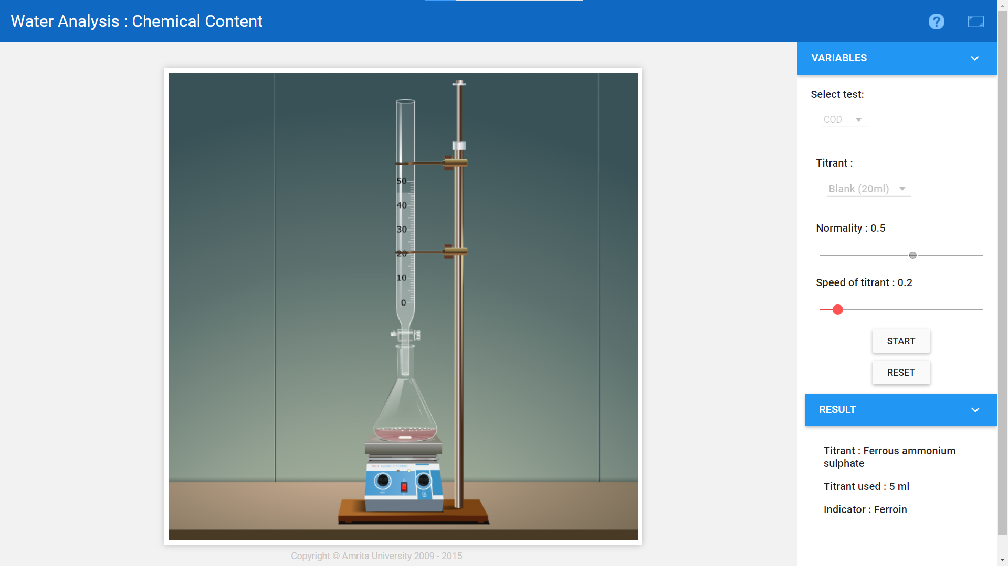

**COD of well-water**

Potassium dichromate consumed = (Vblank-Vsample) =0.2

Normality of FAS =.......0.5....N.

Volume of the water sample =.........20.......mL.

Therefore COD of the water sample =  «math xmlns=¨http://www.w3.org/1998/Math/MathML¨»«mfrac»«mrow»«mi»V«/mi»«mi»o«/mi»«mi»l«/mi»«mo».«/mo»«mi»F«/mi»«mi»A«/mi»«mi»S«/mi»«mo»§nbsp;«/mo»«mi»f«/mi»«mi»o«/mi»«mi»r«/mi»«mo»§nbsp;«/mo»«mi»s«/mi»«mi»a«/mi»«mi»m«/mi»«mi»p«/mi»«mi»l«/mi»«mi»e«/mi»«mo»§#215;«/mo»«mi»N«/mi»«mi»o«/mi»«mi»r«/mi»«mi»m«/mi»«mi»a«/mi»«mi»l«/mi»«mi»i«/mi»«mi»t«/mi»«mi»y«/mi»«mo»§nbsp;«/mo»«mi»o«/mi»«mi»f«/mi»«mo»§nbsp;«/mo»«mi»F«/mi»«mi»A«/mi»«mi»S«/mi»«mo»§#215;«/mo»«mn»8000«/mn»«/mrow»«mrow»«mi»V«/mi»«mi»o«/mi»«mi»l«/mi»«mo».«/mo»«mo»§nbsp;«/mo»«mi»o«/mi»«mi»f«/mi»«mo»§nbsp;«/mo»«mi»s«/mi»«mi»a«/mi»«mi»m«/mi»«mi»p«/mi»«mi»l«/mi»«mi»e«/mi»«/mrow»«/mfrac»«/math»

= …40……..ppm

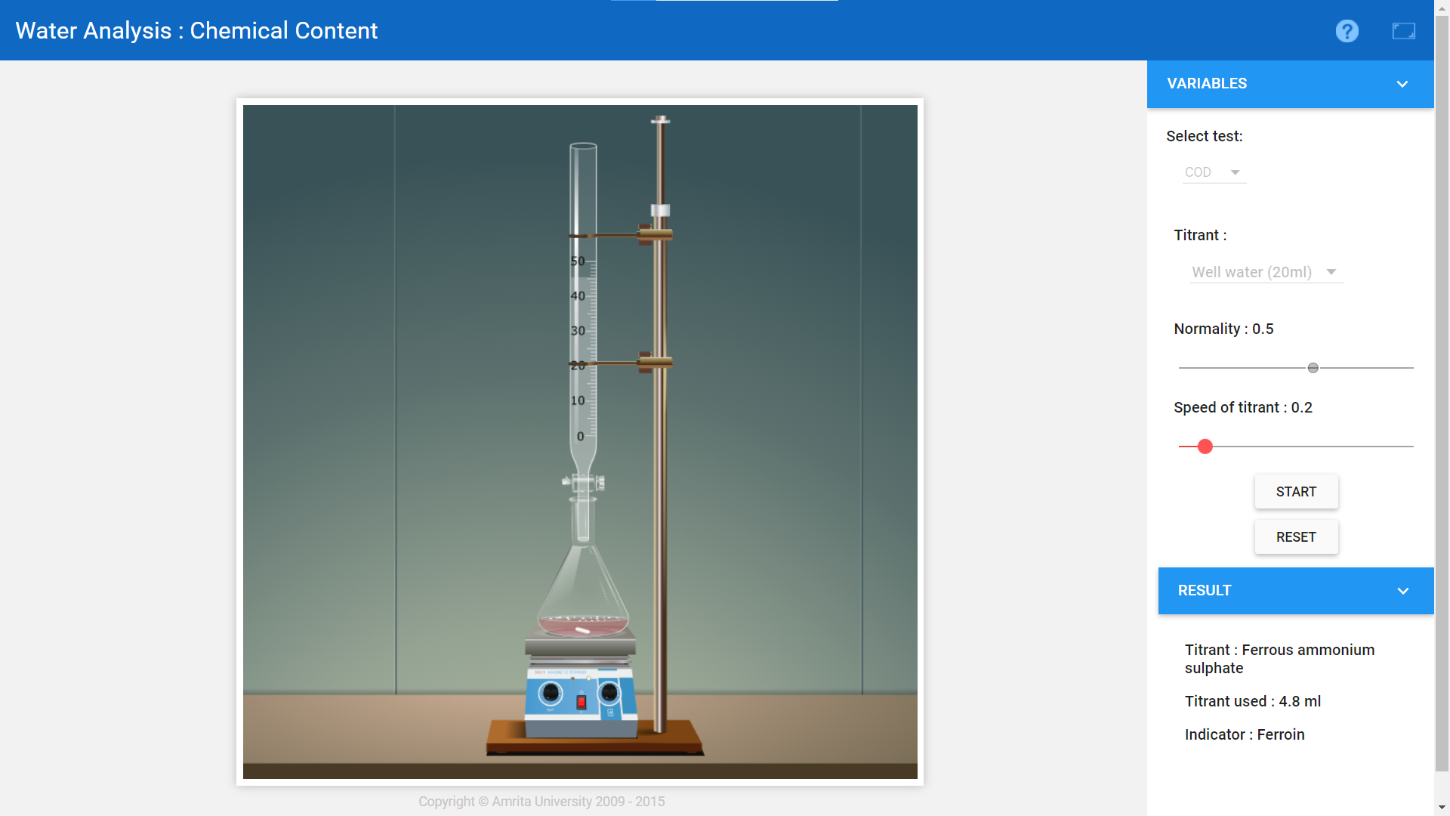

**COD of Domestic-water**

Volume of FAS used= (V2-V1) =.........2.5.........mL.

Normality of FAS =........0.5..........N.

Volume of the water sample =.......20...........mL.

Therefore COD of the water sample =  «math xmlns=¨http://www.w3.org/1998/Math/MathML¨»«mfrac»«mrow»«mi»V«/mi»«mi»o«/mi»«mi»l«/mi»«mo».«/mo»«mi»F«/mi»«mi»A«/mi»«mi»S«/mi»«mo»§nbsp;«/mo»«mi»f«/mi»«mi»o«/mi»«mi»r«/mi»«mo»§nbsp;«/mo»«mi»s«/mi»«mi»a«/mi»«mi»m«/mi»«mi»p«/mi»«mi»l«/mi»«mi»e«/mi»«mo»§#215;«/mo»«mi»N«/mi»«mi»o«/mi»«mi»r«/mi»«mi»m«/mi»«mi»a«/mi»«mi»l«/mi»«mi»i«/mi»«mi»t«/mi»«mi»y«/mi»«mo»§nbsp;«/mo»«mi»o«/mi»«mi»f«/mi»«mo»§nbsp;«/mo»«mi»F«/mi»«mi»A«/mi»«mi»S«/mi»«mo»§#215;«/mo»«mn»8000«/mn»«/mrow»«mrow»«mi»V«/mi»«mi»o«/mi»«mi»l«/mi»«mo».«/mo»«mo»§nbsp;«/mo»«mi»o«/mi»«mi»f«/mi»«mo»§nbsp;«/mo»«mi»s«/mi»«mi»a«/mi»«mi»m«/mi»«mi»p«/mi»«mi»l«/mi»«mi»e«/mi»«/mrow»«/mfrac»«/math»

= ……......500.........ppm

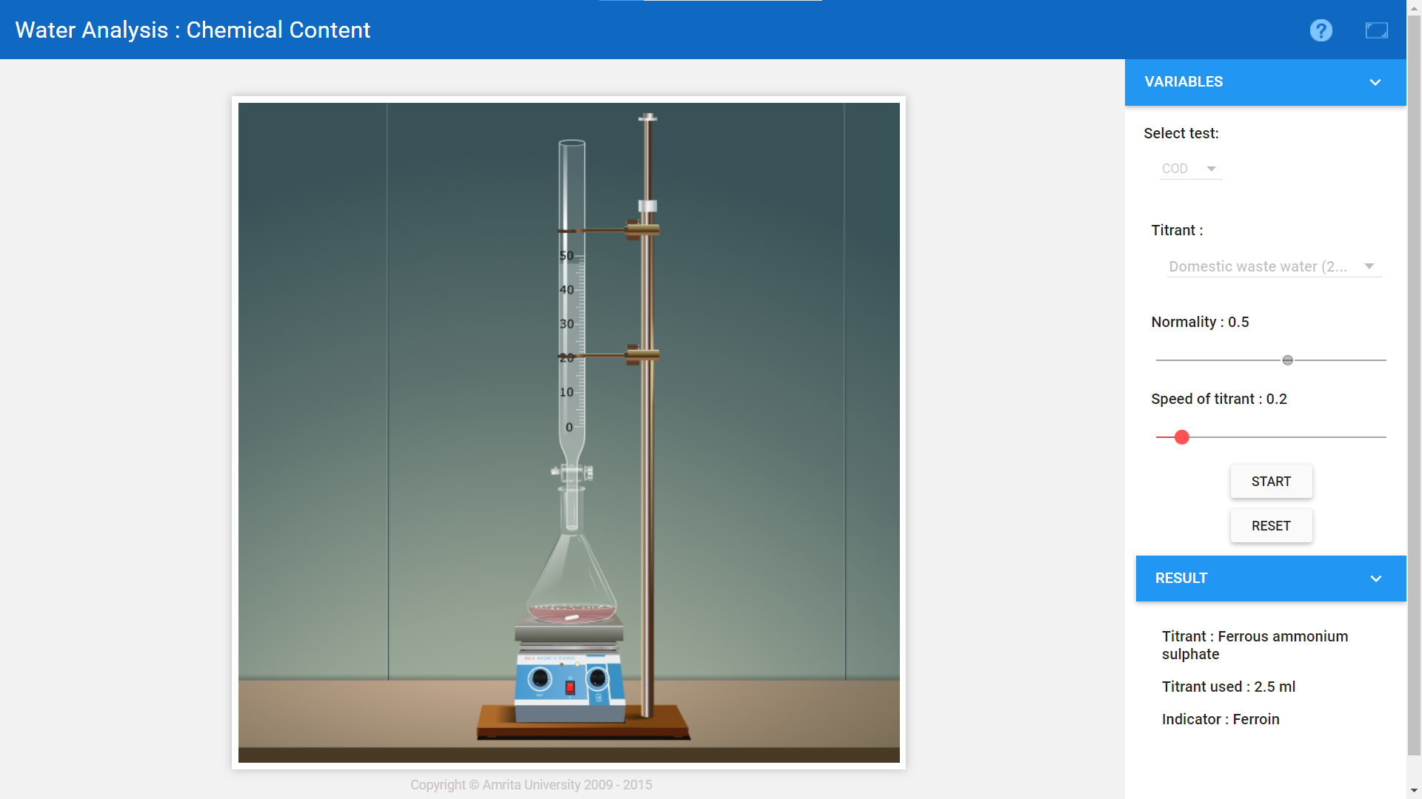

**COD of Tap-water**

Volume of FAS used= (V2-V1) =....0.1..............mL.

Normality of FAS =....0.5..............N.

Volume of the water sample =......20............mL.

Therefore COD of the water sample =  «math xmlns=¨http://www.w3.org/1998/Math/MathML¨»«mfrac»«mrow»«mi»V«/mi»«mi»o«/mi»«mi»l«/mi»«mo».«/mo»«mi»F«/mi»«mi»A«/mi»«mi»S«/mi»«mo»§nbsp;«/mo»«mi»f«/mi»«mi»o«/mi»«mi»r«/mi»«mo»§nbsp;«/mo»«mi»s«/mi»«mi»a«/mi»«mi»m«/mi»«mi»p«/mi»«mi»l«/mi»«mi»e«/mi»«mo»§#215;«/mo»«mi»N«/mi»«mi»o«/mi»«mi»r«/mi»«mi»m«/mi»«mi»a«/mi»«mi»l«/mi»«mi»i«/mi»«mi»t«/mi»«mi»y«/mi»«mo»§nbsp;«/mo»«mi»o«/mi»«mi»f«/mi»«mo»§nbsp;«/mo»«mi»F«/mi»«mi»A«/mi»«mi»S«/mi»«mo»§#215;«/mo»«mn»8000«/mn»«/mrow»«mrow»«mi»V«/mi»«mi»o«/mi»«mi»l«/mi»«mo».«/mo»«mo»§nbsp;«/mo»«mi»o«/mi»«mi»f«/mi»«mo»§nbsp;«/mo»«mi»s«/mi»«mi»a«/mi»«mi»m«/mi»«mi»p«/mi»«mi»l«/mi»«mi»e«/mi»«/mrow»«/mfrac»«/math»

= ……...20............ppm

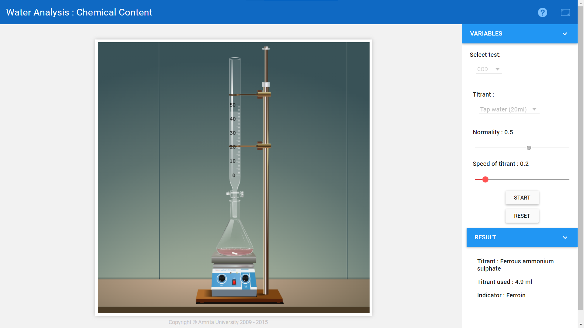

**Result:**

COD of well-water sample = .......40.............ppm.

COD of Domestic-water sample = ........500............ppm.

COD of tap-water sample = ......20..............ppm.