**Roll No: 16010421063**

**Batch No: G3**

**Name: Arya Nair**

**Experiment 3: Hardness of Water**

**Objective:**

To determine the various types of hardness of different water samples.

**Theory:**

Hardness in water is that characteristic, which “prevents the lathering of soap”. This is due to presence in water of certain salts of calcium, magnesium and other heavy metals dissolved in it. A sample of hard water, when treated with soap does not produce lather, but on other hand forms a white scum or precipitate. This precipitate is formed, due to the formation of insoluble soaps of calcium and magnesium.

Thus, water which does not produce lather with soap solution readily, but forms a white curd, is called hard water. On the other hand, water which lathers easily on shaking with soap solution, is called soft water. Such water consequently does not contain dissolved calcium and magnesium salts in it.

**Temporary or carbonate hardness:** It is caused by the presence of dissolved bicarbonates of calcium, magnesium and other heavy metals and the carbonate of iron. Temporary hardness is mostly destroyed by mere boiling of water, when bicarbonates are decomposed, will produce insoluble carbonates or hydroxides, which are deposited as a crust at the bottom of vessel.

**Permanent or non-carbonate hardness:** It is due to the presence of chlorides and sulphates of calcium, magnesium, iron, and other heavy metals. Unlike temporary hardness, permanent hardness is not destroyed on boiling.

The degree of hardness of drinking water has been classified in terms of the equivalent CaCO3 concentration as follows:

|  |  |
| --- | --- |
| Soft | 0-60mg/L |
| Medium | 60-120mg/L |
| Hard | 120-180mg/L |
| Very Hard | >180mg/L |

In a hard water sample, the total hardness can be determined by titrating the Ca2+ and Mg2+ present in an aliquot of the sample with Na2EDTA solution, using NH4Cl-NH4OH buffer solution of pH 10 and Eriochrome Black-T as the metal indicator.

Na2H2Y (Disodium EDTA solution) → 2Na+ + H2Y-

Mg2+ + HD2- (blue) → MgD (wine red) + H+

D (metal-indicator complex, wine red colour) + H2Y- →Y- (metal EDTA complex colourless) + HD- (blue colour) + H+

Ethylenediamine tetra-acetic acid (EDTA) and its sodium salts form a chelated soluble complex when added to a solution of certain metal cations. If a small amount of a dye such as Eriochrome black T is added to an aqueous solution containing calcium and magnesium ions at a pH of 10 ± 0.1, the solution will become wine red. If EDTA is then added as a titrant, the calcium and magnesium will be complexed. After sufficient EDTA has been added to complex all the magnesium and calcium, the solution will turn from wine red to blue. This is the end point of the titration.

**Procedure:**

Under the chemical content, select the tests- Hardness.

**A. Determination of Hardness of Water Sample**

* Select the titrant.
* Adjust the speed of the drops from the burette.
* Adjust the molarity of titrant.
* Select a definite volume of water sample.
* Choose the indicator & start the titration.
* When colour changes from wine red to blue click the "stop" button & note the volume of EDTA used.
* Then calculate the hardness of water sample in ppm using the equation as follows.

**Observations and Calculations:**

|  |  |  |  |  |  |  |
| --- | --- | --- | --- | --- | --- | --- |
| No. | Sample Type | Volume of Sample (mL) | **Burette Reading (mL)** | | | Vol. of EDTA (mL) |
|  |  |  | Initial | R1 | R2 |  |
| 1 | Well water | 12 | 0.0 | 0.8 | 0.8 | 0.8 |
| 2 | Tap water | 13 | 0.0 | 1 | 1 | 1 |
| 3 | Sea Water | 15 | 0.0 | 0.9 | 0.9 | 0.9 |

**Well water:**

* Volume of EDTA used = **0.8ml**.
* Molarity of EDTA **= 0.04M**.
* Volume of the water sample = **12ml**.
* Therefore, the total hardness of the sample is = **266.67ppm.**



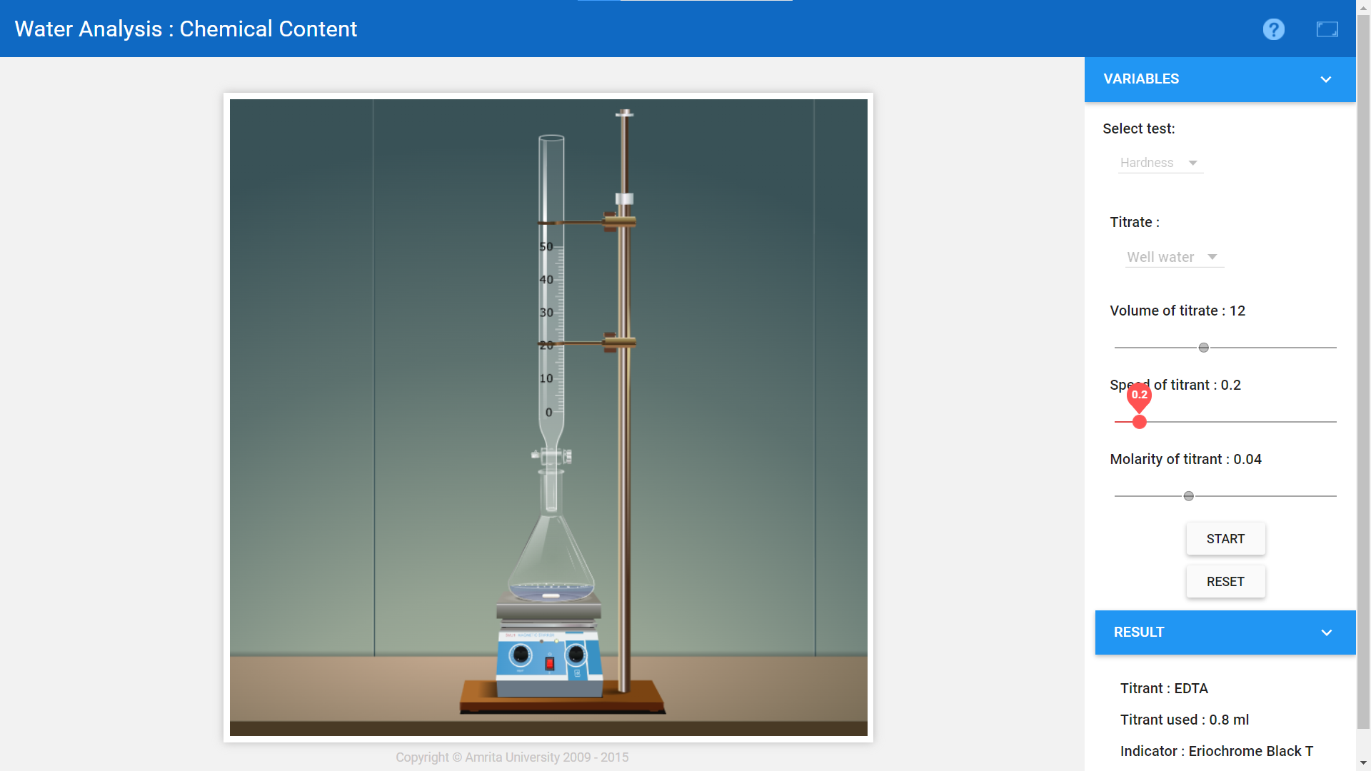

**Tap water:**

* Volume of EDTA used = **1ml.**
* Molarity of EDTA = **0.02M.**
* Volume of the water sample = **13ml.**
* Therefore, the total hardness of the sample is = **153.84ppm**.



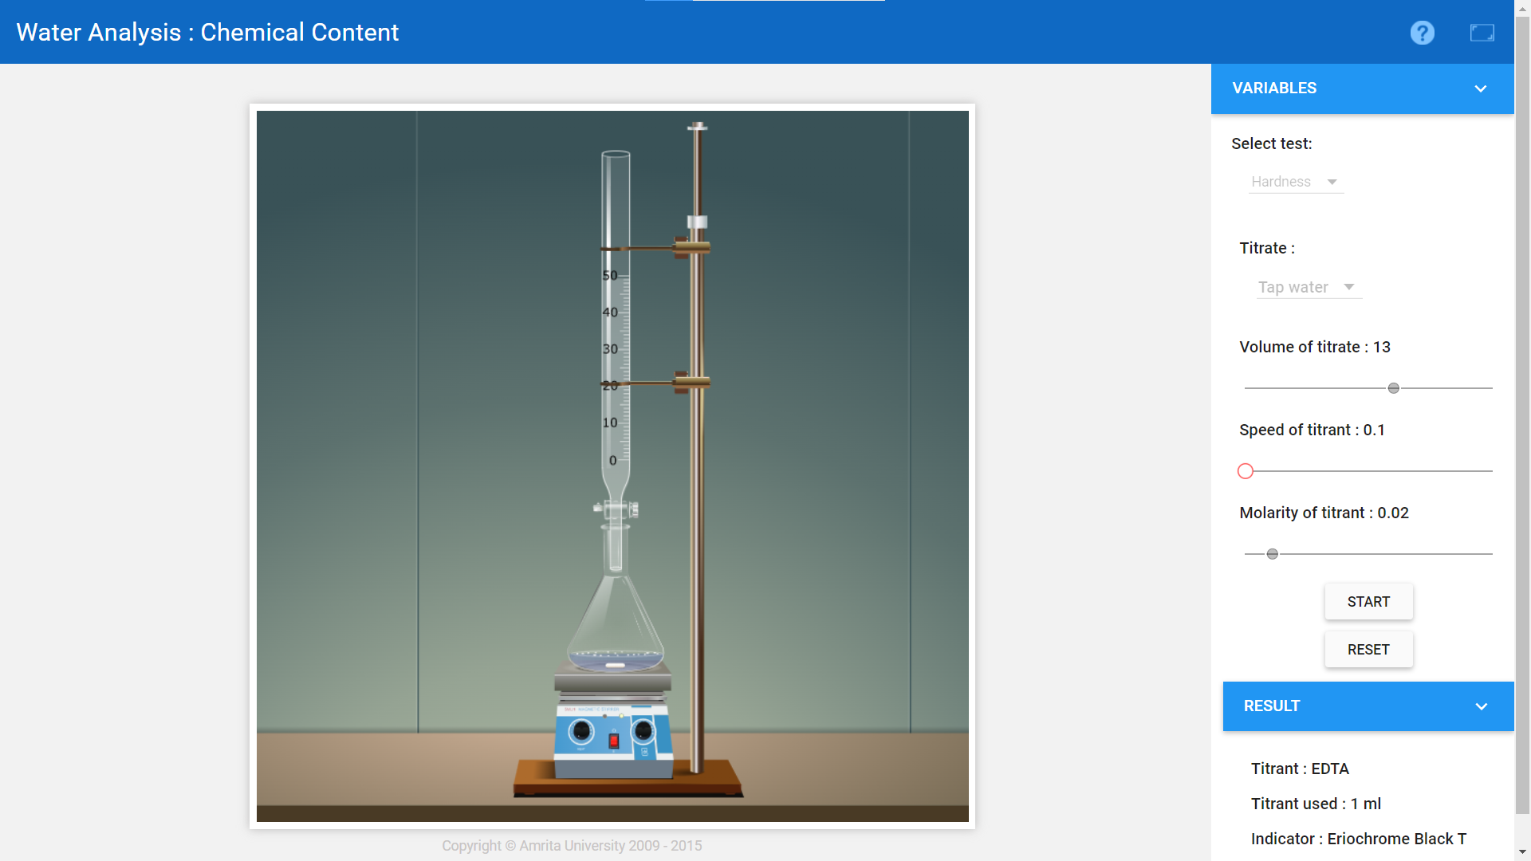

**Sea water:**

* Volume of EDTA used = **0.9ml.**
* Molarity of EDTA = **0.1M.**
* Volume of the water sample **= 15ml.**
* Therefore, the total hardness of the sample is = **600ppm.**



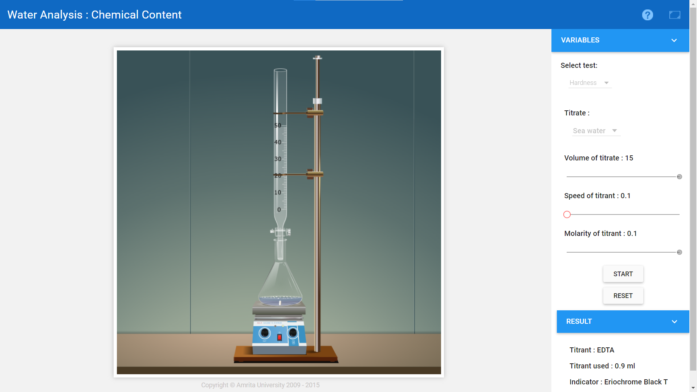

**Result:**

The total hardness of Well water sample is = **266.67ppm.**

The total hardness of tap water sample is = **153.84ppm.**

The total hardness of sea water sample is = **600ppm.**