**Roll No. 16010421063**

**Batch No. G3**

**Name: Arya Nair**

**Experiment 8: Determination of Nitrogen content of the soil sample**

## **Objectives:**

* To determine the available nitrogen in the soil sample by Kjeldahl Method.

### **Principle:**

The Kjeldahl method permits the available nitrogen to be precisely determined in the plant and in the soil. The method of determination involves three successive phases which are,

1. Digestion of the organic material to convert nitrogen into HNO3.
2. Distillation of the released Ammonia into an absorbing surface or medium.
3. Volumetric analysis of the Ammonia formed during the digestion process.

### **Digestion:**

Digestion of the organic material is carried out by digesting the sample with Con. H2SO4 in the presence of CuSO4.H2O as a catalyst and K2SO4 which raise the digestion temperature. The organic material decomposes into several components i.e.,

C → CO2, O → H2O and N → NH3

In the organic matter, some nitrates are present, most of which are lost during the digestion. The loss may be disregarded for most soils. Since the amount of NO3- - N is far lesser than the Organic Nitrogen.

### **Distillation:**

The Ammonia content of the digest is determined by distillation with excess NaOH and absorption of the evolved NH3 is in standard HCl.

(NH4)2SO4 + 2 NaOH → Na2SO4 + 2 NH3 + 2 H2O

NH3 +HCl → NH4Cl

### **Volumetric Analysis:**

The excess of standard HCl is titrated against standard NaOH using Methyl Red as an indicator. The decrease in the multi equivalence of acid as determined by acid-base titration, which gives a measure of the N content of the sample. The end point is determined by a change of colour from pink to yellow.

2 HCl + 2 NaOH → 2 NaCl + H2O

### **Significance:**

The chemical analysis of the soil for nitrogen is less precise when the requirement for this element needs to be forecast over a longer period of time, as they vary not only with species, but with the phase of growth and season as well. Therefore the chemical test for NO3- and NH4+ signifies the momentary status when the sample is taken and measures must be taken instantaneously. The analysis of the extractable Nitrogen content of the soil using a given extractable method.

In reaction to crop response study provides a basis of Nitrogen fertility levels, which will rationalize the use efficiency of Nitrogen fertilizer content of the soil are also needed for the evaluation of C-N ratios of soils which give an indication of the process of transformation of organic Nitrogen to available Nitrogen like ammoniated nitrate Nitrogen.

## **Available Nitrogen Content in Soil:**

Nitrogen is one of the major elements required for life. It will stimulate above ground growth, and produces the rich green colour that is the characteristic of healthy plants, because of this Nitrogen is essential for plant life. 78% of the atmosphere is covered by molecular Nitrogen (N2); this form of Nitrogen cannot be used by animals. This molecular Nitrogen must first combine with Oxygen or Hydrogen to produce compounds such as Ammonia or Nitrate, or some other organic form of Nitrogen. This is called Nitrogen Fixation. Some Nitrogen Fixation occurs by lightning and some other by blue green algae. However, the bulk of Nitrogen Fixation is preferred by bacteria living in the soil. Some of the Nitrogen Fixation bacteria were living free in the soil, while the others were living within the root nodules of some plants such as soya bean, peanut, beans, clover, alfalfa, etc. Because of Ammonia or Ammonium is produced by the decomposition process, the decomposition of materials in the forest is also a source of Nitrogen. The movement of Nitrogen from the atmosphere into inorganic forms, followed by the incorporation of Nitrogen into plant matter is represented as the **Nitrogen Cycle**, which is shown in the figure given below.

The rate of plant growth is proportional to the rate of nitrogen supply. If the soil is deficient in Nitrogen, the plants become stunted and pale. However, an excess of Nitrogen can damage the plants just as over-fertilizing the lawn can burn and damage the grass.

## **Procedure:**

## **Determination of Available Nitrogen Content in Soil:**

* Weigh 50 g of processed soil sample in 500 mL Kjeldahl flask.
* Add 1 g CuSO4, 10 g K2SO4 and 30 mL Con. H2SO4.
* Shake the contents of the flask until through mixing and allowing to stand for at least 30 minutes with frequent shaking or until complete solution results.
* Digest the content until greenish colour appears. K2SO4 raises the boiling point of the acid. So that the loss of acid volatile solution is prevented. CuSO4 5H2O is digestion accelerator which catalyses the speed of digestion process.
* The reagents sometimes contain impurities so run a blank with the same quantities of reagents and subtract the blank value from the value of the soil digest.
* Digestion is effected on the Kjeldahl digestion rack with low flame for the first 10 – 30 min until the frothing stops and then gradually more strongly until the sample is completely charred. The heat is gradually raised until the acid reaches approximately one third the way up the digestion-flask. The flame is not allowed to touch the flask above the part occurred by the liquid. Excessive boiling may cause volatilization of the acid before the organic matter is oxidized.
* Cool the content and dilute to about 100 mL with distilled water. Swirl the flask for about 2 minutes and transfer the fluid part to a 1000 mL distillation flask.
* Wash the residue left in the Kjeldahl flask with 4 or 5 lots of 50 – 60 mL distilled water, decanting the washings into the distillation flask.
* Add a few, glass bead to prevent bumping.
* Fit the flask with two neck joints to one neck dropping funnel is connected for adding 40 % NaOH while to the other neck Kjeldahl trap, which is used to trap the NaOH coming with the distillate. The trap is connected to the condenser with a delivery tube which dips into 50 mL of 0.1 N HCl contained in a conical flask, with one or two drops of methyl red indicator.
* Add about 125 mL (or 100 ml if bumping is a problem) of 40 % NaOH solution till the content are alkaline in reaction (about 5 times the volume of Con. H2SO4 used during the digestion). Heat the RB flask.
* Allow the ammonia formed to be absorbed in standard HCl. Wash down the end of the tube. 150 mL distilled water is added to the conical flask. When no more ammonia is received (test with a red litmus paper turning blue) stop the distillation.
* Titrate the excess of the acid with 0.1 N NaOH solution till the pink colour changes to yellow.
* From the titre value calculate the multi equivalence of the acid participating in the process of ammonia absorbing during digestion.

**Calculations:**

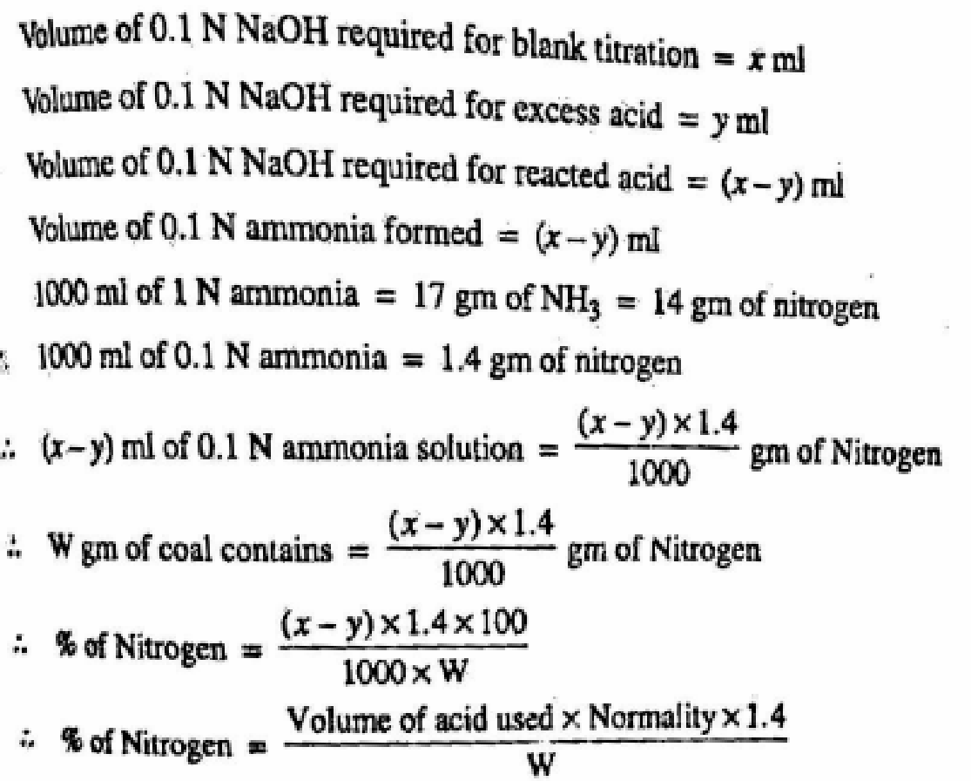

**‘W’ is the weight of Sample taken in gm**

**Numerical Assignment:**

1. 2 g of a soil sample was treated for nitrogen estimation using Kjeldahl’s method. Ammonia liberated during the reaction was absorbed in 50 ml of 0.1 N H2SO4. After absorption, the excess acid required 20 ml of 0.1 N NaOH for neutralization. Calculate the % N of the sample.

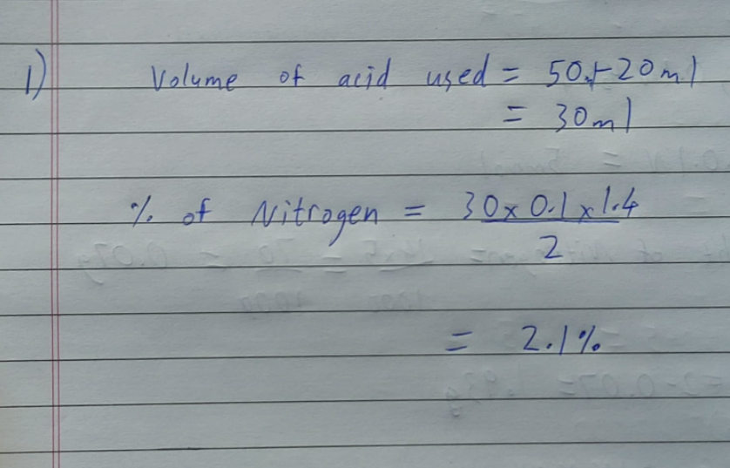

1. 3 g of a soil sample was treated for nitrogen estimation using Kjeldahl’s method. Ammonia liberated during the reaction required 14 ml 0.1 N H2SO4 for neutralization. Calculate the % N of the sample.

