**CO: 3 Identify and compare the material best suited for the energy production in sustainable and efficient manner**

**Name: Dhairya Satra**

**Batch: H-1** **Roll No.: 16010421091**

**Date: 7/1/2022**

**Experiment No. 9**

**Title: To measure the EMF of a cell and predict the spontaneity of the cell reaction**

**Aim: To measure the EMF of a cell and predict the spontaneity of the cell reaction**

**Objectives:**

1. To find EMF of the cell.
2. To calculate the Gibbs free energy change of the cell reaction.
3. To calculate the Equilibrium constant.
4. To predict the spontaneity of the cell reaction.

**Theory:**

Electrode at which oxidation takes place is anode and the electrode at which reduction takes place is cathode. When a metal is in contact with its own ion solution it develops a potential with respect to the electrolyte. The potential difference developed at the anode - electrolyte interface is called oxidation potential and the potential difference developed at the cathode -electrolyte interface is called reduction potential. The potential difference between the anode and cathode is called the EMF of the cell. The potential difference measured at standard conditions (1 atm pressure, 273K) is called standard electrode potential. Standard electrode potential gives the tendency of the electrode to get oxidized or reduced. If the electrolytes are different the two compartments are joined by a salt bridge, which is a tube containing a concentrated electrolyte solution in agar jelly that completes the electrical circuit and enables the cell to function.

**Electrochemical Series:**

A series in which metals are arranged in the decreasing order of reduction potential.

|  |  |
| --- | --- |
|  | **E0 in volt** |
| F2(g) + 2e- → 2F -(aq) | +2.87 |
| H2O2(aq) + 2H+(aq) + 2e- → 2H2O(l) | +1.77 |
| Au+(aq) + e- → Au(s) | +1.68 |
| Cl2(g) + 2e- → 2Cl-(aq) | +1.36 |
| O2(g) + 4H+(aq) + 4e- →  2H2O(l) | +1.23 |
| Br2(l) + 2e- → 2Br-(aq) | +1.09 |
| Ag+(aq) + e- → Ag(s) | +0.80 |
| Fe3+(aq) + e- → Fe2+(aq) | +0.77 |
| I2(s) +  2e- → 2I-(aq) | +0.54 |
| O2(g) + 2H2O(l) + 4e- → 4OH-(aq) | +0.40 |
| Cu2+(aq) + 2e- → Cu(s) | +0.34 |
| S(s) + 2H+(aq) + 2e-→ H2S(g) | +0.14 |
| 2H+(aq) + 2e- → H2(g) | 0.00 |
| Pb2+(aq) + 2e- → Pb(s) | -0.13 |
| Sn2+(aq) + 2e-→ Sn(s) | -0.14 |
| Ni2+(aq) + 2e- → Ni(s) | -0.23 |
| Co2+(aq) + 2e- → Co(s) | -0.28 |
| Fe2+(aq) + 2e- → Fe(s) | -0.44 |
| Zn2+(aq) + 2e- → Zn(s) | -0.76 |
| 2H2O(l) + 2e-→ H2(g) + 2OH-(aq) | -0.83 |
| Mn2+(aq) + 2e- → Mn(s) | -1.03 |
| Al3+(aq) + 3e- → Al(s) | -1.67 |
| Mg2+(aq) + 2e- → Mg(s) | -2.34 |
| Na+(aq) + e- → Na(s) | -2.71 |
| Ca2+(aq) + 2e- → Ca(s) | -2.87 |
| K+(aq) + e- → K(s) | -2.93 |
| Li+(aq) + e- → Li(s) | -3.02 |

We can construct innumerable number of galvanic cells by taking combinations of different half cells. Each half cell consists of a metallic road dipped in to an electrolyte. The metal with higher reduction potential act as cathode and the other will act as anode.

Standard EMF of the cell:



A galvanic cell is represented by putting a vertical line between metal and electrolyte solution and putting a double vertical line between the two electrolytes connected by a salt bridge.

Eg: The symbolic representation of Daniel cell is given below,



First, the reduced form of the metal to be oxidized at the anode (Zn) is written. This is separated from its oxidized form by a vertical line, which represents the limit between the phases (oxidation changes). The double vertical lines represent the saline bridge on the cell. Finally, the oxidized form of the metal to be reduced at the cathode, is written, separated from its reduced form by the vertical line. The electrolyte concentration is given as it is an important variable in determining the cell potential.

**Standard Hydrogen Electrode (S.H.E.):**

The potential of Standard hydrogen electrode used as the reference electrode has been arbitrarily taken as zero. The electrode consist of a glass jacket consisting of dry hydrogen gas bubbled at one atmosphere. There is a platinum wire sealed in the glass jacket. The entire system is immersed in 1M HCl solution. Standard hydrogen electrode can be represented as,



Electrode potential at any concentration can be calculated using Nernst equation. For the reaction,



Nernst Equation,





  if  

  if  

 Where;

 = number of electrons.

 = electrode potential of cell at standard conditions.

 = temperature.

 = universal gas constant.

 = Faraday constant.

When a cell reaction takes place electrical energy is produced which results in decrease in the free energy of the system.

Electrical work = Decrease in free energy

In an electro chemical cell,

Electric work done = Quantity of electric charge produced x E.M.F of the cell

For one mole of electrons quantity of electric charge is 1 (96500 coulomb)

Therefore, for  moles it is .





For a standard cell,



By van 't Hoff relation,







 = equilibrium constant

**Spontaneity or Feasibility of Reaction:**

|  |  |  | **Reaction** |
| --- | --- | --- | --- |
| Negative | >1 | Positive | Spontaneous |
| Zero | =1 | Zero | Equilibrium |
| Positive | <1 | Negative | Non - spontaneous |

**Materials Required:**

1. Beaker
2. Voltmeter
3. Salt bridge
4. Electrode Used  -  Li, K, Ba, Ca, Na, Mg, Al, Mn, Zn, Cr, Fe, Cd, Ti, Co, Ni, Sn, Pb, Cu, Ag, Au, 2H
5. Electrolyte  Used -LiCl, KCl, BaCl2, CaCl2, NaCl, MgSO4, Al(NO3)3, MnSO4, ZnSO4, Cr(NO3)3, FeSO4, CdSO4, TiNO3, CoSO4, NiSO4, SnSO4, PbNO3, CuSO4, AgNO3, AuNO3, HCl

**Procedure:**

1. Set the temperature.

1. Select the cathode from the list.

1. Select the anode from the list.

1. Select concentration of the electrolyte.

1. Record the voltage of the cell.

1. Calculate the Gibbs free energy from the voltage obtained from experiment.

1. Calculate the Equilibrium constant.

1. Predict the spontaneity of the cell reaction.

**Observations and Calculations:  
  
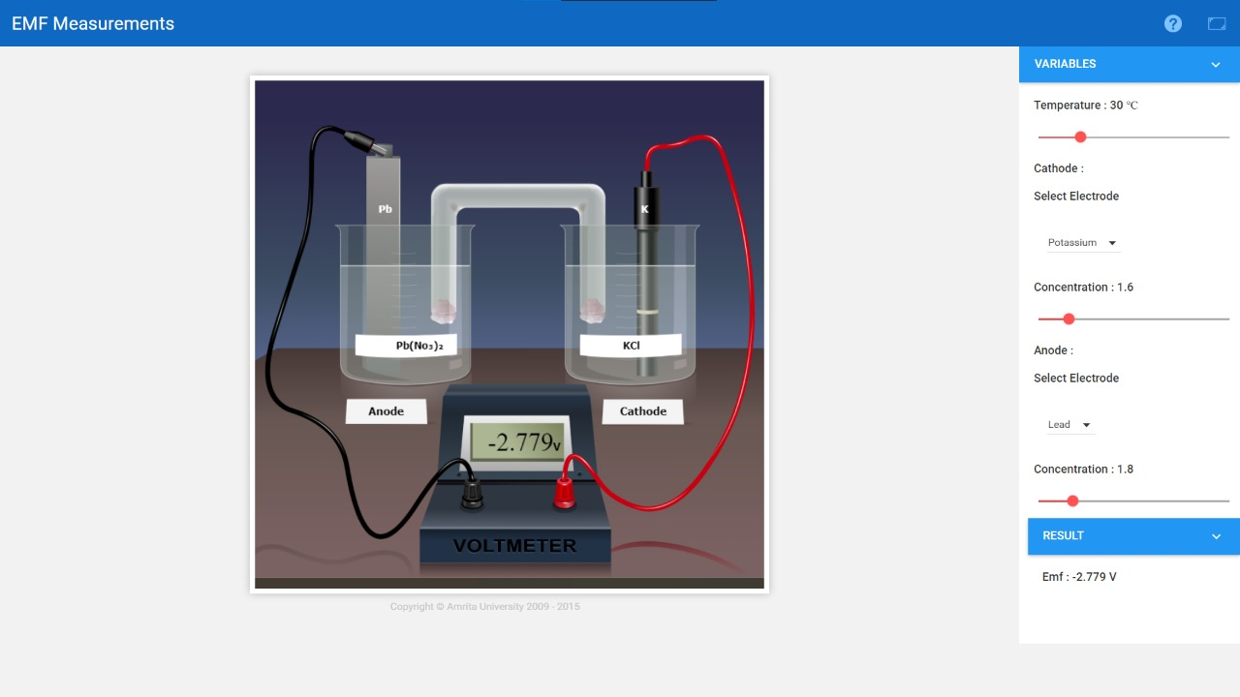**

Cathode: 2K+(aq) + 2e- 2K(s)

Anode: Pb(s)  Pb2+(aq)+ 2e-

Cell Representation: Pb(s) | Pb2+(aq) (1.8M) || K+(aq) (1.6M) | K(s)

Cell Reaction:

Pb(s) + 2K+(aq)  2K(s) + Co2+

Temperature = 30o C

Cathode used = Potassium

Concentration of electrolyte = 1.6M

Anode used = Lead

Concentration of electrolyte = 1.8M

Therefore, EMF of the cell = -2.779 V

The Gibb's free energy change of the cell reaction, Δ*G* = 536.347 KJ

The Equilibrium constant of the cell reaction, *K* = 6.8592*10-94

The spontaneity of the cell reaction = Non-spontaneous (E0 = -ve)

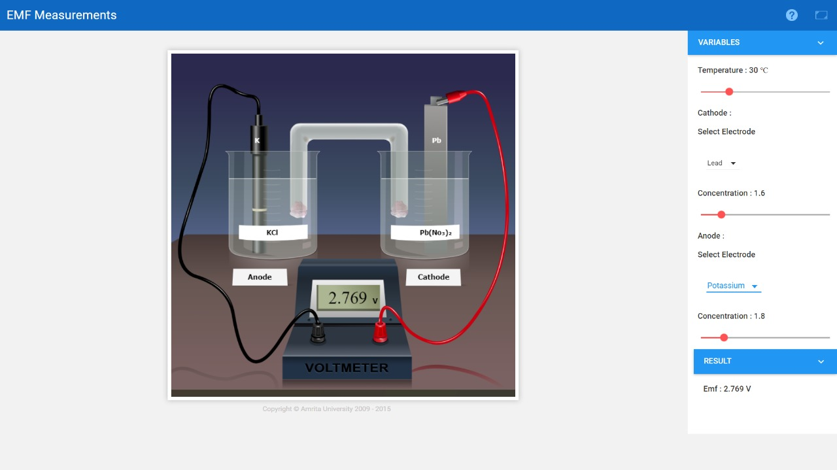

Cathode: Pb2+(aq) + 2e- Pb(s)

Anode: 2K(s)  2K+(aq) + 2e-

Cell Representation: K(s) | K+(aq) (1.8M) || Pb2+(aq) (1.5M) | Pb(s)

Cell Reaction:

Pb2+(aq) + 2K(s) 2K+(aq) + Pb(s)

Temperature = 30oC

Cathode used = Lead

Concentration of electrolyte = 1.8 M

Anode used = Potassium

Concentration of electrolyte = 1.6 M

Therefore, EMF of the cell = 2.769 V

The Gibb's free energy change of the cell reaction, Δ*G* = - 534.347 KJ

The Equilibrium constant of the cell reaction, *K* = 1.4578*1093

The spontaneity of the cell reaction = Spontaneous (K > 1)

**Assignments:**

1. What is the electrode potential of electrode in which conc. of Mg2+ is 0.01 M?

= -2.36 V.

Ans:

EMg2+/Mg = E0Mg2+/Mg +0.0591/n x log [Mg2+]/[Mg]

EMg2+/Mg = -2.36 + 0.0591/2 x log (0.01/1)

EMg2+/Mg = -2.42 V

2. 100 mL of a neutral solution containing 0.2 g of copper was electrolysed till the whole of copper was deposited. The current strength was maintained at 1.2 A and the volume of solution was maintained at 100 mL. Assuming 100% efficiency, find out the time taken for deposition of copper. [At.wt of copper =63.58]

Ans:

The quantity of electricity passed (100% efficiency) =

= Q(C)=I(A)×t(s) = 1.2 A × t(s) = 1.2t C.

The atomic weight of copper = 63.58 g/mol.

Moles of electrons passed = Q / 96500 = 1.2t / 96500

The mass of copper deposited = 0.2 g.

Hence,

0.2 g = atomic weight of copper × mole ratio × moles of electrons passed

0.2 g = 63.58 × 1/2 × 1.2t / 96500

**t = 506s.**

3. The reduction potentials of and electrode are 0.34 V and 0.80 V respectively. Construct a galvanic cell using these values. For what concentration of Ag+ ions will e.m.f of the cell at 25 0C be zero if conc. of Cu2+ is 0.01 M.

Ans:

Given, E0Cu2+/Cu = 0.34 V and E0Ag+/Ag = 0.80 V.

The standard emf will be positive if Cu/Cu2+ is anode and Ag+/Ag is cathode. The cell can be represented as:

Cu ∣ Cu2+ ∥ Ag+ ∣ Ag

The cell reaction is,

Cu + 2Ag+ → Cu2+ + 2Ag

E0cell = Oxid. potential of anode + Red. potential of cathode

= −0.34 + 0.80

= 0.46 volt

Applying the Nernst equation,

Ecell= E0cell − 0.0591/2 x log [Cu2+] / [Ag+]2

When, Ecell=0

E0cell =0.0591/2 x log [Cu2+] / [Ag+]2

or log [Cu2+] / [Ag+]2 = 0.462×2 / 0.0591 = 15.6345

[Cu2+] / [Ag+]2 = 4.3102×1015

[Ag+]2 = 0.01 / 4.3102×1015

= 0.2320×10−17

= 2.320×10−18

[Ag+] = 1.523×10−9M.

4. Calculate the maximum work that can be obtained from the Daniel cell . Given that and are -0.76 and +0.34 V respectively.

Ans:

According to given cell reaction

E0anode(Zn+2/Zn) = −0.76V

E0Cathode(Cu+2/Cu) = +0.34V

n=2

Now, Welectrical = −nF E0cell

= −2×96500 × [0.34−(−0.76)]

= −2×96599×1.1

= **−212.3K Joule.**

5. For Daniel Cell involving the cell reaction, ,the standard free energies of Zn (s), Cu (s), Cu2+ (aq) and Zn2+ (aq) are 0, 0, 64.4 KJmol-1 and -154.0 KJmol-1 respectively. Calculate the standard EMF of the cell.

Ans:

ΔG0 = (G0Zn2+ − G0Cu2+) = (−154 − 64.4) = -218.4 kJ/Mole

ΔG0 = -nF E0cell

−218.4 × 103 = (−2× 96500 x E0cell )

**E0cell = 1.1316 V**

**Self-Evaluation:**

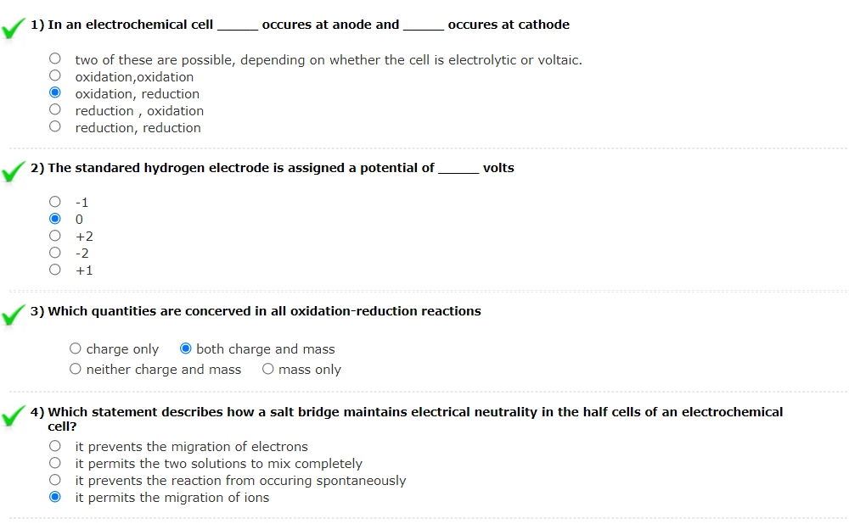

**Results:**

1st experiment

1. The EMF of the cell = -2.779 V
2. The Gibb's free energy change of the cell reaction = 536.347 KJ
3. The Equilibrium constant of the cell reaction = *K* = 6.8592*10-94
4. The spontaneity of the cell reaction = Non-spontaneous

2nd experiment

1. The EMF of the cell = 2.769 V
2. The Gibb's free energy change of the cell reaction = - 534.347 KJ
3. The Equilibrium constant of the cell reaction = *K* = 1.4578*1093
4. The spontaneity of the cell reaction = Spontaneous

**Conclusion:**

From this experiment, we found the emf of the cell nad predicted the spontaneity of the reaction.