**Experiment No: 4**

**Title:** **Thevenin’s Theorem & Norton’s Theorem.**

|  |  |  |  |  |
| --- | --- | --- | --- | --- |
| **Course Name:** |  | **Elements of Electrical and Electronics Engineering** | **Semester:** | **II** |
| **Date**  **Performance:** | **of** |  | **Batch No:** |  |
| **Faculty Name:** |  |  | **Roll No:** |  |
| **Faculty Sign Date:** | **&** |  | **Grade/Marks**  **:** | **/ 25** |

**Aim and Objective of the Experiment:**

● To Verify for Thevenin Theorem for the circuit● To Verify Norton Theorem for the Circuit.

**COs to be achieved:**

**CO1:** Analyze resistive networks excited by DC sources using various network theorems. .

|  |
| --- |
| **Circuit Diagram/ Block Diagram:** |
| **Circuit Diagram**  **Task1:** Calculation of VL and IL    VL = 2.5V IL = 0.83mA |

**Task**

**2**

**:**

**Circuit Diagram to measure**

**V**

**Th:**

V

th

=

3.75V

**Task**

**3**

**:**

**Circuit Diagram to measure**

**R**

**Th:**

R

th

= 1.5

K

ohms

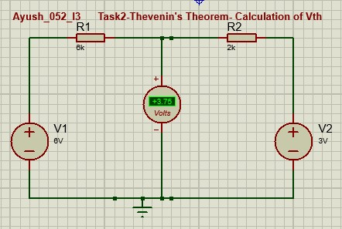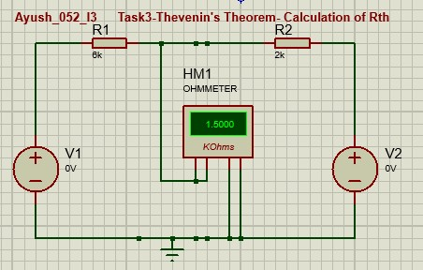

**Task 4:**

Thevenin Equivalent Network

**Norton Theorem**

**:**

**Task 1:**

Calculation of

V

L

and I

L

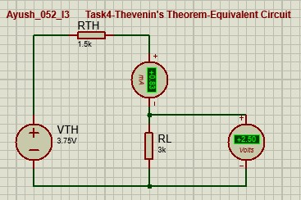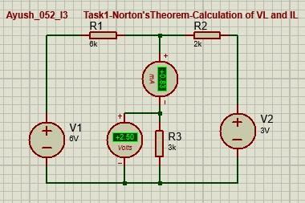

**Task2:**

**Calculation of I**

n

In = 2.5mA

**Task 3:**

**Calculation of Rn**

Rn =2.5 K

ohms

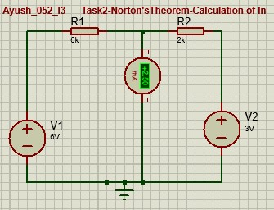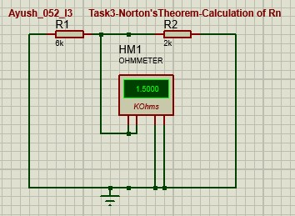

**Task 4:**

Norton Equivalent Network

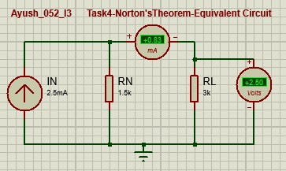

|  |
| --- |
| **Observation Table:** |
| **Observation Table**     |  |  |  |  | | --- | --- | --- | --- | | **Thevenin’s Theorem** | **Vth** | **Rth** | **Isc** | | **Practical value** | **3.75V** | **1.5 ohms** | **0.83mA** | | **Theoretical value** | **3.75V** | **1.5 ohms** | **0.83mA** | |

|  |
| --- |
| **Stepwise-Procedure:** |
| **Thevenin’s Theorm**  1. Connect the circuit as shown in the circuit diagram.  2. Set V1, V2 and measure open circuit voltage VTh across load terminals A and B.   1. Replace all voltage sources by Short circuit and measure RTh across terminals A and B as per the circuit diagram shown in the figure. 2. Draw Thevenin’s equivalent circuit and determine the value of load current from it. 3. Verify the results theoretically.     **Norton’s Theorem**   1. Connect the circuit as shown in the circuit diagram. 2. Set the voltages V1, V2 3. Remove the load resistance and measure the short circuit current ISC through A and B terminals. 4. Replace all the voltage sources by Short circuit and measure RTh across terminals A and B as per the circuit diagram shown in the figure. 5. Draw Norton’s equivalent circuit and determine the value of load current. 6. Verify the results theoretically |

|  |  |  |  |  |  |  |  |
| --- | --- | --- | --- | --- | --- | --- | --- |
|  | **Norton Theorem** | **In** | **Rn** | | **Isc** |  | |
| **Practical value** | **2.5mA** | **1.5 ohms** | | **0.83mA** |
| **Theoretical value** | **2.5mA** | **1.5 ohms** | | **0.83mA** |
|  | | |  | | |  |
| **Thevenin’s Theorem:** Calculation ofVL and I L      2. Calculation of Vth | | | | | |

2

.Calculation of Rth

**Norton Theorem**

1

. Calculation of

V

L

and I

L

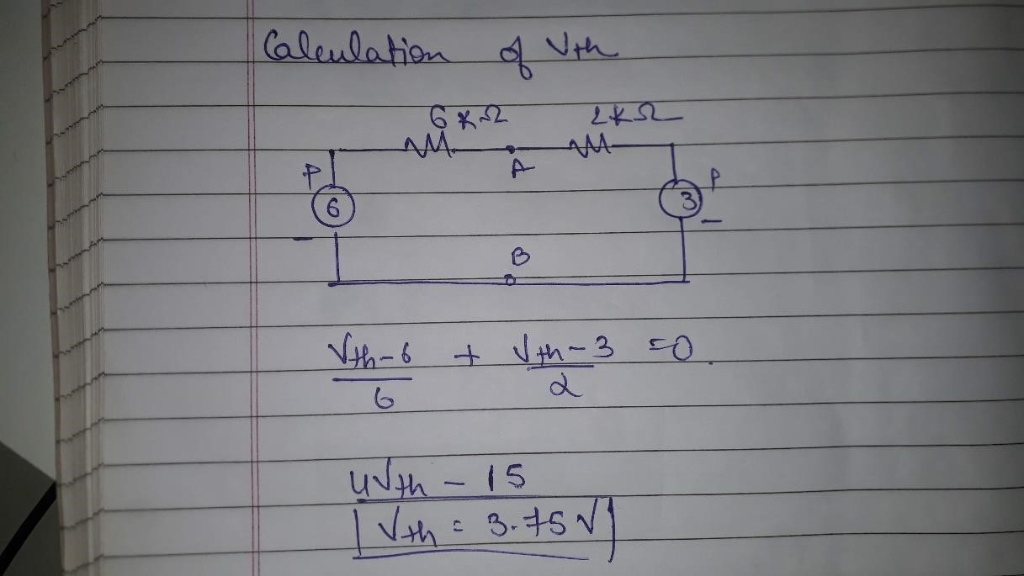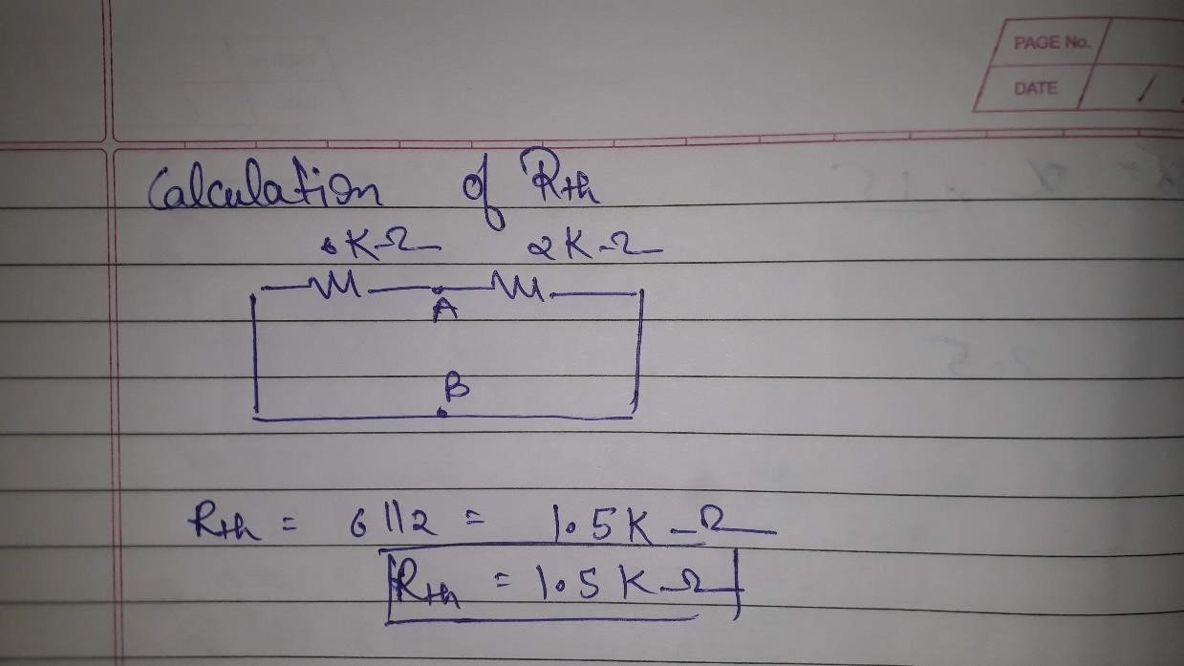

2

.Calculation of In

3

.Calculation of Rn

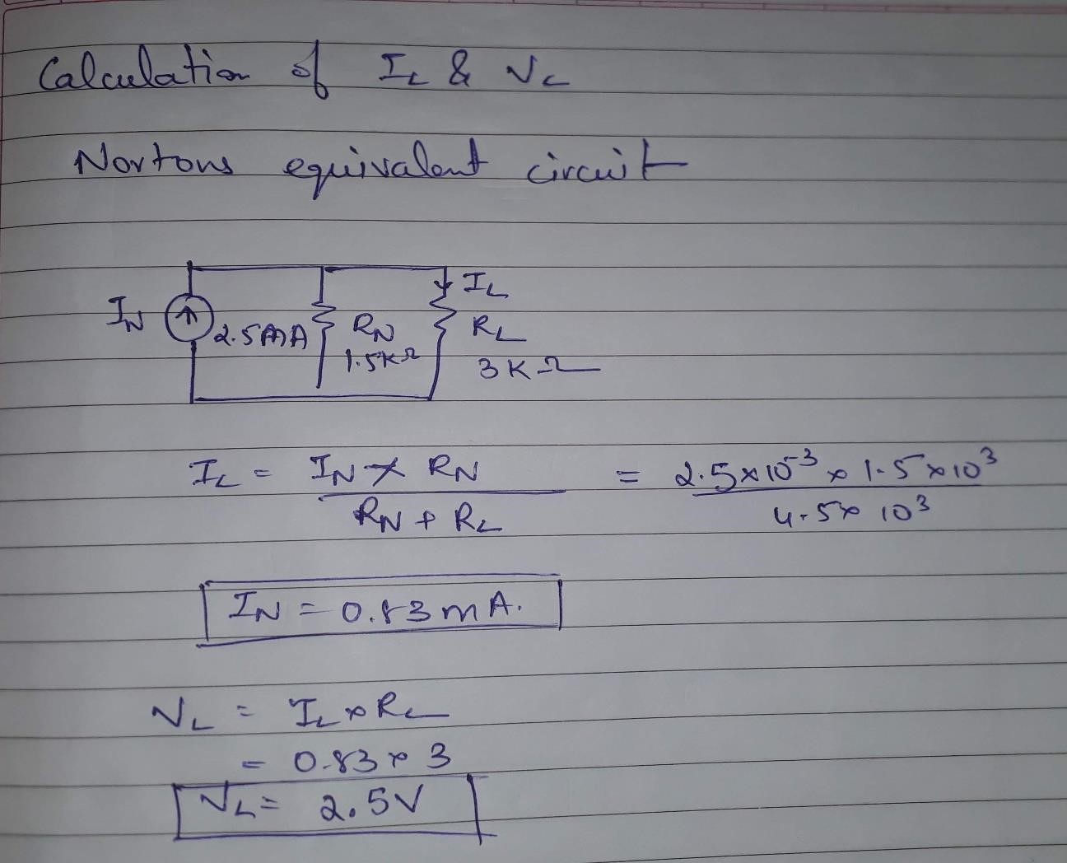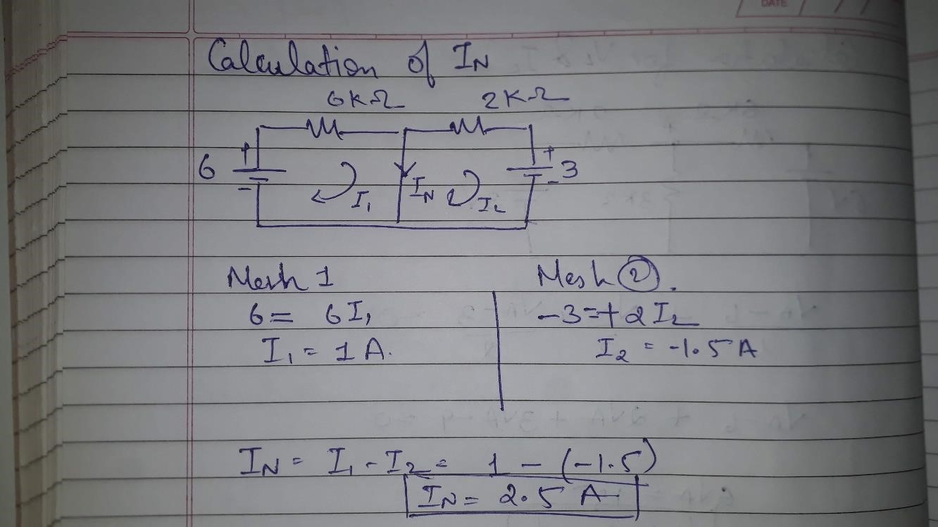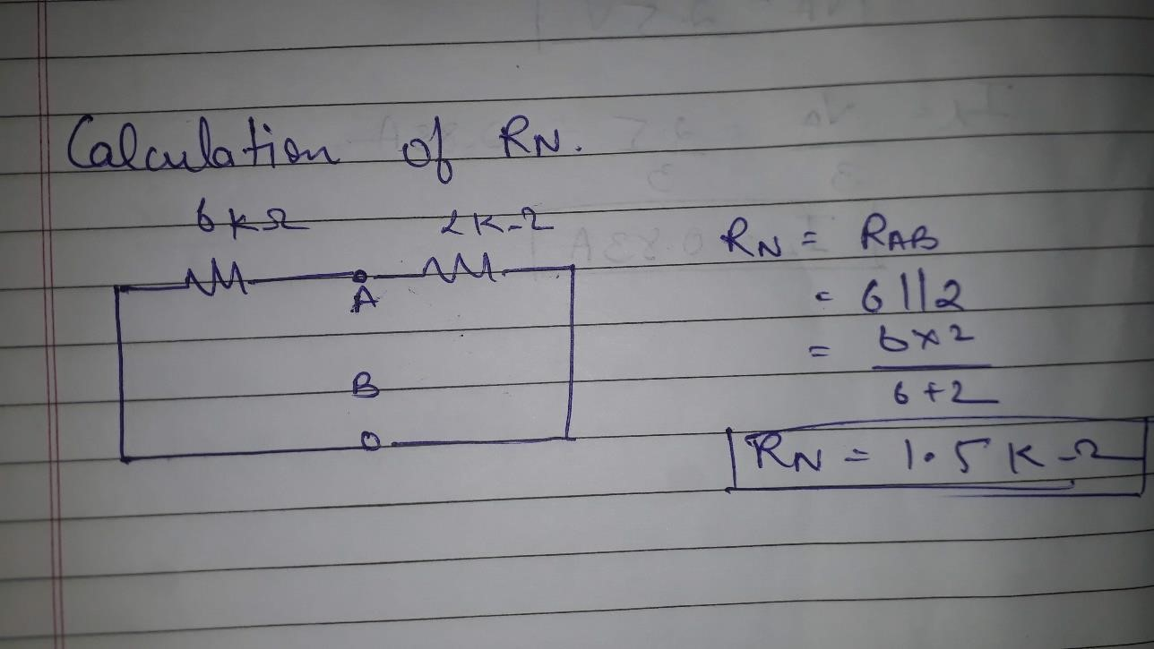

|  |
| --- |
| **Conclusion:** |
| Hence, Thevenin’s and Norton Theorem has been Verified. |

**Signature of faculty in-charge with Date:**